Women, Wealth & Survival: A Data Story of the Titanic
Advanced Data Visualization & Storytelling — Week 2 Deliverable
Built for a non-technical audience: no jargon, no raw tables — just the story the data tells.

1. Introduction
Week 1 was about getting the Titanic passenger data clean and trustworthy. This week is about something different: taking that same data and turning it into a story a non-technical person — a museum visitor, a business stakeholder, a classroom of students — could actually follow and remember.
The guiding question behind every chart in this report is the same one someone unfamiliar with the dataset would naturally ask: 'Why did some people survive and others didn't?' Rather than answering that with a wall of statistics, each visualization below tackles one piece of the answer, building toward a complete picture by the end. The narrative arc is: who was on board → how survival split by sex and class → how age changed the picture → where people boarded and what that reveals → and finally, a single view that ties fare, age, family size and survival together.
A quick note on tools: everything here was built in Python. Plotly was used for the flow diagram, composition treemap, and bubble chart (interactive-style visuals that are especially good at showing hierarchy and multi-variable relationships); Matplotlib and Seaborn were used for the violin plot, heatmap, and stacked bar chart (better suited to precise statistical distributions).

2. Methods & Approach to Storytelling
The dataset is the same cleaned Titanic passenger file from Week 1 (891 passengers, no missing values, engineered features like FamilySize retained). No further cleaning was needed here — the focus this week was entirely on how to represent the data, not how to prepare it.
For each visualization, three decisions were made deliberately:
- Chart type — chosen to match the shape of the question being asked (a flow question gets a flow diagram, a distribution question gets a violin plot, a hierarchy question gets a treemap), not just picked from habit.
- Color — kept consistent throughout the whole report: green always means 'survived', red always means 'did not survive'. This one small consistency rule makes six very different charts feel like a single connected story instead of six disconnected ones.
- Annotation — every chart carries its takeaway directly on the chart (percentages, labels, counts) rather than forcing the reader to cross-reference a legend or a separate table.
The code for every chart is included alongside its explanation so the approach is fully reproducible, not just illustrated.

3. Visual Analysis

3.1 Who was on board, and who made it — the flow diagram
Chart choice: a Sankey diagram is the right tool here because the question is fundamentally about flow — how a population splits, and splits again, and splits again. A bar chart could show one split; a Sankey shows the whole cascade in a single glance, which is exactly what a first-time viewer needs before any other chart makes sense.
import plotly.graph_objects as go

fig = go.Figure(data=[go.Sankey(
node=dict(label=labels, color=node_colors, pad=22, thickness=24),
link=dict(source=sources, target=targets, value=values, color=link_colors)
)])
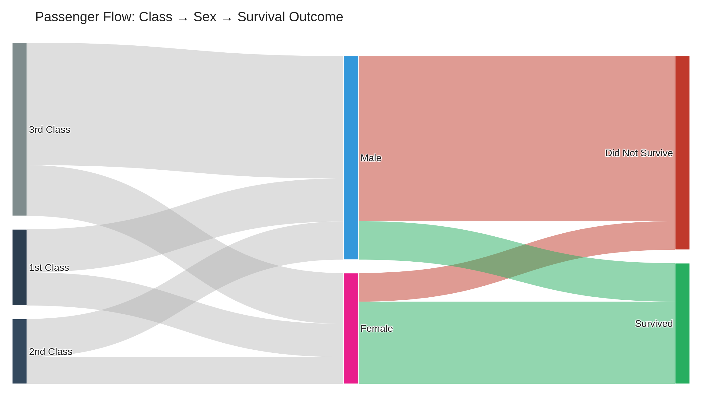
Figure 1 — Passenger flow from class, through sex, to survival outcome. Band width = number of people.
This single chart previews almost the entire story: the third-class band is by far the widest starting point, and by the time it reaches the outcome stage, most of it flows into red. Meanwhile the female bands — much thinner overall — flow overwhelmingly into green. Everything else in this report is really just zooming into pieces of this one picture.

3.2 Did age protect you? — the violin plot
Chart choice: a violin plot was used instead of a simple bar of averages because averages hide shape. A violin shows the full distribution — where the bulk of people actually sit, not just a single number — which matters enormously here, because the interesting finding isn't a shift in the average age, it's a shift in the shape.
import seaborn as sns

sns.violinplot(data=df, x='SurvLabel', y='Age', hue='SexLabel',
split=True, inner='quartile')
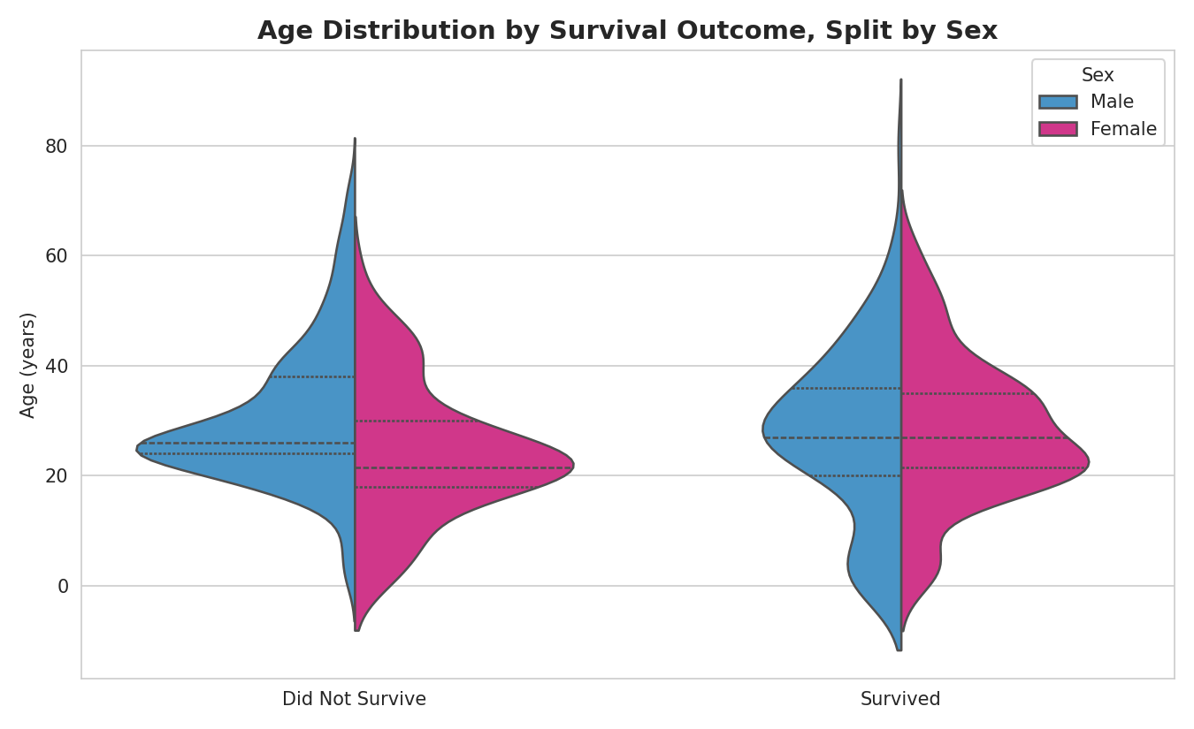
Figure 2 — Age distribution by outcome, split by sex. Dotted lines mark the quartiles.
Look at the bottom of each violin: the 'survived' side (right) bulges outward near age 0-10 in a way the 'did not survive' side doesn't. That bulge is the visual signature of the 'children first' pattern. Passengers aged 12 and under survived at 58.0%, compared with 36.7% for everyone older — and that gap is precisely what shows up as extra width low on the violin.

3.3 Did age matter the same way in every class? — the heatmap
Chart choice: a heatmap was the natural next step, because the previous two charts each answered one question (class matters; age matters) but not how those two forces combine. A grid is the most compact way to show an interaction between two categorical dimensions at once, and color lets a reader spot the pattern before they even read a single number.
pivot = df.groupby(['AgeBand','ClassLabel'])['Survived'].mean().unstack() * 100
sns.heatmap(pivot, annot=True, fmt='.0f', cmap='RdYlGn', center=50, vmin=0, vmax=100)
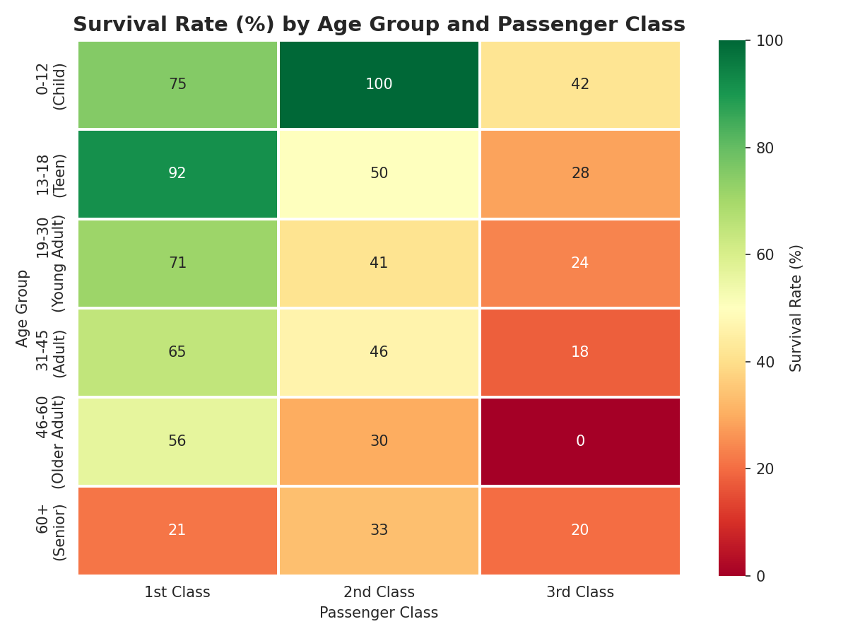
Figure 3 — Survival rate (%) across age group and class. Green = high survival, red = low.
This is the chart that adds real nuance. Being a child helped — but not equally everywhere: first-class children survived 75% of the time, while third-class children survived only 42% of the time. Age offered some protection in every class, but nowhere near enough to fully cancel out the disadvantage of traveling third class. The single darkest cell in the whole grid, unsurprisingly, is 1st-class children at 100%.

3.4 Did where you boarded matter? — the stacked bar
Chart choice: a 100%-stacked horizontal bar keeps the comparison fair across ports that had very different passenger counts (Southampton had 646 boarders, Queenstown only 77). Showing raw counts would have made Southampton look dramatically more important than Queenstown for reasons that have nothing to do with survival; normalizing to percentages puts all three ports on equal footing.
ct = pd.crosstab(df['PortLabel'], df['Survived'], normalize='index') * 100
ct.plot(kind='barh', stacked=True, color=['#c0392b','#27ae60'])
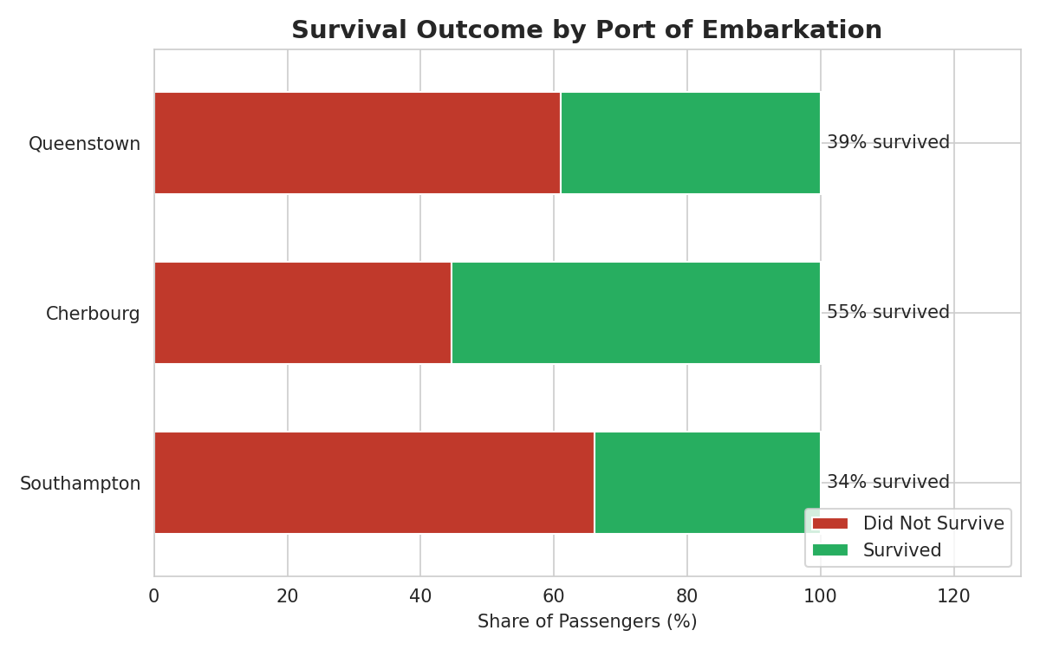
Figure 4 — Survival outcome by port of embarkation, shown as a share of each port's passengers.
Cherbourg stands out — 55% of its passengers survived, well above Southampton's 34% and Queenstown's 39%. On its own this could look like a geographic mystery, but it dissolves as soon as you check class composition: about half of everyone who boarded at Cherbourg traveled first class, versus only 20% at Southampton. Cherbourg wasn't a luckier port — it was a wealthier one. This is a useful reminder built into the story: an interesting-looking pattern in one chart often has its real explanation sitting in another.

3.5 Putting the whole population in one picture — the treemap
Chart choice: a treemap was chosen to close the demographic half of the story because it can show three levels of hierarchy (class, then sex, then outcome) and relative population size simultaneously — something a bar chart or pie chart can't do cleanly at three levels deep. The size of each rectangle is itself information, not just decoration.
import plotly.express as px

fig = px.treemap(grp, path=['ClassLabel','SexLabel','SurvLabel'], values='Count',
color='SurvLabel', color_discrete_map={...})
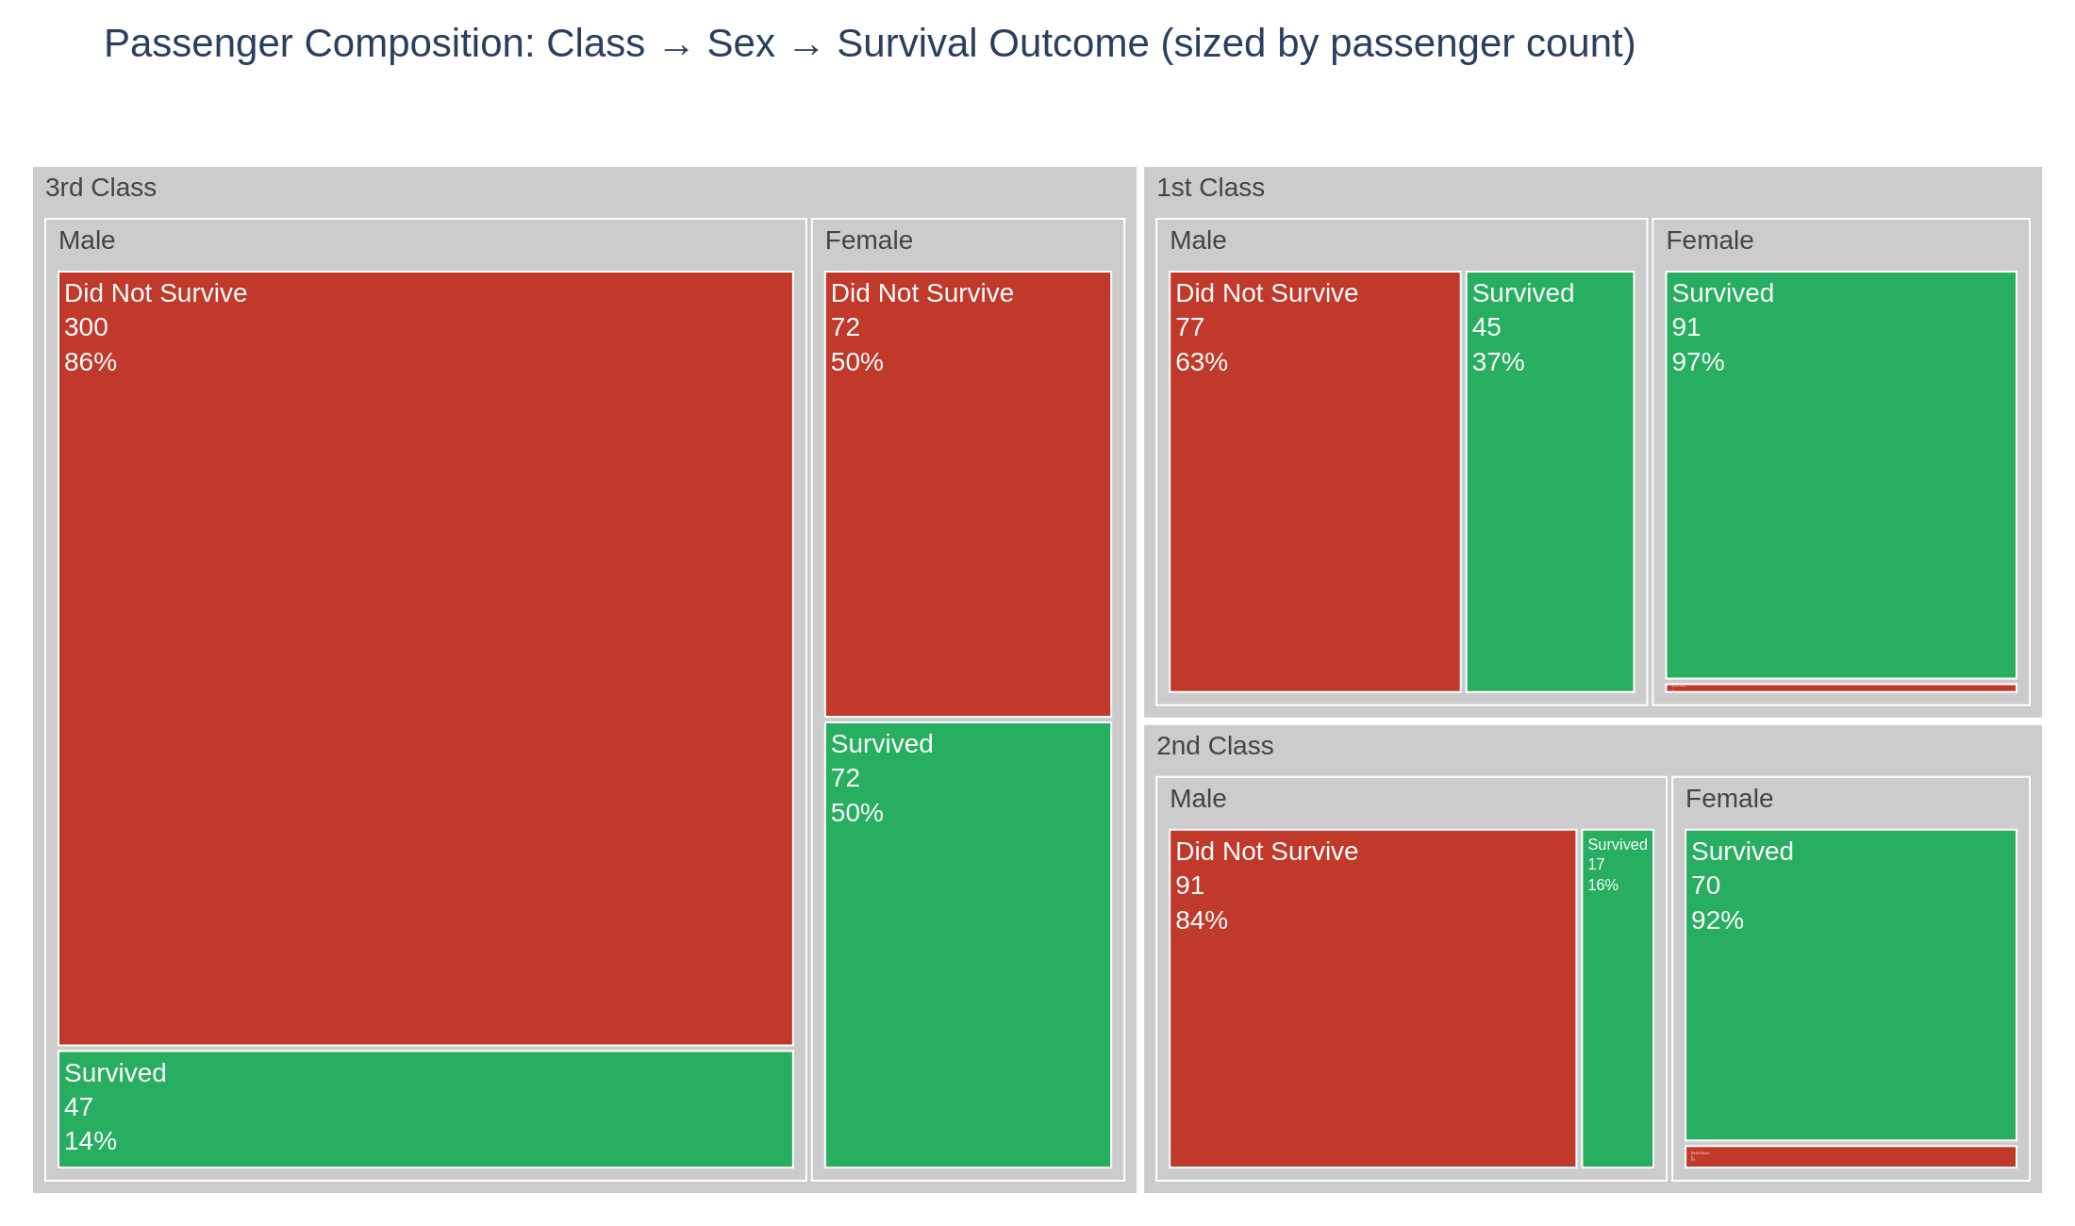
Figure 5 — Passenger composition by class, sex and outcome. Rectangle area = number of passengers.
The scale differences jump out immediately here in a way percentages alone can't convey: that huge red block, third-class males who didn't survive (300 people), is visually the single largest group in the entire dataset — larger than the whole first-class male category combined. Meanwhile first-class and second-class women are almost entirely green. This chart makes the human scale of the tragedy legible in a way a table of percentages never quite manages.

3.6 Bringing it together — fare, age, family size and survival
Chart choice: a faceted bubble chart was used as the closing visual because it's the only chart in this report carrying five variables at once — age (x-axis), fare (y-axis), family size (bubble size), survival (color) and class (separate panel) — which makes it the right chart to end on: a synthesis rather than a single new fact.
import plotly.express as px

fig = px.scatter(df, x='Age', y='Fare', size='FamilySize', color='SurvLabel',
facet_col='ClassLabel', size_max=22, opacity=0.6)
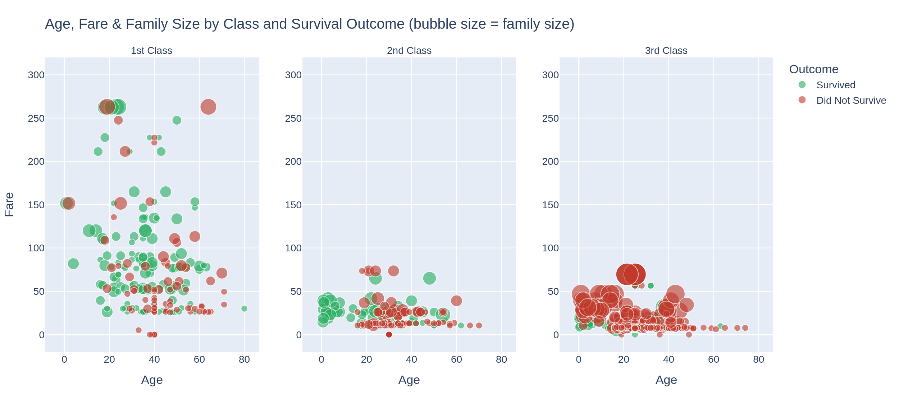
Figure 6 — Age vs. fare, bubble size = family size, faceted by class and colored by outcome.
Read left to right, the panels tell a visual story of their own. The first-class panel is dominated by mid-to-large green bubbles scattered across a wide fare range. The third-class panel is nearly the opposite: a dense wall of large red bubbles bunched at the bottom of the fare axis — large families traveling cheaply, and overwhelmingly not surviving. The median fare among third-class survivors was just £8.52, barely different from the £8.05 median among those who didn't survive — but in first class, survivors paid a median of £77.96 versus £44.75 for non-survivors. Money bought a meaningfully better chance only once you were already inside the first-class system.

4. Summary Table — Chart-to-Narrative Mapping
Visualization | Chart Type | Story Role
Fig. 1 | Sankey diagram | Opens the story — shows the full population split by class, sex, outcome in one view.
Fig. 2 | Split violin plot | Introduces age as a factor — reveals the 'children survived more' shape.
Fig. 3 | Heatmap | Shows age and class interacting — protection from age wasn't equal across class.
Fig. 4 | 100% stacked bar | Introduces geography, then reframes it as a class story, not a location story.
Fig. 5 | Treemap | Shows human scale — which groups were largest, not just which had the highest rate.
Fig. 6 | Faceted bubble chart | Closes the story by tying fare, age, family size and outcome together at once.

5. Business & Scientific Implications
While this specific dataset describes a historical maritime disaster, the analytical pattern it demonstrates generalizes directly to real, current-day problems in risk and safety analytics:
- Emergency evacuation design: the clear interaction between age, physical grouping (family size) and outcome supports a broader principle used in modern evacuation planning — protocols and signage should account for the fact that people evacuate as family units, not as isolated individuals, and very large groups need different guidance than solo travelers or small families.
- Insurance and risk modeling: the finding that fare (a proxy for accommodation tier and physical location) mattered more than age alone mirrors how modern insurance and actuarial models weight location/exposure variables alongside demographic ones — a reminder that the most predictive variable is not always the most intuitive one.
- Resource allocation under scarcity: the third-class outcome data is a case study in what happens when safety resources (lifeboat access, crew attention, clear instructions) are not distributed evenly across a population — directly relevant to modern discussions of equitable resource allocation during public health emergencies, disaster response, and infrastructure failures.
- Customer/user segmentation: the treemap's approach — breaking a population into nested segments and sizing them by volume — is the same technique used in modern customer analytics to identify which segments are both large and underperforming, which is often more actionable than knowing which segment has the single worst rate.

6. Conclusion
The six visualizations in this report were deliberately sequenced, not just collected: each one answers the question the previous one raised, moving from a broad overview (Figure 1) to specific interactions (Figures 2-4) to human scale (Figure 5) to a full synthesis (Figure 6). The result is a narrative a non-technical reader can follow start to finish without needing to understand p-values, regression coefficients, or raw data tables — the charts, colors, and annotations carry the argument on their own.
The central finding holds up from every angle examined: survival on the Titanic was shaped far more by social position — sex, class, and the fare/location that class implied — than by any individual trait like age alone. Age mattered, but it mattered inside the boundaries that class had already set.

