Week 1: Data Acquisition, Cleaning & Exploratory Analysis
Dataset: Titanic Passenger Records (Kaggle / public GitHub mirror)
Prepared as part of the Data Science Foundations track — Week 1 deliverable

1. Objective & Why This Dataset
The goal for this week was to walk through the full early-stage data science workflow end to end: find a real public dataset, get it cleaned up properly, and pull out some genuine insight through exploratory analysis — all while keeping a clear record of the reasoning behind every decision, not just the code.
I picked the Titanic passenger dataset for a few practical reasons. It's messy in exactly the ways real-world data tends to be messy — missing values in different columns for different reasons, a mix of numeric and categorical fields, and a target variable (survival) that actually correlates with other columns, so there's something to find. It's also small enough (891 rows) to fully understand by eye, which makes it easier to sanity-check every cleaning decision instead of just trusting the code blindly.

2. Data Acquisition
The dataset was pulled from a public GitHub mirror of the well-known Kaggle Titanic dataset (datasciencedojo/datasets), which hosts the raw CSV without requiring authentication. It contains 891 passenger records from the RMS Titanic, with 12 original columns covering demographics, ticket/fare information, family relationships aboard, and the survival outcome.
import pandas as pd

# Downloaded via: wget <raw_csv_url> -O titanic.csv
df = pd.read_csv('titanic.csv')
print(df.shape) # (891, 12)
print(df.columns.tolist())
Columns available: PassengerId, Survived, Pclass, Name, Sex, Age, SibSp, Parch, Ticket, Fare, Cabin, Embarked.

3. Initial Inspection
Before touching anything, I wanted to understand what I was actually working with — data types, how much was missing, and whether there were duplicate records that could quietly bias any statistics later.
print(df.dtypes)
print(df.isnull().sum())
print(df.duplicated().sum())
df.describe(include='all').T
Findings from this first pass:
- No duplicate rows at all — good news, nothing to deduplicate.
- Age is missing for 177 of 891 passengers (~19.9%) — significant enough that dropping those rows would throw away real signal.
- Cabin is missing for 687 of 891 (~77.1%) — too sparse to reliably impute values for, but the fact that a cabin was recorded at all might itself be meaningful (likely correlated with class/fare).
- Embarked is missing for just 2 passengers — trivial to handle.
- Pclass, Survived and Sex are stored as plain integers/strings even though they're really categorical — this matters for how pandas/plotting libraries treat them.
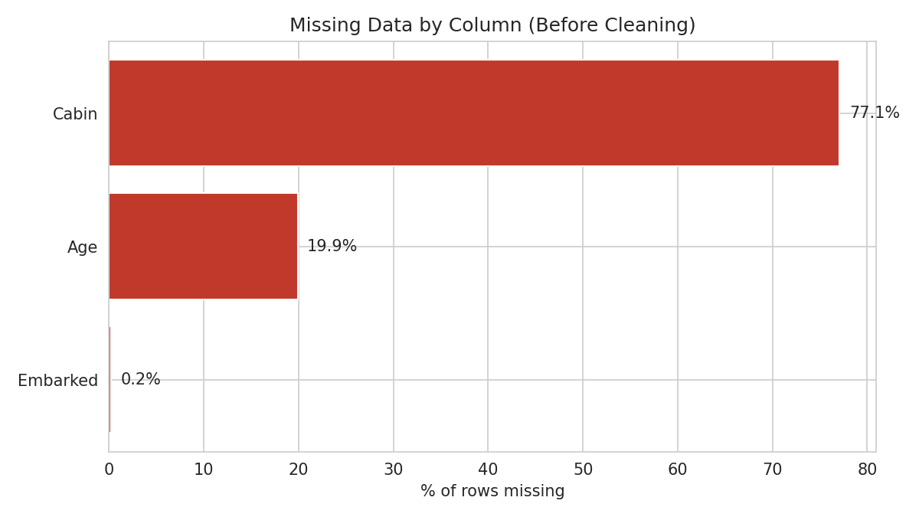
Figure 1 — Share of missing values by column, before any cleaning. Cabin and Age are the two columns that actually need a decision.

4. Data Cleaning
My general rule here: don't just fill in gaps for convenience — think about why the value is missing and what a reasonable stand-in actually is. Below is what I did for each column, and why.

4.1 Embarked — mode imputation
Only 2 missing values out of 891, and the vast majority of passengers boarded at Southampton ('S'). With so few missing and such a dominant category, filling with the mode is low-risk and won't distort the distribution in any meaningful way.
df['Embarked'] = df['Embarked'].fillna(df['Embarked'].mode()[0])

4.2 Cabin — extract signal instead of imputing
With over three-quarters of values missing, trying to guess an actual cabin number would be fabricating data, not cleaning it. But the missingness itself is probably informative — cabins were likely recorded more consistently for higher-fare, upper-class passengers who had private cabins, while third-class passengers often didn't have individual cabin assignments at all. So rather than dropping the column outright, I converted it into two more honest signals: a binary flag for whether a cabin was recorded, and the deck letter where it was available.
df['HasCabinRecord'] = df['Cabin'].notnull().astype(int)
df['Deck'] = df['Cabin'].str[0]
df.drop(columns=['Cabin'], inplace=True)

4.3 Age — grouped median imputation
A single global median for Age would ignore an obvious pattern: age correlates with passenger class (wealthier, older passengers tended to travel first class) and with sex-based social roles of the era. So instead of one blanket median, I imputed missing ages using the median age within each Pclass + Sex group. This keeps the imputed values closer to what's actually plausible for that subgroup rather than flattening everyone toward the same overall average.
df['Age'] = df.groupby(['Pclass', 'Sex'])['Age']
.transform(lambda x: x.fillna(x.median()))

4.4 Data type corrections
Survived, Pclass, Sex and Embarked are all categorical in nature, not continuous numbers, so I explicitly cast them to pandas' category dtype. This matters — otherwise plotting and grouping functions can treat something like Pclass (1, 2, 3) as if the gap between class 1 and 3 is a meaningful numeric distance, which it isn't.
for col in ['Survived', 'Pclass', 'Sex', 'Embarked']:
df[col] = df[col].astype('category')

4.5 Duplicates
Re-checked after all transformations just to be safe (in case the groupby imputation somehow introduced an artifact) — confirmed zero duplicate rows remained.

4.6 Feature engineering
A couple of small derived columns made the exploratory analysis much richer without adding any risk of data leakage, since they're built purely from columns already present:
- FamilySize = SibSp + Parch + 1 (total people traveling together, including the passenger)
- IsAlone = 1 if FamilySize == 1, else 0
- Title extracted from the Name field (Mr, Mrs, Miss, Master, etc.) via regex — a nice proxy for age/social status when Age itself is uncertain
df['FamilySize'] = df['SibSp'] + df['Parch'] + 1
df['IsAlone'] = (df['FamilySize'] == 1).astype(int)
df['Title'] = df['Name'].str.extract(r',\s*([^\.]*)\.')
After all of this, the cleaned dataset has zero missing values across every retained column, no duplicates, correct dtypes, and three new engineered features — all traceable back to a clear, documented reason.

5. Exploratory Data Analysis
With clean data in hand, the goal here was to actually look for patterns — not just describe the data, but ask what it's telling us about who survived and why.

5.1 Age distribution, before and after imputation
First check: did the imputation distort the shape of the Age distribution? Comparing the histogram before (n=714, missing values dropped) and after (n=891, imputed) shows the overall shape holds up — same rough bell curve centered in the late-20s, no artificial spike created at a single value, since the group-wise median spreads imputed values across several sensible medians rather than one number.
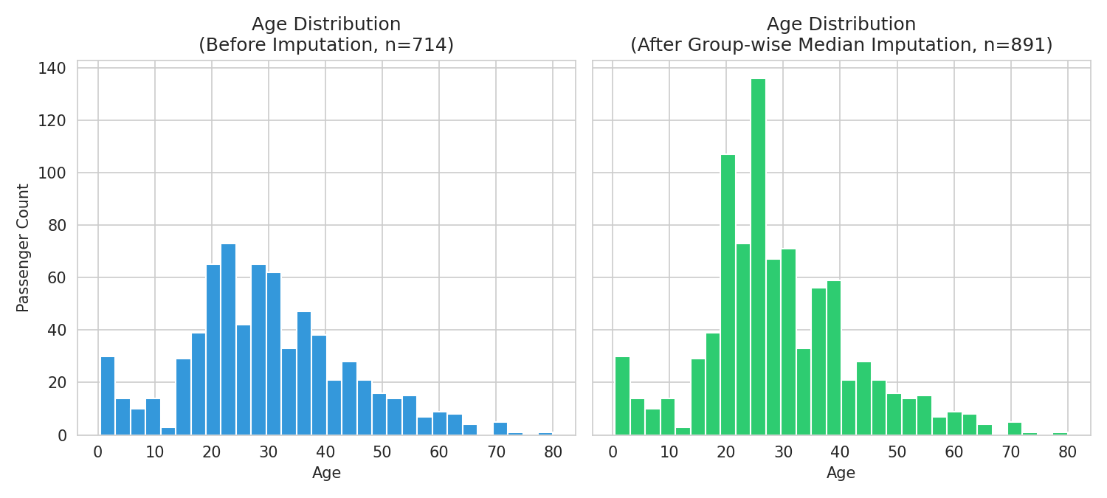
Figure 2 — Age distribution before imputation (blue, missing dropped) vs. after grouped median imputation (green, full dataset).

5.2 Correlation matrix
To get a quick read on which variables actually move together, I built a correlation matrix across the numeric and encoded categorical features. A few things jump out immediately: Fare correlates positively with Survived (0.26), Pclass correlates negatively with Fare (-0.55, which makes sense — class 1 is the 'lower number, higher fare' end), and sex (encoded as 1 = female) shows the strongest single relationship with survival of anything in the matrix.
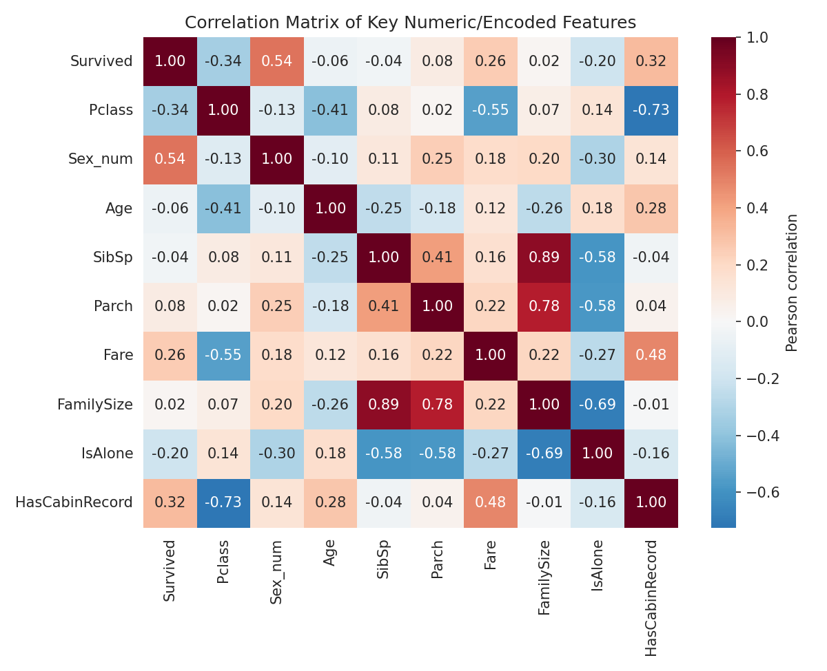
Figure 3 — Pearson correlation matrix across key numeric and encoded categorical variables.

5.3 Survival by class and sex
This is the single clearest pattern in the whole dataset. Overall survival was 38.4%, but that number hides enormous variation: female passengers survived at 74.2% versus 18.9% for male passengers, and within each class, survival dropped sharply from first to third. First-class women survived at roughly 97%, while third-class men survived at only about 13.5%. 'Women and children first' clearly wasn't just a slogan — it shows up directly in the numbers, and class privilege compounded on top of it.
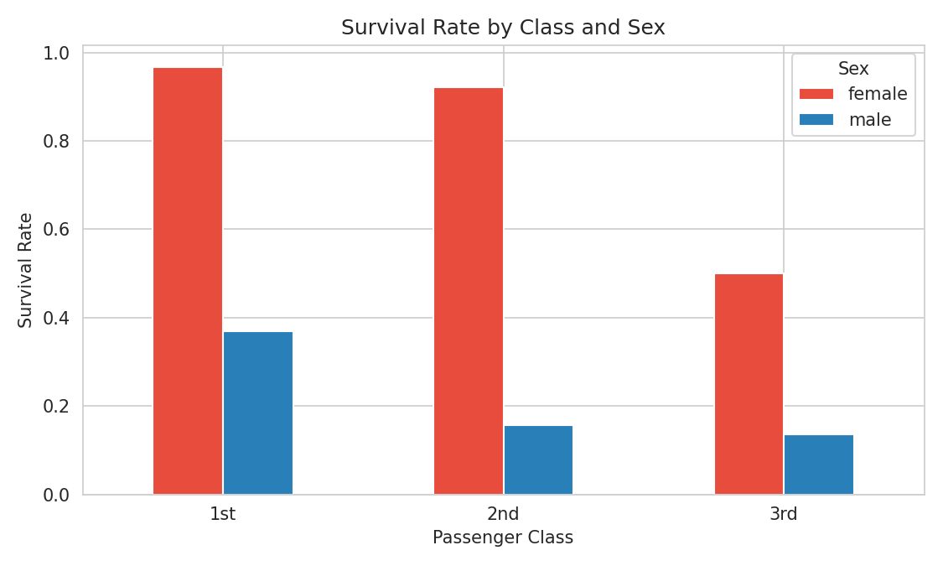
Figure 4 — Survival rate broken down by passenger class and sex.

5.4 Fare distribution by class
The box plot confirms what you'd expect but puts real numbers behind it: first-class fares are far higher and much more spread out (a few passengers paid extremely high fares, visible as outliers above the box), while second and third class fares are lower and far more tightly clustered. This also validates that Pclass and Fare are, unsurprisingly, telling much of the same story from two different angles.
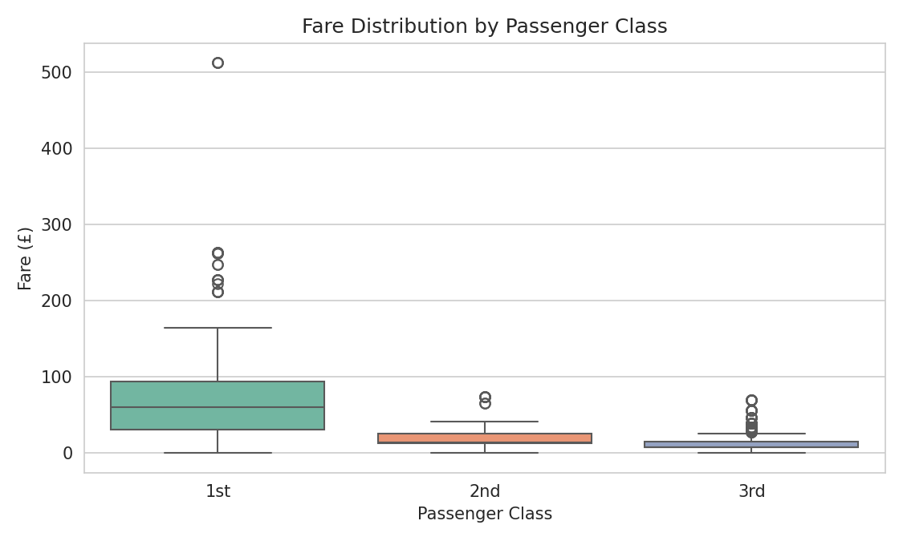
Figure 5 — Fare distribution by passenger class, showing spread and outliers within each class.

5.5 Age vs. Fare, colored by survival
Plotting Age against Fare and coloring each point by outcome doesn't show a clean linear boundary (this isn't a dataset where age and fare alone separate survivors perfectly), but a pattern is still visible: green (survived) points cluster more densely at higher fare values, while red (did not survive) points dominate the lower-fare band across nearly all ages. It reinforces that fare — really, a proxy for class and cabin location — mattered more than age on its own.
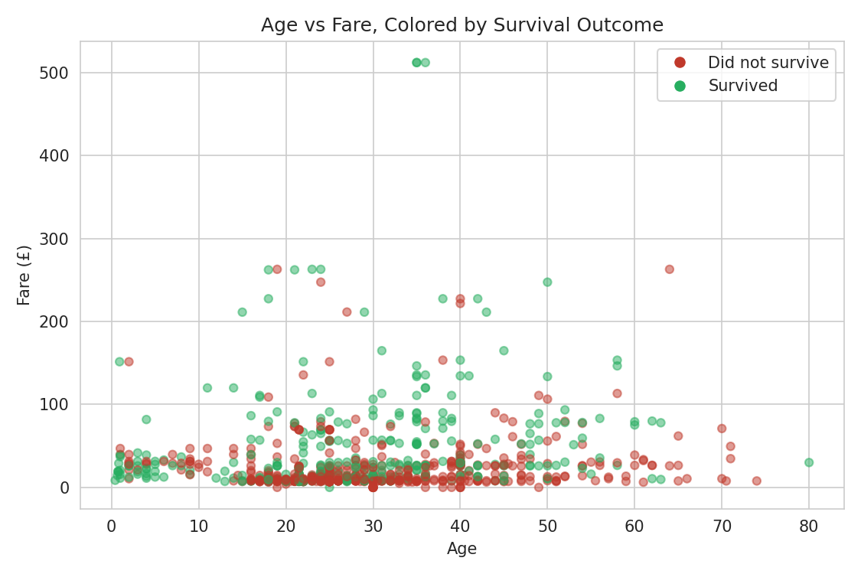
Figure 6 — Age vs. Fare scatter plot, colored by survival outcome (green = survived, red = did not).

5.6 Family size and being alone
One pattern that surprised me a little: traveling completely alone was associated with a lower survival rate (30.4%) than traveling with a small family. Survival actually peaks around a family size of 3–4 (roughly 58–72%), then drops off again for very large families (5+), who likely struggled to stay together or evacuate as a unit during the chaos. So the relationship isn't 'more family is better' — it's closer to an inverted-U: alone was risky, a small family helped, and a very large family became a liability again.

6. Summary Table — Cleaning Decisions
Column | Issue | Action & Rationale
Embarked | 2 missing (0.2%) | Filled with mode ('S') — negligible impact given how few and how dominant the mode is.
Cabin | 687 missing (77.1%) | Too sparse to impute honestly. Converted to HasCabinRecord flag + Deck letter; dropped raw column.
Age | 177 missing (19.9%) | Imputed with median grouped by Pclass + Sex, preserving realistic subgroup differences.
Survived / Pclass / Sex / Embarked | Wrong dtype | Cast to category dtype so they're treated as labels, not ordered numbers.
All columns | Duplicate rows | Checked before and after cleaning — 0 duplicates found both times.

7. Key Insights
- Overall survival rate was 38.4% — most passengers did not survive.
- Sex was the single strongest predictor available: 74.2% survival for women vs. 18.9% for men.
- Class mattered independently of sex: first-class passengers survived at 62.9%, second at 47.3%, third at only 24.2%.
- Fare and Pclass are strongly (inversely) related (r ≈ -0.55), and Fare itself correlates positively with survival (r ≈ 0.26) — largely because fare stands in for class and cabin location, not because paying more physically saved anyone.
- Having a recorded cabin was linked to much higher survival (66.7% vs. 30.0% without one) — again almost certainly a class/location proxy rather than a cause.
- Family size shows a non-linear relationship with survival: traveling completely alone (30.4%) was riskier than traveling in a small group of 3–4 (58–72%), but very large families (5+) saw survival collapse again, likely due to difficulty evacuating together.

8. Limitations & Next Steps
A few honest caveats worth flagging. The Age imputation, while more thoughtful than a single global median, is still an estimate — any model trained on this data should treat imputed ages with slightly less confidence than recorded ones (a missingness indicator column would be a reasonable addition here). The Cabin-derived Deck feature is only available for ~23% of passengers, limiting how much can be drawn from it. And correlation, as always, isn't causation — sex, class and fare are all tangled up with each other and with unobserved factors like cabin location relative to lifeboats, so none of these should be read as a standalone causal driver of survival.
Natural next steps for a Week 2 follow-up: build a simple predictive model (logistic regression or a decision tree) using these cleaned features, evaluate which variables actually carry the most predictive weight once combined, and consider engineering a title-based age-group feature to reduce reliance on the imputed Age column.

9. Conclusion
This week's exercise was as much about process discipline as it was about the Titanic itself. Every cleaning decision here was made for a specific, defensible reason — not just to make the missing-value count hit zero. The exploratory analysis on the cleaned data surfaced patterns that line up with well-documented history (the 'women and children first' protocol, class-based access to lifeboats) while also turning up a less obvious one — the non-linear relationship between family size and survival — that would be easy to miss without actually visualizing the data.

