WEEK 4 — MACHINE LEARNING MODEL DEVELOPMENT & EVALUATION
Customer Churn Prediction Using Python
Internship Project Report
Scikit-learn • Pandas • Matplotlib • Logistic Regression • Decision Tree
Project Element | Details
Problem | Predict whether a customer is likely to churn.
Dataset | Self-generated synthetic telecom-style customer dataset; 2,200 records.
Primary model | Logistic Regression.
Comparison model | Decision Tree classifier.
Preprocessing | Missing-value imputation, standardization, one-hot encoding.
Evaluation | Accuracy, Precision, Recall, F1, ROC-AUC, confusion matrix and ROC curve.
Split | 80% training / 20% testing with stratification.
Reproducibility | Random state = 42.

1. Executive Summary
This project develops an end-to-end machine learning pipeline for predicting customer churn. The goal is to demonstrate the complete model-development lifecycle: defining a business problem, preparing data, selecting an algorithm, preprocessing numerical and categorical variables, training models, evaluating predictions, visualizing performance, and critically discussing model limitations.
A synthetic dataset containing 2,200 customers was created to represent a telecom-style business environment. The target variable is churn, where 1 means the customer left and 0 means the customer remained. The dataset contains 5.9% churn cases.
Two supervised classification models were developed: Logistic Regression and a constrained Decision Tree. Logistic Regression achieved an accuracy of 0.632, recall of 0.769, F1 score of 0.198, and ROC-AUC of 0.728 on the held-out test set.
Recall is especially important in a churn scenario because failing to identify a customer who is actually going to leave can prevent the company from taking a retention action. Therefore, model evaluation should not rely on accuracy alone.

2. Business Problem
Customer churn directly affects recurring revenue. If a company can identify customers with a higher probability of leaving, it can prioritize retention campaigns, customer support, personalized offers, or product interventions.
The machine learning objective is therefore: given a customer's historical and behavioral characteristics, predict whether the customer is likely to churn.

3. Dataset Description
The dataset is self-generated for this internship exercise and is explicitly synthetic. It should not be presented as real telecom-company customer data. Synthetic data allows the complete ML workflow to be demonstrated without exposing personal information.
Feature | Description | Type
tenure_months | Months the customer has been subscribed | Numerical
monthly_charges | Monthly service charge | Numerical
support_tickets | Number of support requests | Numerical
usage_hours_month | Monthly service usage | Numerical
contract_type | Month-to-month, one year, or two year | Categorical
payment_method | Payment method used | Categorical
internet_service | Fiber, DSL, or 5G | Categorical
senior_customer | Senior-customer indicator | Binary
auto_pay | Automatic payment enabled | Binary
churn | Target: customer left or stayed | Binary

The dataset intentionally contains 49 missing monthly-charge values so the preprocessing pipeline can demonstrate median imputation rather than assuming perfectly clean data.

4. Data Preparation & Preprocessing
- Removed the customer identifier from the feature matrix because it carries no meaningful predictive information.
- Separated predictors (X) from the binary target (y).
- Used an 80/20 train-test split with stratification to preserve the churn proportion.
- Median-imputed missing numerical values.
- Standardized numerical features using StandardScaler.
- Imputed categorical missing values with the most frequent category.
- One-hot encoded categorical variables.
- Placed preprocessing inside a Scikit-learn Pipeline/ColumnTransformer so transformations are learned only from the training data and applied consistently to the test data.
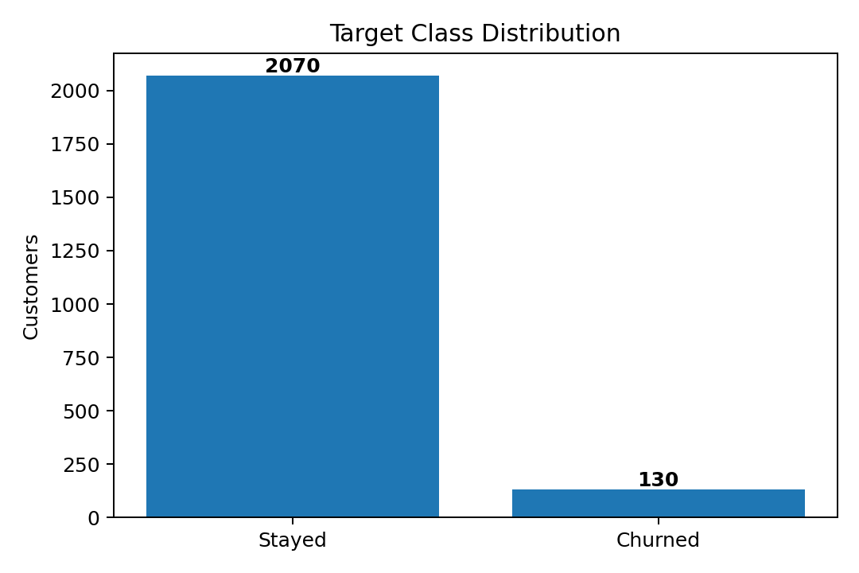
Figure 1. Distribution of the target classes.

5. Model Selection

5.1 Logistic Regression
Logistic Regression was selected as the primary model because it is simple, fast, interpretable, and well suited to binary classification. It estimates the probability that a customer belongs to the churn class and provides coefficients that can later be interpreted in terms of direction and odds.

5.2 Decision Tree
A Decision Tree was included as a comparison model because it can capture non-linear relationships and interactions without requiring feature scaling. The tree depth and minimum leaf size were constrained to reduce overfitting.

6. Model Training
Both models were trained using the same training data and the same preprocessing pipeline. The test set was kept separate until final evaluation. This helps prevent data leakage and gives a more realistic estimate of performance on unseen customers.

7. Evaluation Metrics
Metric | Meaning | Why it matters for churn
Accuracy | Overall proportion of correct predictions | Useful general measure, but can be misleading with class imbalance.
Precision | Of predicted churners, proportion actually churned | Important when retention interventions are expensive.
Recall | Of actual churners, proportion identified | Important when missing a likely churner is costly.
F1 Score | Harmonic mean of precision and recall | Balances false positives and false negatives.
ROC-AUC | Ability to rank churners above non-churners across thresholds | Useful for comparing probability-based classifiers.

8. Model Results
Metric | Logistic Regression | Decision Tree
Accuracy | 0.632 | 0.602
Precision | 0.114 | 0.084
Recall | 0.769 | 0.577
F1 Score | 0.198 | 0.146
ROC-AUC | 0.728 | 0.625

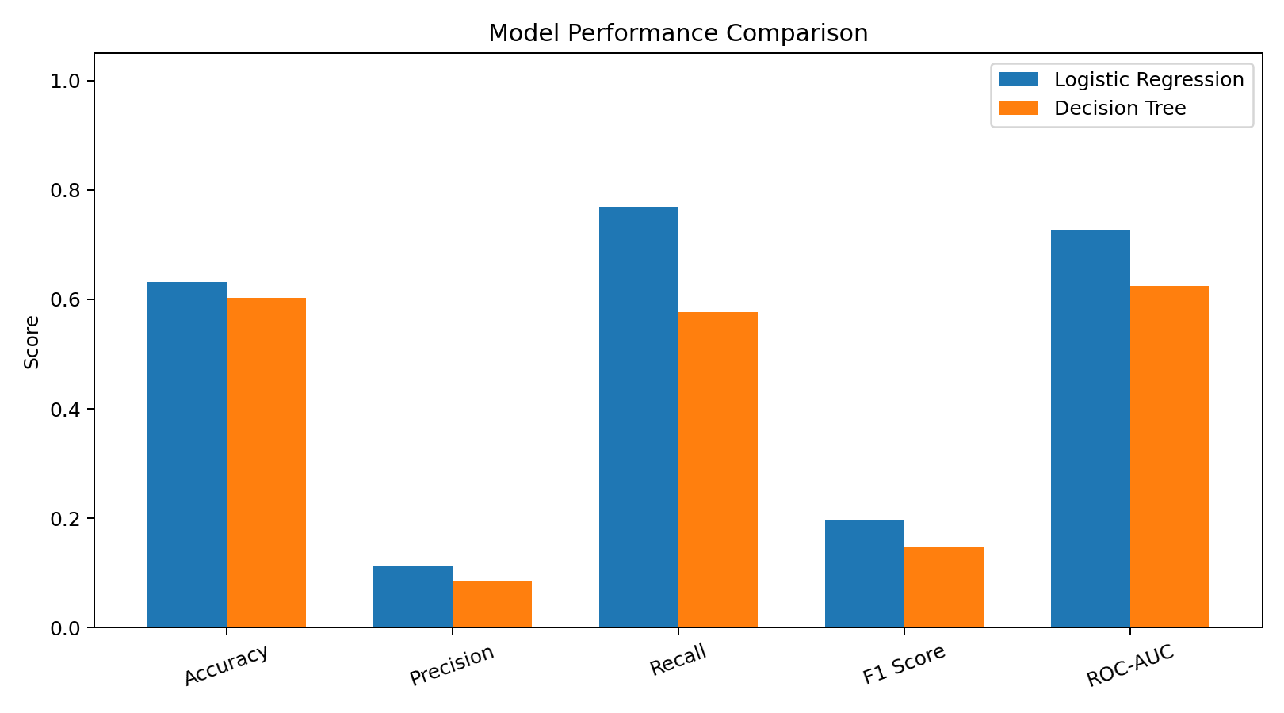
Figure 2. Model performance comparison on the held-out test set.

9. Confusion Matrix Analysis
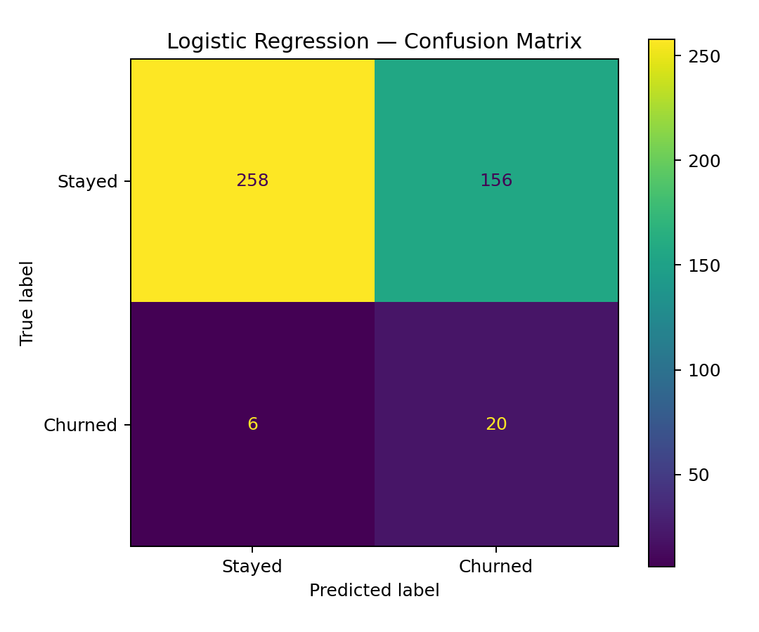
Figure 3. Logistic Regression confusion matrix.
The Logistic Regression model produced 258 true negatives, 156 false positives, 6 false negatives, and 20 true positives. The 6 false negatives represent customers who actually churned but were predicted to stay. In a real retention system, this error could be commercially important because the company would miss an opportunity to intervene.

10. ROC Curve
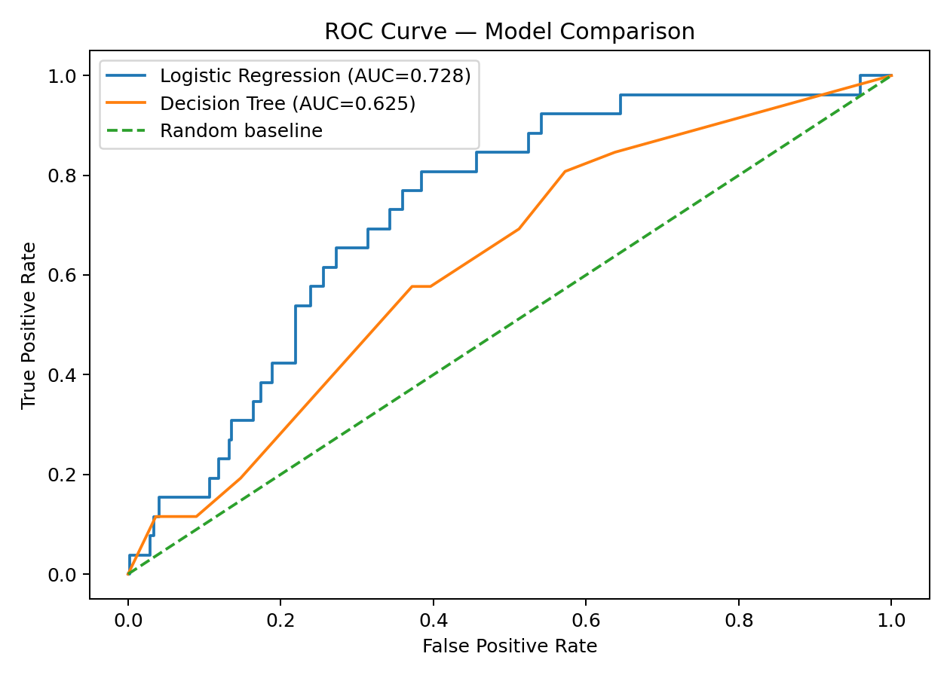
Figure 4. ROC curve comparing the two classifiers.
Logistic Regression achieved ROC-AUC = 0.728, while the Decision Tree achieved ROC-AUC = 0.625. ROC-AUC evaluates ranking performance across classification thresholds rather than relying on a single threshold.

11. Error Analysis & Critical Evaluation
A model with good aggregate metrics can still make costly individual mistakes. False positives may cause the business to spend retention resources on customers who would have stayed anyway. False negatives may be even more costly when a high-value customer leaves without receiving an intervention.
- The synthetic dataset may not represent the complexity of real customer behavior.
- The features do not include richer signals such as complaints, service outages, satisfaction scores, customer lifetime value, or recent engagement trends.
- The chosen classification threshold is not necessarily optimal for a real retention campaign.
- A single train-test split provides limited information about variability; cross-validation would provide a stronger estimate.
- Model performance may degrade when customer behavior changes over time, creating data drift.
- Synthetic relationships can make the model appear cleaner than a real-world dataset.

12. Overfitting & Underfitting
Overfitting occurs when a model learns patterns specific to the training data that do not generalize to unseen customers. A deep Decision Tree is particularly vulnerable to this. The tree used here is constrained using max_depth and min_samples_leaf.
Underfitting occurs when a model is too simple to capture important patterns. Logistic Regression may underfit if churn behavior depends heavily on complex non-linear interactions. Comparing the two models provides an initial check, but a production system would use cross-validation and hyperparameter tuning.

13. Potential Improvements
- Use cross-validation instead of relying on a single train-test split.
- Tune hyperparameters using GridSearchCV or RandomizedSearchCV.
- Test additional algorithms such as Random Forest, Gradient Boosting, or XGBoost where appropriate.
- Perform feature engineering such as tenure bands, recent usage change, ticket frequency, and customer-value indicators.
- Optimize the classification threshold based on the financial cost of false positives and false negatives.
- Use probability calibration if predicted churn probabilities will drive business decisions.
- Monitor model drift and retrain periodically when customer behavior changes.
- Use explainability techniques such as permutation importance or SHAP for stakeholder communication.
- Validate the model on genuinely future data before deployment.

14. Business Interpretation
The purpose of the model is not simply to maximize an evaluation score. A practical churn model should help a company decide which customers deserve attention and how much retention effort should be spent.
For example, the business could rank customers by predicted churn probability and combine that probability with customer value. This would create a more useful prioritization framework than treating every predicted churner identically.

15. 30–35 Hour Internship Work Plan
Workstream | Hours | Output
Problem definition & ML objective | 3 | Business question, target variable, success criteria
Data generation & exploration | 4 | Dataset, data dictionary, quality checks
Preprocessing pipeline | 5 | Imputation, scaling, encoding
Model selection & training | 5 | Logistic Regression + Decision Tree
Evaluation & error analysis | 5 | Metrics, confusion matrix, ROC analysis
Visualization & interpretation | 4 | Performance charts + business explanation
Documentation & review | 5 | Final report + reproducible code
Total | 31 | Complete Week 4 project

This is a suggested 31-hour work allocation aligned with the assigned 30–35 hour workload.

16. Reproducible Python Code
import pandas as pd
from sklearn.model_selection import train_test_split
from sklearn.compose import ColumnTransformer
from sklearn.pipeline import Pipeline
from sklearn.preprocessing import StandardScaler, OneHotEncoder
from sklearn.impute import SimpleImputer
from sklearn.linear_model import LogisticRegression
from sklearn.tree import DecisionTreeClassifier
from sklearn.metrics import (
accuracy_score, precision_score, recall_score,
f1_score, roc_auc_score, confusion_matrix, roc_curve
)
df = pd.read_csv("week4_customer_churn_dataset.csv")
X = df.drop(columns=["customer_id", "churn"])
y = df["churn"]
X_train, X_test, y_train, y_test = train_test_split(
X, y, test_size=0.20,
stratify=y, random_state=42
)
numeric_features = [
"tenure_months", "monthly_charges",
"support_tickets", "usage_hours_month"
]
categorical_features = [
"contract_type", "payment_method",
"internet_service", "senior_customer", "auto_pay"
]
preprocessor = ColumnTransformer([
("num", Pipeline([
("imputer", SimpleImputer(strategy="median")),
("scaler", StandardScaler())
]), numeric_features),
("cat", Pipeline([
("imputer", SimpleImputer(strategy="most_frequent")),
("onehot", OneHotEncoder(handle_unknown="ignore"))
]), categorical_features)
])
model = Pipeline([
("preprocessor", preprocessor),
("model", LogisticRegression(
max_iter=1000,
class_weight="balanced",
random_state=42
))
])
model.fit(X_train, y_train)
pred = model.predict(X_test)
prob = model.predict_proba(X_test)[:, 1]
print("Accuracy:", accuracy_score(y_test, pred))
print("Precision:", precision_score(y_test, pred))
print("Recall:", recall_score(y_test, pred))
print("F1:", f1_score(y_test, pred))
print("ROC-AUC:", roc_auc_score(y_test, prob))
print("Confusion Matrix:")
print(confusion_matrix(y_test, pred))

17. Final Conclusion
This project demonstrates a complete machine learning model-development pipeline in Python, from raw data preparation through preprocessing, model selection, training, evaluation, visualization, and critical error analysis.
Logistic Regression was selected as the primary model because it provides a strong combination of simplicity, interpretability, and suitability for binary churn prediction. A Decision Tree was included as a comparison model to demonstrate that different algorithms can produce different performance profiles.
The project also emphasizes an important practical principle: model evaluation must match the business problem. In customer churn prediction, recall, false negatives, probability thresholds, and customer value can be more informative than accuracy alone.

18. Submission Checklist
✓ Data preparation and preprocessing documented
✓ Algorithm selection justified
✓ Model training pipeline implemented
✓ Multiple evaluation metrics reported
✓ Confusion matrix included
✓ ROC curve included
✓ Model comparison visualization included
✓ Overfitting/underfitting discussed
✓ Sources of error identified
✓ Improvement strategies proposed
✓ Reproducible Python code included
✓ 31-hour workload plan documented

