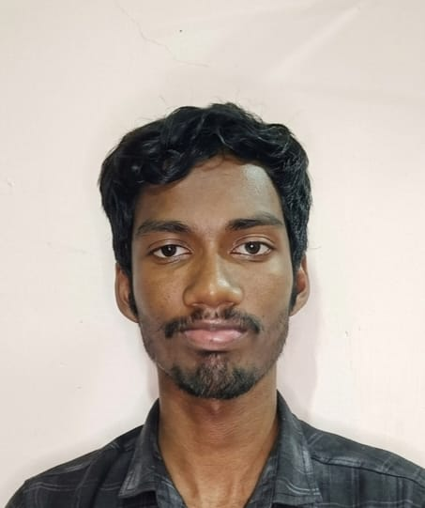
Chiranthan Padmashali

Udupi, Karnataka, India
+91 6363772045
chizerme@gmail.com
LinkedIn
GitHub: Chiranthan-codez

TECHNICAL SKILLS
Languages: Java, Python, C++ (C++17), JavaScript, TypeScript, SQL
Systems & Concurrency: Multithreading, Thread-safe Queues, TCP/IP, Socket-level Packet Processing, Synchronization
Frameworks & Libraries: Spring Boot, Django, Node.js, Express, React
Distributed & Messaging: Apache Kafka, Redis, Microservices, REST APIs, JWT
Cloud & DevOps: AWS (EC2, Elastic Beanstalk), Git, Maven, Linux, Docker (familiar)
Databases: MySQL, Redis
EDUCATION
Manipal Institute of Technology, Manipal Jun 2024 - June 2028
B.Tech, Information Technology | CGPA: 6.07
EXPEIRIENCE
AWS Cloud Intern - IStudio Feb 2026
- Configured ROS2 on Ubuntu within AWS EC2, enabling remote robotics simulation in a cloud environment.
- Deployed full-stack applications on AWS, managing SSH setup, security groups, and package dependencies.
- Developed scalable deployment workflows using Elastic Beanstalk with instance management best practices.
PROJECTS
TradePulse Analytics - Node.js · PostgreSQL · Redis Streams · Docker· project1 Jul 2026
- Built an event-driven trading behavior analytics platform using Node.js, PostgreSQL, and Redis Streams, decoupling trade ingestion from background processing to achieve sub-10ms p95 write latency under concurrent workloads.
- Built a modular behavioral analytics pipeline with Redis Consumer Groups to asynchronously detect trading patterns such as overtrading, revenge trading, and session tilt, while enforcing idempotent event processing through PostgreSQL conflict-handling mechanisms.
- Implemented end-to-end observability with Prometheus, Grafana, and structured logging, enabling real-time monitoring of API performance, database latency, worker throughput, and Redis queue lag across a containerized microservices architecture.
Event-Driven Workflow System-Java 21·Spring Boot 3 · Apache Kafka · PostgreSQL· project2 May 2026
- Built an event-driven microservices platform using Spring Boot, Apache Kafka, and a database-per-service architecture to process seller compliance workflows through asynchronous service communication.
- Implemented fault-tolerant event processing with exponential backoff retries, Dead Letter Queues (DLQs), and idempotency ledgers, ensuring reliable message delivery and preventing duplicate processing.
- Resolved distributed transaction race conditions caused by dual-write operations and established end-to-end observability using correlation IDs, Prometheus metrics, and structured logging to trace event lifecycles across services.
Distributed Key-Value Store-Go 1.25 · Raft Consensus · gRPC · BoltDB· project3 Jun 2026
- Built a strongly consistent distributed key-value store in Go using the Raft consensus algorithm, enabling automatic leader election, replicated state machines, and fault-tolerant data storage across multiple containerized nodes.
- Implemented durable state persistence and log replication with transactional B+Tree storage, ensuring data consistency and recovery during node failures, crashes, and network partitions.
- Resolved distributed state synchronization issues by optimizing follower log conflict resolution and integrated Prometheus metrics with structured logging for end-to-end visibility into leader elections, log replication, and cluster health.
CERTIFICATIONS
JPMorgan Chase Software Engineering Virtual Experience — Forage verify Jan 2026
- Built a Spring Boot microservice integrating Apache Kafka, JPA/Hibernate, and REST APIs with transaction persistence.
AWS Partner: Accreditation(Technical) — Amazon Web Services verify Jun 2026
- Earned foundational knowledge of AWS services, architectures, and best practices to effectively support technical customer engagements and AWS partner solutions.

