Event Month | Event Type | Event Name | Event Images | Event Description
JUNE 2025 | Department activity | codeathon | 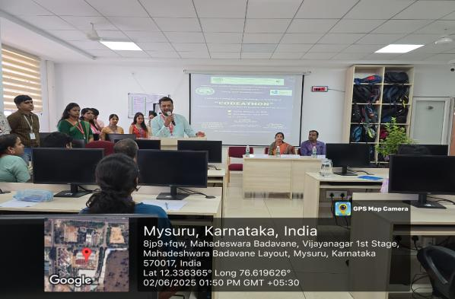 | Department of CSE(AI&ML) conducted CalumnODEATHON for 2nd semester CSE(AI&ML) students on 2/6/2025. The event was inaugurated by Dr. Shoba Shankar , Vice Principal & DAA, Dr. G V Naveen prakash, DAA-FY and Dr. Aditya C R, HoD CSE(AI&ML). Around 185 students participated in the event.
 | Faculty Achivement |  | 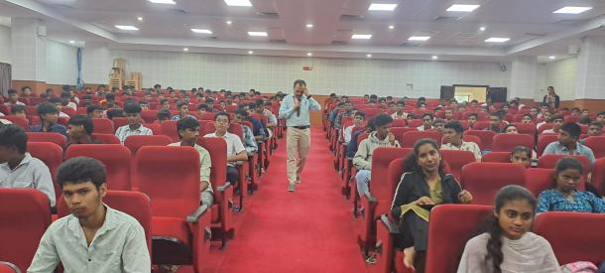 | Dr Vijay C P , Dept of CSE)AIML) Delivered a talk on" Chat GPT" for students of VV polytechnic on occasion of induction program.
 | Student Achivement |  | 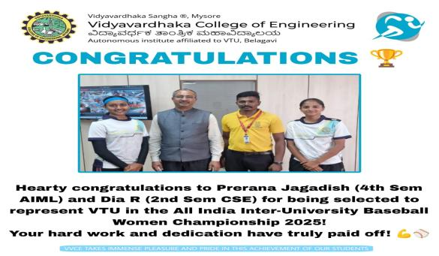 | Prerana Jagadesh of 4th sem CSE(AIML) is Selected for all India Inter- University Baseball women Championship 2025 , representing VTU
JULY 2025 | Department activity | Technical talk | 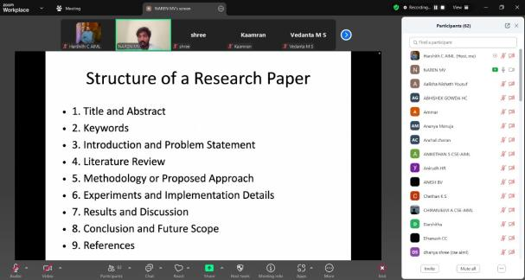  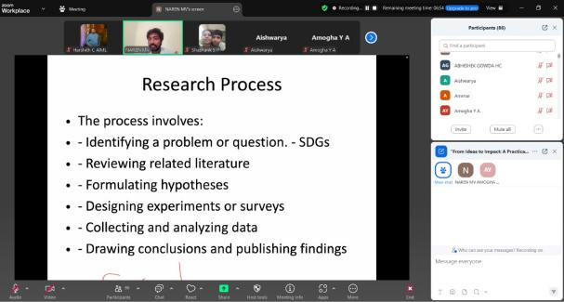 | The Department of CSE (AI&ML) organized an online technical talk on “From Ideas to Impact: A Practical Guide to Research, Literature Survey, and Academic Publishing” on 30th July 2025, attended by 86 students. The session, delivered by Dr. Narendran Sobanapuram Muruganandam, Research Analyst at CICERO, Norway, covered topics such as the fundamentals of research, literature survey techniques, research and implementation paper preparation, useful research tools, and differences between conference and journal papers.
JULY 2025 | Stdents Achivement |  | 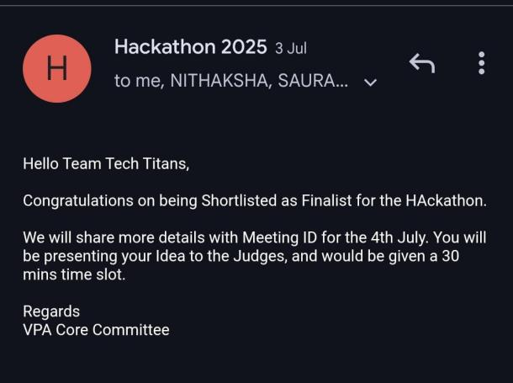  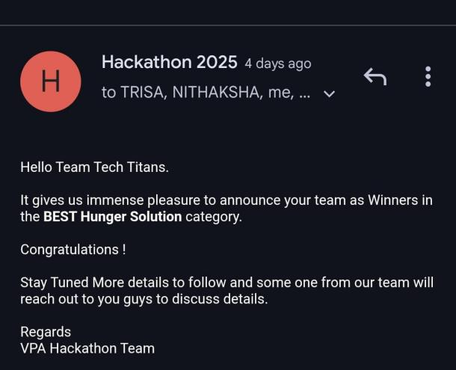 | Saurabh Joshi, Trisa Das, Nithaksha G, Department of CSE (AI&ML and Chiranthan M S (CSE)—emerged as Winners in the "Best Hunger Solution" category at the Global Virtual Open Innovation Hackathon 2025, organized by the Vokkaligara Parishat of America (VPA) during the Vishwa  Vokkaliga Sammelana. The event aimed to tackle real-world challenges aligned with UN SDGs, particularly SDG 2: Zero Hunger and SDG 4: Quality Education, through open innovation and youth collaboration.on 4 july 2025
 |  |  | 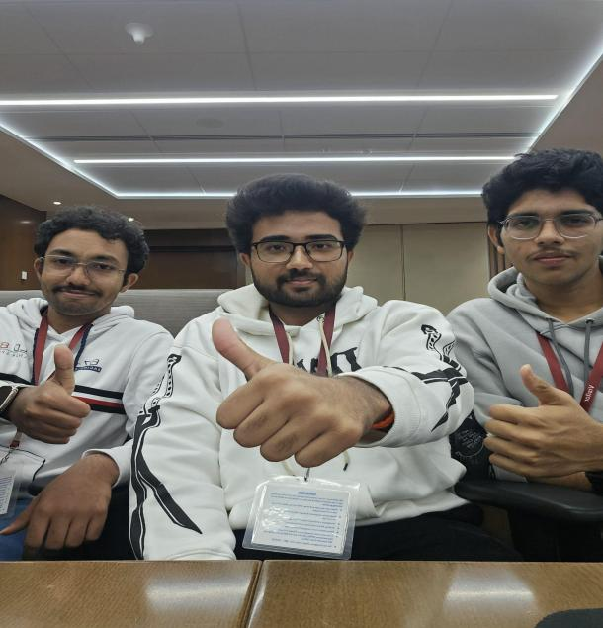  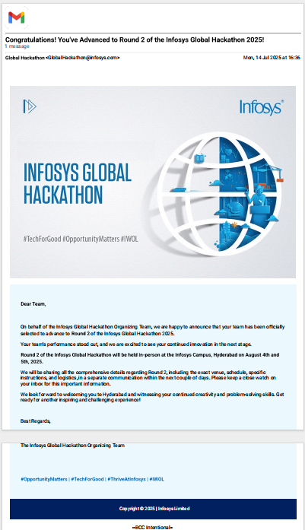 | Preran S Gowda, Shamanth M S and Shashank S have secured a position among the top 3 teams at Infosys Global Hackathon Mysuru.  They have now advanced to the grand finale, which will be held in Hyderabad on August 4th and 5th.
 |  |  |  | T
 | Faculty Achievements |  |  | Prof Soumya GV , Dept of CSE(AIML). Her Proceedings of 3rd IEEE International Conference on Knowledge Engineering and Communication Systems Ickecs 2025 indexed in scopus..
 |  |  |  | Dr Vijay C P , Dept of CSE(AIML), his Proceedings of 3rd IEEE International Conference on Knowledge Engineering and Communication Systems Ickecs 2025 indexed in scopus..
 |  |  | 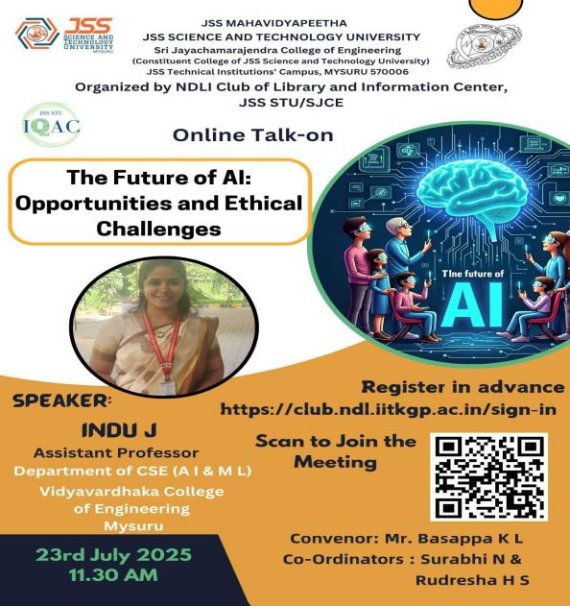 | Prof. Indu J , Dept of CSE(AIML) Delivered a talk on" The Future of AI: Opportunities and Ethical Challenges”. The session was organized by the NDLI Club of Library and Information Center, JSS STU/SJCE on 23rd July 2025
Prof Soumya G V, Dept of CSE(AIML), Server as Peer Reviewer for 3rd IEEE International Conference on Networks, Multimedia and
Information Technology (NMITCON) organized at Nitte Meenakshi Institute of
Technology, Bengaluru.
 |  |  | 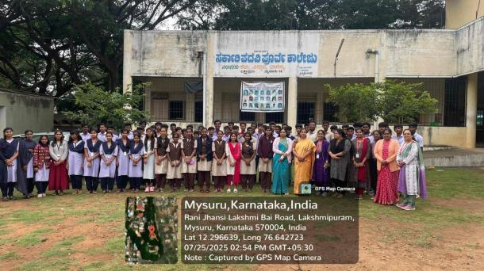 | Outreach activity was conducted in association with hithasrushti club on 26th July 2025 in Lakshmipuram govt. PUC . Awareness about AI and it's applications were created by student coordinated .Quiz on AI was conducted and winners were rewarded with goodies.
 |  |  | 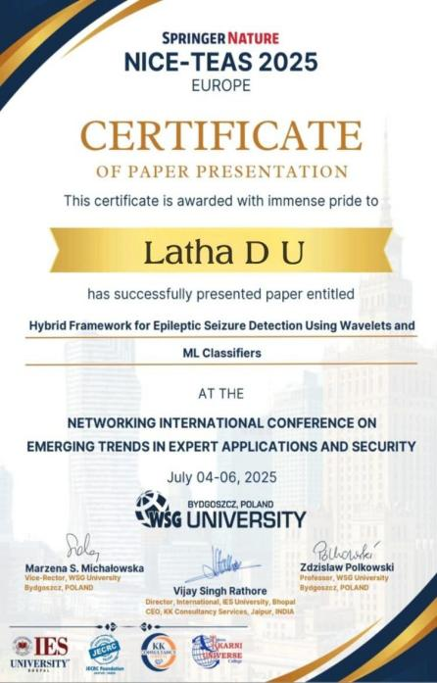 | Prof.Latha D U,Dept of CSE(AIML) Presented a conference paper in NICE-TEAS Springer conference organised by WSG University, Poland.
August 2025
 | Department activity | Outreach | 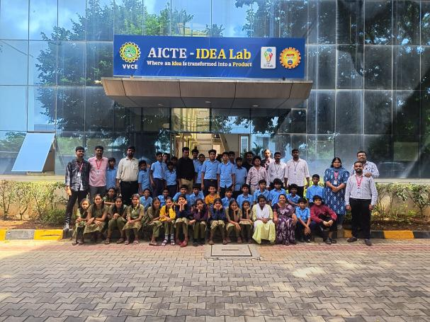  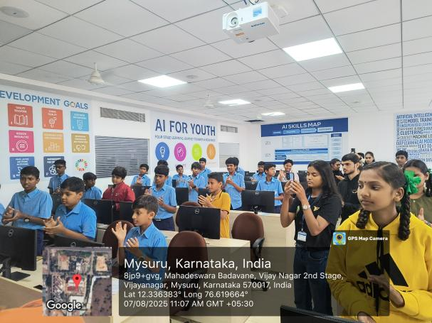 | Department of CSE AIML in association with NSS organized a one day outreach activity for Government High School, Kukkarahalli on 7th August 2025, Thursday. Around 40 students from GHS were part of the event. Outreach activity included exposure on the basics of the computer, MS Word and MS Powerpoint for students. It also included visits to AICTE IDEA Lab, NCC and VVCE BAJA. Fun games were also part of the activity with exciting prizes.
 |  | FDP Organized | 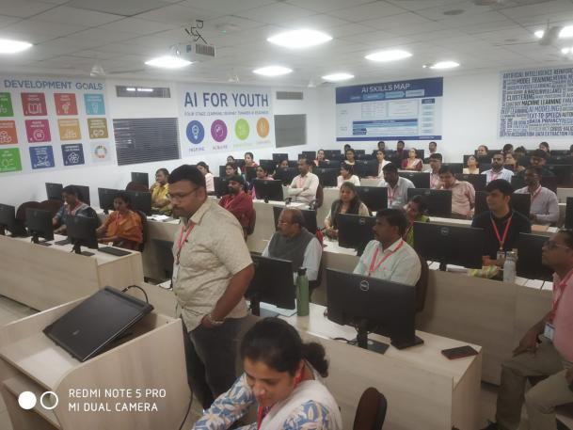  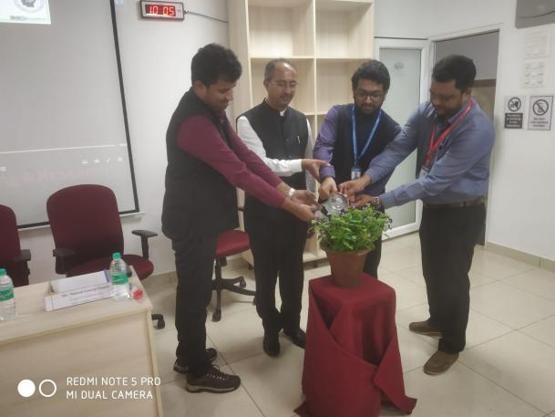 | Department of CSE (,AI&ML) organized 5 days FDP on AI for Teaching, Learning and Research from 9th to 14th August.Resource persons were from Christ University Pune Lavasa campus.
 |  | Student Conclave | 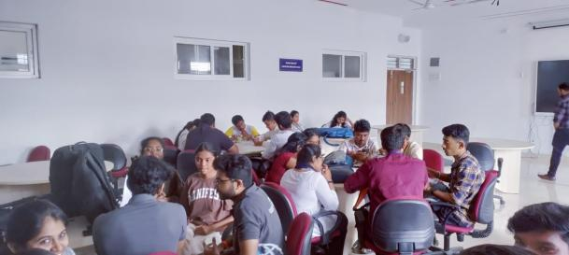  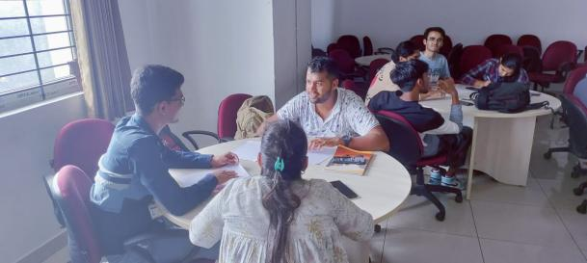 | The Department of CSE AIML organised a Student Conclave on 21St of August 2025, Thursday at M201. Students gave their viewpoints on the Teaching and learning paradigms, Infrastructure, Placement and Training, Examination and Internal assessment, Research & Development and Expectations as a University. 30 students from 5th and 7th semester were part of the conclave.
 |  |  | 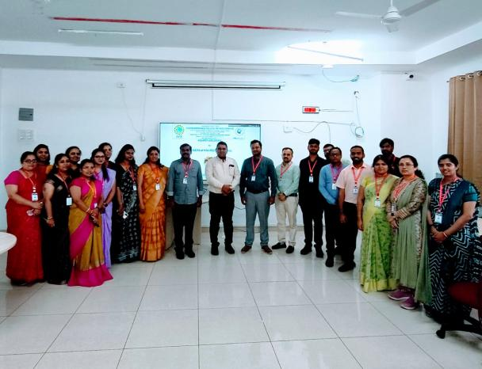 | Department of CSE(AI&ML) conducted a Mock NBA visit on 23 August 2025.  Dr. Janardhanan Gangathulasi, Professor and Dean ( Academics and Research), NITTTR, Chennai, Tamil Nadu was the reviewer.
 | Stdents Achivement |  | 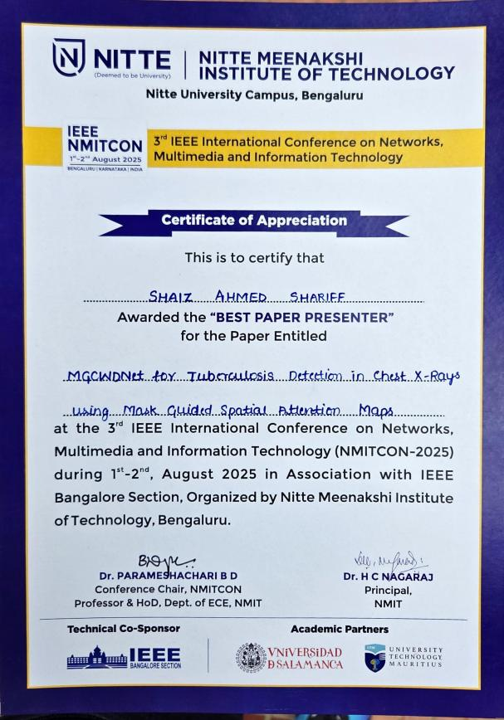 | Mr Shaiz Ahmed Shariff, Department of CSE(AIML) has been awarded the “Best Paper Presenter” at the 3rd IEEE International Conference on Networks, Multimedia and Information Technology (NMITCON-2025) held at Nitte Meenakshi Institute of Technology (NMIT), Bengaluru,on 1st–2nd August 2025.
 |  |  | 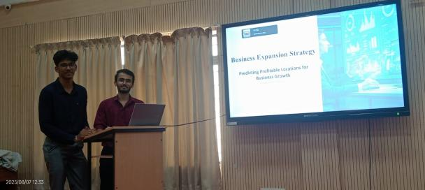 | Mr. Thanush B J, Mr. Aryan Aiyappa and Ms. Anjali Bharadwaj presented their Idea "Optimising Logistics and Business Growth using sales data by adopting ML models" in MSME Idea Hackathon 5.0 for Smart and Sustainable MSME under the category "Innovation for Business Upliftment and Sustainability in coastal and Hilly areas" at Zonal level in the last month. The idea is selected for the State level presentation which would likely happen next month
 |  |  | 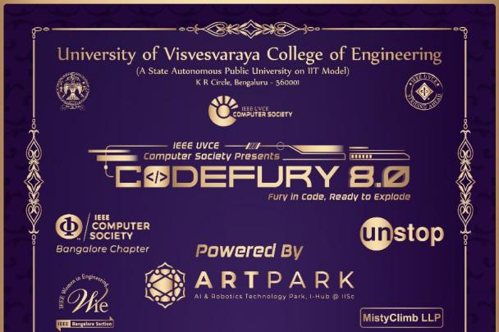  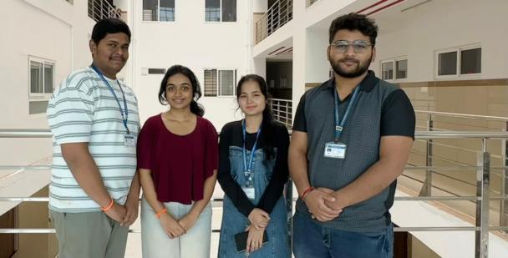 | Students from CSE(AI&ML) participated in CodeFury 8.0, a national-level hackathon organized by IEEE UVCE, Bangalore from 22nd to 24th August 2025. The event witnessed participation from 600+ students across 250+ teams.  The team secured a Consolation Prize in this highly competitive event.  Team Name :  CosmicSentinel  Team Members:  Trisa Das – 4VV23CI117  Saurabh Joshi – 4VV23CI090  Nithaksha G – 4VV23CI064  Chiranthan M S – 4VV23CS068
 | Faculty Achievements |  |  | Prof Nidhishree G, Department of CSE(AIML) has been awarded a Certificate of Distinction for successfully completing the IUCEE International Engineering Educator Certification Program (IIECP), Spring 2025.
 |  |  |  | Prof. Indu J,Department of CSE(AIML) successfully completed the IUCEE International Engineering Educator Certification Program (IIECP), Spring 2025,
 |  |  |  | Prof. Harshith V, Department of CSE(AIML)
 |  |  |  | Dr. Aditya C R, Professor and Head and Prof. Harshith V, Assistant Professor, Department of CSE(AI&ML), delivered sessions in 5-days FDP Organized by the Department of Electrical and Electronics Engineering, VVCE Mysore , in association with IEEE PELS Bangalore Chapter, on “AI FOR ALL – Interdisciplinary Applications Across Engineering Domains” on 30th July 2025. The sessions covered the Foundations of Artificial Intelligence and its advancements, followed by hands-on sessions on AI toolkits, including Orange Data Mining Tool, Snap Visual Programming, and Google Teachable Machine.
 |  |  |  | Prof. Latha D U,Department of CSE(AIML), successfully presented a paper at the 3rd IEEE International Conference on Networks, Multimedia and Information Technology (NMITCON-2025), held at NMIT, Bengaluru.
 |  |  |  | Prof. Soumya G V ,Department of CSE(AIML), successfully presented a paper at the 3rd IEEE International Conference on Networks, Multimedia and Information Technology (NMITCON-2025), held at NMIT, Bengaluru.
 |  |  |  | Prof krithika , Department of CSE(AIML),have published a Q2 Scopus-indexed paper entitled ‘Semi-Automatic Voice Comparison Approach Using Spiking Neural Network for Forensics’ in August 2025,
 |  |  | 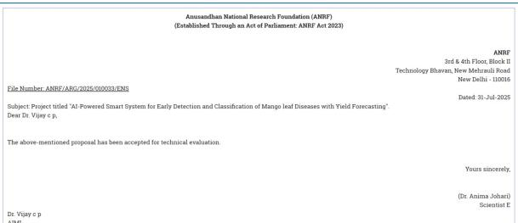 | Dr.Vijay C.P is PI and Dr.Varshitha D.N is CO-PI, Department of CSE(AIML) had put the Proposal of RS .40L Submitted for ANRF under ARG scheme is now Accepted for Technical evaluation.
Sepetember 2025
 | Department Activity | 1-9-2025 | 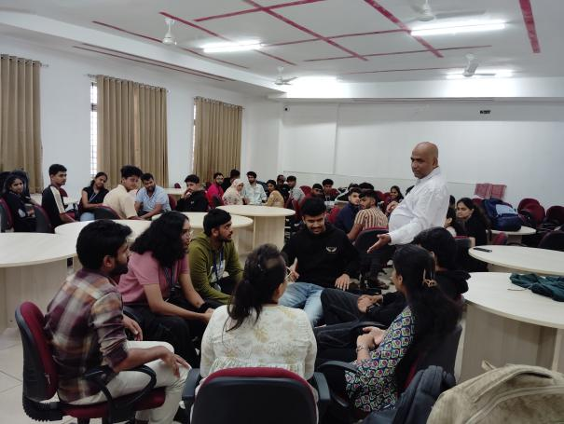  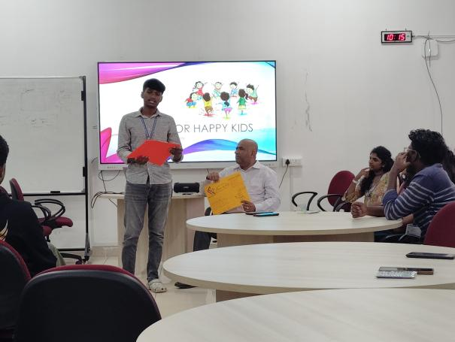 | The department of CSE AIML organized a workshop on leadership program "Grow and Lead your Club" for the core members of all the clubs of the department. Students were guided on qualities needed in leading a club and attributes of a good leader and leadership. The resource person was Dr. Jibrael Jos, Associate Dean, Christ University, Pune Lavasa Campus. Around 35 students were part of the event.
 | Club Activity | 4-9-2025 | 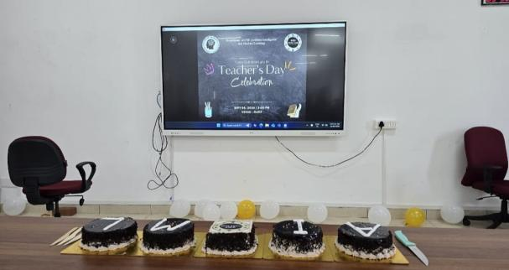  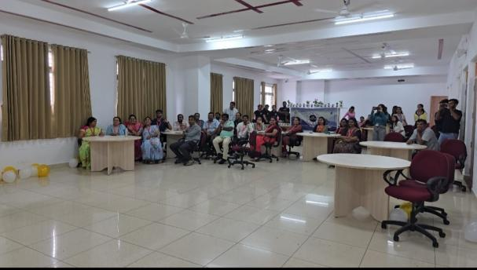 | The Department of CSE AI&ML in association with Yuvaa Club organised Teacher's day on September 4th 2025, Thursday. The event included fun games, dance by students and video tribute. Mr. Chiranjeevi, Mr. Anirudh, Mr. Thanush, Mr. Aryan Ms. Hitha, Ms. Darshitha, Ms. Sindhura, Mr. Anikethan and Mr. Druvan coordinated the event
 |  |  | 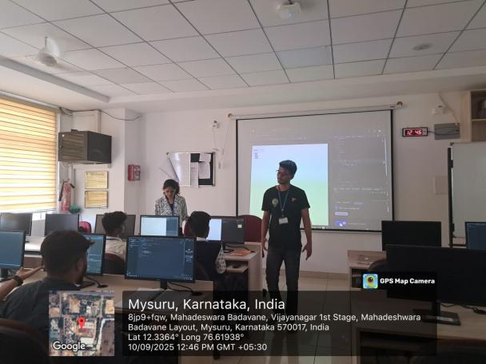 | A Hands-on session on implementing a real time project using HTML, CSS and JavaScript was conducted to Lateral entry students on 10th September 2025, Wednesday. Mr. Harshith M and Ms. Harshika Darda of 7th semester demonstrated the projects and guided the students on Implementation.
 |  |  | 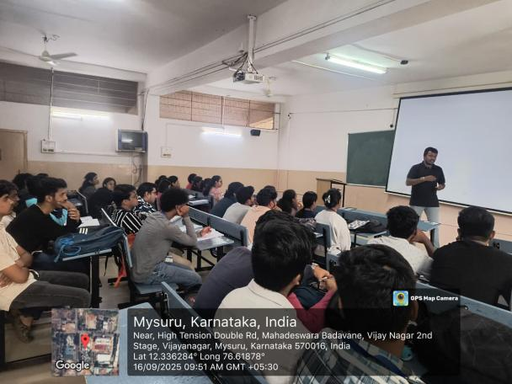 | The department of CSE(AI&ML) conducted an Alumni interaction on "Big data and it's applications and carrier opportunities " for VII semester, CSE(AI&ML) students by Mr.Shivakumar M, Software Engineer,Impaqx Business LLP, Mysore on 16/9/2025
 |  |  | 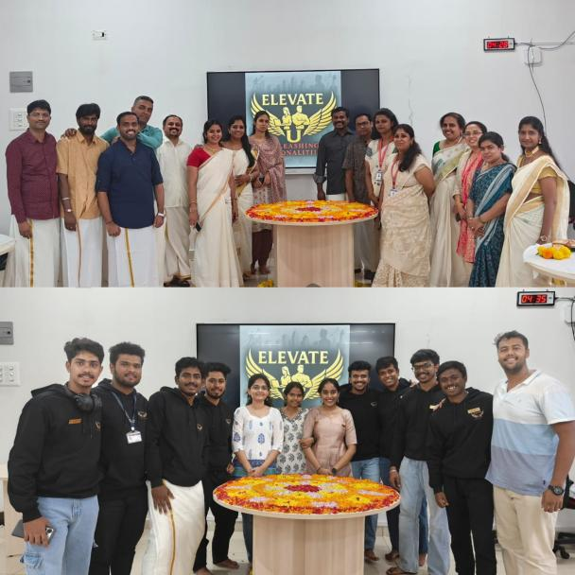 | Department of CSE(AIML) in association with Elevate U club celebrated Onam festival on 12th September 2025. Team building activities, and cooking (without fire) events were conducted for Department staff members. Best dressed female faculty and Best dressed male faculty were awarded. Mr. Sumukh, Mr. SKanda, Mr. Bharaneesh, Ms. Sanjana, Ms. Varshiya, Mr. Puneeth shetty coordinated the event.
 |  |  | 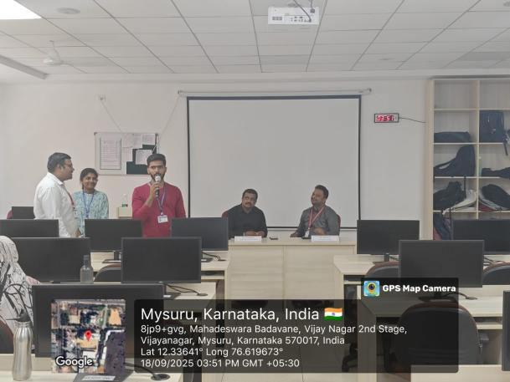  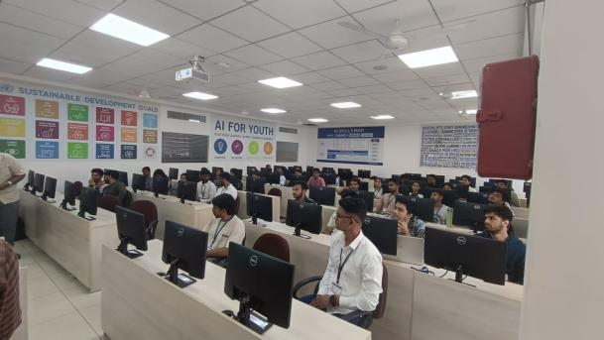 | Department of CSE AI&ML organized a Two days Hands-on workshop on "NoSQL Simplified: Practical Learning with MongoDB" for 7th semester students on 17th and 18th of September 2025. Mr. Kiran Kumar, Senior Engineer Manager, HashedIn of Deloitte was the Resource Person. Demonstration of Indexing, Shrading and Aggregation in MongoDB was conducted in the workshop. Around 100 students participated in the workshop.
 |  |  | 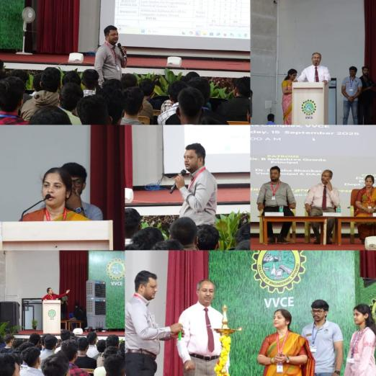  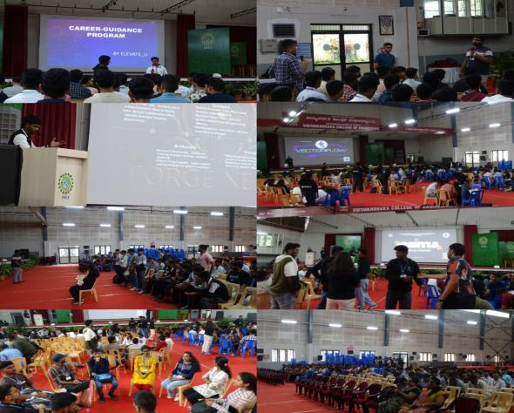 | Department of CSE(AI&ML) conducted orientation program for 3rd sem students on 15th and 16th September. Principal, Vice principal and Dr. Aditya C R, HOD inaugurated the ceremony. Various technical activities were conducted by Elevate u , Ignitia and Vectorflow club.
 |  |  | 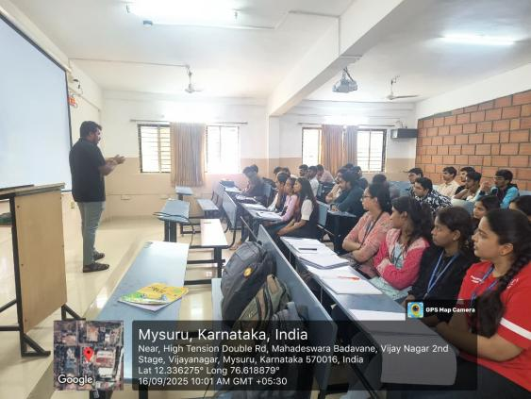 | The department of CSE(AI&ML) conducted an Alumni interaction on "Big data and it's applications and carrier opportunities " for VII semester, CSE(AI&ML) students by Mr.Shivakumar M, Software Engineer,Impaqx Business LLP, Mysore on 16/9/2025
 |  |  | 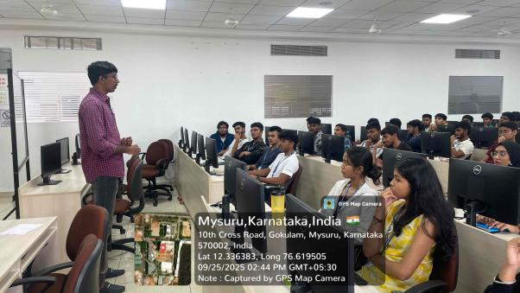 | Department of CSE (AI & ML) conducted an Alumni Interaction on "Exploring Professional Avenues in AI & ML" for 2nd year CSE (AI & ML) students by Mr. Hithesh R, Software Engineer, Cognizant Technology Solutions, on 25/09/2025.
 |  |  | 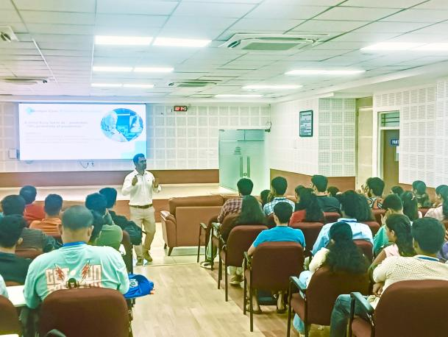 | Department of CSE (AI&ML) conducted a technical talk on "Agentic AI and its applications" on 19-09-2025 for 5th sem students. Dr. Noushanth Shaffi from Sultan Quaboos Univeristy, Sultanate of Oman was the resource person.
 | Student activity |  | 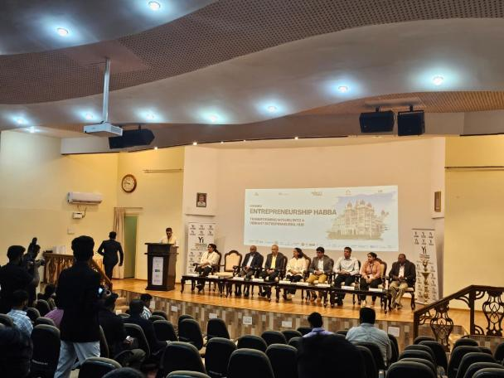  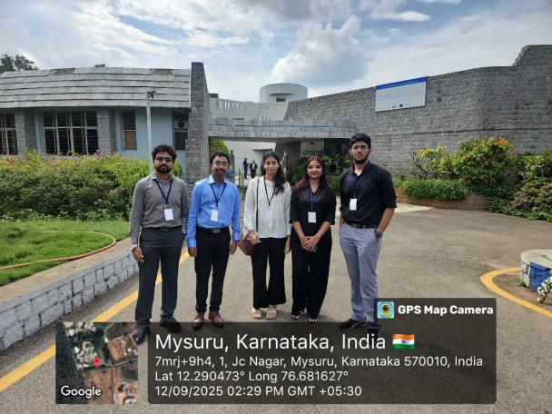 | Student of V sem semester Dept. of CSE(AIML) Preran S Gowda, Shamanth M S, Shashank S.  Honored to join as deleSts at the Mysuru Entrepreneurship Habba 2025, held at SDM IMD, Mysuru on 12th September.  It was an enriching experience with insightful sessions on grants, innovation, personal branding, food bioprocessing, and the exciting Bharath Pitchathon 4.0.
 |  |  | 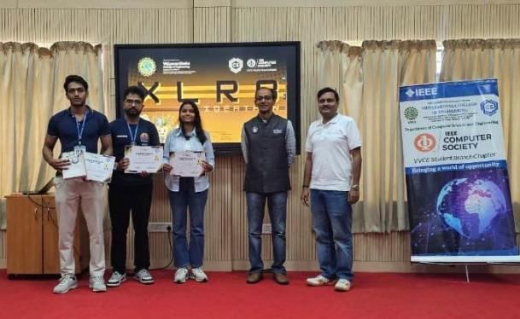 | Shashank ,Ronith and Sanjana Ambarish of V semester B section CSE(AIML), participated in XLR8 Ideathon compitation by IEEE computer society and won FIRST place, in VVCE on 24/9/2025
 |  |  | 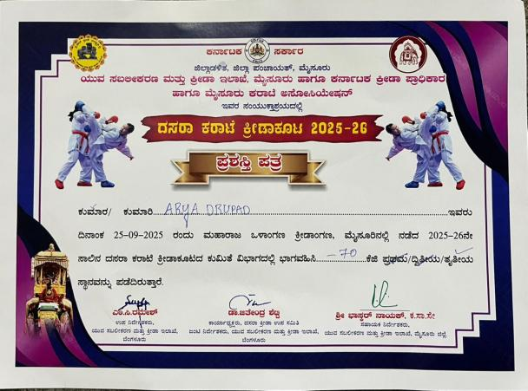 | Mr. Arya Drupad from 1st Year A section AI&ML Department secured bronze medal in Dasara Karate Tournament held in Mysuru on 25/9/2025
 |  | 26-9-2025 | 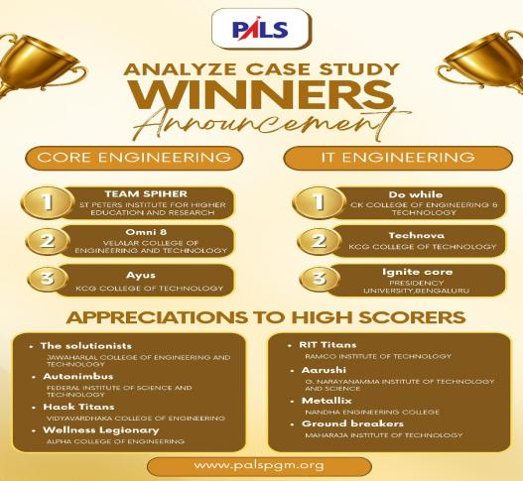 | Team Hack Titans ,students from dept of CSE(AIML) participated in the PALS Analyze Case Study event (online) has won an Appreciation for High Scoring.  Where 44 PALS Partner Institutes took part (TN – 27, AP/Telangana – 5, Karnataka – 4, Kerala – 7).  Team details:  Team Lead: Uthkarsh Gowda V (3rd Sem, C Sec)  Members: P G Ayush Rai (5th Sem, B Sec), Aashish Shirahatti (3rd Sem, A Sec), Kushal P (3rd Sem, B Sec)
 |  | 14-Sept | 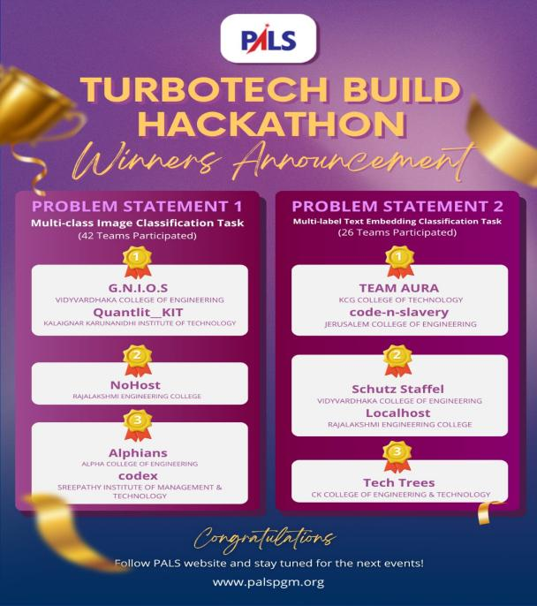 | Two teems from dept of CSE(AIML) final year students participated in PALS TurboTech Build Hackathon and have won 2 prizes.  Won 1st Prize for the problem statement "Multi-class Image Classification Task" by G.N.I.O.S Team. Total 42 teams participated.  Won 2nd Prize for the problem statement "Multi-Label Text Embedding Classification Task" by Schutz Staffel team. Total 26 team participated.  Team details:  G.N.I.O.S: Ammar Mohiuddin and Adhrith Rangaprabhu of 7th sem, A sec  Schutz Staffel: Amogha Y A and Anand Murthy of 7th sem, A sec
 | Faculty Achievements |  | 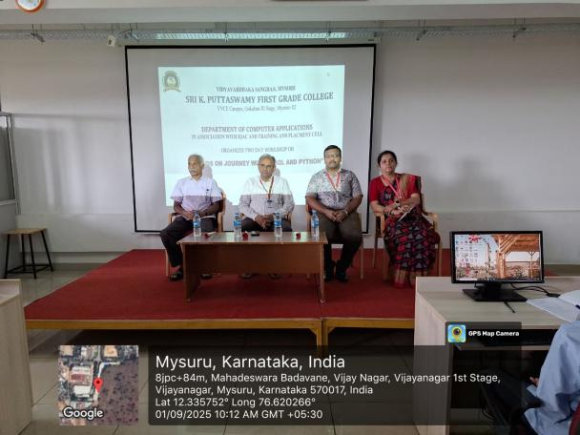  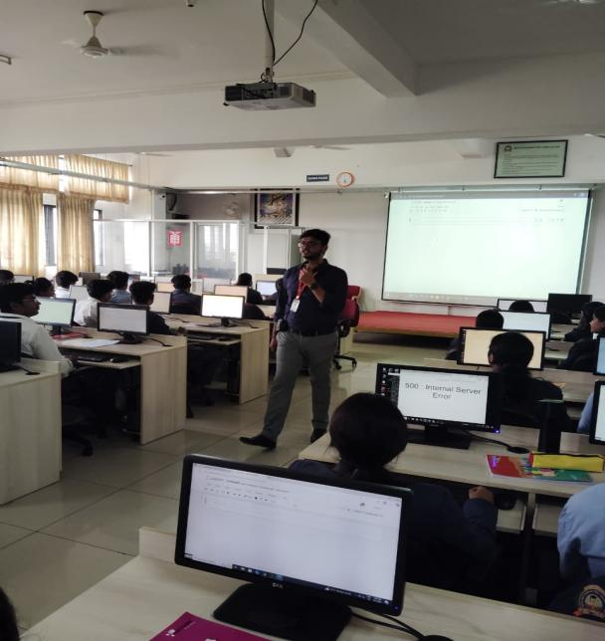 | Prof. Harshith C, Prof. Revathy B D, Prof. Vignesh T V and Prof. Harshith V was a resource person for a technical workshop on "Hands on Journey of MySQL and Python" which was held in Vidyavardhaka First Grade College for final year BCA students. Around 120 students were part of the event.
 |  |  |  | Patent Filed: Patent title: Hybrid AI-Hardware System for Drone Identification and Security Alerting, Patent application No.: 202541086588, Filed Date: 12-09-2025, Dept.: AI&ML, Inventors Name: Dr.Varshitha D N, Prof. Latha D U, Prof. Rashmi K
 |  |  |  | Patent Filed: Patent title: HOLO-EDU: AI-Powered Holographic Learning Assistant, Patent application No.: 202541087899, Filed Date: 16-09-2025, Dept.: AI&ML, Inventors Name: Dr. Vijay C. P, Sumukha S, Sanjana B N, Pavan Raj R G
 |  |  |  | Patent Filed: Patent title: IoT-Enabled Real-Time Weed Management System with Precision IR Laser Ablation with Integrated Water-Curtain Cooling, Patent application No.: 202541087922, Filed Date: 16-09-2025, Dept.: AI&ML, Inventors Name: Dr. Sonali Nandish Manoli, Rohan Lobo, Rohan K, Shashank S P
 |  |  |  | Patent Filed: Patent title: IoT-Enabled Real-Time Automobile Mishap Detection and Emergency Response System, Patent application No.: 202541090247, Filed Date: 22-09-2025, Dept.: AI&ML, Inventors Name: Dr. Balarengadurai C
 |  |  |  | Patent Filed: Patent title: Improving Speaker Verification in Forensics Using DBN-Based Representation Learning, Patent application No.: 202541090252, Filed Date: 22-09-2025, Dept.: AI&ML, Inventors Name: Prof. Kruthika S G, Dr. Trisiladevi C. Nagavi
 | October 2025
 | Department Activities |  | 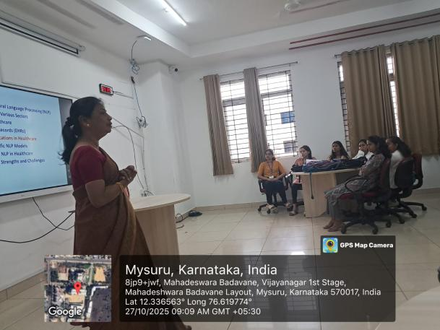  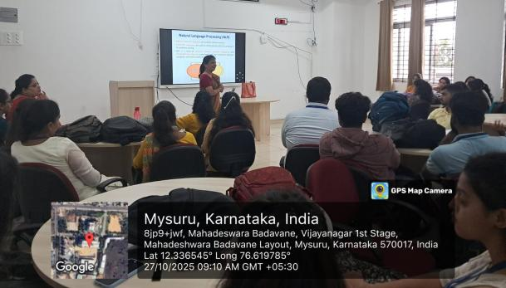 | Technical talk was conducted on 27-10-2025 in the Dept. of AIML on the topic" NLP applications in healthcare" for 7th sem students. Dr.Prathibha R J , Associate Professor of ISE, SJCE was the resource person.  The Department of AIML conducted a technical talk on 27-10-2025 on the topic “NLP Applications in Healthcare” for the 7th semester students. Dr. Prathibha R. J., Associate Professor, Department of ISE, SJCE, served as the resource person.
 |  |  | 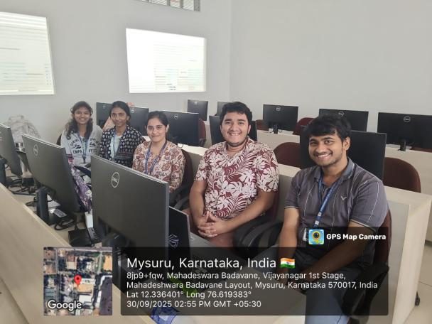 | AWS conducted GenAI Hackathon from 26th sepeartember to 3rd October. Top 5 students from VVCE were shortlisted for the final round held on 3rd October. The AI &ML department hosted the event for AWS
 |  |  | 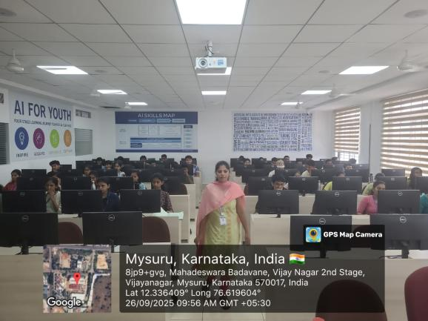 | The Department of AI & ML hosted the GenAI Hackathon organized by AWS, conducted from 26th September to 3rd October. The top five students from VVCE were shortlisted for the final round held on 3rd October.
 |  |  | 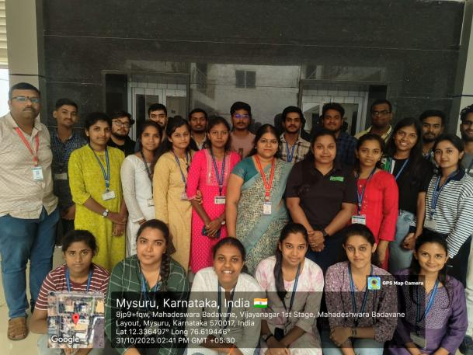  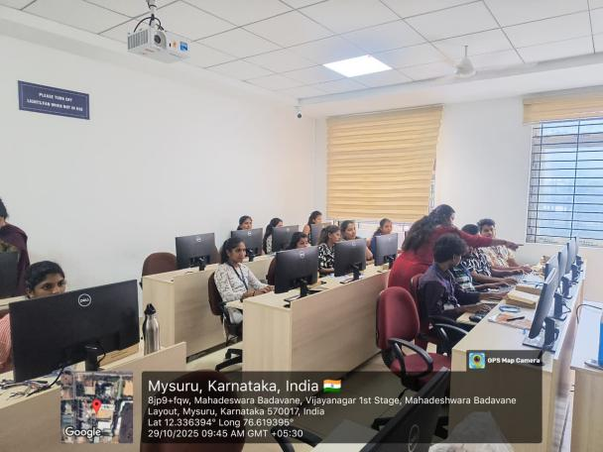 | The Department of CSE(AI&ML) organized a "A three day Skill Enhancement program on AIoT" for 7th semester students in association with Digitoad technologies from 29th October 2025 to 31st October 2025 . The resource person was Ms. Mrunalini , Application Engineer from Digitoad technologies Pvt Ltd, Bangalore .
 |  |  | 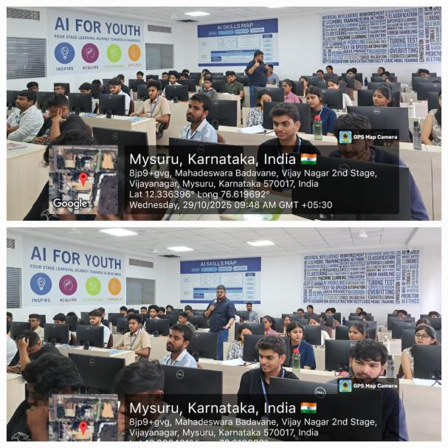 | The Department of CSE(AI&ML) organized a 3 day workshop on Data Visualization toolkits for 3rd sem students titled " Industry focused Data Visualization Workshop: Turning Data into Insights " from 29th to 31st October 2025. The resource person was Mr Naveen S, consultant, Avinya Technologies.
 | Student Achievements
 |  |  | 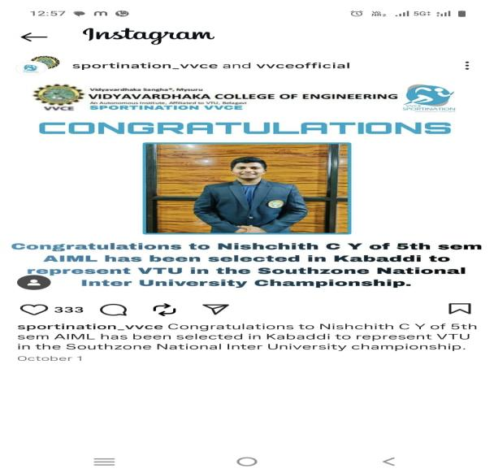 | Nishchith C Y , 5th sem Dept of CSE(AIML) has been selected for Kabaddi to represent VTU in southzone Nationla Inter University Championship
 |  | 5th | 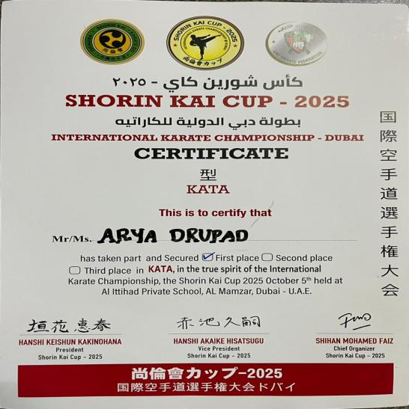  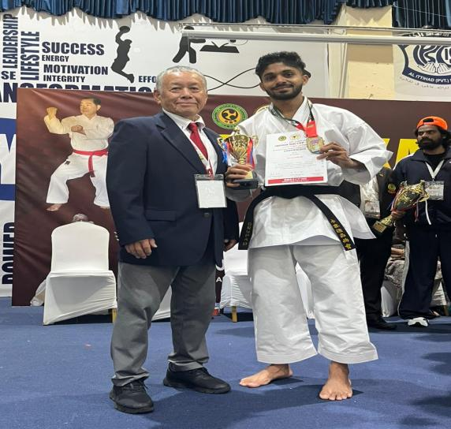 | Mr. Arya Drupad from 1st Year A section AI&ML Department secured first place in the international Karate Championship, the Shorin Kai Cup 2025 October 5th held at AI Ittihad Private School, Dubai, U.A.E.
 |  |  | 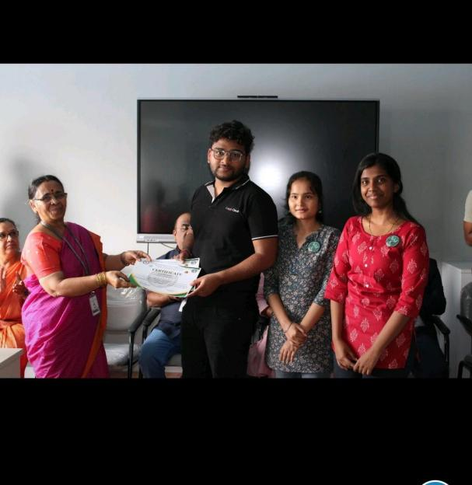  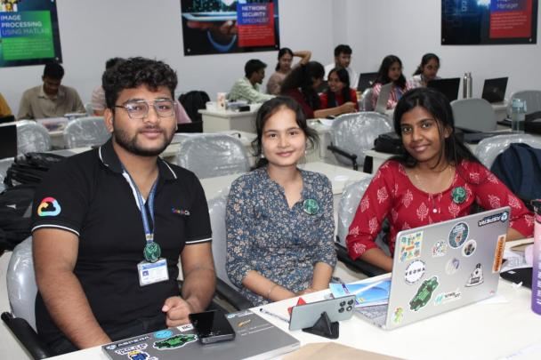 | Team Aplha15 from CSE(AI&ML) VVCE won the Consolation Prize in HAXLR8 2.0, the 24-hour Hackathon organized by the Department of ECE at MIT Mysore!  team members:  Saurabh Joshi ,Trisa Das,Yuktha Billar.
 |  |  | 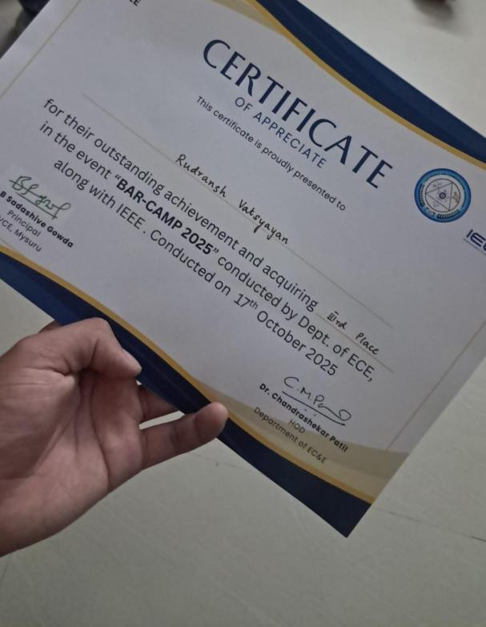 | Rudransh Vatsyayan from I Sem AI&ML- C section participated in the BAR-CAMP 2025 Competition conducted by Dept of ECE along with IEEE in 17th October 2025 & Secured Third place in the competition.
 |  |  | 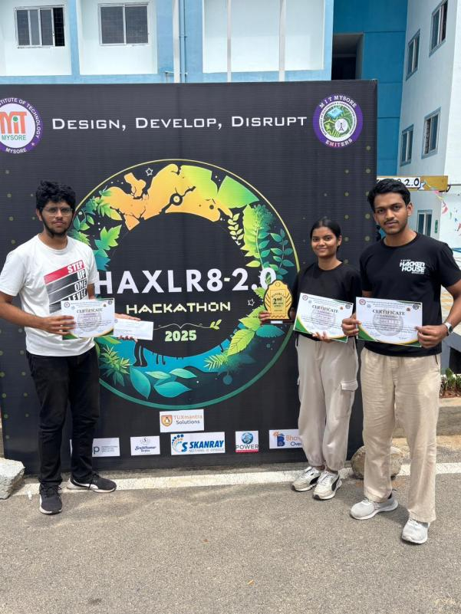  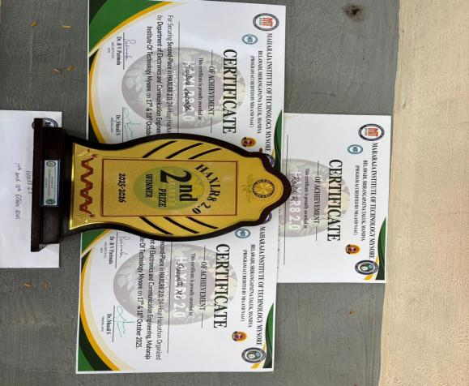 | Students of V semester B section  Ronith R , shamanth and Sanjana Ambareesh have won II place in HAXLR8 2.0 24 hour Hackathon organised by MIT , Mysore on 17th 18th October.
 |  |  | 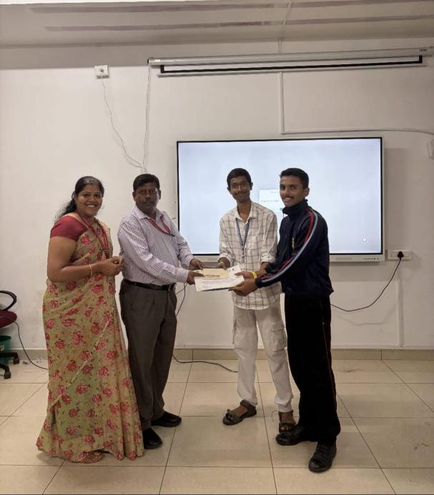 | Team Code Breakers participated in the BAR-CAMP 2025 Competition conducted by Dept of ECE along with IEEE in 17th October 2025.  Team Members:  - P G Ayush Rai - 5th Sem (CSE-AI&ML)  - Nagendra A S - 3rd Sem (CSE-AI&ML) & Secured first place in the competition.
 |  |  | 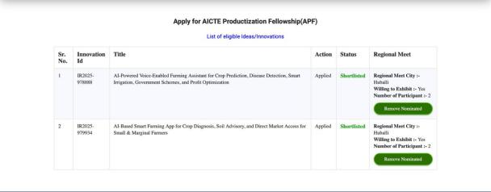  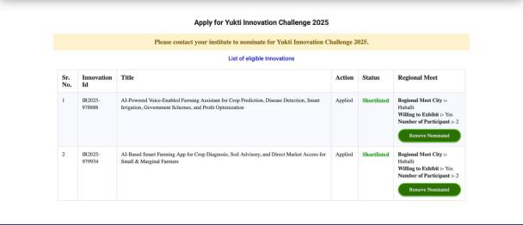 | Projects of Mr. Aashish, Mr. Uthkarsh and Mr. Chandan from 3rd semester, CSE(AIML) have been selected for YUKTI Innovation Challenge 2025 and AICTE Productization Fellowship(APF). Ideas got selected in the first round by the Central Government and they are requested to attend the Regional Meet for pitching the idea with the prototype at Hubbli.
 |  |  | 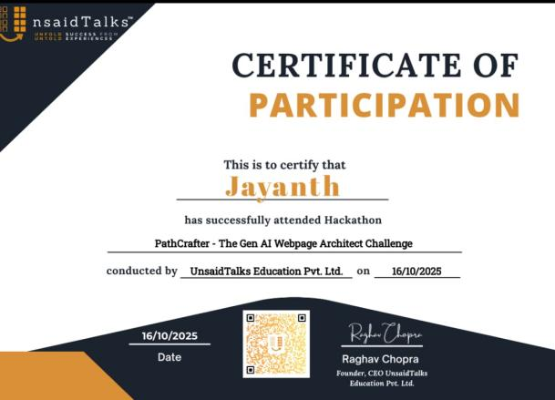  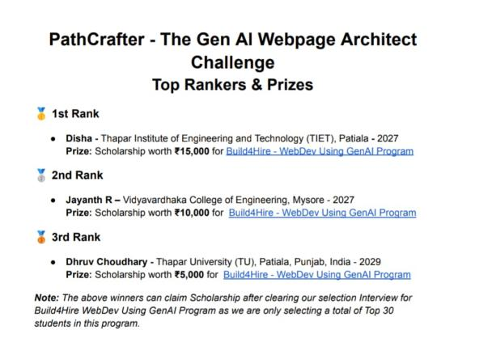 | Jayanth R from 5th semester A section has secured second rank in "PathCrafter - The GenAI webpage architect challenge" organised by Unsaid Talks Education Pvt Ltd. He is qualified for the next round of challenges which will be held next week.
 |  |  | 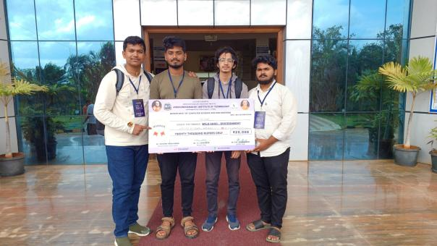 | Harsha M Gowda, Harshith K C, Dishan H S and Lakshmisha of 5th semester A section have won first place in the HackAbhigna hackathon organised by Dept CSE, Adichunchanagiri Institute of technology, Chikkamagaluru under the domain "Wild Card - Environment". They have received a cash prize of ₹20000.
 | Faculty Achievements |  | 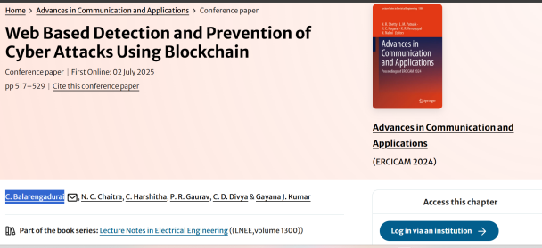  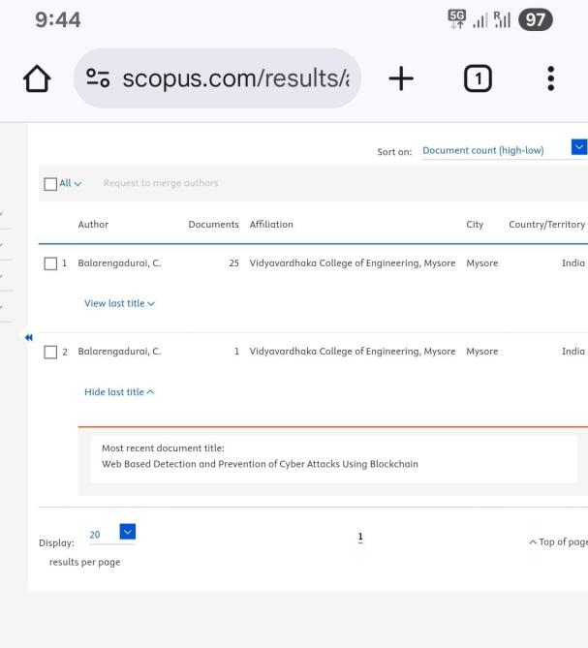 | Dr Balarengadurai C , Dept of CSE(AIML) Published Book Chapter in “Web Based detection and Prevention of Cyber AttacksUsing Blockchain” by springer & indexed in scopus.  https://link.springer.com/chapter/10.1007/978-981-96-0165-3_36
 |  | 09/10/25 | 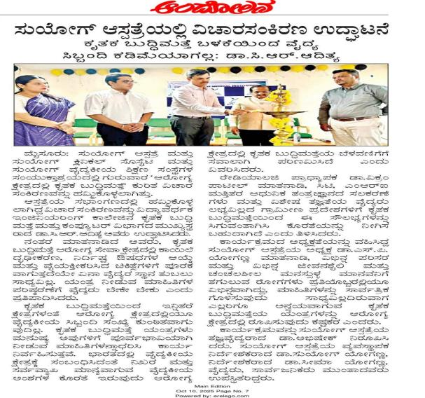 | Dr. Adithya C R Depart of CSE(AIML), Inaugurated and Delivered a keynote session for seminar on "AI in healthcare", organized by Soggy group of medical institution on 09/10/25
 |  | 11/10/2025 | 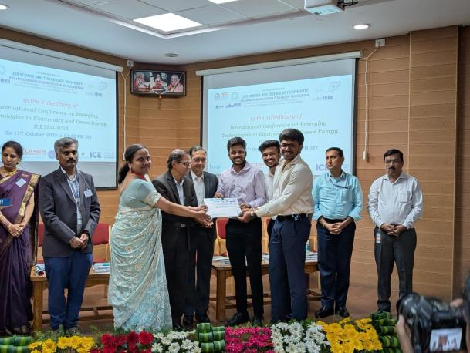 | Dr. Sonali N M, Bharaneesh Gowda, Krish Kedia and Joel Christ D Souza of CSE(AIML) got Best Paper award at ICETEG IEEE conference held at SJCE, Mysuru on 11/10/2025
 |  |  |  | Dr.Varshitha D N has published journal paper entitled "Automated Detection of Polycystic Ovary Syndrome Using Convolution Neural Networks on Ultrasound Images" and it is indexed in Scopus-Q1
 |  | 14th October 2025. | 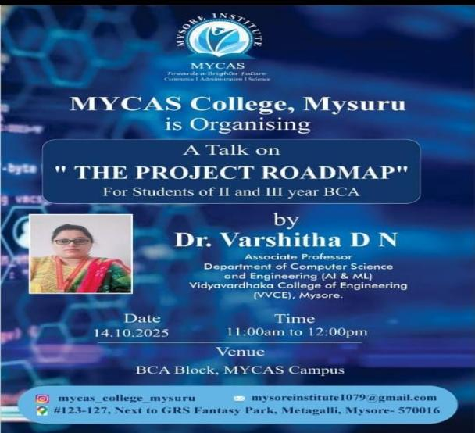  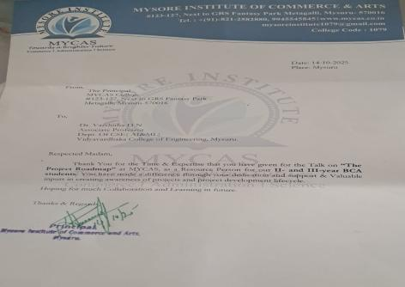 | Dr. Varshitha D N was a resource person for technical talk on "The Project Roadmap " for 2nd and 3year BCA students at Mycas Degree college, Mysuru on 14th October 2025.
 |  |  | 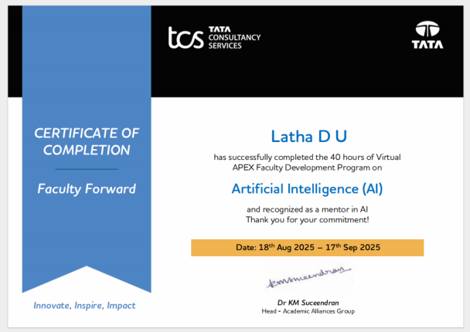  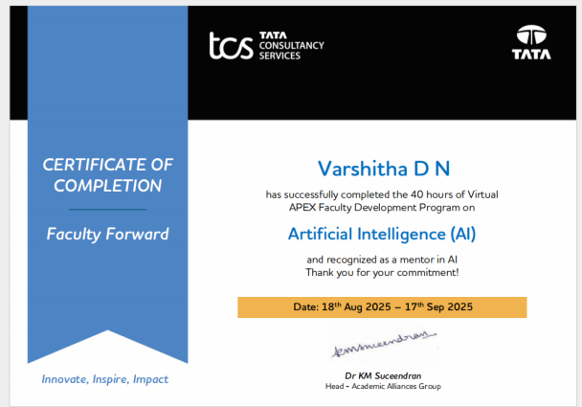 | Prof.Latha D U and Dr.Varshith D N have been certified as AI Mentors by TCS after undergoing 1 month TCS training and evaluation
 |  |  | 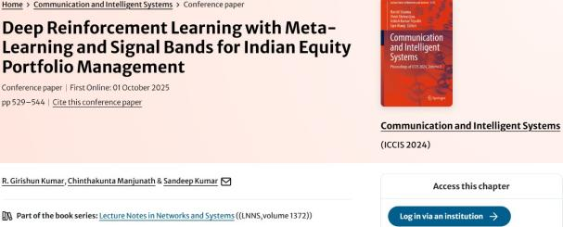 | Dr Manjunath C Dept of CSE(AIML) Published Conference article in Communication and Intelligent Systems. ICCIS 2024. Lecture Notes in Networks and Systems, vol 1372. Springer, Singapore. https://doi.org/10.1007/978-981-96-5726-1_37.
 |  |  |  | Dr Manjunath C Dept of CSE(AIML) Published Article in Q2 journal
 | NOVEMBER 2025
 | Department Activities |  | 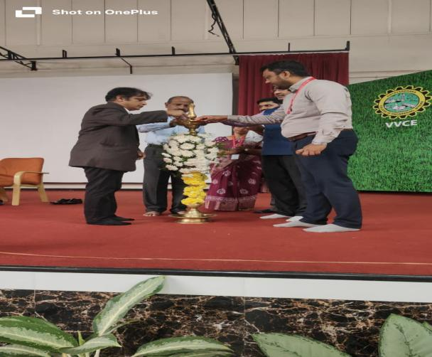  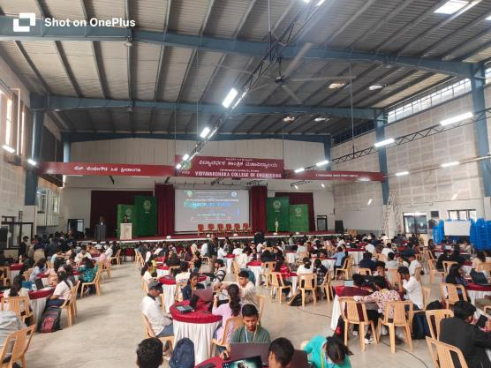 | The Department of CSE AI & ML in association with Velocity foundations has organised a 30 hours AI accelerated "Hack-AI-Thon". Mr. Manju S Hathwar, L&T technology inaugurated the event on 6-11-2025 in the sports complex.
 |  |  | 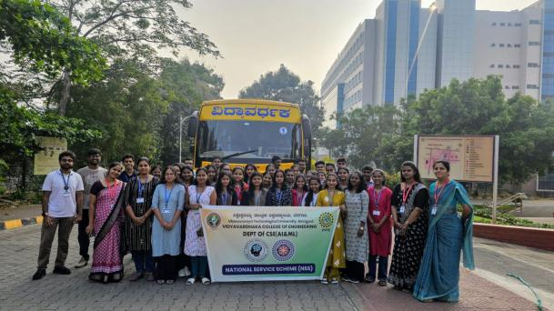  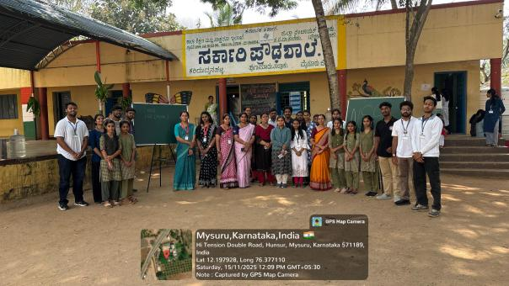 | The Department of CSE(AI&ML) had organized an Outreach activity in association with NSS for 3rd and 5th Semester students on 15th November 2025, Saturday. The students participated enthusiastically in simple, engaging science demonstrations and practical computer literacy sessions.  Scholarship awareness, carrier guidance, health camp (oral health) was arranged for students of 8th 9th and 10th grade students.Additionally, the volunteers also participated in cleaning and planting drives.
 |  |  | 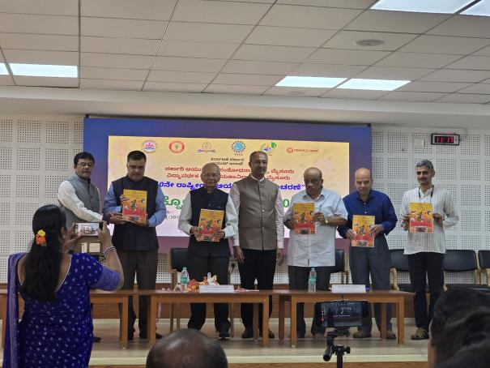  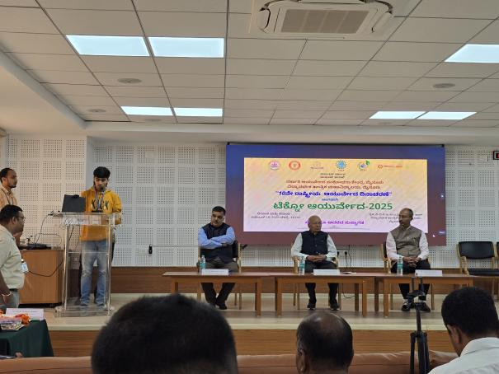 | The Department of CSE (AI&ML) in association with the Government Ayurvedic Research centre, Mysuru hosted a National Conference on "Techno - Ayurveda" on 18th November 2025, Tuesday. The event was graced by Dr. Vidyashankar, Vice chancellor, VTU and Dr. Vipin Singh, Commissioner of AYUSH in the online mode. The event was inaugurated by Dr. Chidananda Gowda, former Vice chancellor, Kuvempu university along with Sri. Gundappa Gowda, President, VVS, Er. Vishwanath P, Secretary, VVS, Mr. Amshi Prasanna Kumar, Chief Editor, Kannadaprabha and Dr. Sadashive Gowda, Principal, VVCE. The conference highlighted the blending of current technology in the field of Ayurveda for diagnosis and treatment for the diseases. Proficient speakers from Ayurveda colleges and engineering colleges participated in the event.
 |  |  | 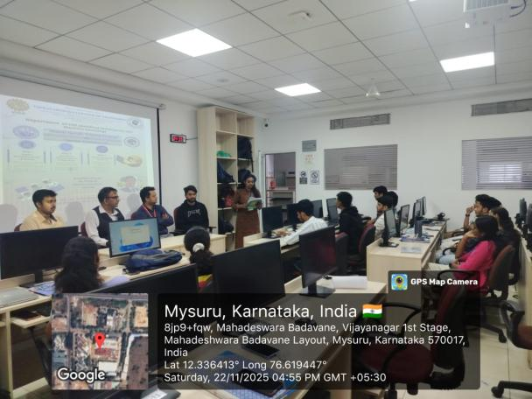  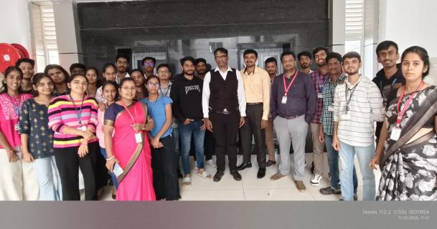 | The Department of CSE (AI & ML) successfully organized a three-days workshop on “Domain Specific Training Program on Agentic AI”, from 20th to 22nd at M310 VVCE, under the guidance of our beloved HOD and in association with ISTE. The resource person was Mr. Pawan.N software consultant from IVIS Labs, Mysuru.
 |  |  | 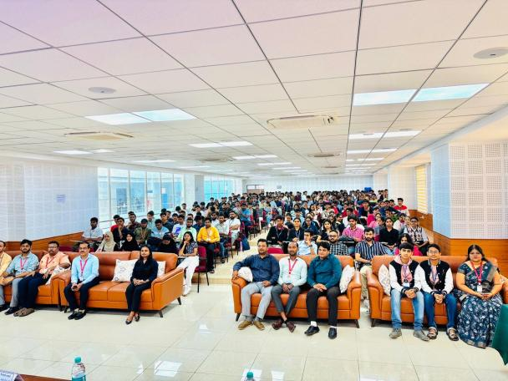 | The Department of CSE(AIML) and Department of Placement and training jointly hosted "Google Dev Fest 2025" in association with Google Developer Groups, Mysuru on 22nd November 2025. Two prolific Speakers addressed the gathering. Mr. Sourabh Mishra, Devops lead, Google developer in his address focused on cloud operations and Devops. Ms. Gayatri Devi Srinivasan, Software engineer, Geekyants Pvt Ltd. addressed on Flutter and Web development. The event had more than 200 participants across karnataka. Participation was from both industry employees and students of engineering colleges.
 |  | 21-11-2025 | 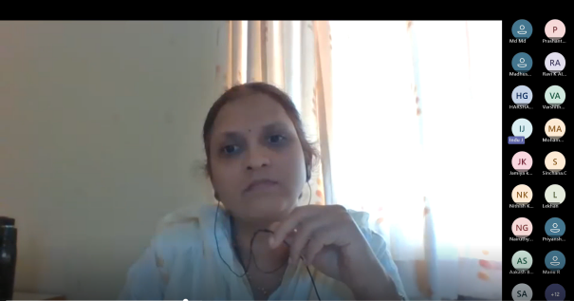  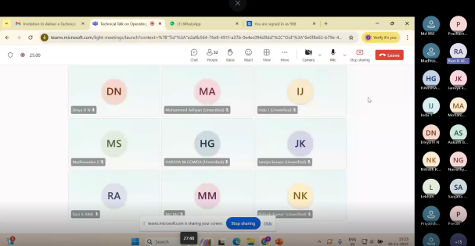 | The Department of CSE (AI & ML) organized a Technical Online Talk on” Operating Systems” for 5th sem Students Resource Person was Mrs. Divya H N , Asst Professor SJCE, Mysore
 |  |  | 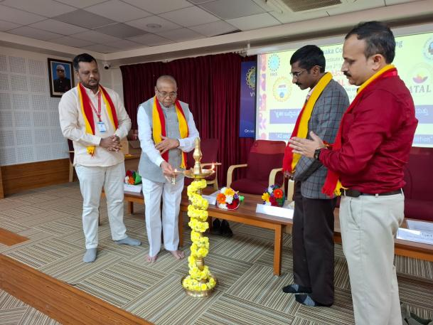  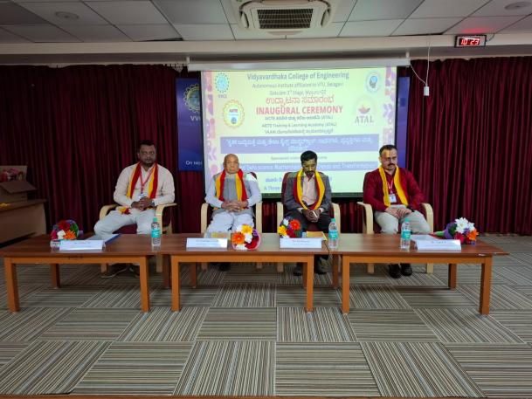 | Department of CSE(AI&ML), Vidyavardhaka College of Engineering, Mysuru hosted 3- Day workshop which was sponsored by AICTE ATAL under VAANI scheme. Faculty members and PG scholars from across karnataka participated in the workshop. Mr. Karthigeyan, CEO of Logycent inaugurated the event and Sri. Gundappa Gowda presided over the event
 |  |  | 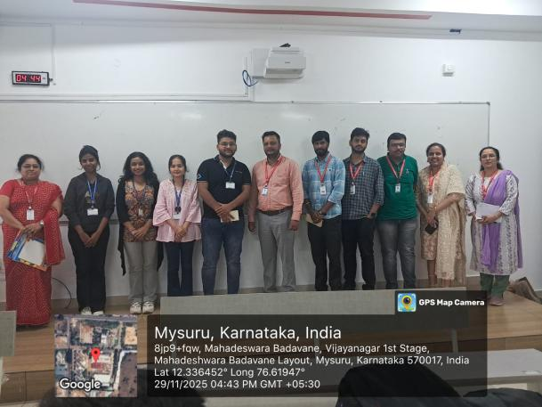  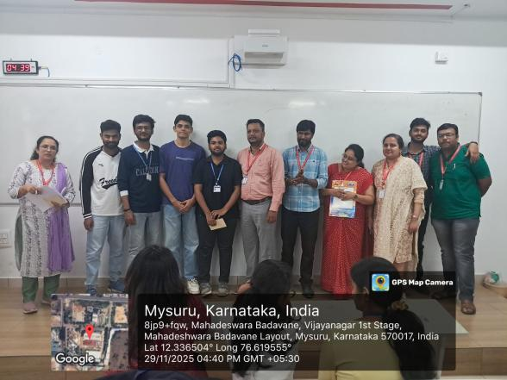 | Department of AI&ML conducted Intra Department Hackathon Code Genz-2.0 on 29-11-2025 for all the 5th semester students. 8 hours were given to students to develop their projects and demonstrate. It was aligned to Design thinking and considered as 8 hours Project based Learning mapped to Basics of ML subjects open ended module. Faculty from different branches were invited as jury members also the cash prizes were given to winners to encourage the students.
 | Stdent achivements |  | 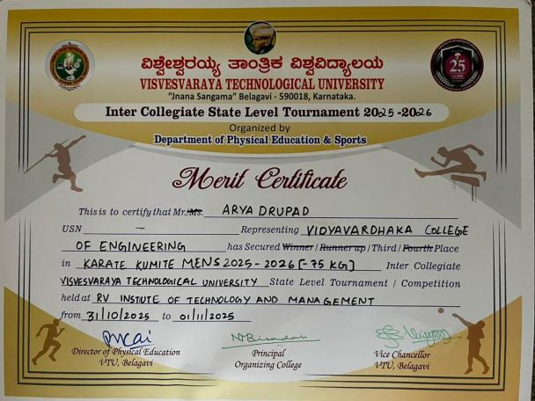 | Mr Arya Drupad from Department of CSE(AIML), 1st year 'A' Section has won a Bronze Medal in Karate in the inter-collegiate state-level tournament held on 31/10/2025 to 01/11/2025 conducted by RV Institute of Technology and Management.
3rd and 5th semester students, from Dept of CSE(AIML), Participated in Ideathon - 2025, held in GSSS, Mysuru.
Team Name: Code Breakers
Team members:-
P.G Ayush Rai (4VV23CI065)
Nagendra AS (4VV24CI113)
Mahathi S (4VV24CI095)
Nagasiri Mourya K N (4VV24CI111)
Mahalakshmi M (4VV24CI094)
 |  |  | 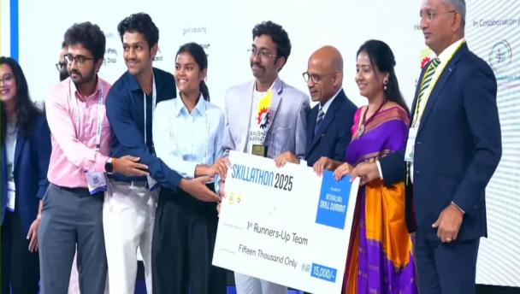 | Students of 5th semester CSE(AI&ML) has secured Second place in the Skillathon at the Bengaluru Skill summit 2025. It was an honour to receive the prize from Dr.Sharanaprakash Hon Minister for Skill development and Entrepreneurship.  Team members:  1.Sanjana Ambarish  2.Preran S Gowda  3.Shashank S  4.Ronith R
 |  |  | 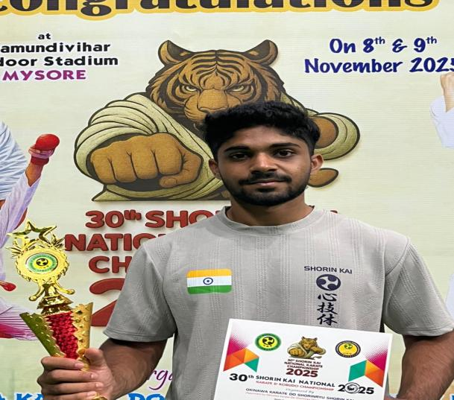 | Mr Arya Drupad from Department of CSE(AIML), 1st year 'A' Section has bagged 1st place in 30th shorin kai national karate tournament which was held on 9/11/2025 at Chamundi Vihar stadium Mysore.
 |  |  | 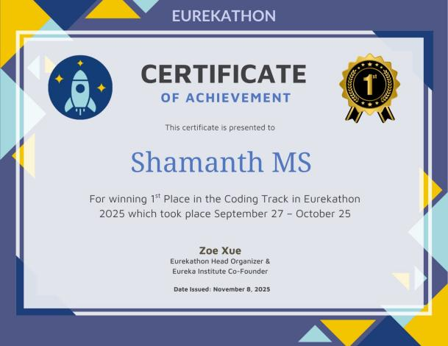 | Mr. Shamath M S 5th semester CSE(AI&ML) had participated in an online Hackathon called Eurekathon organized by Eureka Institute and have been awarded as First place winner and have won many vouchers summing up to 1,364$ and have been offered as a web developer position in the non profit organization Eureka Institute.
 |  |  | 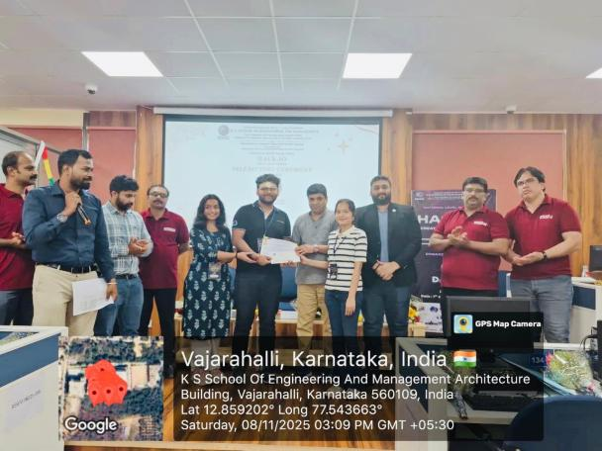 | Team CosmicSeNTinal , Dept of CSE(AIML), has secured the 2nd Runner-Up position at the national-level hackathon conducted by KSSEM, Bengaluru.  With over 2000+ ideas submitted and 200+ teams shortlisted from across the country, it was a highly competitive event, and we are grateful to have represented our department and achieved this milestone.  Our team members are:  Saurabh Joshi  Trisa Das  Nithaksha G
 |  |  | 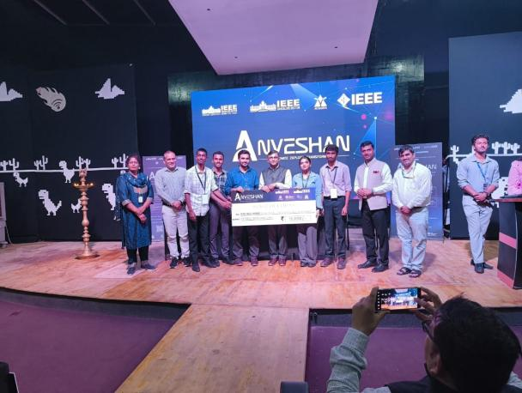 | Team “Code Breakers” from the Department of CSE (AI & ML), comprising Nagendra A. S., Lakshya S. (3rd Sem, CSE-AI&ML), Nandan M. (3rd Sem, CSE), and P. G. Ayush Rai (5th Sem, CSE-AI&ML), participated in the IEEE Anveshan 2-Phase Competition, where the team was selected among the top 6 teams out of 33 in the Ideathon phase held at SJCE Mysuru on 27 October 2025, and went on to secure 1st place in their track during the 24-hour Hackathon held at Acharya Institute of Technology, Bengaluru, on 15–16 November 2025.
 |  |  | 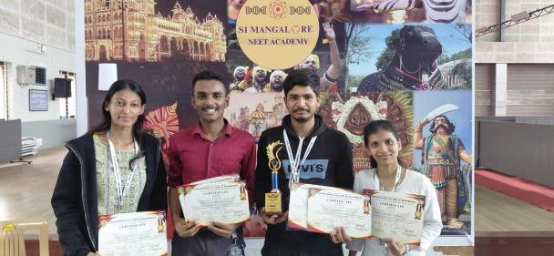 | P G Ayush Rai from 5 th Sem CSE-AIML, Rajashekhar 7th sem ME,Srusti 7th Sem ME, Vaishnavi 5th Sem ME.  They were the runner up of 24 hours hackathon Prayog conducted by the department of ME at VVCE on 20 and 21st of November 2025
 | Faculty Achievements |  | 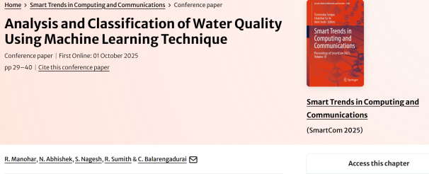 | Dr Balarengadurai C ,Dept of CSE(AIML) Published Conference Paper on “Analysis and Classification of Water Quality Using Machine Learning Technique”  In Springer & indexed in scopus
 |  |  | 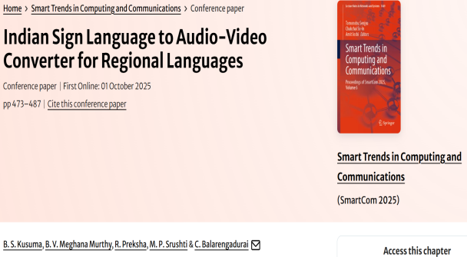 | Dr Balarengadurai C ,Dept of CSE(AIML) Published Conference Paper on” Indian Sign Language to Audio-video COnverter for Regional Language” in Springer & indexed in scopus
 |  |  | 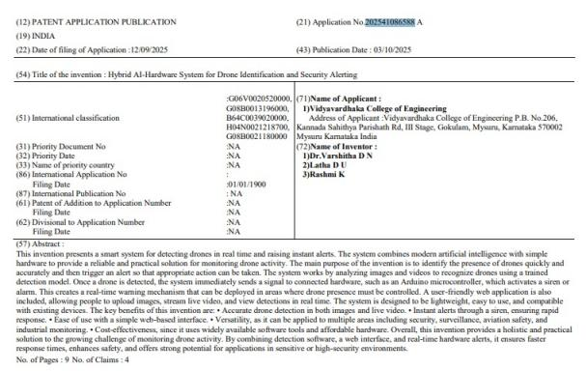 | Patent Published : Patent title: Hybrid AI-Hardware System for Drone Identification and Security Alerting, Patent application No.: 202541086588, Filed Date: 12-09-2025, Dept.: AI&ML, Inventors Name: Dr.Varshitha D N, Prof. Latha D U, Prof. Rashmi K
 |  |  | 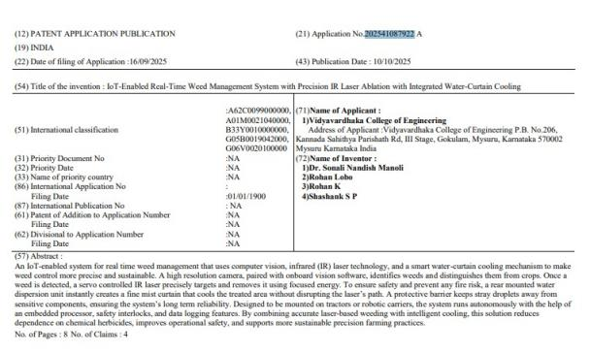 | Patent Published : Patent title: IoT-Enabled Real-Time Weed Management System with Precision IR Laser Ablation with Integrated Water-Curtain Cooling, Patent application No.: 202541087922, Filed Date: 16-09-2025, Dept.: AI&ML, Inventors Name: Dr. Sonali Nandish Manoli, Rohan Lobo, Rohan K, Shashank S P
 |  |  | 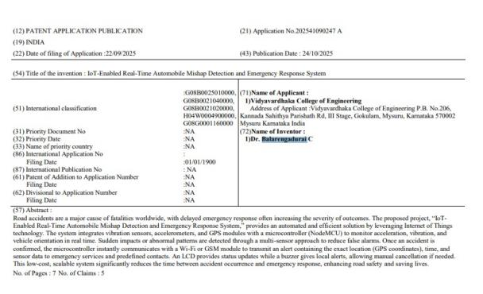 | Patent published: Patent title: IoT-Enabled Real-Time Automobile Mishap Detection and Emergency Response System, Patent application No.: 202541090247, Filed Date: 22-09-2025, Dept.: AI&ML, Inventors Name: Dr. Balarengadurai C
 |  |  | 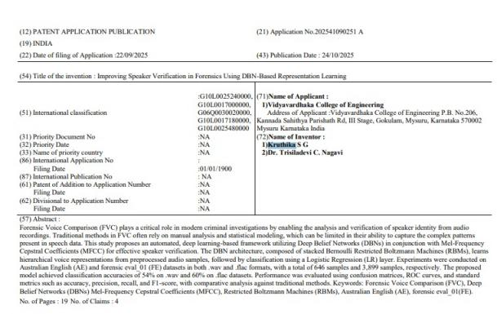 | Patent Published: Patent title: Improving Speaker Verification in Forensics Using DBN-Based Representation Learning, Patent application No.: 202541090252, Filed Date: 22-09-2025, Dept.: AI&ML, Inventors Name: Prof. Kruthika S G, Dr. Trisiladevi C. Nagavi
 |  |  | 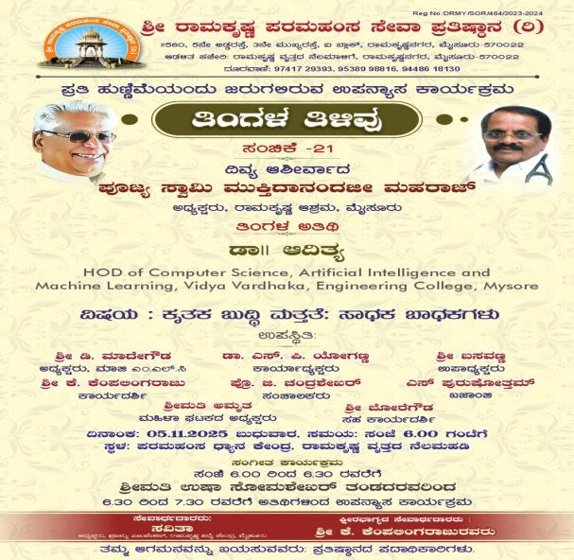 | Dr. Aditya C R HOD, Dept of CSE(AIML) Delivered a Technical Talk on " Merits and Demerits of AI" on 5/11/25
 |  |  | 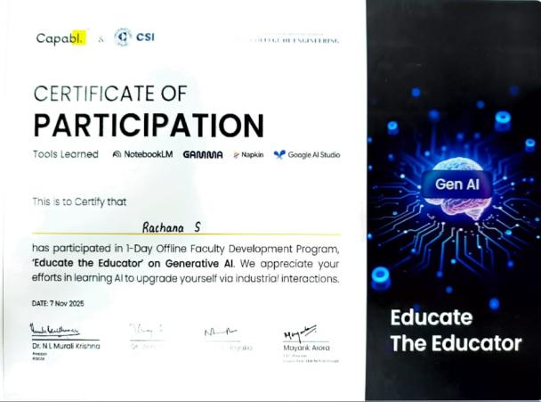 | Prof. RACHANA S, Dept of CSE(AIML) attended the faculty development program on "Educate the Educator on Generative AI" organized by ISTE PESCE Chapters in association with Capabl. And CSI, on 07/11/2025, at AI&ML john McCarthy lab, PES College of Engineering, Mandya.
 |  |  |  | Prof. KRUTHIKA SG, Dept of CSE(AIML), attended the faculty development program on "Educate the Educator on Generative AI" organized by ISTE PESCE Chapters in association with Capabl. And CSI, on 07/11/2025, at AI&ML john McCarthy lab, PES College of Engineering, Mandya.
 |  |  | 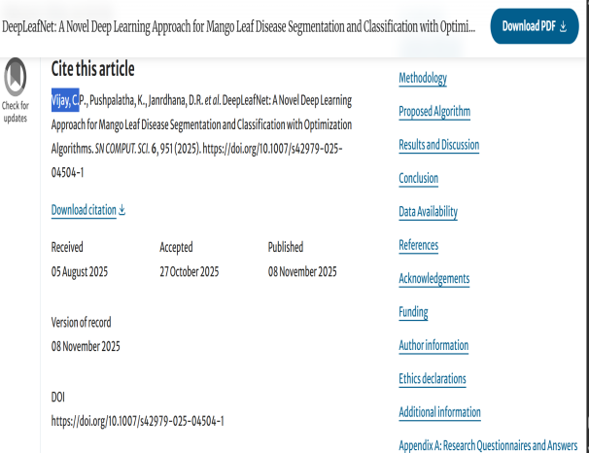 | - Dr Vijay C P Published a Paper on “ A NOvel Deep Learning Approach For Mango Leaf Disease Segmentation and Classificatopn with Optimization Algorithms” Published: 08 November 2025  - Volume 6, article number 951, (2025)
 |  |  | 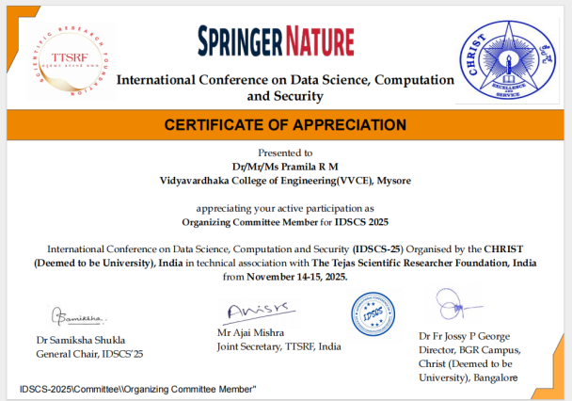
 |  |  | 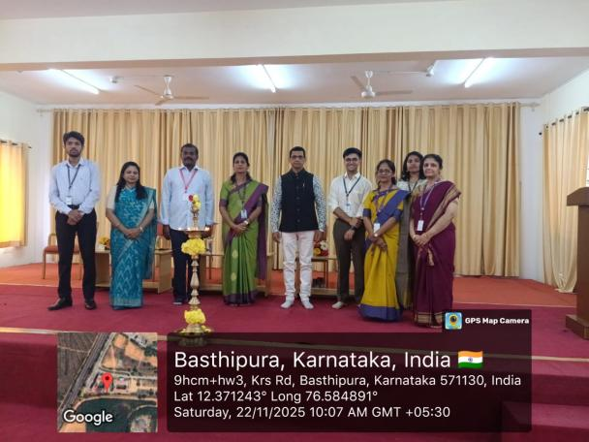 | Dr Balarengadurai C ,Dept of CSE(AIML), was honored to serve as a jury member for the Poster Presentation Competition held on 22.11.2025, organized by the Department of Computer Science & Engineering and CSE (AI & ML) at the National Institute of Engineering (NIE), Mysuru
December 2025
 | Departmentt Activitys |  | 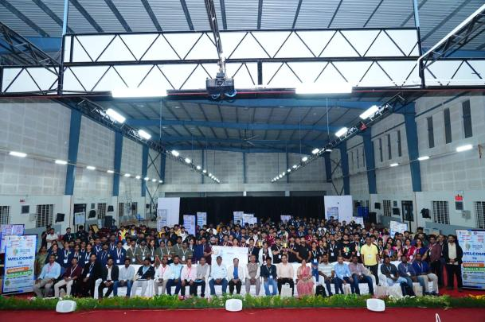  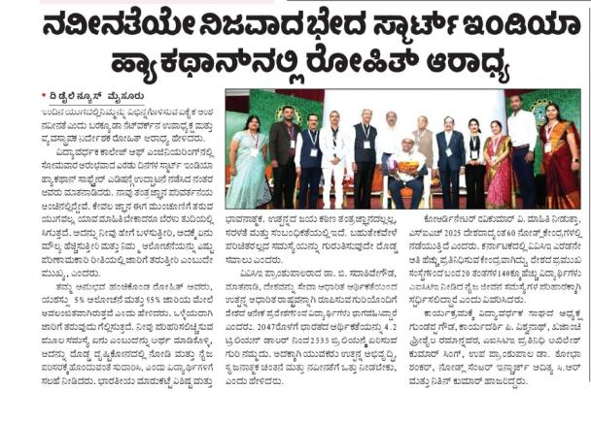 | Department of CSE(AIML) ,VVCE has organized Smart India Hackathon 2025 was hosted in Vidyavardhaka college of engineering by Dept of CSE AI&ML and TAP Dept on 8th and 9th of December 2025. 4 problem statements were allotted to the nodal center 18 teams participated in the event. 4 teams chosen as winners after meticulous mentoring and evaluation sessions.
 |  |  | 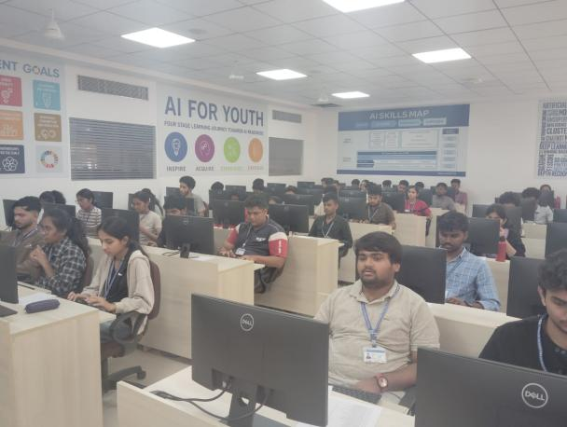  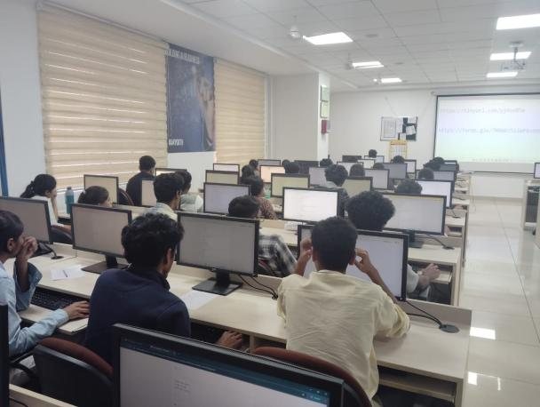 | Department of CSE (AI & ML) conducted Data Structures Codeathon competition for 3rd Semester CSE (AI & ML) students on 27-12-2025.
 |  |  | 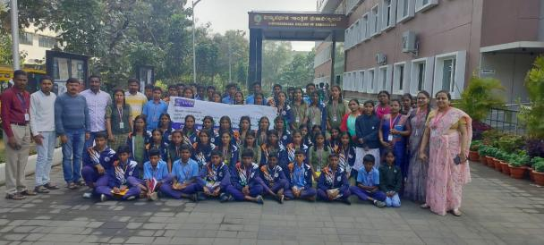  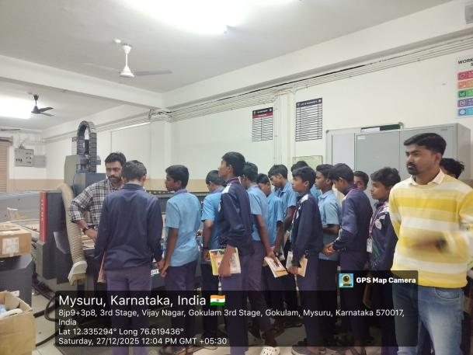 | The Department of CSE (AI & ML) organized a Student Outreach Activity on 27th December 2025 for the students of Swami Vivekananda Youth Movement Government High School, Sargur (Taluk), Mysuru District).
 | Student Achivements |  | 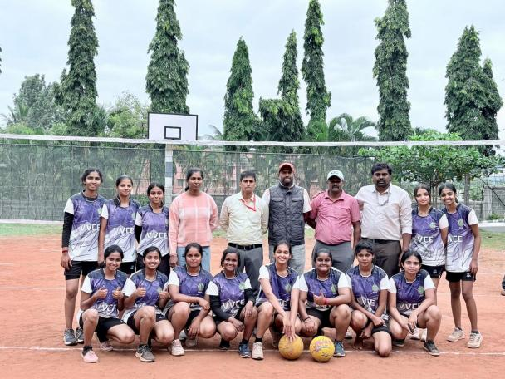 | Prerana Jagdish of 5th B Section is in VVCE Women Throwball Team Champions in VTU Inter - Collegiate Mysuru Division 2025-26 Tournament organized by GSSSITW, Mysuru and qualify for State level
 |  |  | 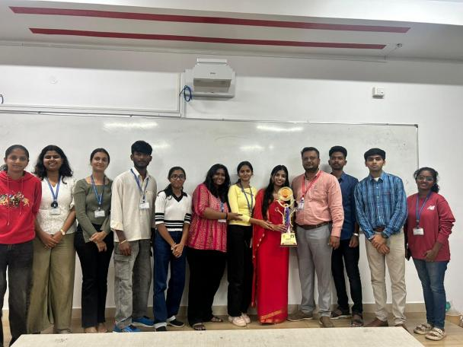 | Students of CSE(AI&ML) won rolling trophy in Taranga event
 |  |  | 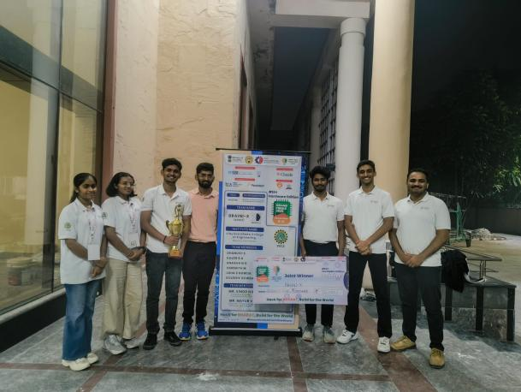  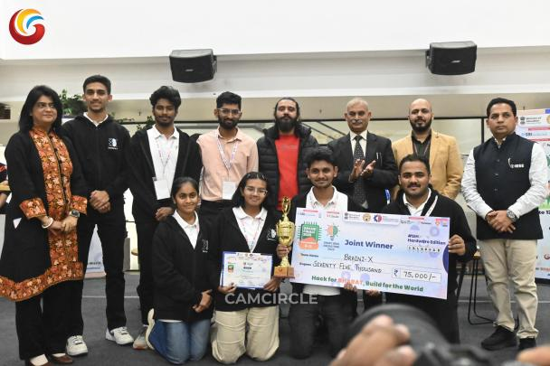 | Harshith student of 7th semester CSE( AI&ML) participated in the Smart india Hackathon ( SIH) 2025 at Galgotias university, Greater Noida, Uttar Pradesh was a WINNER 🏆...
 |  |  | 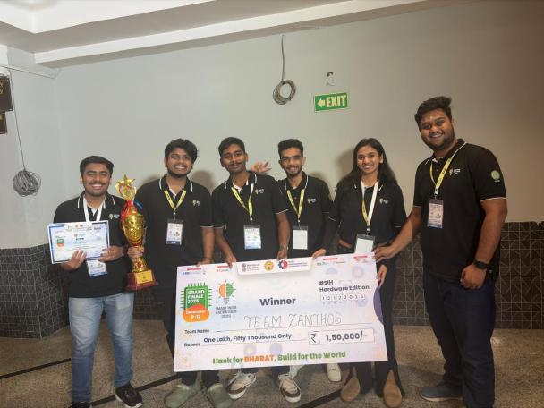 | Team Zanthos led by Yatharath Agarwal of 5th semester ECE emerged as Winners of Smart India Hackathon-2025 hardware edition at G L Bajaj Institute of Technology, Greater Noida.
 | Faculty Achievements |  | 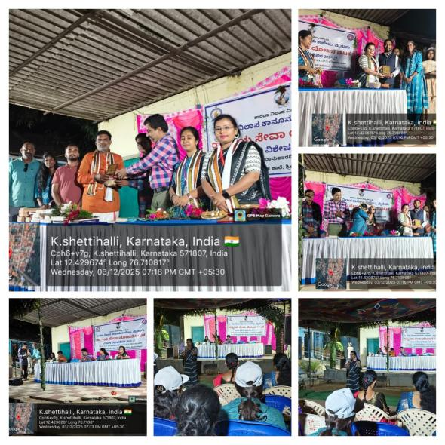 | Prof. Kruthika S G invited as a resource person to deliver a talk on "Digital Forensics Awareness and its role in Modern Criminal Investigations" at the NSS Special Camp organized by Sarada Vilas Law College on 3rd December 2025
 |  |  | 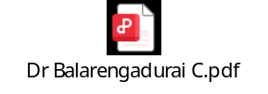 | Dr. Balarengadurai C , Dept of CSE(AIML),successfully completed the IBM Qiskit Fall Fest 2025, conducted from 17th to 19th November 2025 at NIT Puducherry, Karaikal. This program focused on quantum computing concepts using IBM Qiskit and provided valuable exposure to emerging technologies in quantum information science.
 |  |  | 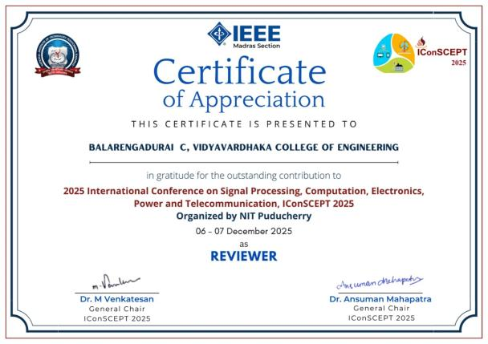 | Dr. Balarengadurai C, Dept of CSE(AIML),was contributed as a Reviewer at the 2025 International Conference on Signal Processing, Computation, Electronics, Power and Telecommunication (IConSCEPT 2025). The conference was organized by NIT Puducherry under the IEEE Madras Section and held on 06–07 December 2025
 |  |  | 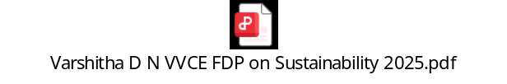 | Dr. Varshitha D N, Dept of CSE(AIML),successfully completed the Faculty Development Program on “Sustainability” organized by the IUCEE Foundation. The FDP was conducted through four online sessions from June to August 2025 and focused on integrating sustainability concepts into engineering education and practice.
 |  |  | 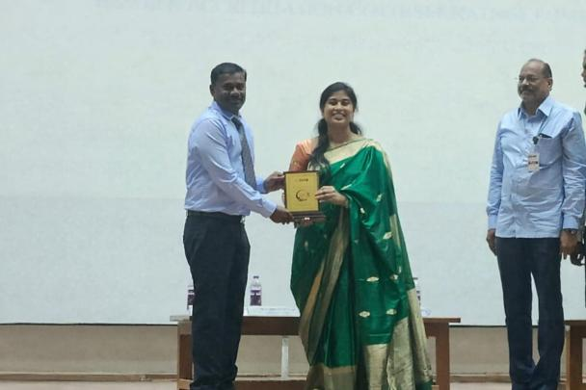 | Dr. Balarengadurai C, Dept of CSE(AI&ML) received the Best Alumnus Award (B.Tech–IT) at the Silver Jubilee Celebration of Karpaga Vinayaga College of Engineering (Autonomous), Chennai.
 |  |  |  | Prof .Latha D U and Dr. Varshitha D N of Dept of CSE(AI&ML),Published a conference paper at 2025 IEEE International Conference for Women in Innovation, Technology & Entrepreneurship (ICWITE)
 |  |  |  | Dr. Manjnath C, Dept of CSE(AI&ML), Serverd as Session chair at 5th international conference 2025 on “6G Communicaton Networking and Signal Processing(SGCNSP)
 |  |  |  | Prof. Kruthika S G,Dept of CSE(AI&ML), Presented a paper on “Enhancing The Forensic Voice Com parison Performance Utilizing M FCC And Deep Belief Network (DBN) Model” in eight International Conferance on Futurestic Trends on Networks and Computing Technilogies(FCNCT’08)
 |  |  |  | Prof, Harshith C , Dept of CSE(AI&ML),Presented a paper on “Predicting CO2 Emission Using Deep Learning Techinques” in International Conference on Smart Mechanical System for Sustainability(ICSMSS-2025)
Jan 2026
 | Department Activitys
 |  |  | 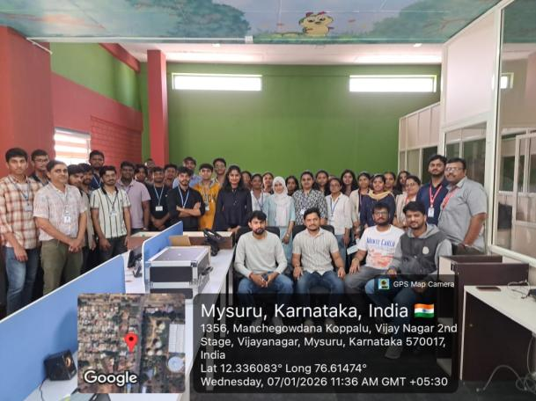  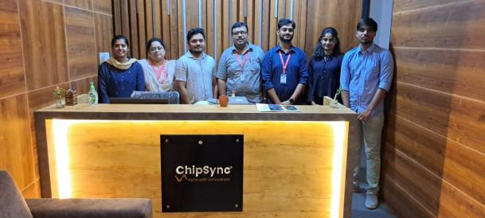 | Department of CSE (AI&ML) organized Industrial visit to ChipSync Technologies for 3rd semester students on 7th January 2026, Wednesday. 30 Students were part of the industrial visit. Chipsync Technologies is a technology-oriented company engaged in the development of innovative solutions in areas such as embedded systems, IoT, VLSI, software development, and emerging digital technologies. The organization focuses on delivering industry-relevant solutions while also contributing to skill development and training initiatives. The visit helped the students to know about. The visit commenced with an introductory session by the technical team of Chipsync Technologies, during which the students were briefed about the company’s vision, core domains, ongoing projects, and industry expectations. This was followed by interactive technical sessions covering various aspects of product development and real-time project implementation.
 |  |  | 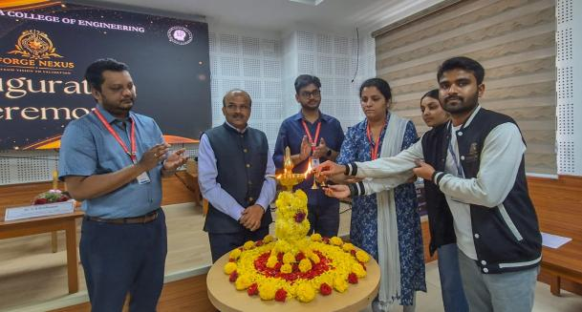  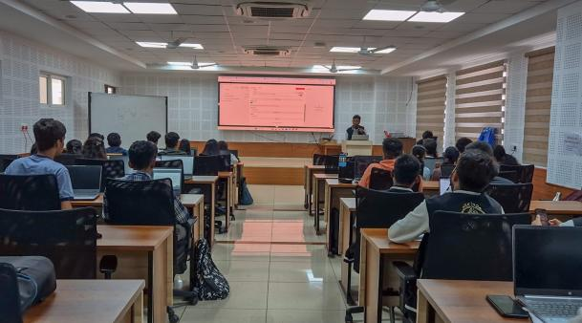 | Department of CSE (AI&ML) officially launched its Research and Development club "ForgeNexus" on Saturday 10th Jan 2026. The club was inaugurated by Dr. G B Krishnappa sir, Dean of Research and Development and Dr. Adtiya C R, Head of the Dept CSE AI&ML. The event was followed by a workshop on N8N Tool. Around 30 students were part of the workshop.
 |  |  | 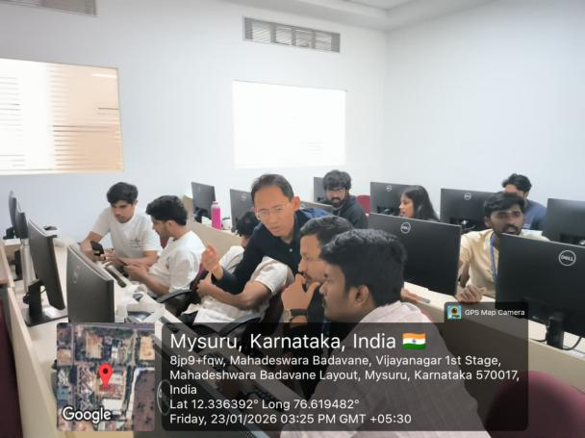  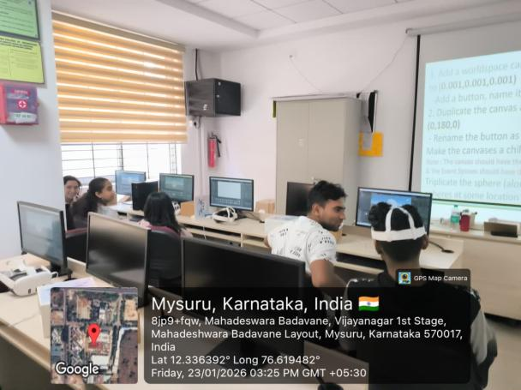 | Department of CSE (AI&ML) organized 5 day workshop on VR Development from 19/01/26 to 23/01/26 for 8th semester students.The resource person was Dr.Kasar ,From Edspire technologies...now students will undergo 16 weeks of free internship on VR Development...
 |  |  | 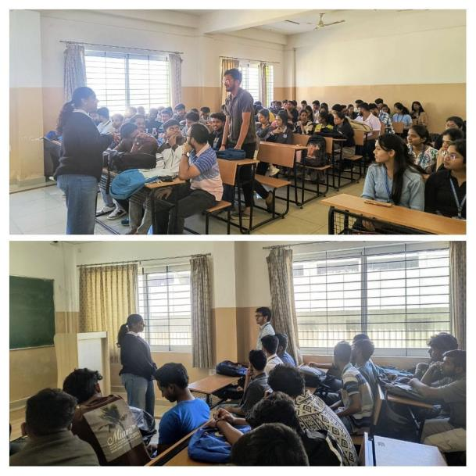 | Department of CSE(AI&ML) conducted an alumni interaction today (31/01/2026) for 6th semester students. Ms.Nagaprapthi P S, Alumnus of CSE(AI&ML) belongs to the 2020-2024 batch currently working as a Cloud Architect at Hewlett packard enterprise Pvt.Ltd.interacted with the students and gave insights on "Industry Trends and Skills and Carrier Path Journeys".
 |  |  | 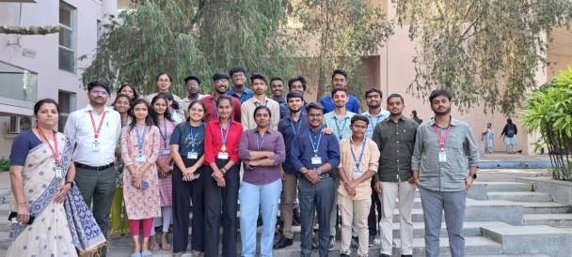  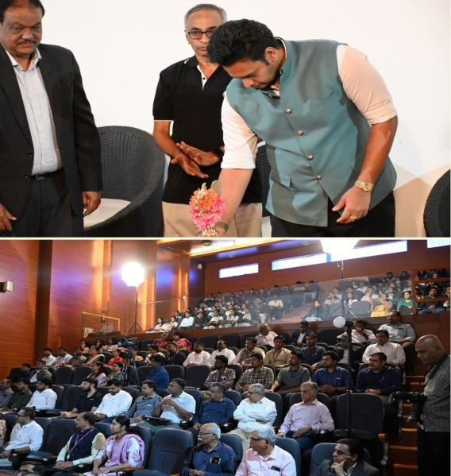 | Department of CSE AI&ML along with faculties attend the JAN AI Summit 2026 organised in collaboration with Cyberverse Foundations, Vignyan labs and Berunda Foundations. The event was inaugurated by Sri. Yaduveer Krishnadatta Chamaraja Wadiyar, Honourable MP of Mysuru and Kodagu. The event had 2 technical talks on AI in agriculture and AI with cybersecurity from the founders of Datawave and Pantherun. Panel discussion on "AI adaptation is an Hourly need" and Master class by the founder of Vignyan labs was part of the event.
 | Student Achivements
 | Faculty Achivements |  | https://ieeexplore.ieee.org/document/11307070 | Prof Latha D U and Dr. Varshitha D N, Dept of CSE(AI&ML), Published a conference paper at 2025 IEEE International Conference for Women in Innovation, Technology & Entrepreneurship (ICWITE)
 |  |  | 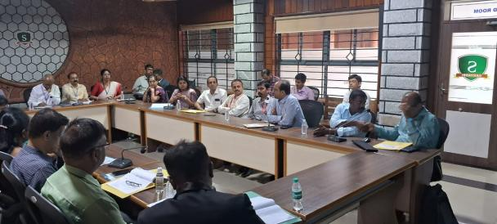 | VVCE Team ( Dr Balarengadurai C, Dr Vedavathi N, Dr Vijaya C P, Savyasachi) served as an External Expert for the NBA & Academic Audit at Sahyadri College of Engineering & Management, Mangalore.
 |  |  | 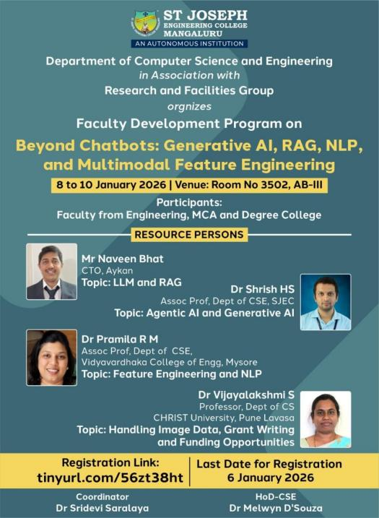 | Dr. Pramila R. M, Dept of CSE(AI&ML), served as a resource person for a Faculty Development Programme (FDP) at St. Joseph Engineering College, Mangalore on 9th and 10th January 2026.
 |  |  | 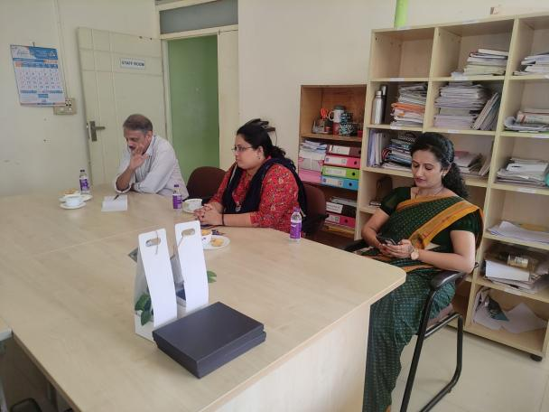 | Dr.Varshitha D N, Dept of CSE(AI&ML), participated in Board of Advisory committe meeting on 16-01-2026 as a memeber in BCA department of MCYAS Degree college, mysore.
 |  |  |  | Dr. Varshitha D N and Prof. Latha D U, Dept of CSE(AI&ML) ,have cleared the NPTEL exam on Design Thinking for Educators scoring 94 and 92 respectively .
 |  |  | 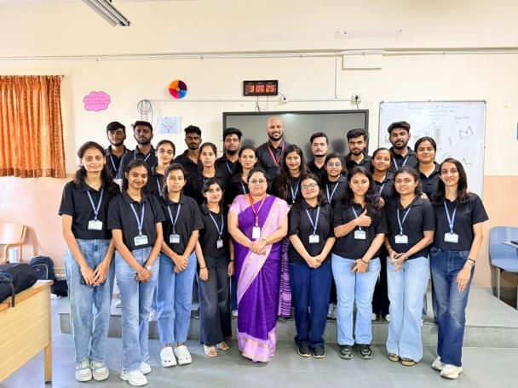 | Dr.Varshitha D N, Dept of CSE(AI&ML) was invited as a jury member for Business Analytics event called as Tatva- which was a part of state level management fest -Vidvath-2026 organised by MBA dept of VVCE on 24-01-2026.
 |  |  | 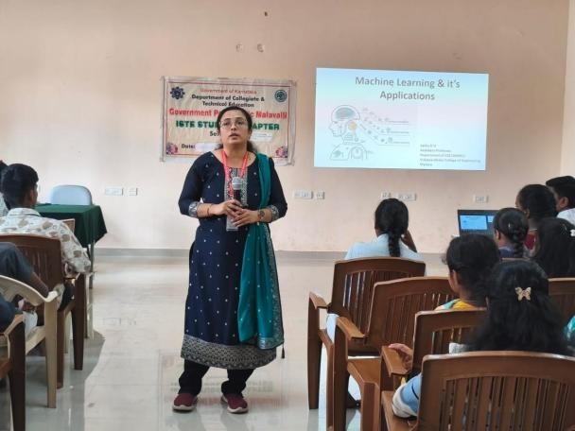 | Prof. Latha D U,Dept of CSE(AI&ML), delivery a technical talk on “Real world Applications of Artificial Intelligence and Machine Learning” under ISTE Student chapter, at Government Polytechnic, Malavalli.
FEB-2026
 | Department Activitys
 |  |  | 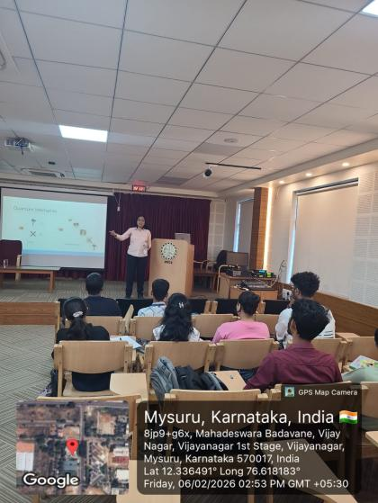  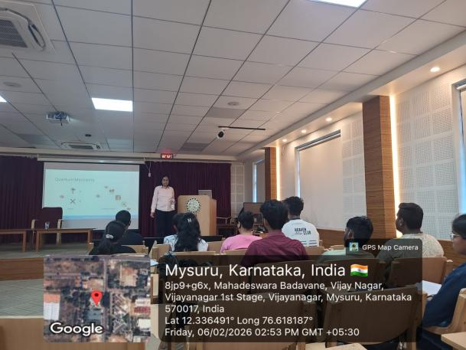 | The Department of CSE(AI&ML) conducted a session on Quantum Computing for 6th semester students on 6/2/2026 from 2.30 pm to 4.30 pm.  Ms Anna Michael from Wells Fargo was the resource person for the session.  The session focused on Quantum Computing Applications,Quantum Algorithms, Challenges and Platforms.
 |  |  | 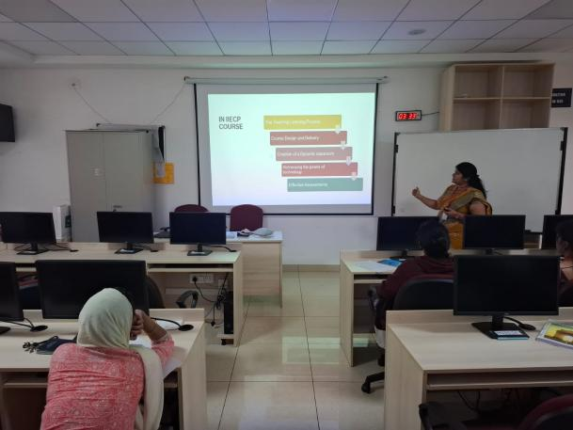  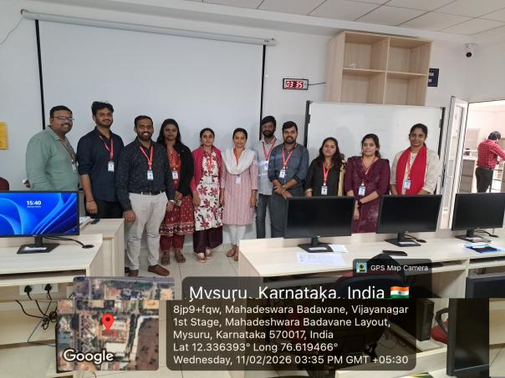 | The department of CSE AI&ML organised a 3 day FDP on "Teaching and Learning methodologies" to the newly joined faculties of VVCE from 9th to 11th February 2026. FDP was focused on Role of Teachers, OBE, course design and delivery, Effective assessment, Harnessing the technology, Creating a dynamic classroom, Why mentoring, Professional ethics and Learners traits. Sessions were handled by the faculties who have completed IUCEE certifications.
 | Student Achivements
 | Faculty Achievement |  | 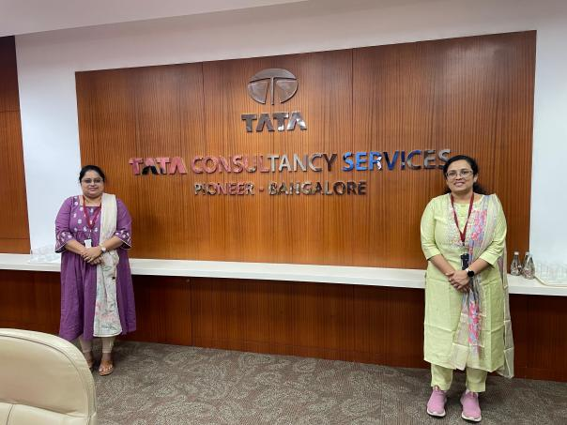 | Dr.Varshitha D N and Prof.Latha D U, Dept of CSE(AI&ML), successfully completed capstone project and attended immersion at TCS, Banglore ITPL campus as part of TCS Apex FDP on 4-2-2025
 |  |  | 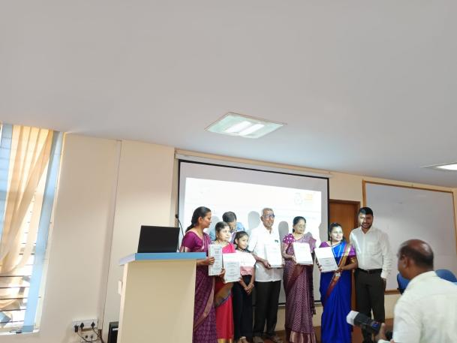 | Dr. Kruthika S G, Dept of CSE(AI&ML) has successfully defended the PhD thesis entitled "Development of voice comparison algorithms for forensics" under the guidance of Dr. Trisiladevi C Nagavi, Associate professor, Dept. Of CS, JSS STU.
 |  |  | 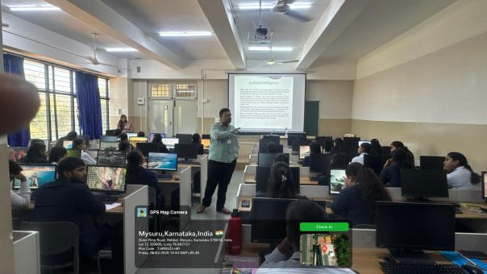  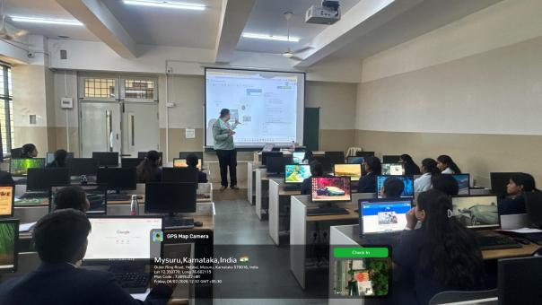 | Prof. Harshith. C Dept of CSE(AI&ML),delivered a Hands-on workshop on AIoT "Build Smart, Think AI" organised by IT Club - Deemahi of Sheshadripuram Degree College, Mysuru on 6th February 2026,  Session focused basics of IoT, AI and AIoT, Sensors and its types along with the practical exposure of AIoT using Tinkercad simulation tool and Arduino programming
 |  |  | 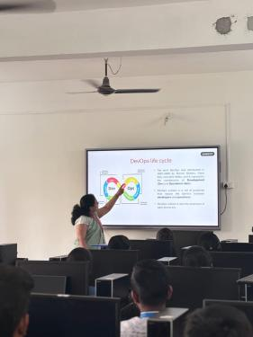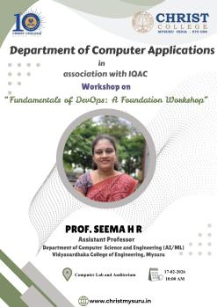 | Prof Seema H R oDept of CSE(AI&ML), delivered a Hands-on workshop on "fundamental of DevOps" organised by Christ College degree College,Mysuru in association with IQAC, on 17th February 2026, Tuesday.
 |  |  |  | Dr. Kruthika S G, Dept of CSE(AI&ML),published a research article titled "Semi-automatic approach utilizing Siamese Neural Network for forensic voice comparison" in *Franklin open journal- Elsevier indexed in* Scopus, *Q2*
 |  |  | 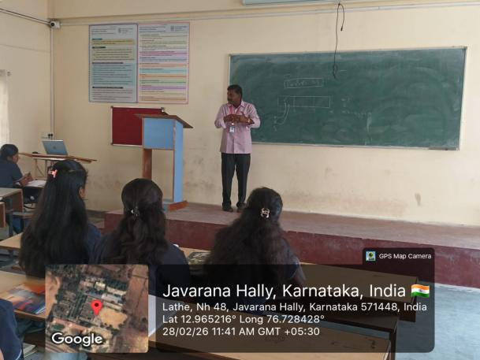  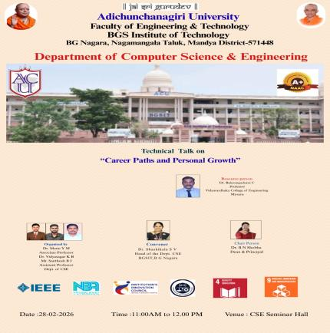 | Dr Balagangaduri , Dept of CSE(AI&ML),Delivered a technical talk on “Career Paths & Personal Growth” for 6th Semester CSE students at BGS Institute of Technology.
 | March 2026
 | Departmet Activity |  | 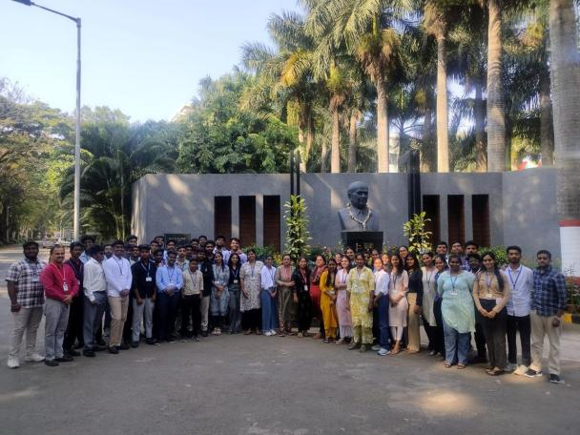 | Department of CSE(AI&ML) organized an exciting industry visit to ISRO’s U R Rao Satellite Centre (URSC) in Bengaluru on 5th March 2026. Students explored cutting-edge research facilities, delved into the fascinating world of space research, and gained hands-on insights into artificial satellite design and development. This immersive experience sparked curiosity and motivation, inspiring our future innovators to dream big in space technology.
 |  |  | 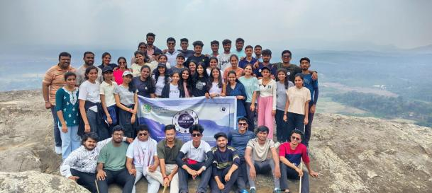 | The Department of CSE AI&ML in association with Yuvaa club had organised a trek to Kunda Betta on 1st March 2026, Sunday for the 6th semester students. 50 students were part of the trek.
 |  |  | 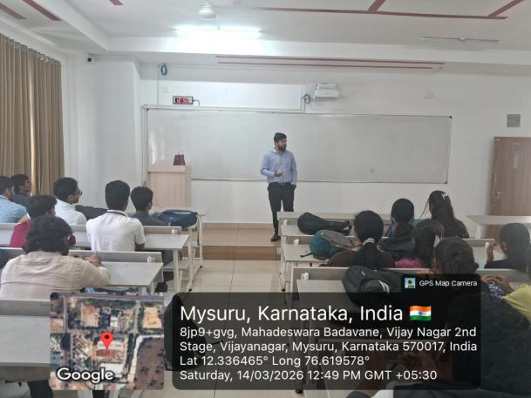 | Dept of CSE (AIML) organized an alumni interaction for 6th semester students by Mr. Abdul Kaif (2025 Batch), Associate Project Manager, Vymo Technologies, Bangalore, on 14-03-2026.
 |  |  | 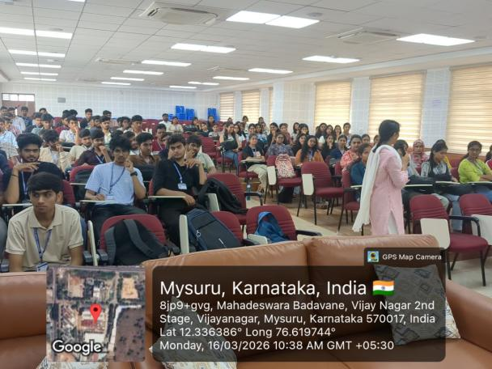 | Dept of CSE (AIML) organized a Technical talk on " Design & Analysis of Algorithms: Bridging Theory with Real-World Applications " for 4th semester students by Dr. Uma B, Professor, Dept. CSE, Malnad College of Engineering, Hassan on 16-03-2026
 |  |  | 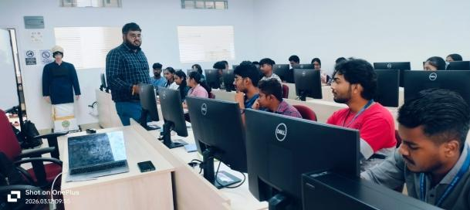  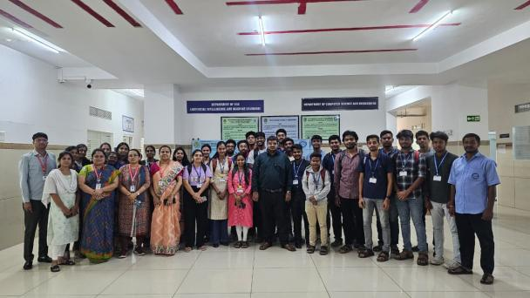 | Department of CSE (AI&ML) organised 5 days Bootcamp of AI career paths for 6th Semester students in association with Avinya Techknows from 12th to 17th of March 2026. Mr. Naveen , Data Engineer was the resource person.
 |  |  | 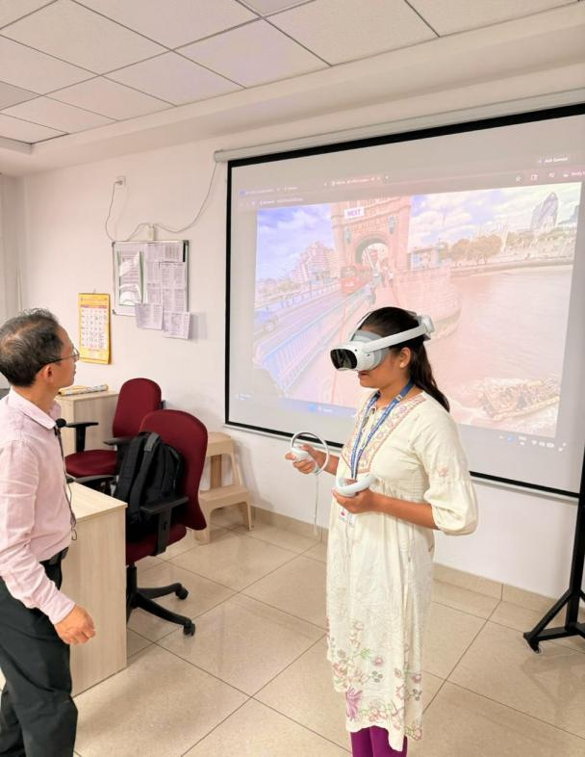 | Department of CSE(AI&ML) organized Skill Development program on XR Foundation,Robotics and AIoT for all students of 4th semester from 26/03/2026 to 28/03/2026. Resource persons were from EDSPIRE Technologies and Digitoad Technologies.The event was organised from Department Skill Labs.
 | Student Achivements |  | 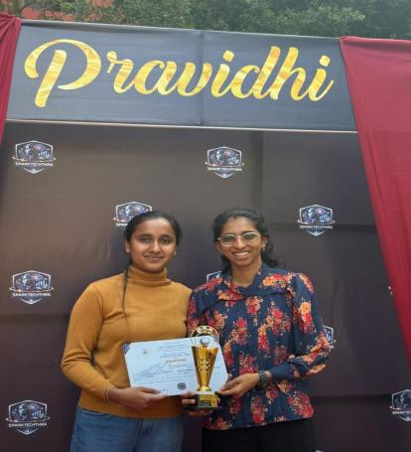  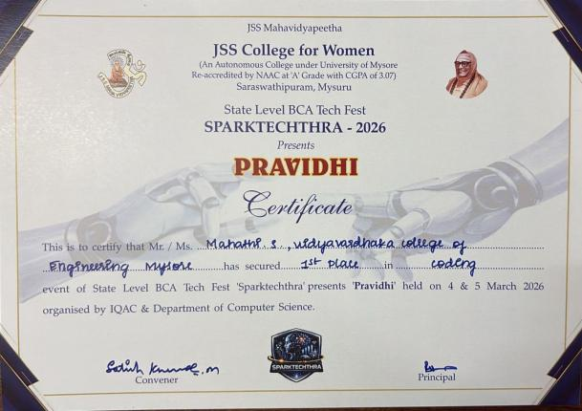 | Mahathi S,Nandana of 4th sem B section participated and won first place in coding event of BCA Tech fest ‘Sparktechthra-2026’ at JSS College of women, Mysuru.
 |  | 5th , 6th march | 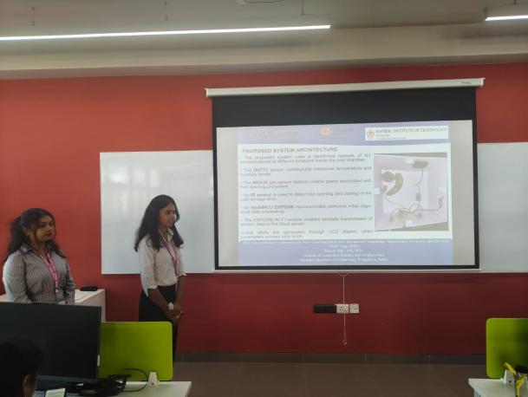 | Inchara and team presented their paper at the NQCOM 2026 International Conference @ Manipal Institute of Technology, Bengaluru.
 |  |  | 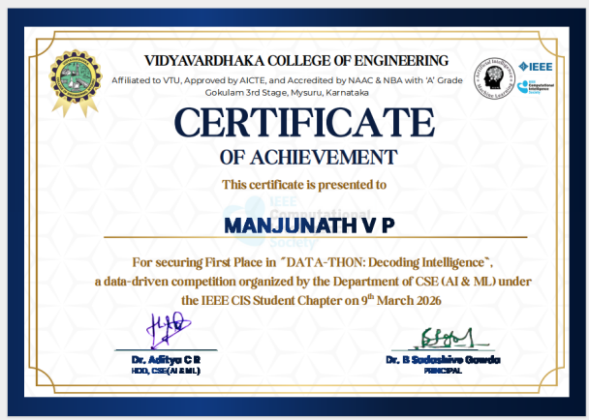 | Manjunath V P from 4th sem B section and team won first prize in ideathon organised by Dept of CSE(AI&ML) on 9th March 2026
 |  |  | 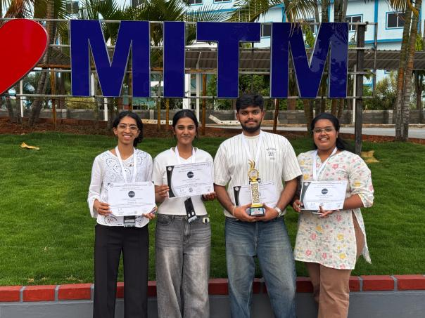  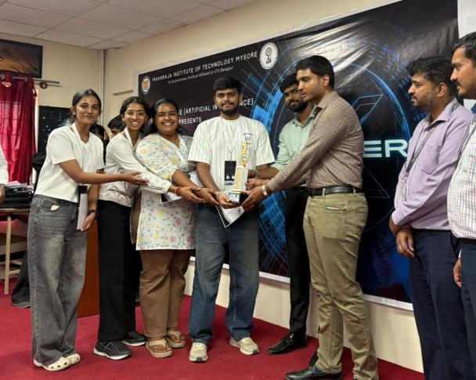 | Mahathi, Manish, Gowri Urs, won 2nd place and a cash prize of 10k at 2 days hackathon organised by  The Department of Computer Science & Engineering (AI),  Maharaja Institute of Technology, Mysore  💡 Theme: College Automation  🌐 Domains: Artificial Intelligence & Web Development  📅 Dates: March 27ᵗʰ & 28ᵗʰ, 2026 (Friday & Saturday
 | Faculty Achivement |  |  | Prof. Arpith M S , Published a Patent on “
 |  |  |  | Industry immersion # L&T Mysuru
Patent published:
Title of the invention : Convoy OS
Date of filing of Application :23/02/2026
Application No.202641020723 A
Publication Date : 06/03/2026
Name of Inventors:
1)Tanishq S Veernekar
2)Yashwanth N
3)Rohith G N
4)Kushal P
5)Harshith C
6)Vignesh T V
 |  |  |  | Dr Pramila R M attended IISc Arm Instruction Enhancement Program (IEP) on Edge AI at IISc Bangalore between March 16-20. 2026.
 |  |  | 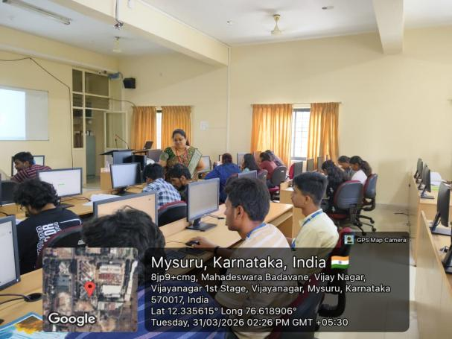  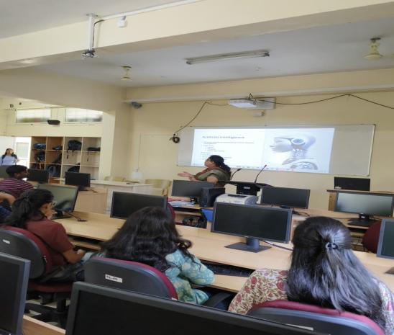 | Dr. Varshitha D N served as a resource person for conducting a workshop on Prompt Engineering on 31-03-2026, as part of Aavishkar Tech Conclave 2026, organized by the IUCEE Student Chapter of VVCE.
Patent published:
Title of the invention : DDOS
Date of filing of
Application :

Application No.
Publication Date :

Patent published:
Title of the invention : Sustainable lighting and Appliances control usin AI and IoT
Date of filing of Application :
Application No:202641020740
Publication Date : 06-03-2026
Name of Inventors:
Dr Varshith D N, Prof Latha D U, Prof Soumya G V, Mr M Chaithnya Kumar, Ms Sameeksha S

 | APRIL 2026
 | Department Activites | 7/4/2026 | 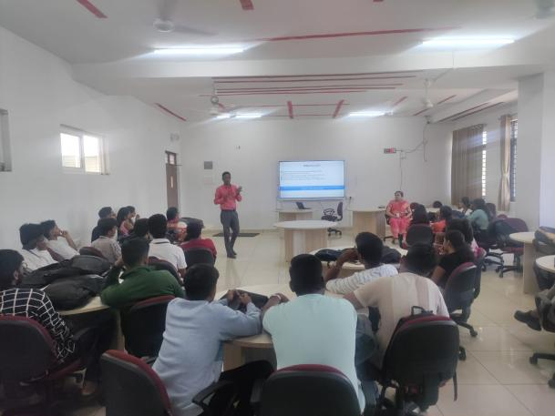 | The Department of CSE AIML organised a talk on "Skills for Research Paper Writing" for 6th semester students. Dr. Praveen Kumar, Assistant Professor, Dept. of Mechanical engineering was the resource person for the event.
 |  |  | 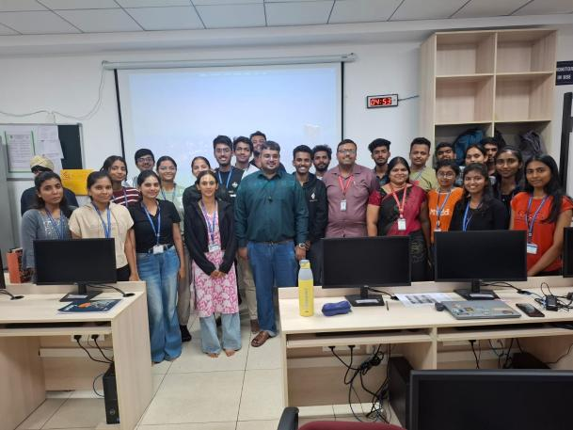  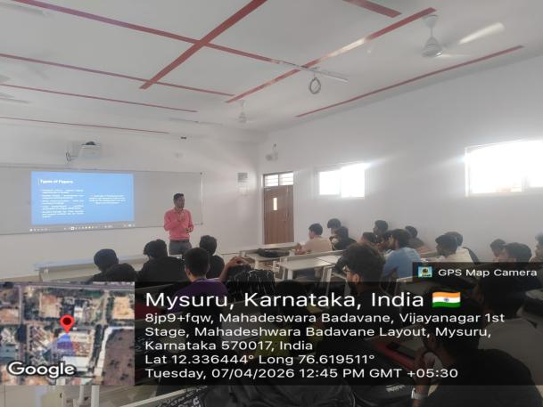 | The Department of CSE(AI&ML) conducted a Two-Day Workshop on “Cloud Computing and its applications” on 6th and 7th April 2026 for Sixth Semester students who opted for Cloud Computing as their professional elective. The workshop focused on both conceptual understanding and hands-on training, covering cloud infrastructure management, resource scheduling, and practical exposure to AWS, AZURE and Aneka - A Distributed Computing Platform. The workshop helped students to gain industry-relevant skills in cloud and distributed application development.
 |  |  | 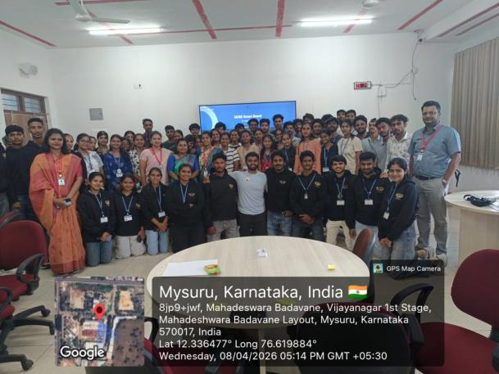 | The Department of CSE (AI & ML) successfully conducted a “One-Day Soft Skills” program for 4th semester students on 08/04/2026, organized by the ElevateU Club.  The program focused on enhancing students’ communication, teamwork, leadership, and problem-solving skills.  We extend our heartfelt thanks to our beloved HOD for his constant support and encouragement.🙏
 |  |  | 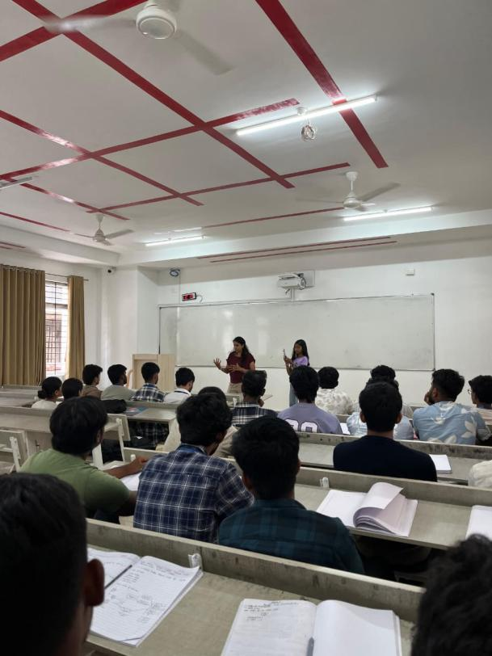 | Department of CSE (AI & ML) organized an Alumni Interaction session for 4th Semester ‘A’ Section students. The session was delivered by Ms. Apoorva (2011 batch), Senior Digital Engineer at Sonata, Bangalore, who shared valuable insights on industry expectations, essential skills, and effective placement preparation strategies.
 |  |  | 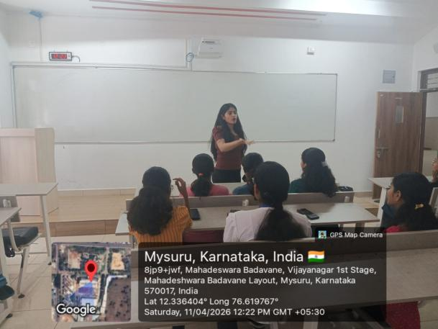 | Alumni Talk on Career Preparation and Placements – 11 April 2026  Department of CSE (AI & ML) organized an Alumni Interaction session for 4th Semester ‘B & C’ Section students. The session was delivered by Ms. Amulya (2022 batch), Software Quality Engineer at Infosys, Mysuru, who shared valuable insights on industry expectations, skill development, and effective strategies for placement preparation.
 |  |  | 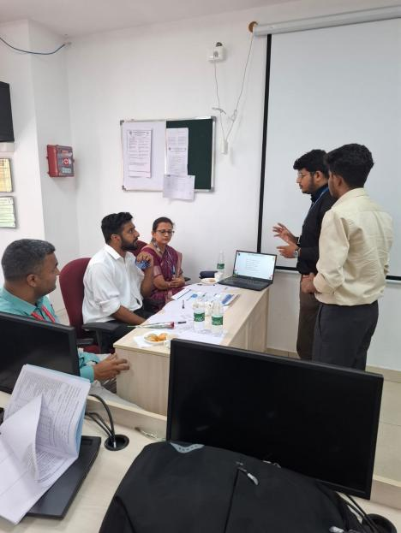 | The Department of CSE AI&ML organised the Vivacious 2026 project expo on 11th April 2026. The experts from industry Dr. Sumithra, Mr. Arjun L G, Mr. Shabari and Experts from academia Dr. Ramakrishna Hegde, Dr. S P Shivaprakash, Dr. R J Prathibha, Dr. Trishiladevi C Nagavi, Dr. Prashanth M V, Dr. Varshitha D N, Dr. Vijay C P, Dr. C Manjunath, Prof. Seema H R was part of the jury members to evaluate the projects. Projects were based on domains such as AI, ML, DL, IoT, Robotics, Audio processing and computer networks.
 |  |  | 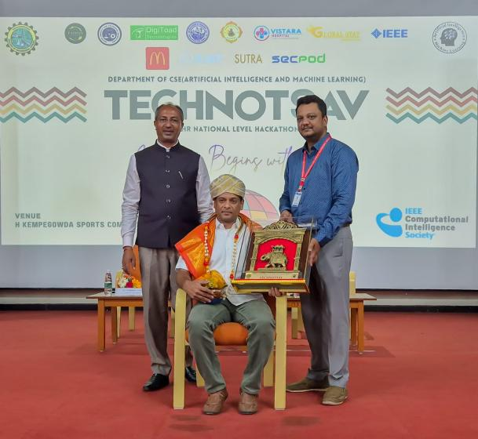  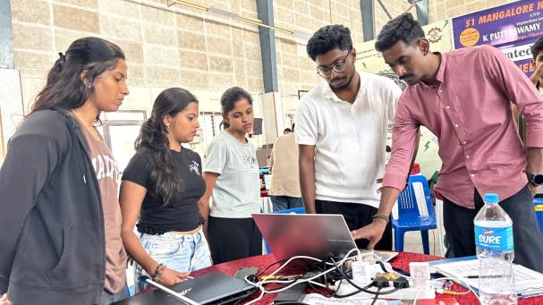 | The Department of CSE AIML in association with IEEE CIS Student chapter organised a Technotsav 2026, a national level 24 hours hackathon on 15th and 16th April 2026 having 50 teams from various colleges for Fintech, Cybersecurity, AIoT and Sustainability. Hackathon was inaugurated by Vishwanath Lakshmikanth, Director - Global Delivery, Incture. Mr. Rohith prajapati from Digitoad technologies, Mr. Thanga prakash from Secpod, Mr. Jaisimha from Envision Techsol, Mr. Bhuvan S Biradar from Artsy Technologies were the Jury members of the event. Winners from Sustainability, Fintech, Sustainability have internships offered by Digitoad, Artsy Technologies and Envision Techsol respectively.
 |  |  | 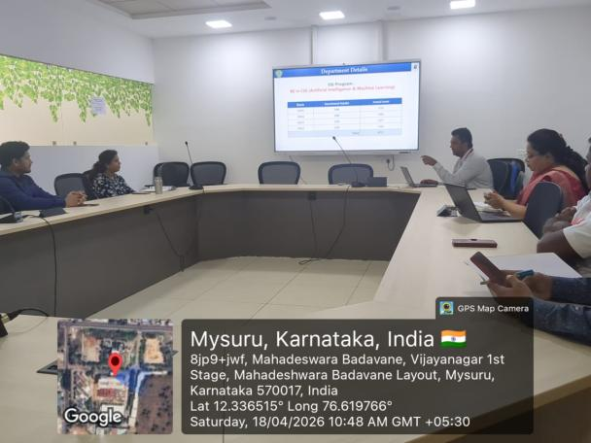 | The Department of CSE (AI&ML) conducted an IAB meeting on 18 April 2026. During the meeting, the Head of the Department, Dr. Aditya C. R., presented an overview of the department and the curriculum planned for the next academic year. Industry experts were invited to participate in the IAB meeting, and their feedback regarding the curriculum, skill development activities, training, and placement opportunities was collected.
 |  |  | 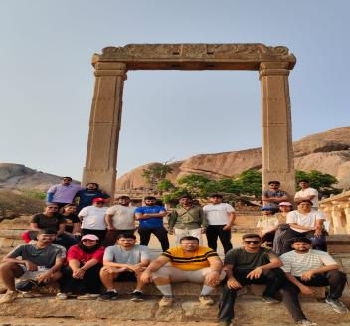  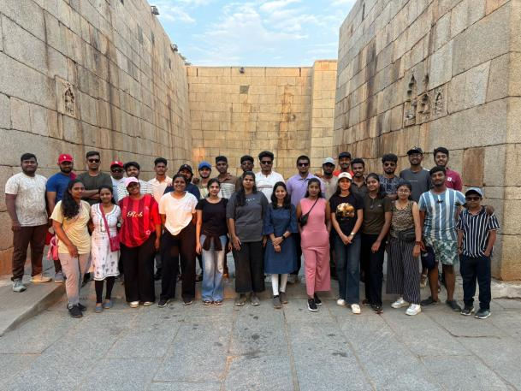 | The Department of CSE AI&ML organised a Field visit as part of the Indian Knowledge System course on 19th and 20th April 2026. 35 students were part of the visit. Chandravalli Thota, Vani Vilasa Dam, Ingadal windmill and Chitradurga Fort were part of the visit.
 |  |  | 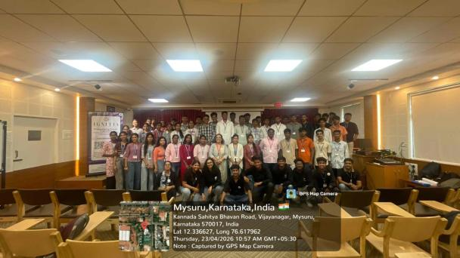 | The Department of CSE (AI & ML) proudly inaugurated the student club Ignitia—Igniting Potential on 23.04.2026, graced by our esteemed Principal, Dr. B. Sadashive Gowda, and Department Head, Dr. Aditya C. R. The day-long celebration kicked off with inspiring speeches that highlighted the club’s mission to nurture innovation, technical prowess, and leadership among students. A series of engaging events followed, meticulously designed to evaluate participants’ technical skills, attitude, and knowledge. The event concluded with prize distribution, where top performers were honored with cash prizes, certificates, and recognition.
 |  |  | 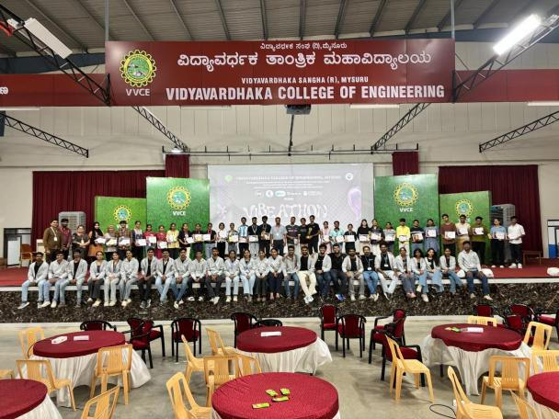  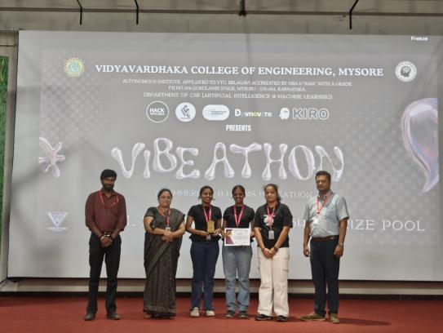 | Dept. of CSE(AI&ML) in association with vectorflow organised 8 hours hackathon - Vibeathon on 27th April 2026. 50 shortlisted teams from various reputed colleges of Karnataka participated in the Event. The companies like Devnovate, Kiro and Figma were also associated. The winners were rewarded with cash prizes and Kiro credits.
 |  |  | 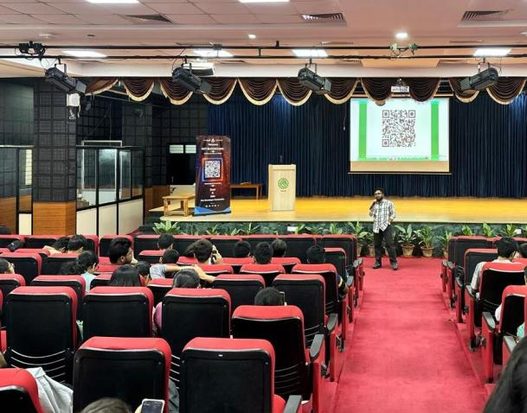  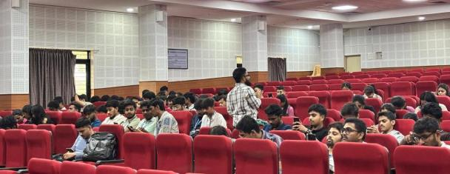 | The VectorFlow Club of the Department of CSE (AI & ML) organized a workshop on “Blockchain Technology” on 28th April 2026. The session was conducted by Mr. Vineet from Agent Clan and Ms. Mrinalini K from MST Blockchain.The workshop aimed to introduce students to the fundamentals and applications of blockchain technology. Around 200 participants from various branches of VVCE attended the event. Additionally, 50 quiz winners were awarded goodies.
 | Student Achivements |  |  | Himanvitha T N of 4th A has secured 5th place in "build with AI" event of Internattional Tech fest InnovateX-4.0 hosted at presidency univeristy Banglore.
 |  |  |  | Surabhi Sripadrao, Vaishnavi and Samay preetham of 8th Sem CSE (AI&ML) presented a paper entitled "Smart Autism screening: Early detection of ASD in children using CNN" at IEEE conference TQCBET 2026 hosted by Christ University, Pune on 10th April 2026
 |  |  |  | Sameeksha S and Chaitanya M of 8th sem CSE(AI&ML) presented a paper entitled "SmartLumina: Sustainable Lighting and appliance control using AI and IOT at IEEE conference named ECMI 2027 hosted by AIT chikmagalore on 10th April 2026 , which will be indexed in scopus.
 |  |  |  | Harshika Darda, Farheen Khan and Chirag V, 8th Sem CSE (AI & ML) students presented a paper entitled "A Systematic and Critical Survey on Forensic Face Sketch Construction and Recognition" at IEEE conference TQCBET 2026 hosted by Christ University, Pune on 10th April 2026.
 |  |  |  | Dr. Sonali Nandish Manoli, Uthkarsh Gowda, Yashwanth N, Tanishq S Vernekar and Rohith GN presented a paper titled "ALIGN: A Real-Time Biomechanical Feedback System Using Computer Vision and Ergonomic Risk Assessment" at the TQCEBT IEEE Conference at Christ University Lavasa Campus, on 11th April 2026.
 |  |  |  | Prof.Nidhishree G, Ms. Manvitha Jayanth, Ms Kusumitha H U, presented a paper Titled "A Privacy-Preserving and Explainable Clinical Decision Support System for Multi Disease Detection using Federated Learning Simulation", was presented at TQCEBT IEEE Conference , Christ University Pune Lavasa Campus on 10th April 2026.
 |  |  |  | Nagendra B S and Mahathi from 4th Semester B section participated in IIC Idea generation competition and won 1st prize entitled as "FaceFetch" which is a smart search engine for event photos, instead of making people scroll through thousands of pictures in a shared Google Drive link to find themselves, it uses AI to do the hunting for them.
 | Faculty Achivements |  |  | Dr Pramila R M delivered an expert lecture on Conversational AI: The Role of NLP in smart systems at Central Institute of Indian Languagues organized by National Testing service India on 1st April 2026.
rticle DOI: 10.3389/fdgth.2026.1703634

Published a paper in Q1 Journal: Frontiers in Digital Health
Authors: Harshith V, Bhargavram Athray, Likitha T Murthy, Samyutha Joshi, VVCE, Mysuru.
 |  |  |  | Dr.Varshitha D N and Prof.Latha D U presented a paper entitled " Pic2Prep: Image Driven Recipe Synthesis with CNN- transformer fusion" at IEEE conference ECMI 2026 hosted by AIT, Chikmagalore on 10th April 2026
 |  |  |  | Harshith C , Harshith V and Vignesh T V from Department of CSE (AI&ML) presented a paper entitled "Secured Authentication Contract Communication for IoT Environment" at IEEE conference TQCBET 2026 hosted by Christ University, Pune on 9th April 2026
 |  |  |  | Prof.Latha D U, Dr.Varshitha D N and Neha C S presented a paper entitled "Acoustic Intelligence: A Machine Learning Framework for Gender Classification from Voice Signals" at IEEE conference ECMI 2026 hosted by AIT, Chikmagaluru on 10th April 2026
 |  |  |  | Prof. Vignesh T V from Department of CSE (AI&ML) presented a paper entitled "AI-Powered Precision Agriculture Platform with Blockchain Traceability and Real-Time Collaboration for Sustainable Farming" at IEEE conference TQCBET 2026 hosted by Christ University, Pune on 9th April 2026.
 |  |  |  | Dr. Sonali Nandish Manoli, Sujan Shekhar, Vansh N, Vibodh Ramesh and Vinochan S. presented a paper Titled "EduRecap: A Multimodal AI framework for Lecture Transcription, Summarization, Visualization and Interactive Learning", was presented at TQCEBT IEEE Conference , Christ University Pune Lavasa Campus on 11th April 2026.
 |  |  |  | Dr. Aditya C R visited Sharnbasva University, Kalburgi, as an examiner for PhD Defence on 11/04/2026
 |  |  | 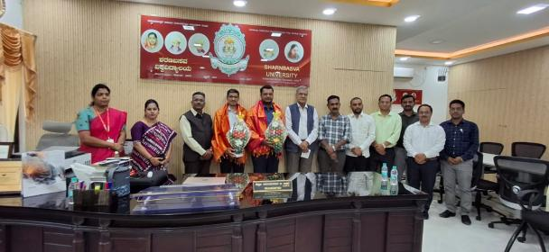  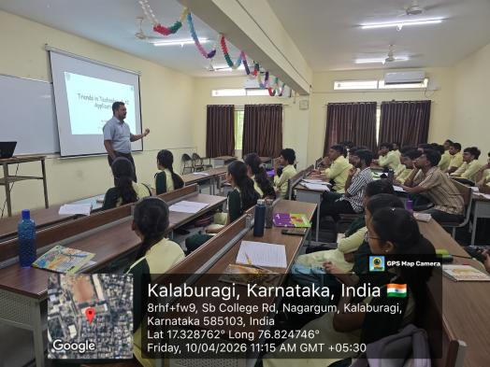 | Dr. Aditya C R delivered an expert talk to students of dept of CSE, Sharnbasva university on 10/04/2026
 |  |  |  | Prof. Latha D U, Dept. Of CSE(AIML) got the design patent granted VVCE
 |  |  |  | Dr Pramila R M participated as session chair in the Third International IEEE conference on Trends in Quantum Computing and Emerging Business Technologies - TQCEBT'26 organized by CHRIST(Deemed to be university), Pune Lavasa Campus. from 9th to 11th April 2026.
 |  |  | 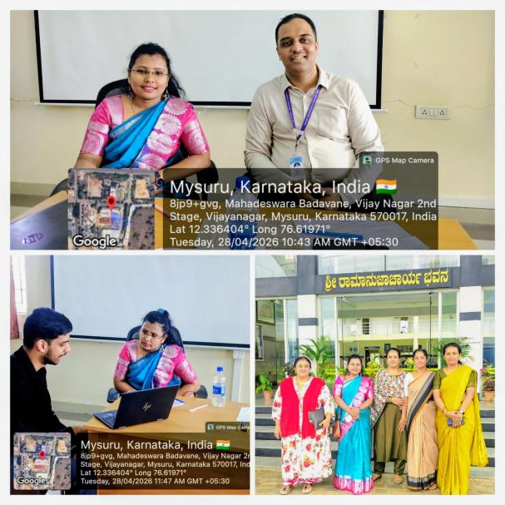 | Dr. Kruthika S.G. served as an External Internship Evaluator for B.E. undergraduate students at the Department of Information Science and Engineering (ISE), The National Institute of Engineering, Mysore.
 | MAY 2026
 | Deparment Activity |  | 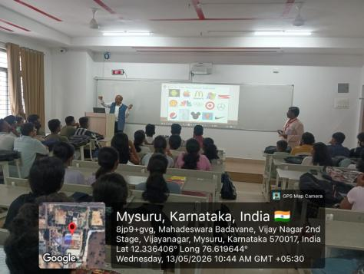  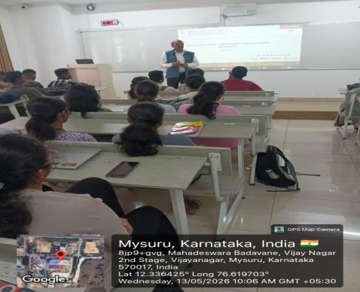 | The Department of CSE (AI & ML) organized a technical talk on “Patents & IPR” for VI Semester students by Dr. G. B. K. Dean R & D held on 13. 05.26.
 |  |  | 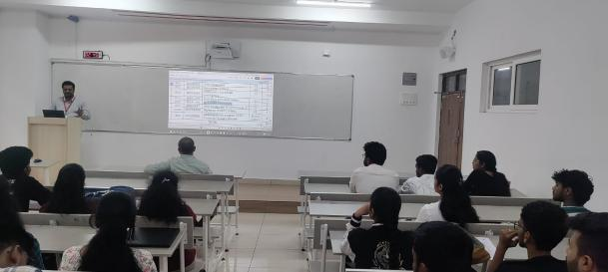  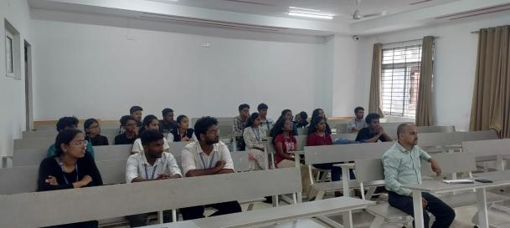 | The Department of CSE AI&ML organized a Student Conclave on 15th May 2026, Friday to discuss the Syllabus and curriculum, Teaching and learning methodology, Training and Placements, Research development, industry collaborations and Mini/Major Project.
 |  |  | 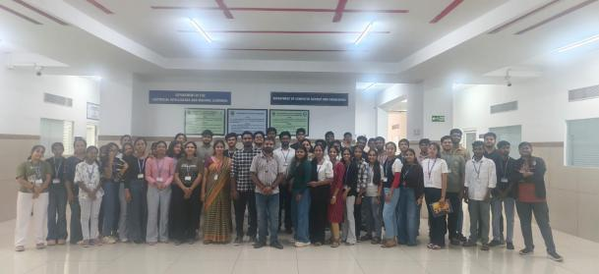  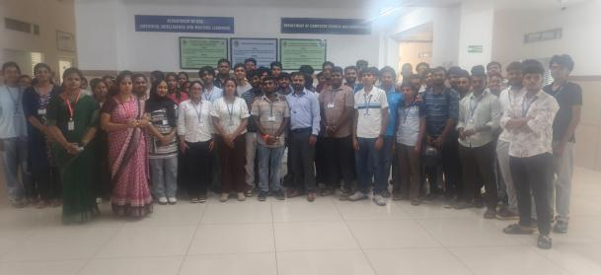 | The Department of CSE (AI & ML) organized a DBMS Workshop for 4th Semester AI & ML students from 13th to 15th May 2026. The workshop was conducted by Mr. Sunil Kumar N, Senior Solution Architect at Alstom, with a focus on developing front-end interfaces and integrating them with back-end databases. The sessions provided students with practical exposure to user interface development, database connectivity, data handling, and real-time web application development.
 |  |  | 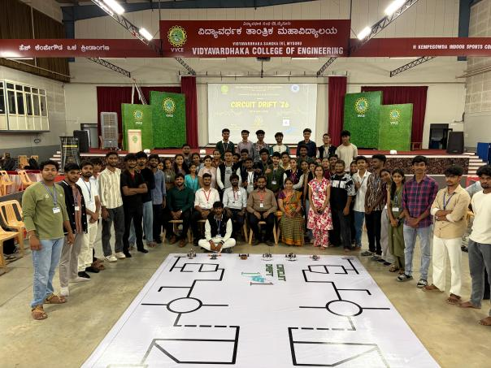  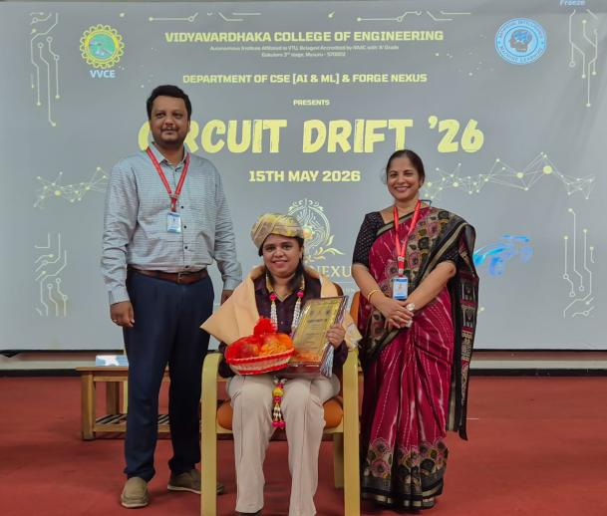 | The Department of CSE (AI & ML), in association with the Forgenexus Club, successfully organized “Circuit Drift 2026”, an intercollege autonomous line-following robot competition on 15-05-2026, with participation from around 20 colleges across the state.  Ms. Punitha, System Software Engineer at Cisco was the Chief Guest. The event was inaugurated by Dr. Shobha Shankar, Vice Principal and Dr. Aditya C.R., HoD, CSE (AI & ML).  Winners:  * 1st Place – Team Loosescrew, VVCE Mysuru  * 2nd Place – Team Navigation, PES Mandya  * 3rd Place – Team Ecephillic, KLE Hubli
 | Students Achivements |  |  | https://ieeexplore.ieee.org/document/11497677/ : Our students published paper in IEEE explore under my guidance. Thank you.
Amogha Y A of CSE(AI&ML) has been granted with IndiaAI Fellowship of 2 Lakh

Project : Domain Generalization For Mitosis Detection
Guide : Dr. Aditya C R
 |  |  | 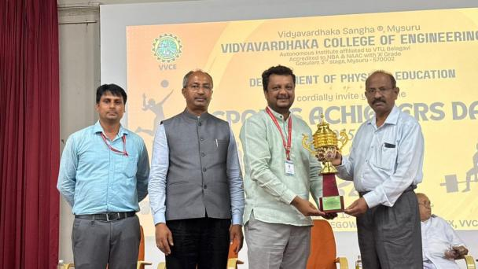  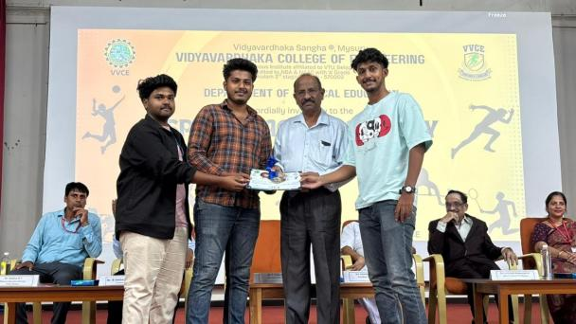 | The Department of CSE AI&ML has secured OVERALL CHAMPIONSHIP - WINNERS in the Inter Department sports competitions organised by the Sportination club.
 | Faculty Achivements |  |  | Latha D U and Dr Varshitha D N published an article in Springer Nature titled “Hybrid Framework for Epileptic Seizure Detection Using Wavelets and ML Classifiers” | Springer Nature Link https://share.google/V85FZSUvf3giOviPe
 |  |  |  | Dr.Varshitha D N and Prof.Latha D U published an article in Q3 scopus indexed journal https://arccjournals.com/journal/asian-journal-of-dairy-and-food-research/DR-2451
 | JUNE 2026
 | Department  Activities |  |  | Forge Nexus Club, Department of CSE (AI & ML), VVCE, organized an educational and industrial exposure visit to IIT Madras Research Park, Chennai, on 15th June 2026. A total of 20 students and 2 faculty members participated in the visit. The visit provided an opportunity to explore research facilities, startup incubators, and innovation ecosystems while gaining insights into emerging technologies, entrepreneurship, and industry-driven research
Student
Achivements
 | Faculty  Achivements |  |  | Dr Balarengadurai C, published a paper in Q1 journal & indexed in Scopus on " An explainable signature detection in bank cheques using IoU-Aware YOLOv8 with Bidirectional Feature Pyramids (OYO-BiFPN) and OCR-guided filtering
 | JULY 2026
 | Department  Activities |  | 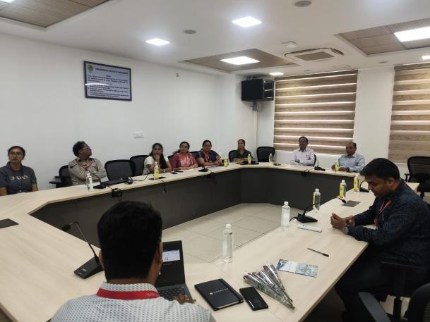  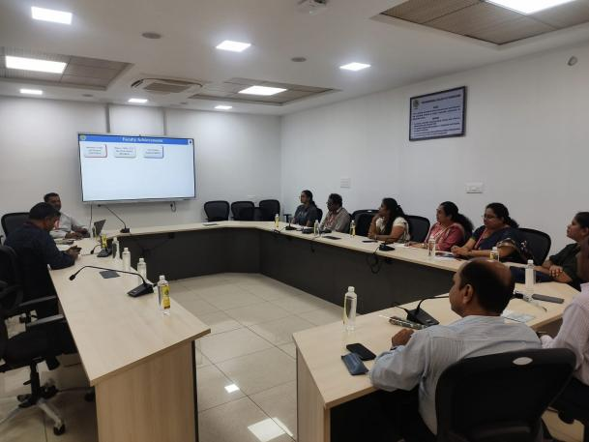 | The Department of CSE(AI&ML) successfully conducted the 7th BoS meeting.Members from academia,Industry and alumni representatives present during the meeting and they gave valuable suggestions to improve the syllabus.
Student
Achivements
 | Faculty  Achivements |  |  | Dr. Pramila R. M. served as the Resource Person for a technical session on "Natural Language Processing (NLP) using Python" conducted on 13th and 14th July 2026 for the Second Semester M.Tech. students of the Department of Computer Science and Engineering at Vidyavardhaka College of Engineering, Mysuru.

