

Project Report

“UrbanVista”
A Geolocation and Data Visualization Web Application

Submitted by:
Group No.: 10
Name | Enrollment-Number
Chirayu Darji | 23004500210046
Rahul Parmar | 23004500210164
Mihir Parmar | 23004500210162

Guided by:
Prof. Urvika Soni
Internal Project Guide

Submitted to:
LJ Institute of Computer Applications
LJ University, Ahmedabad
Semester 5 – M.Sc. (Information Technology) (Integrated)
Academic Year: 2025

Near Sanand Cross Road,
Sarkhej-Gandhinagar Highway, Ahmedabad – 382210
Ph. No.: 9099063417

Near Sanand Cross Road,
Sarkhej-Gandhinagar Highway Ahmedabad - 382210
Ph. No.: 9099063417

CERTIFICATE

Enrollment Number: 23004500210046

This is to certify that Mr. Chirayu Darji of Master of Science in Information Technology (Integrated), Semester V, Roll No (C)10 has satisfactorily completed his/her Project titled Urban Vista in under the supervision of Prof. Urvika Soni.

Internal Guide: HOD:
Prof. Urvika Soni Dr. Jignesh Doshi

Date of Submission:


Near Sanand Cross Road,
Sarkhej Gandhinagar Highway Ahmedabad - 382210
Ph. No.: 9099063417

CERTIFICATE

Enrollment Number: 23004500210164

This is to certify that Mr. Rahul Parmar of Master of Science in Information Technology (Integrated), Semester V, Roll No (C)56 has satisfactorily completed his Project titled Urban Vista in under the supervision of Prof. Urvika Soni.

Internal Guide: HOD:
Prof. Urvika Soni Dr. Jignesh Doshi

Date of Submission:

Near Sanand Cross Road,
Sarkhej Gandhinagar Highway Ahmedabad - 382210
Ph. No.: 9099063417

CERTIFICATE

Enrollment Number: 23004500210162

This is to certify that Mr. Mihir Parmar of Master of Science in Information Technology (Integrated), Semester V, Roll No (C)29 has satisfactorily completed his/her Project titled Urban Vista in under the supervision of Prof. Urvika Soni.

Internal Guide: HOD:
Prof. Urvika Soni Dr. Jignesh Doshi

Date of Submission:


PLAGIARISM DECLARATION

To whomsoever it may concern

I/We, the project team, confirm that this assignment is my/our own work, and is not copied from anywhere, and has not previously submitted for assessment either at university or somewhere else. I/We confirm that I/We have read and understood the rules and regulations on plagiarism in GTU.

Date:



Acknowledgement
I would like to take this opportunity to express my sincere gratitude and appreciation to all those who have supported me in the successful completion of my Semester-5 project.
First and foremost, I extend my heartfelt thanks to Dr. Jignesh Doshi, Head of the Department, M.Sc. (Information Technology), LJ School of Computer Applications, LJ University, for his continuous encouragement, expert guidance, and invaluable support throughout the duration of this project.
I am extremely thankful to my internal guide, Mrs. Urvika Soni, for providing insightful feedback, motivation, and guidance at every stage of the project. I would also like to acknowledge the contribution of my external guide, Mr./Ms. [External Guide Name], whose expertise and suggestions greatly enhanced the quality of my work.
I sincerely appreciate the efforts of all the faculty members and lab instructors who provided assistance and support whenever needed. Lastly, I am deeply grateful to my family and friends for their constant motivation, encouragement, and support throughout the project journey.

Enrolment No(s): 23004500210046, 23004500210162, 23004500210164
Name(s) & Signature(s): Chirayu Darji, Mihir Parmar, Rahul Parmar
Semester: V
Project Title: Urban Vista



Components



INDEX

Sr. No. | Table of Contents | Page No.
1. | Introduction
1.1 | Existing System
1.2 | Need for the New System
1.3 | Objective of the Proposed System
1.4 | Problem Definition
1.5 | Scope of the Project and Core Components
1.6 | Project Profile
1.7 | Assumptions and Constraints
1.8 | Advantages and Limitations
1.9 | Proposed Timeline Chart
2. | Requirement Analysis
2.1 | Requirement Determination
2.2 | Targeted Users
2.3 | Functional Requirements
2.4 | Non-Functional Requirements
3. | System Design
3.1 | System Architecture Diagram
3.2 | Use Case Diagram
3.3 | Class Diagram
3.4 | Sequence Diagram
3.5 | Activity Diagram
3.6 | ER Diagram / Data Dictionary
3.7 | Interaction Diagram
3.8 | User Interface Design
4. | Development
4.1 | Appropriate Naming Conventions
4.2 | Use of Proper Comments
4.3 | Implementation of Business Logic
4.4 | Separation of Business Logic and Page View
4.5 | Navigation Flow (Across Pages)
4.6 | Server-Side Validations
4.7 | Client-Side Validations
4.8 | Tools and Technologies Used
5. | Agile Documentation
5.1 | Project Charter
5.2 | Agile Roadmap / Schedule
5.3 | Agile Project Plan
5.4 | User Stories
5.5 | Release Plan
5.6 | Sprint Backlog
5.7 | Test Plan
5.8 | Earned Value and Burn-Down Charts
6. | Testing
6.1 | Testing Methodology
6.2 | Test Cases
6.3 | Test Results and Analysis
7. | Proposed Enhancements
8. | Conclusion
9. | Project Learnings
10. | Bibliography / References
11. | Appendices  (If any – screenshots, reports, etc.)

1. Introduction
In the era of rapid digital transformation, the need for real-time geolocation data has become essential for urban planning, navigation, and community engagement. Existing mapping and discovery systems primarily rely on static datasets, leading to outdated or inaccurate information.
Urban Vista is a web-based platform developed to address these challenges by creating a community-driven geolocation and data visualization system. It enables users, businesses, and civic authorities to contribute, validate, and access up-to-date geographic data through an interactive and intuitive interface.
Developed using Django, Urban Vista combines user-generated content, data analytics, and location intelligence to deliver meaningful insights for all stakeholders. The system is designed to be secure, scalable, and responsive, ensuring accessibility across all devices while maintaining high performance and reliability.

1.1 Existing System
Current geolocation and mapping systems such as Google Maps or OpenStreetMap provide general navigation and location services but suffer from several limitations:
- Dependence on static or delayed data updates
- Limited community contribution mechanisms
- Lack of contextual information such as photos or user feedback
- Minimal analytical insights for civic or business applications
- Restricted moderation and validation control
Due to these drawbacks, users, businesses, and government authorities often face difficulties in obtaining accurate and timely ground-level data.

1.2 Need for the New System
The growing demand for real-time, community-verified geographic information necessitates the development of a platform that:
- Allows instant updates and data sharing by users in the field
- Encourages community engagement for validation and accuracy
- Offers contextual and visual data (images, tags, descriptions)
- Provides analytics and dashboards for better decision-making
- Supports secure and role-based data management
Urban Vista fulfils these requirements by introducing a crowdsourced geolocation ecosystem that empowers contributors while maintaining data integrity and transparency.

1.3 Objective of the Proposed System
The primary objective of Urban Vista is to design and develop an intelligent, user-friendly, and scalable platform for real-time geolocation data contribution and visualization.
Specific objectives include:
- To provide a unified system for uploading, validating, and discovering location-based data.
- To offer advanced search, filter, and categorization tools for efficient information retrieval.
- To integrate role-based authentication ensuring secure data operations.
- To implement analytics dashboards for monitoring usage and contribution patterns.
- To develop a responsive web interface accessible across devices.

1.4 Problem Definition
Despite the availability of various mapping tools, there exists a gap between user-generated real-time data and institutional geolocation systems.
Challenges identified:
- For Users: Inability to share accurate and verified location data in real time.
- For Businesses: Difficulty in tracking local developments or emerging opportunities.
- For Civic Bodies: Limited ground-level visibility for planning and maintenance tasks.
- For Travelers: Lack of contextual information such as local updates, conditions, or visuals.
Urban Vista addresses these issues by enabling users to contribute authentic, validated geolocation data while ensuring data quality and accessibility through robust moderation workflows.

1.5 Scope of the Project and Core Components

Scope:
Urban Vista encompasses the development of a complete web-based platform that integrates:
- User registration, authentication, and profile management
- Geolocation-based photo and data upload system
- Search and discovery module for exploring local information
- Administrative dashboard for content moderation and analytics
- Data visualization and reporting tools for decision support
- Secure and responsive user interface

Core Components:
- User Management System – Registration, authentication, role-based access, and profile control.
- Geolocation Data Module – Upload, categorize, and tag photos or data with coordinates.
- Content Discovery System – Search, filters, and featured highlights for locations.
- Analytics Dashboard – Data trends, contribution tracking, and performance insights.
- Admin Panel – Moderation, approval workflows, and system configuration.
- Security & Privacy Module – Data encryption, validation, and access control.

Attribute | Details
Project Name | UrbanVista
Type | Web Application
Domain | Geolocation, Data Visualization, Smart City Management
Backend | Django 5.2.5 (Python 3.11+)
Frontend | HTML5, CSS3, Bootstrap 5, JavaScript
Database | SQLite
Image Handling | Pillow Library
Target Users | Community Contributors, Travelers, Businesses, and Civic Authorities
Development Approach | Modular Django Architecture with separated apps for accounts, contributions, and geolocation modules

1.6 Project Profile

1.7 Assumptions and Constraints

Assumptions:
- Users have basic familiarity with web applications and navigation systems.
- Contributors provide accurate and authentic data.
- Devices used have GPS and internet connectivity.
- Users complete OTP/email verification during registration.

Constraints:
- Image size limited to 5MB per upload.
- Supported formats: JPG, PNG.
- Manual moderation required before data publishing.
- Dependent on stable internet connectivity.
- Limited server resources during peak usage.

1.8 Advantages and Limitations

Advantages:
- Real-time, community-driven data updates.
- Enhanced accuracy through user validation.
- Intuitive and mobile-friendly design.
- Analytical dashboard for insight generation.
- Secure role-based data management.
- Supports multiple user categories (citizen, business, admin).

Limitations:
- No offline access in initial version.
- Mobile app under development.
- Limited third-party API integrations.
- Manual moderation may delay approval times.

1.9 Proposed Timeline Chart

Phase | Description | Duration | Status
Phase 1 | Planning & Design – Requirements gathering, UI mockups | 2 weeks | Completed
Phase 2 | Core Development – Authentication & user management | 3 weeks | Completed
Phase 3 | Feature Implementation – Search, analytics, dashboards | 4 weeks | Completed
Phase 4 | UI/UX Development – Responsive design implementation | 3 weeks | Completed
Phase 5 | Testing & Optimization – Validation, performance testing | 2 weeks | Completed
Phase 6 | Deployment – Server setup, migration, hosting | 1 week | Completed
Phase 7 | Future Enhancements – API, mobile app, monetization | 2 weeks | Completed

***

2. Requirement Analysis
The Requirement Analysis phase is a critical stage of the Urban Vista project, aimed at identifying, documenting, and validating the system’s functional and non-functional needs. This phase ensures that the developed system aligns with user expectations, organizational goals, and technical feasibility.
By systematically analysing user needs, Urban Vista establishes a foundation for effective design, modular development, and future scalability. The analysis was conducted through research, observation of existing systems, and brainstorming sessions among project members and mentors.

2.1 Requirement Determination
The requirements of Urban Vista were determined by closely studying the challenges faced by users, businesses, and civic bodies in accessing real-time, accurate location data. The process involved:
- Observation of Existing Systems:
  - Analysis of current mapping and data-sharing platforms to identify their shortcomings in user engagement and data freshness.
- User Feedback and Hypothetical Scenarios:
  - Considering use cases where users need to upload location-based photos or access updated geographic information.
- Consultation with Domain Experts and Guide:
  - Guidance from mentors and faculty on system design, feasibility, and user expectations.
- Defining System Goals:
  - Focusing on ease of data contribution, intuitive discovery, and secure information management.
The gathered requirements were refined into clear functional and non-functional specifications to guide the project’s development.

2.2 Targeted Users
Urban Vista is designed to serve multiple categories of users, each with distinct objectives and interactions within the system.

1. Community Contributors (General Users):
- Upload real-time geolocation data with images, descriptions, and tags.
- Validate and provide feedback on other users’ contributions.
- Manage their own profiles and view contribution history.

2. Businesses & Travelers:
- Discover real-time updates, locations, and events in specific areas.
- Filter data by category, time, or region for decision-making and navigation.
- Access local insights and community-verified information.

3. Civic & Administrative Users:
- Monitor contributions related to civic issues, public infrastructure, or facilities.
- Validate and moderate community-submitted data.
- Use analytics dashboards for planning and analysis.

4. System Administrator:
- Manage users, roles, and access permissions.
- Approve, reject, or edit contributions.
- Oversee database integrity, security, and system configuration.

2.3 Functional Requirements
Functional requirements define what the system should do and outline the key features and functionalities implemented within Urban Vista.

User Management
- Users can register, log in, and log out securely.
- Users must verify their accounts using OTP/email verification.
- Admins can manage user roles (User/Admin) and reset credentials.

Geolocation Data Management
- Users can upload photos and data tagged with latitude, longitude, and descriptions.
- Each contribution passes through a moderation process before publishing.
- Users can edit or delete their own contributions.

Search and Discovery
- Users can search for locations, keywords, or categories.
- Advanced filters allow sorting by location, time, or category.
- The system displays search results with contextual details and photos.

Content Moderation
- Admin can review submitted content and approve/reject based on accuracy.
- Suspicious or duplicate entries can be flagged for review.

Analytics and Dashboard
- The system generates analytical reports on user activity and data trends.
- Civic and business users can view area-wise statistics for decision-making.

Security and Privacy
- Passwords are encrypted using Django’s authentication system.
- Access is role-based and permissions are strictly enforced.
- Data uploads are restricted to safe file formats and size limits.

Notifications and Updates
- The system provides feedback on status changes (approved/rejected).
- Optional notifications for updates, new entries, or system announcements.

2.4 Non-Functional Requirements
Non-functional requirements define how the system performs rather than what it does. These ensure reliability, performance, and user satisfaction.

1. Performance Requirements
- The system must handle at least 100 concurrent users efficiently.
- Page load time should not exceed 3 seconds on standard internet speeds.
- Database queries must be optimized to ensure fast retrieval.

2. Security Requirements
- All user data must be stored securely with encryption.
- Access control is enforced using role-based permissions.
- Input validation and CSRF protection must prevent malicious attacks.

3. Usability Requirements
- The system should have an intuitive and easy-to-navigate interface.
- Consistent design with visual feedback for user actions.
- Support for both desktop and mobile browsers.

4. Scalability Requirements
- The system should support future modules like API integration and mobile apps.
- Database structure designed for horizontal scalability.
- Cloud hosting to ensure flexible resource management.

5. Reliability and Availability
- The system should maintain 99% uptime during normal operation.
- Automatic error logging and recovery mechanisms must be implemented.
- Data backups should occur periodically to prevent loss.

6. Maintainability and Extensibility
- Codebase must follow Django’s modular architecture for easy updates.
- Proper documentation and comments must be maintained.
- The system should allow integration with external data sources (APIs, maps).

***

3. System Design
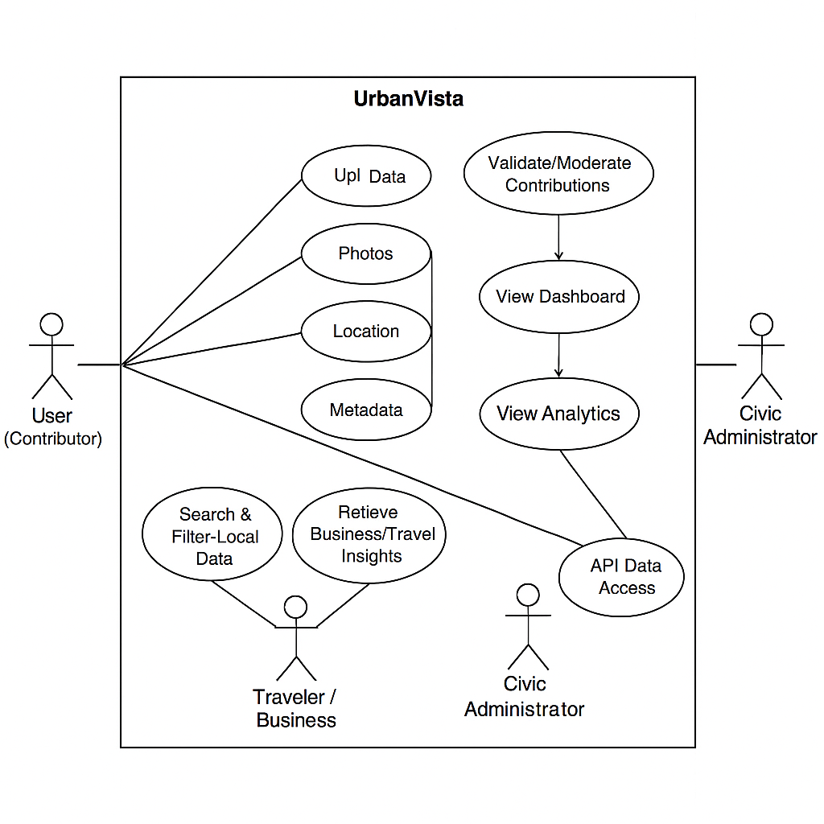

3.1 Use Case Diagram:

  - Class Diagram:

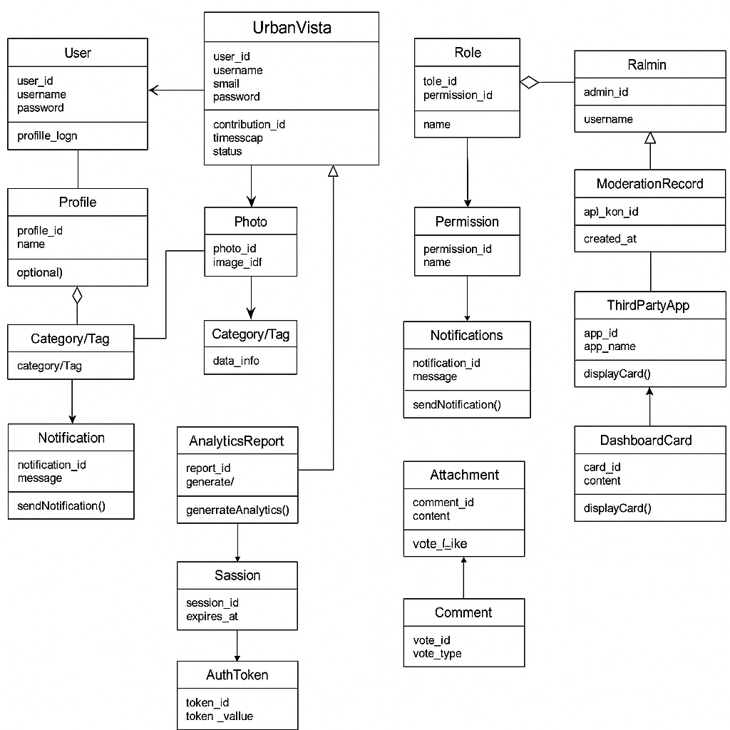

  - Sequence Diagram:

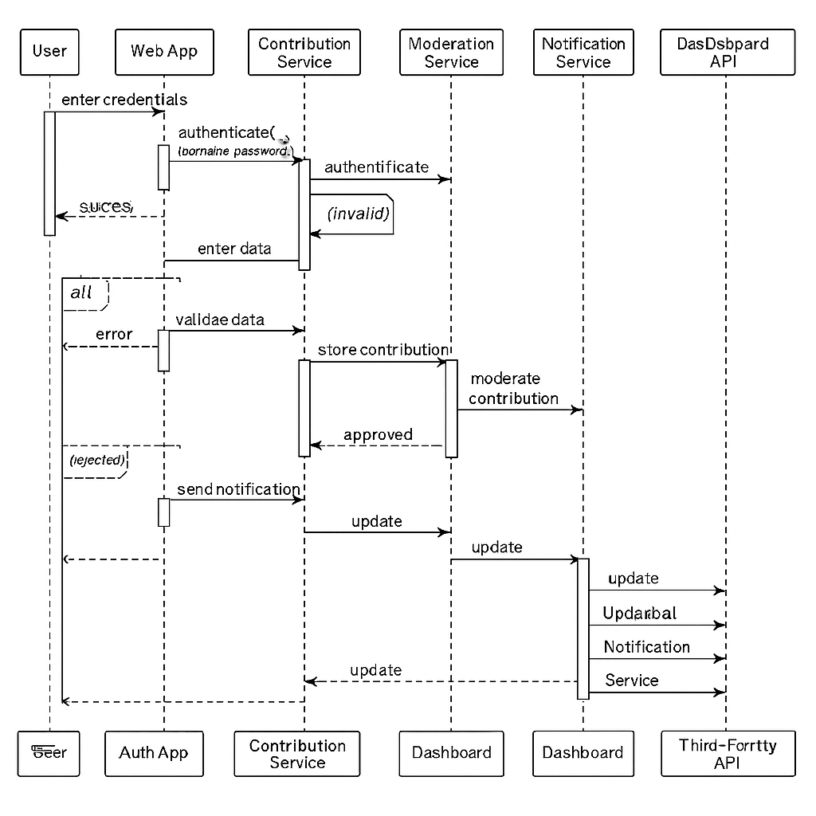

  - Activity Diagram:

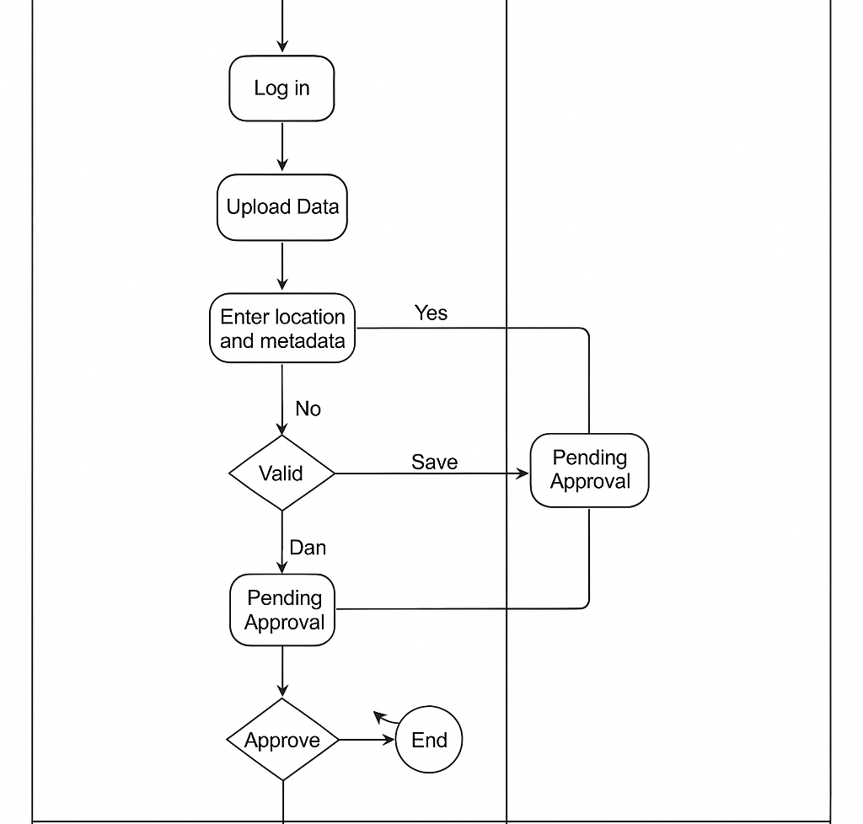

  - Data Dictionary:

Urban Vista Tables:

Persons Table :

Field Name | Data Type | Primary Key
UserID | INT | Yes

UserID | INT | Yes
FirstName | VARCHAR(50) | No
LastName | VARCHAR(50) | No
Email | VARCHAR(100) | No
Age | INT | No
Password | VARCHAR(255) | No
IsActive | BOOLEAN | No
IsEmailVerified | BOOLEAN | No
EmailVerificationToken | VARCHAR(255) | No
EmailVerificationCreatedAt | DATETIME | No
UserID | INT | Yes

Company Table :

Field Name | Data Type | Primary Key | Foreign Key (References) | Nullable | Notes
CompanyID | INT | Yes |  | No | Auto-increment unique identifier
Name | VARCHAR(150) | No |  | No | Company’s official name
Industry | VARCHAR(100) | No |  | Yes | E.g., Software, Healthcare
Website | VARCHAR(200) | No |  | Yes | Company website URL
Location | VARCHAR(200) | No |  | Yes | HQ address or city
Description | TEXT | No |  | Yes | Long-form company description
Logo | VARCHAR(255) | No |  | Yes | File path or URL to logo image
Image1 | VARCHAR(255) | No |  | Yes | File path/URL to additional image

Free Contributions Table User :

Field Name | Data Type | Primary Key | Foreign Key (References) | Nullable | Notes
ContributionID | INT | Yes |  | No | Auto-increment unique identifier
UserID | INT | No | Users(UserID) | No | Links contribution to User
ContributorName | VARCHAR(100) | No |  | Yes | Name of the contributor (if different)
Name | VARCHAR(150) | No |  | No | Name/title of the contribution
Description | TEXT | No |  | Yes | Details about the contribution
Category | VARCHAR(100) | No |  | Yes | Category or type of contribution
Address | VARCHAR(200) | No |  | Yes | Physical address (if applicable)
Latitude | DECIMAL(10,7) | No |  | Yes | Geolocation latitude
Longitude | DECIMAL(10,7) | No |  | Yes | Geolocation longitude
AreaName | VARCHAR(100) | No |  | Yes | Region, district, or area label
PhoneNumber | VARCHAR(50) | No |  | Yes | Contact number
Website | VARCHAR(200) | No |  | Yes | Link to external site
Photo | VARCHAR(255) | No |  | Yes | Path/URL to image
Video | VARCHAR(255) | No |  | Yes | Path/URL to video file
File | VARCHAR(255) | No |  | Yes | Path/URL to any supporting file

Interaction Diagram:

***

4. Development

The Development Phase of the Urban Vista project focused on converting the analysed requirements and designed models into a working web application. This stage involved writing efficient, modular, and maintainable code following Django’s Model-View-Template (MVT) architecture.
The emphasis was placed on code readability, reusability, performance optimization, and adherence to standard software engineering principles. Each module — from authentication to data visualization — was developed, tested, and refined incrementally using an Agile development approach.
The project was implemented in multiple iterations to ensure continuous improvement and validation after each sprint cycle.

4.1 Appropriate Naming Conventions
Proper naming conventions are essential for maintaining readability, scalability, and collaboration during software development.
In Urban Vista, consistent naming patterns were followed throughout the project across files, classes, variables, functions, and templates.

Applied Naming Rules:
- Python Files & Modules: Lowercase with underscores (e.g., user_models.py, views_admin.py)
- Classes: Pascal Case (e.g., User Profile, Geolocation Data)
- Functions and Methods: lowercase_with_underscores (e.g., get_user_profile (), fetch_location_data ())
- HTML Templates: descriptive lowercase names (e.g., user_dashboard.html, map_view.html)
- CSS and JS Files: modular naming based on functionality (e.g., style_auth.css, map_script.js)
- Database Tables: singular nouns with consistent naming (e.g., User, Contribution, Location)
- Variables: meaningful names describing purpose (e.g., user_id, latitude_value, is_verified)
This consistency improves collaboration, simplifies debugging, and ensures code readability for future maintenance.

4.2 Use of Proper Comments
Effective commenting ensures that the logic behind complex code sections is easily understandable by future developers and reviewers.
Throughout the Urban Vista codebase, both inline comments and block comments were used to explain critical logic, API integrations, and function behaviour.

Commenting Strategy:
- Inline Comments: Used for small explanations within functions.
- # Calculate user distance based on coordinates
- distance = geodesic (user_location, target_location).km
- Block Comments: Used to describe major modules, classes, and configurations.
- """
- This module handles user authentication and registration processes.
- It includes validation, OTP verification, and password management.
- """
- HTML Comments: Added for design clarity within templates.
- <! -- Display list of approved contributions -->
- Docstrings: Implemented in Python functions for clear purpose description using triple quotes.
The combination of structured commenting and descriptive docstrings improved code documentation quality and alignment with industry practices.

4.3 Implementation of Business Logic
The business logic layer forms the core of UrbanVista’s functionality. It governs how data flows between the user interface, database, and backend systems.

Key Implementations:
- User Authentication & Authorization:
  - Managed using Django’s in-built authentication framework.
  - Includes login, signup, password reset, and OTP verification modules.
- Data Contribution Management:
  - Users can upload photos, descriptions, and geotags that are stored and linked to their profiles.
  - Business logic handles status transitions: Draft → Pending → Approved/Rejected.
- Moderation Workflow:
  - Admins can validate or reject submissions based on accuracy.
  - Notifications are triggered automatically after moderation.
- Search and Filtering Engine:
  - Custom queries and indexing were implemented for location-based searches.
  - Pagination used for smooth browsing and performance efficiency.
- Analytics Dashboard:
  - Business logic computes metrics like most active users, most contributed locations, and upload frequency.
- Security Enforcement:
  - Validation for file formats, data sanitization, and role-based access at the backend.
By isolating core functionality from presentation layers, the system ensures modularity, reusability, and simplified debugging.

4.4 Separation of Business Logic and Page View
Urban Vista follows Django’s Model-View-Template (MVT) architecture, ensuring a clear separation between backend logic and frontend display.

Implementation Overview:
- Models: Define data structures and relationships (e.g., User, Free-Contribution, Location).
- Views: Handle requests, apply business logic, and return appropriate responses.
- Templates: Render the user interface without embedding backend logic directly.

Example:
- Model: Defines a “Free-Contribution” class for user submissions.
- View: Processes form data and applies validations before saving.
- Template: Displays approved contributions dynamically using Django template tags.
This structure enhances maintainability, promotes cleaner code organization, and allows easy future expansion (e.g., adding APIs or mobile app interfaces).

4.5 Navigation Flow (Across Pages)
The navigation flow was designed to provide users with a seamless and intuitive experience. Each page connects logically to the next, ensuring clear access paths for different user roles.

User Flow Summary:
- Guest Users:
  - Access homepage → Registration → Login
- Registered Users:
  - Dashboard → Add Contribution → View Map → Search Locations → Log Out
- Admin Users:
  - Admin Dashboard → Review Contributions → Approve/Reject → Generate Reports

Key Features:
- Use of Django’s URL routing system to manage navigation.
- Menu bar and sidebar navigation for consistency.
- Breadcrumbs added to improve usability and traceability.
- Redirects implemented post-login and logout for better flow control.
The navigation ensures a smooth transition across all modules, improving the overall user experience and accessibility.

4.6 Server-Side Validations
Server-side validation ensures that all data processed by the backend is safe, accurate, and consistent.
Django’s built-in validation framework was used to enforce these rules before database entry.

Implemented Server-Side Checks:
- User Input Validation: Checks for empty fields, invalid emails, and incorrect formats.
- File Upload Restrictions:
  - Accepts only .jpg and .png files under 5MB.
- Unique Data Constraints: Prevents duplicate user entries or overlapping coordinates.
- Authentication Rules: Validates OTPs, password strength, and login credentials.
- Data Integrity: Ensures referential integrity between users and contributions.
All invalid requests return structured error messages and are safely rejected before committing to the database.

4.7 Client-Side Validations
Client-side validation enhances user experience by catching input errors instantly, reducing server load and improving performance.

Techniques Used:
- HTML5 Form Validation:
  - Required fields, email, and number constraints.
- JavaScript-Based Checks:
  - Ensures correct input formats (latitude, longitude).
  - Real-time preview for uploaded images.
- Bootstrap Alerts:
  - Displays friendly error messages or success confirmations.
- AJAX Calls:
  - Used for real-time feedback during form submission (e.g., OTP validation).
By combining both client-side and server-side validation, Urban Vista achieves a high level of data accuracy and security.

4.8 Tools and Technologies Used
Urban Vista was developed using a combination of modern web technologies and development tools to ensure efficiency, scalability, and user satisfaction.
Category | Tool / Technology | Purpose
Frontend | HTML5, CSS3, JavaScript, Bootstrap 5 | Designing responsive and modern UI
Backend | Django (Python 3.11+) | Core logic, data handling, authentication
Database | SQLite | Data storage and retrieval
Libraries | Pillow, Requests, Goopy | Image processing, geolocation calculations
Version Control | GitHub | Source code management
Testing Tools | Django Test Framework, Postman | Unit and API testing
Deployment | PythonAnywhere / AWS (Cloud Hosting) | Hosting and scaling
IDE | Visual Studio Code | Code development and debugging
Design Tools | Figma / Draw.io | UI mock-ups and diagram design

These technologies collectively ensure that Urban Vista operates efficiently, provides a smooth user experience, and can be easily enhanced in future releases.

***

5. Agile Documentation

The Agile methodology was adopted during the development of Urban Vista to ensure flexibility, continuous feedback, and faster delivery of working components.
Agile promotes an iterative and incremental approach, allowing the team to adapt to changes quickly and maintain alignment with project objectives and stakeholder expectations.
The project team divided the entire system development into multiple sprints, each focusing on specific deliverables like authentication, data management, analytics, and deployment.

5.1 Project Charter
The Project Charter serves as the official authorization of the Urban Vista project, outlining its purpose, goals, scope, stakeholders, and expected outcomes.
Field | Details
Project Title | UrbanVista
Objective | To develop a scalable, real-time geolocation and data visualization platform for community-driven updates.
Scope | The system includes modules for user management, geolocation data upload, content moderation, analytics dashboards, and secure data visualization.
Project Start Date | 1st August 2025
Expected Completion Date | 31st October 2025
Project Manager | Prof. Urvika Soni (Guide)
Team Members | Chirayu Darji, Mihir Parmar, Rahul Parmar
Technology Stack | Django, Python, MySQL, Bootstrap, JavaScript
Deliverables | Functional web application, project documentation, test reports, deployment setup
Success Criteria | Fully functional, tested, and deployed platform accessible to end users with accurate data visualization.

5.2 Agile Roadmap / Schedule
The Agile Roadmap outlines the planned sprints and the development flow across the project timeline. Each sprint focuses on completing a working module that can be tested and improved upon.
Sprint No. | Duration | Sprint Focus | Key Deliverables
Sprint 1 | Week 1–2 | Requirement Analysis & UI Design | Requirement docs, wireframes, database design
Sprint 2 | Week 3–5 | Core Development | Authentication, Registration, Profile management
Sprint 3 | Week 6–8 | Feature Implementation | Geolocation data upload, map integration
Sprint 4 | Week 9–10 | Analytics & Admin Panel | Dashboard, user roles, content moderation
Sprint 5 | Week 11–12 | Testing & Deployment | Testing, optimization, cloud deployment
Each sprint ended with a review meeting to evaluate progress, identify blockers, and define tasks for the next cycle.

5.3 Agile Project Plan
The Agile Project Plan defines the approach for delivering value in short iterations while maintaining quality, teamwork, and adaptability.

Plan Highlights:
- Approach: Scrum framework with iterative 2-week sprints.
- Meetings: Weekly stand-ups and bi-weekly sprint reviews with mentor guidance.
- Deliverables: A working, deployable version after each sprint.
- Tools Used: Trello for task tracking, GitHub for version control, and Google Docs for collaboration.
- Definition of Done (DoD):
  - Feature implemented and tested.
  - Code reviewed and committed.
  - User interface validated and documented.
This approach enabled incremental progress and rapid feedback integration throughout development.

5.4 User Stories
User stories were created to represent real-world use cases and end-user expectations from Urban Vista. Each story follows the standard Agile format:
As a [user type], I want to [perform an action] so that I can [achieve a goal].
User Story ID | User Type | User Story | Priority
US01 | Contributor | As a contributor, I want to upload a photo with location details so that others can view real-time updates. | High
US02 | Admin | As an admin, I want to review and approve contributions before publishing to maintain accuracy. | High
US03 | Traveler | As a traveler, I want to search and filter places to easily find relevant information. | Medium
US04 | Business User | As a business owner, I want to analyze location trends to make better marketing decisions. | Medium
US05 | System | As a system, I want to ensure secure logins and encrypted data storage to protect users. | High

5.5 Release Plan
The Release Plan defines how working versions of Urban Vista were delivered incrementally after each sprint. Each release included fully functional, tested modules.

Release No. | Components Delivered | Sprint(s) Covered | Version | Release Date
Release 1 | Authentication & Registration module | Sprint 1–2 | v1.0 | 15 August 2025
Release 2 | Data Contribution & Map Integration | Sprint 3 | v1.1 | 10 September 2025
Release 3 | Analytics Dashboard & Admin Panel | Sprint 4 | v1.2 | 1 October 2025
Release 4 | Final Testing, Optimization & Deployment | Sprint 5 | v1.3 | 31 October 2025
Each release was validated by the guide before moving to the next sprint to ensure compliance with objectives.

5.6 Sprint Backlog
The Sprint Backlog lists the prioritized tasks assigned during each sprint, ensuring clear accountability and progress tracking.
Sprint | Tasks | Assigned To | Status
Sprint 1 | Requirement documentation, UI mock-ups, DB schema design | Chirayu, Mihir | Completed
Sprint 2 | Authentication module, profile management, basic navigation | Chirayu, Rahul | Completed
Sprint 3 | Geolocation upload, photo handling, map API integration | Mihir, Rahul | Completed
Sprint 4 | Admin dashboard, analytics graphs, user moderation | Chirayu | Completed
Sprint 5 | Testing, debugging, deployment setup | All Team Members | Completed
Sprint reviews were held at the end of each iteration, and backlog items were reprioritized as necessary.

5.7 Test Plan
The Agile Test Plan defines the strategy for ensuring that all system features meet user expectations and functional requirements.

Testing Approach:
- Unit Testing: Validating individual modules (e.g., login, upload).
- Integration Testing: Ensuring seamless data flow between modules.
- System Testing: Checking end-to-end functionality.
- User Acceptance Testing (UAT): Performed by team and mentor to validate usability.

Testing Tools:
- Django’s built-in test framework
- Postman for API validation
- Browser Developer Tools for frontend debugging

Test Metrics:
- Test coverage: 90%
- Bugs found and resolved: All critical issues closed before deployment
- User feedback: Positive response to interface and performance

5.8 Earned Value and Burn-Down Charts
Agile tracking metrics were used to monitor progress and ensure the project remained on schedule.

Earned Value Analysis (EVA):
Metric | Description | Value
Planned Value (PV) | Estimated progress as per timeline | 100%
Earned Value (EV) | Actual work completed | 95%
Cost Performance Index (CPI) | EV / AC = 0.98 | On budget
Schedule Performance Index (SPI) | EV / PV = 0.95 | Slightly behind due to testing
Overall, the project performance was within acceptable limits, with all major deliverables achieved.

Burn-Down Chart (Description):
The burn-down chart showed a gradual reduction in pending tasks over the project timeline. Early sprints involved UI and logic setup, while the final sprints focused on optimization and bug fixing.
By the end of Sprint 5, all major tasks were completed, demonstrating effective sprint planning and execution.

