Installation Guide for gnuradio, Blockstream & bitcoinfibre into Raspberry Pi 3 model B

2018/02/06 Ver.0.01
ChirimenJako @Luqina
Auriga @aurigajp
MIT license

CAUTION!!!
This document explains how to install gnuradio, Blockstream, bitcoinfibre, and all Raspbian Linux into empty USB-HDD. I confirmed it works with only this clean-install method. If you want to install them into your existing Raspbian environment, please study and understand what to do inside patches well and try it on your own risk.
Anyway, ABSOLUTELY NO WARRANTY

Preperations:
- Raspberry Pi 3 model B
- 8GB reasonable price & speed microSD card
- USB-HDD (500GB～2GB)
- Reliable 5V USB Power Source
- RTL-SDR

Download and write boot image into microSD
Make Raspbian stretch image into microSD with Win32DiskImager

RASPBIAN STRETCH WITH DESKTOP
Image with desktop based on Debian Stretch
Version:November 2017
Release date:2017-11-29
Kernel version:4.9
Release notes:Link
SHA-256:64c4103316efe2a85fd2814f2af16313abac7d4ad68e3d95ae6709e2e894cc1b

This is very common procedure, so, please refer to the other technical sources.

Install Raspbian stretch into Raspberry Pi 3 model B
Power off Raspberry Pi.
Connect USB-HDD to Raspberry Pi.
Insert microSD into Raspberry Pi.
Turn on Power.

Setup Preferences (Mouse / Keyboard / Region / Time-zone / Resolution / Bluetooth, etc…)
Enable VNC server (optional)
DON’T set super user password until finish the installation.
We checked out this installation using user ‘pi’ account only.
NOTE(for Japanese): Don’t set Menu Language ‘Japanese’ for now.
reboot

Setup bootable USB HDD

Firmware upgrade (It has done once already, no need to do it again.)
pi@raspberrypi$:~ $ sudo apt update
pi@raspberrypi$:~ $ sudo apt -y install rpi-update
pi@raspberrypi$:~ $ sudo rpi-update

Modify config.txt
pi@raspberrypi$:~ $ echo “program_usb_boot_mode=1” | sudo tee -a /boot/config.txt
pi@raspberrypi$:~ $ echo “program_usb_boot_timeout=1” | sudo tee -a /boot/config.txt
pi@raspberrypi$:~ $ reboot

Check firmware version
pi@raspberrypi$:~ $ vcgencmd otp_dump | grep 17:
Check if it’s 17:3020000a

Initialize connected USB-HDD
pi@raspberrypi$:~ $ sudo umount /dev/sda2 (if necessary)
pi@raspberrypi$:~ $ sudo umount /dev/sda1 (if necessary)
pi@raspberrypi$:~ $ sudo parted /dev/sda
(parted) mktable msdos [Yes]
(parted) mkpart primary fat32 0% 100M
(parted) mkpart primary ext4 100M 100%
(parted) quit

Format USB-HDD
pi@raspberrypi$:~ $ sudo mkfs -t vfat -n BOOT -F 32 /dev/sda1
pi@raspberrypi$:~ $ sudo mkfs -t ext4 /dev/sda2 [Yes]

Mount USB-HDD on microSD file-system
pi@raspberrypi$:~ $ sudo mount /dev/sda2 /mnt
pi@raspberrypi$:~ $ sudo mkdir /mnt/boot
pi@raspberrypi$:~ $ sudo mount /dev/sda1 /mnt/boot

Copy boot image from microSD to USB-HDD
pi@raspberrypi$:~ $ sudo rsync -ax --progress / /boot /mnt

Modify USB-HDD /boot/cmdline.txt
pi@raspberrypi$:~ $ ls -al /dev/disk/by-partuuid
pi@raspberrypi$:~ $ sudo vi /mnt/boot/cmdline.txt (leafpad is much easier)
Modify PARTUUID from that of microSD to USB-HDD.
Insert rootdelay=10 (after ‘rootwait’)

Modify USB-HDD /etc/fstab
pi@raspberrypi$:~ $ sudo vi /mnt/etc/fstab (leafpad is much easier)

Update SSH Host Key
pi@raspberrypi$:~ $ cd /mnt
pi@raspberrypi$:/mnt $ sudo mount --bind /dev dev
pi@raspberrypi$:/mnt $ sudo mount --bind /sys sys
pi@raspberrypi$:/mnt $ sudo mount --bind /proc proc
pi@raspberrypi$:/mnt $ sudo chroot /mnt
root@raspberrypi:/# rm /etc/ssh/ssh_host*
root@raspberrypi:/# dpkg-reconfigure openssh-server
root@raspberrypi:/# exit
pi@raspberrypi$:/mnt $ sudo umount dev
pi@raspberrypi$:/mnt $ sudo umount sys
pi@raspberrypi$:/mnt $ sudo umount proc
pi@raspberrypi$:/mnt $ cd
pi@raspberrypi$:~ $ sudo umount /mnt/boot
pi@raspberrypi$:~ $ sudo umount /mnt

Power off
pi@raspberrypi$:~ $ poweroff

Disconnect Power Source (physically!)
Remove microSD,
Connect Power Source again.

Make swap partition on microSD to expand I/O bandwidth (STRONGLY RECOMMENDED)
Insert microSD
Click [Cancel] on GUI
pi@raspberrypi$:~ $ sudo umount /dev/mmcblk0p1
pi@raspberrypi$:~ $ sudo umount /dev/mmcblk0p2
pi@raspberrypi$:~ $ sudo parted /dev/mmcblk0
(parted) mktable msdos [Yes]
(parted) quit
pi@raspberrypi$:~ $ reboot

pi@raspberrypi$:~ $ sudo mkswap -f /dev/mmcblk0
pi@raspberrypi$:~ $ sudo swapon --fixpgsz --discard=once /dev/mmcblk0
pi@raspberrypi$:~ $ sudo swapoff /var/swap #down HDD swap priority
pi@raspberrypi$:~ $ sudo swapon /var/swap #resume HDD swap area

Check swap environment
pi@raspberrypi$:~ $ swapon
NAME TYPE SIZE USED PRIO
/var/swap file 100M 0B -2
/dev/mmcblk0 partition 7.3G 0B -1

Upgrade overall Raspberry Pi modules
pi@raspberrypi$:~ $ sudo apt update && sudo apt -y upgrade && reboot

NOTE: Raspberry Pi may have been restored to the default environment by upgrading automatically.
Please check the Preferences and swap file settings…
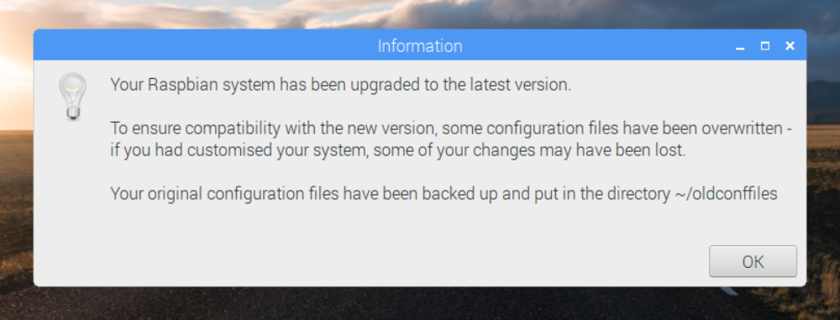

NOTE: gnuradio dependency chart
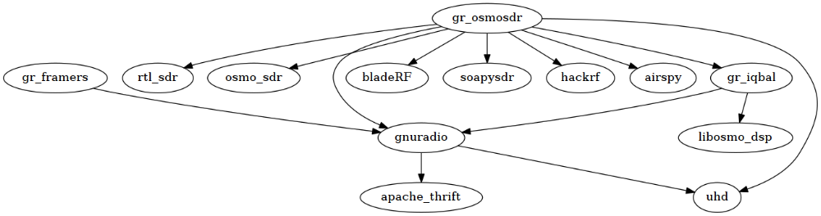

Build overall modules
copy build_Blockstream_RaspPi3B-2018-02-07_1.tar.gz into your home directory.
pi@raspberrypi$:~ $ tar -zxvf build_Blockstream_RaspPi3B-2018-02-07_1.tar.gz
pi@raspberrypi$:~ $ script buildall.log
Script started, file is buildall.log
pi@raspberrypi$:~ $ ./build_BlockStream_RasPi3B.sh

Approximately, it will take around 15 hours building pilgrimage.
Wait for finish by Sleep, Gaming, Trading, Read any Books, and clean up the other tasks. That’s up to you!

Test after build finish
pi@raspberrypi$:~ $ exit
exit
Script done, file is buildall.log
pi@raspberrypi$:~ $ source ~/.profile # Just in case
pi@raspberrypi$:~ $ sudo ldconfig # Just in case
pi@raspberrypi$:~ $ cd ~/satellite/grc
Insert RTL-SDR into USB port.
pi@raspberrypi$:~/satellite/grc $ ./rx.py --freq <your frequency> --gain 40
e.g.: ./rx.py --freq 1083250000 --gain 40

Put temporary value into frequency parameter just for checking software is enough for now. Ku-Band LNB output frequency is over 1GHz = 1000^3 = 1000000000. You have to calculate exact frequency from your home region satellite frequency and your LNB L.O. frequency when you connect RTL-SDR with satellite antenna and try receiving Blockstream satellite radio wave.

If everything is OK, you can see the following result.
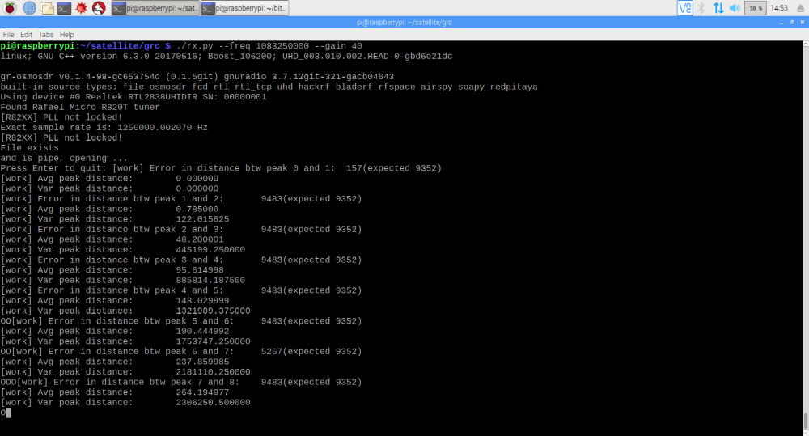

CONGRATULATIONS!!!

If this document helps you, you can tip a pinch of BTC to the following address.
We can progress to the next step by your donations!

BTC Legacy | BTC Segwit
 | 
153w1iUUzMdFu8ckWrXsJiDSk81rk8r7K1 | 38jcX8eZQkX7npyZuMEV8wqbj76Wq2oouX

End of Document.

