E-Commerce Analytics & Customer Churn Prediction
Superstore Sales Dataset - Project Report
Author: Chirantan Dey
Date: 11 October 2026
Programme: AI-Powered Data Analytics - Training cum Internship
Dataset: https://www.kaggle.com/datasets/rohitsahoo/sales-forecasting

1. Executive Overview
This project converts four years of raw Superstore sales transactions into business-ready intelligence: a cleaned dataset, exploratory analysis of what happened, a leakage-safe churn prediction model of what might happen, and a customer risk table with recommended actions.
KPI | Value
Total Revenue | $2,261,537
Total Orders | 4,922
Unique Customers | 793
Average Order Value | $459.48
Data Period | 03 Jan 2015 - 30 Dec 2018
Customers Scored for Churn Risk | 782
Risk Distribution | High 1 / Medium 741 / Low 40

2. Data & Methodology

2.1 Source and golden rule
- Dataset downloaded from Kaggle: https://www.kaggle.com/datasets/rohitsahoo/sales-forecasting
- Raw file stored at data/raw/train.csv (9,800 rows x 18 columns) and NEVER modified (golden rule).
- Mixed-format order dates parsed with pd.to_datetime(format='mixed', dayfirst=True); 0 unparseable dates remained.

2.2 Cleaning rules applied
- Impossible/unparseable dates dropped (0 rows affected).
- Numeric columns forced with pd.to_numeric(errors='coerce'); invalid rows dropped.
- Rows with Quantity or Revenue <= 0 removed (0 rows affected).
- Exact duplicate rows removed (0 duplicates found).
- Text hygiene: whitespace trimmed; Category and Region title-cased.

2.3 Enrichment columns created
- Year, Month_Name, Month_Year for trend analysis.
- Customer_Segment (New vs Repeat) based on unique orders per customer.
- Order_Value_Category (Low / Medium / High) via revenue tertiles.

2.4 Leakage-safe churn design
- Feature cutoff: 2018-01-01. RFM features use ONLY orders before this date (6,542 rows, 782 customers).
- Target: no purchase in the following 180-day window (2018-01-01 to 2018-06-30; 1,148 rows, 427 active customers).
- Class balance: 360 churned vs 422 retained.
- Features: Recency, Frequency, Monetary, Avg_Order_Value (never Customer_ID, never the target, never future data).
- Model: Pipeline(StandardScaler + LogisticRegression), stratified 75/25 train-test split, saved to models/churn_logreg.joblib.

3. Exploratory Data Analysis - What Happened?
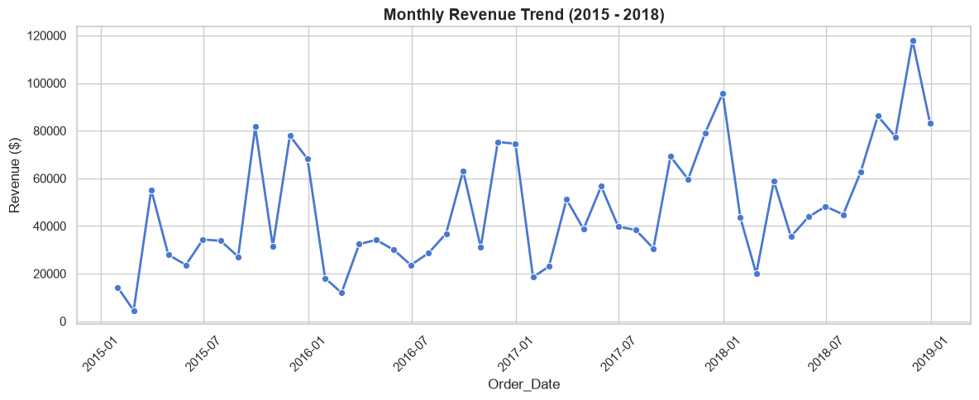
Figure 1 - Monthly Revenue Trend (2015-2018): upward trend with recurring Q4 spikes.
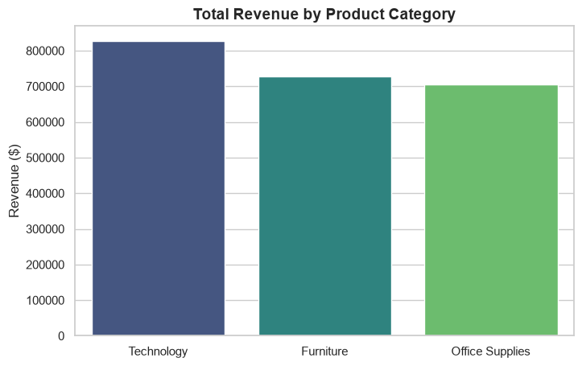
Figure 2 - Total Revenue by Product Category: Technology leads, then Furniture and Office Supplies.
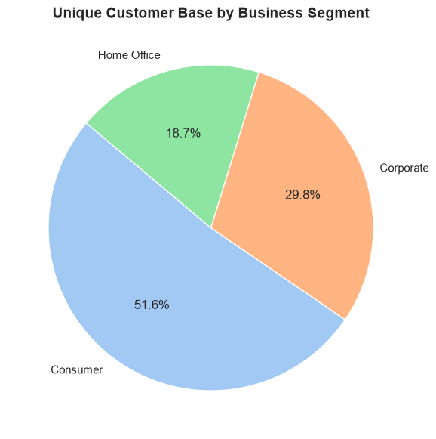
Figure 3 - Unique Customer Base by Segment: Consumer 51.6%, Corporate 29.8%, Home Office 18.7%.
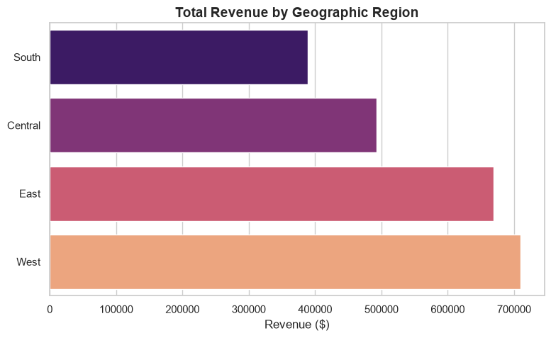
Figure 4 - Total Revenue by Region: West leads; South and Central lag.
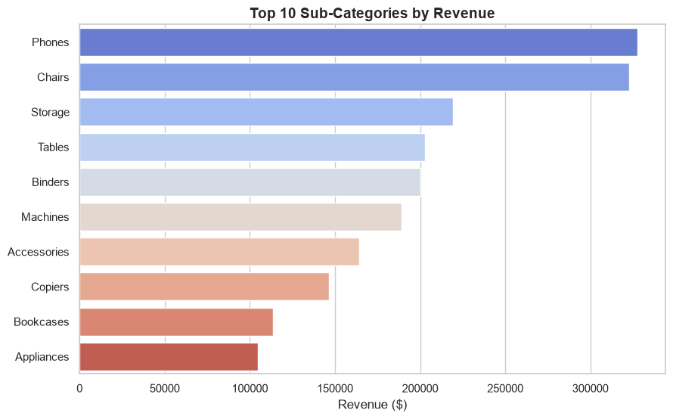
Figure 5 - Top 10 Sub-Categories by Revenue: Phones, Chairs and Storage lead.

3.1 Observations
- Revenue shows a clear upward trend from 2015 to 2018 with consistent seasonal spikes in Q4.
- Technology drives the highest revenue, followed by Furniture and Office Supplies; Phones, Chairs and Storage lead at sub-category level.
- The customer base is predominantly Consumer (51.6%), then Corporate (29.8%) and Home Office (18.7%).
- The West region generates the highest revenue; South and Central lag behind.

3.2 Insights and hypotheses
- Insight: the business relies heavily on Q4 seasonal spikes and the Technology category for annual revenue.
- Hypothesis: Q4 spikes may be driven by holiday shopping and end-of-year corporate budget spending; Phones dominance may indicate a high average order value for electronics.
- Insight: West significantly outperforms other regions, suggesting higher population density, better marketing penetration, or more efficient logistics there.

4. Predictive Modelling - What Might Happen?
Baseline logistic regression on leakage-safe RFM features (test-split performance):
Metric | Value
Accuracy | 52.0%
Precision | 44.7%
Recall | 18.9%
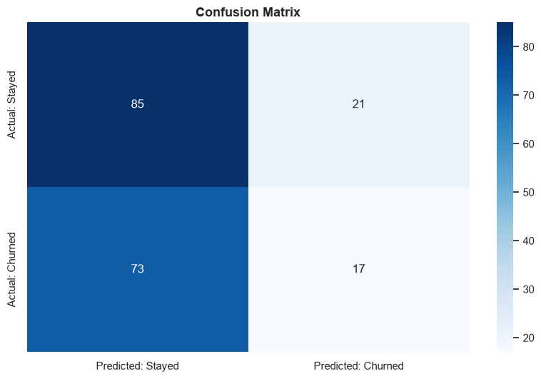
Figure 6 - Confusion Matrix of the leakage-safe churn model (25% test split).

4.1 Interpretation
High Recency (e.g. >500 days since last purchase) and low Frequency (1-2 orders) are associated with a higher predicted probability of churn. For example, customer MW-18235 (956 days recency) was flagged High Risk at 81.2% probability. However, the model struggled to separate churners confidently: most customers fall in a Medium Risk band (probabilities 55-68%).
Crucial analyst note: the low recall (18.9%) indicates that basic RFM features alone are insufficient to predict e-commerce churn. We observe associations in the data, not causations - the model cannot prove why customers leave, only that certain historical behaviours correlate with future inactivity.

5. Customer Risk Analysis
Churn probability | Risk level
Below 40% | Low Risk
40% to below 70% | Medium Risk
70% or higher | High Risk

5.1 Top 20 highest-risk customers
Customer_ID | Recency | Frequency | Monetary | Churn_Probability | Risk_Level
MW-18235 | 956 | 1 | $3,334 | 81.2% | High Risk
JE-16165 | 27 | 1 | $2,658 | 68.1% | Medium Risk
CM-12385 | 474 | 2 | $6,682 | 68.0% | Medium Risk
SM-20320 | 372 | 3 | $24,509 | 64.7% | Medium Risk
LW-16990 | 241 | 1 | $1,692 | 62.0% | Medium Risk
KF-16285 | 297 | 2 | $4,779 | 61.0% | Medium Risk
ML-17410 | 779 | 1 | $877 | 60.6% | Medium Risk
RH-19495 | 519 | 2 | $3,492 | 60.0% | Medium Risk
JK-16090 | 620 | 1 | $893 | 58.9% | Medium Risk
BF-11275 | 1016 | 1 | $389 | 58.8% | Medium Risk
RB-19330 | 776 | 1 | $670 | 58.6% | Medium Risk
GM-14695 | 103 | 2 | $4,728 | 58.6% | Medium Risk
MH-18115 | 131 | 1 | $1,416 | 58.2% | Medium Risk
DK-12895 | 463 | 2 | $2,661 | 57.0% | Medium Risk
GR-14560 | 772 | 2 | $1,284 | 56.6% | Medium Risk
VT-21700 | 636 | 2 | $1,737 | 56.3% | Medium Risk
VF-21715 | 891 | 2 | $674 | 56.3% | Medium Risk
DK-13150 | 758 | 1 | $434 | 56.2% | Medium Risk
SR-20425 | 932 | 1 | $213 | 56.1% | Medium Risk
JH-15430 | 1042 | 1 | $56 | 55.9% | Medium Risk

5.2 Reading the table
- MW-18235 is the only High Risk customer (81.2%, 956 days recency, 1 order).
- 741 of 782 customers sit in the Medium Risk 'fence-sitter' band - the model is uncertain about them.
- SM-20320 combines Medium Risk (64.7%) with $24,509 lifetime revenue - the highest-value retention target in the table.

6. Strategic Recommendations - What Should We Do?
- Target high-value Medium Risk customers: prioritise win-back discounts for Medium Risk customers with high historical Monetary value (e.g. SM-20320) rather than blanketing all medium-risk users - better ROI.
- Capitalise on Q4 and Technology: allocate the majority of Q4 marketing budget to Technology/Phones, the proven revenue engines.
- Investigate regional disparities: run a diagnostic analysis on South and Central to uncover logistics bottlenecks or untapped market potential.
- Iterate the model: future versions should add categorical preferences, discount usage and shipping times to improve the 18.9% recall and shrink the fence-sitting Medium Risk bucket.

7. Conclusion & Next Steps
The pipeline delivers what a business-intelligence project must: facts (KPIs and trends), insights (drivers and segments), risks (churn probabilities and risk bands), opportunities (high-value fence-sitters, Q4/Technology seasonality) and actions (targeted retention, regional diagnostics, model iteration). All outputs are reproducible from the notebook and stored in data/processed and models/.

