POI_DP NGSI10 Lookalike API Specification

## Introduction

This document specifies the FIWARE POI_DP (Point of Interest Data Provider) Generic Enabler additional NGSI10 lookalike API provided together with the new Dynamic POI feature (see poi_dp_dyn_spec.docx). The NGSI10 lookalike API is meant to give a common look and feel API for the POI_DP as currently implemented for the Orion Context Broker GE. This additional API includes support for the contextEntities and queryContext services for the Convenience GET Operations and the JSon based NGSI10 POST Operations except the XML support. To better match the current POI_DP implementation the POI data structures have been kept original and do not follow the NGSI10 information model. The option to use regular expressions in matching the desired value fields is supported. The main use case for this API is for users already familiar with the NGSI10 and/or FIWARE Orion CB.

## Specification

This chapter is divided into two sections; the first one describes the Convenience Operations and the second one the NGSI10 JSon based lookalike API.

### POI_DP Convenience Operations

The POI_DP Convenience Operations include one single easy to use versatile API to fetch the POI data using either radial search around a given position or by giving the ID of a known POI item using the below **GET** requests:

http://<host>/poi_dp_dyn/ngsi10/contextEntities/<latitude>/<longitude>/<radius>[/<category>]

or

http://<host>/poi_dp_dyn/ngsi10/contextEntities/<poi_id>[/component/<component>]

where:

<latitude/longitude> Coordinates of the desired POIs in wgs84 decimal degrees

<radius> Radius of the spatial search in meters for the desired POIs

<category> Desired POI category

<poi_id> Universally Unique ID (UUID) of the desired POI

<component> Desired POI data components, e.g. fw_core, fw_sensor

The response will be a JSon string including the POI data details:

{

"pois": {

"<poi-id>": {

"fw_core": {

"location": {

"wgs84": {

"latitude": <latitude>,

"longitude": <longitude>

}

},

"categories": [

"<category>",…

],

“<field>”: <value>,

"name": {

"": "<name>"

}

},

"<component>": {

“<field>”: <value>

}

},

<poi_id>...

}

}

Where:

<poi_id> Universally Unique ID (UUID) of the POI

<latitude/longitude>Coordinates of the POIs in wgs84 decimal degrees

<category> Category/categories the POI belongs to

<component> Data components of the POI includes, e.g. fw_core, fw_sensor

<field> Value fields the POI component includes

<value> Value of the POI component field

<name> Name of the POI

Examples:

<http://dev.cie.fi/FI-WARE/poi_dp_dyn/ngsi10/contextEntities/65/24.5/20000>

will return:

{"pois":{"09cf0de1-2a56-430b-8fb8-81b4950fdc57":{"fw_core":{"location":{"wgs84":{"latitude":65.0094651,"longitude":24.7128748}},"categories":["library"],"source":{"name":"OpenStreetMap","website":"http:\/\/www.openstreetmap.org","license":"http:\/\/www.openstreetmap.org\/copyright"},"name":{"":"Hailuodon kirjasto"}}},"ab9bf40c-cb15-41bb-b64d-

…

3aa40d3587f1":{"fw_core":{"location":{"wgs84":{"latitude":65.039333333333,"longitude":24.772333333333}},"categories":["sensor"],"name":{"":"ST_816_Hailuoto_R"}},"fw_sensor":{"data":[{"name":{"en":"Air_temperature"},"type":"temp","value":"5.1","unit":"C"},{"name":{"en":"Road_temperature"},"type":"temp","value":"17.6","unit":"C"},{"name":{"en":"Wind_speed"},"type":"wind","value":"2.6","unit":"m\/s"},{"name":{"en":"Wind_direction"},"type":"winddir","value":"196","unit":"\u00b0"}]},"fw_dynamic":{"host_type":"kelikamerat","host_id":["12025"],"data_type":"kelikamerat_sensors"}}}}

and the call:

<http://dev.cie.fi/FI-WARE/poi_dp_dyn/ngsi10/contextEntities/65/24.5/20000/fuel>

will return only the fuel stations:

{"pois":{"36a5e867-64a4-447b-ac16-094154513447":{"fw_core":{"location":{"wgs84":{"latitude":65.0192047,"longitude":24.7410111}},"categories":["fuel"],"source":{"name":"OpenStreetMap","website":"http:\/\/www.openstreetmap.org","license":"http:\/\/www.openstreetmap.org\/copyright"},"name":{"":"SEO Hailuoto"}}}}}

the same information can now be retrieved also by the poi_id 36a5e867-64a4-447b-ac16-094154513447:

<http://dev.cie.fi/FI-WARE/poi_dp_dyn/ngsi10/contextEntities/36a5e867-64a4-447b-ac16-094154513447>

or by specifying the additional optional desired component fw_core (which is the only one available in this case):

<http://dev.cie.fi/FI-WARE/poi_dp_dyn/ngsi10/contextEntities/36a5e867-64a4-447b-ac16-094154513447/component/fw_core>

### POI_DP NGSI10 Lookalike Operations

The only NGS10 JSon operation provided is the queryContext and the url format for this call is:

http://<host>/poi_dp_dyn/ngsi10/queryContext

This call always requires a JSon query string to be included as the **POST** data. The format of this string is the same as given above for the POI data response, except for the additional radius information required by the spatial search:

{

"pois": {

"<poi-id>": {

"fw_core": {

"location": {

"wgs84": {

"latitude": <latitude>,

"longitude": <longitude>

}

“radius”: <radius>

},

"categories": [

"<category>",…

],

“<field>”: <value>,

"name": {

"": "<name>"

}

},

"<component>": {

“<field>”: <value>

}

},

<poi_id>...

}

}

where:

<poi_id> Universally Unique ID (UUID) of the desired POI, or “*” to query several

<latitude/longitude>Coordinates of the desired POIs in wgs84 decimal degrees

<radius> Radius of the spatial search in meters for the desired POIs

<category> Desired POI category/categories

<component> Data components the desired POIs need to have

<field> Value fields of the components the desired POIs need to have

<value> Value of the component field required POIs need to match or “.*” to

match all values or any other valid regular expression needing to match.

Examples:

Calls to our demo server <http://dev.cie.fi/FI-WARE/poi_dp_dyn/ngsi10/queryContext> will depending on the JSon POST query string respond e.g. for

{"pois":{"36a5e867-64a4-447b-ac16-094154513447":{},"91834e4b-b465-446b-9e4a-5af9eeafe5f1":{}}}

the contents of the two specified POIs:

{"pois":{"36a5e867-64a4-447b-ac16-094154513447":{"fw_core":{"location":{"wgs84":{"latitude":65.0192047,"longitude":24.7410111}},"categories":["fuel"],"source":{"name":"OpenStreetMap","website":"http:\/\/www.openstreetmap.org","license":"http:\/\/www.openstreetmap.org\/copyright"},"name":{"":"SEO Hailuoto"}},"fw_dynamic":null},"91834e4b-b465-446b-9e4a-5af9eeafe5f1":{"fw_core":{"location":{"wgs84":{"latitude":61.507694,"longitude":23.699528}},"categories":["sensor"],"name":{"":"VT12_Tre_Paasikiventie"}},"fw_sensor":{"data":[{"name":{"en":"Air_temperature"},"type":"temp","value":"11.8","unit":"C"},{"name":{"en":"Road_temperature"},"type":"temp","value":"14.9","unit":"C"},{"name":{"en":"Wind_speed"},"type":"wind","value":"0.1","unit":"m\/s"},{"name":{"en":"Wind_direction"},"type":"winddir","value":"215","unit":"\u00b0"}]},"fw_dynamic":{"host_type":"kelikamerat","host_id":["4020"],"data_type":"kelikamerat_sensors","components":["fw_sensor"],"_ctrl":{"timestamp":1431364821}}}}}.

And for the radial search for POIs having a fw_dynamic component with host_type value “kelikamerat”:

{"pois":{"*":{"fw_core":{"location":{"wgs84":{"latitude":65.0192047,"longitude":24.7410111},"radius":15000}},"fw_dynamic":{"host_type":"kelikamerat"}}}}

The response will be:

{"pois":{"f6dcb385-8c9e-4b7a-9325-3aa40d3587f1":{"fw_core":{"location":{"wgs84":{"latitude":65.039333333333,"longitude":24.772333333333}},"categories":["sensor"],"name":{"":"ST_816_Hailuoto_R"}},"fw_sensor":{"data":[{"name":{"en":"Air_temperature"},"type":"temp","value":"7.4","unit":"C"},{"name":{"en":"Road_temperature"},"type":"temp","value":"18.7","unit":"C"},{"name":{"en":"Wind_speed"},"type":"wind","value":"3.7","unit":"m\/s"},{"name":{"en":"Wind_direction"},"type":"winddir","value":"268","unit":"\u00b0"}]},"fw_dynamic":{"host_type":"kelikamerat","host_id":["12025"],"data_type":"kelikamerat_sensors","components":["fw_sensor"],"_ctrl":{"timestamp":1431242508}}}}}

See Section 3 for information how to make these calls using our demo API tool.

## POI_DP NGSI10 Lookalike API demo

A short simple demonstration of how to use the additional ngsi10 lookalike POI API is provided by using a simple RESP API tool available in:

* REST API DEMO tool: <http://dev.cie.fi/FI-WARE/poi_dp_dyn/ngsi10>

Open the above demo tool with Chrome or Firefox browser and select the desired API URL from the predefined cases available or edit your own URL. Then in the same way select/edit the POST data if needed and click GET or POST method depending on the required case. An additional JSon formatted data field is also provided in case you need to modify the JSon query string. See figure 1 below.

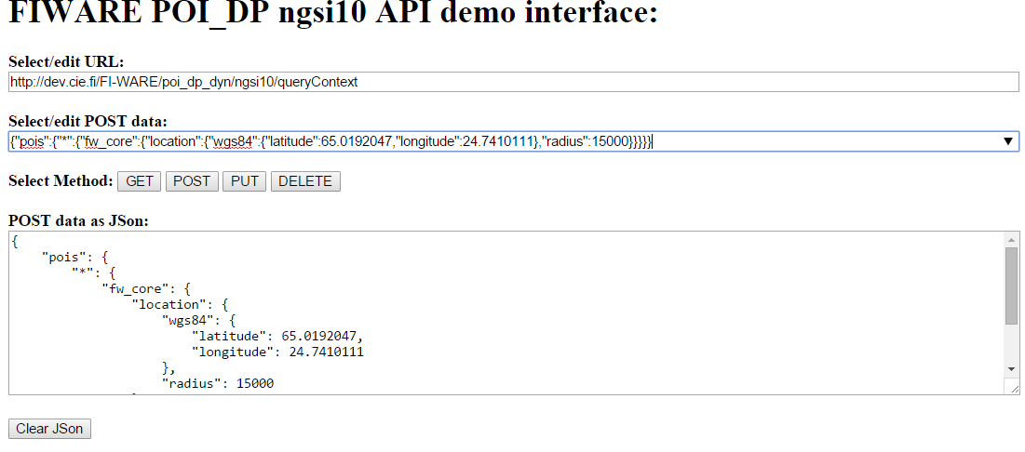

Figure 1. POI API demo tool

The response generated by the server will be shown at the bottom of the page as illustrated in the figure 2. The response will include:

* Header information
* Response as plain text
* Response in JSon pretty print (if available)

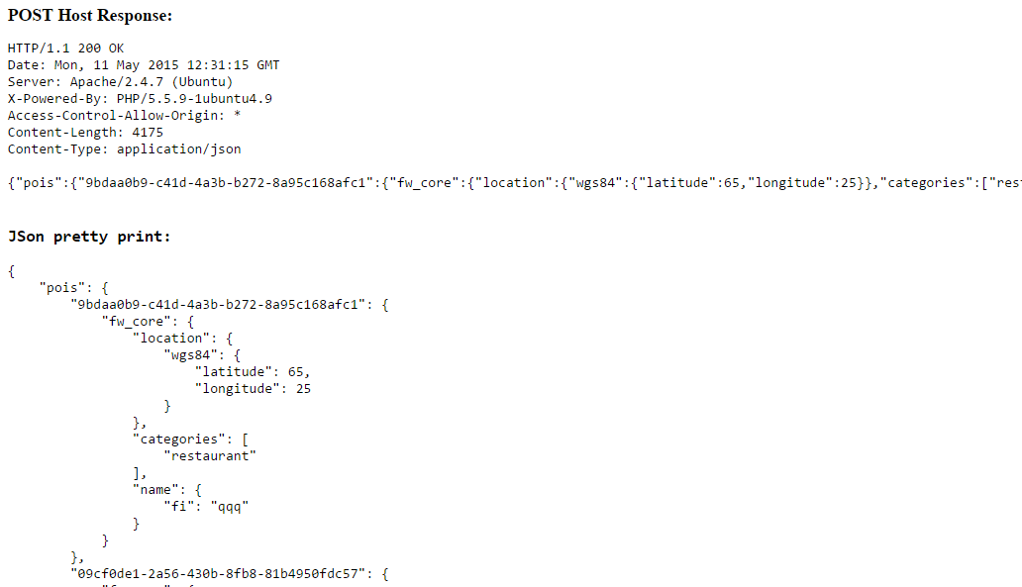

Figure 2. POI API demo tool response