**DocSpot**

**Introduction:**

The Docspot project is a web-based application designed to simplify the process of booking doctor appointments. Built on the MERN stack (MongoDB, Express.js, React.js, and Node.js), the platform provides an intuitive and user-friendly interface for both patients and doctors. Users can search for doctors based on specialization, location, and availability, while doctors can manage their schedules and appointments efficiently.

The application aims to bridge the gap between patients and healthcare providers by offering a seamless digital solution for appointment management. With features such as user authentication, real-time booking, and notifications, the platform enhances convenience and reduces wait times, ensuring a better healthcare experience for everyone.

**Team Members:**

1. M. Chiranjeevi - Front End Developer
2. A. Mahalakshmi – Back End Developer
3. G. Surya -Tester
4. P. Akash - Supporter

**Description:**

Docspot is a robust web application crafted to simplify the process of booking doctor appointments. Leveraging the MERN stack, it combines MongoDB for the database, Express.js and Node.js for the server-side framework, and React.js for a dynamic, responsive user interface. The platform is designed to cater to both patients and healthcare providers, offering features such as:

* **User-friendly Interface**: A seamless experience for patients to browse, search, and book appointments with doctors.
* **Doctor Profiles**: Comprehensive profiles for doctors, including specialization, qualifications, experience, and availability.
* **Real-Time Booking**: Instant confirmation of appointments without unnecessary delays.
* **Appointment Management**: Tools for doctors to manage and optimize their schedules.
* **Secure Authentication**: Ensures user data is protected through secure login and account management.

The platform is built to address the challenges of traditional appointment booking systems, saving time and effort for both patients and healthcare professionals. Docspot offers scalability, flexibility, and a modern approach to healthcare management.

**Scenario based use case**

**Scenario**: A Working Professional Booking an Appointment

**Persona**: Ramesh, a 35-year-old software engineer, works long hours and struggles to make time for his health checkups. He has been feeling fatigued lately and decides it’s time to consult a doctor.

1. **Login/Sign-Up**: Ramesh logs into the Docspot platform using his credentials. If he's a new user, he can quickly register by providing basic details like name, email, and phone number.
2. **Search for a Doctor**: Using the search functionality, Ramesh filters doctors based on **specialization (general physician)**, **location (near his office)**, and **availability (evening slots)**.
3. **Doctor Profile and Reviews**: Ramesh finds Dr. Priya Sharma, whose profile highlights her qualifications, years of experience, and patient reviews. Confident in her expertise, he decides to book an appointment.
4. **Booking Appointment**: Ramesh selects an available time slot that fits his schedule and confirms the booking. He receives a real-time notification on the platform and an email confirmation.
5. **Appointment Reminder**: On the day of the appointment, Ramesh receives a reminder notification via email and SMS, ensuring he doesn’t forget.
6. **Doctor Visit**: Ramesh meets Dr. Priya Sharma, who diagnoses his issue and prescribes the necessary treatment.
7. **Post-Appointment Feedback**: After his consultation, Ramesh rates his experience and leaves a review for Dr. Priya to help other users.

**TECHINICAL ARCHITECTURE:**

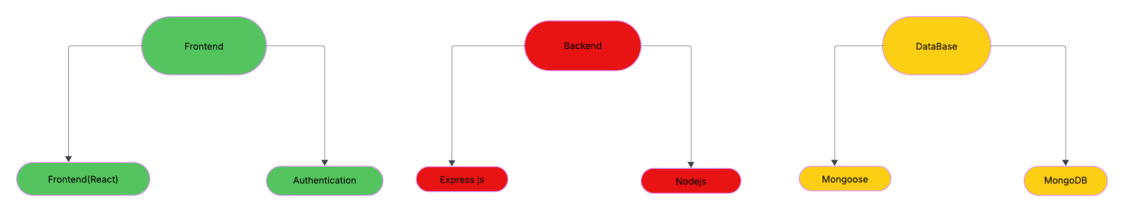

**Technical Architecture :**

The Docspot project leverages the MERN stack to create a modern, efficient, and scalable web application. Below is an overview of its technical architecture:

1. **Frontend**:
   * **Technology**: React.js
   * **Description**: The user interface is built using React.js, ensuring a responsive and dynamic experience for users. React components are utilized to provide reusable and modular code, streamlining development and maintenance.
   * **Features**:
     + User authentication screens
     + Doctor search and profile display
     + Appointment booking interface
     + User-friendly forms and filters
2. **Backend**:
   * **Technology**: Node.js and Express.js
   * **Description**: The server-side logic is implemented using Node.js, with Express.js as the web application framework. This setup ensures a robust and scalable backend capable of handling API requests and business logic.
   * **Features**:
     + RESTful API endpoints for managing users, doctors, and appointments
     + Secure session management
     + Middleware for error handling and authentication
3. **Database**:
   * **Technology**: MongoDB
   * **Description**: MongoDB is used for storing and managing data. Its NoSQL nature provides flexibility in managing structured and unstructured data related to users, doctors, and appointments.
   * **Features**:
     + Data storage for user profiles, doctor information, and appointment details
     + Query optimization for fast data retrieval
     + Secure storage of sensitive user information
4. **Integration and Deployment**:
   * **Cloud Hosting**: Platforms like AWS or Heroku can be used for hosting the application.
   * **Version Control**: Git is utilized for managing code versions.
   * **Deployment Pipeline**: CI/CD pipelines are set up for automated testing, building, and deployment.
5. **Security**:
   * **Authentication**:
     + JWT (JSON Web Token) for secure authentication and session management.
   * **Data Protection**:
     + HTTPS for secure communication between the client and server.
     + Passwords hashed using bcrypt for secure storage.
6. **Architecture Diagram**: (Include a visual representation of how the components interact, such as a flow showing user interaction with the frontend, API communication, and database integration.)

**ER-Diagram:**

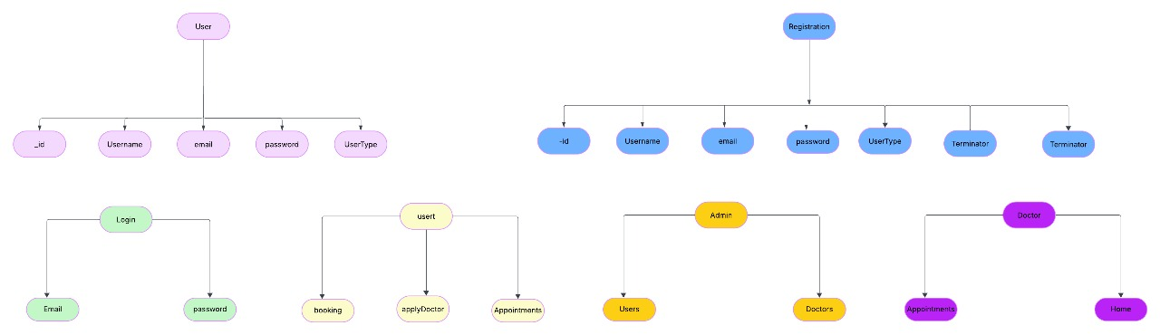

**This ER diagram represents the database structure for a user management system. Here's a breakdown of its components and their relationships:**

1. **User Entity:**
   * Contains attributes like _id, Username, email, password, and UserType.
   * Represents the core details of a user in the system.
2. **Registration Entity:**
   * Includes _id, Username, email, password, UserType, and a Terminator attribute (listed twice, perhaps to show a unique constraint or marker for process flow).
   * Manages user registration information.
3. **Login Entity:**
   * Consists of Email and password as attributes.
   * Facilitates authentication of users during login.
4. **Usert Entity (likely a typo for "User" or could represent a specific subcategory of users):**
   * Includes attributes such as booking, applyDoctor, and Appointments.
   * Handles user actions related to services like booking or applying for a doctor.
5. **Admin Entity:**
   * Includes attributes Users and Doctors.
   * Manages administrative functionalities related to user and doctor records.
6. **Doctor Entity:**
   * Attributes include Appointments and Home.
   * Represents doctor-specific functionalities and their interaction with user appointments.

This diagram outlines the relationships and attributes necessary for organizing and managing user data efficiently. It highlights how users, admins, and doctors interact within the system, ensuring proper database design for functionality.

**Features:**

**For Patients:**

* **Doctor Search**: Search doctors by specialty, location, availability, or ratings.
* **Online Appointment Booking**: Simple and quick booking process with a calendar view of available slots.
* **Health Profile**: Maintain personal health history, past appointments, and medical records.
* **Notifications and Reminders**: SMS or email alerts for upcoming appointments and follow-ups.
* **Online Payments**: Integration with secure payment gateways for consultation fees.
* **Doctor Reviews**: Option to leave reviews and ratings for doctors.

**For Doctors:**

* **Schedule Management**: Doctors can set their availability and manage appointments.
* **Patient Information**: Access detailed patient profiles and health records.
* **Reminders**: Get notifications about upcoming or canceled appointments.
* **Online Consultations**: Option for video or phone consultations if applicable.

**For Admins:**

* **Dashboard**: View and manage all activities in the system (appointments, users, and payments).
* **User Management**: Add, edit, or delete patient and doctor profiles.
* **Reports**: Generate reports on appointment statistics, revenue, or system usage.
* **Specialty Management**: Add new specialties or services offered.

**Additional Features (Optional):**

* **Emergency Appointments**: Priority booking for urgent cases.
* **Integration with Wearable Devices**: Sync with fitness trackers or health monitoring devices.
* **Multilingual Support**: Support multiple languages for better accessibility.
* **AI-based Suggestions**: Use AI to recommend doctors based on patient preferences or symptoms.

**PREREQUISITES:**

To develop a full-stack banking management app using AngularJS, Node.js, and MongoDB, there are several prerequisites you should consider. Here are the key prerequisites for developing such an application:

**Node.js and npm:** Install Node.js, which includes npm (Node Package Manager), on your development machine. Node.js is required to run JavaScript on the server side.

* Download: <https://nodejs.org/en/download/>
* Installation instructions: <https://nodejs.org/en/download/package-manager/>

**MongoDB:** Set up a MongoDB database to store hotel and booking information. Install MongoDB locally or use a cloud-based MongoDB service.

* Download: <https://www.mongodb.com/try/download/community>
* Installation instructions: <https://docs.mongodb.com/manual/installation/>

**Express.js:** Express.js is a web application framework for Node.js. Install Express.js to handle server-side routing, middleware, and API development.

* Installation: Open your command prompt or terminal and run the following command: **npm install express**

**React.js**: React.js is a popular JavaScript library for building user interfaces. It enables developers to create interactive and reusable UI components, making it easier to build dynamic and responsive web applications. To install React.js, a JavaScript library for building user interfaces, follow the installation guide: <https://reactjs.org/docs/create-a-new-react-app.html>

**HTML, CSS, and JavaScript:** Basic knowledge of HTML for creating the structure of your app, CSS for styling, and JavaScript for client-side interactivity is essential.

**Database Connectivity:** Use a MongoDB driver or an Object-Document Mapping (ODM) library like Mongoose to connect your Node.js server with the MongoDB database and perform CRUD (Create, Read, Update, Delete) operations.

**Front-end Framework:** Utilize Angular to build the user-facing part of the application, including products listings, booking forms, and user interfaces for the admin dashboard.

**Version Control**: Use Git for version control, enabling collaboration and tracking changes throughout the development process. Platforms like GitHub or Bitbucket can host your repository.

* Git: Download and installation instructions can be found at: <https://git-scm.com/downloads>

**Development Environment:** Choose a code editor or Integrated Development Environment (IDE) that suits your preferences, such as Visual Studio Code, Sublime Text, or WebStorm.

* Visual Studio Code: Download from <https://code.visualstudio.com/download>
* Sublime Text: Download from <https://www.sublimetext.com/download>
* WebStorm: Download from <https://www.jetbrains.com/webstorm/download>

**To Connect the Database with Node JS go through the below provided link:**

* Link: https://www.section.io/engineering-education/nodejs- [mongoosejs-mongodb/](https://www.section.io/engineering-education/nodejs-mongoosejs-mongodb/)

**Install Dependencies:**

* Install the required dependencies by running the following command:

**npm install**

**Start the Development Server:**

* To start the development server, execute the following command:
* cd backend
* npm start

**npm run dev or npm run start**

* The banking management app will be accessible at http://localhost:3000 by default. You can change the port configuration in the .env file if needed.

**Access the App:**

* Open your web browser and navigate to <http://localhost:3000>.
* After opening the website it loads a home page at first we have create the account using the Register option .
* After That login to the account by entering the proper credentials.

You have successfully you have successfully login on your account local machine. You can now proceed with further uploading the data and updating and testing as needed.

**PROJECT STRUCTURE:**

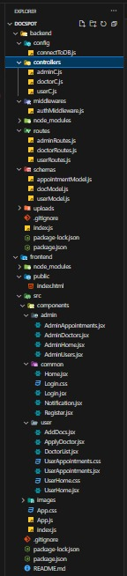

The frontend structure assumes a React app and follows a modular approach. Here's a brief explanation of the main directories and files:

* **src/components:** This directory has minor components such as Login, Register, etc.,
* **src/pages:** The pages folder contains all the pages of the application like landing page, home page, etc.,

       The backend folder contains the schema file to store the database schemas and the js file to store the backend API request and response code.

**Application Flow for DocSpot:**

1. **User Access**:
   * A user visits the application.
   * They are directed to the **Login Page (**Login.jsx**)** in the pages/ folder.
   * The user logs in by providing valid credentials (handled by the backend API via userRoutes.js).
2. **Role-Based Routing**:
   * Based on the user's role (user, doctor, or admin), they are routed to the appropriate section of the application.

**For Regular Users:**

1. **Home Page**:
   * Upon successful login, users land on the **User Home Page (**UserHome.jsx**)**, which provides an overview of features like browsing doctors, scheduling appointments, and applying to become a doctor.
2. **Apply to Become a Doctor**:
   * If a user wants to become a doctor, they navigate to the **ApplyDoctor Component (**ApplyDoctor.jsx**)**.
   * They fill out and submit an application form.
   * This request is sent to the backend via APIs defined in userRoutes.js, where the admin will later review it.
3. **Search and View Doctors**:
   * Users can browse the **Doctor List (**DoctorList.jsx**)** to view available doctors.
   * The component fetches the doctor data from the backend via doctorRoutes.js.
4. **Manage Appointments**:
   * Users navigate to **UserAppointments (**UserAppointments.jsx**)** to:
     + View their scheduled appointments.
     + Book a new appointment with a doctor.
     + Cancel existing appointments.
   * All these actions are supported by APIs in userRoutes.js and doctorRoutes.js.

**For Doctors:**

1. **Doctor Dashboard**:
   * Doctors log in and are routed to their respective dashboard (not detailed in your file structure but logically part of the application).
   * They manage their profile, availability, and appointments, interacting with backend APIs via doctorRoutes.js.

**For Admins:**

1. **Admin Dashboard**:
   * Admins log in and access the administrative panel (not explicitly mentioned in the file structure).
   * They can:
     + Review and approve/reject doctor applications (handled by APIs in adminRoutes.js).
     + Monitor users and doctors.
     + Manage the overall system.
2. **Notifications**:
   * The **Notification Component (**Notification.jsx**)** is triggered for all users to provide updates such as:
     + Appointment confirmations.
     + Status of doctor applications.
     + System alerts.

**Project Flow:**

**Milestone 1: Project Setup and Configuration:**

1. **Create project folders and files:**

Now, firstly create the folders for frontend and backend to write the respective code and install the essential libraries.

* Client folders.
* Server folders

1. **Install required tools and software:**

For the backend to function well, we use the libraries mentioned in the prerequisites. Those libraries include

* Node.js.
* MongoDB.
* Bcrypt
* Body-parser

Also, for the frontend we use the libraries such as

* React Js.
* Material UI
* Bootstrap
* Axios

After the installation of all the libraries, the package.json files for the backend looks like the one mentioned below.

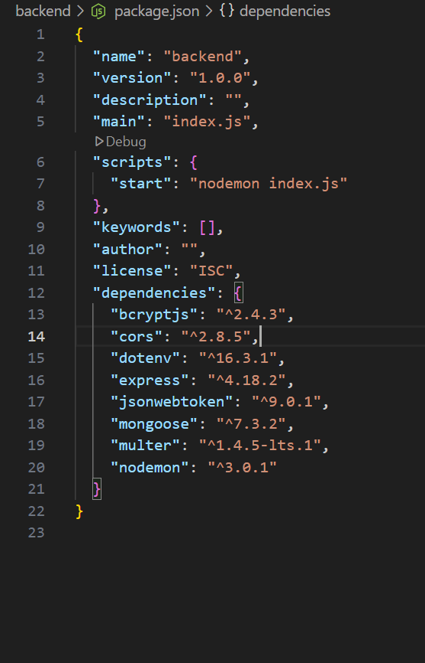

**Backend Interaction:**

* All frontend requests are routed to the backend via appropriate APIs:
  + **User Routes (**userRoutes.js**)**: Handles user actions like login, registration, and appointment management.
  + **Doctor Routes (**doctorRoutes.js**)**: Facilitates doctor-specific functionalities.
  + **Admin Routes (**adminRoutes.js**)**: Manages admin-related operations.

**Database:**

* Backend communicates with the database using the connection setup in connectToDB.js, ensuring persistence and integrity of data

After the installation of all the libraries, the package.json files for the frontend looks like the one mentioned below.

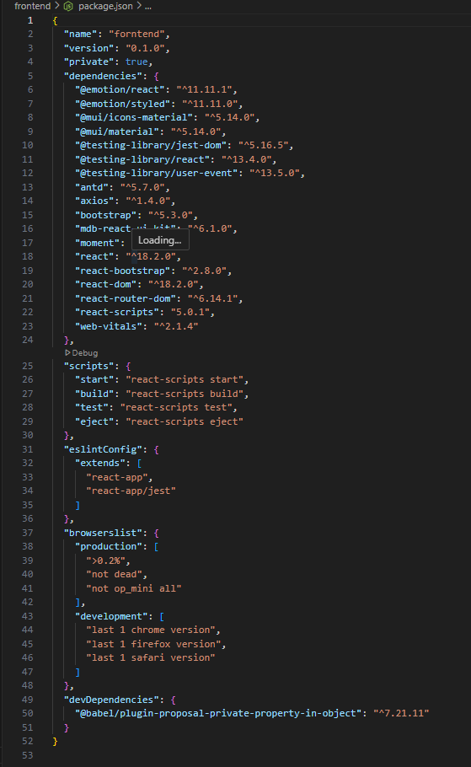

**Milestone 2: Backend Development:**

1. **Set Up Project Structure:**
   * Create a new directory for your project and set up a package.json file using npm init command.
   * Install necessary dependencies such as Express.js, Mongoose, and other required packages.
2. **Database Configuration:**
   * Set up a MongoDB database either locally or using a cloud-based MongoDB service like MongoDB Atlas.
   * Create a database and define the necessary collections for users, transactions, loans and deposits.
3. **Create Express.js Server:**
   * Set up an Express.js server to handle HTTP requests and serve API endpoints.
   * Configure middleware such as body-parser for parsing request bodies and cors for handling cross-origin requests.
4. **Define API Routes:**
   * Create separate route files for different API functionalities such as authentication, loans, deposits, and transactions.
   * Implement route handlers using Express.js to handle requests and interact with the database.
5. **Implement Data Models:**
   * Define Mongoose schemas for the different data entities like Bank, users, transactions, deposits and loans.
   * Create corresponding Mongoose models to interact with the MongoDB database.
   * Implement CRUD operations (Create, Read, Update, Delete) for each model to perform database operations.
6. **User Authentication:**
   * Implement user authentication using strategies like JSON Web Tokens (JWT) or session-based authentication.
   * Create routes and middleware for user registration, login, and logout.
   * Set up authentication middleware to protect routes that require user authentication.
7. **Handle new transactions:**
   * Allow users to make transactions to other users using the user’s account id.
   * Update the transactions and account balance dynamically in real-time.
8. **Admin Functionality:**
   * Implement routes and controllers specific to admin functionalities such as fetching all the data regarding users, transactions, deposits, and loans.
   * Add a feature to approve or decline the loan applications made by the users.
9. **Error Handling:**
   * Implement error handling middleware to catch and handle any errors that occur during the API requests.
   * Return appropriate error responses with relevant error messages and HTTP status codes.

**Milestone 3: Database Development:**

* Set up a MongoDB database either locally or using a cloud-based MongoDB service like MongoDB Atlas.
* Create a database and define the necessary collections for users, transactions, stocks and orders.
* Also let’s see the detailed description for the schemas used in the database.

1. **User Schema:**
   * Schema: userSchema
   * Model: ‘User’
   * The User schema represents the user data and includes fields such as username, email, balance, and password.
   * It is used to store user information for registration and authentication purposes.
   * The email field is marked as unique to ensure that each user has a unique email address**.**
   * The balance field represents the amount in users account and it gets updated with transactions.
2. **DocSpot Schema:**

* Schema: DocSpot Schema
* Model: ‘DocSpot’
* The DocSpot schema represents the users data and is useful for admin authentication.

1. **Booking Schema:**
   * Schema: Appoints Schema
   * Model: appointments
   * The Appointments schema represents the booking requests data such as patient details, Doctor details, Doctor, time, etc.,
2. **DoctorMode Schema:**
   * Schema: DoctorMode
   * Model: Docotor approval
   * TheDoctorMode schema represents the Doctors data such as user details, pricing, details, qualification, duration, etc.,

The code for the database connection looks like,

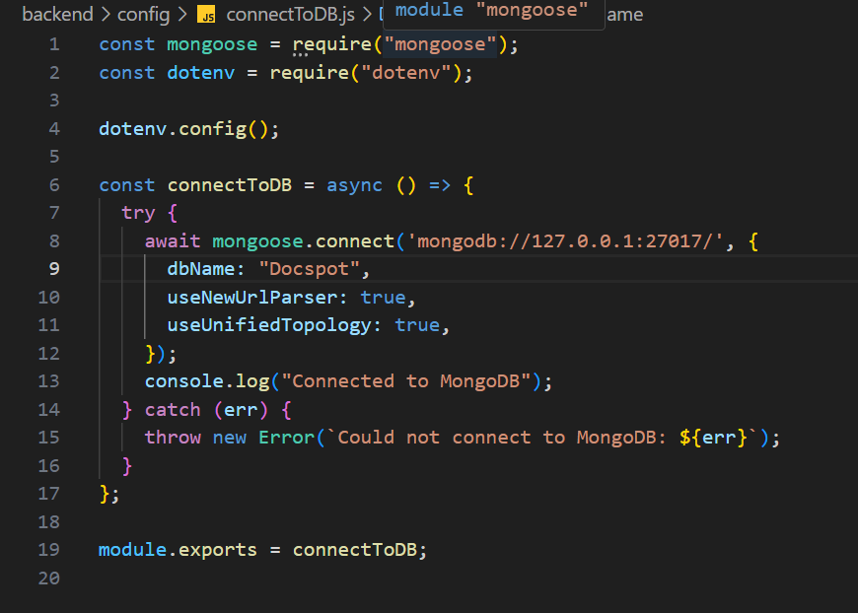

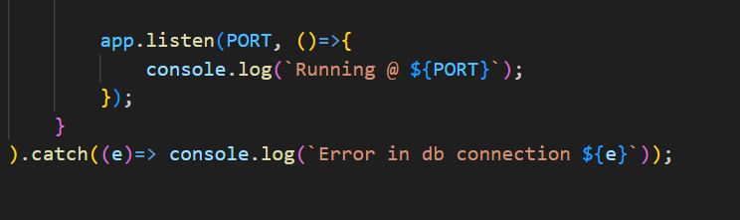

The Schemas for the database are given below

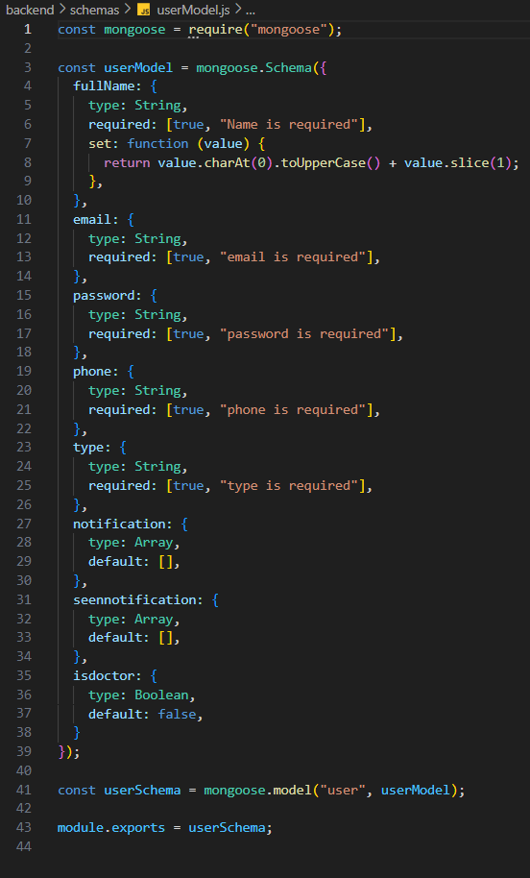

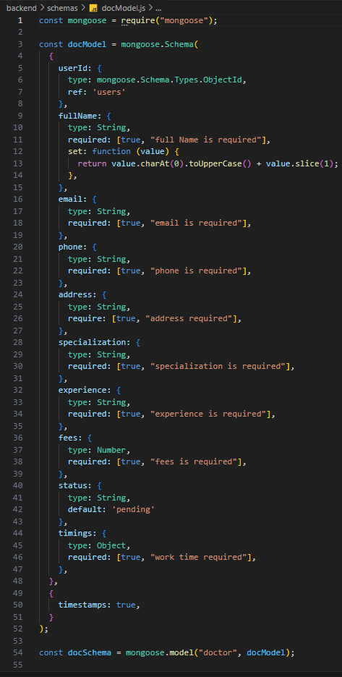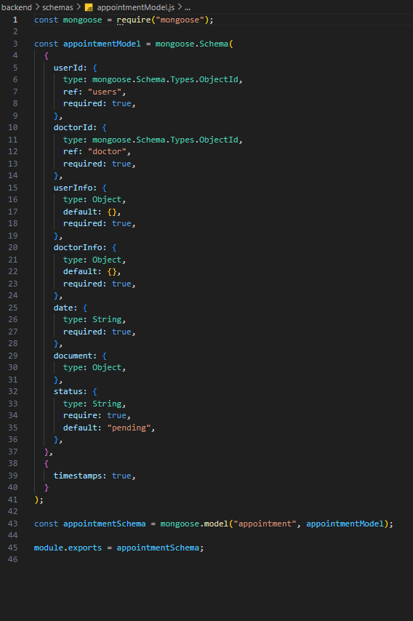

**Milestone 4: Frontend Development:**

* **Setup React Application:**

Bringing the banking management application to life involves a three-step development process. First, a solid foundation is built using React.js. This includes creating the initial application structure, installing necessary libraries, and organizing the project files for efficient development. Next, the user interface (UI) comes to life. To start the development process for the frontend, follow the below steps.

* Create React Js application.
* Install required libraries.
* Create the structure directories.
* **Design UI components:**

Crafting a seamless user experience in SB Bank requires designing UI components. This involves creating individual elements like buttons, forms, and menus. We'll then define their arrangement and visual style (layout and styling) for a cohesive look. Finally, navigation elements will be implemented to ensure users can easily move between different functionalities within the app.

* **Implement frontend logic:**

In the final leg of the frontend development, we'll bridge the gap between the visual interface and the underlying data. It involves the below stages.

* Integration with API endpoints.
* Implement data binding.

**Milestone 5: Project Implementation:**

On completing the development part, we then run the application one last time to verify all the functionalities and look for any bugs in it. The user interface of the application looks a bit like the images provided below.

**Testing:**

1**. Unit Testing Objective**: Test individual components and functions to ensure they work as expected. Tools: Jest, React Testing Library, Mocha, Chai Examples: Test the handleMenuItemClick function in UserHome.jsx to ensure it sets the active menu item correctly.

2. **Integration Testing Objective:** Test the interaction between different components and modules. Tools: Jest, React Testing Library, Cypress Examples: Test the interaction between UserHome.jsx and UserAppointments.jsx to ensure the correct component is rendered when a menu item is clicked. Test the interaction between Notification.jsx and the backend API to ensure notifications are fetched and displayed correctly.

3. **End-to-End (E2E) Testing Objective:** Test the entire application flow from start to finish. Tools: Cypress, Selenium, Puppeteer Examples: Test the login flow to ensure a user can log in and be redirected to the dashboard. Test the booking flow to ensure a user can book an appointment with a doctor.

4. **Performance Testing Objective**: Ensure the application performs well under different conditions. Tools: Lighthouse, WebPageTest, JMeter Examples: Test the loading time of the UserHome.jsx component. Test the response time of the backend API when fetching user data.

5. Security Testing Objective: Identify and fix security vulnerabilities. Tools: OWASP ZAP, Burp Suite, npm audit Examples: Test for SQL injection vulnerabilities in the backend API. Test for XSS vulnerabilities in the frontend components.

6. **Usability Testing Objective:** Ensure the application is user-friendly and intuitive. Tools: UserTesting, Lookback, Hotjar Examples: Conduct user testing sessions to gather feedback on the UserHome.jsx layout and navigation. Use heatmaps to analyze user interactions with the DoctorList.jsx component.

7**. Regression Testing Objective:** Ensure new changes do not break existing functionality. Tools: Jest, Cypress, Selenium Examples: Run a suite of tests after each deployment to ensure existing features still work as expected. Use automated tests to quickly identify any regressions introduced by new code changes.

8. **Accessibility Testing Objective**: Ensure the application is accessible to all users, including those with disabilities. Tools: Axe, Lighthouse, WAVE Examples: Test the UserHome.jsx component for keyboard navigation and screen reader compatibility. Ensure all images in DoctorList.jsx have appropriate alt text.

9. **Code Quality and Static Analysis Objective:** Ensure the codebase follows best practices and coding standards. Tools: ESLint, Prettier, SonarQube Examples: Use ESLint to enforce coding standards and catch potential issues in the code. Use SonarQube to analyze the codebase for code smells and technical debt. By implementing these testing strategies, you can ensure that your project is robust, reliable, and user-friendly.

* **Home page:**

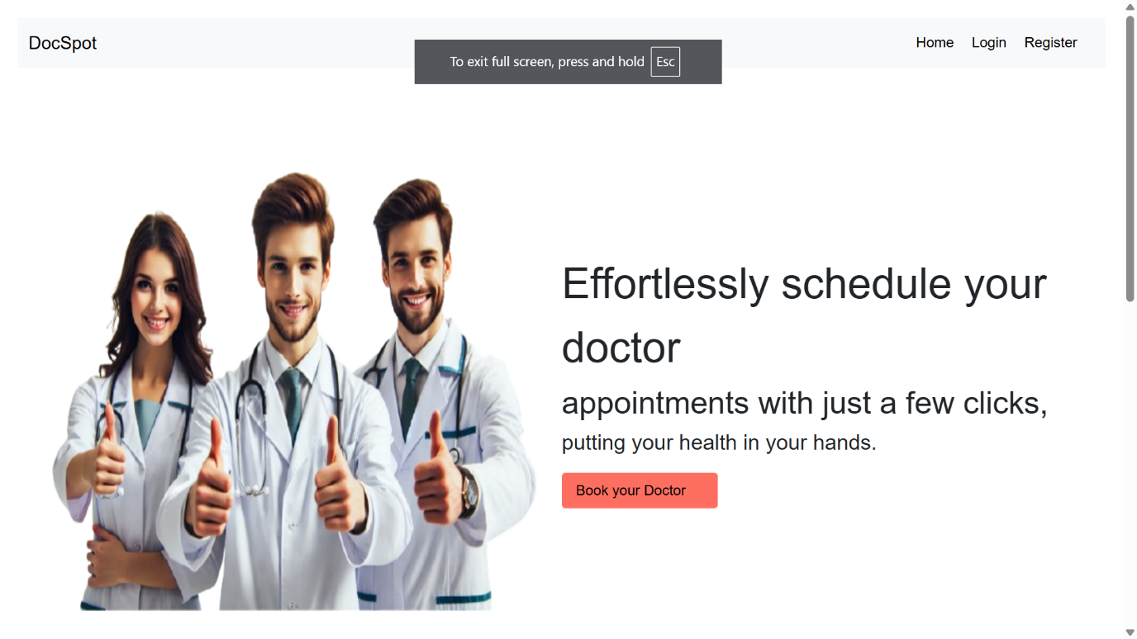

* **Registration Page**

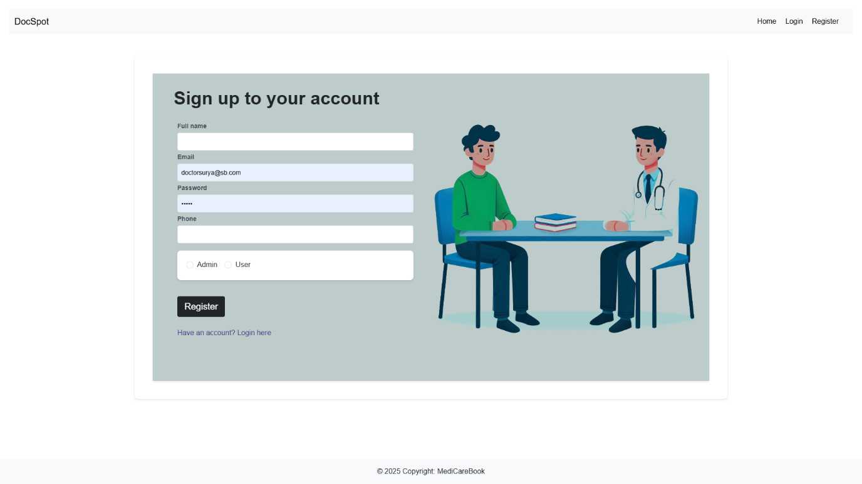

* **Login Page**

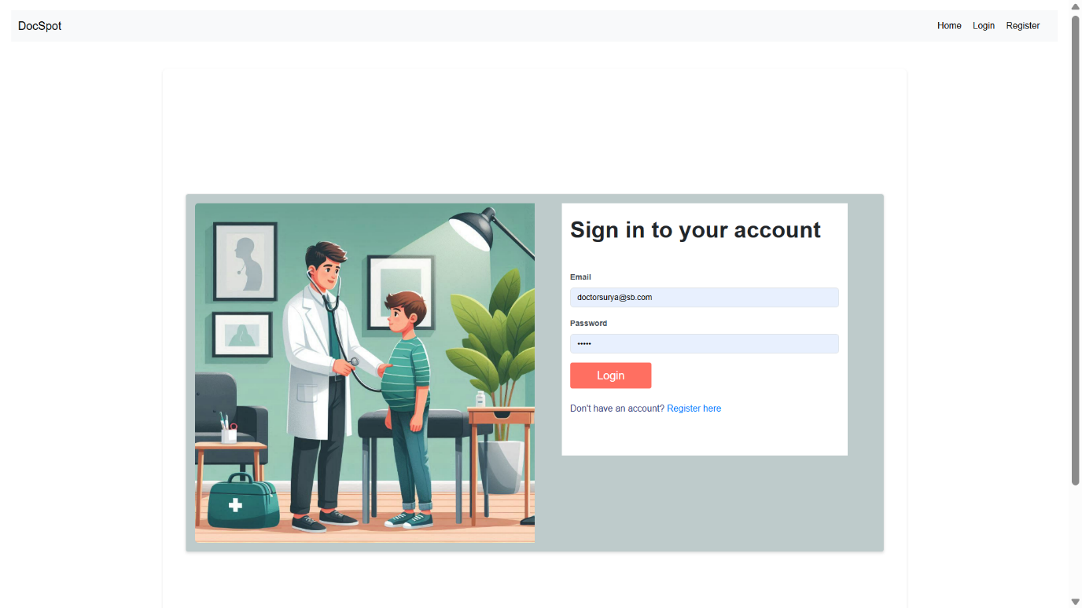

* **Login Home Page**

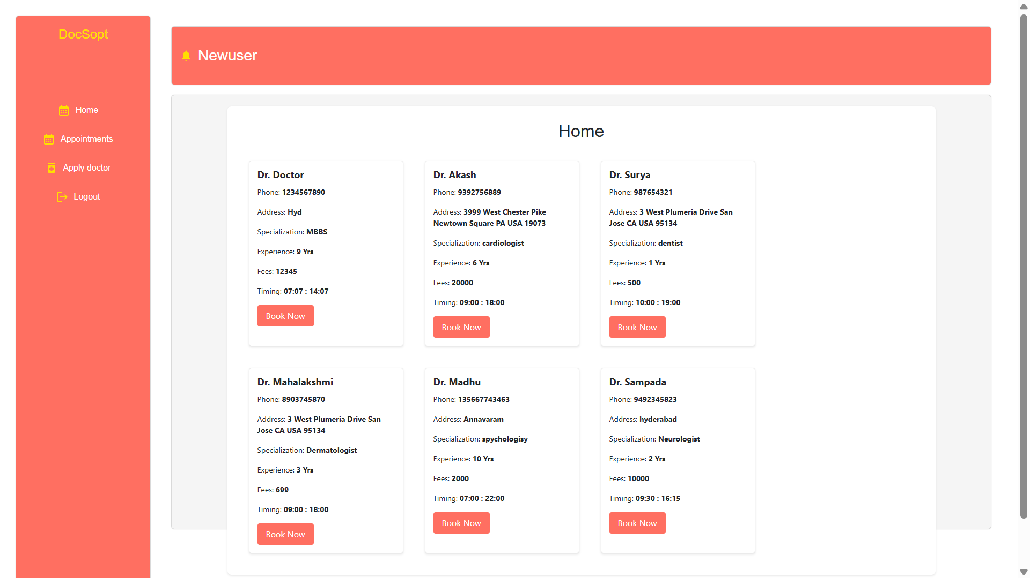

* **Appoimtments**

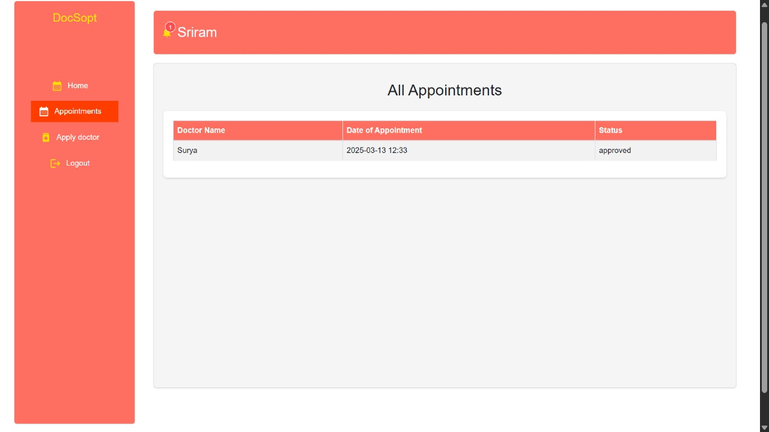

* **Apply Doctor**

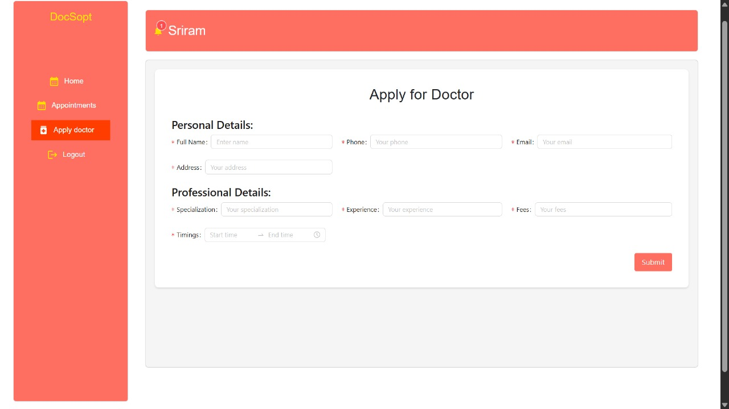

* **Doctor Home Page**

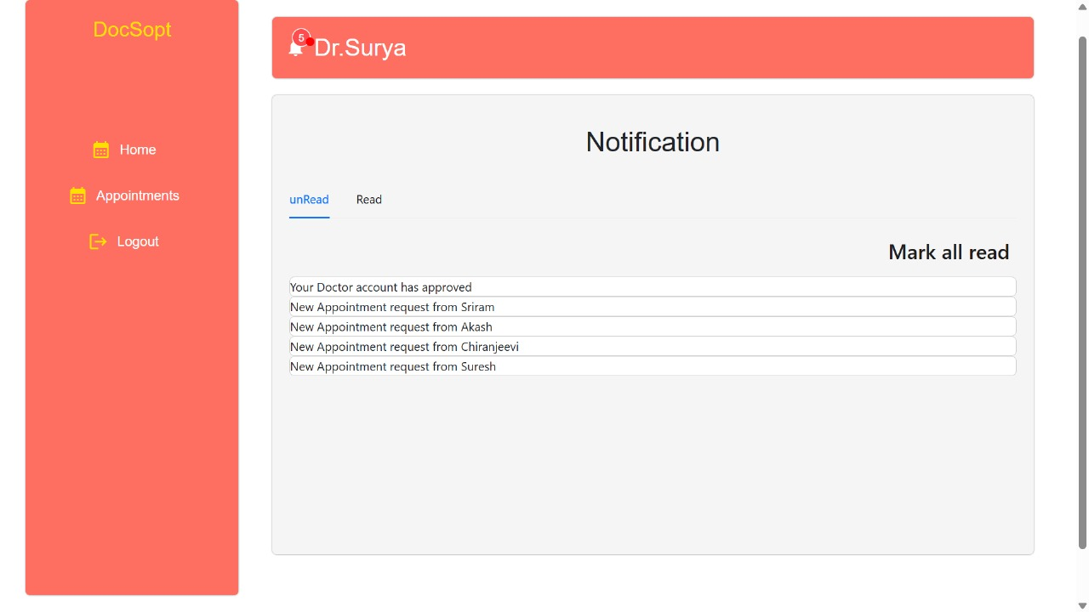

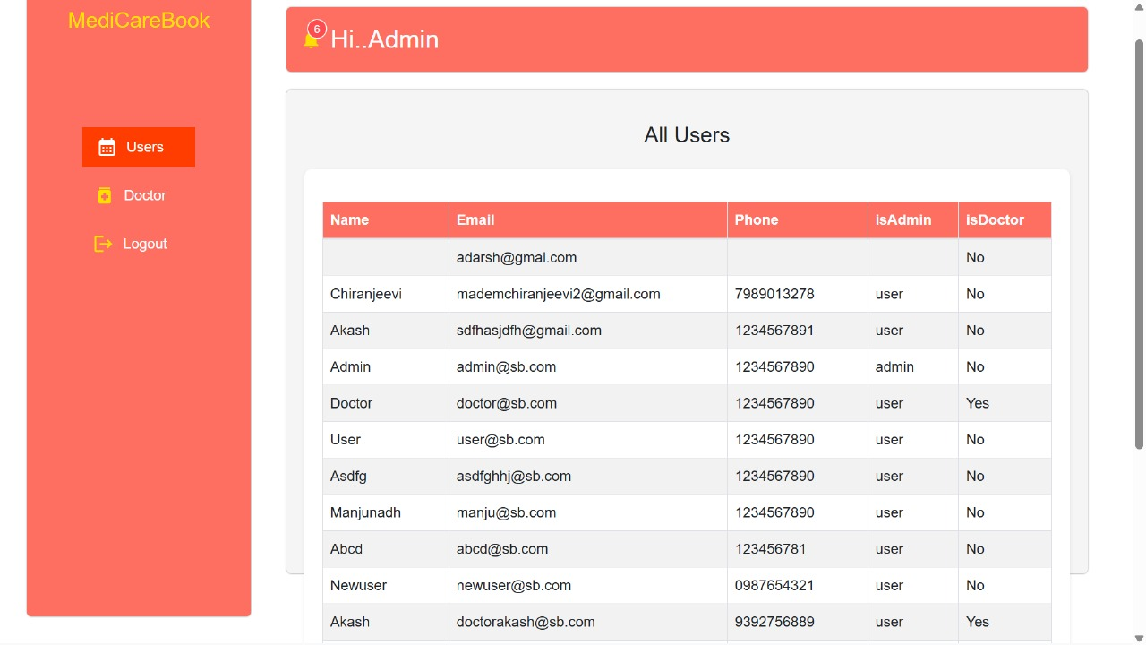

* **Admin Home Page**



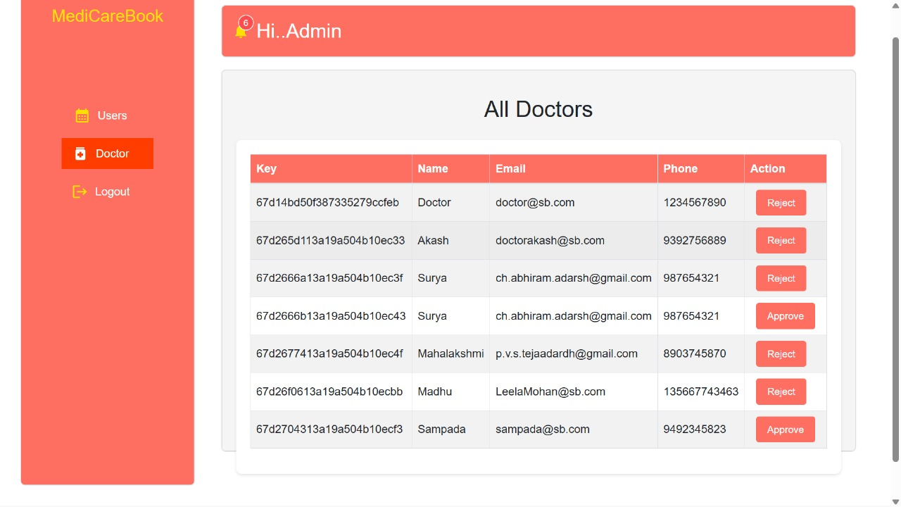

**Known Issues:**

1**. State Management Issues Issue**: Inconsistent state updates or state not being properly managed across components. Solution: Consider using a state management library like Redux or Context API to manage global state.

2. **API Error Handling Issue:** Lack of comprehensive error handling for API requests. Solution: Implement proper error handling for all API requests to provide meaningful feedback to the user.

3. **Form Validation Issue:** Forms may lack proper validation, leading to incorrect or incomplete data submission. Solution: Implement form validation using libraries like Formik or Yup to ensure data integrity.

4. **Performance Bottlenecks Issue**: Components may re-render unnecessarily, causing performance issues. Solution: Use React's useMemo and useCallback hooks to optimize component rendering.

5. **Accessibility Issues Issue:** The application may not be fully accessible to users with disabilities. Solution: Use tools like Axe or Lighthouse to identify and fix accessibility issues.

6. **Security Vulnerabilities Issue:** Potential security vulnerabilities such as XSS, CSRF, or SQL injection. Solution: Implement security best practices, such as sanitizing user inputs and using prepared statements for database queries.

7. **Styling Conflicts Issue**: CSS styles may conflict or override each other, leading to inconsistent UI. Solution: Use CSS modules or styled-components to scope styles locally and avoid conflicts.

8. **Responsive Design Issue**: The application may not be fully responsive, leading to poor user experience on different devices. Solution: Use media queries and responsive design techniques to ensure the application works well on all screen sizes.

9. **Testing Coverage Issue**: Insufficient test coverage, leading to undetected bugs and regressions. Solution: Increase test coverage by writing unit, integration, and end-to-end tests for all critical components and functionalities.

10. **Code Quality Issue:** Inconsistent code quality and potential code smells. Solution: Use linters like ESLint and code formatters like Prettier to maintain consistent code quality.

11. **Dependency Management Issue:** Outdated or vulnerable dependencies. Solution: Regularly update dependencies and use tools like npm audit to identify and fix vulnerabilities.

12. **User Experience Issue**: Lack of user feedback for actions such as form submissions or API requests. Solution: Provide visual feedback (e.g., loading spinners, success/error messages) to improve user experience.

13. **Navigation and Routing Issue**: Inconsistent or broken navigation and routing. Solution: Ensure that all routes are properly defined and tested, and use React Router for managing navigation.

14. **Data Fetching Issue:** Inefficient data fetching leading to slow load times. Solution: Use techniques like lazy loading and pagination to optimize data fetching. By addressing these potential issues, you can improve the overall quality, performance, and user experience of your project.

**Future Enhancements:**

1. **Improved State Management Enhancement**: Implement a state management library like Redux or Context API to manage global state more efficiently. Benefit: Simplifies state management across the application and makes it easier to handle complex state interactions.

2. **Enhanced Form Validation Enhancement**: Use libraries like Formik and Yup for form validation. Benefit: Ensures that all forms have consistent and robust validation, improving data integrity and user experience.

3. **Responsive Design Enhancement**: Ensure that all components are fully responsive and work well on different screen sizes. Benefit: Provides a better user experience on mobile devices and tablets.

4. **Accessibility Improvements Enhancement**: Conduct an accessibility audit and fix any issues identified. Benefit: Makes the application accessible to users with disabilities, improving usability for all users.

5. **Performance Optimization Enhancement**: Optimize component rendering using React's useMemo and useCallback hooks. Benefit: Reduces unnecessary re-renders and improves application performance.

6. **Code Splitting and Lazy Loading Enhancement:** Implement code splitting and lazy loading for components. Benefit: Reduces initial load time and improves performance by loading components only when needed.

7**. Unit and Integration Testing Enhancement:** Increase test coverage by writing more unit and integration tests. Benefit: Ensures that all components and functions work as expected, reducing the likelihood of bugs.

8**. End-to-End Testing Enhancement**: Implement end-to-end testing using tools like Cypress or Selenium. Benefit: Tests the entire application flow, ensuring that all features work correctly from the user's perspective.

9. **Security Enhancements Enhancement**: Conduct a security audit and fix any vulnerabilities identified. Benefit: Protects the application from security threats and ensures data privacy and integrity.

10. **User Feedback and Analytics Enhancement:** Implement user feedback and analytics tools like Hotjar or Google Analytics. Benefit: Gathers insights into user behavior and identifies areas for improvement.

11. **Internationalization (i18n) Enhancement**: Implement internationalization to support multiple languages. Benefit: Expands the application's reach to a global audience.

12**. Continuous Integration and Deployment (CI/CD) Enhancement:** Set up CI/CD pipelines using tools like GitHub Actions or Jenkins. Benefit: Automates the build, test, and deployment process, ensuring faster and more reliable releases.

13**. Improved Documentation Enhancement**: Create comprehensive documentation for the codebase and user guides. Benefit: Makes it easier for new developers to understand the code and for users to navigate the application.

14. **Enhanced User Interface Enhancement:** Improve the UI design using modern design principles and frameworks like Material-UI or Ant Design. Benefit: Provides a more polished and professional look and feel to the application.

15. **Real-time Features Enhancement:** Implement real-time features using WebSockets or libraries like Socket.io. Benefit: Provides real-time updates and notifications, improving user engagement. By implementing these enhancements, you can improve the overall quality, performance, and user experience of your project.