GUARDIAN SENTINEL
Hybrid Deep Learning Framework for Phishing and Business Email Compromise Detection

A Final Year Project Report
Submitted in partial fulfillment of the requirements for the award of the degree
Bachelor of Technology
in
Computer Science and Engineering

Prepared By: ______________________________
Register Number: __________________________
Guide / Supervisor: _______________________
Department / Institution: _________________
Date: 08 April 2026

Abstract
Guardian Sentinel is an AI-driven email security platform designed to detect phishing emails and Business Email Compromise (BEC) attempts using a hybrid detection strategy. The project combines deep learning based text classification with a heuristic BEC feature engine to improve both accuracy and explainability. The deployed system uses a Bidirectional Long Short-Term Memory (Bi-LSTM) model for inference, a FastAPI backend for real-time processing, Gmail integration for live inbox synchronization, and a React dashboard for security monitoring. The application can analyze email content, assign a threat score, expose triggered BEC indicators, cache processed emails, and allow the user to review or delete suspicious messages from Gmail. This report presents the problem definition, system design, module implementation, methodology, results, limitations, and future improvements of the project.

1. Introduction
Email remains one of the most widely used communication media in organizations, and it is also one of the most frequently exploited attack surfaces. Modern phishing campaigns are no longer limited to poorly written spam messages. Attackers now craft highly targeted emails that imitate executives, vendors, HR departments, and financial teams. These attacks often aim to steal credentials, obtain confidential information, or trigger fraudulent money transfers. Business Email Compromise is especially dangerous because the messages often appear genuine and may bypass traditional keyword or rule-only filters.
Guardian Sentinel was developed as a final year project to address this problem with a practical, research-oriented, end-to-end system. The project includes data preprocessing, neural network based classification, heuristic explainability, Gmail ingestion, backend APIs, and a user-facing dashboard for reviewing safe and suspicious emails.

2. Problem Statement
Traditional spam filters are often insufficient for detecting sophisticated phishing and BEC attacks because such emails can appear linguistically legitimate and contextually relevant. A more intelligent system is required to analyze the email body, recognize malicious intent patterns, identify BEC signals such as urgency or fund transfer manipulation, and present the outcome in an understandable way for users.

3. Objectives
- To build an intelligent system for detecting phishing and BEC emails from message content.
- To implement a hybrid pipeline that combines deep learning with heuristic BEC feature extraction.
- To provide a real-time API for email analysis and live Gmail inbox synchronization.
- To design a dashboard that displays safe emails, suspicious emails, threat scores, and triggered warning flags.
- To allow users to manage suspicious emails through feedback logging and Gmail delete actions.
- To evaluate the system using standard visual outputs such as confusion matrix and performance curves.

4. Existing System
Conventional email security tools rely heavily on static rules, blacklists, and header-based checks. These methods may detect obvious spam, but they are less effective against targeted phishing emails that use normal business language. They also provide limited explainability to the end user and may not integrate directly with a user-facing analysis dashboard.

5. Proposed System
The proposed system is a hybrid deep learning and heuristic security platform. The deployed runtime uses a trained Bi-LSTM model to classify email content and a heuristic BEC engine to expose suspicious behavioral signals such as executive impersonation, victim isolation, urgency, credential phishing, and bank manipulation. The solution is implemented as a FastAPI backend connected to Gmail for live synchronization and a React frontend for visualization.
- Fetch or receive email content from Gmail sync or direct prediction input.
- Clean and preprocess the message using tokenization and stopword removal.
- Generate heuristic BEC indicators from the message text.
- Run the Bi-LSTM model on the processed sequence.
- Return spam verdict, confidence score, and explainable flags.
- Display the results in a dashboard for security review and action.

6. System Architecture
The architecture of Guardian Sentinel is composed of four major layers: input and acquisition, preprocessing and feature engineering, classification and analysis, and visualization and control.
- Input Layer: Gmail inbox messages or manually supplied email text.
- Preprocessing Layer: Regex cleaning, lowercasing, stopword removal, tokenization, sequence padding.
- Heuristic Layer: BEC signal extraction for explainability.
- Neural Layer: Bi-LSTM model with tokenizer and sequence inference.
- Backend Layer: FastAPI endpoints for predict, sync, cache reset, feedback, profile fetch, and delete.
- Frontend Layer: React dashboard for inbox views, detail analysis, metrics, and export options.

7. Module Description
The project is divided into the following functional modules:
- Data preprocessing module in `data_pipeline.py` for cleaning text and generating BEC features.
- Model module in `models.py` for ANN, RNN, LSTM, and Bi-LSTM architectures.
- Training orchestration module in `main.py` for loading datasets and generating model artifacts.
- Backend service module in `api.py` for runtime inference and Gmail-connected operations.
- Gmail integration module in `gmail_service.py` for OAuth, email retrieval, MIME parsing, and trash action.
- React frontend module in `guardian-ui/` for safe inbox, spam review, and analytical views.
- Evaluation module in `evaluate.py` for plots, confusion matrix, and model analysis outputs.

8. Technology Stack
Layer | Technology
Programming Language | Python, TypeScript
Backend Framework | FastAPI, Uvicorn
Frontend Framework | React, Vite, Tailwind-based styling
Machine Learning | TensorFlow / Keras
Data Processing | Pandas, NumPy, NLTK, scikit-learn
Email Integration | Gmail API, OAuth 2.0
Visualization | Recharts, Matplotlib, Seaborn
Persistence | CSV cache files and browser localStorage

9. Dataset and Training Methodology
The training workflow combines three datasets available in the repository: `spam_ham_dataset.csv`, `BusinessEmail_train.csv`, and `BusinessEmail_test.csv`. The merged dataset is preprocessed and then split into training and testing partitions. The tokenizer learns the vocabulary from training data, converts text into integer sequences, and pads them to a fixed length of 50 tokens.
Multiple model architectures are implemented for comparison: ANN, RNN, LSTM, and Bi-LSTM. The deployed runtime uses the Bi-LSTM artifact because bidirectional sequence learning is well suited for understanding long-form business email context. The project also supports optional GloVe embeddings during Bi-LSTM preparation.

10. BEC Heuristic Features
To improve explainability, the system supplements neural classification with a rule-driven heuristic layer. This layer identifies suspicious behavior patterns frequently associated with Business Email Compromise.
Feature | Description
persona_impersonation | Detects references to high-level roles such as CEO, CFO, founder, director, or attorney.
victim_isolation | Detects secrecy or confidentiality cues such as 'keep this confidential'.
urgency_engagement | Detects urgent phrasing such as 'immediate', 'ASAP', or 'action required'.
bank_manipulation | Detects financial transfer language such as wire transfer, routing number, or bank account.
evasion_cleanup | Detects attempts to avoid verification or delete communication records.
credential_phishing | Detects sign-in, password, account verification, or login-related bait.

11. Implementation Details
At runtime, the FastAPI server loads the saved Bi-LSTM model and tokenizer. The `/predict` endpoint accepts raw email text and returns a classification result with confidence and BEC flags. The `/sync-inbox` endpoint authenticates with Gmail, fetches selected message groups such as unread, inbox, sent, archived, or all messages, performs inference, and stores the processed outputs in a cache file. The `/emails` endpoint provides quick access to previously processed mail items, improving the frontend loading experience.
The React dashboard provides two inbox views: Safe Inbox and Spam. It also includes project metrics, connected profile information, sync scope selection, local cache restore, detail view for selected messages, threat deletion, feedback submission, and an overview panel for analytics. The interface is designed to present both operational usability and model explainability.

12. Implemented Features
- Real-time phishing and BEC prediction using a saved Bi-LSTM model.
- Explainable threat analysis with BEC warning flags.
- Gmail OAuth-based integration and live inbox synchronization.
- Multiple sync scopes including unread, read, inbox, sent, archived, trash/spam, and all mail history.
- Project-level caching using backend CSV storage and frontend localStorage.
- Separate safe and threat inbox views for security review.
- Detailed email panel with score, sender, subject, and content preview.
- Threat deletion action that moves suspicious email to Gmail trash.
- Feedback endpoint for recording human corrections.
- Threat reporting and analytical views in the frontend.

13. User Interface Screens
The following screenshots show the major interface states of Guardian Sentinel. Inbox content has been redacted for privacy before inclusion in this report.
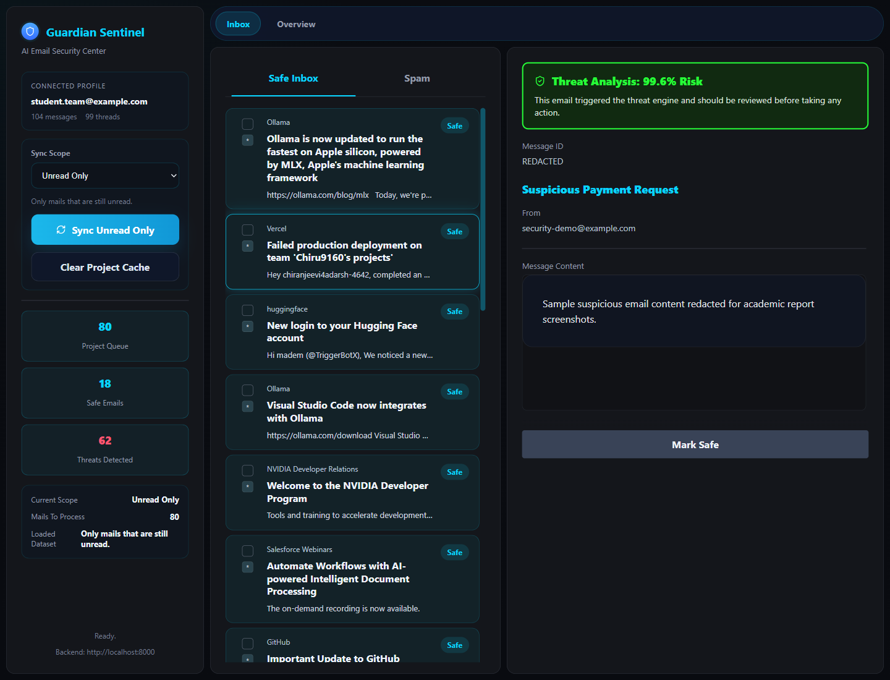
Figure 1. Safe Inbox dashboard showing synchronized legitimate messages and security summary.
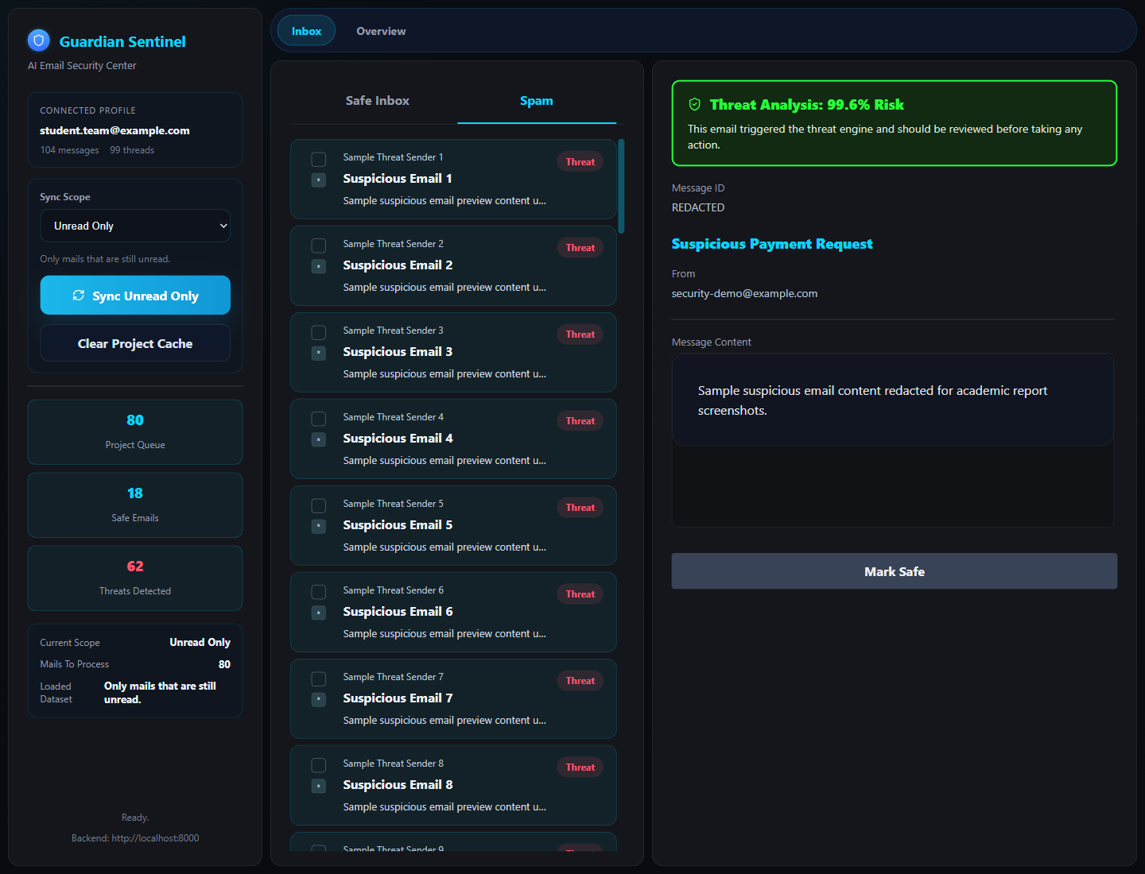
Figure 2. Threat analysis view showing a suspicious email, risk score, and delete action.

14. Results and Evaluation
The repository includes evaluation outputs such as a confusion matrix and model performance curves. These figures demonstrate the project focus on comparative model analysis and operational detection quality. The repository README reports a research-phase accuracy of 98.2% for the hybrid framework, while the present runtime continues to use the saved Bi-LSTM artifact for deployment.
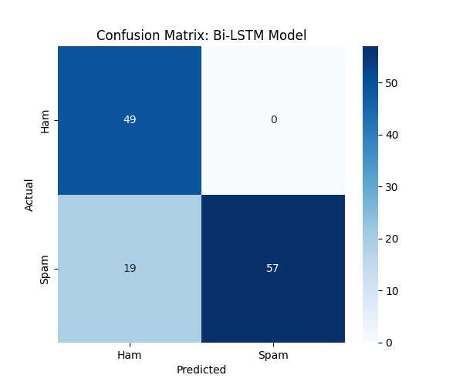
Figure 3. Confusion matrix generated during model evaluation.
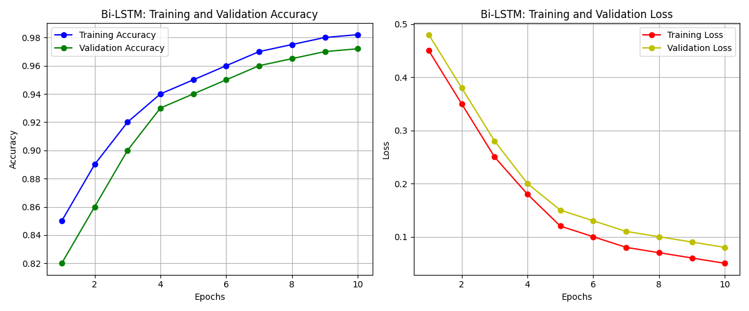
Figure 4. Performance curves showing training and evaluation behavior.

15. Advantages of the System
- Combines deep learning accuracy with interpretable heuristic warning signals.
- Supports real-world operation through Gmail connectivity and dashboard review.
- Separates safe and suspicious messages for quicker triage.
- Persists processed mail state for faster loading and continuity across sessions.
- Provides a practical base for future retraining and real-time deployment improvements.

16. Limitations
- HTML rendering quality depends on the actual message content returned by Gmail.
- Feedback logging and retraining workflow are not yet fully aligned.
- The repository contains multiple frontend variants, which may increase maintenance drift.
- The cached email store can preserve older message states until refreshed.
- Some evaluation outputs in the repository mix research artifacts and illustrative plotting.

17. Future Scope
- Automated retraining using user feedback and newly labeled email samples.
- Support for multilingual phishing detection and cross-domain threat detection.
- Integration with broader enterprise security platforms and threat intelligence feeds.
- Improved explainability dashboards for analyst-friendly investigation.
- Dedicated health monitoring, audit logging, and production readiness improvements.
- Unified frontend strategy with a single primary interface and stronger deployment workflow.

18. Conclusion
Guardian Sentinel demonstrates how a final year project can combine academic deep learning research with an operational product-style implementation. The system addresses phishing and Business Email Compromise detection through a hybrid architecture that includes preprocessing, sequence modeling, heuristic explainability, backend APIs, Gmail integration, and a modern frontend dashboard. Its current implementation already supports live email synchronization, threat scoring, explainable warning flags, and message-level action handling. With further refinement in retraining, evaluation consistency, and production hardening, the project can evolve into a more robust and deployable intelligent email security platform.

19. References
- Project repository source files: `api.py`, `data_pipeline.py`, `gmail_service.py`, `models.py`, `main.py`, and `guardian-ui/`.
- Systematic literature review summary in `RESEARCH.md`.
- Project context and implementation notes in `project_context.md`.
- TensorFlow / Keras documentation for deep learning model construction.
- FastAPI documentation for REST API development.
- Google Gmail API documentation for OAuth and message operations.

