**Create a package named "com.example hr" that includes an Employee class. The**

**Employee class should have the following fields:**

**name - a string that represents the employee's name.**

**id- an integer that represents the employee's ID number.**

**salary-a double that represents the employee's salary.**

**a. The Employee class should also have the following methods:**

**b. public void printName()- a method that prints the employee's name to the console.**

**c. public void printSalary() - a method that prints the employee's salary to the console.**

**d. Create a second package named "com.example.hrtest" that includes a class named "Employee Test". The "Employee Test" class should include a main method that creates an instance of the "Employee" class, sets the employee's name, ID number, and salary, and calls its methods to print the employee's name and salary to the console.**

**e. In your main method, use the import statement to import the "com.example.hr package and access the "Employee" class**

**f Compile and run your program to verify that it successfully creates an instance of the Employee" class and calls its methods to print the employee's name and salary to the console.**

Com.example.hr Package

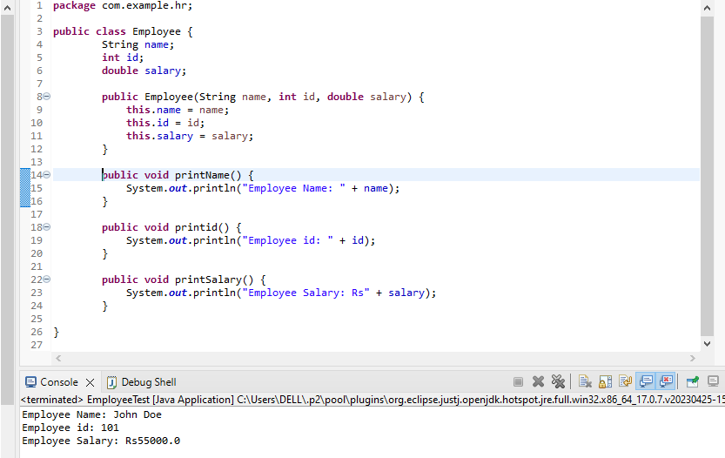

Imported com.example.hr.Employee

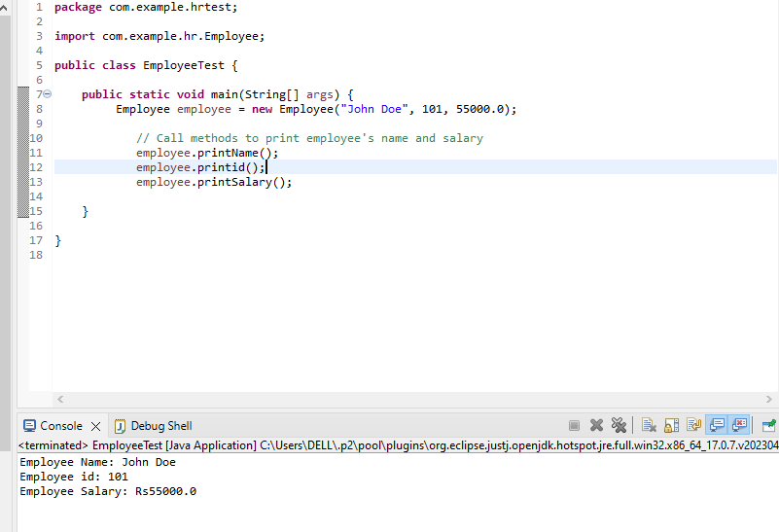

**2. Write a Java program to create an ArrayList of strings and then remove all the elements from the ArrayList**

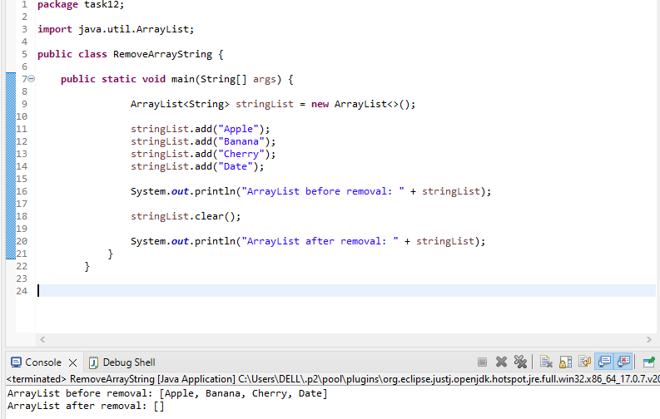

**3. Write a Java program to create a TreeMap of employee IDs and names. Then, print out the names of all the employees in alphabetical order.**

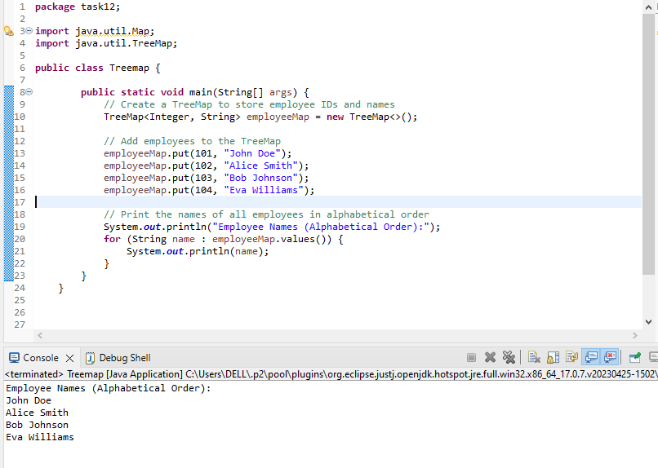

**4. Write a program to convert List to Array**

