2. Write a program that reads in a string from the user and uses a loop to reverse the order of the characters in the string. Then, output the reversed string.

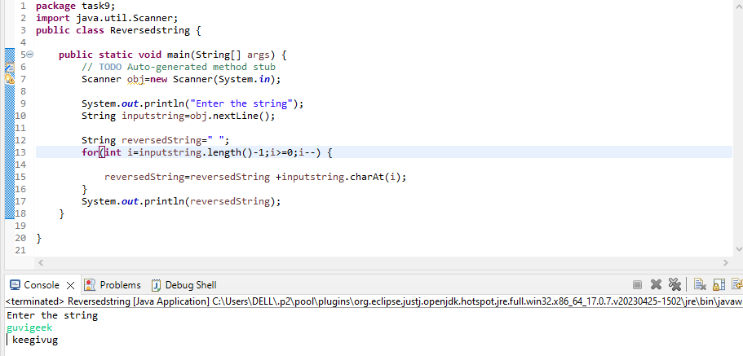

3. Write a program to print the given below pattern.

Sample Input:

4

Sample Output:

1

23

456

78910

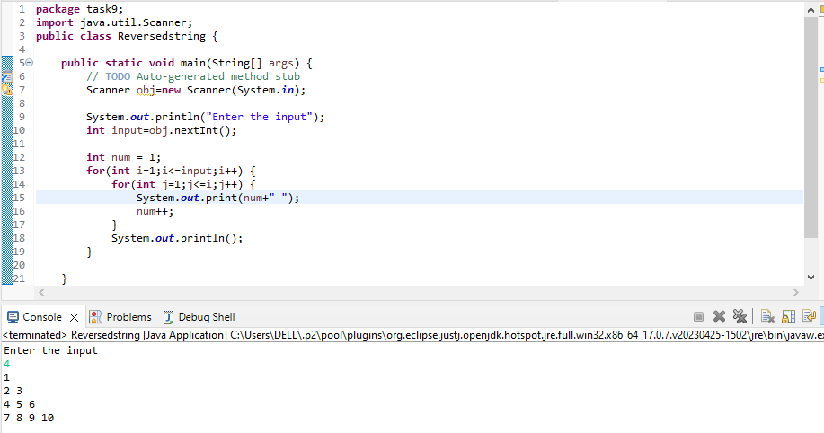4. Write a program to print the given below pattern.

Sample Input"

5

Sample Output:

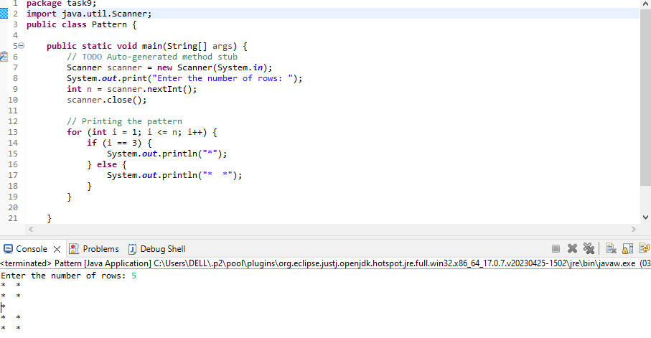

5. Anna University Grading System

The newly appointed Vice-Chancellor of Anna University wanted to create an automated grading system for the students to check their grade. When a student enters a mark. The

grading system displays the corresponding grade. Write a program to solve the given problem. The grades for marks 100-S. 90-99 is A, 80-89 is B, 70-79 is C, 60-69 is D. 50-59 is E and less than 50 is F.

Input format:

The input consists of one integer which corresponds to the marks scored by the

student

Output format:

I If a student marks greater than 100. print "Invalid Input". Otherwise, print the

grade.

Sample Input:

78

Sample Output:

C

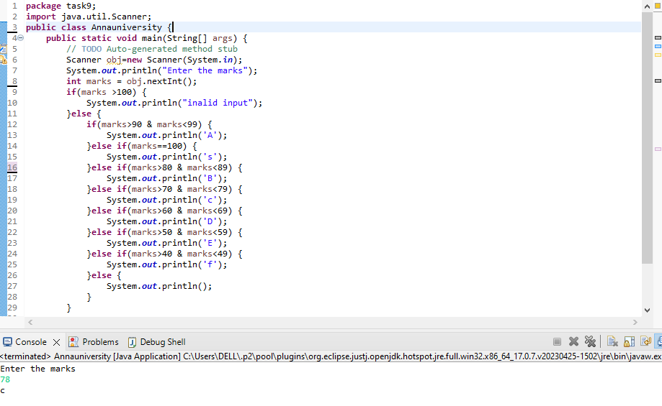

6. Write a program to calculate the hotel tariff. The room rent is 20% high during peak seasons [April-June. November-December]. Note: Use the switch construct.

Input format:

The first input containing an integer which denotes the number of the month

The second input containing the floating-point number which denotes the room

rent per day

The third input containing an integer which denotes the number of days stayed in

the hotel

Output format:

Print the hotel tariff to be paid in floating point with 2 decimal places

Refer the sample output for formatting

Sample Input:

3

1500

2

Sample Output:

3000.00

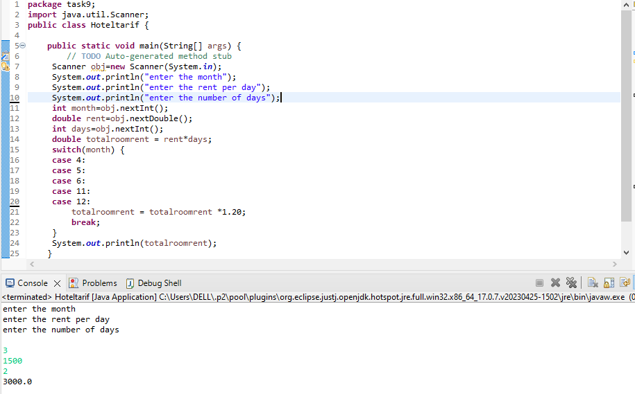

1. Write a program to check whether a given string is a palindrome or not using for loop and if-else statement.

