Smart Barangay: An AI-Powered Web and Mobile Services
Portal for Barangay Tandang Sora, Butuan City

A Capstone Project Presented to
the Faculty of the Computer Studies Program
Father Saturnino Urios University
Butuan City

In Partial Fulfillment
of the Requirements for the Degree of
Bachelor of Science in Information Technology

by
Donnel L. Simbajon
Chistopher B. Raper
John Reanne P. Viray
Justin Kim P. Nadela

June 2026

TABLE OF CONTENTS

CHAPTER 1 THE PROBLEM AND REVIEW OF LITERATURE
Introduction 5
1.1 Background of the Study 5
1.2 Review of Related Literature 10
1.2.1 Barangay and Local Government Information System 10
1.2.2 E-Government and Digital Public Services 12
1.2.3 Web-based and Mobile-based Information System 14
1.2.4 Artificial Intelligence in Government Services 15
1.2.5 Large Language Models (LLM) and Generative AI 16
1.2.6 Ai Chatbot and Conversational Systems 18
1.2.7 Knowledge Management and Information Retrieval 19
1.2.8 Workflow Automation and Digital Request Management 21
1.2.9 Ai Memory and Context-Aware Systems 22
1.3 Theoretical Framework 23
1.3.1 DeLeone and McLean Information System Success Model 23
1.3.2 Human-Computer Interaction Theory 25
Conversational AI and Natural Processing Theory 26

1.3.4 A Graph-Based Retrieval-Augmented Generation Approach 27
1.4 Conceptual Framework 29
Research Paradigm 31
1.5 Statement of the Problem 32
1.6 Objective of the Study 32
1.7 Significance of the Study 34
1.8 Scope and Limitation of the Study 36
1.9 Definition of Terms 37
CHAPTER 2 METHODOLOGY
2.1Research Design 42
2.1.1 Software Development Model 42
2.1.2 Phases of the Waterfall Model 43
2.1.3 Requirements Analysis and Specifications 45
System Architecture 50
Data Flow Diagram 53
Use Case Diagram 54
Entity Relational Diagram 56
2.2 Software Requirements 57
2.2.1 Technical Requirements 57
Environment, Population, and Sample 58

Researched Environment 58
Sampling Technique 60
Ethical Consideration 61
Research Instrument 62
Data Gathering Procedure 63
Prototype 66
References 73

CHAPTER 1 THE PROBLEM AND REVIEW OF LITERATURE

INTRODUCTION
This chapter introduces the Smart Barangay Portal, an AI-assisted web and Progressive Web Application (PWA) system developed for Barangay Tandang Sora, Butuan City. It outlines the background of the study, review of related literature, statement of the problem and objectives, theoretical, conceptual, and research paradigm, scope and limitations, and definition of terms. This revised manuscript distinguishes verified current functionality from planned enhancements.

1.1 Background of the Study
Governments worldwide are increasingly adopting Artificial Intelligence (AI) as part of e-governance, using computers, mobile devices, and the internet so that systems can answer questions, process requests, and assist citizens at any time without requiring an in-person visit or human staff (Wirtz, Weyerer, & Geyer, 2019; Al-Ansi et al., 2024; United Nations, 2024; World Bank, 2022).
Al-Ansi et al. (2024) found that governments adopting such tools reported measurable gains in response speed and accuracy. In the Philippines,

this movement takes shape as the "E-Barangay" framework, encouraging barangays, the smallest government units to modernize services digitally (Bringula et al., 2022; Department of Information and Communications Technology [DICT], 2023). At the national level, DICT-led programs apply AI to improve service delivery, streamline administrative processes, and strengthen data-driven, citizen-centered governance (DICT, 2024) advancing the country's push for an efficient, transparent government that supports digital-age innovation and growth (National Economic and Development Authority [NEDA], 2023; United Nations, 2024; World Bank, 2022).
Despite these efforts, local adoption lags: as of 2024, only 318 of the country's more than 1,600 local government units (LGUs) had implemented DICT's eLGU barangay clearance system (DAP, 2024), and the Department of the Interior and Local Government's (DILG) Barangay Information Governance System (BIGS) has only recently reached the grassroots level (OpenGov Asia, 2025). Many barangays including Barangay Tandang Sora (Barangay 12) in Butuan City have yet to embrace this shift; even where digital tools exist, such as the cloud-based systems Olipas (2020) describes, they function only as basic filing systems, requiring staff to manually encode, monitor, and retrieve

records rather than answer resident questions, process requests independently, or reduce in-person visits.
In Barangay Tandang Sora, this gap is evident in daily operations. Interviews with barangay officials (Annex A) confirmed that records and services are still managed through paper logbooks, handwritten forms, and manual filing senior citizens, for instance, are recorded entirely by hand in notebooks vulnerable to human error, damage, and unauthorized access. Residents seeking basic information, such as clearance requirements, rely on informal inquiries or the barangay's social media page and group chats, where it is quickly buried under newer posts and hard to locate, leading to recurring misinformation, repeated inquiries, and continued reliance on in-person visits for information that could otherwise be self-served.
Residents therefore default to visiting the barangay hall in person for documents, questions, or appointments, creating long queues at peak hours; this burdens residents, who take time off work or school for routine inquiries, and staff, who spend much of the day on repeat questions instead of higher-value work. The pattern reflects a gap between current practice and two policy pushes toward digital governance: DICT's SPARK Program (Philippine Information Agency [PIA], 2024) and Butuan City's Smart Eco City vision,

which promotes technology-driven governance, innovation, and digital resilience in public service delivery (City Government of Butuan, 2024; PIA, 2025).
AI directly answers these problems: where information gets buried in group chats, AI-powered systems can give residents instant, on-demand access to it; where staff lose hours to repeat questions, chatbots can absorb routine inquiries and provide 24/7 assistance without added personnel (Wirtz, Weyerer, & Geyer, 2019; Al-Ansi et al., 2024; OECD, 2023). Evidence from other governments shows this shift raises efficiency, shortens response times, and improves citizen satisfaction (Wirtz, Weyerer, & Geyer, 2019; Al-Ansi et al., 2024; United Nations, 2024; OECD, 2023), gains that could equally modernize barangay operations toward more responsive, citizen-centered governance.
Recent advances go further: memory-augmented systems let AI retain prior interactions and generate more relevant, continuous responses, cutting repetitive input an advantage where citizens return with related or follow-up questions (Lewis et al., 2020; Borgeaud et al., 2022). Context-aware computing adds a further layer, adapting responses to user intent and interaction history to improve efficiency and user experience (Dey, 2001); applied to barangay operations, these technologies can streamline inquiries, lighten staff workload,

and give residents faster, more consistent information.
To address these problems, this study proposes the Smart Barangay Portal, an AI-integrated system with two components: a Web Portal for barangay staff and administrators, and a Mobile Application for residents.

1.2 Review of Related Literature
1.2.1 Barangay and Local Government Information Systems
Barangays, as the smallest administrative units in the Philippines, often struggle with inefficient manual processes and fragmented data management systems that hinder effective governance and timely service delivery (Tosper Jr. et al., 2025; Reyes et al., 2021). Tosper Jr. et al. (2025) addressed these challenges by developing WebYu, a web-based Barangay Information

Management System for Barangay Yuson in Guimba, Nueva Ecija. Using the Scrum development methodology and evaluating the system through the ISO/IEC 25010 software quality model, they reported an overall quality rating of “Excellent,” with particularly high scores in maintainability and security (Tosper Jr. et al., 2025). Field testing further showed substantially faster processing times for barangay certifications and fewer documentation errors compared to manual methods, demonstrating that digitalization can significantly improve efficiency, accessibility, and transparency at the barangay level (Tosper Jr. et al., 2025; Reyes et al., 2021).
In a similar initiative, Enaño et al. (2025) developed BarangayConnect, a web-based information portal for resident data, administrative services, and community records in Barangay San Miguel, Pasig City. The system centralizes resident information, automates document requests (e.g., clearances and certificates of residency), and provides dashboards for data-driven decision-making (Enaño et al., 2025; Asian Development Bank, 2021). Evaluated using ISO/IEC 25010, BarangayConnect achieved strong ratings in efficiency, usability, and portability, though the authors recommended further enhancements in functionality and reliability (Enaño et al., 2025). Together, WebYu and similar e-governance systems illustrate that web-based barangay systems can reduce manual paperwork, speed up service delivery, and improve

transparency goals that are directly aligned with SMART BARANGAY (Asian Development Bank, 2021).
Despite these advances, existing barangay systems such as WebYu and BarangayConnect still rely primarily on structured forms and menu-driven interfaces (Tosper Jr. et al., 2025; Enaño et al., 2025). They do not incorporate advanced AI or large language model (LLM) capabilities to handle complex, natural-language inquiries about barangay ordinances, documentary requirements, or service procedures. This limitation suggests that while digital transformation at the barangay level has progressed, there remains a gap in intelligent, conversational interaction that SMART BARANGAY aims to address.

1.2.2 E-Government and Digital Public Services
The broader literature on e-government supports the move toward digital public services as a means to improve government–citizen interaction, efficiency, and transparency. In the context of Philippine local government, Santos (as cited in Enaño et al., 2025) observed that digital platforms are increasingly replacing manual, paper-based processes for certificates, permits, and clearances, with the COVID-19 pandemic accelerating the need for contactless and efficient service delivery. However, challenges such as unstable

internet connections, limited technological infrastructure, and gaps in digital literacy among staff still hinder full implementation, highlighting the importance of user-friendly, reliable systems and continuous capacity-building (Enaño et al., 2025).
At the global level, the United Nations (2022) emphasized in its E-Government Survey that digital government initiatives should prioritize inclusivity, accessibility, and responsiveness to citizen needs, especially in local government units that serve as the first point of contact for many residents. Digital public services improve government–resident interaction by enabling remote access to transactions, reducing waiting times, and increasing transparency through traceable processes (United Nations, 2022). Yet many e-government platforms still focus primarily on transactional efficiency without integrating intelligent assistance that can guide citizens through complex procedures or answer diverse questions in natural language. SMART BARANGAY extends this e-government vision by combining digital service automation with AI-powered conversational support, thereby enhancing both accessibility and user experience at the barangay level.

1.2.3 Web-Based and Mobile-Based Information Systems
Web-based and mobile-based information systems are central to modernizing barangay services by enabling residents to access transactions and information through multiple devices and platforms. Enaño et al. (2025) designed BarangayConnect using standard web technologies (HTML, CSS, JavaScript, PHP, and MySQL), creating a responsive and user-friendly interface accessible on both computers and smartphones via browsers. The system supports automated request handling, record management, and report generation through an intuitive dashboard for barangay staff, demonstrating that web-based platforms can effectively centralize resident data and streamline administrative services (Enaño et al., 2025).
The integration of web and mobile access is particularly important for barangay services because many residents rely on smartphones as their primary device for communication and information access. BarangayConnect is accessible via mobile browsers but does not include a dedicated mobile application, and the authors explicitly recommend a separate mobile app to improve accessibility and user experience (Enaño et al., 2025). SMART BARANGAY responds to this need through a web portal for staff and a mobile-friendly Progressive Web Application (PWA) for residents, using a shared backend for the features currently implemented.

Integrated web and mobile-friendly platforms can use API-based communication to share data between front-end applications and a back-end database. In SMART BARANGAY, the current build supports shared authentication, request storage, status tracking, and administrative verification flows through Supabase. Complete synchronization, real-time service updates, and all end-to-end document workflows remain subject to deployment and integration testing.

1.2.4 Artificial Intelligence in Government Services
Artificial intelligence (AI) is increasingly being adopted in public administration to support decision-making, automate routine tasks, and enhance service delivery. Singh and Hess (2026) examined AI chatbots in public services across several countries and found that AI-based conversational agents have significant potential to improve efficiency, citizen engagement, and accessibility, particularly for structured query services such as basic information requests and status checks. Their findings show that AI chatbots can operate as first-line support, providing 24/7 access to information and freeing human staff to focus on more complex tasks (Singh & Hess, 2026).

However, AI implementation in government also presents challenges. AI systems depend on training data that may be incomplete or biased, and in public services, inaccurate or inappropriate outputs can undermine trust and accountability (Singh & Hess, 2026). To mitigate these risks, public-sector AI systems must rely on curated knowledge sources, transparent decision logic, and mechanisms for human oversight, particularly when dealing with sensitive or high-impact decisions.
Intelligent government systems that combine AI with structured workflows can automate routine inquiries, guide citizens through procedures, and escalate complex cases to human personnel. This supports SMART BARANGAY's goal of assisting with repetitive questions and routing service requests while keeping staff responsible for decisions that require human judgment. In the current build, the chatbot provides knowledge-based answers and a basic request-intake flow; broader workflow automation is treated as an implementation target until verified end to end.

1.2.5 Large Language Models (LLMs) and Generative AI
Large language models (LLMs), including GPT-based systems, have advanced natural language understanding and generation capabilities that

enable them to answer complex questions, explain procedures, and generate human-like text. In government contexts, LLMs can be applied to support citizen inquiries, document drafting, and policy explanation, provided that their outputs are grounded in reliable, domain-specific information. Retrieval-Augmented Generation (RAG) techniques enhance LLMs by combining them with external knowledge bases, so that the model retrieves relevant information from curated documents (such as ordinances and service guidelines) before generating a response.
In barangay services, LLMs can support residents by answering questions about documentary requirements, explaining step-by-step processes for obtaining clearances, and clarifying policy details in plain language. Compared with traditional rule-based systems, LLMs can handle diverse phrasings, understand follow-up questions, and maintain context across multiple conversational turns. At the same time, LLMs carry risks of “hallucinating” unsupported information if not properly constrained, which is not acceptable for official government advice.
SMART BARANGAY addresses these concerns by integrating an LLM chatbot that is grounded in the barangay’s official rules, policies, and service guidelines. By combining LLM capabilities with RAG and a controlled

knowledge base, the system aims to provide flexible yet trustworthy responses tailored to barangay-specific information needs.

1.2.6 AI Chatbots and Conversational Systems
AI chatbots and conversational systems are increasingly used as virtual assistants in e-government service platforms. In a study on intelligent chatbots as frontline agents in e-government service platforms, researchers reported that chatbots can significantly reduce response time, improve consistency of information, and enhance citizen satisfaction when properly designed and integrated into service workflows (Intelligent Chatbots as Frontline Agents, n.d.). Chatbots can handle frequently asked questions, guide users through procedures, and collect initial data before handing off to human staff, thereby acting as a scalable interface between citizens and government services.
Rule-based chatbots, which rely on predefined intents and fixed response templates, are limited in their ability to handle varied natural-language inputs and complex conversational flows. They often fail when users phrase questions unexpectedly or ask follow-up questions outside predefined paths, which can lead to user frustration and reduced trust in digital services. LLM-powered chatbots, by contrast, are better able to interpret diverse phrasing and

maintain context over multiple turns, making them more suitable for complex interactions such as multi-step applications or clarifications of local regulations.
However, LLM-powered chatbots in government settings require strict control to ensure that responses remain accurate, appropriate, and aligned with official policies. SMART BARANGAY is configured to use a barangay knowledge base, RAG-capable API services, and session identifiers. The final deployment must ensure that only approved sources are retrieved, unsupported questions receive a safe fallback, and privacy and retention controls are tested before compliance is claimed.

1.2.7 Knowledge Management and Information Retrieval
Knowledge management and information retrieval are critical for enabling residents to access barangay ordinances, requirements, announcements, and service guidelines efficiently. AI-powered information access systems combine structured knowledge bases with semantic search mechanisms to allow users to pose queries in natural language and receive relevant results. In government settings, such systems enable citizens to locate specific policies, understand

procedural steps, and identify necessary documents without navigating complex websites or static documents.
BarangayConnect illustrates the value of integrating analytical and knowledge-related capabilities within a barangay system. Enaño et al. (2025) incorporated data analytics and linear regression algorithms to analyze demographic and community data, supporting data-driven governance and service planning. While BarangayConnect focuses more on analytics than on conversational retrieval of text-based knowledge, it demonstrates that barangay-level systems can support more advanced functions than simple record-keeping (Enaño et al., 2025). SMART BARANGAY extends this vision by incorporating a knowledge-based chatbot that retrieves and explains information from official barangay documents, ordinances, and service guidelines.
By centralizing official rules and policies in a structured knowledge base and linking them to the LLM chatbot, SMART BARANGAY ensures that residents can ask questions such as “What do I need to get a barangay clearance?” and receive accurate, policy-grounded answers. This approach improves information accessibility and reduces reliance on informal inquiries or unorganized social media posts, which may be incomplete or outdated.

Digital Request Management and Limited Workflow Automation
Workflow automation and digital request management are essential for modernizing barangay administrative processes such as the issuance of clearances, certificates, and other resident documents. Digital request systems allow residents to submit applications online, track their status, and receive notifications when documents are ready, thereby reducing physical visits and queuing at the barangay hall. These systems also create clearer audit trails and improve transparency by recording each step of the process.

WebYu demonstrated that digitizing barangay processes can substantially reduce processing time and documentation errors, with field testing showing significantly faster handling of certifications and fewer manual mistakes compared to traditional approaches (Tosper Jr. et al., 2025). BarangayConnect similarly automates the issuance of documents such as clearances and certificates of residency, reducing manual work while providing dashboards that allow officials to monitor workloads and service performance (Enaño et al., 2025).
SMART BARANGAY applies these ideas through a chatbot-assisted intake flow. When a resident describes a need, such as requesting a barangay clearance, the current interface can identify a related service and display a basic request card. This is an assisted intake feature rather than a complete service-specific dynamic form.

After submission, the request is stored for status tracking and administrative review when the resident record is correctly linked. Required fields, document uploads, automatic approval decisions, filled-template generation, payment processing, and ready-for-pickup delivery are not yet a single verified end-to-end workflow.

1.2.9 AI Memory and Context-Aware Systems
AI memory and context-aware systems allow chatbots to maintain conversation history and interpret user input based on prior exchanges, leading to more natural and efficient interactions. Session-based AI memory enables the chatbot to recall previous messages within a session, understand follow-up questions, and provide coherent, context-sensitive responses. This capability is especially important for multi-step processes such as document applications, where residents may need to ask sequential questions or clarify prior information.
In SMART BARANGAY, the chatbot client creates a session identifier and sends it with chat requests to support conversational context. The current persistence path does not yet prove complete database-linked session memory for every message or a fully enforced multi-request session. Therefore, session context is described as a design capability under verification, not as permanent cross-session memory.

The Philippine Data Privacy Act of 2012 (Republic Act No. 10173) requires personal data to be handled securely and only for legitimate, authorized purposes. The system must enforce user/session isolation, a documented retention period, access controls, and a tested deletion procedure. These controls should be reported as implemented only after deployment verification.

1.3 Theoretical Framework
1.3.1 DeLone and McLean Information Systems Success Model
DeLone and McLean (2003) proposed a comprehensive model for measuring the success of information systems through six interdependent dimensions: System Quality, Information Quality, Service Quality, Use, User Satisfaction, and Net Benefits. Originally introduced in 1992 and updated in 2003 to incorporate service quality as a distinct evaluative dimension, this model has been extensively applied in e-government research to assess digital public service platforms. Its utility lies in its capacity to connect technical performance characteristics with user-centered outcomes, providing a holistic

framework for evaluating both the operational and experiential success of information systems in real-world deployment contexts.
In the context of the Smart Barangay Portal, the DeLone and McLean model informs how system quality, information quality, service quality, user satisfaction, and net benefits will be evaluated across the staff web portal, resident PWA, and chatbot. The current build provides a basis for testing responsiveness, knowledge-answer quality, request tracking, and usability. Claims about notification reliability, processing efficiency, reduced in-person visits, and net benefits must be supported by actual UAT and performance evidence rather than projected outcomes.

1.3.2 Human-Computer Interaction Theory
Human-Computer Interaction (HCI) is an interdisciplinary field that examines the design, evaluation, and implementation of interactive computing systems for human use, with a central focus on usability, user experience, and accessibility (Dix, Finlay, Abowd, & Beale, 2004). Nielsen's (1994) foundational usability heuristics including learnability, efficiency, memorability, error prevention, and satisfaction provide concrete evaluative criteria for assessing the quality of digital interfaces. A core principle of HCI is that effective system design must accommodate the diverse characteristics, abilities, and expectations of intended users, ensuring that technology serves as an enabler of access rather than a barrier to participation.
HCI theory shapes the design decisions of both the resident-facing and staff-facing components of the Smart Barangay Portal. For resident-users a population that encompasses youth, working adults, and senior citizens with varying levels of digital literacy the mobile PWA's chatbot interface adopts a conversational interaction model that minimizes technical barriers and reduces the need for prior technology training. The chatbot's support for queries in Bisaya, Filipino, and English reflects an HCI-informed design principle of linguistic accessibility that prioritizes natural communication. For barangay staff, the administrative web portal employs a structured dashboard layout

that organizes service request management, document uploads, and announcement publishing into clearly defined workflows, reducing cognitive load and the likelihood of operational error. These design decisions are further reinforced by the system's PWA architecture, which ensures consistent interface behavior across mobile phones, tablets, and desktop computers regardless of device capability (Dix et al., 2004; Nielsen, 1994).

1.3.3 Conversational AI and Natural Language Processing Theory
Conversational AI encompasses the design and implementation of computational systems capable of interpreting and generating human language in contextually meaningful and communicatively effective ways. The transformer-based neural architecture introduced by Vaswani et al. (2017) established the theoretical foundation for modern large language models (LLMs) by enabling systems to capture complex linguistic relationships and long-range contextual dependencies through self-attention mechanisms. Building upon this architecture, Brown et al. (2020) demonstrated that large-scale language models can perform diverse natural language processing tasks with high accuracy through in-context learning, establishing the theoretical basis for LLM integration in specialized, domain-specific application environments.

The Smart Barangay Portal's AI-assisted chatbot is grounded in Conversational AI and NLP theory through its API and RAG-oriented implementation. It accepts natural-language resident queries and maps them to informational responses or a basic service-intake flow. The client sends a session identifier to support conversational context, but complete persistent session memory, multi-request grouping, and retention/deletion enforcement require additional implementation and testing. The current system should therefore be described as context-assisted rather than as a fully implemented session-memory architecture.

1.3.4 A Graph-Based Retrieval-Augmented Generation Approach
Information Retrieval (IR) theory addresses the computational processes by which relevant information is identified, retrieved, and presented from structured or unstructured document collections in response to a user's expressed information need (Manning, Raghavan, & Schutze, 2008). Classical

IR models including the vector space model and probabilistic retrieval frameworks establish the foundational logic for matching user queries to document content based on computed relevance scores. Lewis et al. (2020) extended this foundation through the Retrieval-Augmented Generation (RAG) framework, which combines neural document retrieval with generative language models to produce factually grounded, contextually accurate outputs substantially reducing the hallucination and factual inaccuracy problems associated with standalone LLMs operating without access to verified source documents.
The Smart Barangay Portal's AI chatbot is architecturally grounded in RAG theory, implemented through LangChain's document retrieval pipeline integrated with a Supabase vector database. Barangay officials upload official ordinances, service guidelines, and policy documents to the system, which are subsequently indexed as domain-specific vector embeddings representing the barangay's authoritative knowledge base. When a resident submits a query, the RAG mechanism retrieves the most semantically relevant document passages and uses these as the factual grounding for the chatbot's generated response ensuring that answers accurately reflect the barangay's official policies rather than generalized or potentially inaccurate internet content. This design directly addresses one of the core problems identified in the study: residents

receiving outdated or incorrect barangay information through informal channels such as social media. By anchoring AI-generated responses to verified, locally uploaded documents, the system operationalizes IR and RAG theory as a practical mechanism for accurate, policy-consistent public information delivery at the barangay level (Manning et al., 2008; Lewis et al., 2020).

1.4 Conceptual Framework
The conceptual framework of this capstone study adopts the Input-Process-Output (IPO) model, which integrates the principles of Retrieval-Augmented Generation (RAG) Theory, Conversational AI and Natural Language Processing (NLP) Theory, and the Data Privacy Act of 2012 (Republic Act No. 10173). The IPO model is appropriate for this study because it reflects the design, development, and evaluation of an AI-powered web and mobile system by illustrating the flow of data from resident inquiry to administrative output.
The input component consists of resident-generated data, specifically inquiries and service requests submitted in Bisaya, Filipino, and English, as well as staff-managed data such as uploaded ordinances, service guidelines, and identity validation records used to authenticate users and administrators.

In accordance with Conversational AI and NLP Theory, these inputs must be accurately captured and interpreted across multiple languages and linguistic variations to enable the system to generate contextually relevant and policy-based responses rather than generic or unsupported replies.
The process component represents the current core operations of the system. It includes portal access and user identification, natural-language processing of resident queries, retrieval of configured knowledge, basic request-intake display, storage of submitted records, staff verification or request review where supported, and presentation of announcements and notifications. Service-specific dynamic forms, payment handling, filled-template generation, and automatic delivery are proposed extensions. Privacy controls must include explicit session ownership, retention, and deletion verification before the Data Privacy Act claim is stated as fully implemented.
The output component refers to the results produced by the interaction between the resident and the system, as well as the administrative actions that follow. Current outputs include chatbot guidance, stored service requests for administrative review, registration verification states, request status displays, announcements, and in-app notification records where configured.

Automated report generation, generated official templates, payment notices, and external push/SMS delivery should be treated as target outputs unless the corresponding implementation and test evidence are included. The expected broader outcomes, such as fewer in-person visits and improved efficiency, remain evaluation hypotheses rather than guaranteed results.

Research Paradigm
Figure 1.1 Input - Process - Output (IPO)
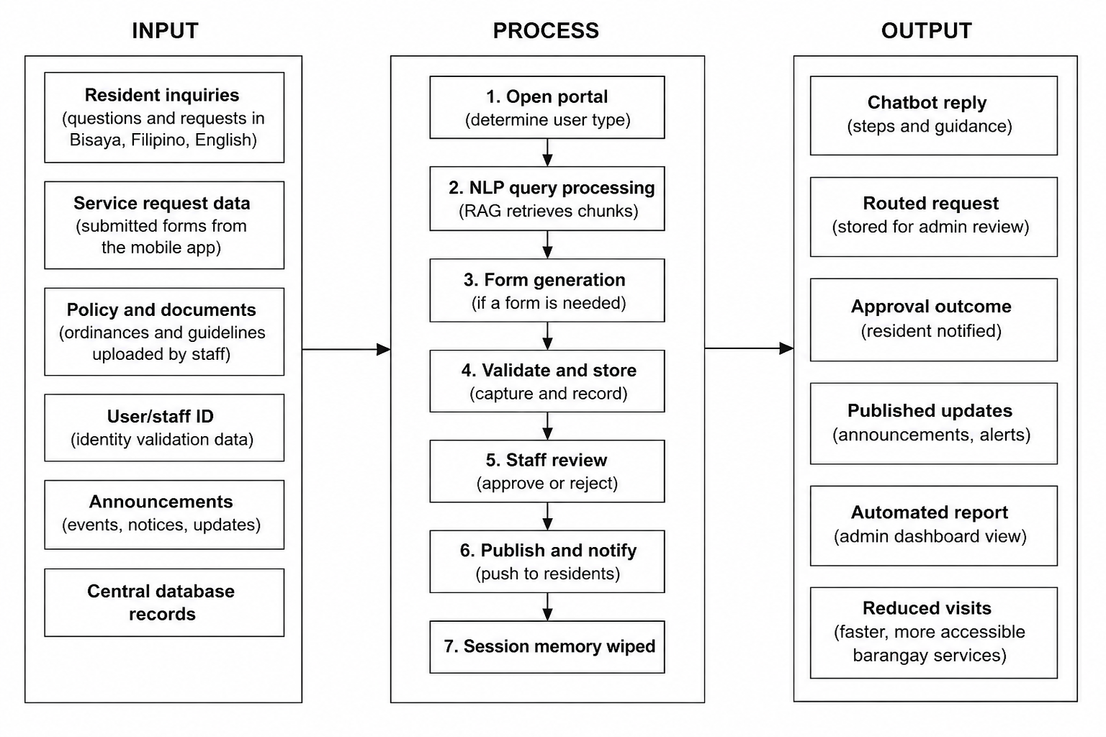

1.5 Statement of the Problem
Despite national efforts to promote digital local governance, adoption of systems such as the DICT’s eLGU barangay clearance system and the DILG’s Barangay Information Governance System remains limited (DAP, 2024; OpenGov Asia, 2025). In Barangay Tandang Sora, records and resident services are still handled through paper logbooks, handwritten forms, and manual filing, making information retrieval slow and prone to error (Annex A). Residents also rely on informal channels such as social media pages and group chats for barangay information, which can lead to outdated guidance and repeated inquiries (Annex A). As a result, residents and staff experience delays and unnecessary time spent on routine transactions. This study addresses this gap through the development of the Smart Barangay Portal, an AI-enabled system for faster and more accessible barangay services (City Government of Butuan, 2023; DICT, 2024; NEDA, 2023; PIA, 2024).

1.6 Objectives of the Study
The main objective of this study is to develop SMART BARANGAY, an AI-assisted web and Progressive Web Application system that supports the administrative and constituent services of Barangay Tandang Sora, Butuan City.

To achieve this objective, the study pursues the following specific objectives:
- To design and develop a staff web portal and resident-friendly Progressive Web Application with shared authentication and database access for the features implemented in the current build.
- To integrate a large language model (LLM) and retrieval-oriented knowledge services to assist with resident inquiries and identify possible service-request intents, subject to source validation and safe fallback behavior.
- To implement configured administrative services covering barangay knowledge content, announcements, resident verification, and monitoring of supported service requests. Service-specific documents such as clearances, certificates of indigency, proof of income, and barangay IDs should be claimed only when their fields, validation, workflow, and output are implemented and tested.
- To implement an AI-assisted chatbot that provides continuous access to configured barangay information and guides residents to the appropriate service or human review when the system cannot safely answer.
- To support a traceable digital request workflow from resident intake to staff review and status tracking. Full automation of document generation, payment collection, pickup notification, and final delivery is outside the currently verified scope unless completed and evaluated before submission.

1.7 Significance of the Study
The significance of this study lies in its potential to improve the delivery of barangay services through an AI-powered web and mobile portal developed for Barangay Tandang Sora, Butuan City. By integrating a digital request system, an administrative dashboard, and an AI chatbot, the proposed Smart Barangay Portal may help streamline service delivery, reduce manual workloads, and improve access to accurate and timely information for residents.
This study is beneficial to the following stakeholders:
Barangay Officials and Staff.
The system may lessen the burden of repetitive inquiries and manual recordkeeping by assisting with information dissemination, resident verification, request intake, and status monitoring. Barangay personnel remain responsible for reviewing submissions, approving or rejecting requests, issuing official documents, and performing tasks that require administrative judgment.
Residents of Barangay Tandang Sora.
Residents may benefit from faster and more convenient access to

barangay information and services through the mobile application and AI
chatbot. Instead of visiting the barangay hall for every inquiry or request, they may submit forms, ask questions, and track transactions remotely, thereby saving time and effort.
Barangay Administration and Local Governance.
The portal may support better organization of records, improved monitoring of requests, and more efficient reporting. In addition, the system may contribute to transparent and responsive governance by providing a centralized platform for service delivery and communication.
Vulnerable and Time-Constrained Users.
Senior citizens, working residents, and other users with limited time or mobility may benefit from remote access to barangay information and supported services. The system's access controls and session handling are intended to protect user information, but retention, deletion, and notification privacy controls must be verified in the deployed environment.
Future Researchers and Developers.
This study may serve as a reference for future researchers who wish to develop similar AI-powered local government systems. It may also provide a basis for further improvements in digital governance, chatbot integration, and

barangay-level digital service delivery and future workflow automation.

1.8 Scope and Limitation of the Study
This study focuses on the design, development, deployment, and evaluation of the Smart Barangay Portal for Barangay Tandang Sora, Butuan City. The system is composed of a web portal intended for barangay officials and administrators and a resident-facing Progressive Web Application (PWA), rather than a separately compiled native Android or iOS application.
The scope of the study includes uploading and managing barangay rules, policies, and service guidelines; posting announcements and updates; resident registration with staff verification where the migration is deployed; receiving and monitoring supported service requests; providing AI-assisted responses to resident inquiries; and enabling residents to submit basic requests digitally. The study also covers the RAG-oriented chatbot route and request status tracking. Service-specific dynamic forms, attachments, filled templates, payments, external push/SMS delivery, automated report exports, and complete session deletion are limitations or future enhancements unless separately verified.
The study is delimited to Barangay Tandang Sora and does not claim to represent all barangays in Butuan City or in the Philippines. Its findings, performance, and user feedback are limited to the selected respondents and the actual operational setting of the barangay. Thus, the results may not be directly generalized to other barangays without further testing and adaptation.

1.9 Definition of Terms
The following terms are defined operationally as used in this study:
Artificial Intelligence refers to the language-model and retrieval-assisted technology used by the Smart Barangay Portal to interpret resident inquiries and provide guided information; it does not independently approve official requests or replace barangay staff decisions.
Barangay Official refers to an authorized personnel who manages barangay services, records, requests, and announcements using the system.
Chatbot refers to the virtual assistant integrated into the Smart Barangay Portal
that interacts with users and provides information regarding barangay services and procedures.
Document Request refers to the process of applying for barangay-issued documents such as clearances, certificates, and other official records through the system.
Information Retrieval refers to the process of locating and providing relevant information from stored documents and records based on a user's query.
Knowledge Base refers to the collection of official barangay documents, policies, ordinances, guidelines, and service information used by the chatbot.
Large Language Model refers to an artificial intelligence technology capable of understanding and generating human language for conversational interactions.
Natural Language Processing refers to the technology that enables computers to understand, interpret, and respond to human language.
Notification refers to a stored or displayed in-app message used to inform users about configured announcements or request/verification updates. External push, SMS, and automatic status-triggered delivery require separate implementation and deployment verification.
Progressive Web Application refers to a web-based application that provides features and functionality similar to a mobile application.
Resident refers to an individual living within Barangay Tandang Sora who accesses the services provided by the Smart Barangay Portal.
Resident Inquiry refers to a question, concern, or request for information submitted by a resident through the system.
Retrieval-Augmented Generation refers to an AI approach that retrieves information from trusted documents before generating responses.
Role-Based Access Control refers to a security mechanism that restricts access to system features based on a user's assigned role and permissions.
Service Request refers to an application, transaction, or request submitted by a resident for processing by barangay personnel.
Session-Based Memory refers to the temporary conversational context associated with an active chatbot session. In this study, the intended behavior is limited, user-owned, and subject to explicit retention and deletion controls; it should not be interpreted as permanent memory across sessions.
Smart Barangay Portal refers to the AI-powered web and mobile system developed
in this study to improve barangay service delivery, communication, and information management.
User Authentication refers to the process of verifying a user's identity before granting access to the system.
Web Portal refers to the administrative component of the Smart Barangay Portal used by barangay personnel to manage services, records, requests, and announcements.
Workflow Automation refers to system-supported routing, storage, status tracking, or notification steps that reduce manual repetition. In the current implementation, automation is partial; official review, approval, document issuance, payment decisions, and delivery remain staff-controlled unless a specific workflow is demonstrated end to end.

CHAPTER 2 METHODOLOGY
This chapter presents the research methods and procedures used in the development of Smart Barangay. It describes how the Smart Barangay Portal was developed and evaluated. It covers the research design, the step-by-step development process, the participants involved, the survey instrument used to measure user acceptance, the ethical standards observed, and the statistical methods applied to analyze the results.

2.1 Research Design
2.1.1 Software Development Model
This study utilized the Waterfall Model as its software development methodology. The Waterfall Model was a sequential and structured approach in which each phase of development was completed in full before progressing to the next, ensuring that requirements, design specifications, and compliance considerations were clearly defined and approved at the earliest stages of the project. This model was deemed appropriate for the development of the Smart Barangay Portal because the system operated within a fixed regulatory and procedural environment governed by Republic Act No. 10173 (Data Privacy Act

of 2012) and guidelines issued by the Department of the Interior and Local Government (DILG). The clearly defined and largely stable nature of these legal and administrative requirements made an upfront, linear development approach more suitable than an iterative one, as core functionalities such as data privacy safeguards, restricted access protocols for sensitive records, and resident service workflows needed to be established and validated before development proceeded to subsequent stages.
2.1.2 Phases of the Waterfall Model
Figure 2.1 WaterFall Model Framework.
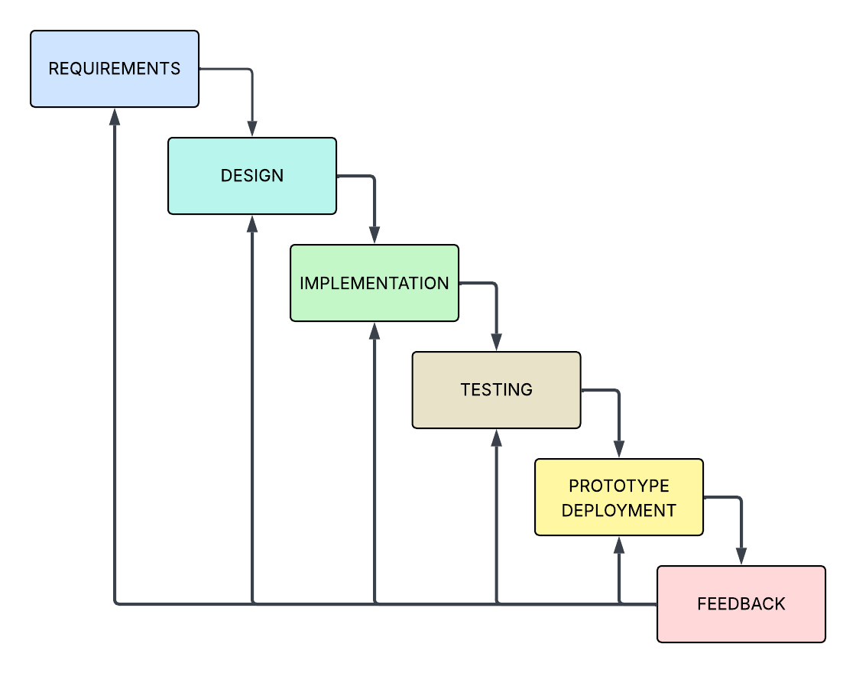

It illustrates the Waterfall Model used in the development of the Smart Barangay system. It shows the sequential cycle of requirements analysis, system design, development, testing, deployment, and maintenance, which allowed the researchers to systematically develop, evaluate, and improve the Smart Barangay system throughout the project.
Table 2.1 Project Development Timeline.
Phase | Duration | Focus / Deliverables
Requirements Analysis | Weeks 1-2 | Stakeholder consultation,  documentation of functional and  legal requirements
System Design | Weeks 3-4 | Architecture planning,  database schema design,  and interface wireframes
Implementation | Weeks 5-7 | Development of the API,  RAG AI chatbot, database,  and PWA/admin portal interfaces
Integration and  Testing | Weeks 8 - 9 | System integration,  functional testing,  and data privacy compliance  verification
Deployment | Weeks 10 - 11 | System release, cloud configuration,  and stakeholder onboarding
Operation and  Maintenance | Weeks 12 | Post-deployment monitoring,  issue resolution, and stakeholder  evaluation

2.1.3 Requirements Analysis and Specification
The Web Portal functions as a digital office for the barangay. Authorized staff can manage configured knowledge content, post announcements and community updates, verify resident registrations where the approval migration is deployed, and review supported service requests. Records are stored in Supabase for the implemented modules, while full operational coverage and production controls remain subject to deployment testing.
The resident-facing PWA features an AI-assisted chatbot that uses configured barangay information and a RAG-capable API route when available. For supported intents, the interface can guide a resident and show a basic request-intake card. It does not yet provide a verified dynamic form for every document type, automatic filled-template generation, payment collection, or external pickup/delivery notification.

Resident privacy is a required design objective, not a completed claim by default. The system must enforce authenticated ownership, row-level access, session isolation, a documented retention period, and a tested deletion process. The final thesis should state compliance with Republic Act No. 10173 only for controls that are implemented, deployed, and supported by verification evidence.
By integrating an AI-assisted chatbot, a digital records system, resident verification, and a supported request-status workflow, the Smart Barangay Portal aims to reduce unnecessary in-person inquiries and improve staff visibility. Staff review and official document issuance remain part of the process, while broader automation is a future enhancement unless demonstrated.
Requirements Analysis and Specification – This phase involved the identification of system requirements through review of barangay

administrative processes, applicable legal mandates, and consultation with barangay personnel and resident representatives. Functional requirements for the AI Chatbot (Agent), service request handling, and notification system, as well as non-functional requirements such as data privacy compliance, were documented during this stage.
System Design – This phase translated the documented requirements into the system's architectural blueprint, encompassing the design of the Barangay Services Hub, the integration of the Retrieval-Augmented Generation (RAG) AI module, the Application Programming Interface (API) structure, and the database schema. Interface design for both the administrative web portal and the resident-facing Progressive Web Application (PWA) was also finalized during this stage.
Implementation - This phase involved coding the current FastAPI-based API routes, RAG-oriented chatbot services, Supabase data layer, resident PWA, and administrative web portal according to the approved design. Features that remain partial, such as service-specific forms, template generation, payment handling, external notifications, and reporting exports, are recorded as limitations rather than treated as completed outputs.

Integration and Testing - This phase covers functional, security, and privacy testing of the implemented modules. Only test cases that were actually executed, including their date, environment, fixtures, and results, should be reported as findings.

Unverified target workflows must remain marked as pending validation.
Deployment - This phase refers to configuring and releasing the verified build to its intended environment. A feature should be labeled deployed only after its migration, environment variables, external services, access controls, and end-to-end behavior have been checked in the target environment.
Operation and Maintenance - This phase covers monitoring and issue resolution after deployment. If production monitoring or stakeholder use has not yet occurred, it should be reported as planned work rather than completed operation.
Project Team Roles
Project Leader – Oversees the overall direction of the study, defines project objectives, and ensures that each development phase aligns with the requirements of barangay stakeholders.
Systems Analyst – Responsible for gathering and documenting requirements, as well as translating barangay administrative processes into functional and
technical specifications.
Developer – Responsible for the design, coding, and integration of the system's

hardware-independent software components, including the AI agents, API, and database.
Quality Assurance Evaluator – Responsible for conducting system testing, validating compliance with data privacy requirements, and verifying the accuracy and reliability of system outputs prior to deployment.

System Architecture
Figure 2.2 System Flowchart.
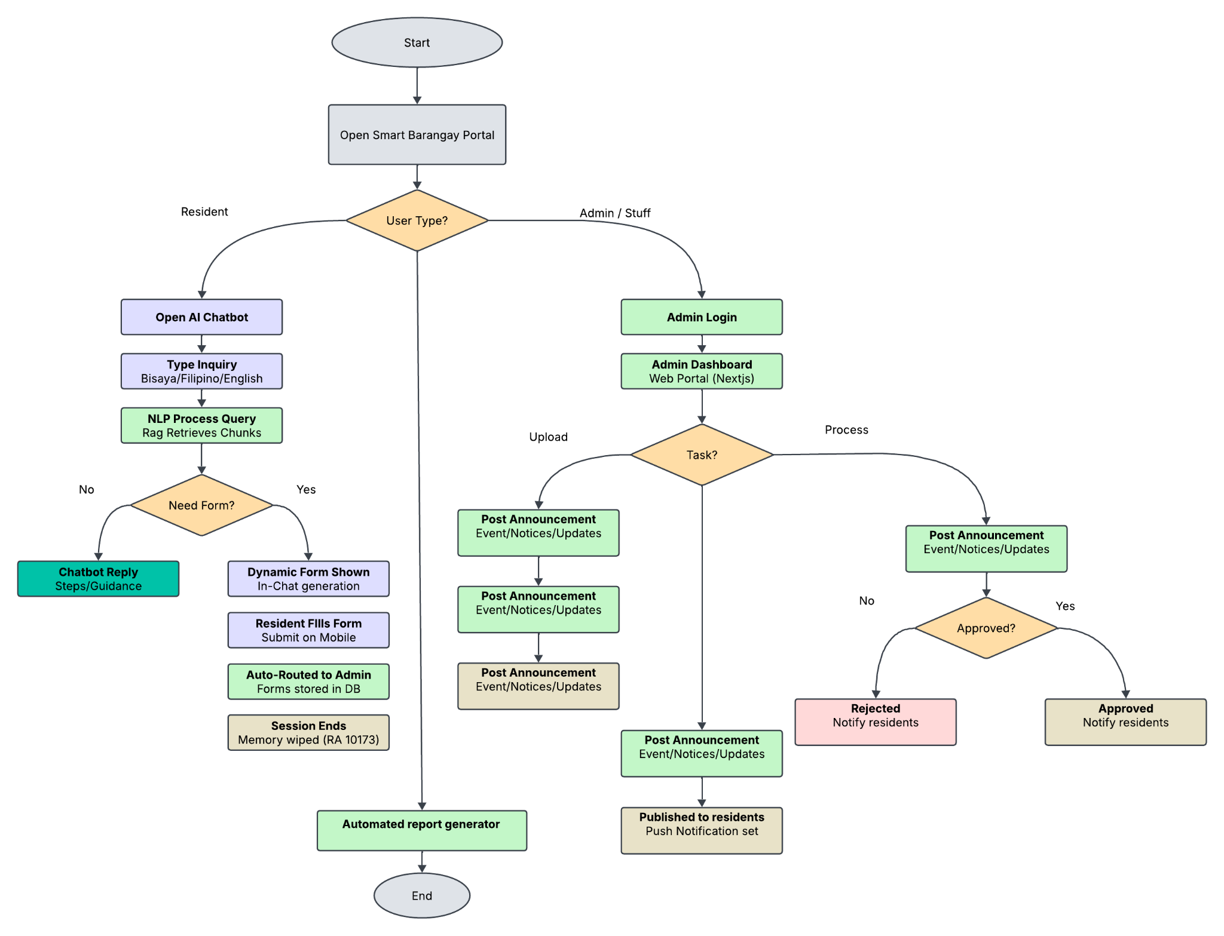

The system flowchart illustrates the sequential logic governing user interaction within the Smart Barangay Portal, beginning with the initiation of the platform and branching according to the type of user accessing the system,

either a resident or a barangay administrator.
For resident-users, the portal directs the user to the AI-assisted chatbot, where an inquiry may be entered in Bisaya, Filipino, or English. The RAG-capable route or local knowledge fallback provides guidance when a matching topic is available. The current interface may display a basic request-intake card for supported intents, after which a request is stored for status tracking and possible administrative review. It should not be described as a complete dynamic-form, automatic-template, payment, or deletion workflow until those components are verified.
For barangay administrators, access begins with an administrator login, which leads to the administrative dashboard built on a Next.js web portal. From the

dashboard, the administrator selects the specific task to be carried out, which may involve posting announcements, notices, event schedules, or general

For supported administrative tasks, staff review resident verification records, announcements, and service requests through the web portal. Approval or rejection remains a staff decision. In-app notification records and realtime verification updates are available where configured; automatic ready-for-pickup notifications, payment notices, push delivery, and SMS delivery require explicit status-triggered implementations and deployment testing.
Resident and administrator data can support dashboard monitoring. A fully automated report-generation and export function is not claimed in this revised manuscript unless it is implemented, reproducible, and reconciled against database records.

Data Flow Diagram (DFD)
Figure 2.3 Data Flow Diagram.
The DFD illustrates how data is moved between the system components.
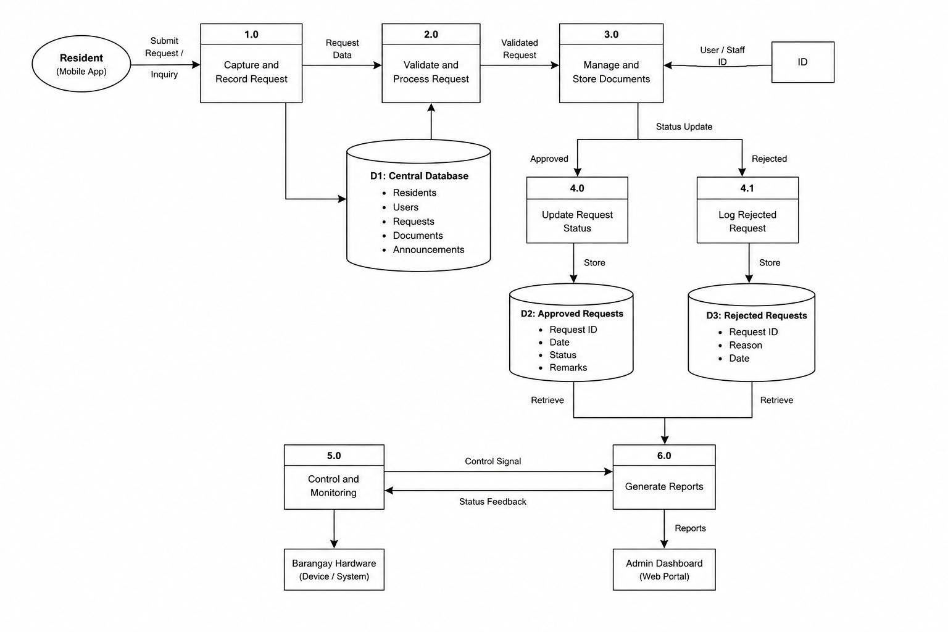
The Data Flow Diagram should be interpreted as the target and current-supported flow: residents submit inquiries or supported requests through the PWA, the chatbot/API provides guidance, records are stored in the database, and staff review or verification actions update the applicable records. Knowledge indexing, notifications, report generation, payment handling, and document generation are separate capabilities and must be labeled according to their actual deployment status.

This flow supports digital service access, record organization, resident verification, and request monitoring. It does not by itself prove completed automatic document issuance, external notification delivery, payment processing, or report exports.

Use Case Diagram
The use case diagram used showed the interaction between system users and the system functions.
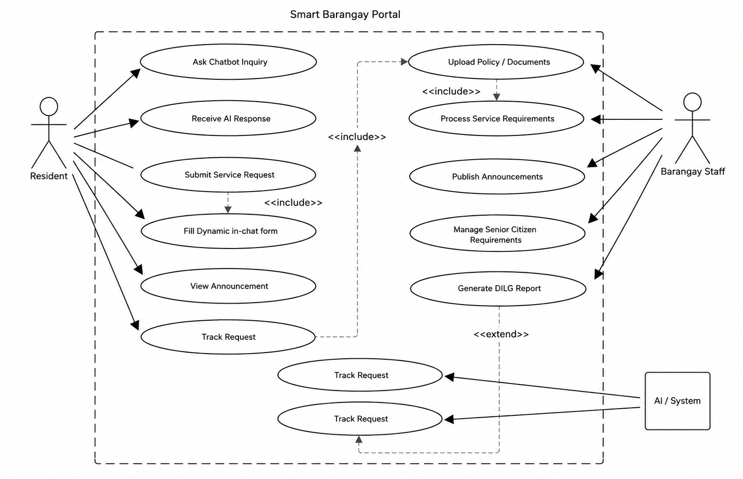
Figure 2.4 Use Case Diagram

The Use Case Diagram shows the intended interactions between residents, barangay staff, and the AI-assisted system. Residents can register, ask configured knowledge questions, submit supported requests, view announcements, and track statuses. Staff can verify residents, manage configured content, and review requests. Automated inquiry assistance and routing are supported, while official approval, document issuance, payment decisions, and complete report generation remain staff-controlled or future functions unless tested end to end.

Entity Relationship Diagram (ERD)
The ERD defines how the data is structured in the database.
Figure 2.5 Entity Relationship Diagram
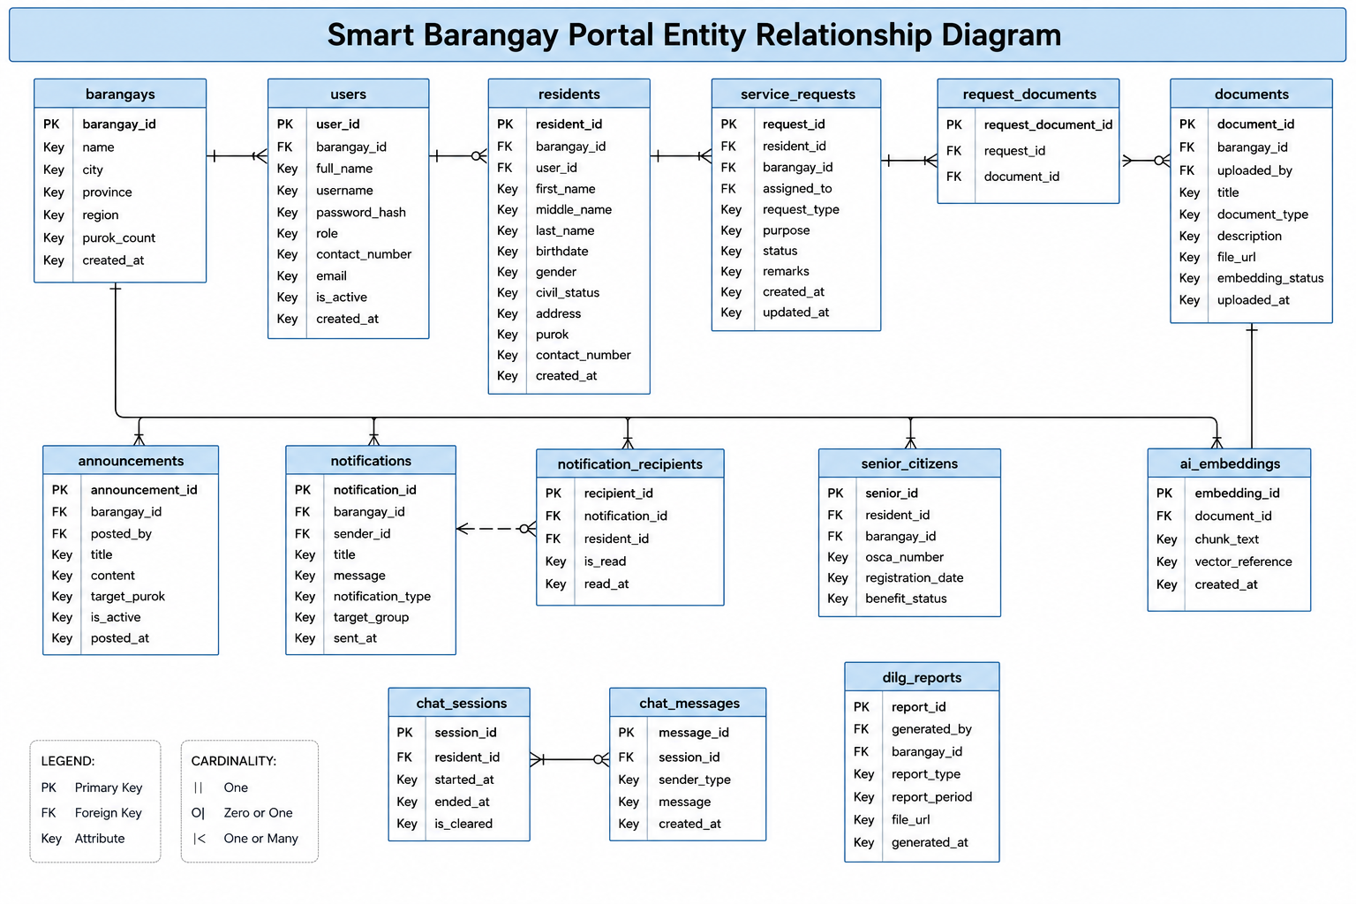
The ERD shows how the Smart Barangay Portal organizes barangay, resident, user, service-request, document, announcement, notification, and audit data. The current schema supports these relationships in configured environments, but the application must use the residents primary key consistently when creating requests. Chat-session persistence and document/embedding links must also be verified against the deployed schema before they are presented as complete working flows.

This structure provides a foundation for record tracking and knowledge retrieval. Reliable multi-request sessions, generated documents, notification events, payment metadata, and report outputs require additional tables, services, or tested workflows where they are not yet present.

2.2 Software Requirements
2.2.1 Technical Requirements
Component | Requirement
FastApi | Ver
Database | Supabase
Node.js | 24.16.0
Framework | LangChain,
Npm | 11.17.0

As shown in Table 2.1, these software requirements set the foundation for the system’s architecture and ensure compatibility, security, and performance across all components. By adhering to these required versions and platforms, the system is able to provide reliable user authentication,

seamless integration of AI-driven features, and efficient data management throughout all intended operating environments.

Table 2.2 Hardware Requirements
Component | Requirement
Mobile Device | Android 14 and IOS 17+
Desktop | Windows 10+

Environment, Population, and Sample

Researched Environment
This study was conducted at Barangay Tandang Sora (Barangay 12), Butuan City, Agusan del Norte, Caraga Region, Philippines. Butuan City serves as the regional center of Caraga and has been actively pursuing digital transformation under its Smart Eco City framework, making it a strategically relevant setting for an e-governance study of this nature. Barangay Tandang Sora is a populated urban barangay within Butuan City characterized by a

significant volume of daily resident transactions, including clearance requests, senior citizen registrations all of which are currently managed through manual, paper-based processes.
The system development and testing were carried out using computing facilities at Father Saturnino Urios University (FSUU), Butuan City, where the research team developed and hosted the portal in a controlled development environment prior to its pilot deployment in the barangay. The production environment utilized a cloud-based hosting infrastructure compliant with the Philippine Data Privacy Act of 2012, ensuring secure and accessible service delivery for both residents and barangay personnel.
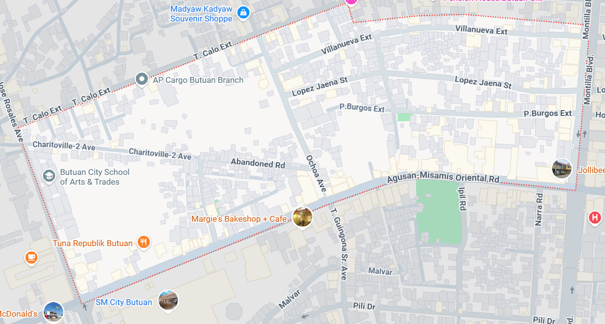
Map of Tandang Sora

Sampling Technique
This study employed purposive sampling for the barangay official group, as the 30 participants were deliberately selected based on their designated roles in barangay administration and their direct involvement in the services addressed by the Smart Barangay Portal. All selected officials had functional responsibilities related to at least one of the system's modules document processing, senior citizen registration making them the most appropriate evaluators of the administrative components of the system.
For the resident group, stratified random sampling was used to ensure proportional representation across three demographic strata: age group (youth aged 18–35, adults aged 36–59, and senior citizens aged 60 and above), gender (male and female), and technology experience level (low, moderate, and high). This stratification was necessary to test the moderating effects of age, gender, and experience on behavioral intention and use behavior, as specified in the study's UTAUT hypotheses. Within each stratum, participants were selected randomly from the barangay's official household roster to minimize selection bias and ensure that the findings are representative of the broader resident population of Barangay Tandang Sora.

Ethical Consideration
This study adhered strictly to the ethical standards governing research involving human participants, in accordance with the guidelines of Father Saturnino Urios University and the provisions of the Philippine Data Privacy Act of 2012 (Republic Act No. 10173). Prior to data collection, the research team secured the formal endorsement of the Barangay Captain of Barangay Tandang Sora and obtained written informed consent from all 120 UAT respondents. Each consent form clearly explained the purpose of the study, the nature of their participation, the voluntary nature of their involvement, and their right to withdraw at any time without consequence. No participant was subjected to any form of coercion or undue influence.
Furthermore, the research team committed to transparency in the reporting of all methods, results, and limitations of the study. All sources, frameworks, and prior works referenced in the development and evaluation of the Smart Barangay Portal have been properly cited and acknowledged in accordance with academic integrity standards. No data fabrication, falsification, or plagiarism was committed at any stage of the research process.

Research Instrument
The primary data collection instrument used in this study was a structured User Acceptance Testing (UAT) questionnaire, composed of two versions: one for barangay officials and one for residents. Both versions were developed by the research team based on validated scales drawn from the Technology Acceptance Model (TAM) and the SERVQUAL framework, adapted to the specific context of the Smart Barangay Portal.
The questionnaire was divided into the following parts:
Part I Respondent Profile collected demographic information including age, gender, position (for officials), and self-assessed technology experience level, which served as the moderating variables in the UTAUT analysis.
Part II System Usability and Acceptance contained 20 Likert-scale items (1 = Strongly Disagree to 5 = Strongly Agree) measuring the four UTAUT constructs: Performance Expectancy, Effort Expectancy, Social Influence, and Facilitating Conditions, as well as Behavioral Intention and Use Behavior.

Part III Service Quality Assessment contained 10 SERVQUAL-based items measuring five service quality dimensions Reliability, Responsiveness,

Assurance, Empathy, and Tangibles as experienced through the portal's interface and AI chatbot.
Part IV Open-ended Feedback provided respondents space to share qualitative observations, suggestions, and concerns about specific system features.
The instrument underwent content validation by three expert validators a computer science faculty member, an e-governance practitioner, and a barangay official and was pre-tested on 10 non-sample respondents to establish internal consistency. The Cronbach's alpha reliability coefficient of the final instrument was computed prior to the main data collection, with a target reliability score of α ≥ 0.80 consistent with the benchmark established by Bringula et al. (2022).

Data Gathering Procedure
The data gathering process for this study was carried out in four sequential phases:
Phase 1 Pre-Development Assessment. Prior to system development,

the research team conducted a needs assessment at Barangay Tandang Sora through direct observation of existing manual processes, informal interviews
with barangay officials, and a review of current administrative records. This phase documented the specific inefficiencies in document processing, resident inquiry management, and registry maintenance that the Smart Barangay Portal was designed to address.
Phase 2 System Development. Following the needs assessment, the team developed the current AI-assisted chatbot, administrative dashboard, resident PWA, request-intake flow, resident verification workflow, and database/API integrations. The implementation uses the documented TypeScript/Next.js, FastAPI, Supabase, and AI service components. A complete automated reporting module, automatic document-template generation, payment workflow, and external notification delivery are not claimed unless the corresponding code and deployment evidence are included.
Phase 3 Pilot Deployment and UAT. Once the system passed internal integration testing and quality assurance, it was deployed in acontrolled pilot environment accessible to the 120 selected respondents. Barangay officials

For UAT, participants should be given access only to the workflows available in the tested build, such as registration, resident verification, asking a knowledge question, submitting a supported request, and viewing status. Tasks such as generating a sample report or completing an automatic document workflow must be removed from the completed-results narrative unless they were actually available and tested. The manuscript should include the actual participant count and collection dates.
Phase 4 System Performance Benchmarking. Performance evaluation should report only executed measurements, such as chatbot response time, request submission time, dashboard load time, or notification delivery time, with the test environment and sample size stated. A 200-query intent-accuracy test or report-generation benchmark must not be presented as a completed result without raw queries, scoring criteria, timings, and computed results.

Prototype

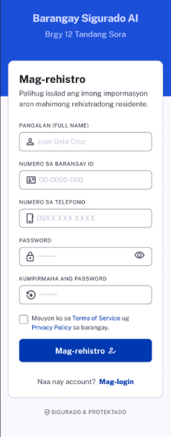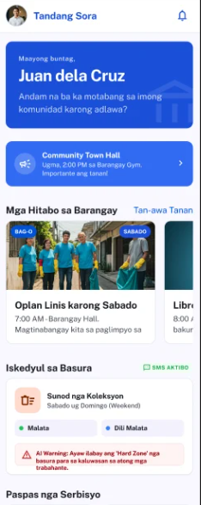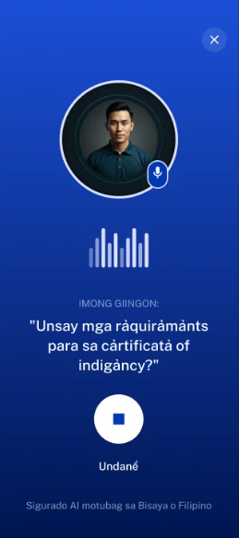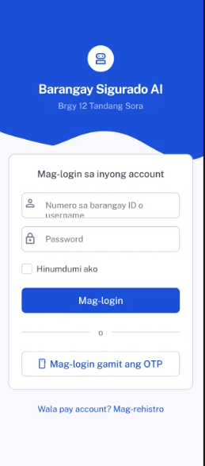

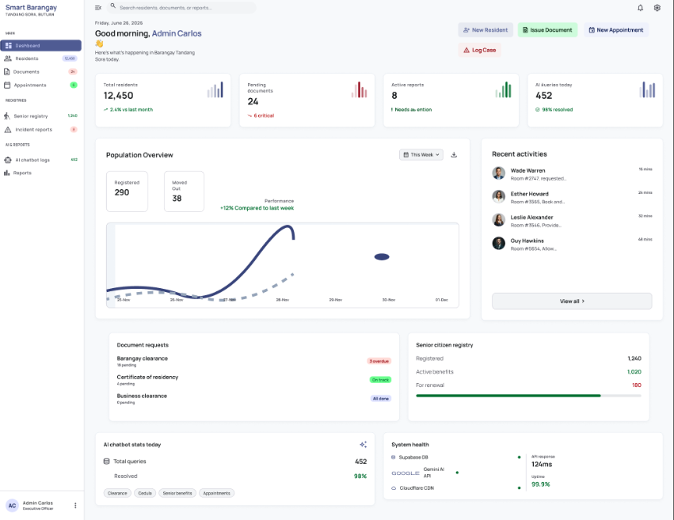

REFERENCES

Apostol, E., & Maquilan, M. (2021). Barangay constituents information and services management system. Academia.edu. https://www.academia.edu/46962511/BARANGAY_CONSTITUENTS_INFORMATION_AND_SERVICES_MANAGEMENT_SYSTEM

Butuan City Government. (n.d.). City Information and Communications Technology Office. https://www.butuan.gov.ph/city-information-and-communications-technology-office/

Dela Cruz, J., & Santos, R. (2021). Barangay profiling system with analytics. Academia.edu. https://www.academia.edu/50813118/Barangay_Profiling_System_With_Analytics

Guerrero, R. L., & Aranas, A. (2022). WEB-BON: The design and development of a web-based barangay information and record management system. ResearchGate. https://www.researchgate.net/publication/366877340_WEB-BON

Laranjo, J., et al. (2022). BALANGAY: A decision support system for barangay local government units. In Advances in Intelligent Systems and Computing (pp. 145–156). Springer. https://link.springer.com/chapter/10.1007/978-981-19-7663-6_13

Milano, S. (2022). Barangay integrated management system with mobile support. Academia.edu. https://www.academia.edu/84426305/Barangay_Integrated_Management_System_with_Mobile_Support

Philippine Information Agency. (2024). Butuan City strengthens digital workforce with DICT’s SPARK. https://pia.gov.ph/news/butuan-city-strengthens-digital-workforce-with-dicts-spark/

Turingan, O. R. (2022). E-Barangay: A framework for digitalizing local government services. International Journal of Electronic Government Research (IJEGR), 18(1). IGI Global. https://www.igi-global.com/article/e-barangay/288071

Wirtz, B. W., & Müller, W. M. (2022). An integrated framework of AI chatbot implementation in public administration. Public Management Review. NCBI. https://pmc.ncbi.nlm.nih.gov/articles/PMC8721490/
Enaño, J. V., Natividad, K. P., Pantoja, D. R., Ebi, F. C. D., Bautista, J. V., & Cura, D. (2025). BarangayConnect: A web-based information portal for resident data, administrative services, and community records using data analytics and linear regression algorithms. International Journal of Research and Innovation in Social Science, 9(10), 1485–1497. https://doi.org/10.47772/IJRISS.2025.910000127
Republic Act No. 10173. (2012). Data Privacy Act of 2012. Congress of the Philippines.
Singh, R., & Hess, T. (2026). AI chatbots for public services. International Journal of New Research in Dynamics, 6(3), 112–120. https://ijnrd.org/papers/IJNRD2603452.pdf
Tosper Jr., R., Mangalino, J., Obena, K., Simon, M., Tayag, M., & Reyes, D. (2025). WebYu: A Barangay Yuson web-based information management system initiatives. Philippine E-Journals, 37(5). https://ejournals.ph/article.php?id=30194
United Nations. (2022). United Nations E-Government Survey 2022: The future of digital government. United Nations. https://publicadministration.un.org/egovkb/
Al-Ansi, A. M., Garad, A., Jaboob, M., & Al-Ansi, A. (2024). Elevating e-government: Unleashing the power of AI and IoT for enhanced public services. Heliyon, 10(4), e40591. https://doi.org/10.1016/j.heliyon.2024.e40591

Brown, T. B., Mann, B., Ryder, N., Subbiah, M., Kaplan, J., Dhariwal, P., Neelakantan, A., Shyam, P., Sastry, G., Askell, A., Agarwal, S., Herbert-Voss, A., Krueger, G., Henighan, T., Child, R., Ramesh, A., Ziegler, D. M., Wu, J., Winter, C., ... Amodei, D. (2020). Language models are few-shot learners. Advances in Neural Information Processing Systems, 33, 1877–1901.https://arxiv.org/abs/2005.14165
DeLone, W. H., & McLean, E. R. (2003). The DeLone and McLean model of information systems success: A ten-year update. Journal of Management Information Systems, 19(4), 9–30. https://doi.org/10.1080/07421222.2003.11045748
Dix, A., Finlay, J., Abowd, G. D., & Beale, R. (2004). Human-computer interaction (3rd ed.). Pearson Prentice Hall.
Lewis, P., Perez, E., Piktus, A., Petroni, F., Karpukhin, V., Goyal, N., Kuttler, H., Lewis, M., Yih, W. T., Rocktäschel, T., Riedel, S., & Kiela, D. (2020). Retrieval-augmented generation for knowledge-intensive NLP tasks. Advances in Neural Information Processing Systems, 33, 9459–9474. https://nlp.stanford.edu/IR-book/
Manning, C. D., Raghavan, P., & Schütze, H. (2008). Introduction to information retrieval. Cambridge University Press. https://doi.org/10.1017/CBO9780511809071

Nielsen, J. (1994). Usability engineering. Morgan Kaufmann. https://www.worldcat.org/title/usability-engineering/oclc/28006057
Vaswani, A., Shazeer, N., Parmar, N., Uszkoreit, J., Jones, L., Gomez, A. N., Kaiser, Ł., & Polosukhin, I. (2017). Attention is all you need. Advances in Neural Information Processing Systems, 30, 5998–6008.
https://arxiv.org/abs/1706.03762
Bautista, J. R., et al. (2023). BALANGAY: A decision-support system for document requests and community management. Journal of Philippine ICT Development, 12(1), 45–62.
Bringula, R. P., et al. (2022). E-Barangay: A framework for a web-based system for local communities and its usability [Updated framework]. ResearchGate. https://www.researchgate.net/publication/322301825
City Government of Butuan. (2024). Smart Eco City roadmap: Strategic development for a sustainable Butuan. Butuan City ICT Office.
Kaur, A., & Sharma, P. (2023). AI in public administration: A systematic review of chatbot integration and citizen engagement. Government Information Quarterly, 40(1), 101783. https://doi.org/10.1016/j.giq.2023.101783
Olipas, C. N. P. (2020). Development of a cloud-based barangay management information system. International Journal of Computing Sciences Research, 4(1), 195–211. https://doi.org/10.25147/ijcsr.2017.001.1.41

Panganiban, J. M. S., et al. (2024). Promoting equitable care: Analysis of patient satisfaction in urban primary care sites in the Philippines. BMJ Open Quality, 13(1), e002483. https://doi.org/10.1136/bmjoq-2023-002483
Philippine Information Agency. (2024, February 15). DICT launches SPARK program to accelerate digital transformation in local communities. https://pia.gov.ph
Bringula, R. P., Vale, M. A. D., & Napolis, J. A. (2022). E-Barangay: A framework
for a web-based system for local communities and its usability. *International
Journal of E-Government Research, 18*(1), 1-20.
https://doi.org/10.4018/IJEGR.288071
Lagura, G. B. (2025). Towards digital governance divide index development:
Evaluating city government websites in the Philippines. *Journal of Community
Development Research, 18*(1), 1-17.
Quimba, F. M. A., Caboverde, C. E. C., & Salazar, A. M. C. (2025). *How ready
are LGUs for AI adoption? Issues, challenges and policy implications*
(PIDS Discussion Paper No. 2025-48). Philippine Institute for Development
Studies. https://doi.org/10.62986/dp2025.48
Ramos, J. P., & Lim, C. M. (2024). English-Tagalog NLP chatbot for progressive
web application-based barangay information system. *Journal of Engineering
and Science, 5*(2), 1-15. https://journal.esrgroups.org/jes/article/view/2426

Bautista, M. T. T., Bolanos, A. K. B., Camba, U. J., de Guzman, L. M.,
Goh, M. L. I., Raguro, M. C. F., & Tolentino, L. S. (2023). BALANGAY:
A web-based document request and incident reporting system. In *Lecture
Notes in Networks and Systems* (Vol. 663, pp. 127-136). Springer.
https://doi.org/10.1007/978-981-19-7663-6_13
Bautista, M. T. T., Bolanos, A. K. B., Camba, U. J., de Guzman, L. M., Goh, M. L. I., Raguro, M. C. F., & Tolentino, L. S. (2023). BALANGAY: A web-based document request and incident reporting system with decision support for barangay program development. In A. Abraham, et al. (Eds.), *Lecture Notes in Networks and Systems* (Vol. 663, pp. 127-136). Springer. https://doi.org/10.1007/978-981-19-7663-6_13
Bringula, R. P., Vale, M. A. D., & Napolis, J. A. (2022). E-Barangay: A framework for a web-based system for local communities and its usability. *International Journal of E-Government Research, 18*(1), 1-20. https://doi.org/10.4018/IJEGR.288071
Kaur, R., Singh, S., & Rani, N. (2022). A survey on providing customer and public administration based services using AI: Chatbot. *Artificial Intelligence Review, 55*(4), 2137-2179. https://doi.org/10.1007/s10462-021-10057-3
Quimba, F. M. A., Caboverde, C. E. C., & Salazar, A. M. C. (2025). *How ready are LGUs for AI adoption? Issues, challenges and policy implications* (PIDS Discussion Paper Series No. 2025-48). Philippine Institute for Development Studies. https://www.pids.gov.ph/publication/discussion-papers/how-ready-are-lgus-for-ai-adoption
Ramos, J. P., & Lim, C. M. (2024). English-Tagalog NLP chatbot for progressive web application-based barangay information system. *Journal of Engineering and Science, 5*(2), 1-15. https://journal.esrgroups.org/jes/article/view/2426
Asian Development Bank. (2021).
Digital government in the Philippines: Building inclusive and efficient public service delivery.
https://www.adb.org/publications/digital-government-philippines
Reyes, J. P., Dela Cruz, M. A., & Santos, L. B. (2021).
Enhancing local government efficiency through digital information systems in the Philippines. International Journal of Information Systems and Technology, 5(2), 45–53.
Borgeaud, S., Mensch, A., Hoffmann, J., Cai, T., Rutherford, E., Millican, K., … Silver, D. (2022). Improving language models by retrieving from trillions of tokens. https://arxiv.org/abs/2112.04426
Dey, A. K. (2001).Understanding and using context. Personal and Ubiquitous Computing, 5(1), 4–7. https://doi.org/10.1007/s007790170019
Lewis, P., Perez, E., Piktus, A., Petroni, F., Karpukhin, V., Goyal, N., … Riedel, S. (2020).Retrieval-augmented generation for knowledge-intensive NLP tasks. https://arxiv.org/abs/2005.11426

Revision Note - System Alignment
This revision was prepared from the current code audit at repository revision 0d23a14. The thesis now distinguishes implemented capabilities from partial or planned capabilities. The revised research emphasizes AI-assisted information access, resident verification, supported digital request intake, staff-controlled processing, and status tracking. Full automation of document generation, payment, pickup/delivery notifications, report exports, and complete session deletion requires additional implementation and evidence.
Original source preserved: Copy of the final Barangay AI - IT32.docx. This revised copy is saved under a new filename; the source file was not overwritten.

