SOFTWARE ENGINEERING

NutriVisionary
AI-Based Nutrition & Health Tracking Mobile Application

DELIVERABLE 3 — SPRINT 2
Module: AI Integration, Camera Tracking & UI Enhancements

GROUP MEMBERS
Shaheer Chishti | 23L-0994
Ali Aznawar | 23L-0520
Ali Yousef | 23L-0737

1. Project Title and Introduction
NutriVisionary is an intelligent mobile application designed to help users track their nutrition, monitor health metrics, and receive AI-driven dietary recommendations. The system integrates AI-based food recognition, persistent authentication, and enhanced UI features to improve user experience and engagement.

1.3 Sprint 2 Scope
Sprint 2 focuses on integrating advanced AI features and improving usability. The sprint includes camera-based calorie tracking, persistent login sessions, and dark mode implementation. These features enhance both functionality and user experience beyond the foundational UI developed in Sprint 1.

2. User Stories
US-05: Camera-Based Calorie Tracking
As a user, I want to capture food images so that the system can estimate nutritional values automatically.
Sub User Stories:
- User opens camera module
- User captures food image
- Image sent to AI API
- System processes and returns calorie data
- Display results on UI
Acceptance Criteria:
- Camera opens successfully
- Image captured without crash
- AI response received within 5 seconds
- Calories displayed correctly

US-06: Persistent Login
As a user, I want to remain logged in so that I do not have to log in repeatedly.
Sub User Stories:
- Store login session locally
- Check session on app start
- Auto-login user
- Clear session on logout
Acceptance Criteria:
- User remains logged in after closing app
- No login required until logout
- Session securely stored

US-07: Dark Mode
As a user, I want a dark mode option so that I can use the app comfortably in low light.
Sub User Stories:
- User toggles dark mode
- Theme applied globally
- Preference saved locally
Acceptance Criteria:
- Theme switches instantly
- Dark mode persists after restart
- All screens follow theme

3. Structured Specifications
Detailed structured specifications for selected user stories.

4. Scrum Board
Snapshot 1 — Start of Sprint
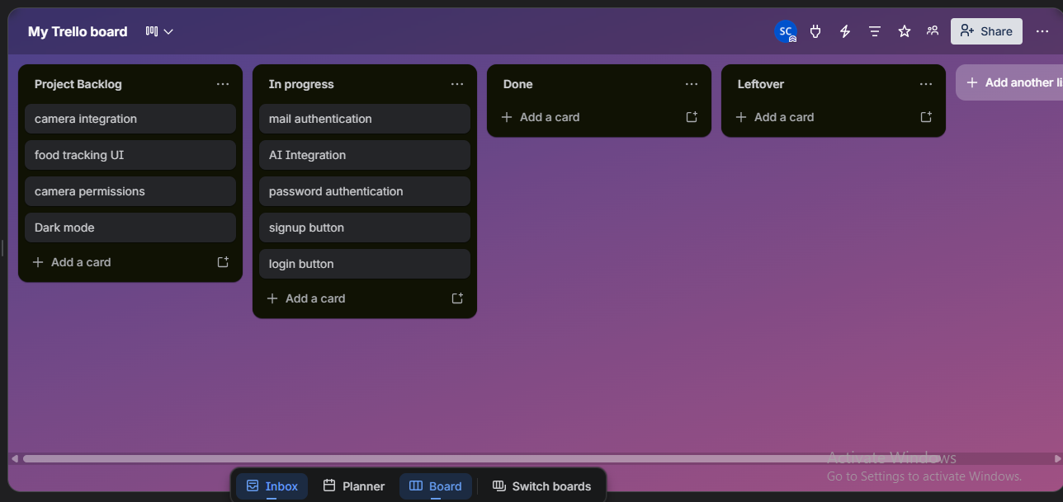
Snapshot 2 — Mid Sprint
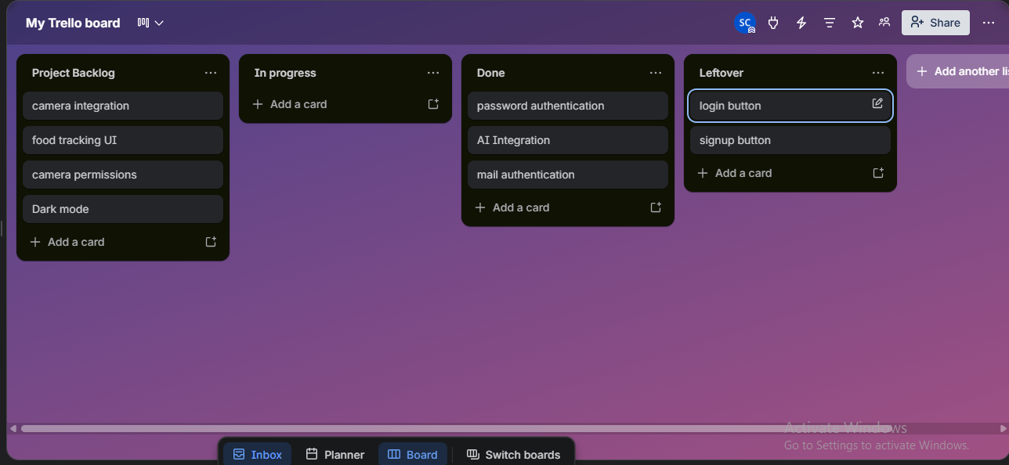
Snapshot 3 — End Sprint
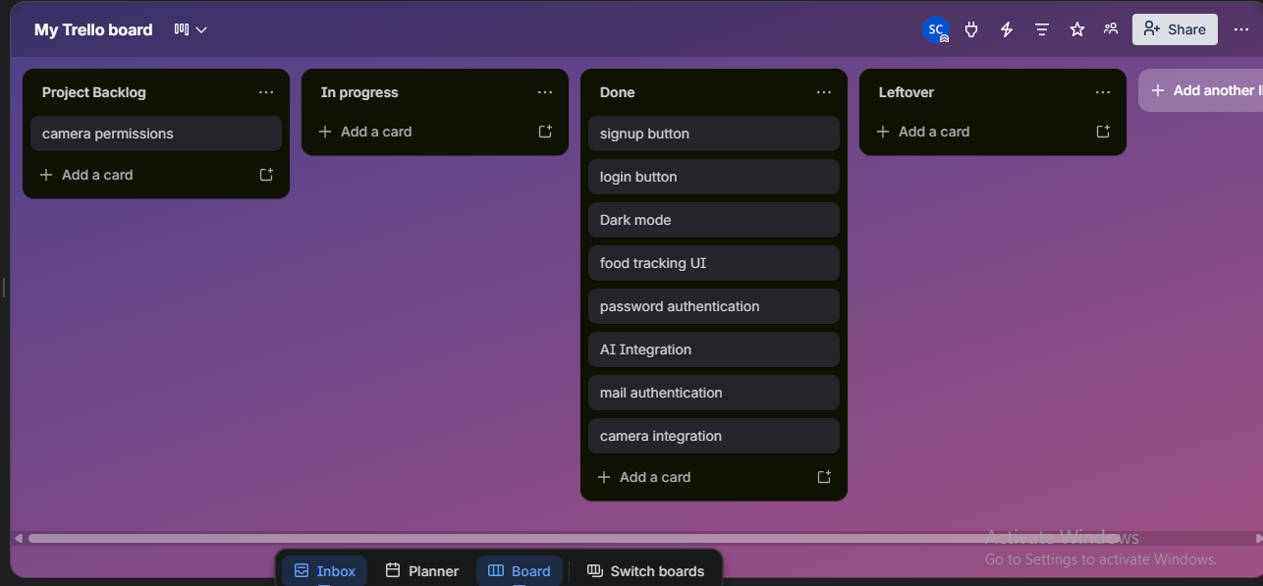

Burndown Chart

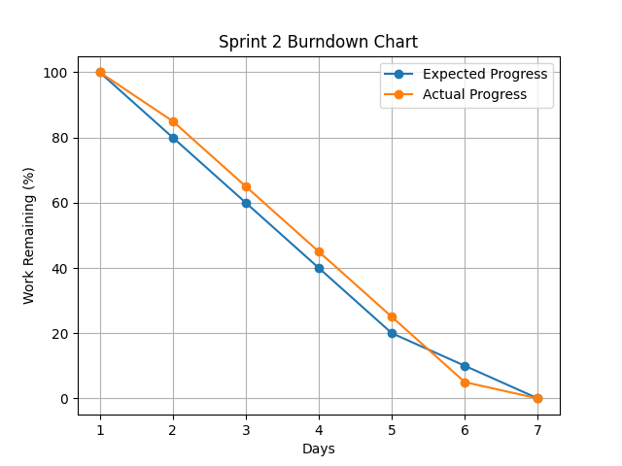

5. Non-Functional Requirements
Performance
All operations including AI processing should complete within 3–5 seconds.
Usability
Users should easily navigate features with minimal learning curve.
Scalability
System should handle increasing users and AI requests efficiently.
Reliability
App should function without crashes during camera or login operations.
Responsiveness
UI interactions must respond within 200 ms.
Security
User data and sessions must be securely stored.
Compatibility
App must support Android 8.0 and above.
Maintainability
Code should be modular and extendable for future AI features.

6. Implementation Screenshots
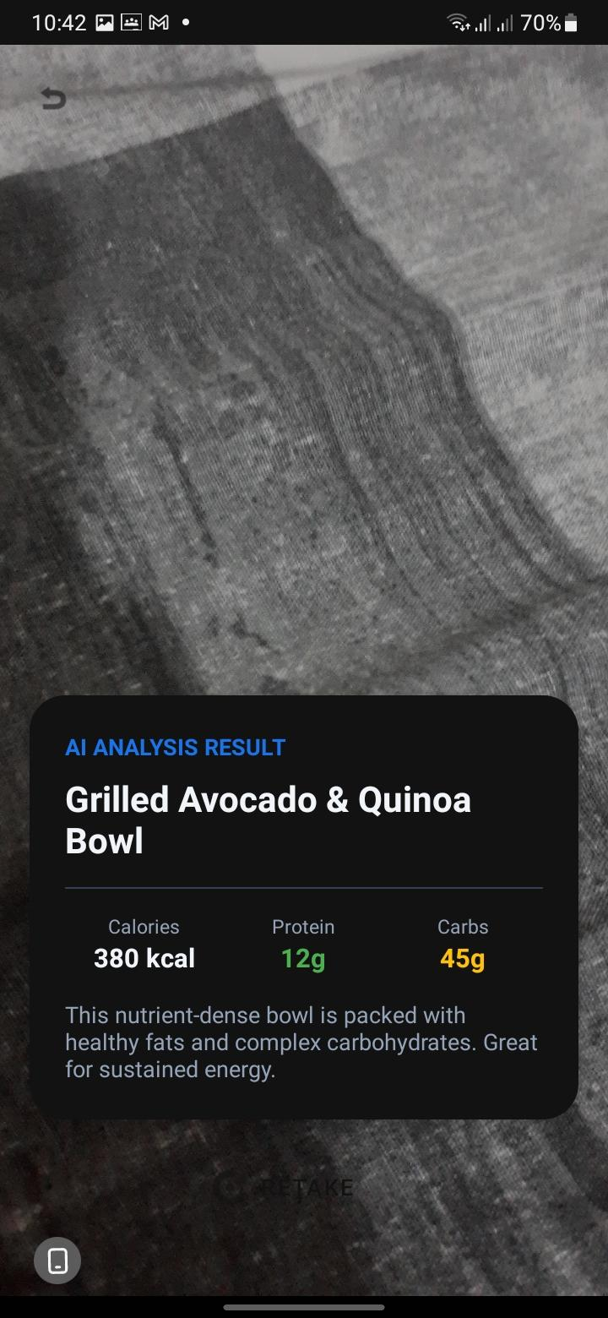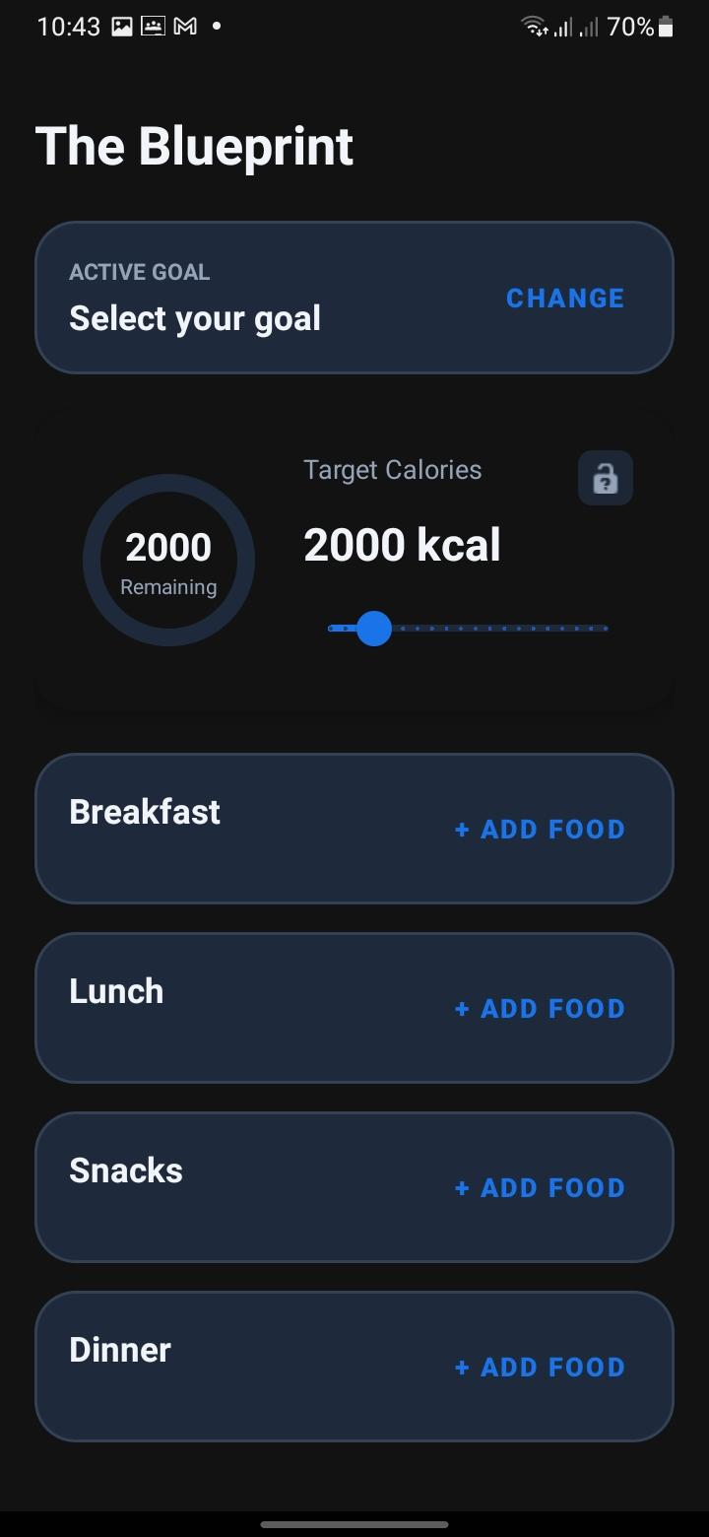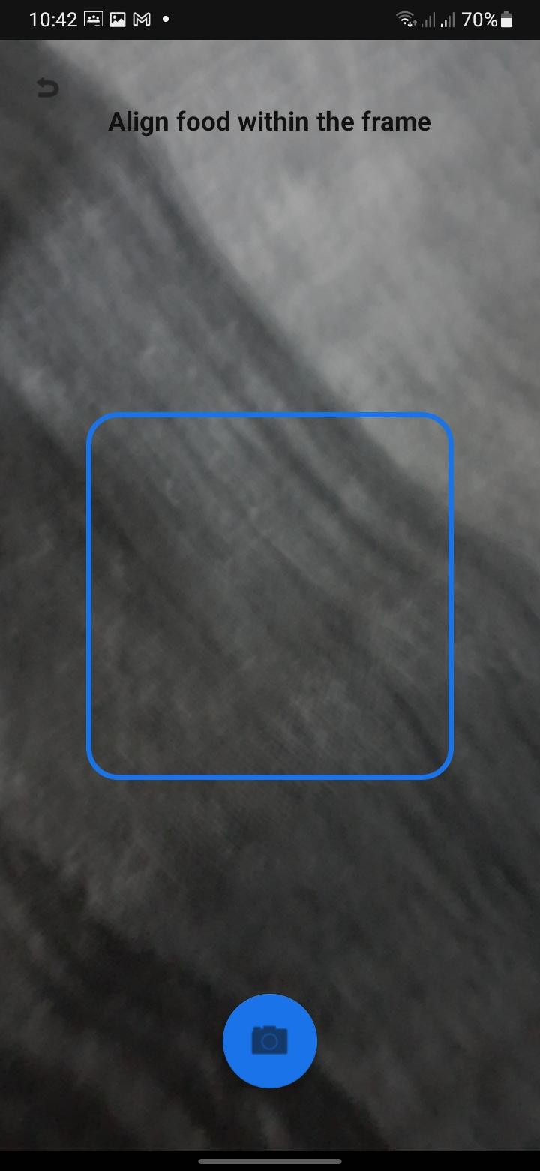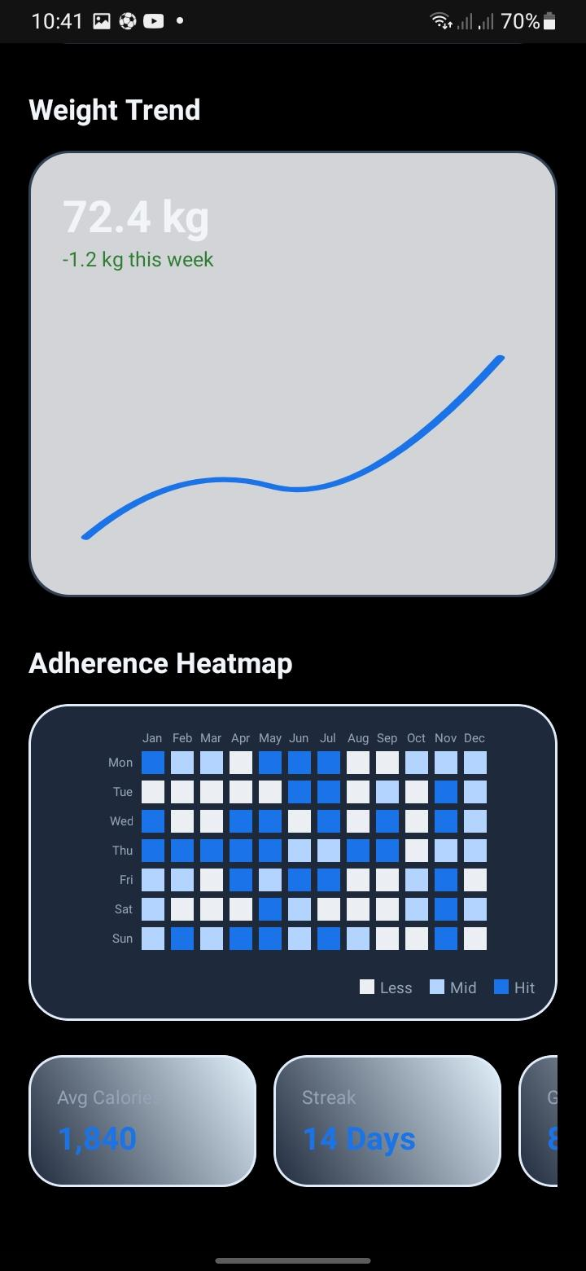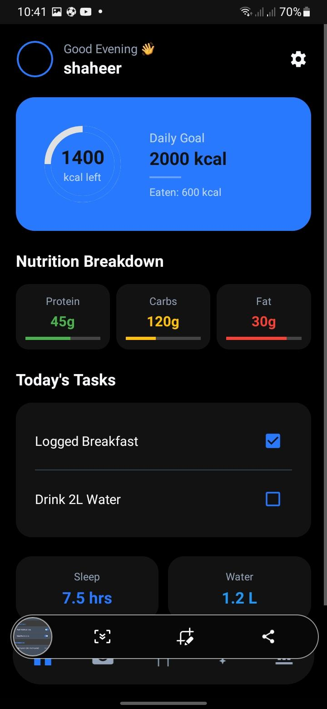
Member Domain Primary Responsibilities Key Deliverables
Shaheer Development Core Logic & AI Integration Camera Module & Theme Engine
Ali Aznawar Quality Testing & Documentation Test Cases & Reports
Ali Yousef Architecture System Design API Integration & Flow

