SOFTWARE ENGINEERING

NutriVisionary
AI-Based Nutrition & Health Tracking Mobile Application

DELIVERABLE 2 — SPRINT 1
Module: User Management & Core UI

GROUP MEMBERS
Shaheer Chishti | 23L-0994
Ali Aznawar | 23L-0520
Ali Yousef | 23L-0737

1. Project Title and Introduction
NutriVisionary is an intelligent mobile application designed to help users track their nutrition, monitor health metrics, and receive AI-driven dietary recommendations. The system combines manual food tracking, AI-based food recognition, and personalized analytics to improve user health and lifestyle.

1.3 Sprint 1 Scope
Sprint 1 focuses on core user management and UI development. The features include user authentication, profile setup, dashboard UI, and navigation structure. AI-based features and camera integration will be implemented in later sprints.

2. User Stories

US-01: User Registration & Login
As a user, I want to create and log into my account so that I can access personalized features.
Sub User Stories:
- User enters email and password
- System validates input
- Account created in Firebase
- User session persists
Acceptance Criteria:
- Login and signup forms must work
- Errors shown for invalid input
- User redirected to dashboard

US-02: Profile Setup
As a user, I want to enter my health details so that the app can personalize recommendations.
Sub User Stories:
- Enter weight, height
- Save profile
- Retrieve profile data

US-03: Dashboard UI
As a user, I want to view my daily nutrition summary so that I can track progress.
Sub User Stories:
- View calories
- View macros
- View tasks and score

US-04: Navigation System
As a user, I want easy navigation so that I can switch screens quickly.
Sub User Stories:
- Bottom navigation
- Open different screens

3. Structured Specifications
Detailed structured specifications for selected user stories.

4. Scrum Board
Snapshot 1 — Start of Sprint
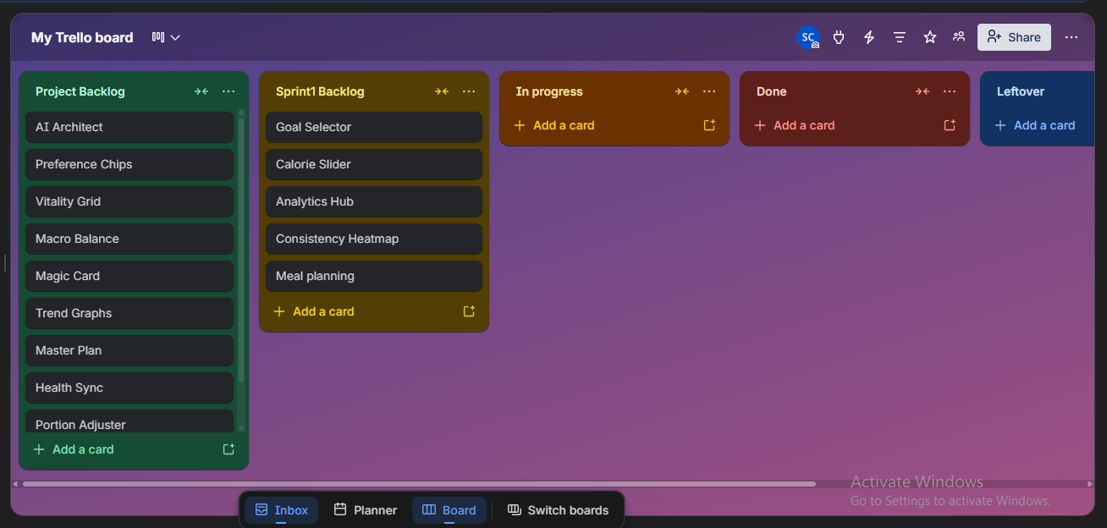
Snapshot 2 — Mid Sprint
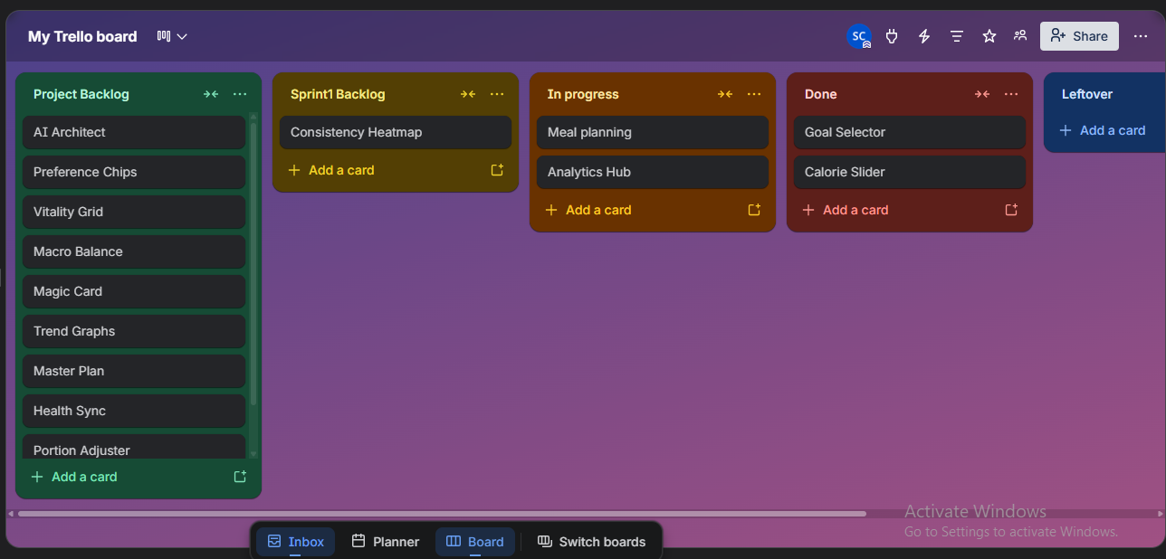
Snapshot 3 — End Sprint
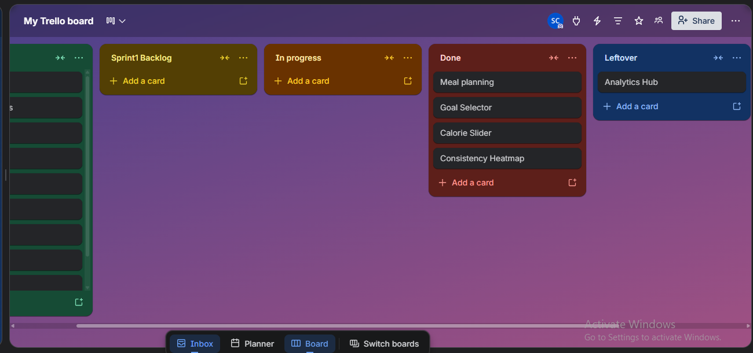
Burndown Chart
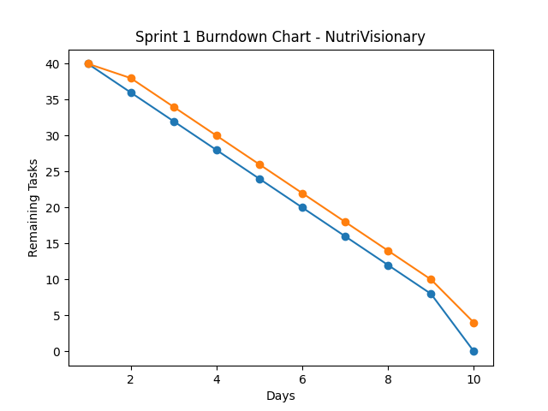
Expectation
Reality

5. Non-Functional Requirements

1. Performance
The application should provide fast and smooth performance across all screens. Dashboard loading, navigation between screens, and data retrieval operations should complete within 2 seconds under normal conditions. The app must efficiently handle real-time updates such as calorie tracking and progress visualization without noticeable lag. API responses (nutrition data or chatbot replies) should be processed and displayed within 3–5 seconds.

2. Usability
The system should be intuitive and user-friendly, even for users with no prior experience with fitness applications. A new user should be able to register, set up their profile, and log their first meal within 5 minutes. The interface should follow a clean design with clear navigation, readable fonts, and proper visual hierarchy. All actions should provide immediate feedback, and error messages must be simple and understandable.

3. Scalability
The application should be able to handle growth in the number of users and data efficiently. It must support at least 10,000 concurrent users without performance degradation. The system should handle large datasets such as food databases and user logs while maintaining fast retrieval times. The architecture should allow future expansion, including adding more AI features and integrations.

4. Reliability
The system should operate consistently with minimal failures. The app should not crash more than once in 20 hours of usage under normal conditions. User data such as meals, profiles, and progress must be stored securely and should not be lost. In case of failure, the system should recover gracefully without affecting stored data.

5. Responsiveness
All user interactions such as button clicks, navigation, and form submissions should respond within 100–200 milliseconds. UI elements like progress bars, charts, and animations should update smoothly. Delays beyond acceptable thresholds should be minimized to ensure a seamless experience.

6. Security
User data must be protected using secure authentication mechanisms. All sensitive information (such as user profiles and health data) should be stored securely using Firebase authentication and database rules. Unauthorized access must be prevented, and user sessions should be managed safely.

7. Compatibility
The application should function consistently across different Android devices and screen sizes. It must support Android version 8.0 (Oreo) and above. The UI should adapt properly to various resolutions without breaking layouts or functionality.

8. Maintainability
The codebase should follow clean architecture principles with proper modularization (activities, services, models). Code should be well-documented and readable to allow easy updates and debugging. Future developers should be able to extend features such as AI modules or analytics without major restructuring.

6. Implementation Screenshots
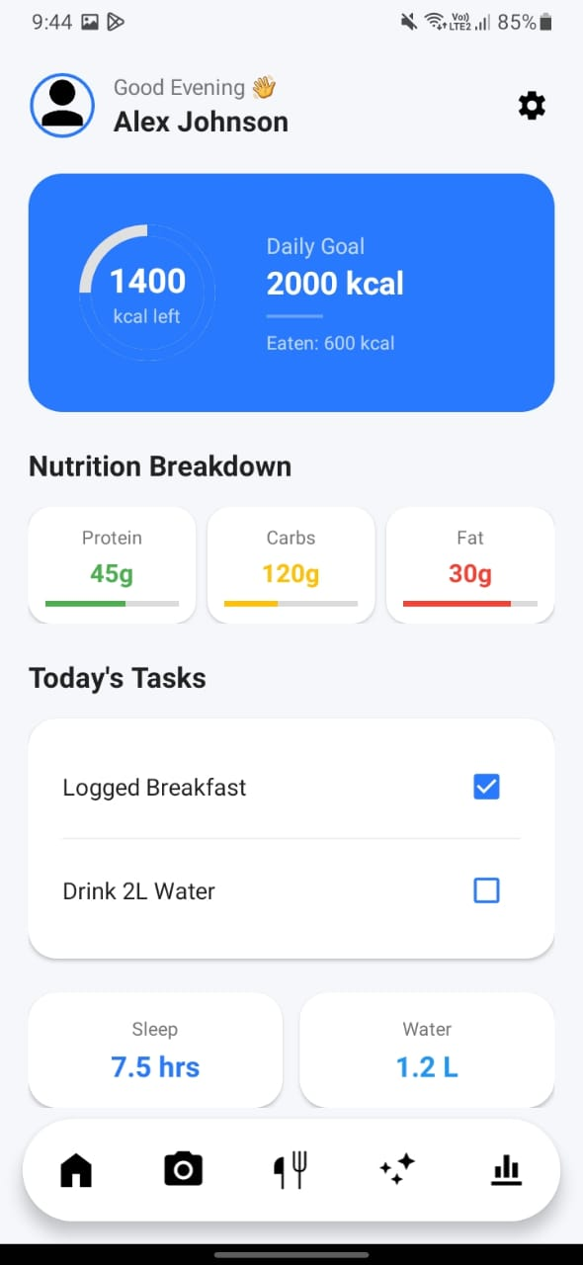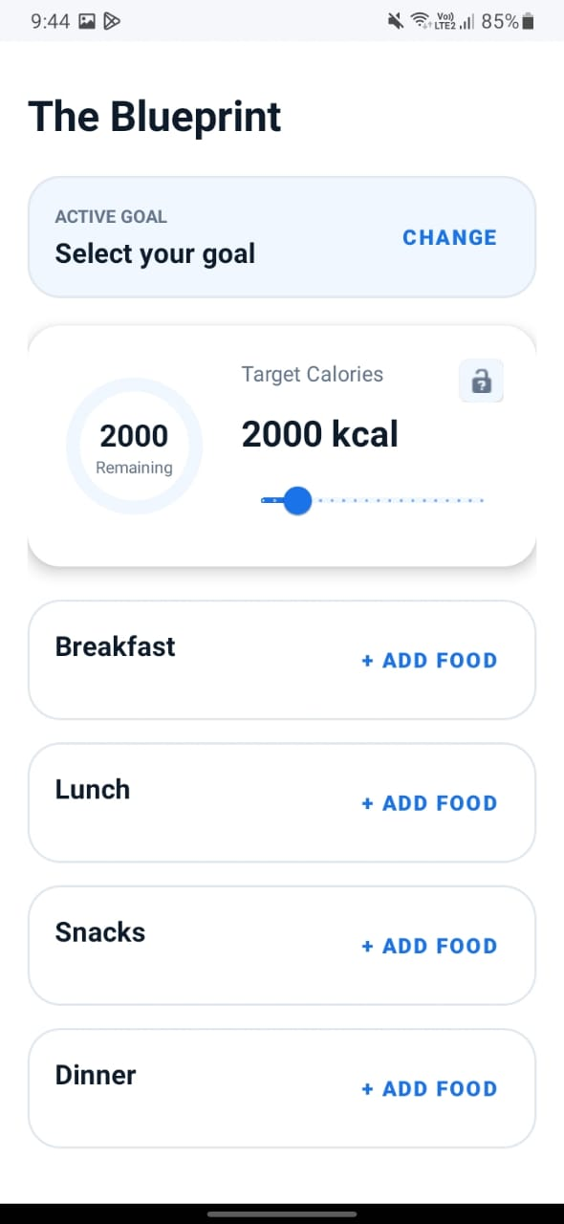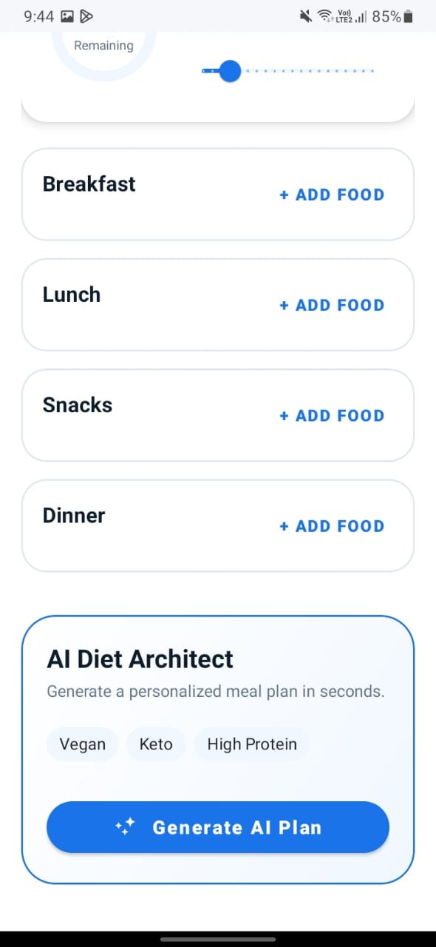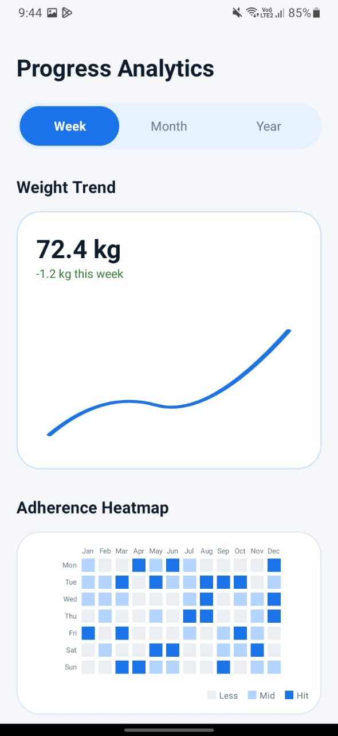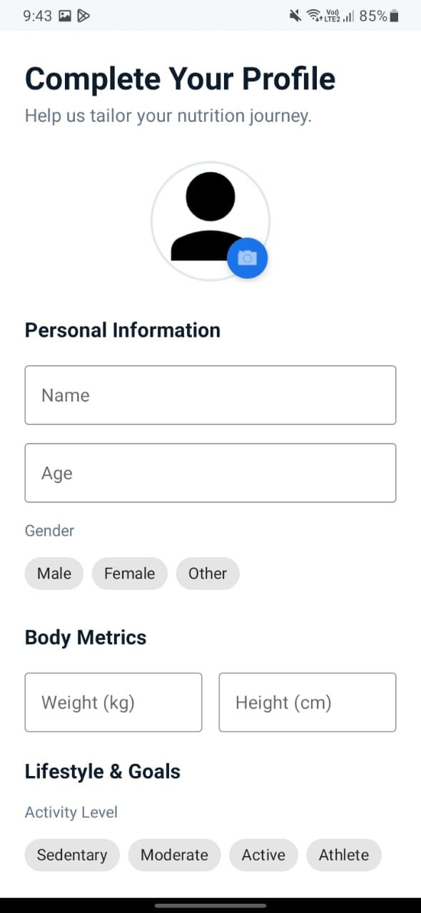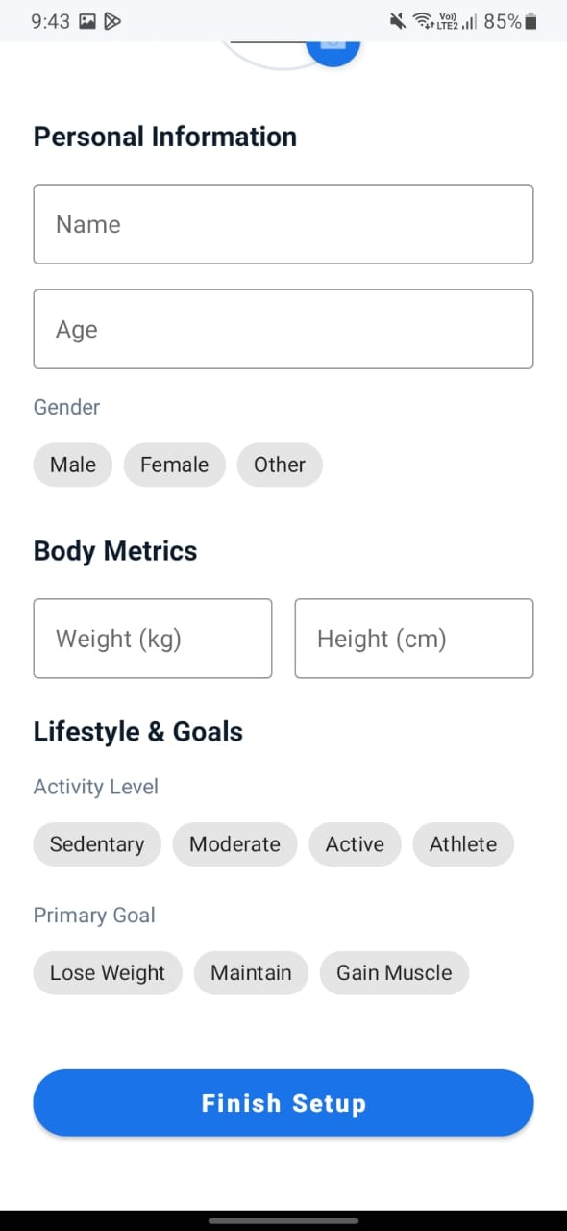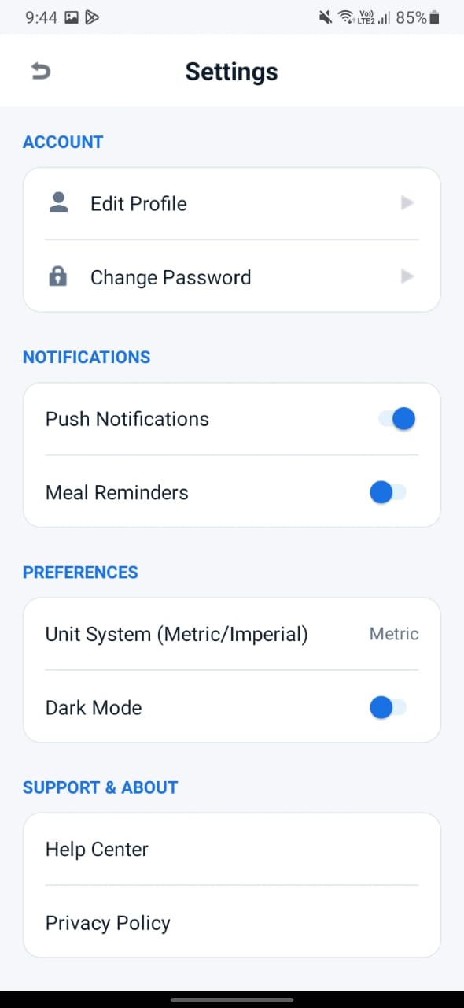

Member | Domain | Primary Responsibilities | Key Deliverables
Shaheer | Development | Core XML Architecture & Logic | UI Blueprint & Theme Engine
Ali Aznawar | Quality | Testing & User Documentation | UI Audit & Functional Manual
Ali Yousef | Architecture | Data Modeling & Logic Flow | Database Schema & API Specs

