Clear is the right answer.

 int[] numarray = new int[10];

is the correct answer

Output:

50

Radius=10

Output:

2

5.2

0

0

Int[] numbers **= INSERT Number here**

Int max = numbers[0]

for(inti=1;i<numbers.length;i++){

if(numbers[i]>max)

max = numbers[i];}

System.out.println(max);

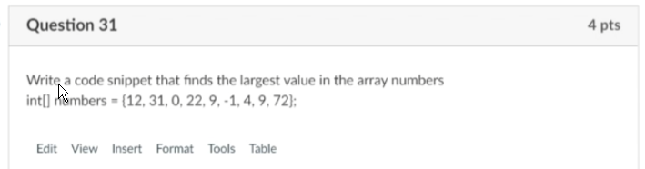

int n = 100;

for (int i = 1; i <= n; i++) {

if (i % 2 == 0) {

System.out.print(i + " ");}}

Student student = new Student("James Bond");

Student.setGPA(3.6);

student.setPhoneNumber(1233210910);

double [] scores = new double[40];

public class Student {

private String name;

private String phone;

private double GPA;

public Student(String name) {

this.name = name;

}

public Student(String name, String phone, double GPA) {

this.name = name;

this.phone = phone;

this.GPA = GPA;

}

public String getName() {

return name;

}

public String getPhone() {

return phone;

}

public void setPhone(String phone){

this.phone = phone;

}

public double getGPA() {

return GPA;

}

public void setGPA(double GPA) {

this.GPA = GPA;

}

}

Information hiding in other words is encapsulation. If an item is not visible, then you put it together with methods that have access. We use getters and setters to receive and change the item.

Integer division is division where both sides are an integer. Not float or doubles. Integer division result will always be an integer.

**https://i.imgur.com/XimLo5B.png**

PARAPHRASE MF

As the name says, Infinite loop is a never-ending loop or a loop that continues infinitely.