This project required curation of Coca Cola financial reports as an analyst to a competitor to understand its business strategies and suggest what’s worth replicating and what needs tweaking. Coca cola’s financial report archives gave access to income statements, balance sheets, and cash flow statements.

For this purpose, the focus is on the statements of income, also known as the earnings statement or the profit and loss statement.

Steps involved in the data curation process:

* Files containing financial information were retrieved from the C[oca Cola website](https://investors.coca-colacompany.com/financial-information/financial-results). Data was available in PDF, Excel, and html file formats. The excel files were downloaded by quarter for those available. Others were retrieved from the html files to an excel sheet.
* The excel sheets were unformatted in terms of data types and content structure. Formatting was done to ease the retrieval process during analysis.
* Data was edited for uniformity in content structures.
* Data exploration and cleaning was carried out on Jupyter Notebook.

Insights from Data Exploration

Analysis showed that the second quarter of each year recorded the highest income revenues and gross profits.

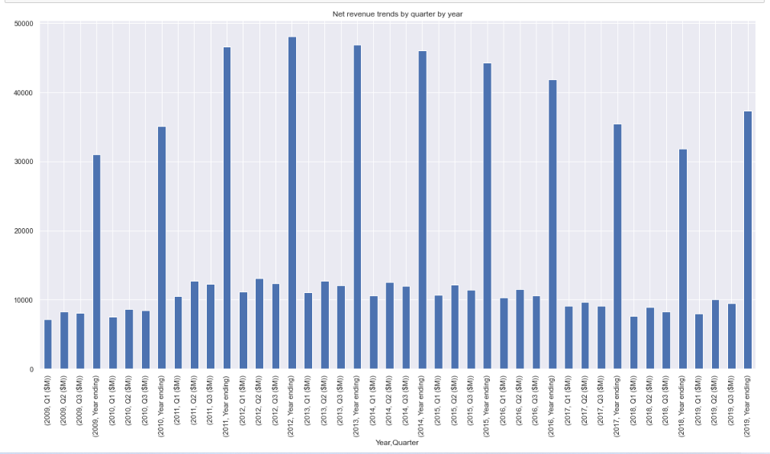

Fig 1: Net revenue by Quarter by Year

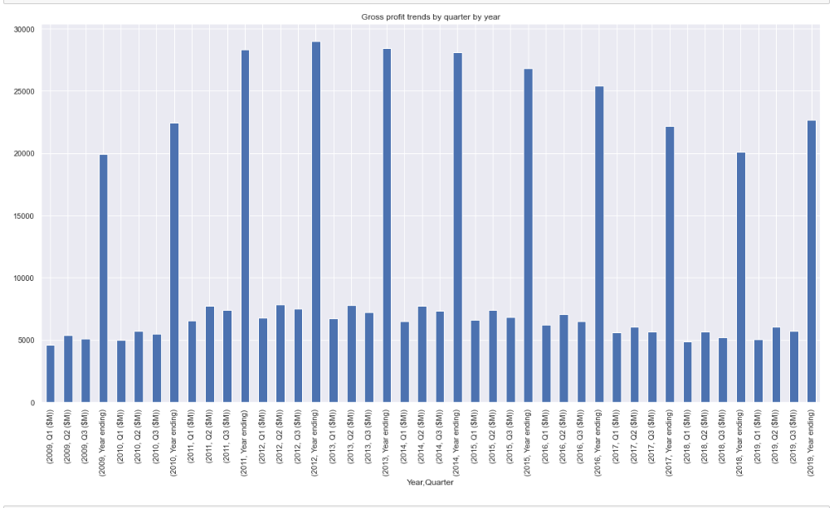

Fig 2: Gross profit by Quarter by Year

Based on these observations, I’d implore my client with a beverage company to optimize product sales and advertisements at the second quarter of each year.