Hamoye Data Storytelling Project

Datatype - Health Industry (Covid-19)

# The Truth About COVID 19 and the Nigerian economy

On the 27th of February, 2021, Nigeria recorded its first case of coronavirus in Lagos State. Since then, it has been a matter of self-protection, increase in case numbers, and a series of both correct and incorrect information on the coronavirus. During this same period, the Nigerian economy was also going through recession, inflation, unemployment and public debt (African Development Bank Group, ADBG).

Vulnerability index to COVID 19 shows that the rate of infection does not directly subject affected states to potential hazard. Lagos has maintained the first position in terms of infection, recovery and death from the COVID 19 pandemic, yet it has lesser chances of feeling severe impact from a new wave. On the other hand, Kaduna which has almost 10 times less infection rate than Lagos will be mostly impacted by a fresh wave and has higher chances of going through a hazard. Confirmed cases in Nigeria appear to be increasing at 100 per day over the past 30 days as of 5th of March, 2022.

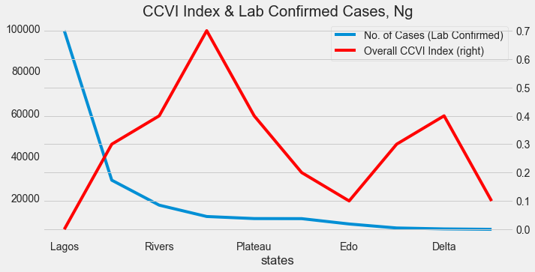

Fig1: Vulnerability index and number of confirmed cases in Nigeria by state.

Population density has little effect on the rise of cases. This is almost unbelievable, considering that the higher the population, the lower the chances of consistently maintaining 2 metres distance from one another and the higher the chances of the virus spreading.

However, when you think about it, Kano, Kaduna, and Oyo states, among the top 5 most populated states in Nigeria, have significantly lesser infection records compared to Lagos (Nigeria Infopedia). In a way, this proves that population has very little to do with spread of the coronavirus infection. Perhaps, the small land size of Lagos State could account for the infection rate. You would agree that it is the smallest of all mentioned states and if it was to be ranked, it would not make the top 15 of large states.

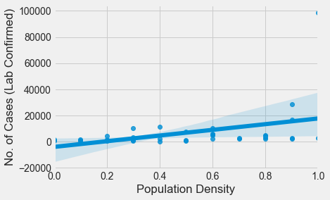

Fig2: Population density correlation map with rate of infection

Since 2014, real GDP for Nigeria has always increased by a quarter. However, the second quarter of 2020 experienced a huge dip that fairly recovered in the third.

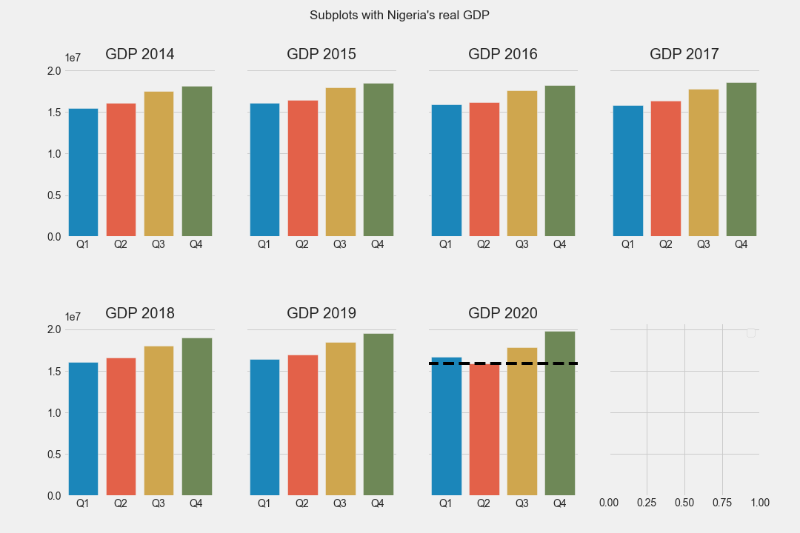

Fig 3: Real GDP by quarter from 2014 to 2020

New variants of covid 19 keep coming into light. First it was Delta, and then, Omicron, Alpha, Beta and Gamma. As scientists seek to predict the next move of this deadly virus and how vaccination and other forms of immunity may or may not restrict it, it is important that individuals, health practitioners, and policy makers start to consider how the standard of living may change.

The reality is, Nigeria is, and has been, taking severe hits from different common purely economic angles. However, combining these existing conditions with a pandemic, or the slowly approaching endemic of the Omicron variant, may be the worst hit that the giant of Africa suffers in a long time. Provision of social protection for Nigerians can reduce welfare losses and poverty hike agitated by the pandemic.

The coronavirus pandemic should've been majorly a health crisis. But in Nigeria, it is more economical than health.