# The Solution to Food Shortage in Africa: The Data POV

What would you say is the easiest solution to the food shortage problem in Africa? Some reasonable solutions may be to increase food production or create access to efficient food storage systems. You may also suggest developing and implementing some processing methods to transform raw food and increase shelf life and possibly nutritional value.

You're not entirely wrong. But, let's see what real life data has to say about the African food shortage problem.

For this short research, we're focusing on the food production and supply rate across 45 African countries. There are over 90 foodstuff products under consideration. However, we'll consider them as a whole for robust insight.

To start with, the assumption (null hypothesis) is that food production is equal to food supply/ consumption across most African countries. For balancing, the alternative hypothesis is that food production is not equal to food supply in most African countries.

Results from exploration of the datasets showed that of all 45 countries, Nigeria, Egypt, and South Africa had the highest food production rate consistently for 10 years. A closer look at this data revealed that the difference in food production across these 3 countries were in fact, significant and begs the question: just how much food are countries like Algeria and Rwanda producing for their citizens.

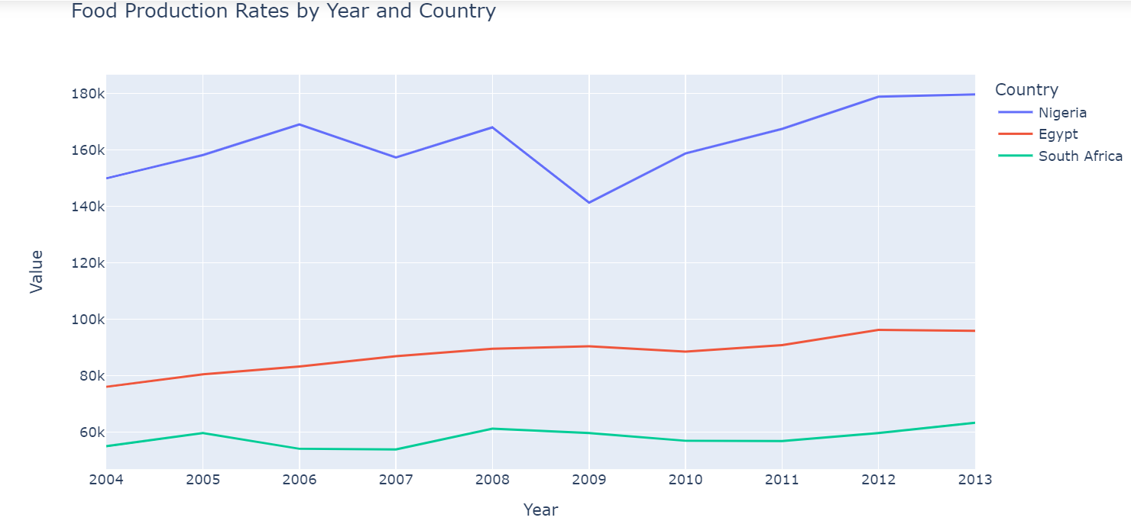

Fig 1: Top 3 African countries in food production

The food supply data made it clear that production had little to do with consumption (supply). The most likely reason for this would be the difference in population. But is that really it?

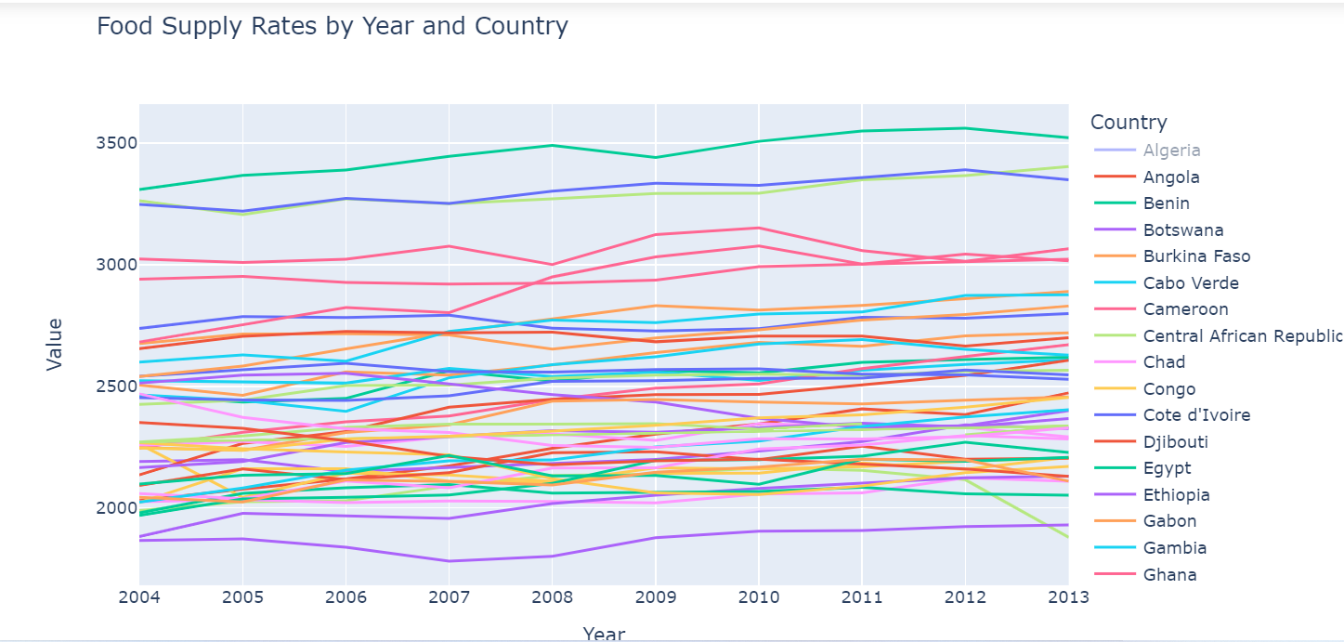

Fig 2: Food supply rates by country. Egypt is represented by the deep green colour at the top of the graph. The deep blue line next to it represents Tunisia and is closely followed by a line with a lighter shade of green that represents Morocco.

Comparing both datasets further emphasized the little correlation between production and supply of food. The selected countries - Nigeria, Egypt, Tunisia, South Africa, and Morocco were selected based on performance in earlier explorations.

The figure below shows that despite Nigeria ranking really high in terms of production, supply and consumption rate is almost nonexistent. Similarly, Tunisia with a rather consistent low food production over 10 years, has citizens’ consumption rate continuously rising.

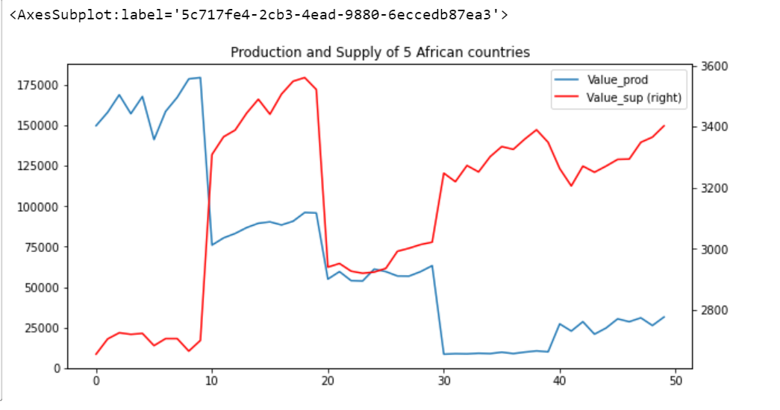

Fig 3: Production and supply relationship in 5 countries

* Key  
  On X-axis:  
  0-9 represents Nigeria  
  10-19 represents Egypt  
  20-29 represent South Africa  
  30-39 represent Tunisia  
  40-49 represent Morocco  
  On Y-axis:  
  Left represents Production  
  Right represents Supply

**Conclusion**

From what we have, it's a little sad to see that food production is not the major reason for food scarcity as some of the countries with high food production have low consumption. The proportion of food lost either from spoilage or careless wastage in one nation might account for the mouths that several other nations are unable to feed.

I think we can all agree to reject the null hypothesis on this note.

As for practical solutions to food shortage, there’s no one solid path to it. Sharing of resources across nations would go a long way to bridge the imbalances created by economic or climate instabilities. Also, better storage, processing, production, and transportation facilities have their roles to play.