
ASSIGNMENT COVER SHEET

Every piece of written work you submit for assessment must have this cover sheet attached

COURSE DETAILS

Question 1

Table 1: Linear regression model assessing the association between women’s BMI and physical health outcome score (n = 3452)
Analysis of Parameter Estimates
Parameter | Estimate | 95% Confidence Interval | P-values | r-squared
Intercept | 61.58 | 59.90, 63.25 | <0.0001 | 0.05
BMI (kg/m²) | -0.46 | -0.52, -0.40 | <0.0001
Scale | 9.83
A linear model was used to assess the effect of BMI on physical health outcome score. The BMI was also assessed for curvilinear association with physical health outcome.
Working with the linear model, an increase in 1 kg/m² in the women’s BMI is associated with a decrease of 0.46 (Table 1) in the physical outcome score (95% CI: 0.40, 0.52). This effect is statistically significant (P < 0.0001). From the r-squared value, BMI accounts for 5.7% variability in physical health outcome score, and therefore, this model explains 5.7% of the variance.

Figure 1: Predictions (solid line) for the women’s physical health outcome score for each BMI (kg/m²) based on a linear model
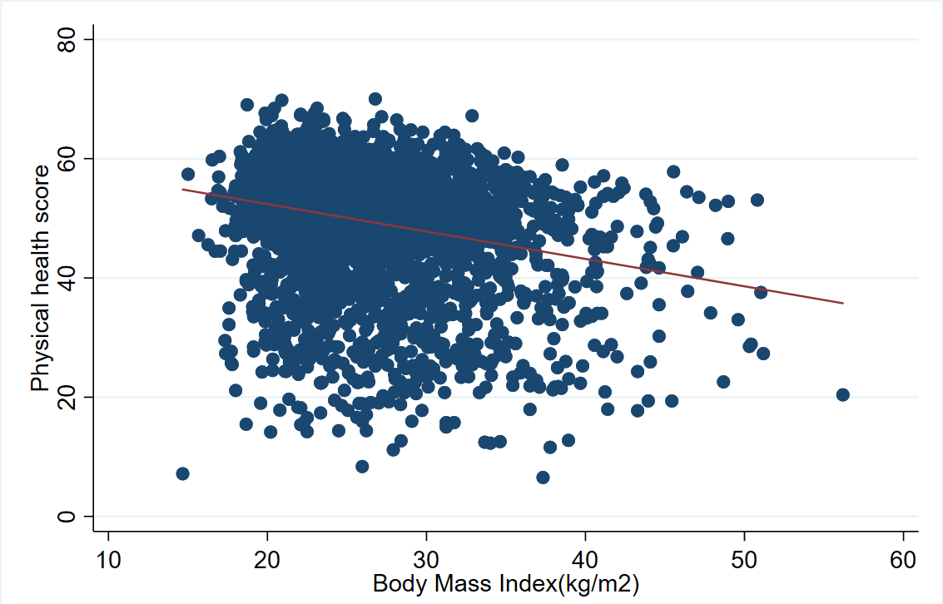

Question 2

Table 2: Multiple linear regression models to assess the associations of BMI, alcohol use, exercise level, and smoking status with women’s physical health outcome score (n=3311)

 | Univariate models |  |  | Adjusted model
 | Coefficient | 95% CI | p-value | Coefficient | 95% CI | p-value
Women’s BMI  Exercise group | -0.46 | (-0.52, -0.40) | <0.001 | -0.40 | (-0.46, -0.37) | <0.001
1 (lowest level) | Reference |  |  | Reference
2 | 3.76 | (2.79, 4.73) | <0.001 | 2.70 | (1.71, 3.69) | <0.001
3 | 5.32 | (4.31, 6.34) | <0.001 | 3.89 | (2.86, 4.92) | <0.001
4 (highest level) | 5.86 | (4.93, 6.82) | <0.001 | 4.51 | (3.55, 5.47) | <0.001
Smoking category
Never smoker | Reference |  |  | Reference
Ex-smoker | -0.41 | (-1.18, 0.38) | 0.295 | -0.77 | (-1.53, -0.01) | 0.047
Irregular smoker | -0.69 | (-0.37, 1.99) | 0.615 | -0.89 | (-3.63, 1.84) | 0.521
Weekly smoker | 3.00 | (-0.56, 6.56) | 0.098 | 2.83 | (-0.60, 6.23) | 0.106
Daily smoker | -2.49 | (-3.46, -1.52) | <0.001 | -2.35 | (-3.33, -1.37) | <0.001
Alcohol use
Non-drinker | Reference |  |  | Reference
Low risk drinker | 3.69 | (2.67, 4.70) | <0.001 | 2.35 | (1.32, 3.38) | <0.001
Rarely drinks | 0.94 | (-0.16, 2.04) | 0.093 | 0.69 | (-0.42, 1.80) | 0.222
Risky drinker | 2.56 | (0.88, 4.24) | 0.003 | 1.80 | (0.11, 3.50) | 0.037
High risk drinker | 0.47 | (-2.83, 3.77) | 0.781 | -0.01 | (-3.24, 3.21) | 0.994
The adjusted model includes BMI, exercise, smoking and alcohol use.

The decrease in women’s physical health outcome associated with BMI (0.40 kg/m² 95%CI: 0.37 to 0.46) in the adjusted model is slightly different (lower) from that observed in the unadjusted value. Similarly, the effect of exercise decreased in all groups compared to the unadjusted model. The effect of alcohol use on physical health reduced in the adjusted model compared to the unadjusted values, with only the association of the low-risk drinker being significant (2.35, 95% CI (1.32, 3.38) p<0.0001). However, the effect of smoking in the adjusted model increased in the ex-smokers and irregular smokers and decreased in the weekly and daily smokers, with only daily smoking having a significant association (p<0.0001) in both models. These non-negligible differences between the adjusted and unadjusted values indicate a confounding of the original effect of one variable by the other variables.
The model explains 10.1% of the variation in women’s physical health outcome, most of which can be attributed to BMI and exercise.

Question 3
Physical health outcome score for someone with BMI=24, exercise group =4, who’s a non-smoker and a low-risk drinker.

Physical health outcome score = 53.30

Question 4

Table 3: Likelihood ratio test assessing statistical significance of alcohol use and smoking as predictors of physical health (n=3311)
Likelihood Ratio Statistics
Source | DF | Chi-Square | p-value
Smoking | 4 | 26.68 | <0.0001
Alcohol use | 4 | 30.90 | <0.0001
The likelihood ratio tests indicate that smoking and alcohol use are statistically significant predictors of physical health outcome, with alcohol use being a slightly stronger predictor.

Question 5

In a scenario where the normality assumption is not met for the outcome variable, given the predictors, one approach would be to transform the data using a logarithm scale, especially if the distribution is positively skewed (to the right). This may affect the interpretability of the effect of each predictor on the physical health outcome. An alternative approach is to run a sensitivity analysis and compare p-values obtained from both the transformed and original data. If the statistical significance are similar, then the model can be interpreted based on the original data.

Question 6

Table 4: Multiple linear regression models to assess the associations of metals and height for age Z score (HAZ) in Ugandan children (n=95)
 | Univariate models |  |  | Adjusted model
 | Coefficient | 95% CI | p-value | Coefficient | 95% CI | p-value
Pb | -0.425 | (-0.993, 0.144) | 0.141 | -0.796 | (-1.471, -0.120) | 0.021
As | -0.002 | (-0.468, 0.463) | 0.992 | -0.052 | (-0.582, 0.478) | 0.846
Cd | 0.031 | (-0.252, 0.314) | 0.829 | 0.197 | (-0.179, 0.573) | 0.300
Se | 1.653 | (0.538, 2.768) | 0.004 | 1.924 | (0.608, 3.240) | 0.005
Zn | 0.562 | (-0.371, 1.496) | 0.235 | -0.198 | (-1.368, 0.972) | 0.737
Admitted to hospital | Reference: Yes |  |  | Reference: Yes
No | -0.208 | (-1.147, 0.732) | 0.662 | 0.038 | (-0.893, 0.969) | 0.936
Education level | Reference: completed primary school or less |  |  | Reference: completed primary school or less
Completed secondary school or more | -0.465 | (-1.252, 0.322) | 0.244 | -0.488 | (-1.303, 0.326) | 0.237
The adjusted model includes Pb, As, Cd, Se, Zn, mother’s education attainment level and indication of child admission to the hospital.

The adjusted model showed significant negative association (p=0.021) between Pb exposure and HAZ score with larger effect (-0.796 95% CI: (-1.471, -0.120)) compared to the unadjusted model. The effect of Se exposure increased with adjustment (1.924 95% CI: (0.608, 3.240)), indicating confounding of the original effect by other predictor variables in the model. In terms of effect size and statistical significance, SE exposure is the strongest predictor (p=0.005), followed by Pb exposure. The model explains 14.9% variation in HAZ score.

Based on the multiple regression model, the largest positive residual is 4.231 and the largest negative -6.962. Possible explanations for the high residuals and deviation from the predicted values include outliers or extreme values in the real data, potential non-linear association, and errors in measurement.

Appendix
// Assignment 1

* reading in the data

use "Z:\midagecohort.dta", clear

* exploring dataset
codebook
describe

// Q1 Create regression model to describe the association between BMI and physical health outcome. Assess linearity of model. Chose a model, present and interpret its coefficients, CIs, p-values and r-squared values. Produce a scatter graph of BMI and physical health with the predicted values from your chose model overlaid

// Primary outcome is m2pcswha
* Exploring outcome distribution

hist m2pcswha, normal
hist m2pcswha, percent start(5) width(5) normal xtitle("Physical Health Component")

* checking relationship between physical health and BMI
scatter m2pcswha m2bmi || lfit m2pcswha m2bmi, xtitle(Body Mass Index) ytitle(Physical health score) legend(label(1 "Physical health"))

* scatter plot shows a negative linear relationship
* correlation testing
corr m2pcswha m2bmi

* regression model
regress m2pcswha m2bmi
predict fitl // fitted values for linear model
est store model0

* P value < 0.0001, r-squared = 0.057, which means BMI accounts for 5.7% variability in physical health scoare and for every increase in BMI, physical activity score reduces by 0.46 (CI 0.4 - 0.52)

* testing for curvilinearity
* centering the bmi values based on the mean
sum m2bmi if m2pcswha~=. // mean is 26.2604
gen centrebmi = m2bmi - 26.2604
hist centrebmi
gen centrebmi_sq = centrebmi^2
regress m2pcswha centrebmi centrebmi_sq
*the above analysis showed evidence of curvilinear relationship with p value = 0.002 and < 0.0001. Also, r-squared increased slightly to 5.9%. We're choosing the linear model because there isn't much difference and it's easier to interpret for prediction
predict fitc // fitted values for curved model
est store model1

* scatter graph for predicted value of both models
scatter m2pcswha m2bmi || line fitl m2bmi, xtitle(Body Mass Index(kg/m2)) ytitle(Physical health score) legend(label(1 "Physical health"))

// Q2 produce a table presenting the results from a univariable model for each exposure nad a multiple regression model including BMI, exercise, smoking and alcohol use.
regress m2pcswha m2bmi
regress m2pcswha i.m2metminexgrp
regress m2pcswha i.m2smkAIHW
regress m2pcswha i.m2alcnhmrc
regress m2pcswha ib2.m2alcnhmrc // using the non-drinkers as reference instead of default 1

* multiple regression model
regress m2pcswha m2bmi i.m2metminexgrp i.m2smkAIHW ib2.m2alcnhmrc

// Q3 use the multiple regression model from Q2 to predict physical health outcome score for someone with BMI=24, Ex=4, non-smoker and low-risk drinker
regress m2pcswha m2bmi i.m2metminexgrp i.m2smkAIHW ib2.m2alcnhmrc
// making predictions from the created regresion model
predict fv, xb

//predicting standard errors for the fv
predict fvse, stdp

//predicting the residuals... that's regression with 95% for individual values
predict res, res

//predicting se for resisuals
predict resse, stdr

//Create the 95%CI using our standard formula..
generate lowCI_res = fv - 1.96*resse
generate highCI_res = fv + 1.96*resse

// predicting physical health outcome
list m2bmi lowCI_res highCI_res if m2bmi>23.99 & m2bmi<24.01 & m2metminexgrp==4 & m2alcnhmrc==1 & m2smkAIHW==1 //... didn't work...

//calculating manually intercerpt + coeff*BMI + coeff*Exe4 + coeff*alcohol2 + coeff*smoking
disp 56.04389 + (-0.4*24) + (4.51*1) + (2.35*1) + (0*1)

// Q4 Use likelihood ratio test to assess whether smoking and alochol use are stat. significant predictors of physical health

drop if m2alcnhmrc==. | m2bmi==. | m2pcswha==. | m2smkAIHW==. | m2metminexgrp==.
codebook
regress m2pcswha m2bmi i.m2metminexgrp i.m2smkAIHW ib2.m2alcnhmrc
est store full_model
regress m2pcswha m2bmi i.m2metminexgrp i.m2smkAIHW
est store no_alcohol
regress m2pcswha m2bmi i.m2metminexgrp ib2.m2alcnhmrc
est store no_smoking
// Running LR testing
//Calculating LRT for alcohol use
lrtest full_model no_alcohol
//calculating LRT for smoking
lrtest full_model no_smoking

// Q5 Use the multiple regression model to assess the normality assumption

//summarise the residuals...
summarize res, detail

//...and plot a histogram
histogram res, percent normal title(Histogram of residuals from multiple regression model)

// Q6 Produce the multiple linear regression model used in provided research paper
import excel "Z:\pone.0233108.s005.xlsx", sheet("Sheet 1") firstrow clear

// outcome variable is HAZ; predictors are Pb, se, zn, as, cd, education, and admit
codebook

//data transformation of Metal records to log 2
gen pb2 = log(pb_ugdL)/log(2)
gen as2 = log(as_ugL)/log(2)
gen se2 = log(se_ugL)/log(2)
gen zn2 = log(zn_ugL)/log(2)
gen cd2 = log(cd_ugL)/log(2)

//univariable models
regress haz pb2
regress haz as2
regress haz se2
regress haz zn2
regress haz cd2
xi: regress haz i.admit_ever
xi: regress haz i.edulevel
//multiple regression model
regress haz pb2 as2 se2 zn2 cd2 i.admit_ever i.edulevel

// Producing residuals based on multiple regression model
// making predictions from the created regresion model
predict fv, xb

//predicting standard errors for the fv
predict fvse, stdp

//predicting the residuals... that's regression with 95% for individual values
predict res, res

//predicting se for resisuals
predict resse, stdr

//To see the 10 smallest and largest, sort haz, then list the 10 smallest and biggest...
sort res
list haz res in 1/10 //These are 10 smallest
list haz res in 86/95 //These are 10 biggest

