An Analysis of the Influence of Estrogen Receptor Gene Expression and other Factors on Survival (or Death) in Patients with Breast Cancer
Author: Halimat Chisom Atanda
Background
Cancer is a genetic disease characterised by abnormalities in the gene structure and function, and it affects various sites in the body. According to the World Health organisation, breast cancer is the most common type of cancer in women, and after years of research to understand the disease, data has shown that patients with the same kind of cancer and similar characteristics like age can react very differently to similar treatment. Genomics research explores the level of gene expression in cancer and can provide relevant information about its progression and therefore, contribute to developing more accurate estimates of effective treatment options.
This study began with data on 450 randomly selected patients with information about age, gene presence, chemotherapy, and survival period. It was originally collected by researchers in Cambridge Research Institute and British Columbia Cancer Centre and published in Nature, but retrieved from the Molecular Taxonomy of Breast Cancer International Consortium on Kaggle as Breast Cancer Gene Expression Profiles (METABRIC) | Kaggle. Considering the data source, the population would most likely be British and Canadian women (or women in the UK and Canada) with breast cancer at the time of collection. This study explores the relationship between age, chemotherapy, cause of death, presence of estrogen receptors (the gene), survival months, tumour size, and tumour stage. Three of these variables - age, overall survival in months, and tumour size (mm) - are continuous, two are binary - chemotherapy and estrogen receptor status, and two are categorical - tumour stage and death from cancer.
More specifically, the aim of this study is to understand the influence of oestrogen receptor, age, and tumour size and stage on breast cancer progression and survival among patients.
Exploratory Data Analysis
Patients with missing values were dropped from the study, which reduced the sample to 332 patients. This still meets the analysis requirement for this study (between 100 and 500 data values).
Table 1: Summary statistics for Age, Survival period, and Tumour size of breast cancer patients
Variable | Mean | SD | Min. | Max. | Median
Age (years) | 61.11 | 12.45 | 33.04 | 92.14 | 61.56
Survival period (months) | 129.28 | 73.38 | 4.43 | 318.20 | 121.05
Tumor size (mm) | 25.46 | 11.42 | 1.00 | 99.00 | 23.00

Table 2: Distribution and percentage occurrences for chemotherapy, tumour stage, estrogen receptor status, and cause of death among breast cancer patients.
Variable | Variable Case | Number (Percentage)
Chemotherapy | Yes | 81 (24.40%)
Chemotherapy | No | 251 (75.6%)
Estrogen receptor status | Positive | 257 (77.41%)
Estrogen receptor status | Negative | 75 (22.59%)
Tumour stage | Stage 0 | 1 (0.30%)
Tumour stage | Stage 1 | 106 (31.93%)
Tumour stage | Stage 2 | 196 (59.04%)
Tumour stage | Stage 3 | 26 (7.83%)
Tumour stage | Stage 4 | 3 (0.90)
Death from cancer | Died of disease | 118 (35.54%)
Death from cancer | Died of other causes | 73 (21.99%)
Death from cancer | Living | 141 (42.47)

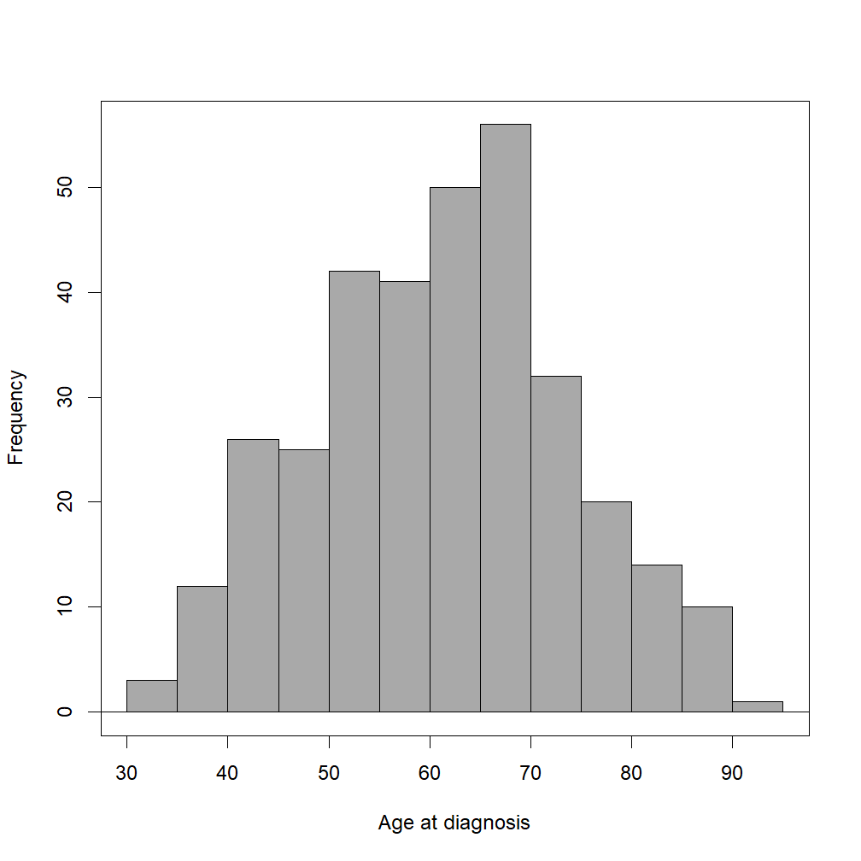
Figure 1: Distribution of age of patients with breast cancer (33.04 – 92.14 years).
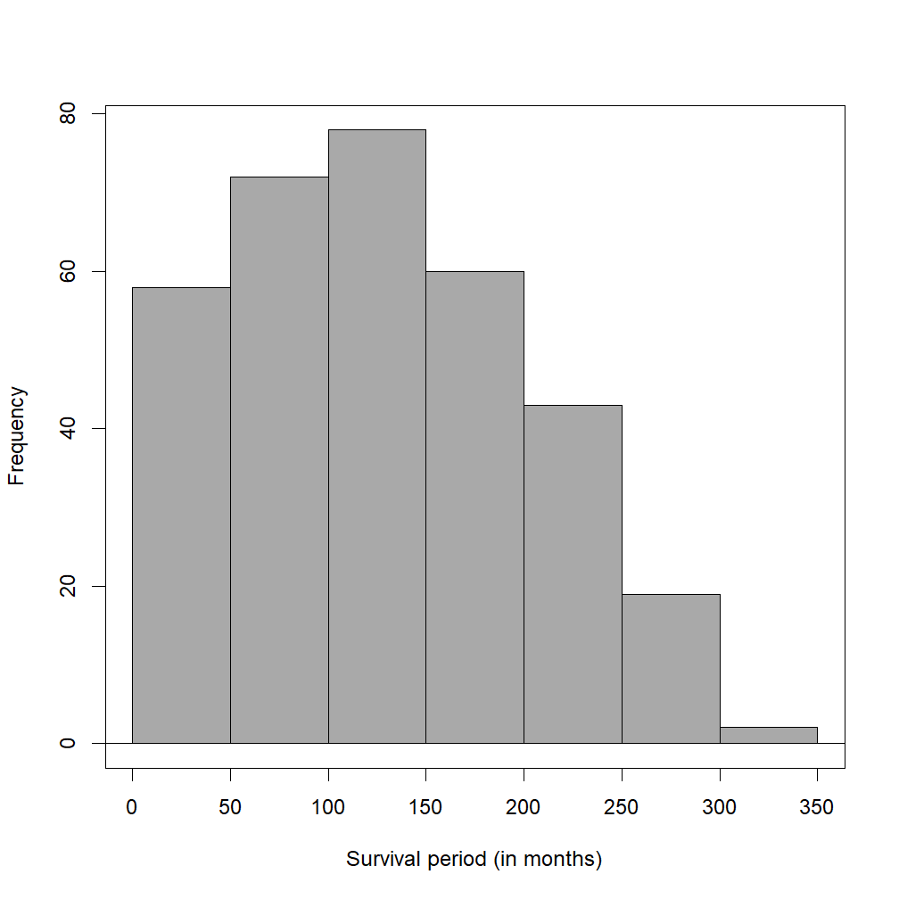
Figure 2: Distribution of survival period (counted in months) in breast cancer patients
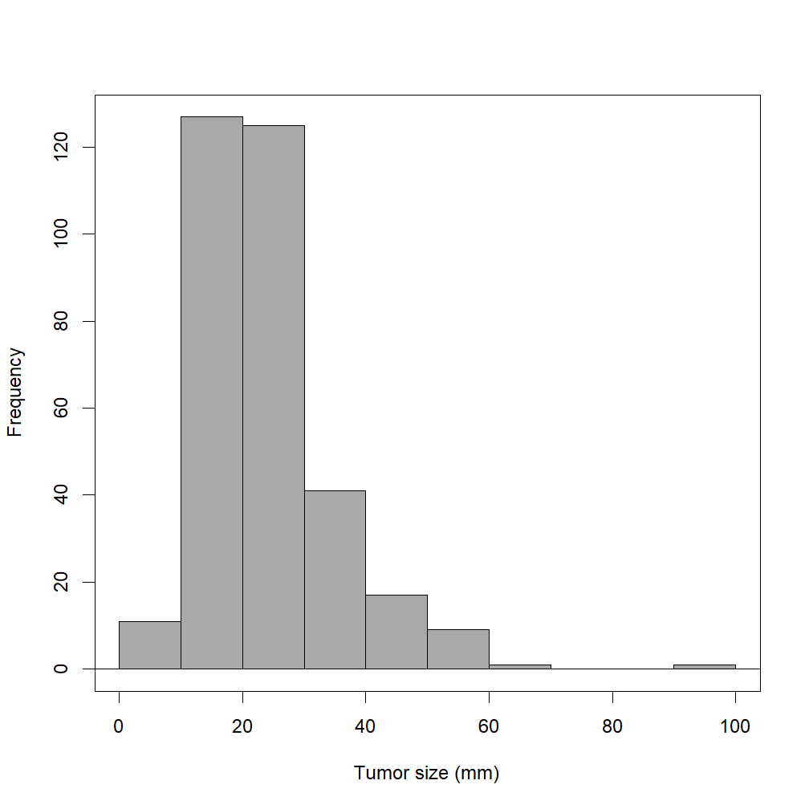
Figure 3: Distribution of tumour size (mm) in breast cancer patients
The figures above show the distribution of age (figure 1), survival time (figure 2), and tumour size (figure 3) in breast cancer patients from the British Columbia Cancer Centre. The age distribution is normal, from the figure 1 and closeness of the mean (61.11) and median (61.56). Majority of the participants were between the ages 50 and 70 at the time of diagnosis of breast cancer, which is slightly within the midlife age range, and there’s a gradual decline in diagnosis as the age increases or decreases from that range. Many patients, regardless of age, appear to survive beyond 5 years (60 months) after diagnosis, which is displayed by the positive skewness in the survival time distribution (figure 2). The diameter of the tumour often ranges between 2 and 5 cm (20 and 50mm), however, larger tumours (>90mm) are not impossible, though rare, hence the outlier in figure 3.
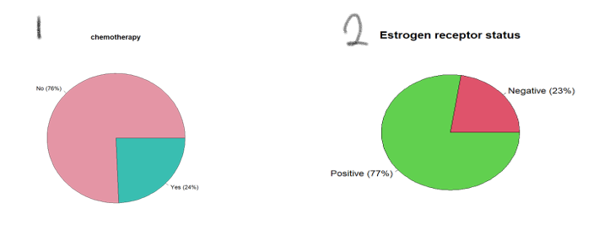
Figure 4: Percentage distribution of chemotherapy treatment (1) and estrogen receptor gene status (2) in breast cancer patients
Chemotherapy is the most common treatment or management program for many cancer types. Surprisingly, figure 4.1 shows that only a few breast cancer patients (24%) opted for it during the study. This could imply that chemotherapy is no longer an effective or trusted treatment option, possibly due to more complex genetic properties of the tumours. Estrogen receptor (ER) is one of the three major genes whose absence is a cause for worry in breast cancer diagnosis as it complicates target selection for existing therapeutic approaches, though only 23% of the patients (figure 4.2) have this attribute.
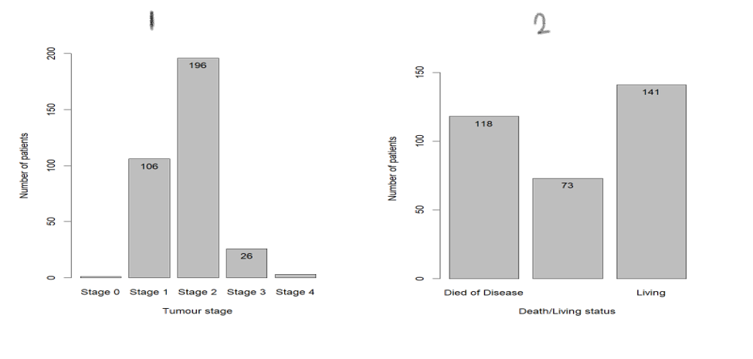
Figure 5: Distribution of breast cancer patients based on tumour stage (1) and living status (2)
Cancers, including breast cancer, have multiple stages of progression, with stage 0 being the least severe and stage 4 being fatal. Summary statistics (Table 2) shows that most patients were either in stage 1 or 2 of the breast cancer (also figure 5(1)). Figure 5(2) shows that there are more patients (141) living with breast cancer than are dying from it (118).
Statistical Hypothesis Testing for Categorical Variables: Chi-Squared test to check the association between ER status and other categorical variables.
Null hypothesis: Estrogen receptor gene has no effect on breast cancer progression and patient survival.
Alternative Hypothesis: Estrogen receptor gene affects breast cancer progression and patient survival.
Underlying assumptions for chi-squared test:
- The observed frequencies are independent; that is the value of one observation has no effect on another observation.
- The cell sizes are small, i.e., more than 80% of expected frequencies are higher than the value 5 – Tables 4, 6, and 8.
Table 3: Observed frequencies of tumour stages based on estrogen receptor status.
 | Stage 1 (%) | Stage 2 (%) | stage 3 (%) | Total (%)
er_Negative | 18 (24.0) | 44 (58.7) | 13 (17.3) | 75 (100)
ER_positive | 89 (34.6) | 152 (59.1) | 16 (6.2) | 257 (100)
Total | 107 (32.2) | 196 (59.0) | 29 (8.7) | 332 (100)
Table 4: Expected frequencies for tumour stages based on estrogen receptor status
 | stage 1 (%) | stage 2(%) | Stage 3 (%) | Total (%)
er_negative | 24.17 (32.2) | 44.28 (59.0) | 6.55 (8.7) | 75 (100)
er_positive | 82.83 (32.2) | 151.72 (59.0) | 22.45 (8.7) | 257 (100)
Total | 107 (32.2) | 196 (59.0) | 29 (8.7) | 332 (100)
There were initially 5 tumour stages, but after creating a contingency table for this variable, 4 of the expected frequencies were less than the value of 5, and therefore a Chi-Squared test would not be the right statistical model. To accommodate the Chi-Squared test, stages 0 and 1 were merged to stage 1, and stages 3 and 4 merged to stage 3 (Table 3 & 4). With these values and at (X² (2) = 10.24, p = 0.006), we can conclude that there is an association and statistically significant difference between the tumour stages in breast cancer with respect to ER status. The percentage of patients with negative ER status was significantly higher in patients with stage 3 breast cancer.
Table 5: Observed frequencies of death status based on estrogen receptor status.
 | died from disease (%) | death from other causes(%) | living (%) | Total (%)
er_negative | 38 (50.7) | 8 (10.7) | 29 (38.7) | 75 (100)
er_positive | 80 (31.1) | 65 (25.3) | 112 (43.6) | 257 (100)
Total | 118 (35.5) | 73 (22.0) | 141 (42.5) | 332 (100)
Table 6: Expected frequencies for estrogen receptor status and death status.
 | died from disease (%) | death from other causes(%) | living (%) | Total (%)
er_negative | 26.66 (35.5) | 16.49 (22.0) | 31.85 (42.5) | 75 (100)
er_positive | 91.34 (35.5) | 56.51 (22.0) | 109.15 (42.5) | 257 (100)
Total | 118 (35.5) | 73 (22.0) | 141 (42.5) | 332 (100)
From Tables 5 & 6 above, we can conclude that there is an association and statistically significant difference between death status with respect to ER status (X² (2) = 12.21, p = 0.002). The percentage of patients with negative ER status was significantly higher (50.7%) in those that died of breast cancer and lower (10.7%) in patients that died of other causes.
Table 7: Patient’s evaluation of chemotherapy treatment by ER status
 | no (%) | yes (%) | Total (%)
er_negative | 31 (41.3) | 44 (58.7) | 75 (100)
er_positive | 220 (85.6) | 37 (14.4) | 257 (100)
Total | 251(75.6) | 81 (24.4) | 332 (100)
Table 8: Expected frequencies for ER status and chemotherapy treatment.
 | no (%) | ER_Positive (%) | Total (%)
No | 56.7 (75.6) | 18.3 (24.4) | 75 (100)
Yes | 194.3 (75.6) | 62.7 (24.4) | 257 (100)
Total | 251 (75.6) | 81 (24.4) | 332 (100)
From Tables 7 & 8 above, we can conclude that there is a statistically significant relationship between the receipt chemotherapy treatment and ER status in breast cancer patients (X² (1) = 61.69, p = 4.0e-15). The percentage of ER negative patients that underwent chemotherapy was much higher than expected (58.7%).
At baseline, the tumour stages (p = 0.001), death status (p = 0.002), and chemotherapy treatment (p < 0.001) in breast cancer patients were statistically significantly different with respect to ER status, with relatively more stage 3 patients having ER negative status (Tables 3 & 4), more ER-negative patients reportedly dying from breast cancer) (Tables 5 & 6), and more ER negative patients undergoing chemotherapy) (Tables 7 & 8).
Correlation and Regression Analysis to test the Association between Age at Diagnosis, Tumour Size, and Survival Period
Null hypothesis: There’s no association between tumour size, patient age, and survival period.
Alternative hypothesis: There’s an association between tumour size, patient age, and survival period.
Assumptions for this test:
- Data is normally distributed (sample size is large enough >30 to accommodate normality assumptions)
- There’s an equal spread of data (homoscedasticity) along the zero line of residuals (figure 7)
- Observations are independent; the value of one observation has no effect on the value of another.
- There’s a linear relationship between all tested variables (figure 6).
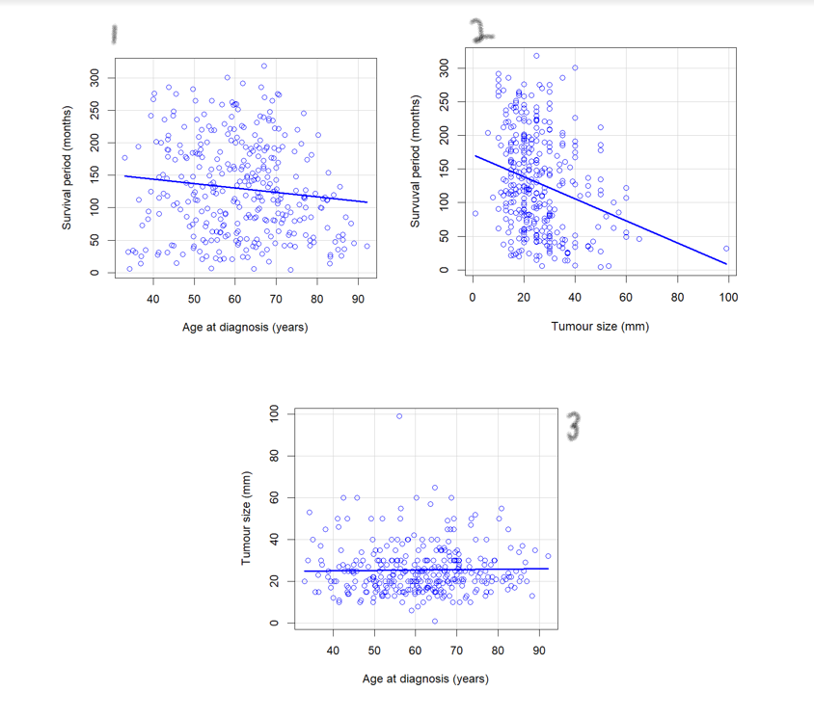
Figure 6: Scatterplot showing the graphical relationship between age at diagnosis, tumour size, and survival period of breast cancer patients.
The figure above shows a slight negative correlation (downward slope) between diagnosis age and survival period (1), and tumour size and survival period (2). The third figure (3) shows that there’s very little, if any, linear association between diagnosis age and tumour size. Therefore, correlation and regression analysis will only be performed to identify the degree of association between diagnosis age and survival period, and tumour size and survival period.
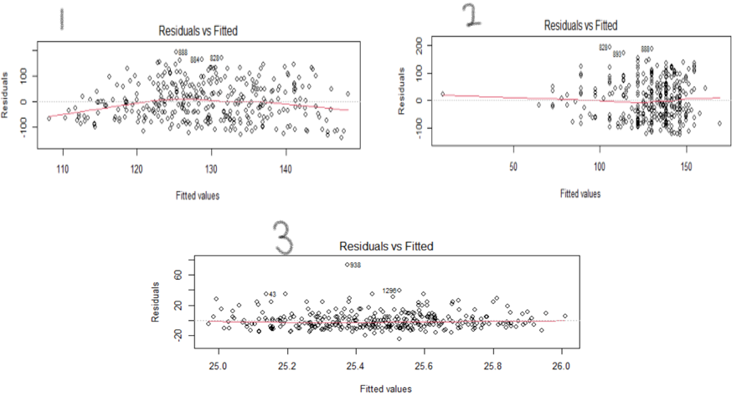
Figure 7: Homoscedasticity analysis for breast cancer patients’ age and survival status (1), and patient tumour size and survival outcome (2)
There is a statistically significant low correlation between diagnosis age and survival period (r(330) = -0.12, p=0.036). The higher the age at diagnosis, the lower the survival time in breast cancer patients (b=-0.68, se(b)=0.3, and/or 95%CI (-1.31, -0.05), t(330)=-2.1). However, there is weak evidence of the effect of age on survival period (p=0.036). Also, the age at diagnosis predicts and accounts for 1.3% of variance in the survival period. With a slope of -0.68, and an intercept of 170.86, we can predict that for each unit increase in the patient’s age, there’ll be a decrease in survival months by 0.68, (ie, survival_months = 170.86 - 0.68age at diagnosis).
The Pearson’s correlation coefficient, r(330) = -0.26, p < 0.0001, shows a modest negative association between tumour size and survival period and is statistically significant at the 5% level (b=-1.63, se(b)=0.3, and/or 95%CI (-2.30, -0.97), t(330)=-4.8). That is, as the tumour size increases in breast cancer patients, survival period decreases. Also, the tumour size predicts and accounts for 6.6% of variance in the survival period. With a slope of -1.63, and an intercept of 170.91, we can predict that for each millimetre increase in the tumour size, there’ll be a decrease in survival months by 1.63, (ie, survival_months = 170.91 - 1.63tumour size).
Discussion
This study explored the influence of ER receptor gene, tumour size and stage, and age on breast cancer progression and patient survival. The analysis continuously showed a statistically significant higher tumour severity and death among patients with negative ER status. That is, the occurrence of severe tumour stages and higher deaths in patients with negative ER status was not due to chance. It also shows that as the patient ages (p<0.001) and/or the tumour size increases (p=0.036), the patients’ survival time decreases, albeit to a small degree. Some of the strengths of this study were the large sample and population size as well as the clear and concise research questions. This study was not without limitations. For instance, a different statistical analysis may have better represented the relationship between tumour stages and ER receptor status as opposed to data transformation to fit Chi-Squared test. Also, as cancer is a genetic disease, there are several other factors that may have contributed to poor survival rate but weren’t explored in this study and that could mean the study conclusion is biased.
From this study, we can conclude that the absence of estrogen receptor in breast cancer patients, as well as higher ages and tumour size, poses a higher risk of death and severe tumour stages to the patients.

