- Question 1
Observations used: BMI as a continuous variable, excluding missing entries. Average daily hours spent on TV or games as continuous variable, excluding missing values and entries that exceeded the maximum hours in a day (>24). Gender for subgroup analyses.
Selected statistical measures: Correlation and regression to analyse the relationship between BMI and average daily hours. Correlation determines if there’s an association between the BMI and average screen time. Regression predicts the BMI based on the average daily screen time.
Null hypothesis: There is no linear association between the BMI and average daily screen time.
Alternative hypothesis: There is a linear association between the BMI and average daily screentime.
Assumptions for correlation and regression test:
- Data is normally distributed (sample size is large enough >30 to accommodate normality assumptions)
- There’s an equal spread of data (homoscedasticity) along the zero line of residuals. This assumption was not satisfied for the data, which led to the log transformation of the response variable.
- Observations are independent based on the study design; measurements were not repeated for participants.
- There’s a linear relationship between BMI and average daily screen time (figure 4).

Table 1: Summary statistics for BMI and average daily screen time
Variable | Mean | SD | Min. | Max. | Median (Q2) | Q1 | Q3 | Total (n)
BMI (kg/m²) | 28.02 | 6.45 | 16.20 | 79.20 | 26.90 | 23.60 | 31.00 | 1317
Average screen time/ day (hour) | 3.63 | 2.74 | 0.00 | 20.00 | 3.00 | 2.00 | 4.00 | 1317

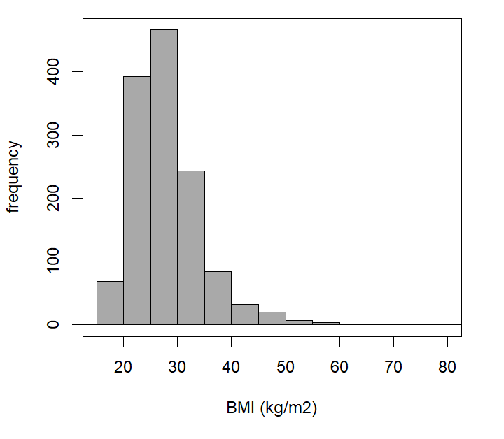
Figure 1: Frequency distribution of BMI (kg/m²) of participants
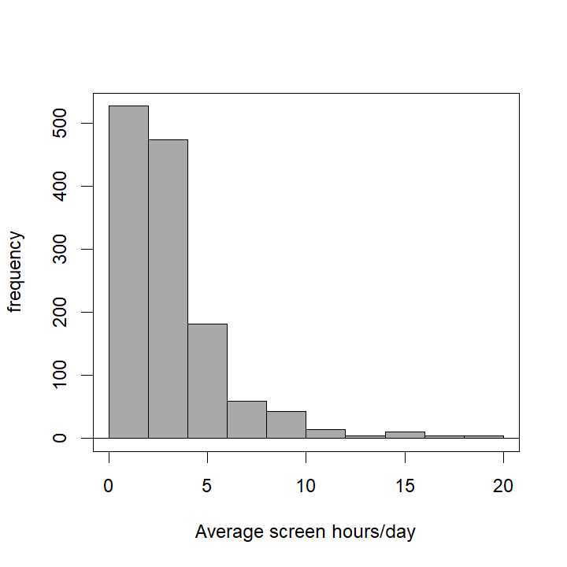
Figure 2: Frequency distribution of average daily screen time among participants

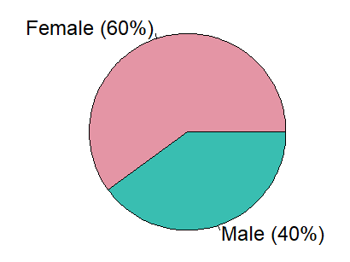
Figure 3: Percentage distribution of gender of participants
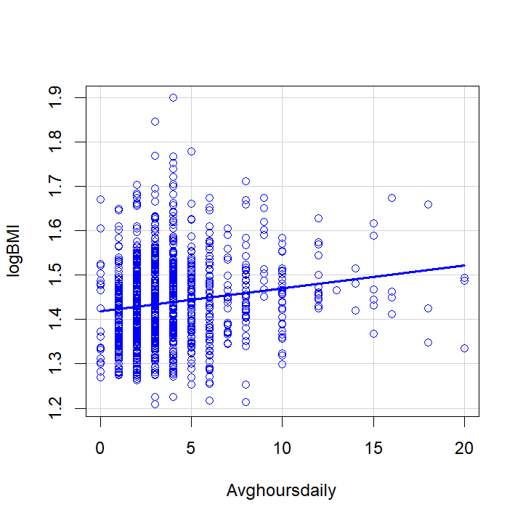
Figure 4: Scatter plot showing linear relationship between BMI (log10 transformed) and average daily screen time.
BMI data was log₁₀ transformed due to heteroscedasticity. However, the results of the statistical test (regression) were the same (statistically significant at the 5% significance level) with the transformed and untransformed data. Therefore, the untransformed data were reported for ease of interpretation.
There is a statistically significant low positive correlation (figure 4) between BMI and average daily screentime (r(1315)=0.15, p < 0.001). A high average screen time could mean high BMI in participant (b=0.35, se(b)=0.06, and/or 95%CI (0.22, 0.47), t(1315)=5.39). There is strong evidence of the effect of average daily screen time on BMI (p<0.001). Also, the average daily screen time predicts and accounts for 2% of variance in the BMI. With a slope of 0.35, and an intercept of 27.77, we can predict that for each hour increase in average daily screen time for any participant of the health trends survey, there’ll be an increase in BMI by 0.35, (i.e., BMI = 27.77 + 0.35averagescreentime). Therefore, we reject the null hypothesis and conclude that there’s a linear and statistically significant relationship between BMI and average daily screen time in the population.
Between the men and women subgroups, there was no difference in the relationship between BMI and average screen time, and there is an overlap of 95% confidence intervals for men (0.02, 0.33) and women (0.30, 0.68).
- Question 2
Selected observations and statistical test: One-way ANOVA to assess the relationship between BMI, which is a continuous variable, and income range, which is a categorical variable with 4 categories. Missing values for both variables were excluded from the analysis.
Null hypothesis: Participant’s BMI is independent on their income category, and BMI means for all categories are equal
Alternative hypothesis: Participant’s BMI is dependent on their income category, and means are different.
Assumptions for one way ANOVA:
- All 4 income categories ($0to$34,999, $35,000 to $99,999, $100,000 to $199,999, and $200,000 or more) have normally distributed BMI data (sample size, n, is large enough >30 to accommodate normality assumptions)
- The standard deviation of BMI of all 4 categories ($0to$34,999, $35,000 to $99,999, $100,000 to $199,999, and $200,000 or more) is the same. Homogeneity can be assumed since the standard deviations are fairly similar, ranging from 4-7, with means between 24 and 28 and the box plots and histograms were used to visualise.
- There are 4 independent simple random samples, one from each income category ($0to$34,999, $35,000 to $99,999, $100,000 to $199,999, and $200,000 or more) population.
Table 2: Distribution and percentage occurrences for income ranges, BMI categories, and gender
Variable | Variable cases | Number (percentage %)
Gender | Male | 526 (39.94)
Gender | Female | 791 (60.04)
BMI | Underweight | 10 (0.76)
BMI | Healthy weight | 437 (33.18)
BMI | Overweight | 466 (35.38)
BMI | Obese | 404 (30.68)
Income ranges | $0 to $34,999 | 508 (38.57)
Income ranges | $35,000 to $99,999 | 576 (43.74)
Income ranges | $100,000 to $199,999 | 178 (13.52)
Income ranges | $200,000 or more | 55 (4.18)
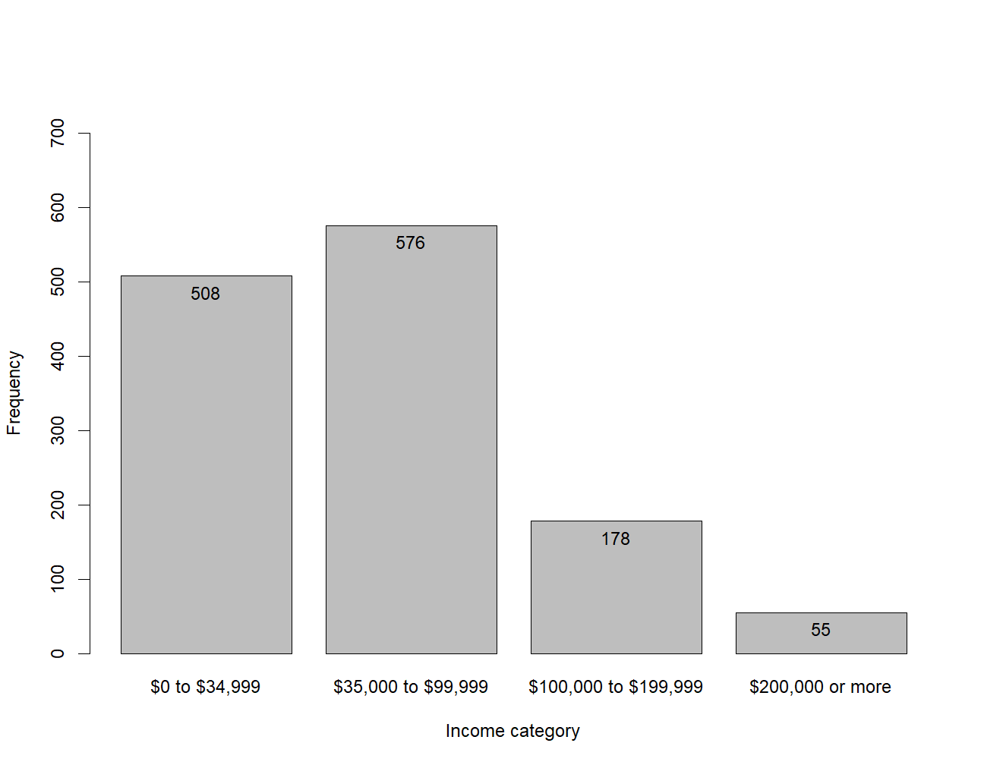
Figure 5: Number of participants per income category

There is a statistically significant difference in BMI across income range categories F(3,1313)=7.37, p < 0.001). That is, at least one income range group is significantly different from another, and therefore requires further analysis.
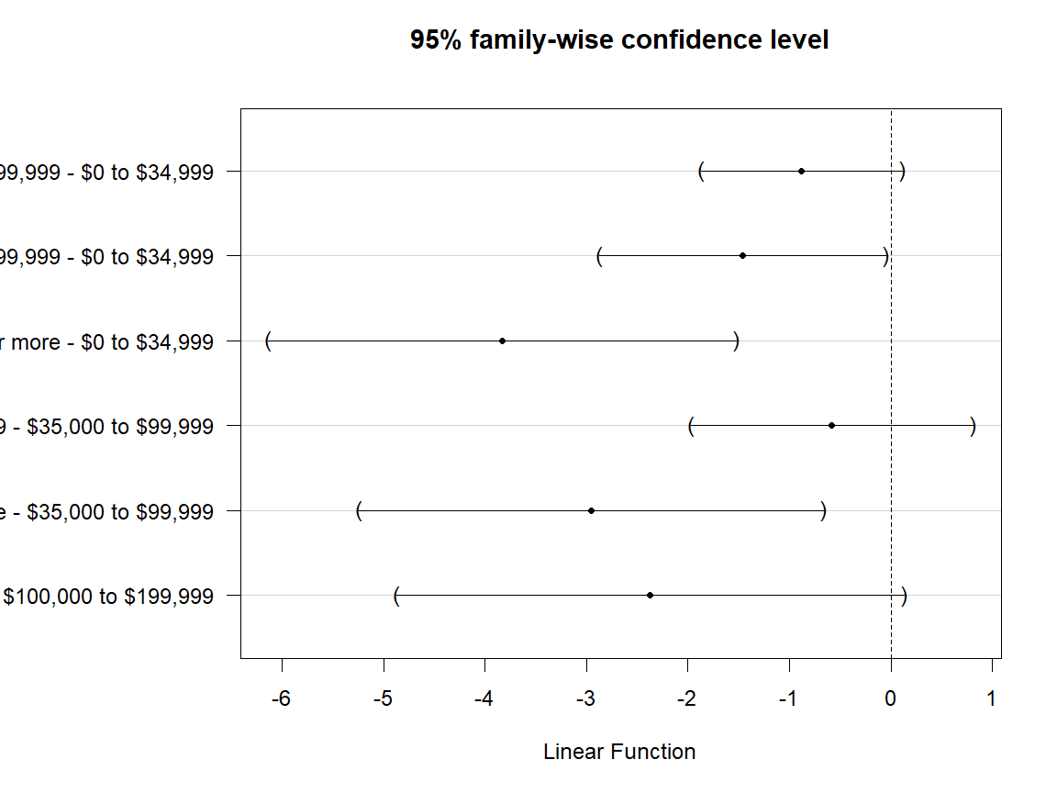
Figure 6: Tukey's all-pairs comparison plot with a family-wise Type I Error rate of 0.5, showing 3 group of income ranges with statistically significant different BMI means (not crossing the vertical line at 0).
Table 3: Average BMI in participants of the Health Information National Trends Survey (HINTS) divided into income ranges
Income range | Mean | SD | n
$0 to $34,999 | 28.8ª | 7.1 | 508.0
$35,000 to $99,999 | 27.9^{ab} | 6.4 | 576.0
$100,000 to $199,999 | 27.3^{bc} | 4.8 | 178.0
$200,000 or more | 24.9^{c} | 4.4 | 55.0
Means with the same subscript are not statistically significant. The BMI means of $0 to $34,999 and $100,000 to $199,999; $0 to 34,999 and $200,000 or more; and $35,000 to $99,999 and $200,000 or more are significantly different (Figure 6 and Table 3). We can conclude that the income range of the population influences their BMI.
In the men subgroup, the BMI means for all income ranges were equal, while the women subgroup was slightly similar to the population relationship with statistically significant different means for $0 to $34,999 and $100,000 to $199,999; $0 to $34,999 and $35,000 to $99,999; $0 to 34,999 and $200,000 or more; and $35,000 to $99,999 and $200,000 or more.
- Question 3
Selected observations and statistical test: Chi-squared test to check the relationship between 4 BMI weight categories (underweight, healthy weight, overweight, and obese) and 4 income categories ($0to$34,999, $35,000 to $99,999, $100,000 to $199,999, and $200,000 or more).
Null hypothesis: Participants’ weight status is independent and not associated with their income category.
Alternative Hypothesis: Participants’ weight status is dependent and associated with their income category.
Underlying assumptions for chi-squared test:
- The observed frequencies are independent; that is the value of one observation has no effect on another observation and measurements were not repeated in participants.
- The cell sizes are small, i.e., more than 80% of expected frequencies are higher than the value 5 (Table 5).
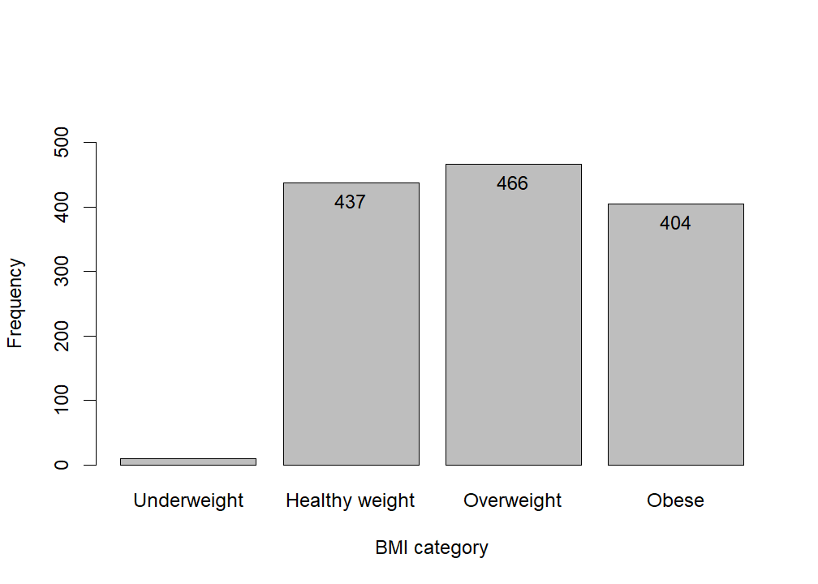
Figure 7: Number of participants per weight category
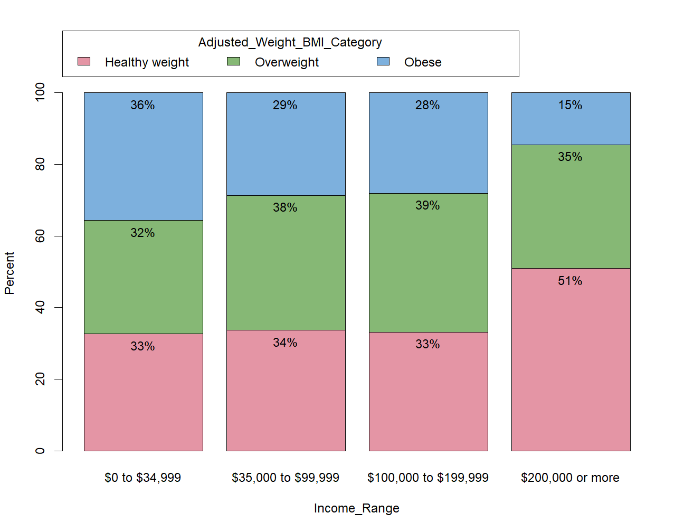
Figure 8: Percentage distribution of weight (BMI) categories per income range category
Table 4: Observed frequencies of weight status based on income range
 | Healthy weight (%) | Overweight (%) | Obese (%) | Total (%)
$0 to $34,999 | 166 (32.7) | 161 (31.7) | 181 (35.6) | 508 (100.0)
$35,000 to $99,999 | 194 (33.7) | 217 (37.7) | 165 (28.6) | 576 (100.0)
$100,000 to $199,999 | 59 (33.1) | 69 (38.8) | 50 (28.1) | 178 (100.0)
$200,000 or more | 28 (50.9) | 19 (34.5) | 8 (14.5) | 55 (100.0)
Total | 447 (33.9) | 466 (35.4) | 404 (30.7) | 1317 (100.0)
Table 4: Expected frequencies of weight status based on income range
 | Healthy weight (%) | Overweight (%) | Obese (%) | Total (%)
$0 to $34,999 | 172.4 (33.9) | 179.8 (35.4) | 155.8 (30.7) | 508.0 (100.0)
$35,000 to $99,999 | 195.5 (33.9) | 203.8 (35.4) | 176.7 (30.7) | 576.0 (100.0)
$100,000 to $199,999 | 60.4 (33.9) | 63.0 (35.4) | 54.6 (30.7) | 178.0 (100.0)
$200,000 or more | 18.7 (33.9) | 19.5 (35.4) | 16.9 (30.7) | 55.0 (100.0)
Total | 447.0 (33.9) | 466.0 (35.4) | 404.0 (30.7) | 1317.0 (100.0) (1nnn) (100.0)

After creating a contingency table for the default weight categories (Table 2), 4 of the expected frequencies were less than the value of 5, and therefore a Chi-Squared test would not be the right statistical model. To accommodate the Chi-Squared test, underweight was merged with healthy weight (Table 3 & 4). With these values and at (X² (6) = 18.24, p = 0.006), we can conclude that there is a statistically significant association between the weight status and income ranges of participants in the national trends survey. The percentage of participants with income range of $200,000 or more was higher in healthy and obese weights, and that of $0 to $34,999 was higher in obese participants of the national trends survey, compared to expected frequencies.
- Question 4 Summary
The study explored the influence of average daily screen time and income range on the BMI (as an individual value and a weight category) of the health information national trends survey participants. The analysis showed a statistically significant (p<0.001) higher BMI in participants that reported high average daily screen time. It also showed a statistically significant association (p=0.006) between income range category and weight category, and between BMI values and income range category (p<0.001), which implies that weight of many participants depends on their income.
One of the strengths of this study were large sample size (1317) based on the idea that the larger the sample size, the closer the findings and conclusions are to the population. A second strength is the specificity of the research question which ensured that only specific variables were explored. The study has its limitations. For instance, a different statistical analysis may have shown a more accurate relationship between the wight categories and income range categories, instead of transforming the data for Chi-Squared test. Also, some data points had to be excluded due to incorrect or missing values which reduced initial sample size from 1500 to 1317.
Overall, the association between weight and income range category may require further exploration for a more valid association level that represents the population. Since both transformed and untransformed data gave similar statistical relationship and assumptions were validated for other variables in correlation, regression, and ANOVA tests, the results are a valid representation of the population.

