**Performance Test Plan**



**Document Status:** V1.0

**Change log:**

|  |  |  |  |  |  |
| --- | --- | --- | --- | --- | --- |
| **Change ref#** | **Prepared / Modified by** | **Version#** | **Reviewed & Approved by** | **Comments** | **Date** |
| #v1.0 | Farid and Chithra | V1.0 |  | Draft version | 13/11/2022 |
|  |  |  |  |  |  |
|  |  |  |  |  |  |
|  |  |  |  |  |  |
|  |  |  |  |  |  |
|  |  |  |  |  |  |

1 Requirement Background 4

**1.1** **Objective of the Project** 4

**1.2** **Project Contacts and Approvals** 5

**1.3** **Core Technical Team: POC** 5

2 Scope of Work 6

**2.1** **Use Cases** 6

**2.2** **Test Data** 8

**2.3** **System Architecture – logical** 11

**2.4** **Production vs Performance Environment** 12

**2.5** **Testing Strategy Tools and Pocess** 14

**Load Genertor Setup** 16

**2.6** **Test Types/Acceptance Criteria** 17

**2.7** **Performance Testing LifeCycle** 18

**2.8** **Scope Exclusions** 19

**2.9** **Assumptions** 19

**2.10** **Risks** 20

**2.11** **Dependencies:** 21

3 Performance Monitoring 21

4 Performance Deliverables 22

**4.1** **RACI Matrix** 22

5 High Level Testing Dates 23

6 Appendix 24

# Requirement Background

## **Objective of the Project**

The main objective is to check the performance of the Alyusr mobile application and check its behavior under different variety of load.

Below are the three types of transactions that will be covered under performance Testing objective:

1-Transactions initiated from UXP Browser

2-Transactions initiated from MW

3-Page Rendering Time

Comparison of the results will be conducted against current production system based on provided results.Please see the Appendix(1A)]

Based on the below mentioned metrices we will share performance Testing results.

1. **Response time:**

The time that passes from the moment a request goes to the server and until the last byte is received from the server is called response time.

1. **Concurrent Users:**

This metric shows a number of active users at any point.

1. **Error Rate:**

This metric is calculated as the ratio of invalid to valid answers[depending on SLA’s] over a period of time. The results are calculated in percentage.

## **Project Contacts and Approvals**

|  |  |  |  |
| --- | --- | --- | --- |
| **Name** | **Role** | **Approver (Y/N)** | **Extension** |
| Mohammed Moutia |  | Y |  |
| Nader Tawfiq Kolsi |  | Y |  |
| Fadi Hatim Mahmoud |  |  |  |
| Atif Abdulkhaliq Ali |  |  |  |
| Subramani G C |  |  |  |
| Sarfraz Ahmed Farooq |  |  |  |
| Sofiane Bin Mokhtar |  |  |  |
| Najib Anwer |  |  |  |
| TestCrew – Test Manager |  | Y |  |
| TestCrew - Principal Performance Engineer | Farid Sharipov |  |  |
| TestCrew - Performance Engineer | Chithra Devaraj |  |  |

## **Core Technical Team: POC**

|  |  |  |  |
| --- | --- | --- | --- |
| **Name** | **Role** | **Approver (Y/N)** | **Extension** |
|  | Application Support Team |  |  |
|  | Development Team |  |  |
|  | Integration Development |  |  |
|  | DB Team |  |  |

# Scope of Work

There will be three types of transactions cover in current scope:

1. Initiated from Browser
2. Initiated from MW
3. Page Rendering Time

Both of the transactions are define in below use cases.

## **Use Cases**

Below are the use cases that will be cover in Performance Testing scope

|  |  |  |  |
| --- | --- | --- | --- |
| **No.** | **EndPoint** | **Component/Module** | **Steps** |
| 1 | T24[Browser] | Create Customer | 1-Login with business user  2-Add Customer with filling the details  3-Customer will be added successfully |
| 2 | T24[Browser] | CASH Deposit | 1-Login with Business user  2-Perform Cash deposit |
| 3 | T24[Browser] | IPS | Blocked by PMO |
| 4 | T24[Browser] | Swift | 1-Accounts will be provided by BAB Team  2-Fund Transfer between accounts  3-Fund Transfer Successfully completed |
| 5 | T24[Browser] | Sarie | 1-Accounts will be provided by BAB Team  2-Fund Transfer between accounts  3-Fund Transfer Successfully completed |
| 6 | T24[Browser] | Enjaz Easy | Session to be provided |
| 7 | MQ[Interface] | pos purchase | 1-ofs Message will be provided by BAB Team 2-Message will be sent to queue and it will be consumed by T24 |
| 8 | T24[Browser] | Sadad Payment | Session to be provided |
| 9 | T24[Browser] | Transfast | Session to be provided |
| 10 | T24[Browser] | Westorn Union | Session to be provided |
| 11 | T24[Browser] | Fund Transfer[Local Transfer] | 1-Accounts will be provided by BAB Team  2-Fund Transfer between accounts  3-Fund Transfer Successfully completed |
| 12 | MQ[Interface] | ENQUIRY.SELECT,BAB.EAI.ACCT.LIST.ALL | 1-ofs Message will be provided by BAB Team 2-Message will be sent to queue and it will be consumed by T24 |
| 13 | MQ[Interface] | FUND.TRANSFERR,BAB.EAI.OWN.BAB.ACCT | 1-ofs Message will be provided by BAB Team 2-Message will be sent to queue and it will be consumed by T24 |
| 14 | MQ[Interface] | BAB.S.EAI.GET.SARIE.DATE | 1-ofs Message will be provided by BAB Team 2-Message will be sent to queue and it will be consumed by T24 |
| 15 | MQ[Interface] | SMB.H.FT.DETAILS,EAI.MNGBNF | 1-ofs Message will be provided by BAB Team 2-Message will be sent to queue and it will be consumed by T24 |
| 16 | MQ[Interface] | BAB.VISA.CRD.ISSUE,BAB.EAI.CTX.UPD | 1-ofs Message will be provided by BAB Team 2-Message will be sent to queue and it will be consumed by T24 |
| 17 | MQ[Interface] | BAB.H.CARD.PAY.GW.TXN,BAB.EAI.UPD | 1-ofs Message will be provided by BAB Team 2-Message will be sent to queue and it will be consumed by T24 |
| 18 | MQ[Interface] | BAB.H.CUS.ADD.INFO,EAI.IPS.QTL | 1-ofs Message will be provided by BAB Team 2-Message will be sent to queue and it will be consumed by T24 |
| 19 | MQ[Interface] | BAB.EAI.WU.AR.EN.ADD.TRANS | 1-ofs Message will be provided by BAB Team 2-Message will be sent to queue and it will be consumed by T24 |
| 20 | T24[Browser] | Page Rendering Time | 1-Login with business user  2-Click on different screens randomly and calculate Time |

## **Test Data**

Below are the test data required and prepared by both BAB and Test Crew Team.

|  |  |  |  |  |  |
| --- | --- | --- | --- | --- | --- |
| **No.** | **Interface** | **Component/Module** | **Use Case** | **Test Data** | |
| 1 | T24 | Create Customer | 1-Login with business user  2-Add Customer with filling the details | 1- 1000 Business userName/Password  2-Create customer using business user  3-Primary ID needs to be dynamic | |
| 2 | T24 | CASH Deposit | 1-Login with business user  2-Go to Teller cash deposit menu  3-Commit the Transaction | 1-1000 business users  2-1000 Account Number  2-ID Type relevant ot Account Number  3-ID Number relevant to Account Number | |
| 3 | T24 | IPS | Blocked | Blocked by PMO | |
| 4 | T24 | Swift | 1-Login with business user  2-Fund Transfer between international accounts with provided data | 1-1000 Business Users  2-1000 Accounts Details | |
| 5 | T24 | Sarie | 1-Login with business user  2-Fund Transfer between accounts with provided data | 1-1000 Business Users  2-1000 Accounts Details | |
| 6 | T24 | Enjaz Easy | Session to be provided | Blocked by QA | |
| 7 | MQ | pos purchase | Ofs message to be provided | 1-ofs message 2-MQ Channel Name 3-Queue Manager  4-Host/port | |
| 8 | T24 | Sadad Payment | Session to be provided | Blocked by QA | |
| 9 | T24 | Transfast | Session to be provided | Blocked by QA | |
| 10 | T24 | Westorn Union | Session to be provided | Blocked by QA | |
| 11 | T24 | Fund Transfer Local Transfer | 1-Login with business user  2-Fund Transfer between accounts with provided data | 1-1000 Business Users  2-1000 Accounts Details | |
| 12 | MQ | ENQUIRY.SELECT,BAB.EAI.ACCT.LIST.ALL | 1- Sample ofs message provided by BAB  2-Use this request to send message | 1-ofs message 2-MQ Channel Name 3-Queue Manager  4-Host/port | |
| 13 | MQ | FUND.TRANSFERR,BAB.EAI.OWN.BAB.ACCT | 1- Sample ofs message provided by BAB  2-Use this request to send message | 1-ofs message 2-MQ Channel Name 3-Queue Manager  4-Host/port | |
| 14 | MQ | BAB.S.EAI.GET.SARIE.DATE | 1- Sample ofs message provided by BAB  2-Use this request to send message | 1-ofs message 2-MQ Channel Name 3-Queue Manager  4-Host/port | |
| 15 | MQ | SMB.H.FT.DETAILS,EAI.MNGBNF | 1- Sample ofs message provided by BAB  2-Use this request to send message | 1-ofs message 2-MQ Channel Name 3-Queue Manager  4-Host/port | |
| 16 | MQ | BAB.VISA.CRD.ISSUE,BAB.EAI.CTX.UPD | 1- Sample ofs message provided by BAB  2-Use this request to send message | 1-ofs message 2-MQ Channel Name 3-Queue Manager  4-Host/port | |
| 17 | MQ | BAB.H.CARD.PAY.GW.TXN,BAB.EAI.UPD | 1- Sample ofs message provided by BAB  2-Use this request to send message | 1-ofs message 2-MQ Channel Name 3-Queue Manager  4-Host/port | |
| 18 | MQ | BAB.H.CUS.ADD.INFO,EAI.IPS.QTL | 1- Sample ofs message provided by BAB  2-Use this request to send message | | 1-ofs message 2-MQ Channel Name 3-Queue Manager  4-Host/port |
| 19 | MQ | BAB.EAI.WU.AR.EN.ADD.TRANS | 1- Sample ofs message provided by BAB  2-Use this request to send message | 1-ofs message 2-MQ Channel Name 3-Queue Manager  4-Host/port | |
| 20 | T24 | Page Rendering Time | 1-business users  2-Use those users to click on multiple screens | 1-Login with business user  2-Click on different screens randomly and calculate Time | |

## **System Architecture – logical**

**T24 Layered Archtecture**



## **Production vs Performance Environment**

|  |  |  |  |
| --- | --- | --- | --- |
| **#** | **Component** | **Y/N** | **Details** |
| 1 | Do Performance and Prod Web Servers have the same hardware configuration (CPU, Memory, Disk, etc)? | Y | Same configuration for Prod and Performance |
| 2 | Do Perforamance and Prod have the same number of App Servers? | N | There are 4 app servers in Prod and 3 in Performance |
| 3 | Do Performance and Prod App Servers have the same hardware configuration (CPU, Memory, Disk, etc)? | Y | Same configuration for Prod and Performance |
| 5 | Is Performance database scaled appropriately similar to production? | Y | Same configuration for Prod and Performance |
| 6 | Do Perf and Prod DB Server(s) have the same hardware configuration (CPU, Memory, Disk, etc)? | Y | Same configuration for Prod and Performance |
| 7 | Application server running under which OS? | Y | Windows 2016 64 bit |

**2.4.1 Performance InfraStructure and Server Informstion**

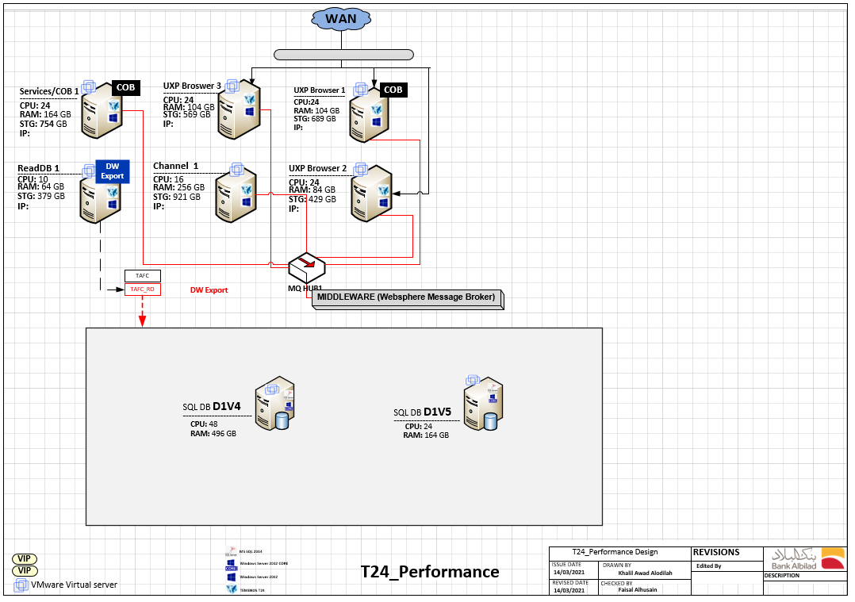

Following are the MQ Details of Performance Server.

|  |  |
| --- | --- |
| **MQHUB SIT stress Test** | |
| IP | 10.38.7.19 |
| Port | 1451 |
| Queue manager name | BBHUBLX03S |
| TTG channel | GTLR.CHNL |
| Tcserver Channel | GLBS.CHNL |

## **Testing Strategy Tools and Pocess**

Following are the points for Test strategy:

* Transaction pumped in from R19 Browser for User Load and Stress testing.
* From MQ – To inject OFS messages & to process/send requests to T24 – to measure the load, breakdown and advice on scalability, the system should be able to automatically modify the OFS message to avoid T24 detecting duplicate transactions.
* BAB Team will provide the ofs messages[requests] and Test Crew team will manuplate the request to inject messages on T24 system.
* To calculate the Page Rendering Time Test crew Team will randomly click on different screen through Load Testing Tool.
* Performance of transactions that integrate with third party applications internally will be broken down using App Dynamics APM tool. This breakdown will identify time taken to interact with third party application.

**Tools:**

* The performance testing tool which will be used is JMeter.
* AppDynamics will be used for monitoring.
* Grafana will be used for preparing dashboards

**Process:**

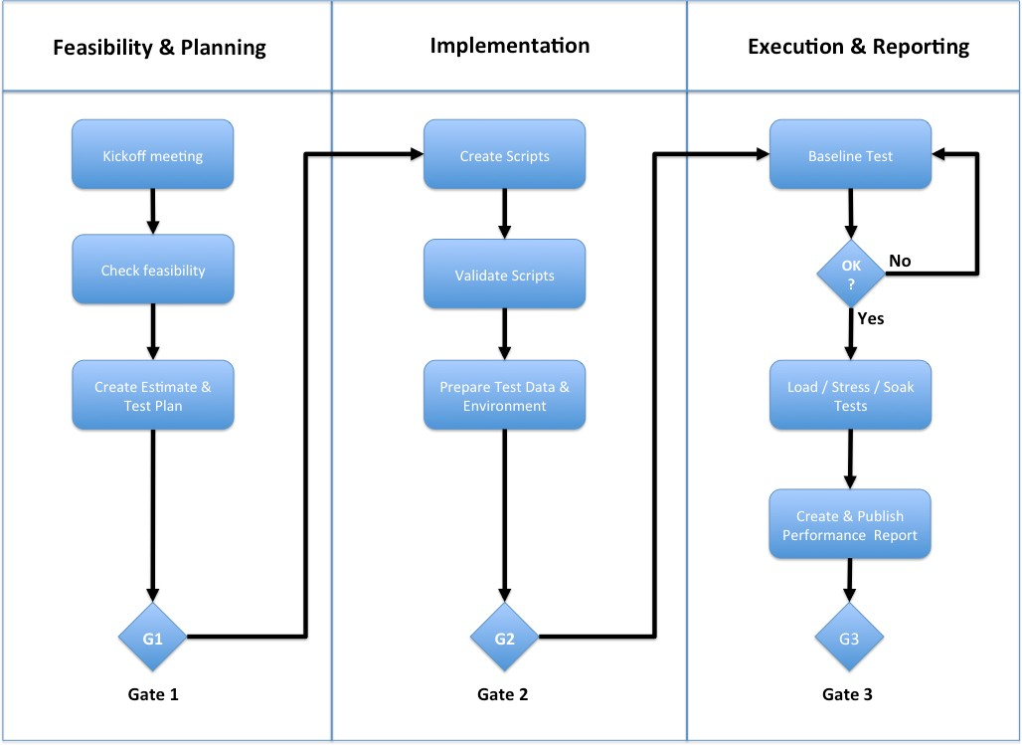

## **Load Genertor Setup**

We will use load generator machines provided by BAB team for scripting/execution.

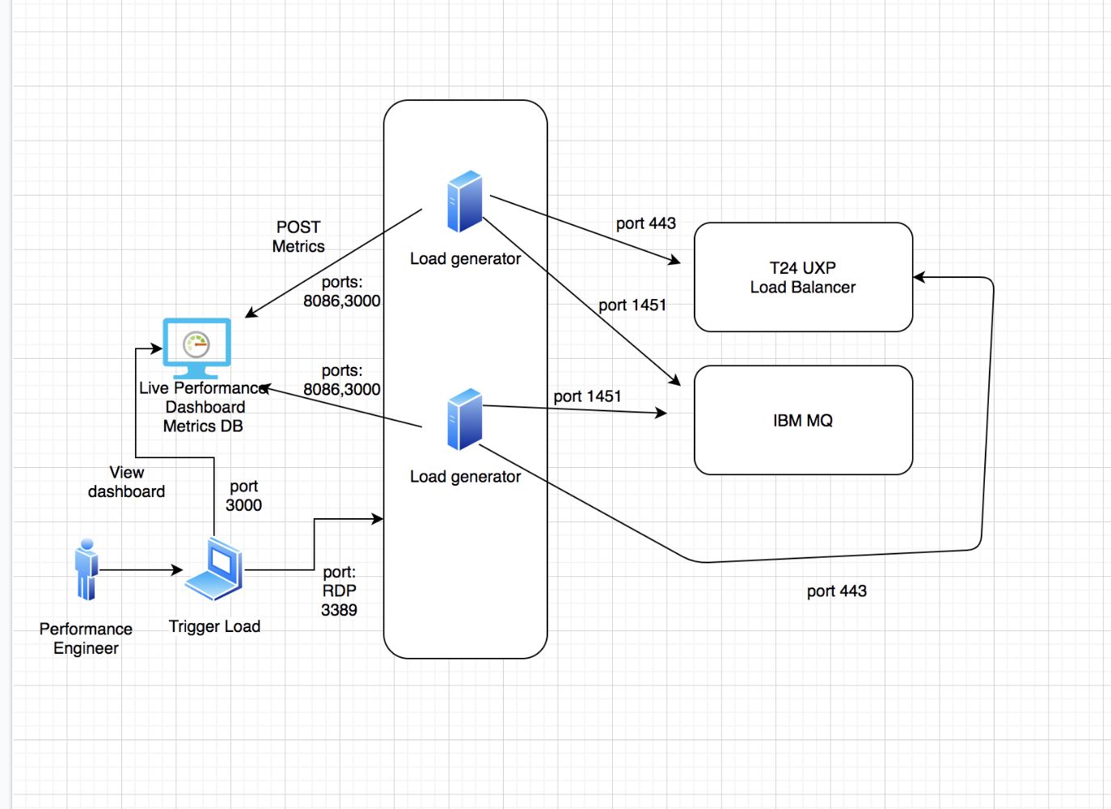

## **Test Types/Acceptance Criteria**

Before any test 15 minutes of light shakedown test will be executed to ensure that environment and scripts are functionally working.

Following are the Testing types will be conducted during execution:

|  |  |  |
| --- | --- | --- |
| **Test Types** | **Scenario/Use Cases** | **Cycles/iterations** |
| Load Testing | Use Cases defined in Scope | 1 |
| Endurance Testing | Use Cases defined in Scope | 1 |

If comparison results does not meet acceptance criteria than above two test types can be repeated until results are acceptable for all stakeholders.

Testing will be done in incremental model starting from 5 concurrent to 200 concurrent users/messages and we will keep on increasing the load until it reached its breaking point or the sla’s would be met.

## **Performance Testing LifeCycle**

The following activities are in the life cycle of performance testing:

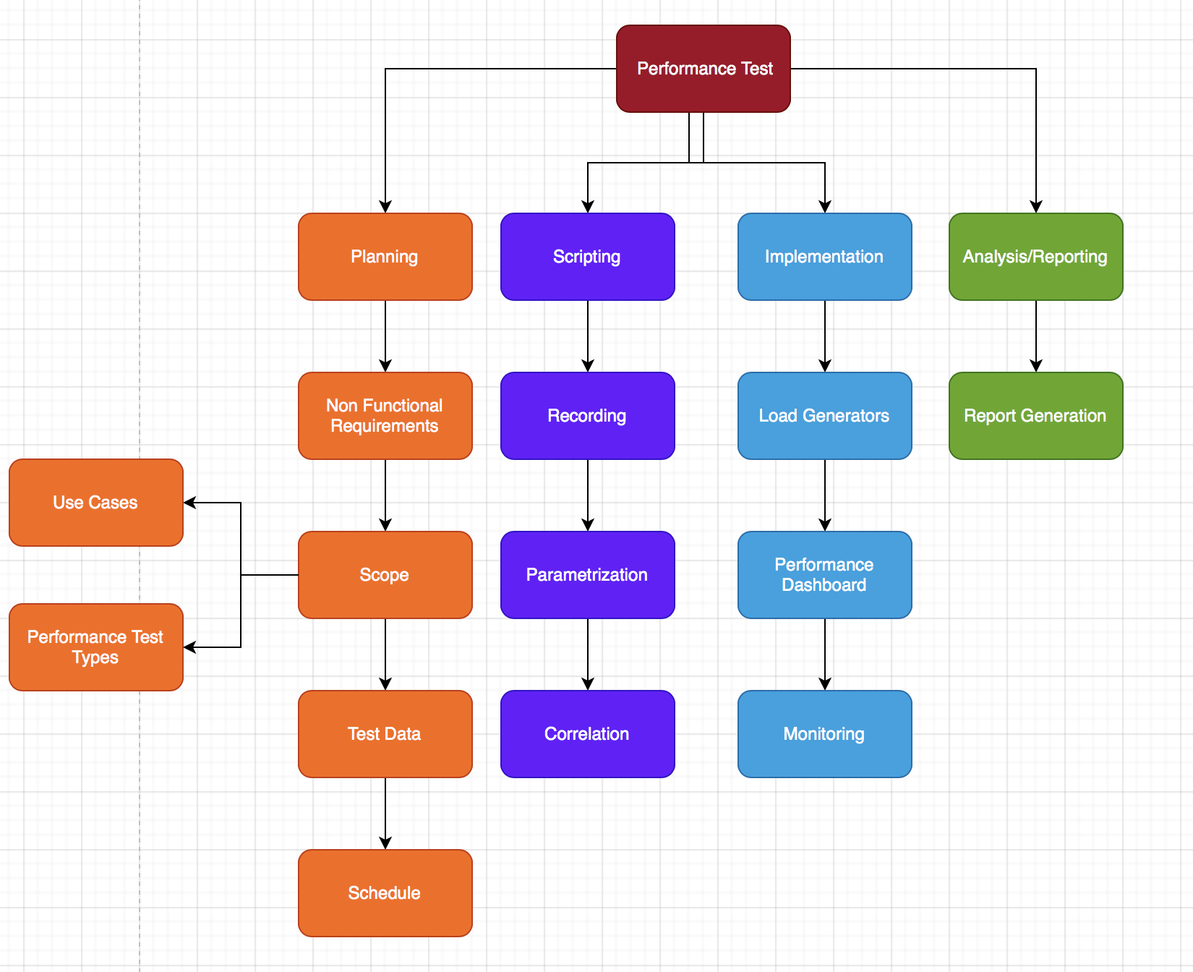

## **Scope Exclusions**

The following are considered out of scope for Performance Testing unless explicitly stated otherwise:

1. Functional testing activities. It is assumed that the code delivered for performance testing is stable, without any critical/severe functional defects
2. PayLoad sample data will be provided by BAB Team
3. Testing of any other external systems.
4. Implementation (code changes, configuration changes etc) of performance tuning activities of the application (Supplier will collaboratively work with stakeholders in identification of tuning options)
5. Execution of hardware and communication infrastructure-related enhancements
6. Setting up and maintenance of Perf or Prod environments
7. Any other type of testing not set forth in this scope document
8. Development of stubs or simulators in case application interfaces are unavailable.

## **Assumptions**

The following assumptions are made:

|  |  |
| --- | --- |
| **Sr#** | **Assumptions** |
| 1 | Availability of Pre-Prod/Perf test server, test data for scripting & execution. |
| 2 | Workflows to be scripted must be documented prior to script creation. |
| 3 | AppDynamics is installed in Performance environment |
| 4 | All Severe defects must be resolved prior to script creation. |
| 5 | Testing will occur in Performance test environment. |
| 6 | Performance test execution must happen on the same build of code that goes to production. |
| 7 | There are no batch jobs running in Performance during execution |

## **Risks**

The following are made:

|  |  |  |  |  |  |
| --- | --- | --- | --- | --- | --- |
| **Sr#** | **Risks Description** | **Probability[0-5]** | **Impact[0-5]** | **Leve of Risk[P*I]** | **Risk Mitigation Plan and Recommandation** |
| 1 | if server not setup & configured in Perf test environment, performance Testing can not commence. | 1 | 5 | 5 | it will add delay in Testing that’s why Proper communication and follow up is required. |
| 2 | If the functional Testing is not completed Performance Testing can not be kick off | 2 | 5 | 10 | It will add delay in Testing and that is why we need to complete the functional Testing before Performance Testing. |
| 3 | Load Generators are not ready by the time of Scripting | 1 | 5 | 5 | Proper communication and follow up is required. |
| 4 | If jmeter does not support any of the flow | 2 | 5 | 10 | Need to check with other tools |
| 5 | Missing Test Data | 1 | 4 | 4 | Maker sure Test Data will be provided by the BAB Team prior to execution |
| 6 | Code changes during scripting or execution will often cause script failures. | 2 | 4 | 8 | Make sure there will be no code changes in the System |
| 7 | AppDynamics should also configure with Performance Environment for monitoring | 1 | 4 | 4 | Make the Appdynamics available for performance Environment |

## **Dependencies:**

1. Screenshots depicting the step by step workflow for the business processes identified by the team are required for the performance test team to start scripting.
2. Availability of stable application in the Perf test environment by performance test scripting start date.
3. Minimum set of test data available for scripting by performance test scripting start date.
4. Full set of test data available for test execution by performance test execution start date.

# Performance Monitoring

We will be using Appdynamics for the monitoring purposes.

Following are the list we are going to monitored

|  |  |
| --- | --- |
| **Metrics** | CPU utilization |
| Memory Utilization |
| I/O Utilization |

# Performance Deliverables

Following are the performance Testing deliverables:

1. **Project Plan:**

This document will include Test Plan, Testing strategy inclding Test Cases and Test Data

1. **Scripts:**

This will include all the scripts related to the projects prior to execution

1. **Test Intermidiate Summary Report:**

This will contain the test results and provided after each execution

1. **Test Closure Report:**

This report will contain the final closure report covering all the effort and bottlenecks in the system.

## **RACI Matrix**

|  |  |  |  |  |
| --- | --- | --- | --- | --- |
| **Test Deliverables** | **Responsible** | **Approver** | **Consulted** | **Informed** |
| Project Plan | Test Crew Team | BAB Team | BAB Team | BAB Team |
| Scripts | Test Crew Team | BAB Team | BAB Team | BAB Team |
| Test Intermidiate Summary Report | Test Crew Team | BAB Team | BAB Team | BAB Team |
| Test Closure Report | Test Crew Team | BAB Team | BAB Team | BAB Team |

# High Level Testing Dates

These dates are tentative and will vary depending upon system availability and functionality.

|  |  |  |
| --- | --- | --- |
| **Performance Testing Stage** | **Start Date** | **End Date** |
| Test scope and plan | 10/08/2021 | 02/02/2022 |
| Environment setup & Data creation | 01/09/2021 | 25/02/2022 |
| Test scripts and data validation | 24/01/2022 | 24/02/2022 |
| Execution | 28/02/2022 | 10/03/2022 |
| Reports (TSR) | 10/03/2022 | 17/03/2022 |
| Closing Activities (TCR) | 17/03/2022 | 25/03/2022 |

# Appendix

**1A:**

|  |  |  |  |
| --- | --- | --- | --- |
| **Sr#** | **Module** | **Transactions Per Day** | **Transaction Per Second we will generate [TPS]** |
| 1 | Create Customer | 62701 | 1 |
| 2 | Fund Transfer[UXP] | N/A | N/A |
| 3 | Fund Transfer[UXP] | N/A | N/A |
| 4 | Fund Transfer-UXP-Local Transfer | 138207 | 1.5 |
| 5 | Enquiry Select | 282828 | 3.5 |
| 6 | Fund Transfer MQ | 17570 | 1 |
| 7 | Get Sarie Date | 48466 | 1 |
| 8 | Manage BNF | 14237 | 1 |
| 9 | VISA CARD Issue | 11795 | 1 |
| 10 | Card Pay | 4805 | 1 |
| 11 | Add Customer Info | 12041 | 1 |
| 12 | AddTransactions | 3361 | 1 |

**1B:**

|  |  |  |  |  |  |  |
| --- | --- | --- | --- | --- | --- | --- |
| Application | Average Time Taken | Maximum Time Taken | Minimum Time Taken | Txns < 1 Second | Txns 1 Second To 2 Seconds | Txns 2 Seconds To 15 Seconds |
| BAB.S.EAI.GET.SARIE.DATE | 0.0714 | 0.375 | 0.062 | 3453 | 0 | 0 |
| ENQUIRY.SELECT | 0.7242 | 4.313 | 0.062 | 708 | 107 | 89 |
| ENQUIRY.SELECT | 0.0911 | 0.25 | 0.062 | 531 | 0 | 0 |
| ENQUIRY.SELECT | 0.178 | 0.437 | 0.062 | 174 | 0 | 0 |
| BAB.S.EAI.IPS.PRXY.MNG | 0.1383 | 1.188 | 0.062 | 158 | 3 | 0 |
| ENQUIRY.SELECT | 0.1314 | 0.5 | 0.125 | 438 | 0 | 0 |
| ENQUIRY.SELECT | 0.0774 | 0.313 | 0.062 | 1213 | 0 | 0 |
| ENQUIRY.SELECT | 0.1655 | 0.5 | 0.125 | 230 | 0 | 0 |
| BAB.H.CUS.ADD.INFO | 0.1476 | 0.5 | 0.062 | 448 | 0 | 0 |
| BAB.EAI.WU.AR.EN.ADD.TRANS | 0.0705 | 0.188 | 0.062 | 374 | 0 | 0 |
| ENQUIRY.SELECT | 0.1355 | 0.438 | 0.062 | 541 | 0 | 0 |
| ENQUIRY.SELECT | 0.1465 | 0.313 | 0.125 | 140 | 0 | 0 |
| ENQUIRY.SELECT | 1.4533 | 11.438 | 0.125 | 181 | 72 | 83 |
| BAB.W.TANFEETH.REQ | 0.2258 | 0.438 | 0.125 | 10 | 0 | 0 |
| ENQUIRY.SELECT | 0.071 | 0.438 | 0.062 | 4362 | 0 | 0 |
| ENQUIRY.SELECT | 0.2682 | 1.875 | 0.063 | 9154 | 25 | 0 |
| ENQUIRY.SELECT | 0.0834 | 0.375 | 0.062 | 4578 | 0 | 0 |
| ENQUIRY.SELECT | 0.1527 | 4 | 0.062 | 817 | 0 | 2 |
| ENQUIRY.SELECT | 0.0723 | 0.313 | 0.062 | 602 | 0 | 0 |
| ENQUIRY.SELECT | 0.0982 | 0.141 | 0.062 | 62 | 0 | 0 |
| ENQUIRY.SELECT | 0.114 | 0.253 | 0.062 | 62 | 0 | 0 |
| ENQUIRY.SELECT | 0.1344 | 0.313 | 0.062 | 218 | 0 | 0 |
| ENQUIRY.SELECT | 3.6298 | 34.1 | 0.125 | 25 | 12 | 45 |
| ENQUIRY.SELECT | 0.1972 | 0.563 | 0.125 | 250 | 0 | 0 |
| ENQUIRY.SELECT | 3.9515 | 11.397 | 0.25 | 30 | 16 | 284 |
| BAB.S.EB.MNG.BILL.ACL | 0.0738 | 0.188 | 0.062 | 39 | 0 | 0 |
| ENQUIRY.SELECT | 0.1233 | 0.375 | 0.062 | 113 | 0 | 0 |
| ENQUIRY.SELECT | 0.0898 | 0.125 | 0.062 | 16 | 0 | 0 |
| ENQUIRY.SELECT | 0.1312 | 0.187 | 0.125 | 10 | 0 | 0 |
| ENQUIRY.SELECT | 0.2301 | 2.001 | 0.062 | 229 | 0 | 1 |
| ENQUIRY.SELECT | 0.1381 | 0.19 | 0.125 | 23 | 0 | 0 |
| BAB.CARD.ISSUE | 1.4423 | 2 | 0.375 | 3 | 9 | 1 |
| FUNDS.TRANSFER | 0.5543 | 3.125 | 0.312 | 570 | 6 | 11 |
| FUNDS.TRANSFER | 0.4446 | 2.939 | 0.187 | 446 | 2 | 5 |
| FUNDS.TRANSFER | 0.5801 | 2.754 | 0.187 | 40 | 3 | 1 |
| BAB.H.CUST.PROSPECTIVE | 4.9904 | 9.908 | 1.125 | 0 | 3 | 24 |
| ENQUIRY.SELECT | 0.2145 | 0.438 | 0.063 | 7 | 0 | 0 |
| FUNDS.TRANSFER | 0.4527 | 2.877 | 0.25 | 397 | 0 | 9 |
| ENQUIRY.SELECT | 0.1151 | 0.125 | 0.063 | 19 | 0 | 0 |
| ENQUIRY.SELECT | 0.1875 | 0.188 | 0.187 | 2 | 0 | 0 |
| ENQUIRY.SELECT | 0.1621 | 0.438 | 0.062 | 191 | 0 | 0 |
| CUSTOMER | 0.6223 | 3.876 | 0.188 | 19 | 1 | 2 |
| ENQUIRY.SELECT | 0.3648 | 0.688 | 0.125 | 29 | 0 | 0 |
| ENQUIRY.SELECT | 0.1489 | 0.313 | 0.124 | 76 | 0 | 0 |
| FUNDS.TRANSFER | 1.125 | 2.5 | 0.375 | 2 | 0 | 1 |
| FUNDS.TRANSFER | 0.6801 | 3.438 | 0.312 | 124 | 5 | 2 |
| FUNDS.TRANSFER | 0.4089 | 3.125 | 0.203 | 9006 | 7 | 28 |
| FUNDS.TRANSFER | 0.3835 | 2.625 | 0.187 | 433 | 1 | 2 |
| ENQUIRY.SELECT | 0.125 | 0.125 | 0.125 | 6 | 0 | 0 |
| ENQUIRY.SELECT | 1.1838 | 19.689 | 0.062 | 1342 | 86 | 203 |
| FUNDS.TRANSFER | 0.4126 | 0.5 | 0.328 | 27 | 0 | 0 |
| ENQUIRY.SELECT | 0.1278 | 0.5 | 0.062 | 1435 | 0 | 0 |
| FUNDS.TRANSFER | 0.4404 | 3.063 | 0.25 | 564 | 7 | 2 |
| ENQUIRY.SELECT | 0.1405 | 0.187 | 0.125 | 4 | 0 | 0 |
| ENQUIRY.SELECT | 0.473 | 2.062 | 0.062 | 24 | 5 | 1 |
| FUNDS.TRANSFER | 0.438 | 0.438 | 0.438 | 1 | 0 | 0 |
| ENQUIRY.SELECT | 0.6363 | 0.688 | 0.563 | 11 | 0 | 0 |
| BAB.FORMATTER.MSG20022 | 0.2086 | 2.453 | 0.124 | 980 | 11 | 5 |
| BAB.H.CUST.PROSPECTIVE | 0.4047 | 2 | 0.25 | 20 | 0 | 1 |
| ENQUIRY.SELECT | 0.0737 | 0.125 | 0.062 | 33 | 0 | 0 |
| ENQUIRY.SELECT | 0.4375 | 0.5 | 0.375 | 4 | 0 | 0 |
| ENQUIRY.SELECT | 0.1252 | 0.188 | 0.063 | 4 | 0 | 0 |
| ENQUIRY.SELECT | 0.2126 | 1.437 | 0.125 | 24 | 1 | 0 |
| ENQUIRY.SELECT | 0.1123 | 0.313 | 0.062 | 49 | 0 | 0 |
| BAB.W.EB.PYRL.PROCESS | 10.5662 | 57.72 | 0.188 | 4 | 2 | 1 |
| ENQUIRY.SELECT | 0.313 | 0.313 | 0.313 | 1 | 0 | 0 |
| FUNDS.TRANSFER | 0.8193 | 3.437 | 0.375 | 30 | 0 | 3 |
| FUNDS.TRANSFER | 1.3375 | 3.313 | 0.5 | 7 | 0 | 3 |
| EB.MNG.TXN | 0.6855 | 3.125 | 0.187 | 42 | 2 | 4 |
| ENQUIRY.SELECT | 0.171 | 0.313 | 0.063 | 84 | 0 | 0 |
| ENQUIRY.SELECT | 0.1216 | 0.188 | 0.062 | 19 | 0 | 0 |
| ENQUIRY.SELECT | 0.3023 | 3.907 | 0.062 | 958 | 15 | 14 |
| ENQUIRY.SELECT | 0.0892 | 0.125 | 0.062 | 7 | 0 | 0 |
| BAB.H.CARD.PAY.GW.TXN | 0.1519 | 0.75 | 0.125 | 186 | 0 | 0 |
| ENQUIRY.SELECT | 0.2405 | 0.687 | 0.125 | 433 | 0 | 0 |
| ENQUIRY.SELECT | 0.1873 | 0.25 | 0.125 | 6 | 0 | 0 |
| ENQUIRY.SELECT | 0.2815 | 0.375 | 0.25 | 6 | 0 | 0 |
| BAB.VISA.CRD.ISSUE | 0.5243 | 1.625 | 0.125 | 10 | 3 | 0 |
| SMB.H.FT.DETAILS | 0.2621 | 0.687 | 0.125 | 733 | 0 | 0 |
| FUNDS.TRANSFER | 1.8642 | 6.25 | 0.062 | 136 | 1 | 112 |
| BAB.S.EAI.PERSLD.SCHED | 0.4018 | 0.5 | 0.25 | 7 | 0 | 0 |
| ENQUIRY.SELECT | 0.2657 | 0.313 | 0.25 | 4 | 0 | 0 |
| ENQUIRY.SELECT | 0.1456 | 0.187 | 0.125 | 3 | 0 | 0 |
| BAB.H.EB.USR | 0.375 | 0.375 | 0.375 | 2 | 0 | 0 |
| FUNDS.TRANSFER | 1.111 | 3.875 | 0.437 | 11 | 5 | 2 |
| BAB.CARD.ISSUE | 0.4778 | 1.641 | 0.062 | 28 | 8 | 0 |
| FUNDS.TRANSFER | 0.5633 | 3.438 | 0.312 | 447 | 0 | 16 |
| FUNDS.TRANSFER | 0.7348 | 3.563 | 0.312 | 184 | 0 | 14 |
| ENQUIRY.SELECT | 0.1389 | 0.188 | 0.125 | 18 | 0 | 0 |
| FUNDS.TRANSFER | 0.5126 | 0.563 | 0.437 | 5 | 0 | 0 |
| SMB.H.FT.DETAILS | 0.7495 | 1.062 | 0.437 | 1 | 1 | 0 |
| FUNDS.TRANSFER | 0.5509 | 3.328 | 0.312 | 1143 | 0 | 25 |
| FUNDS.TRANSFER | 1.7395 | 3.313 | 0.437 | 3 | 0 | 3 |
| FUNDS.TRANSFER | 0.4975 | 3.313 | 0.25 | 191 | 4 | 5 |
| BAB.H.AC.ADD.INFO | 0.396 | 0.438 | 0.375 | 3 | 0 | 0 |
| CUSTOMER | 0.563 | 0.563 | 0.563 | 1 | 0 | 0 |
| LD.LOANS.AND.DEPOSITS | 2.9935 | 5.937 | 1.188 | 0 | 2 | 5 |
| BAB.H.CUST.PROSPECTIVE | 0.3958 | 0.438 | 0.375 | 6 | 0 | 0 |
| ENQUIRY.SELECT | 0.1391 | 0.875 | 0.062 | 17607 | 0 | 0 |
| ENQUIRY.SELECT | 0.1327 | 0.688 | 0.062 | 9280 | 0 | 0 |
| ENQUIRY.SELECT | 0.1531 | 16.844 | 0.062 | 4974 | 26 | 10 |
| ENQUIRY.SELECT | 0.1594 | 0.5 | 0.125 | 82 | 0 | 0 |
| ENQUIRY.SELECT | 0.0918 | 0.313 | 0.062 | 171 | 0 | 0 |
| FUNDS.TRANSFER | 0.4322 | 3.188 | 0.25 | 702 | 5 | 10 |
| SMB.BTMS.INWARD.MQ | 0.1669 | 0.438 | 0.062 | 204 | 0 | 0 |
| ENQUIRY.SELECT | 0.137 | 0.313 | 0.062 | 295 | 0 | 0 |
| FUNDS.TRANSFER | 0.5376 | 0.688 | 0.5 | 5 | 0 | 0 |
| FUNDS.TRANSFER | 0.5 | 0.5 | 0.5 | 1 | 0 | 0 |
| CUSTOMER | 0.344 | 0.375 | 0.313 | 2 | 0 | 0 |
| BAB.H.LOAN.INIT.OFFER | 0.2655 | 0.374 | 0.188 | 4 | 0 | 0 |
| FUNDS.TRANSFER | 1.187 | 1.437 | 0.937 | 1 | 1 | 0 |
| SMB.H.FT.DETAILS | 0.479 | 0.562 | 0.375 | 3 | 0 | 0 |
| ENQUIRY.SELECT | 0.38 | 0.437 | 0.328 | 3 | 0 | 0 |
| FUNDS.TRANSFER | 0.6072 | 0.688 | 0.501 | 7 | 0 | 0 |
| SMB.H.FT.DETAILS | 0.375 | 0.562 | 0.187 | 8 | 0 | 0 |
| ENQUIRY.SELECT | 0.25 | 0.25 | 0.25 | 1 | 0 | 0 |
| FUNDS.TRANSFER | 0.1043 | 0.187 | 0.062 | 18 | 0 | 0 |
| FUNDS.TRANSFER | 0.625 | 1 | 0.375 | 3 | 1 | 0 |
| ENQUIRY.SELECT | 0.187 | 0.187 | 0.187 | 1 | 0 | 0 |
| BAB.H.STMT.REQUEST | 0.25 | 0.25 | 0.25 | 1 | 0 | 0 |
| ENQUIRY.SELECT | 0.125 | 0.125 | 0.125 | 2 | 0 | 0 |
| BAB.U.EB.NTFCN.PRFL.USR.TMP | 0.438 | 0.438 | 0.438 | 1 | 0 | 0 |
| FUNDS.TRANSFER | 0.437 | 0.437 | 0.437 | 1 | 0 | 0 |
| BAB.H.CUST.PROSPECTIVE | 0.439 | 1.891 | 0.25 | 9 | 1 | 0 |
| ENQUIRY.SELECT | 0.07 | 0.078 | 0.062 | 2 | 0 | 0 |
| FUNDS.TRANSFER | 1.9166 | 2.625 | 0.688 | 1 | 0 | 2 |
| FUNDS.TRANSFER | 0.531 | 0.625 | 0.437 | 8 | 0 | 0 |
| BAB.SIMAH.RESPONSE | 1.062 | 1.062 | 1.062 | 0 | 1 | 0 |
| FUNDS.TRANSFER | 0.3855 | 0.438 | 0.313 | 6 | 0 | 0 |
| FUNDS.TRANSFER | 0.578 | 0.625 | 0.562 | 4 | 0 | 0 |
| BAB.W.MUB.EOD.RECON.EXT | 0.5 | 0.5 | 0.5 | 1 | 0 | 0 |
| ENQUIRY.SELECT | 0.0864 | 0.125 | 0.062 | 13 | 0 | 0 |
| ENQUIRY.SELECT | 0.1873 | 0.188 | 0.187 | 3 | 0 | 0 |
| BAB.H.WU.CAN.REF.SEND.MONEY | 0.312 | 0.312 | 0.312 | 1 | 0 | 0 |
| CUSTOMER | 1.156 | 1.937 | 0.375 | 1 | 1 | 0 |
| BAB.H.EB.TXN.REMRKS | 0.3125 | 0.375 | 0.25 | 2 | 0 | 0 |
| BAB.H.EB.USR | 0.375 | 0.375 | 0.375 | 1 | 0 | 0 |
| FUNDS.TRANSFER | 0.875 | 0.875 | 0.875 | 1 | 0 | 0 |
| ENQUIRY.SELECT | 0.0836 | 0.125 | 0.063 | 3 | 0 | 0 |
| BAB.H.NATHEER | 0.2505 | 0.313 | 0.188 | 2 | 0 | 0 |
| BAB.H.TF.BENEFICIARY | 0.438 | 0.438 | 0.438 | 1 | 0 | 0 |
| FUNDS.TRANSFER | 0.063 | 0.063 | 0.063 | 1 | 0 | 0 |
| ENQUIRY.SELECT | 0.125 | 0.125 | 0.125 | 2 | 0 | 0 |
| BAB.H.CORP.OWNERS | 0.188 | 0.188 | 0.188 | 2 | 0 | 0 |
| BAB.S.EAI.ACTIVATE.BEN | 0.125 | 0.125 | 0.125 | 1 | 0 | 0 |
| BAB.S.UPD.EXP.IDS | 0.187 | 0.187 | 0.187 | 1 | 0 | 0 |
| FUNDS.TRANSFER | 0.375 | 0.375 | 0.375 | 1 | 0 | 0 |
| FUNDS.TRANSFER | 0.375 | 0.375 | 0.375 | 1 | 0 | 0 |
| BAB.VISA.CRD.ISSUE | 0.563 | 0.563 | 0.563 | 1 | 0 | 0 |
| FUNDS.TRANSFER | 0.6095 | 0.688 | 0.562 | 4 | 0 | 0 |
| CUSTOMER | 0.75 | 0.75 | 0.75 | 1 | 0 | 0 |
| BAB.H.CUST.PROSPECTIVE | 0.5 | 0.5 | 0.5 | 1 | 0 | 0 |

# 