1.Create classes college, student and create multiple objects using the classes.

College:

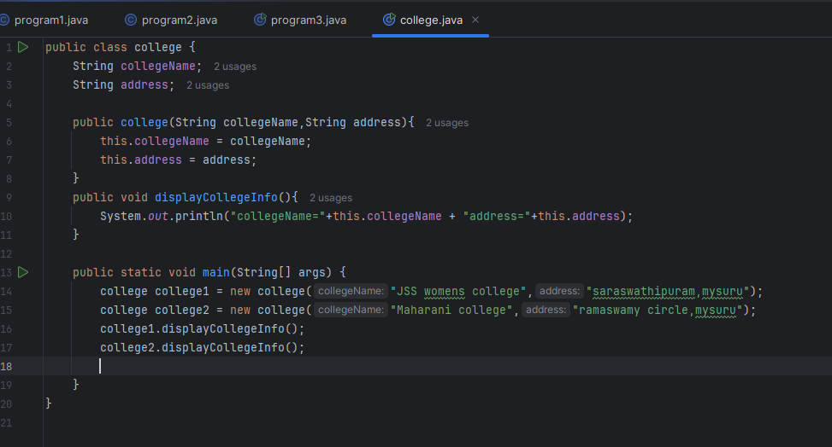

Output:

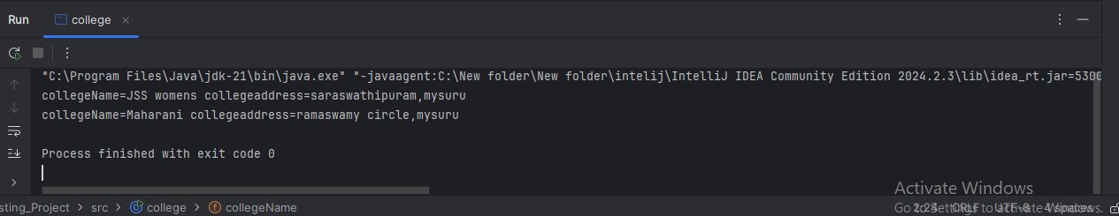

Student:

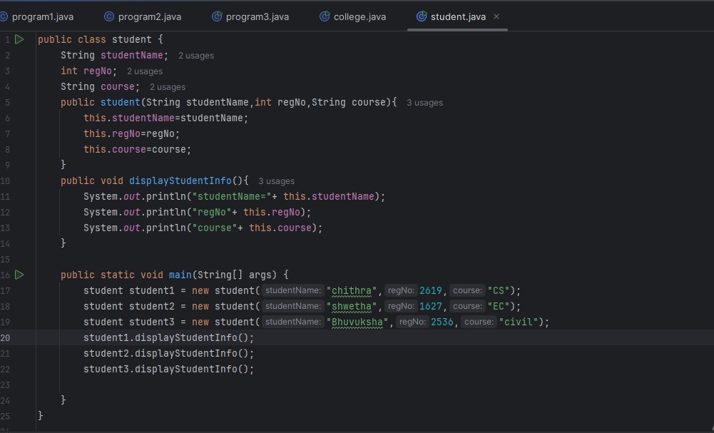

Output:

