1.Class:

A class is a blueprint for creating objects. Define a class that represents an entity, like a car.

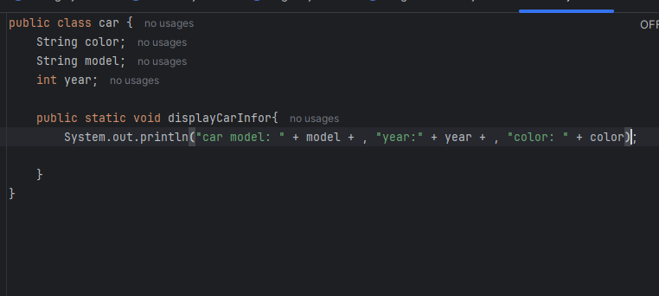

2.Object:

An object is an instance of a class using the car class, create an object and set its properties.

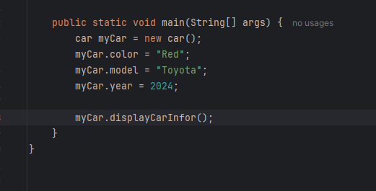

3.Variable:

A variable store data for use in a program. Variable can be define in classes or methods.

\*Instance variable (ex: color, model)

\*Local variables (ex: speed in a method)

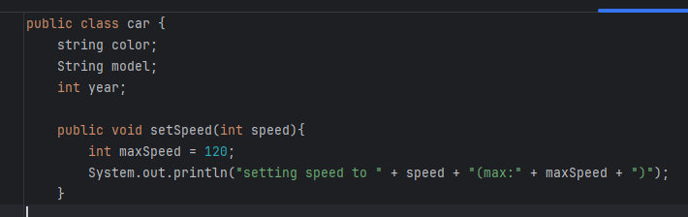

4.Datatypes

Datatypes define the type of data a variable can hold. Here are a few examples:

Primitive datatypes: int, float, double, boolean, char.

Non-primitive datatypes: String, Arrays, Classes.

