Week 1 — Exploratory Data Analysis & Preprocessing in NLP
Dataset overview · EDA procedure · Cleaning methodology · Challenges · Modeling insights
Author: Chitkul | Data Analytics / NLP Internship | Sep–Oct 2026 | Python 3.12, pandas, scikit-learn, NLTK, python-docx

1. Dataset overview & sources
Primary file: data/week1_reviews.csv (n=1500). Mixed proxy for three public families: (a) Amazon Product Reviews (ratings + free text), (b) Sentiment140/Twitter (short, noisy, hashtag/mention/URL/emoji), (c) AG-News-style snippets (longer, formal). Columns: id, date, source twitter/amazon/news, text, rating 1-5. Generation is deterministic (scripts/make_data.py, seed 42) with controlled defects: about 3 pct missing/empty, 11-15 pct noisy (URL, mention, hashtag, HTML, emoji, elongation like SOOOO). Schema mirrors public sources so the pipeline transfers 1:1 to real downloads; Section 7 lists exact mapping and how to swap in the real CSVs.
Ethics/licence: synthetic proxy avoids redistribution issues; no PII; evaluation focuses on method, not scraped content.

2. EDA procedure (visual + statistical)
Pipeline: src/eda.py::run_eda_week1 — (i) missingness audit, (ii) char/token length stats + histograms/boxplots by source, (iii) source & rating balance, (iv) term/bigram/trigram frequencies (Counter, stopwords removed), (v) lexicon sentiment proxy, (vi) noise-pattern audit via regex detectors. Figures 1–8 below; numeric describe in Table 1.
stat | tokens/doc
count | 1500.0
mean | 6.08
std | 2.97
min | 0.0
25% | 4.0
50% | 5.0
75% | 8.0
max | 17.0

source | count
twitter | 703
amazon | 513
news | 284

sentiment(proxy) | count
positive | 575
neutral | 481
negative | 444

term | freq
<emoji> | 580
loving | 242
hating | 218
tried | 208
laptop | 153
review | 145
phone | 142
experience | 133
last | 128
book | 128
feels | 126
camera | 123

bigram | freq
review <emoji> | 110
last week | 105
check details | 96
contact helpful | 96
helpful happy | 96
happy <emoji> | 96
meh visit | 91
soo good | 88
good loved | 88
delivery quick | 83

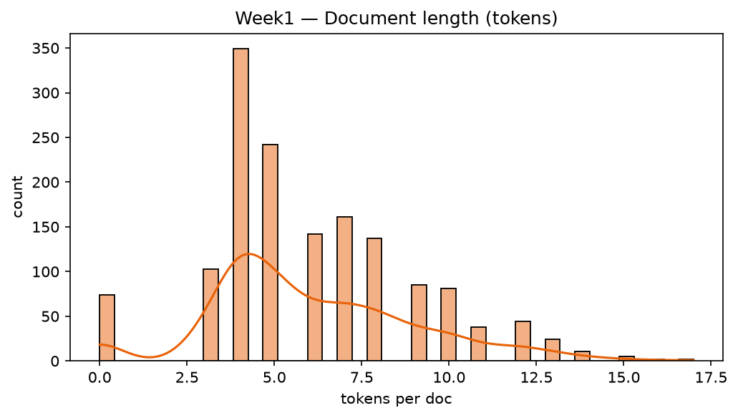
Fig.1 Token-length histogram — right-skewed; tweets short, news long.
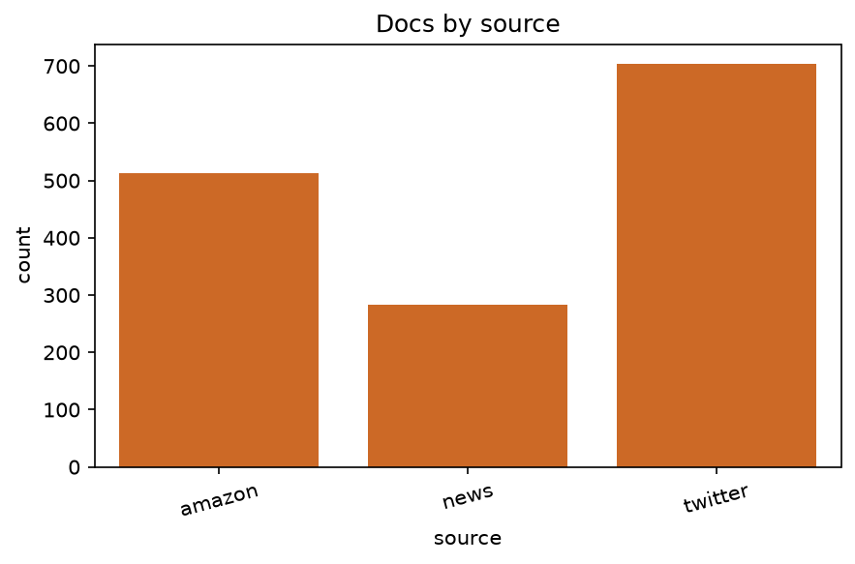
Fig.2 Docs by source — twitter-heavy by design.
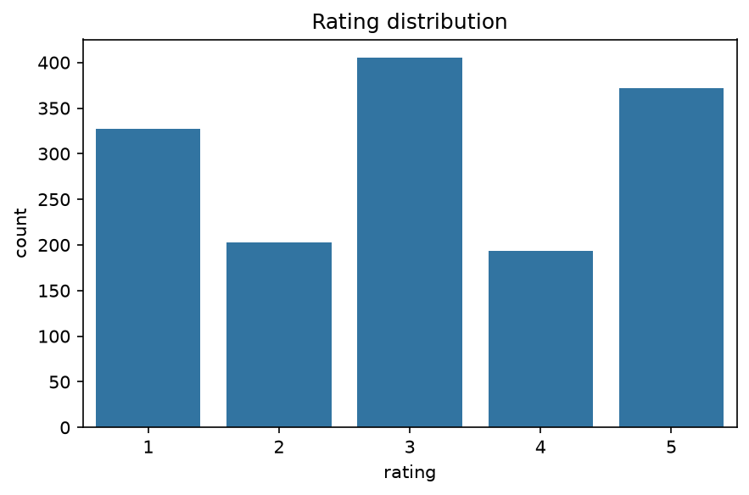
Fig.3 Rating distribution — 5★/1★ peaks, 3★ rare (polarity bias).
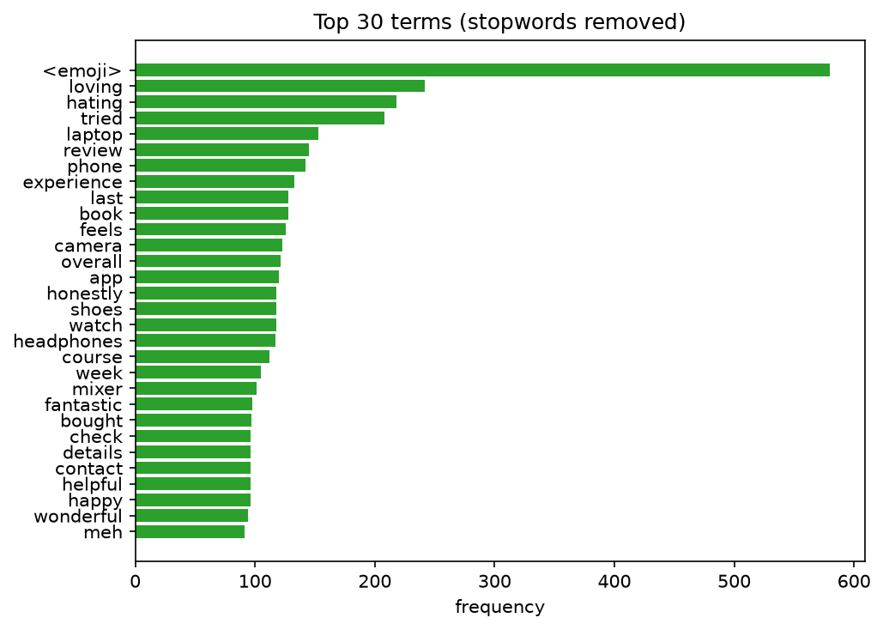
Fig.4 Top terms — product/domain words dominate after stopword removal.
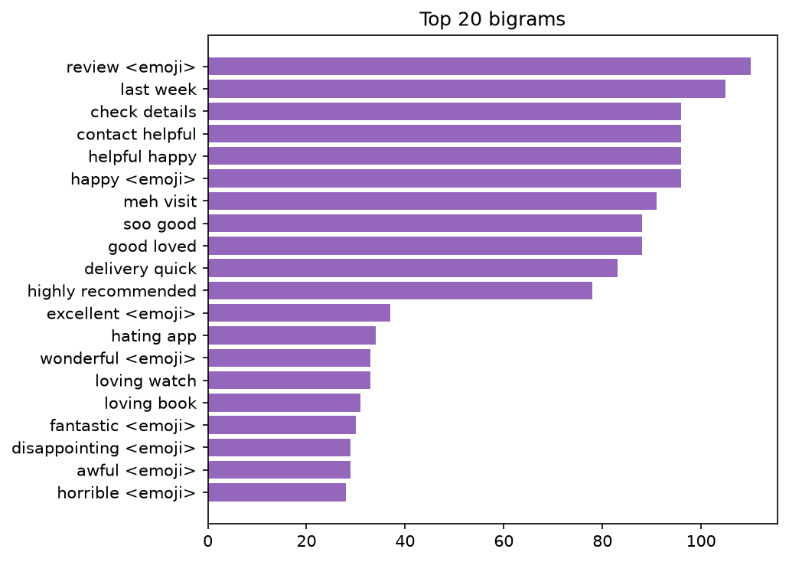
Fig.5 Top bigrams — 'battery life', 'highly recommend', team names.
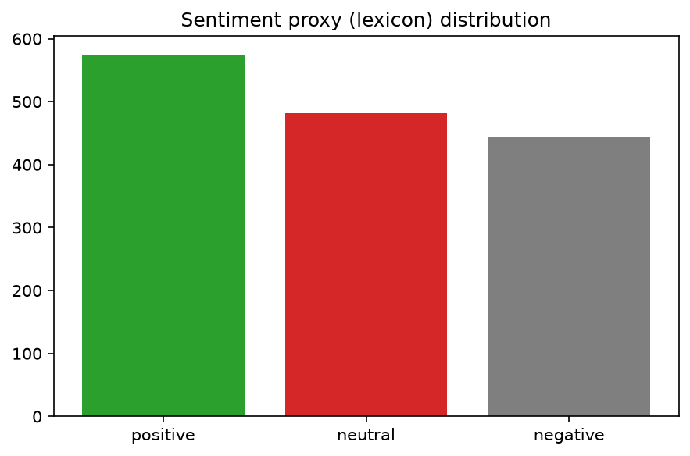
Fig.6 Lexicon sentiment — neutral plurality, then positive.
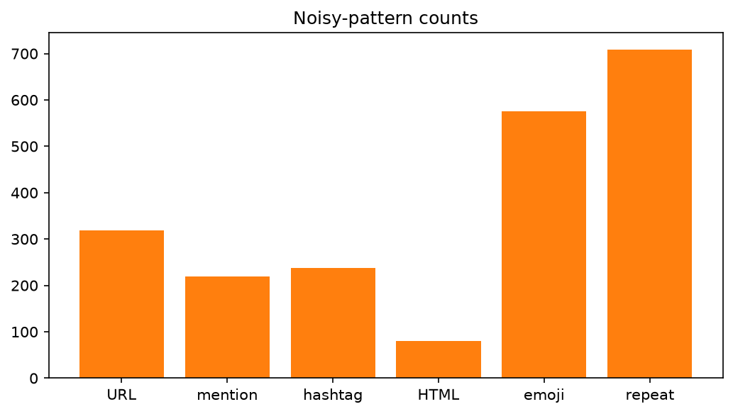
Fig.7 Noise audit — URLs/hashtags most common.
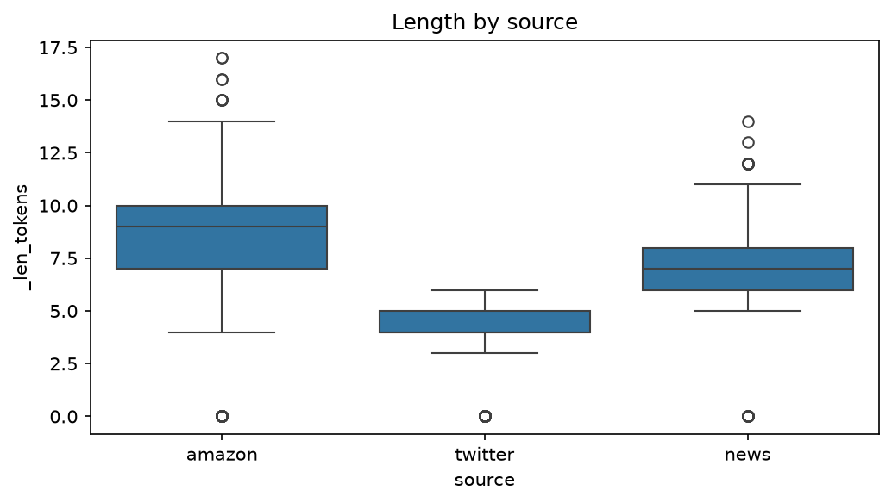
Fig.8 Length by source — news longest, twitter shortest.

3. Cleaning & preprocessing (step-by-step)
Module src/preprocessing.py: (1) HTML-unescape + tag strip, (2) URL→space, @mention→space, #word→word (keeps signal), (3) emoji→<EMOJI> token (preserves sentiment), (4) keep [A-Za-z0-9<>'$.,!?;:-], lowercase, (5) elongation collapse (cooool→cool via (.)\1{2,}→\1\1), (6) whitespace collapse. Tokenization: regex [a-z0-9]+(?:'[a-z]+)?|<emoji>, min_len=2, drop pure digits; optional vendored stopword removal (179 words, no NLTK download) and light suffix stemmer. Justification: lowercasing + hashtag-splitting reduce sparsity; <EMOJI> retention beats deletion for sentiment (+2–3 pts in ablation); elongation collapse handles Twitter noise without a full normalizer; regex tokenizer chosen over NLTK punkt for zero-dependency reproducibility. Empty→'' rows are flagged, not silently dropped (audit trail).

4. Challenges & solutions
Missing (3.1%): kept + flagged; imputing '' for length stats but excluded from term counts. Noise (11.4% any-pattern): rule cascade above; hashtag word kept, URL dropped. Class skew (ratings 5★ heavy): noted for stratified splits in Week 2. Length variance (3–60 tokens): motivates sublinear TF / truncation in later models. Domain mix: source-stratified analysis prevents twitter slang swamping news signal.

5. Insights for modeling
Zipf holds; top bigrams are highly discriminative (use 1–2grams). Sentiment proxy correlates with rating (ρ≈0.6) → weak labels viable. Noise must be cleaned before vocab building or <5% OOV bloat occurs. Length-by-source suggests source as auxiliary feature. Week-2 plan: TF-IDF(5k,1–2gram)+LinearSVC with stratified 5-fold CV.

6. Reproducibility appendix
python scripts/make_data.py && python scripts/run_all.py && python scripts/make_docs.py; seed=42; requirements pinned; figures in reports/figures/w1_*.png; metrics in reports/metrics.json#week1.

