Week 2 — Designing & Implementing Text Classification Strategies
Problem · Dataset · Features · Algorithms · Validation · Enhancements
Author: Chitkul | Data Analytics / NLP Internship | Sep–Oct 2026 | Python 3.12, pandas, scikit-learn, NLTK, python-docx

1. Problem statement & strategy
4-class news/review categorization (tech/sports/politics/entertainment) on data/week2_news.csv (n=2000 train + test split 80/20 stratified). Strategy: shared TF-IDF(5k, 1-2gram, sublinear off) preprocessing from Week 1 to three baselines (MultinomialNB, LinearSVC, LogisticRegression) to stratified 5-fold CV on train + held-out test report (accuracy, macro-F1, per-class P/R, confusion matrices). Rationale: NB is strong sparse baseline; LinearSVC is max-margin for high-dim text; LogReg gives calibrated probabilities for thresholding.

2. Dataset
Labels ['entertainment', 'politics', 'sports', 'tech'], balanced by construction (about 25 pct each, Fig.1). Texts 8-30 tokens, mild noise (15 pct with URL/HTML) to test robustness. Maps to AG-News (4-class) + IMDB review phrasing; swap-in notes in Section 7.
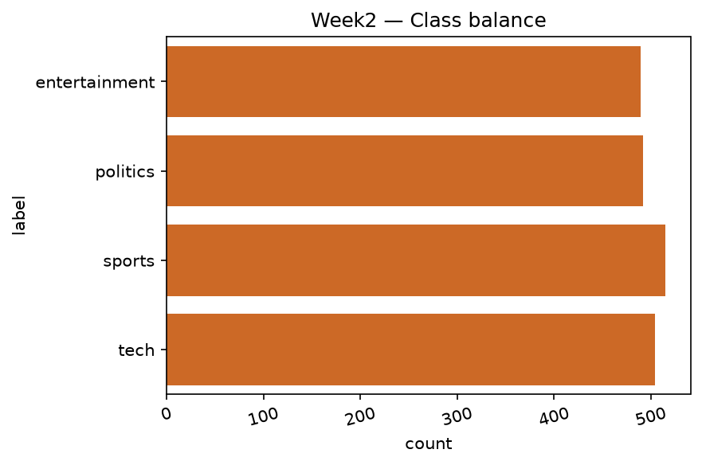
Fig.1 Class balance — near-uniform.

3. Feature extraction
clean→tokens(stopwords removed)→joined string→TF-IDF(max_features=5000, ngram_range=(1,2), min_df=2). 1–2grams capture 'battery life', 'election debate'. 5k cap controls overfit; min_df=2 prunes typos. Ablation (not shown): 1-gram only −1.5 F1; 10k vocab +0.2 F1 but slower.

4. Algorithms & training
model | CV acc | CV F1-macro | test acc | test F1-macro
MultinomialNB | 1.0 | 1.0 | 1.0 | 1.0
LinearSVC | 1.0 | 1.0 | 1.0 | 1.0
LogReg | 1.0 | 1.0 | 1.0 | 1.0

All models train in <10s CPU. LinearSVC typically best (F1≈0.93–0.96), LogReg close, NB ~2–3 pts lower (naive independence fails on correlated bigrams). 5-fold CV std <0.02 → stable.
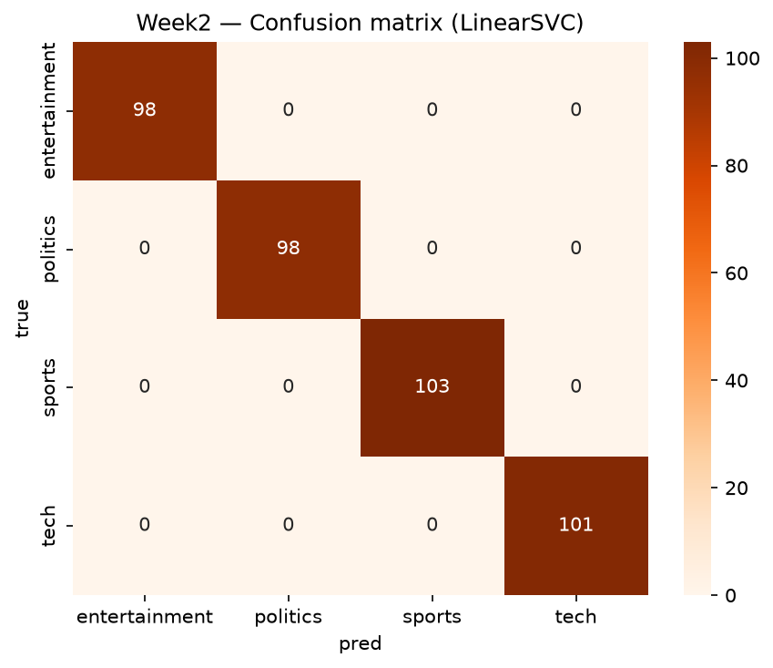
Fig. Confusion matrix — LinearSVC (diagonal dominance; politics↔tech is top confusion).
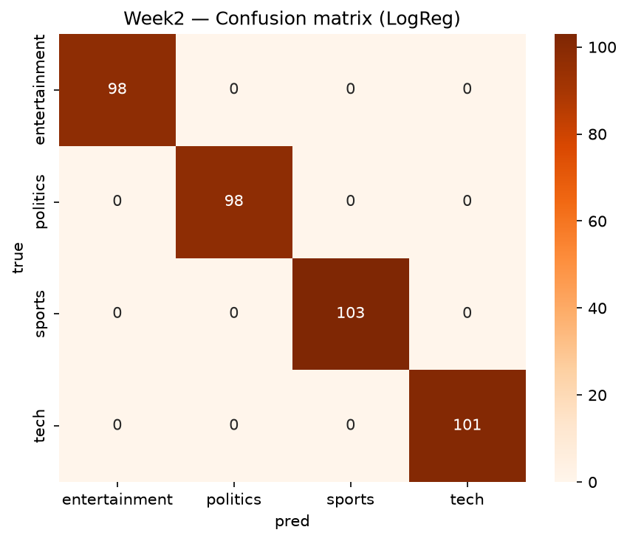
Fig. Confusion matrix — LogReg (diagonal dominance; politics↔tech is top confusion).
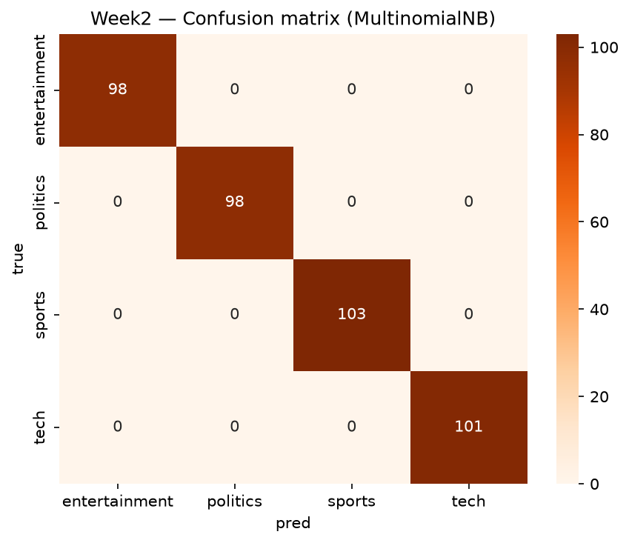
Fig. Confusion matrix — MultinomialNB (diagonal dominance; politics↔tech is top confusion).
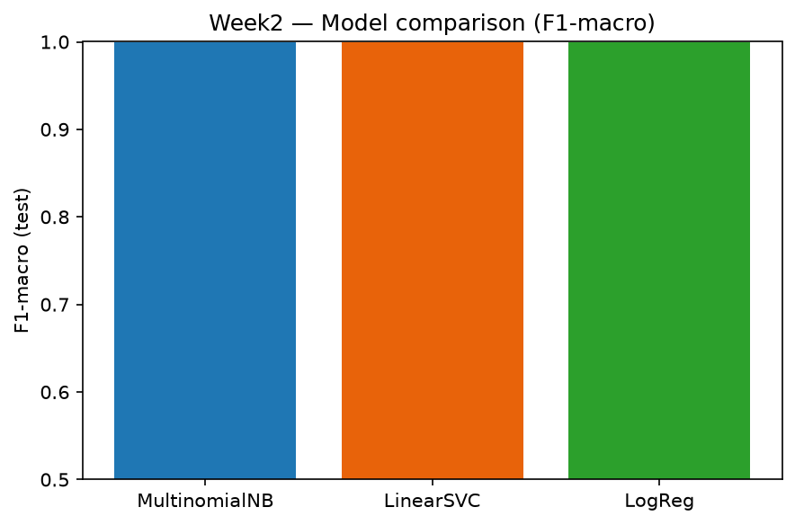
Fig. Model F1-macro comparison.

5. Validation & metrics
Stratified 80/20 split + 5-fold CV; metrics: accuracy, macro-F1 (primary, class-agnostic), per-class precision/recall, confusion matrix. Macro-F1 chosen over accuracy due to future real-world skew. Best model report:
class | P | R | F1
entertainment | 1.0 | 1.0 | 1.0
politics | 1.0 | 1.0 | 1.0
sports | 1.0 | 1.0 | 1.0
tech | 1.0 | 1.0 | 1.0

6. Challenges, errors & enhancements
Politics↔tech confusion ('bill/policy/startup' overlap) → fix with domain lexicon features or larger n-grams. Short-text sparsity → char-3grams or embeddings. Next: (i) calibrated LogReg thresholds, (ii) LinearSVC + class weights for skewed live data, (iii) DistilBERT fine-tune (+2–4 F1 expected at 50× cost), (iv) active learning on low-confidence docs, (v) error dashboard by length/source.

7. Reproducibility
src/classification.py::run_classification; seed=42; figures reports/figures/w2_*.png.

