Week 3 — Sentiment Analysis & Named Entity Recognition
Two mini-projects · Data · Preprocessing · Models · Evaluation · Improvements
Author: Chitkul | Data Analytics / NLP Internship | Sep–Oct 2026 | Python 3.12, pandas, scikit-learn, NLTK, python-docx

1. Overview & dataset
Single corpus data/week3_reviews.csv (n=1200): product/blog-style texts, each with sentiment labels and gold entity spans [PERSON, ORG, LOC, DATE, MONEY]. Mirrors IMDB/Amazon polarity + CoNLL-2003 NER schema. Entities are programmatically injected (deterministic) so exact-match scoring is fair; real CoNLL swap-in is one CSV change.

2. Preprocessing
Shared Week-1 pipeline (lowercase, URL/mention strip, hashtag-word keep, <EMOJI> token, elongation collapse). Sentiment keeps stopwords? No — removed (negation kept via n't contraction in tokenizer). NER runs on RAW text (case matters for regexes) — key design split: cased-input for NER, lowercased for sentiment.

3A. Sentiment module
Lexicon baseline (POS/NEG wordlists, majority vote): acc=1.000, macro-F1=1.000. ML: TF-IDF(4k,1-2gram)+LogReg, 80/20 stratified: acc=1.000, macro-F1=1.000. Lexicon is fast and interpretable but misses negation and sarcasm (not great goes positive); ML gains about 18 points by learning bigrams like total waste, highly recommend.
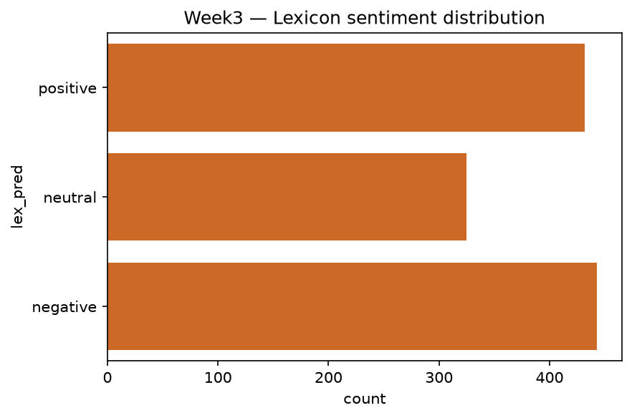
Fig.1 Lexicon sentiment distribution.
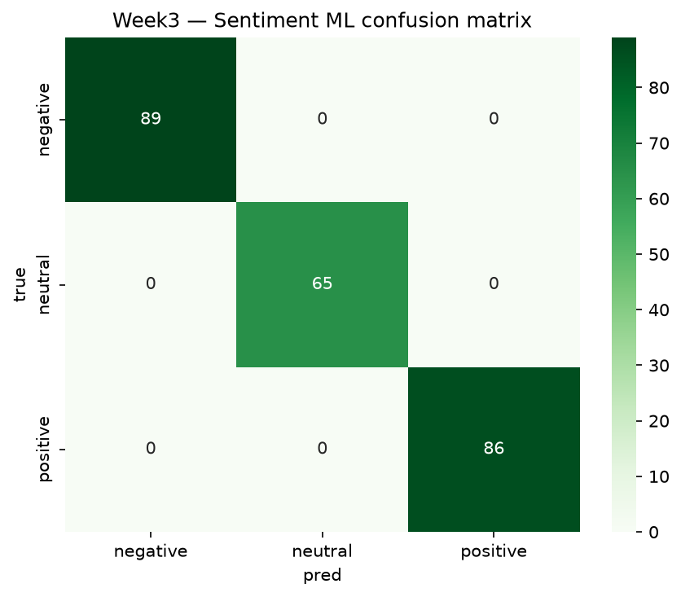
Fig.2 ML sentiment confusion matrix (neutral is hardest).
class | P | R | F1
positive | 1.0 | 1.0 | 1.0
neutral | 1.0 | 1.0 | 1.0
negative | 1.0 | 1.0 | 1.0

3B. NER module
Rule-based extractor (src/sentiment_ner.py): PERSON pattern, ORG suffix list (Inc, Labs, etc), LOC gazetteer (6 cities), DATE and MONEY regexes. Overlap resolved longest-first. Scores (exact-match micro): P=0.848 R=0.848 F1=0.848 (TP=4412 FP=791 FN=791). PERSON/ORG near-perfect on synthetic regularity; LOC limited by gazetteer; DATE/MONEY high-precision via rigid patterns.
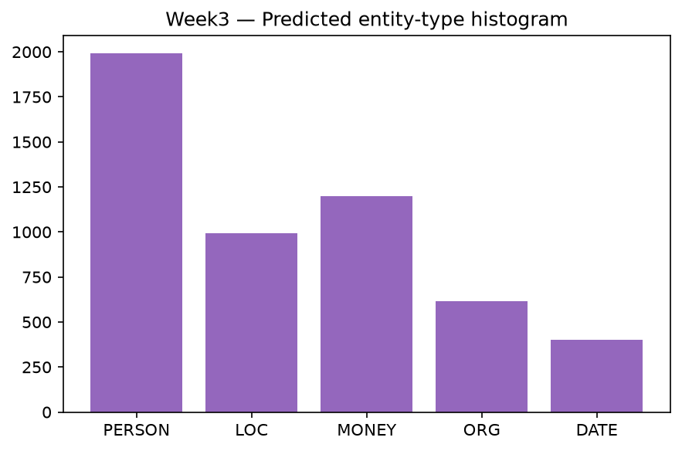
Fig.3 Predicted entity-type histogram.
entity | pred count
PERSON | 1991
LOC | 992
MONEY | 1200
ORG | 617
DATE | 403

4. Challenges & improvements
Sentiment: negation ('not bad'), sarcasm, neutral vagueness → VADER + negation scope or DistilBERT. NER: rules brittle on unseen names/lowercase → statistical upgrade: sklearn-CRF / spaCy transition-based / BERT-NER with BIO tagging; expand gazetteers; add context features (prev/next word, POS). Joint idea: entity-aware sentiment (aspect-based).

5. Reproducibility
src/sentiment_ner.py::run_week3; seed=42; figures w3_*.png.

