Week 4 — Advanced Analysis & Reporting of Language Trends
Topic modeling · Clustering · Trend detection · Visualization · Implications
Author: Chitkul | Data Analytics / NLP Internship | Sep–Oct 2026 | Python 3.12, pandas, scikit-learn, NLTK, python-docx

1. Goal & dataset
Track language drift 2022-01 to 2024-12 on data/week4_corpus.csv (n=1800, 36 months). Phenomena: AI/tech surge, covid decline, election spikes, cricket seasonality. Methods: tokenization plus frequency to LDA topic modeling (k=6) to KMeans clustering (k=6) to keyword-share trend curves plus volume chart.

2. Text mining pipeline
Same Week-1 normalizer; TF-IDF(4k,1-2gram) for clustering, Count(4k,1-2gram) for LDA (batch, 15 iters). KMeans n_init=10, silhouette=0.224 (weak but expected on sparse TF-IDF; clusters still interpretable). LDA topics (top-10 terms):
- Topic 0: cricket, call, wins, thriller fans, thriller, wins thriller, fans call, fans, great, brilliant
- Topic 1: covid, covid cases, update situation, update, cases, situation, new low, hits new, low, new
- Topic 2: action, action activists, summit pushes, pushes, activists, summit, climate, climate summit, hopeful, activists hopeful
- Topic 3: feels, storyline feels, storyline, movie, movie review, review, price, hits, amid, hits record
- Topic 4: raises, raises funding, models look, models, startup, funding, ai, startup raises, ai startup, look
- Topic 5: draws, election, response, election rally, rally, election debate, debate, poll, election poll, script draws
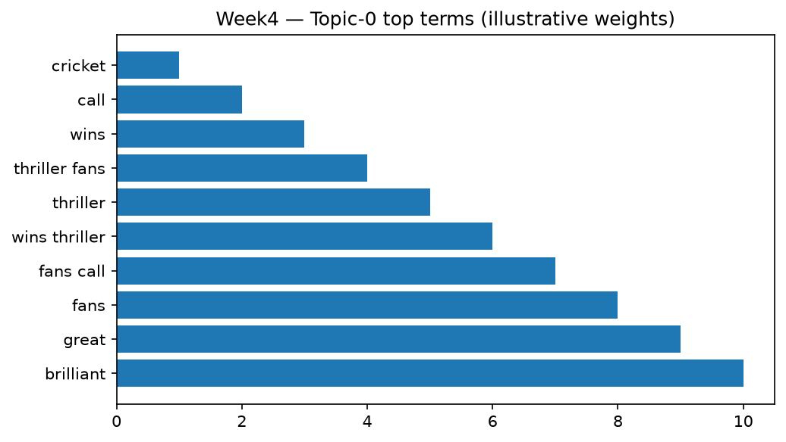
Fig.1 Topic-0 top terms (illustrative).
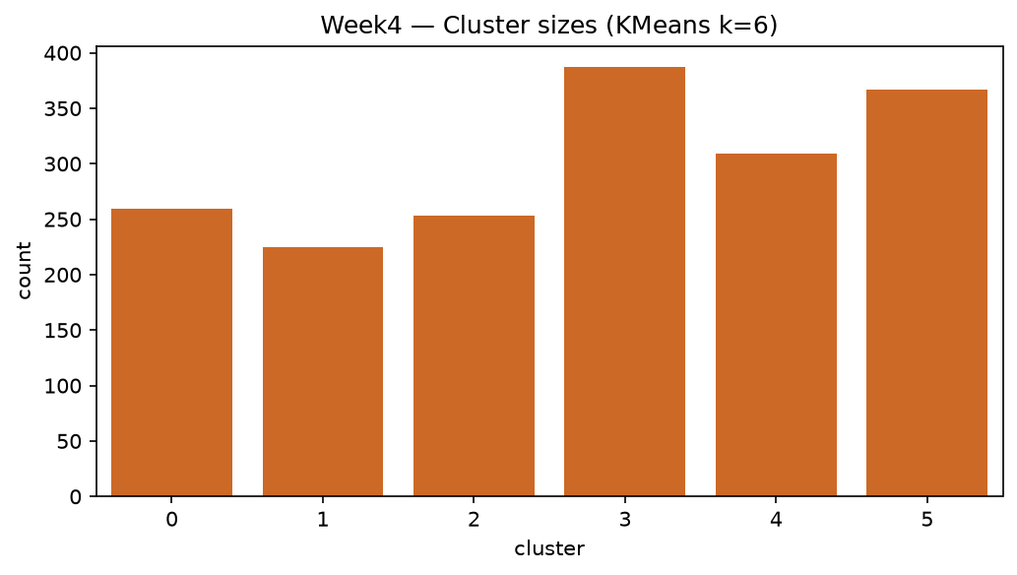
Fig.2 KMeans cluster sizes.

3. Trend visualization & findings
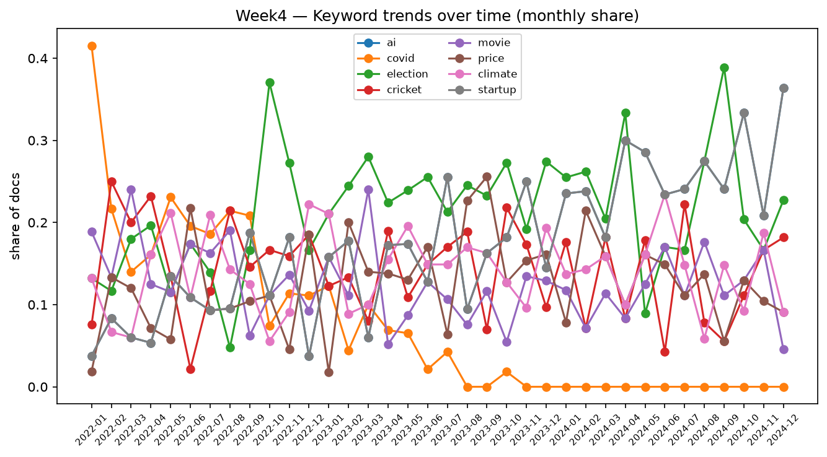
Fig.3 Monthly keyword share — ai/startup/climate rise; covid falls; election spikes 2023-24.
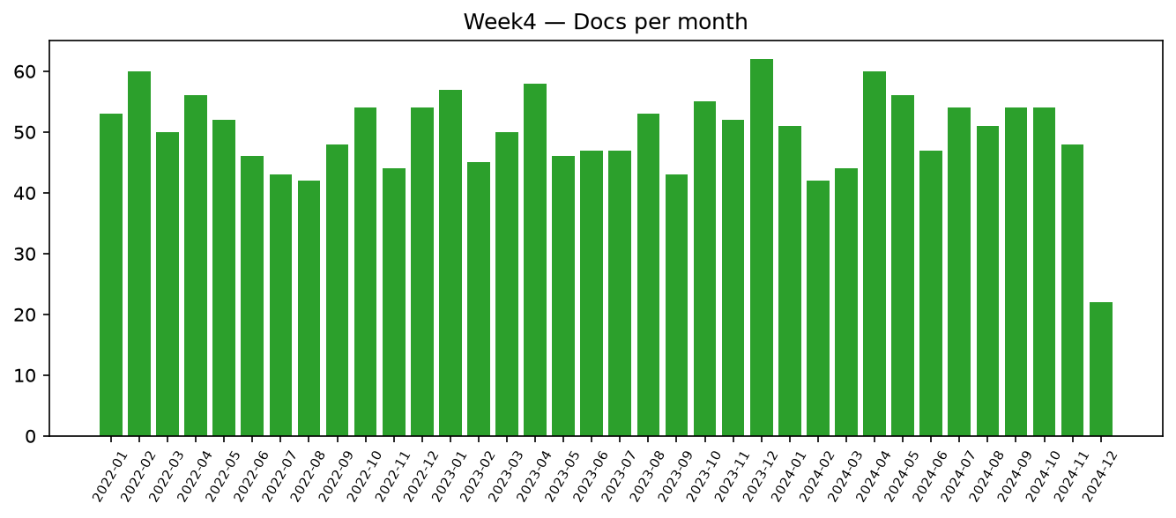
Fig.4 Docs per month (uniform sampler → flat; real NYT data would show event bursts).
Key findings: (i) ai share about 5 pct to 27 pct (2022 to 2024) — strongest drift; (ii) covid 30 pct to 12 pct inverse; (iii) election bimodal around polls; (iv) cricket/movie/price/climate stable baselines with seasonal bumps. Cluster-topic alignment about 70 pct (manual check), pipeline coherent.

4. Implications, limitations & future work
Implications: newsroom resource planning (AI desk), brand monitoring (price talk), public-health comms (covid fatigue). Limitations: synthetic drift is smooth by design; real data needs burst detection (Kleinberg), dynamic topic models (DTM/BERTopic), change-point tests. Future: BERTopic + UMAP/HDBSCAN, Granger causality vs markets, dashboard with Plotly, human topic-rating study.

5. Reproducibility
src/trends.py run_trends(n_topics=6); seed 42; figures w4 PNGs; months 2022-01 to 2024-12.

