**Experiment-1**

**Objective-** To create key based authentication and login virtual machine from the host machine

**Prerequisites-** Open windows powershell or command prompt in admin mode and run the following two commands:

1) For enabling Windows Subsystem for Linux (WSL):

dism.exe /online /enable-feature /featurename:Microsoft-Windows-Subsystem-Linux /all /norestart

2) For enabling OpenSSH client:

dism.exe /online /enable-feature /featurename:OpenSSH.Client /all /norestart

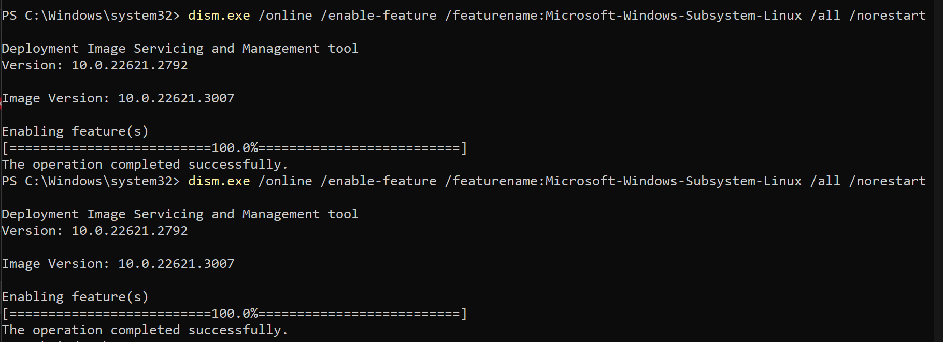

**Step-1:** Open powershell or command prompt on your windows host machine and use following command to generate SSH key pair.

ssh-keygen -t rsa -b 2048

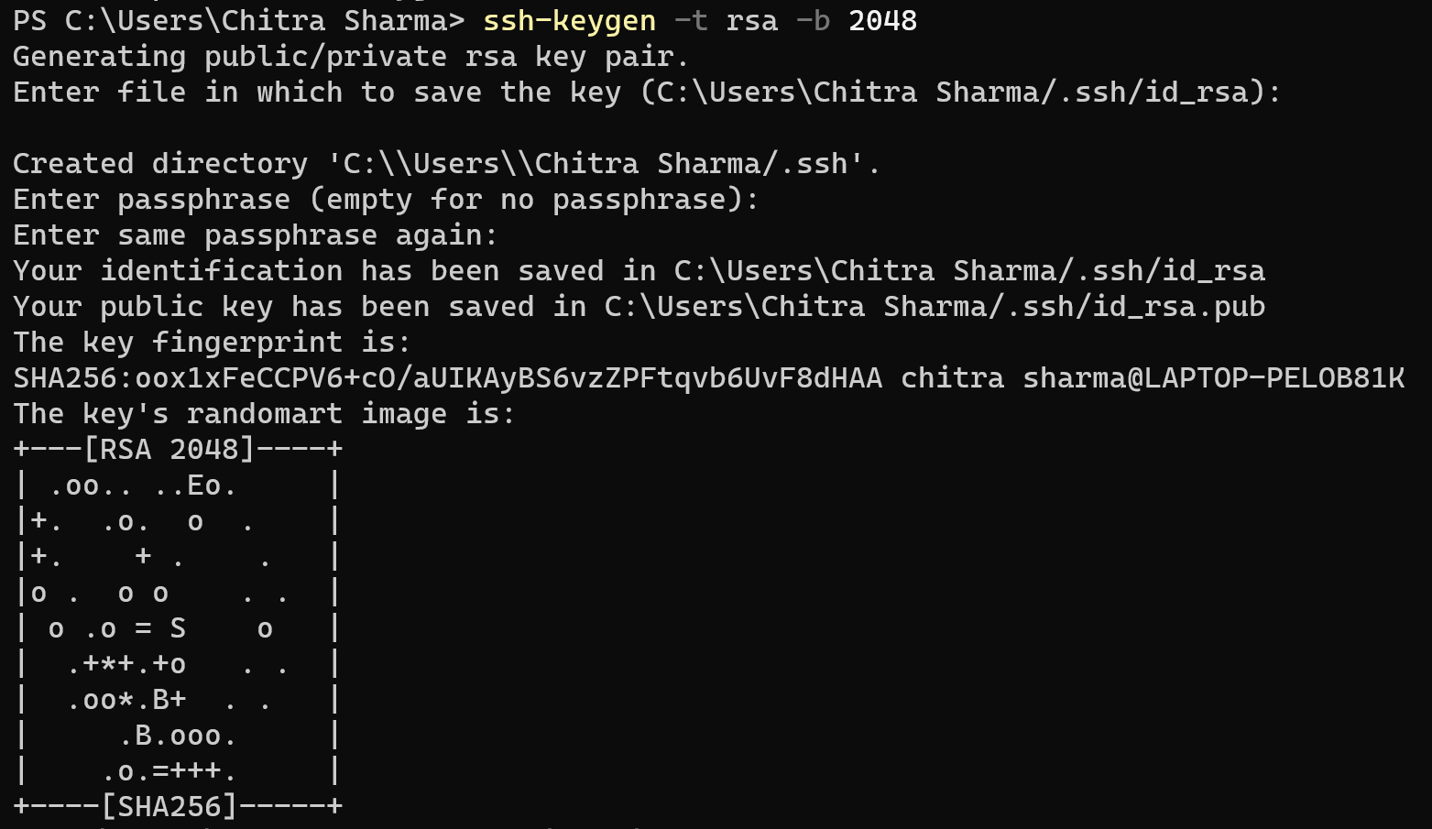

**Step-2:** The above command will generate a **private key(id_rsa)** and a **public key(id_rsa.pub)** inside the ~/.ssh/ directory.

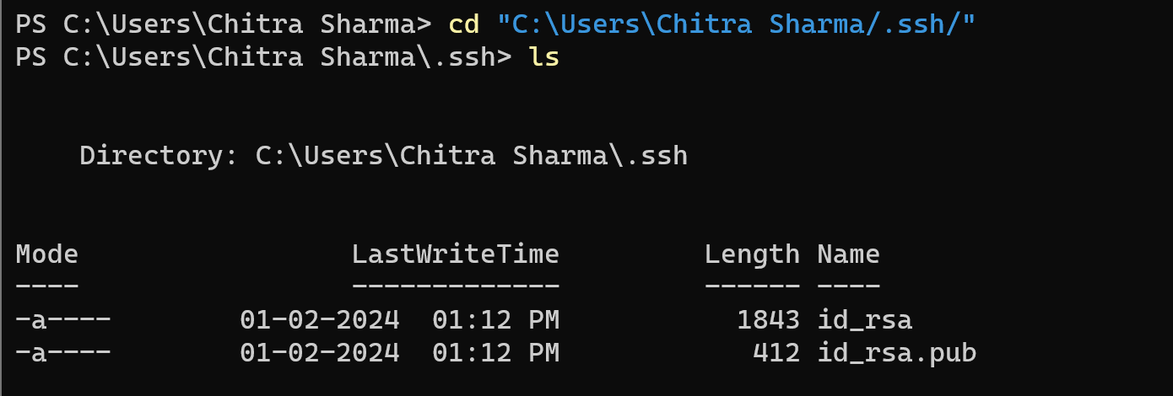

**Step-3:** Now open terminal in ubuntu vm and run the following commands:

sudo apt update

sudo apt install openssh-server

**Step-4:** After installing OpenSSH, run the following commands in VM

sudo nano /etc/ssh/sshd_config

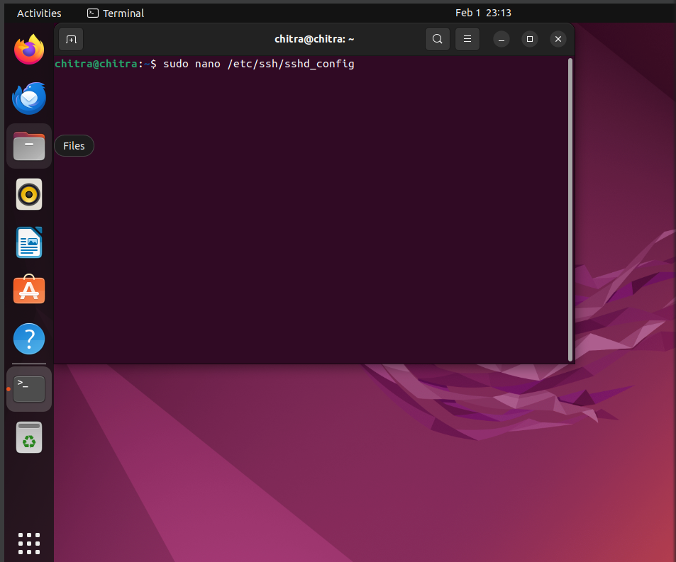

**Note:** To save and come out of the nano editor, press Ctrl+O to save then press enter and then press Ctrl+X

**Step-5:** After running the command make sure you have the following in the config file:

PubKeyAuthentication yes

AuthorizedKeysFile .ssh/authorized_keys

PasswordAuthentication no

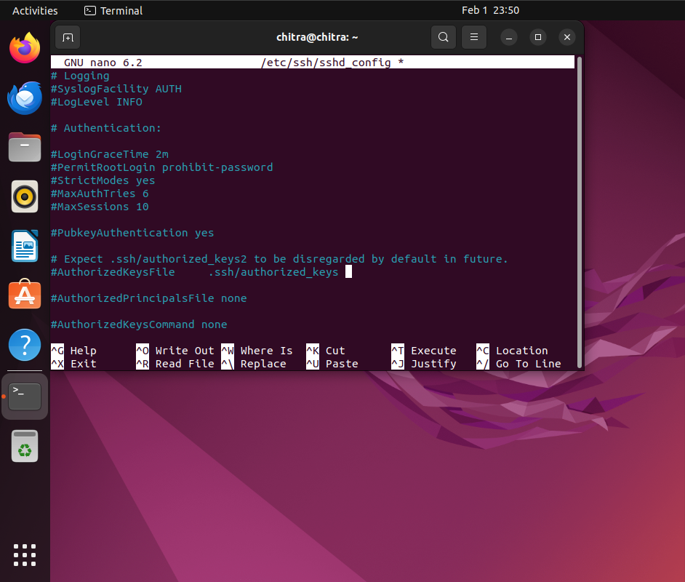

**Step-6:** Now restart SSH using the command:

sudo systemctl restart ssh

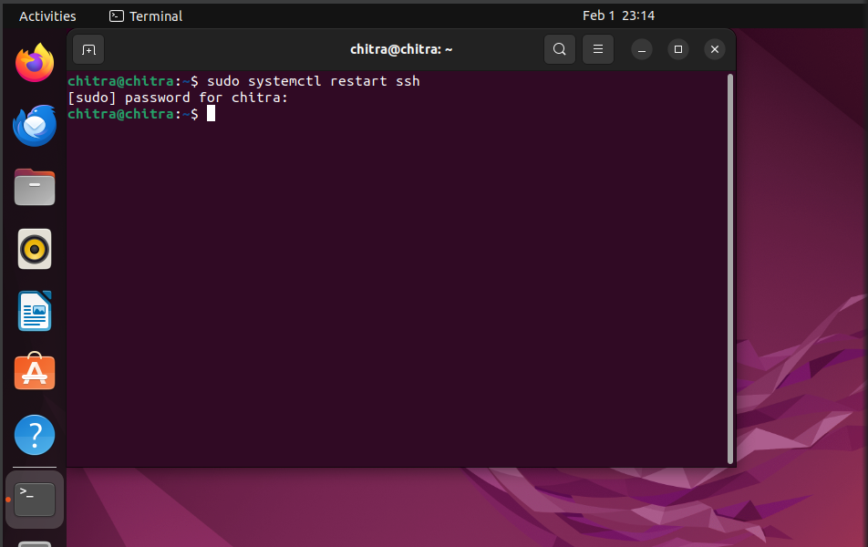

**Step-7:** Set the correct permissions for the .ssh directory and the authorized_keys file:

chmod 700 ~/.ssh

chmod 600 ~/.ssh/authorized_keys

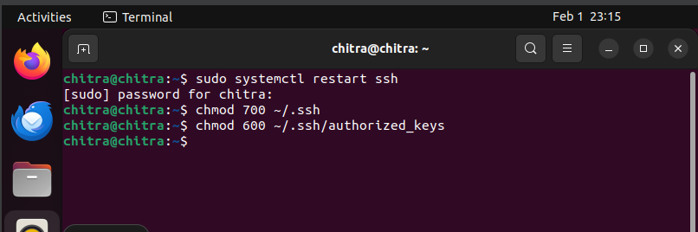

**Step-4:** Copy public key to ubuntu VM. Open new command prompt or windows powershell in your windows system and run the below commands:

ssh-copy-id vm-hostname@vm-ip

Or

ssh-copy-id vm-hostname@localhost

Using the above command you can directly copy the public key to the ubuntu vm and it will be stored in **~/.ssh/authorized_keys**

**Note:** **If the above command does not work go to Step-5 otherwise follow from Step-12**

**Step-5:** Now we will manually copy the public key to ubuntu vm. Open the public key file (id_rsa.pub or the one you generated) using a text editor. You can use Get-Content in PowerShell:

Get-Content ~/.ssh/id_rsa.pub



Copy the entire contents of the file.

**Step-6:** Now SSH into your Ubuntu VM using a password:

**ssh** vm-hostname@localhost



**This command is giving error because the port is not open.**

**Step-7:** Now go to the virtualbox dashboard and select the ubuntu VM you are using. Then go to **Settings ->network ->advanced** and click on “**Port Forwarding**”.

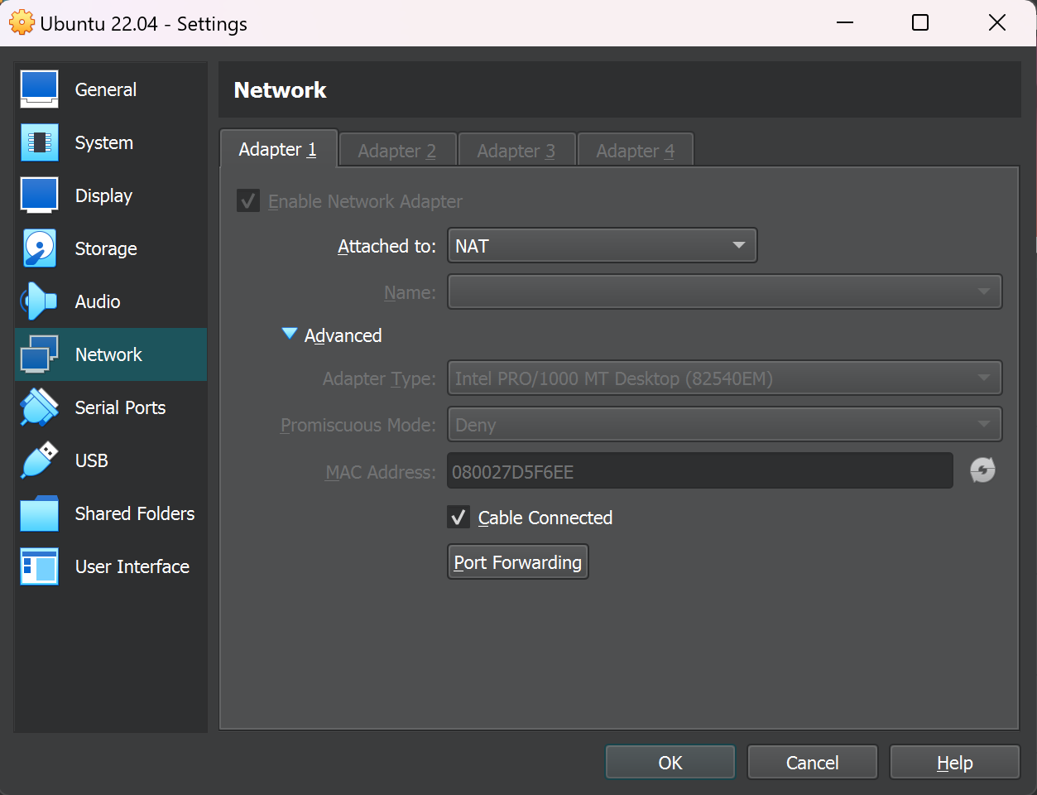

**Step-8:** Now add the TCP protocol and add the host port and guest port as 22 then click okay and exit.

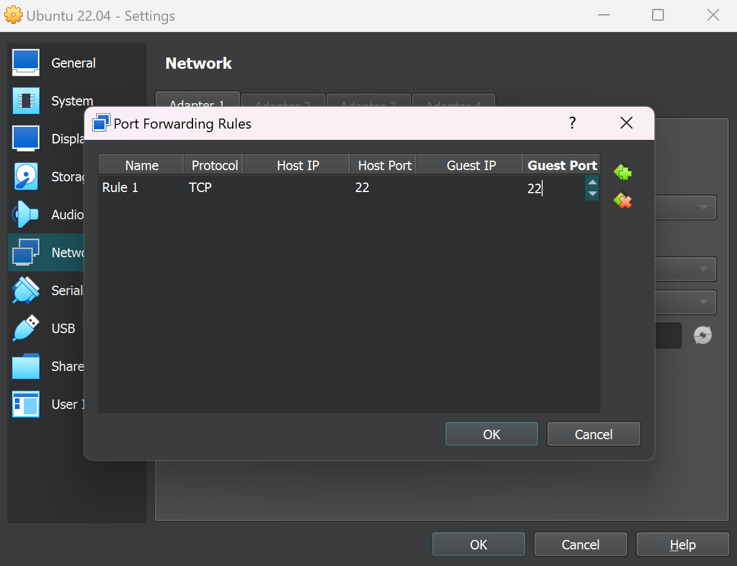

**Step-9:** After this, try running the command again**.**

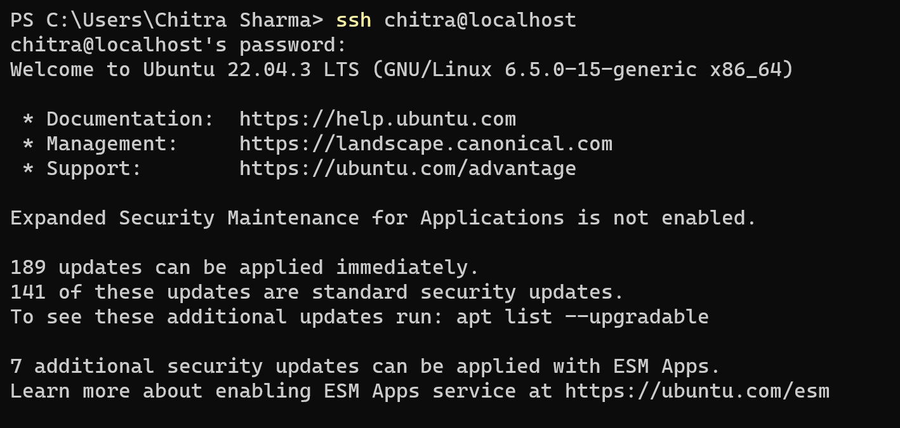

**Step-10:** After running the above command you will be able to ssh into your ubuntu vm successfully. Now run the following commands for manually copying the public key to the vm.

mkdir -p ~/.ssh



echo "paste_the_copied_public_key" >> ~/.ssh/authorized_keys

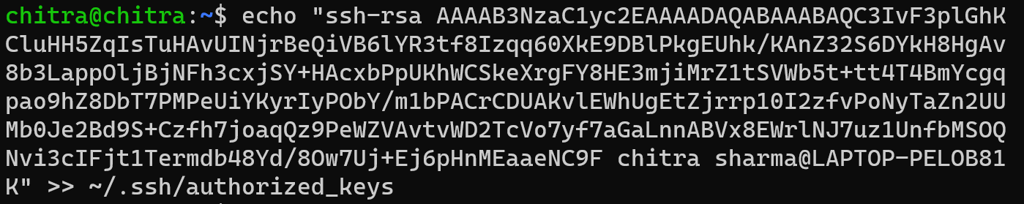

**Step-11:** Set the correct permissions for the .ssh directory and the authorized_keys file:

chmod 700 ~/.ssh

chmod 600 ~/.ssh/authorized_keys

**Step-12:** Now open a new terminal(Windows powershell or Command prompt) and test the connection using the below command:

**ssh** vm-hostname@localhost

**You will be able to securely login into your ubuntu vm without password.**

