**EXPERIMENT -4: Dockerfile**

Ques-1: Do the following

1. Create a dockerfile and run
2. Create an image from the dockerfile
3. Run a container from this docker image
4. Push this image into your repository
5. Pull the image from repository
6. Run a container from this image
7. Install JDK on top of it
8. Write a Hello-World program in it
9. Convert the entire set into an image again
10. Run a container from this image

**Step-1:** Firstly make images folder using the command and then navigate to the folder

mkdir images

cd documents/images



**Step-2:** Now make a java program and save it in the same “images” folder and save it with the name of the class. Here, the program is saved with the name, Hello.java

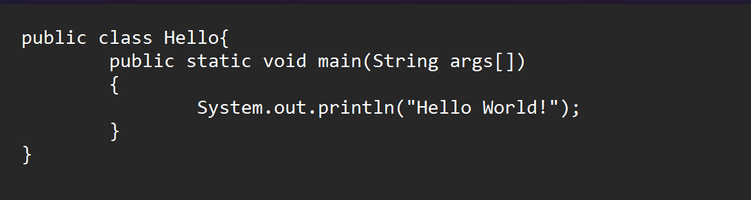

**Step-3:** Now open notepad and create a dockerfile. The file should be saved in all files format within the double quotes i.e. “dockerfile”.

notepad dockerfile



**Step-4:** In order to run a java program inside the container, we need to include the following instruction inside the dockerfile.

FROM ubuntu:latest

RUN apt-get update && apt-get install -y openjdk-11-jdk

COPY Hello.java /app/

WORKDIR /app/

RUN javac Hello.java

CMD ["java", "Hello"]

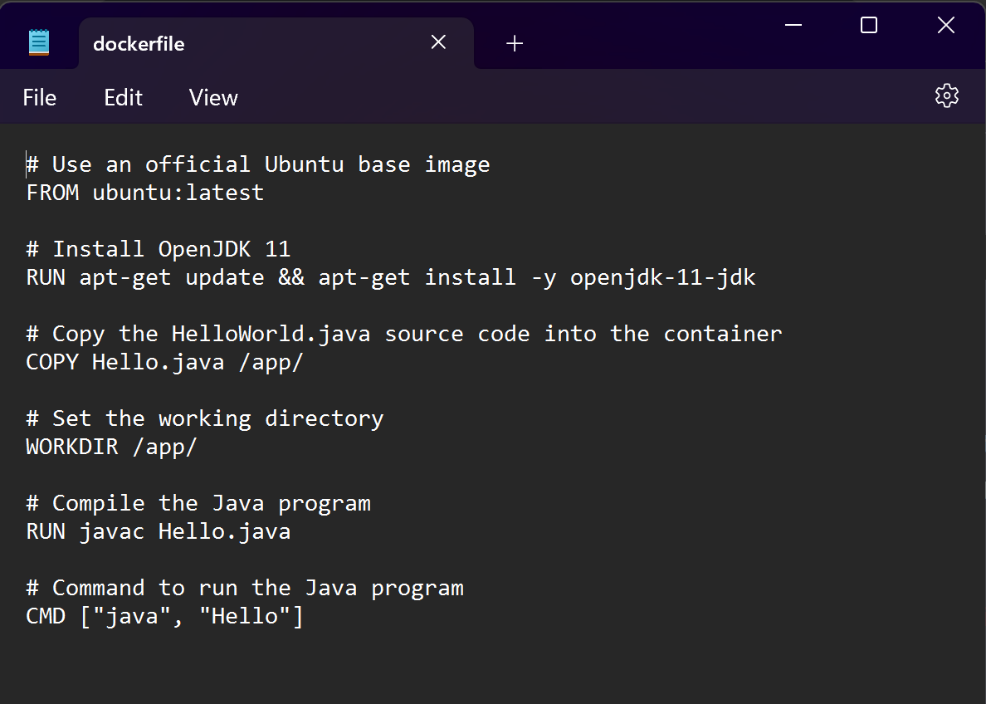

**Step-5:** Now build an image using this dockerfile.

docker build -t mybusybox:1.0 .

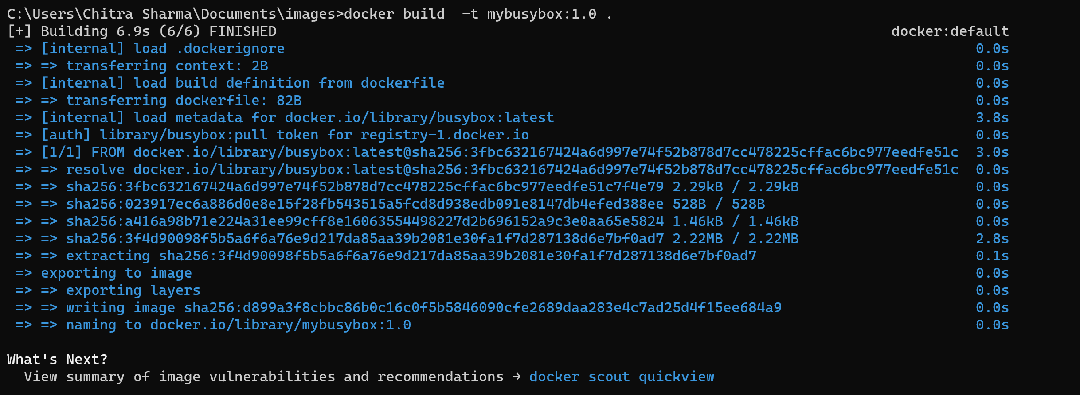

**Step-6:** Next step is to run a container from the image that we just created

docker run - -name=newcon mybusybox:1.0



**Step-7:** Now commit the changes in the container to a new image.

docker commit newcon newimage



**Step-8:** Login to your docker account

docker login

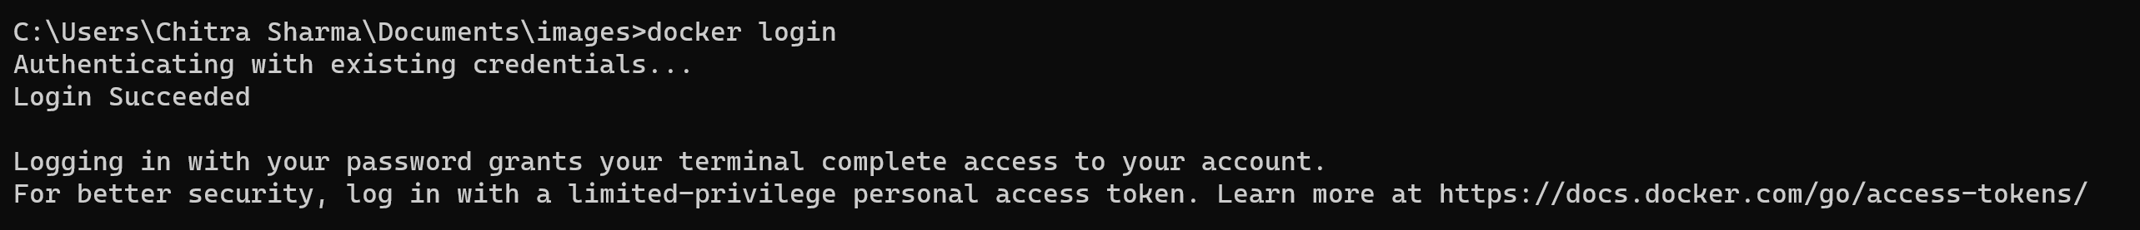

**Step-9:** Tag the image with the Docker hub username and repository name and then push the tagged image to your private Docker hub repository

docker tag newimage your-dockerhub-username/newimage

docker push your-dockerhub-username/newimage



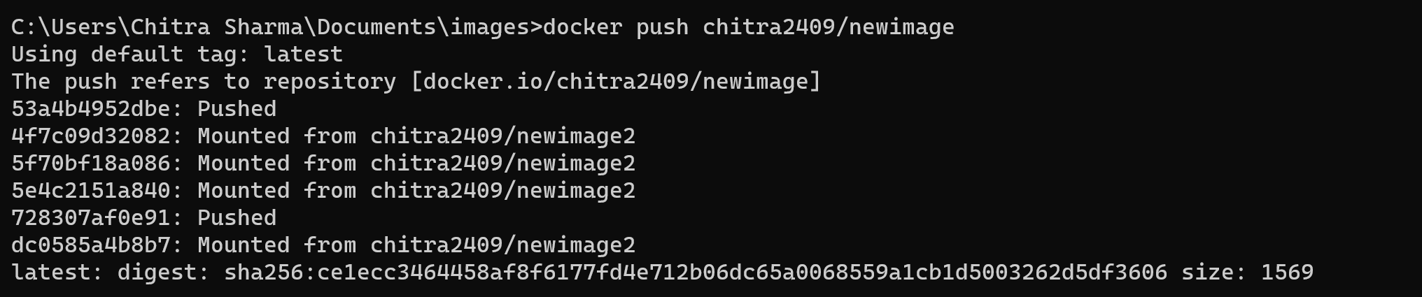

Step-8: Pull the image from your private docker hub repository

docker pull chitra2409/newimage

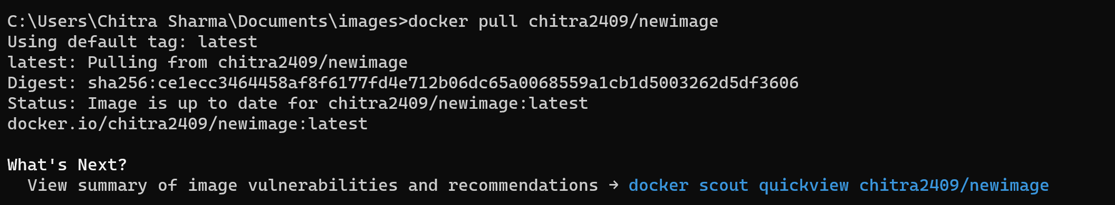

Step-9: Run a container using the pulled image

docker run -it chitra2409/newimage

