**EXPERIMENT 1- Installation of VMware Workstation and creating Ubuntu VM in it**

**Step-1:** Download the VMware workstation from official website.

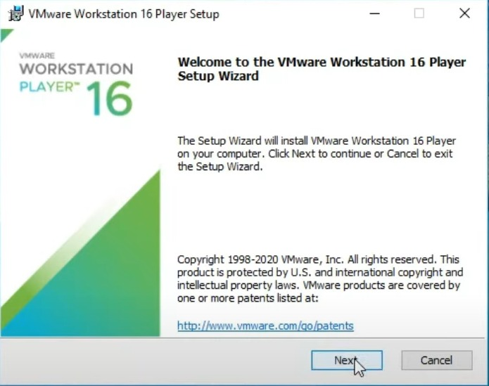

**Step-2:** Select the installation destination and a dd any additional features.

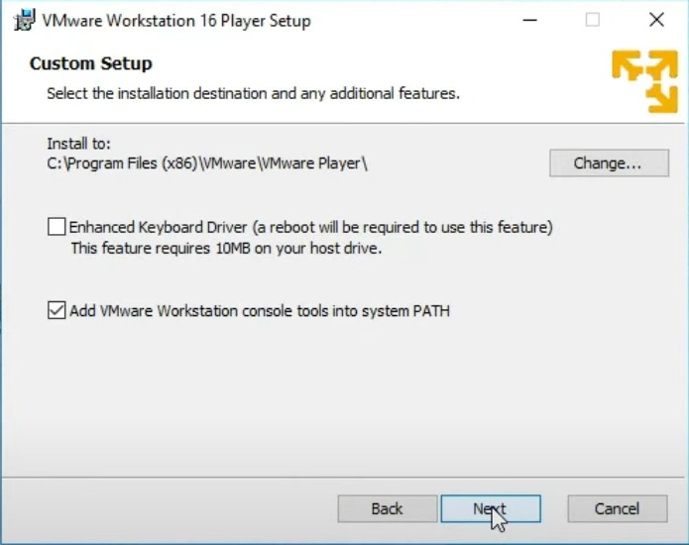

**Step-3:** Click install to begin the installation.

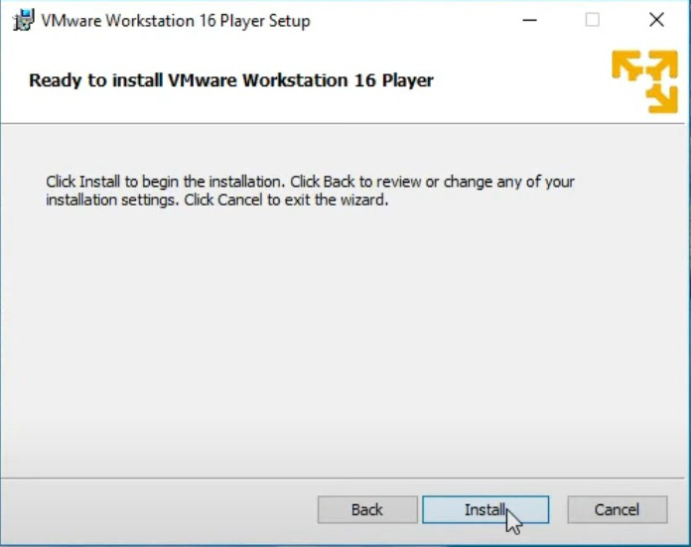

**Step-4:** Click the Finish button to exit the Setup Wizard.

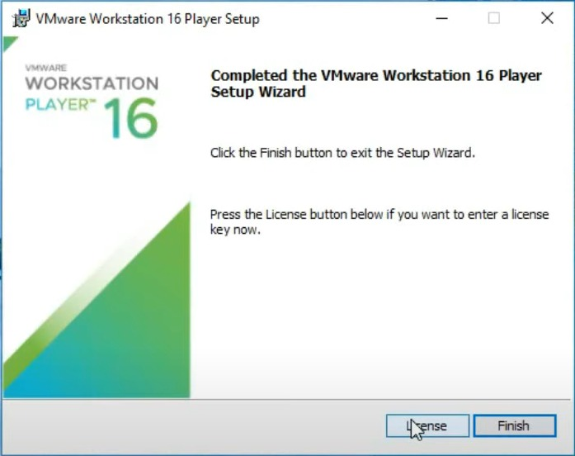

**Adding virtual machine onto the VMware Workstation**

**Step-1:** Open the workstation and accept the terms and conditions and check on ok.

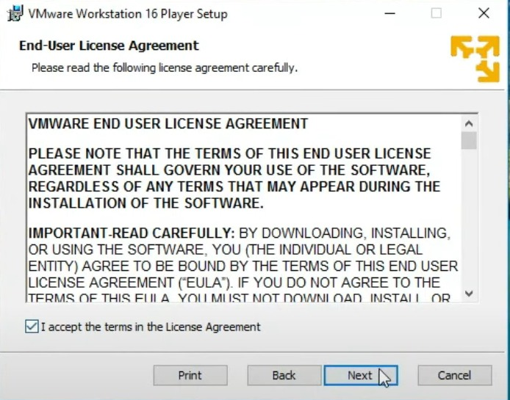

**Step-2:** Now choose the ISO file.

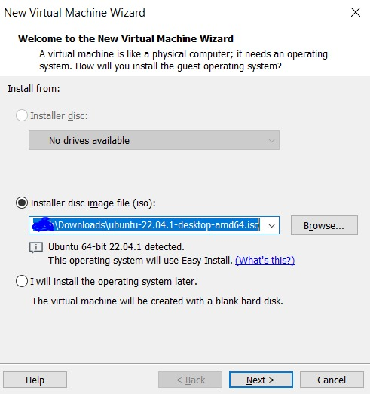

**Step-3:** Now name the virtual machine.

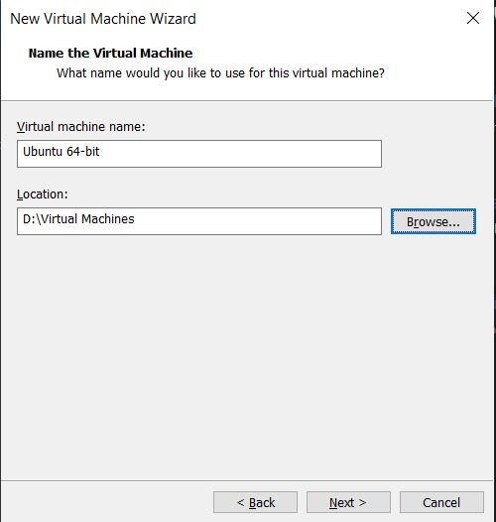

**Step-4:** Specify the disk capacity.

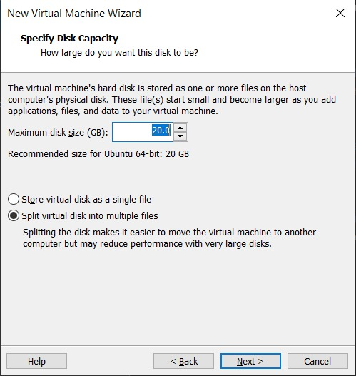

**Step-5:** Now click on customize hardware.

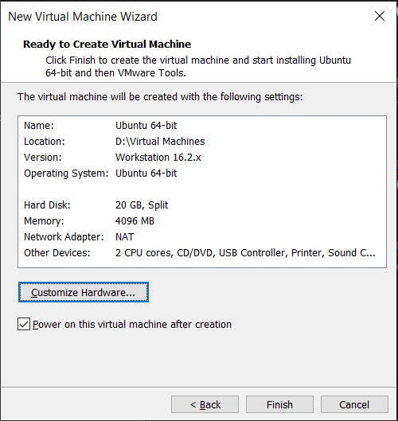

**Step-6:**Installation is complete. Now you can see that your virtual machine is running successfully.

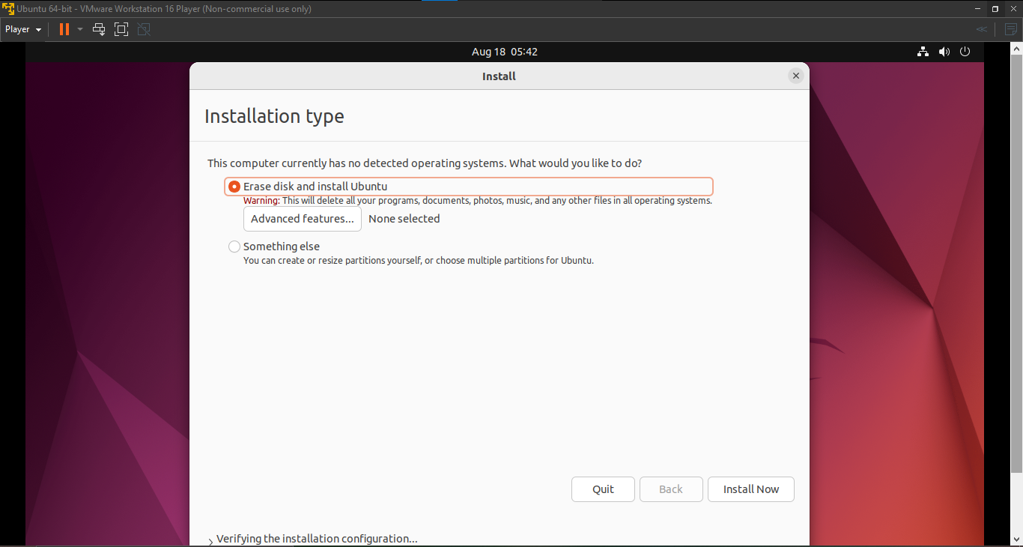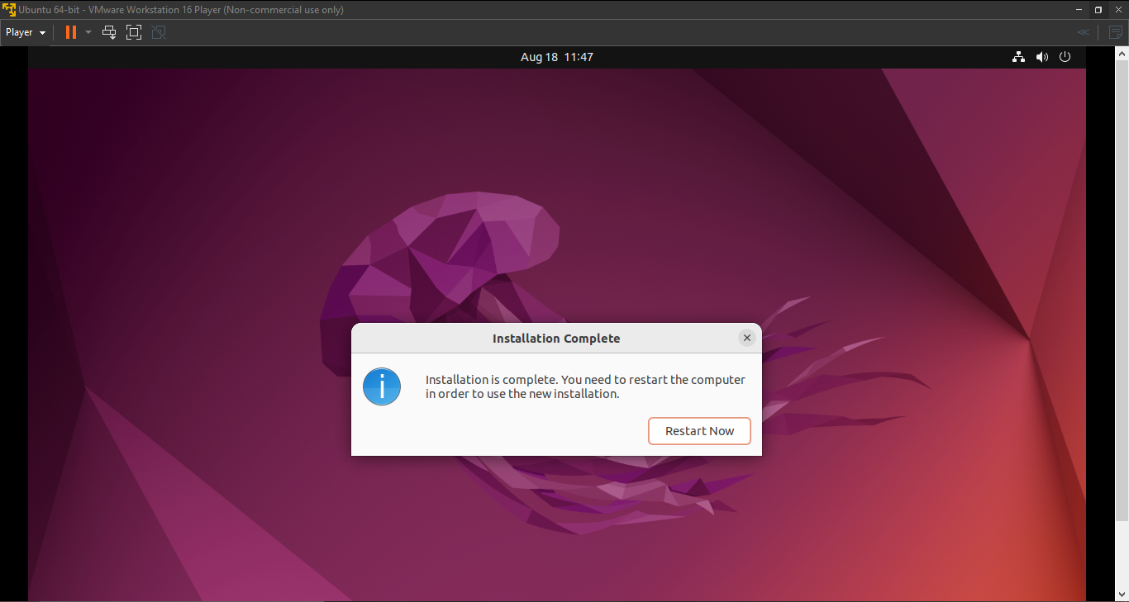

**QUESTIONS:**

**1)**What is an ISO image?

**Ans**- An ISO image is an exact replica of the entire content of a physical optical disc, such as a CD, DVD, or Blu-ray disc, down to and including the file system. There is no compression applied, and they are a sector-by-sector replica of the disc. With ISO images, we can store a precise digital replica of a disc and then use that image to create a new disc that is a precise copy of the original. You may mount an ISO image as a virtual disc in the majority of operating systems (and many utilities), in which case all of our apps will treat it as if an actual optical disc were inserted.

**2)**What is the difference between dual boot and having multiple virtual machines running in an hypervisor?

**Ans**- Dual booting allows for only one system to be executed at once on a real computer, which increases system speed. But if we use a virtual machine, our computer will simultaneously run the host OS, the VM software, and the guest OS. Consequently, the PC's performance is significantly impacted.

**3)**Why virtualization is the foundational technology for cloud computing?

**Ans-** The foundation of cloud computing is virtualization since it is the technology that makes it possible to build an intelligent abstraction layer that conceals the complexity of underlying hardware or software.

**4)** Compare the Type-1 and Type-2 Hypervisors.

**Ans-** Type- 1 Hypervisor

1. A hypervisor that runs directly on the host's hardware to control the hardware and to manage guest operating systems.
2. Called a native or Bare Metal Hypervisor.
3. Runs directly on the host's hardware.
4. Examples: AntsleOs, Xen, XCP-ng, Microsoft Hyper V, VMware ESX/ESXi, Oracle VM Server for x86.

Type- 2 Hypervisor

1. A hypervisor that runs on a conventional operating system just as other computer programs do.
2. Called a Host OS Hypervisor.
3. Runs on an operating system similar to other computer programs.
4. Examples: VMware Workstation, VMware Player. VirtualBox, Parallel Desktop for Mac.

