**EXPERIMENT-2**

**Creating Windows 10 Virtual Machine in VMWorkstation**

**Step-1**:Download the copy of the windows 10 installation media from the Microsoft website.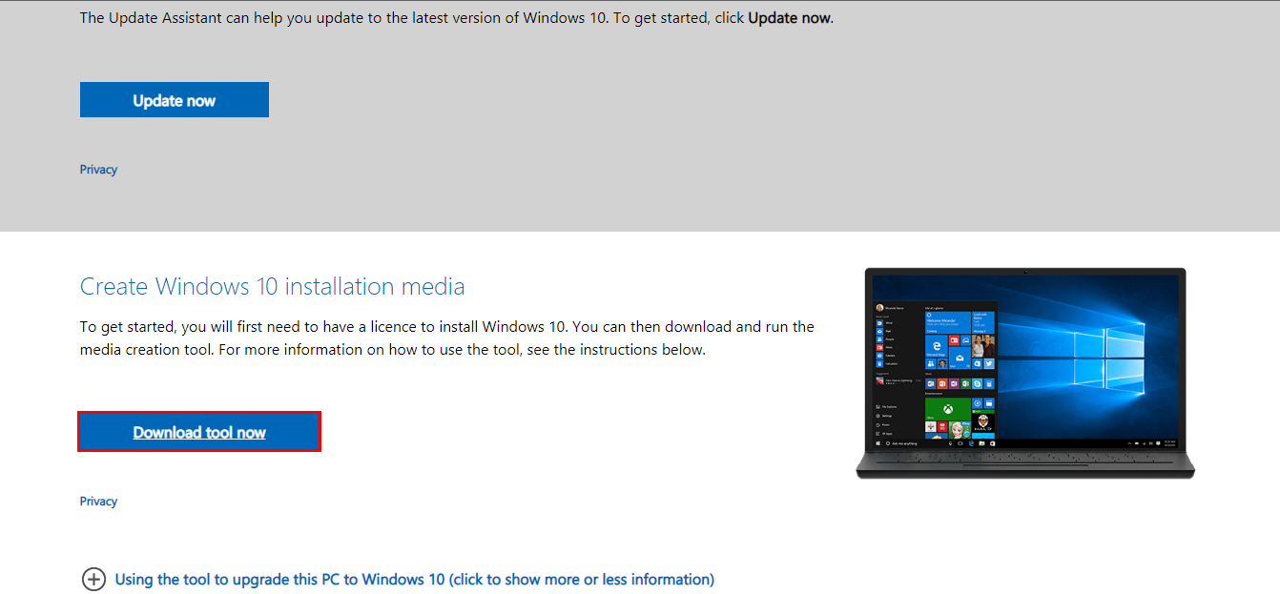

**Step-2**: Accept the terms and conditions.

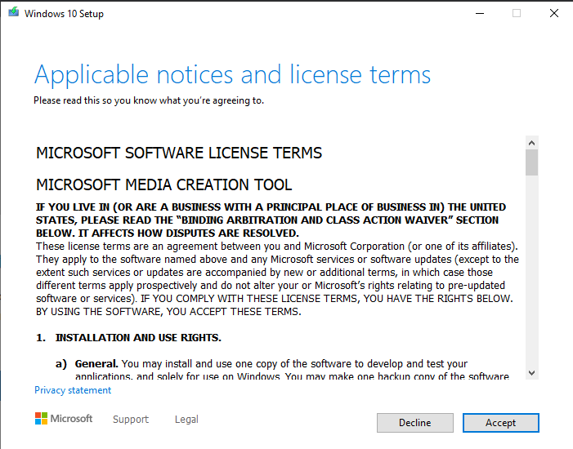

**Step-3:** Click on create installation media

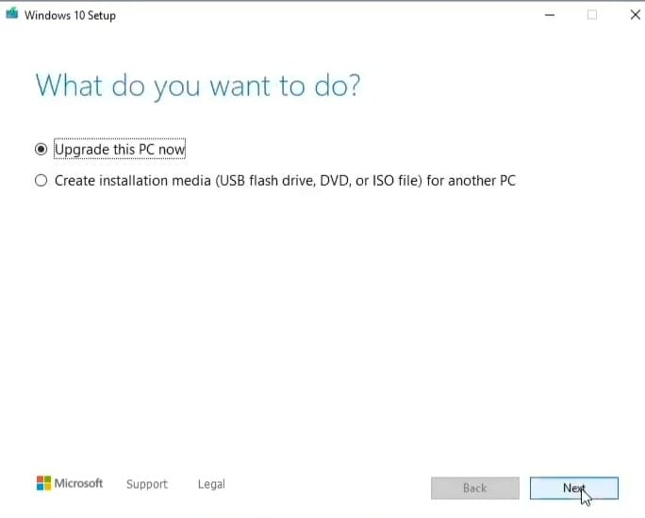

**Step-4:** Select language, architecture and media.

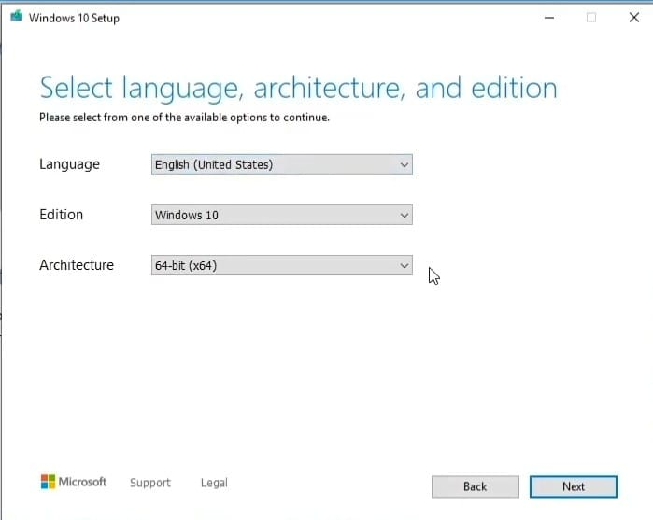

**Step-5:** Choose the ISO file.

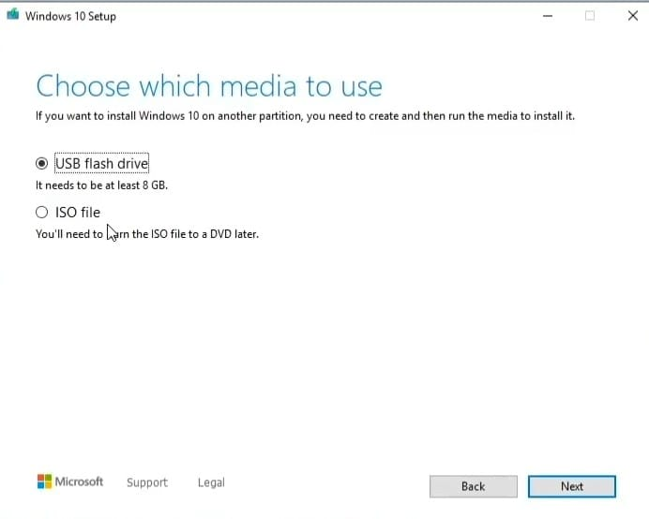

**Step-6:** The file is downloading. It will take few minutes. Then click on next.

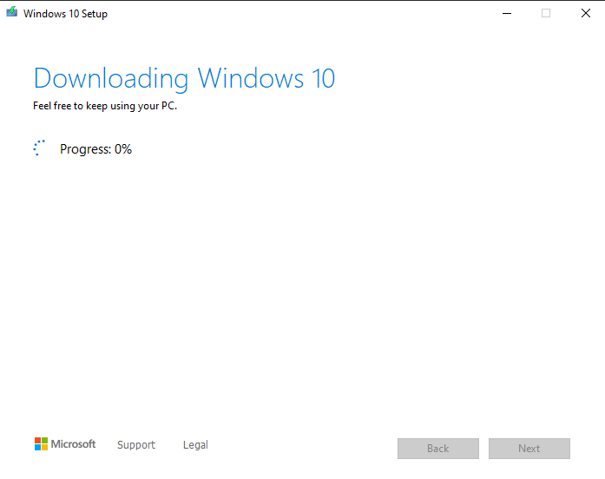

**Step-7:** Burn the ISO file to a DVD.

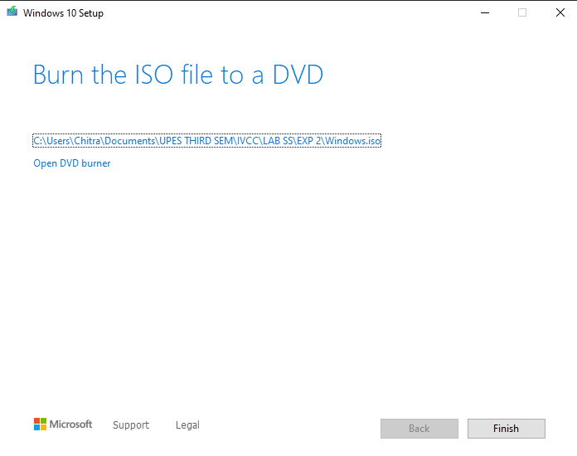

**Step-8:**Now click on create a new virtual machine.

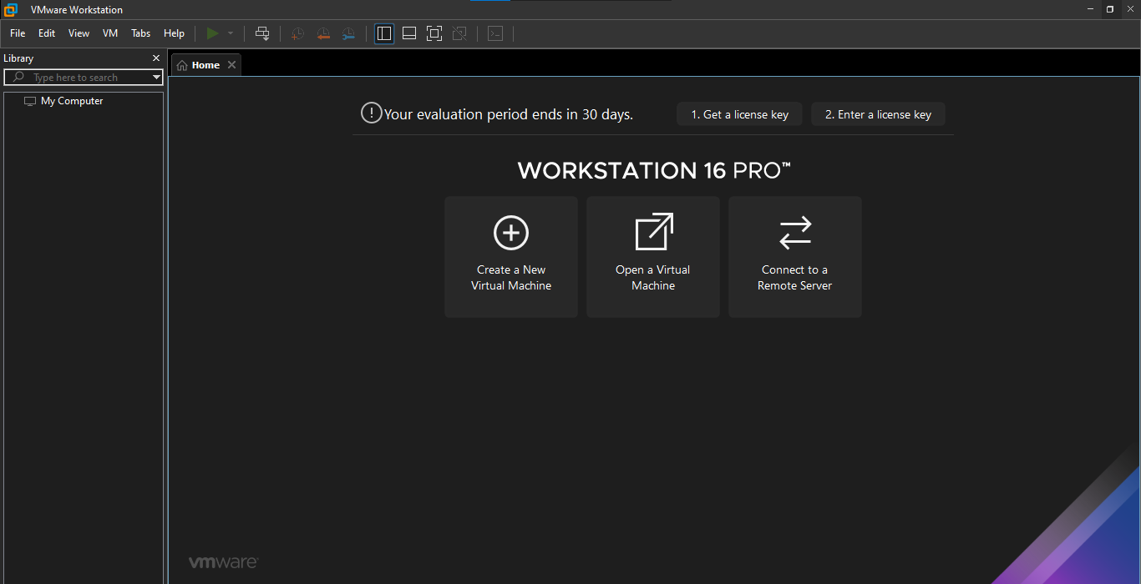

**Step-9:** Select the configuration you want.

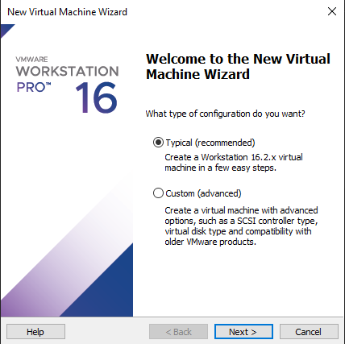

**Step-10:**

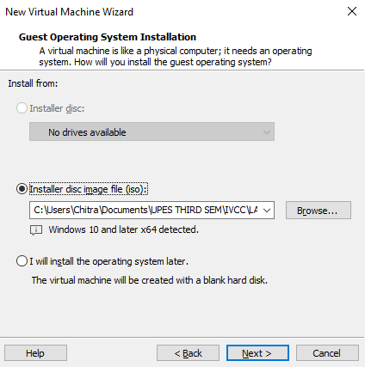

**Step-11:** Name your virtual machine.

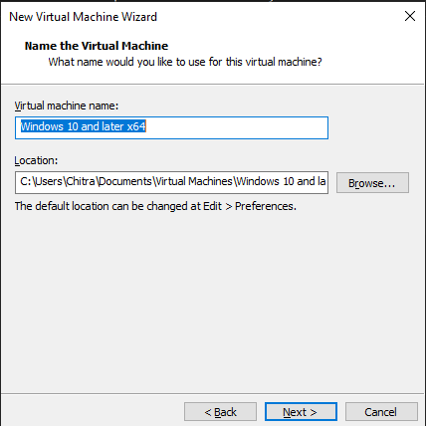

**Step-12:** Specify the disk capacity.

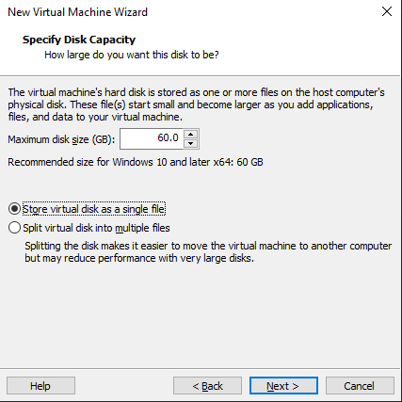

**Step-13:** Click on finish and you are ready to create the virtual machine.

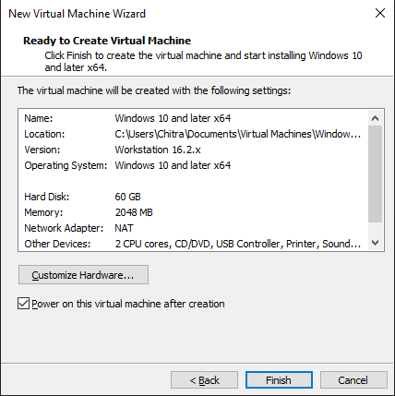

**Step-14:** Specify the details.

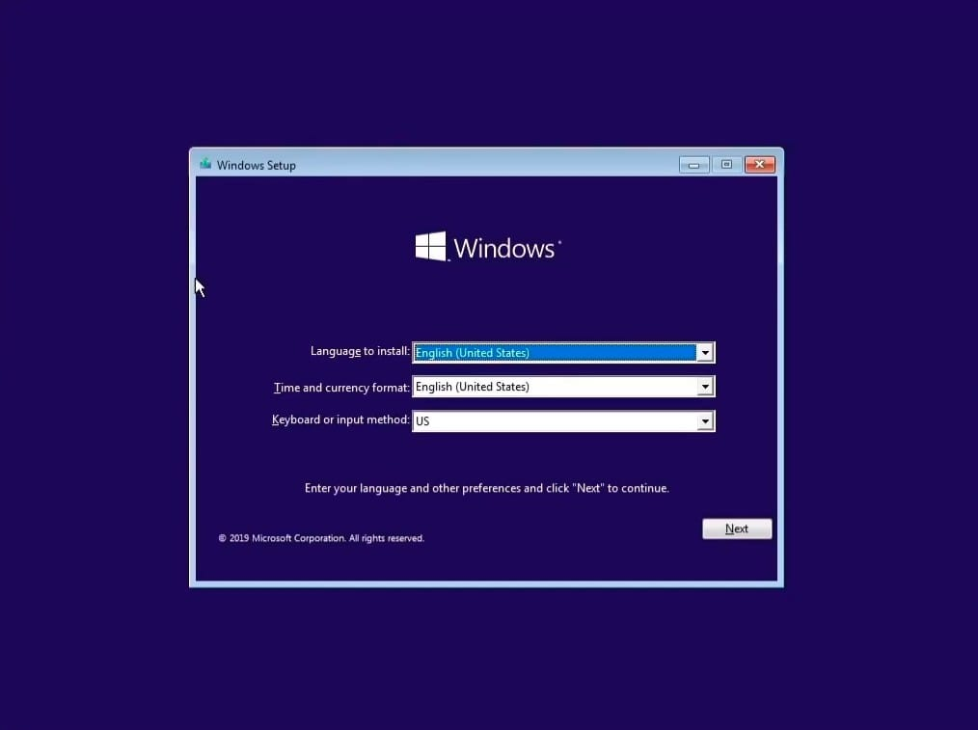

**Step-15:** Click on “I don’t have a product key”.

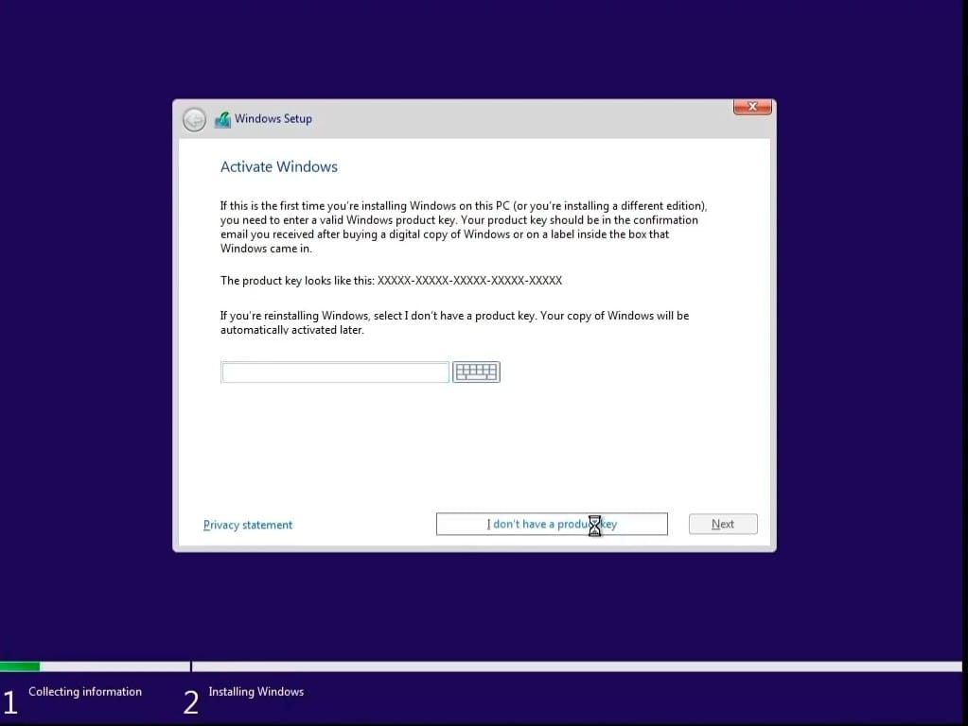

**Step-16:** Select the Windows 10 Pro option.

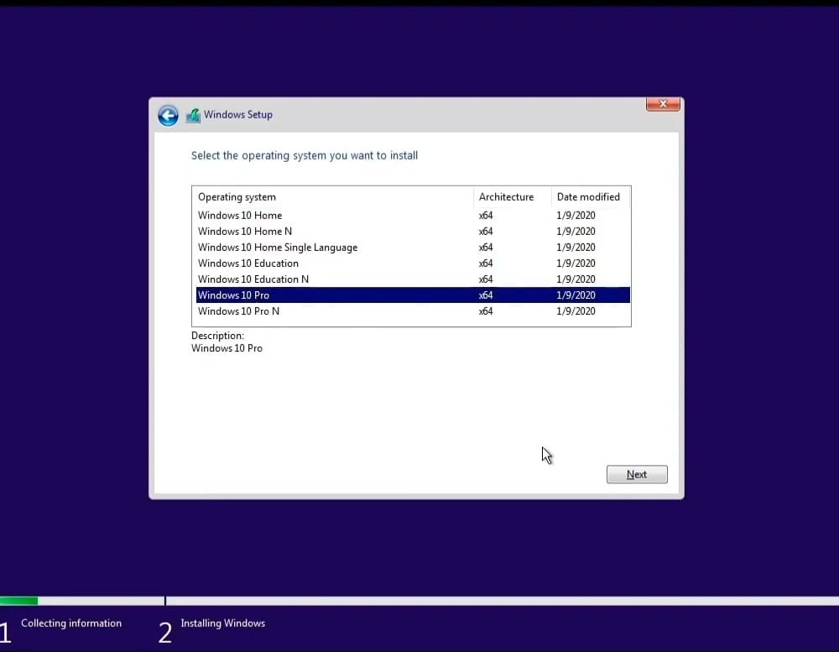

**Step-17:**Accept the terms and click next.

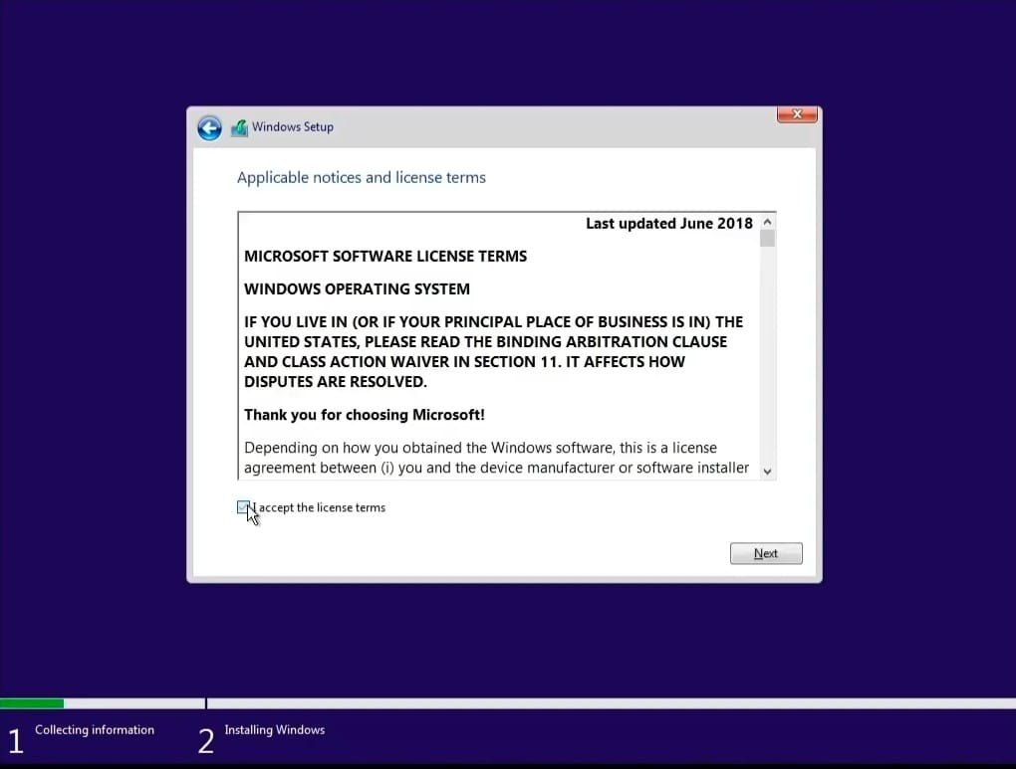

**Step-18:** Select the custom option.

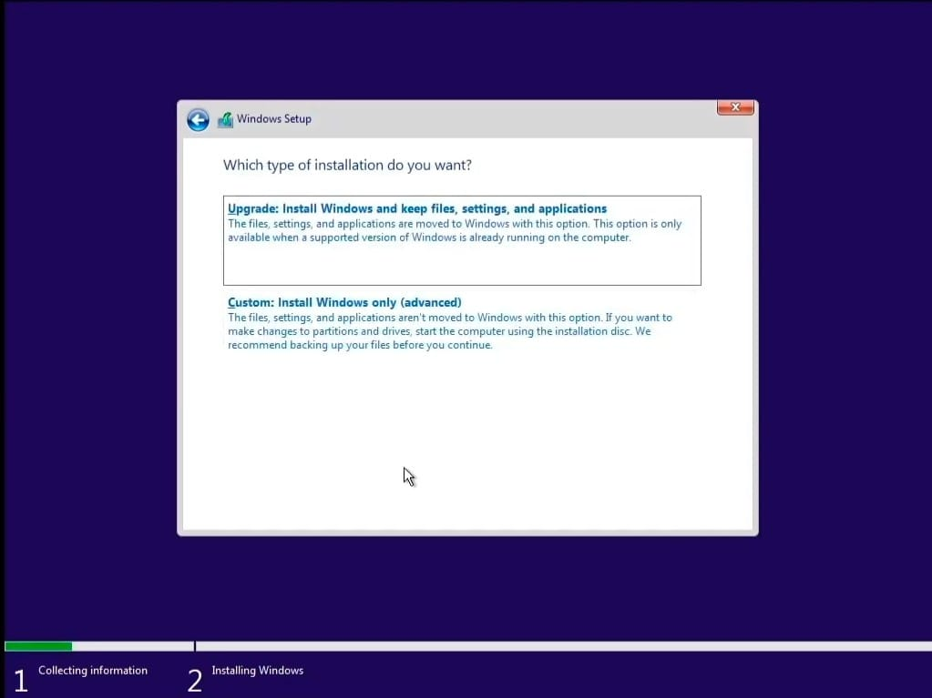

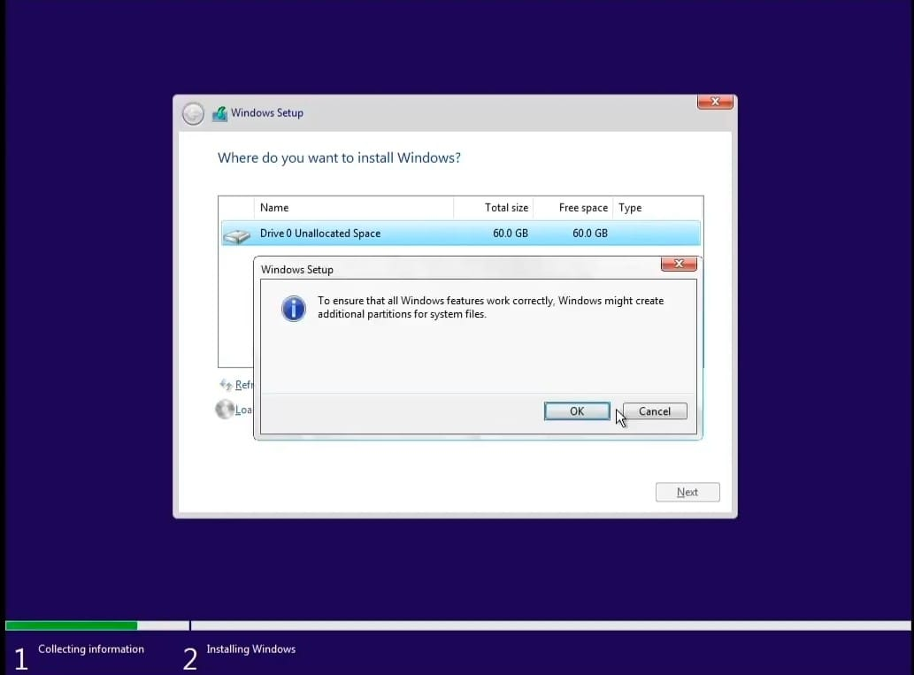

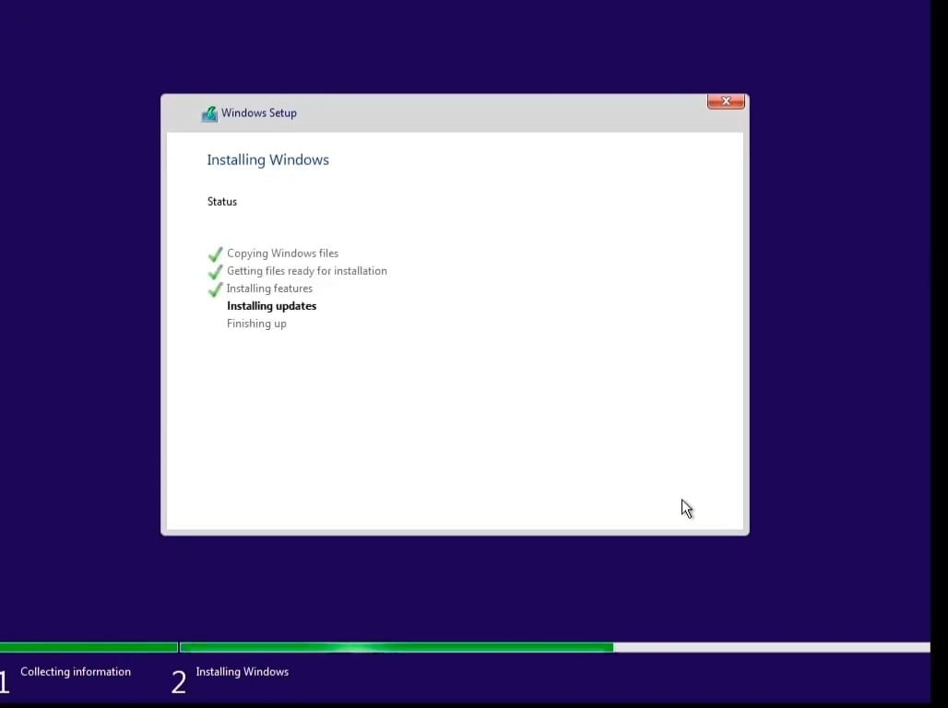

**Step-19:** Complete the process.

