**EXPERIMENT 3- Creation of VM image of Base Operating System**

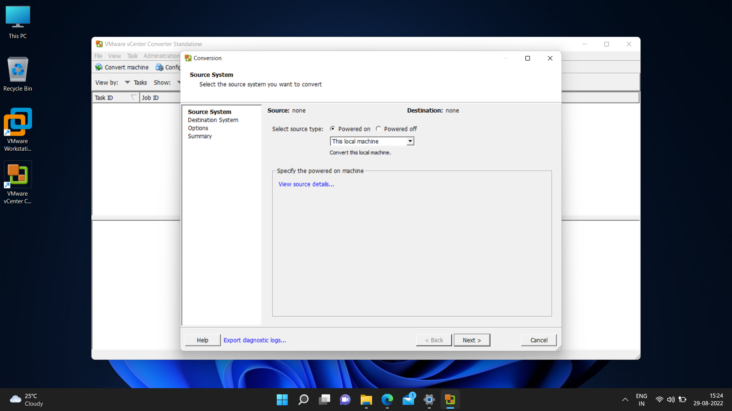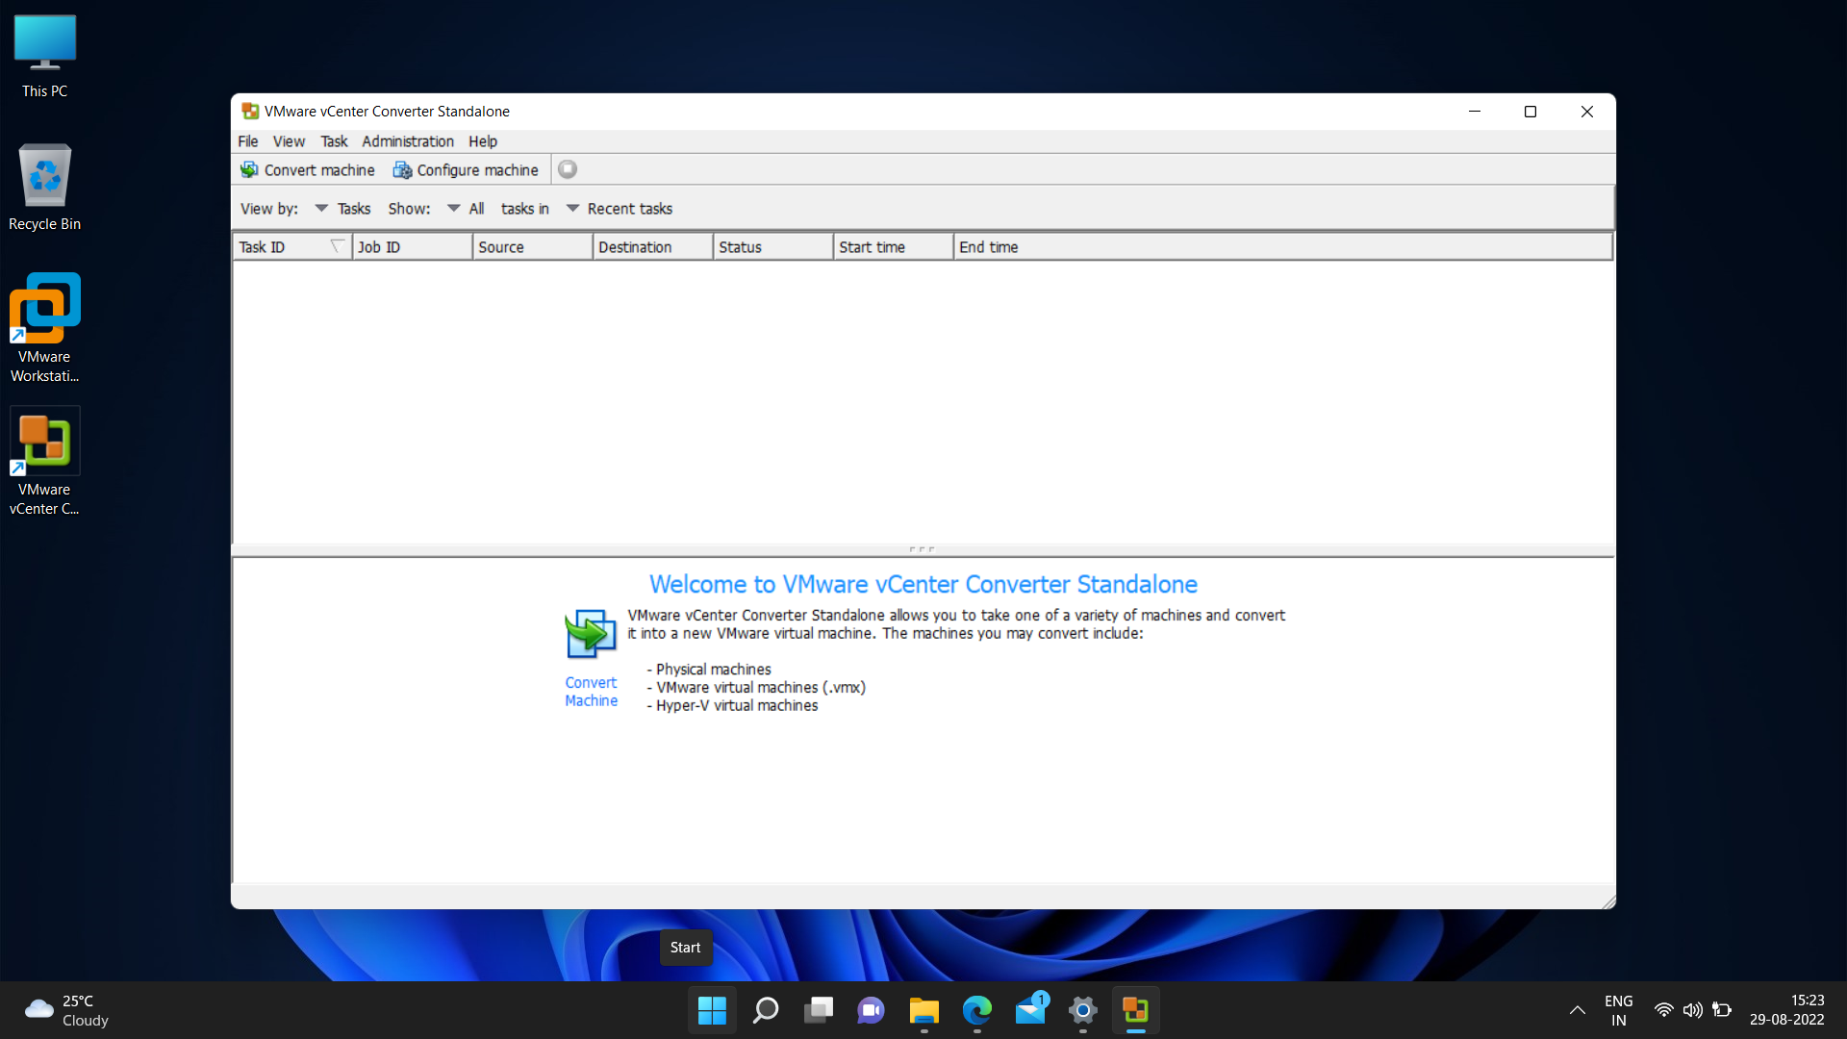

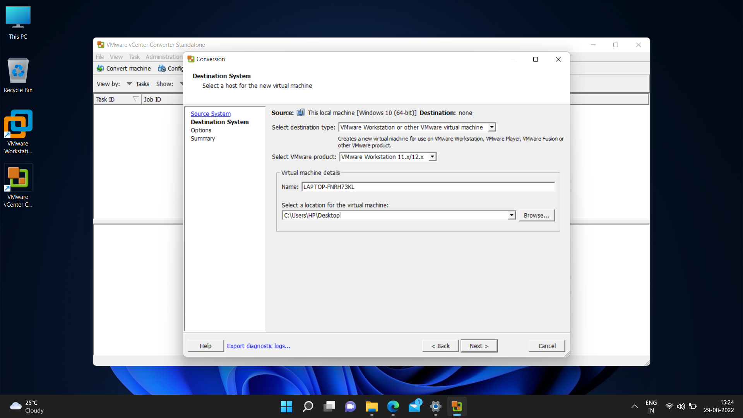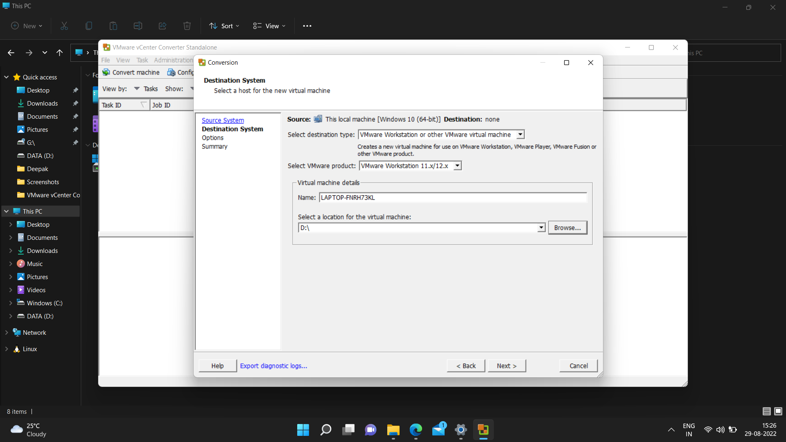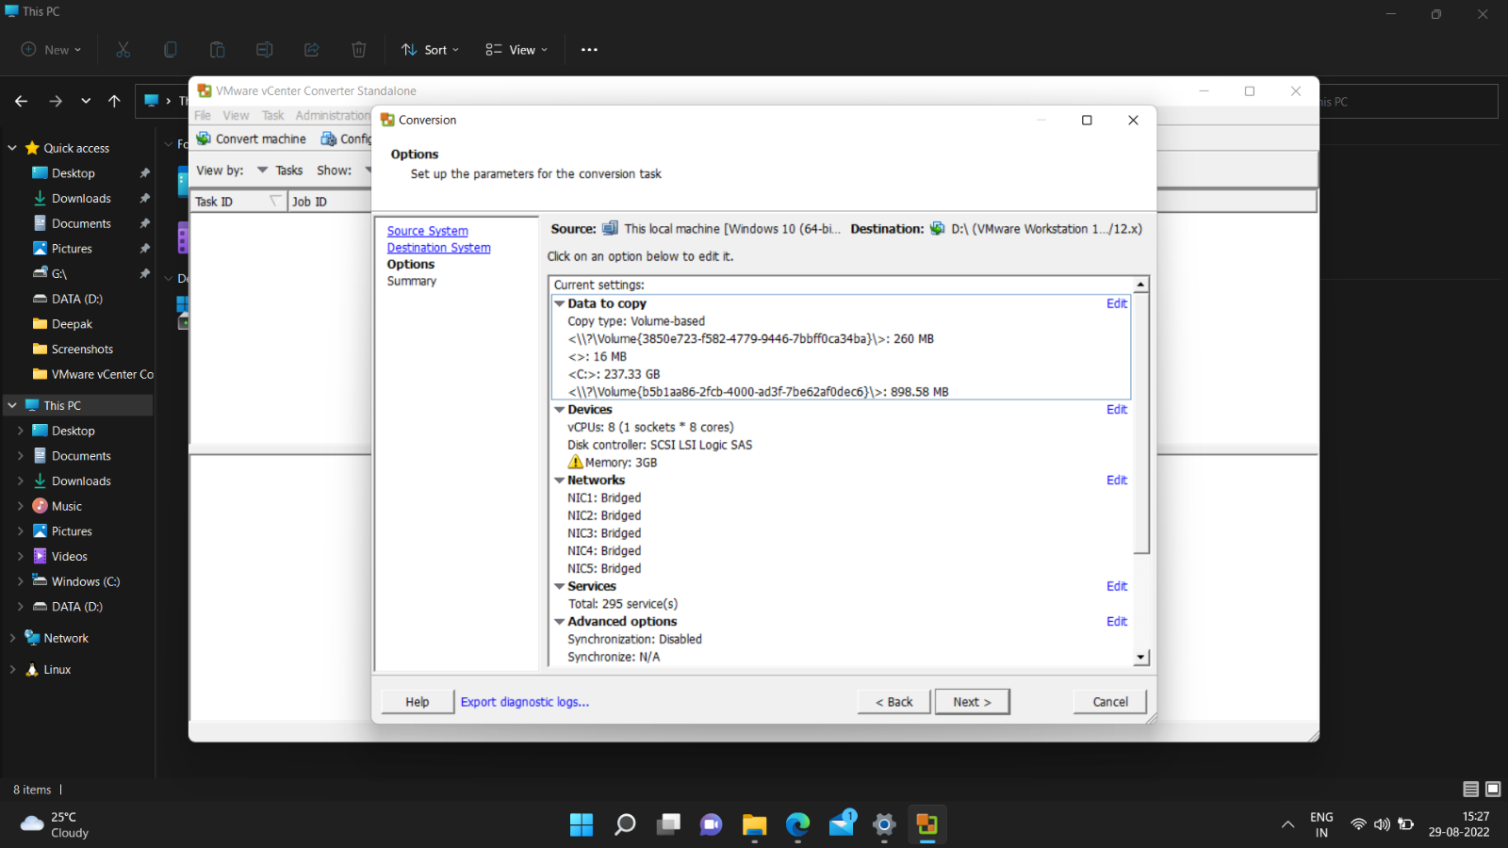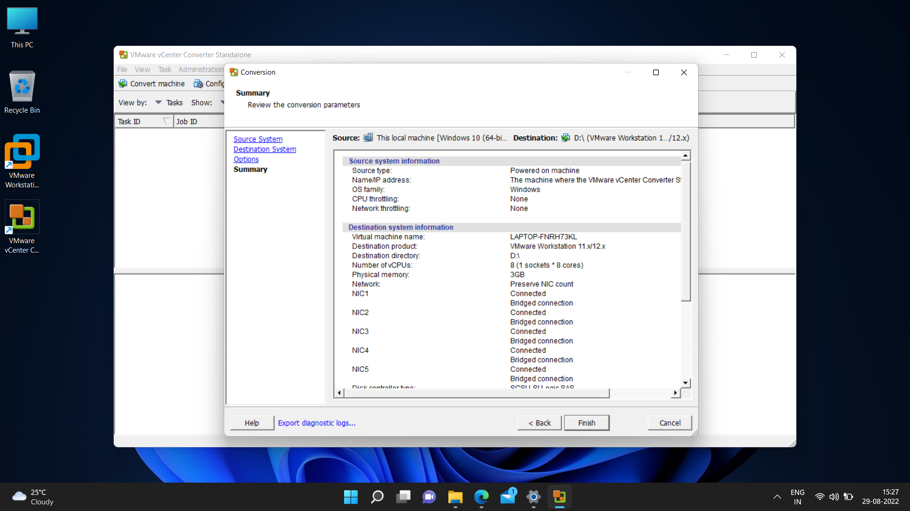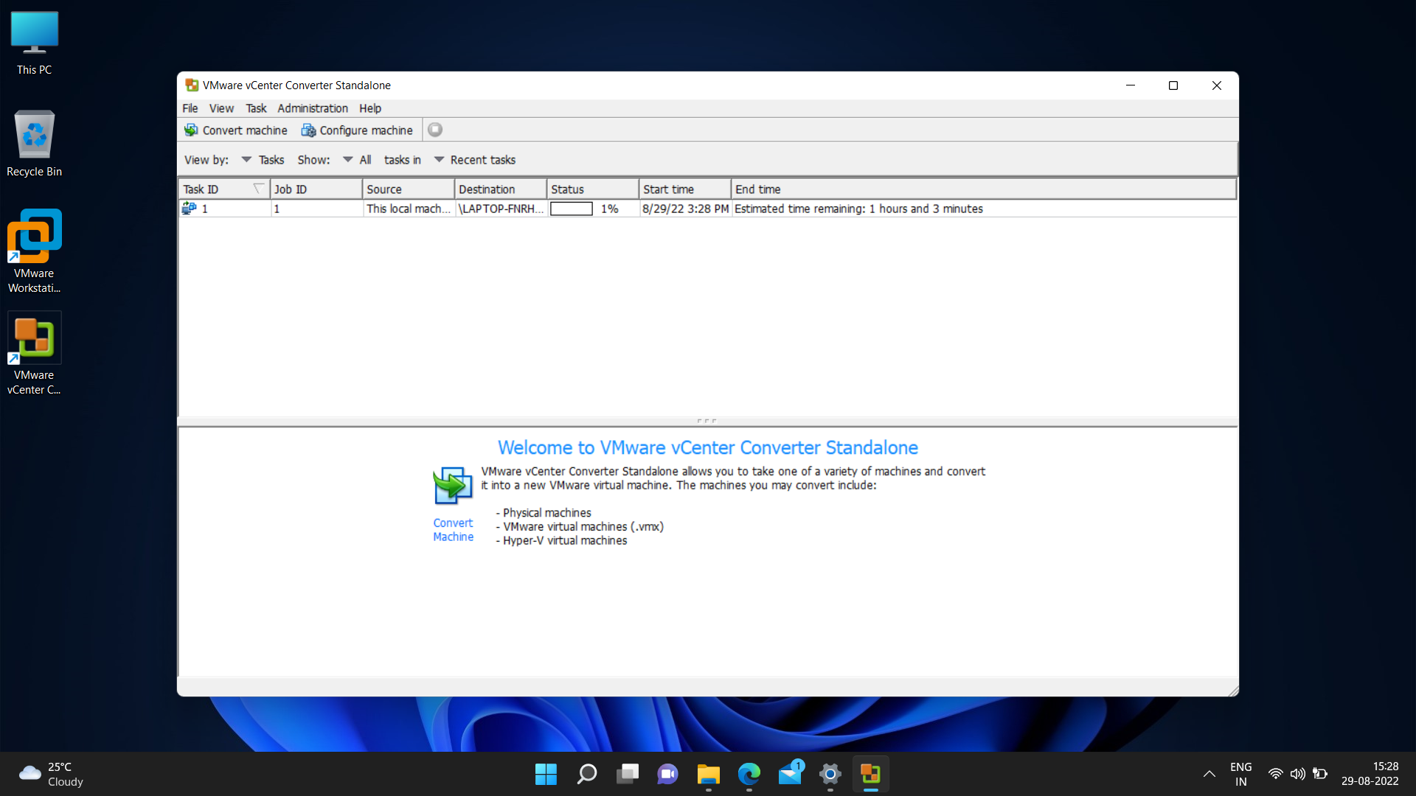

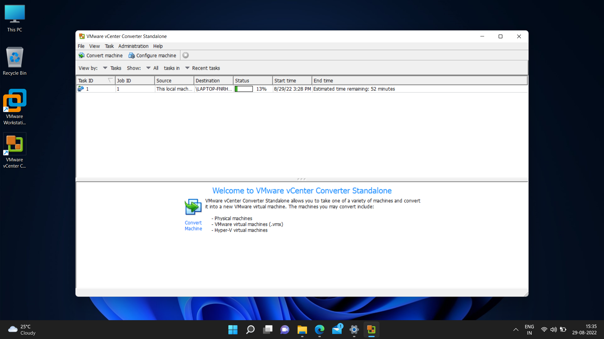

**QUESTIONS:**

**Ques1**-What is VMware VCenter converter software used for?

**Ans-** VMware vCenter Converter, is a software mainly useful for converting physical machines into virtual machines, but which can also be used to reconfigure existing virtual machines.

->It can quickly convert local and remote physical machines to virtual machines without downtime.

->It allows simultaneous conversions that facilitate large-scale virtualization implementations.

->The centralized management console allows us to queue and monitor many simultaneous conversions, both local and remote.

**Ques2** -Recently, VMware has removed VCenter converter software from their download product list. What are the reasons for doing so? Explain in detail.

**Ans**- VMware removed the software’s download link in response to unclear security threats. According to VMware, Converter has security issues. VMware cited this as a precautionary measure to prevent customers from using legacy technology. Removing the software appears to be more valuable than developing a patch. Although a renewed version of vCenter Converter is already in progress. The updated tool will meet the high standards for security and stability, providing enhanced functionality and supporting the latest technologies available in vSphere virtual machines.