# EXPERIMENT-5: Installation of VMWare ESXi 7.0 Server (also called as VSphere Hypervisor)

**Step-1:** At first we will download the iso image and make the new virtual machine.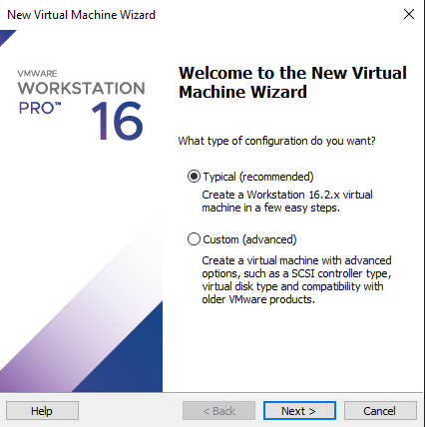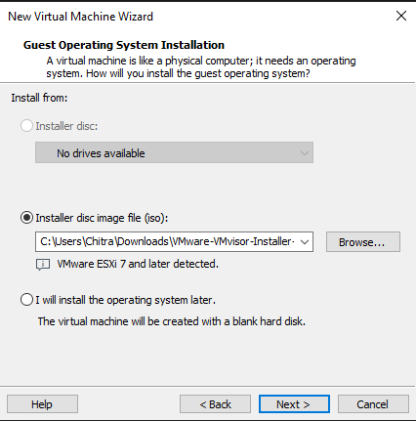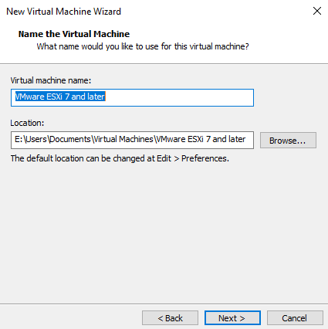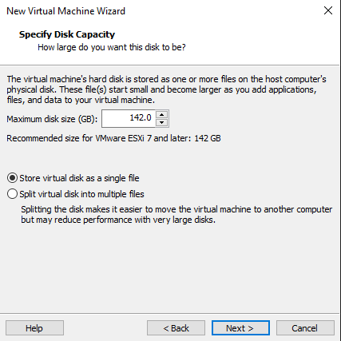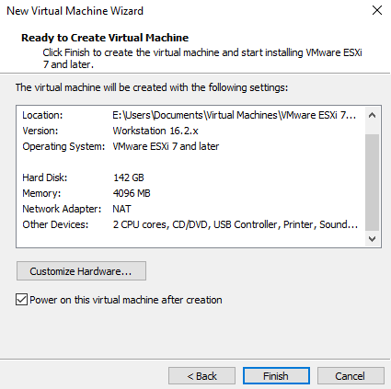

**Step-2:** The installation of VMware ESVi 7 will start.

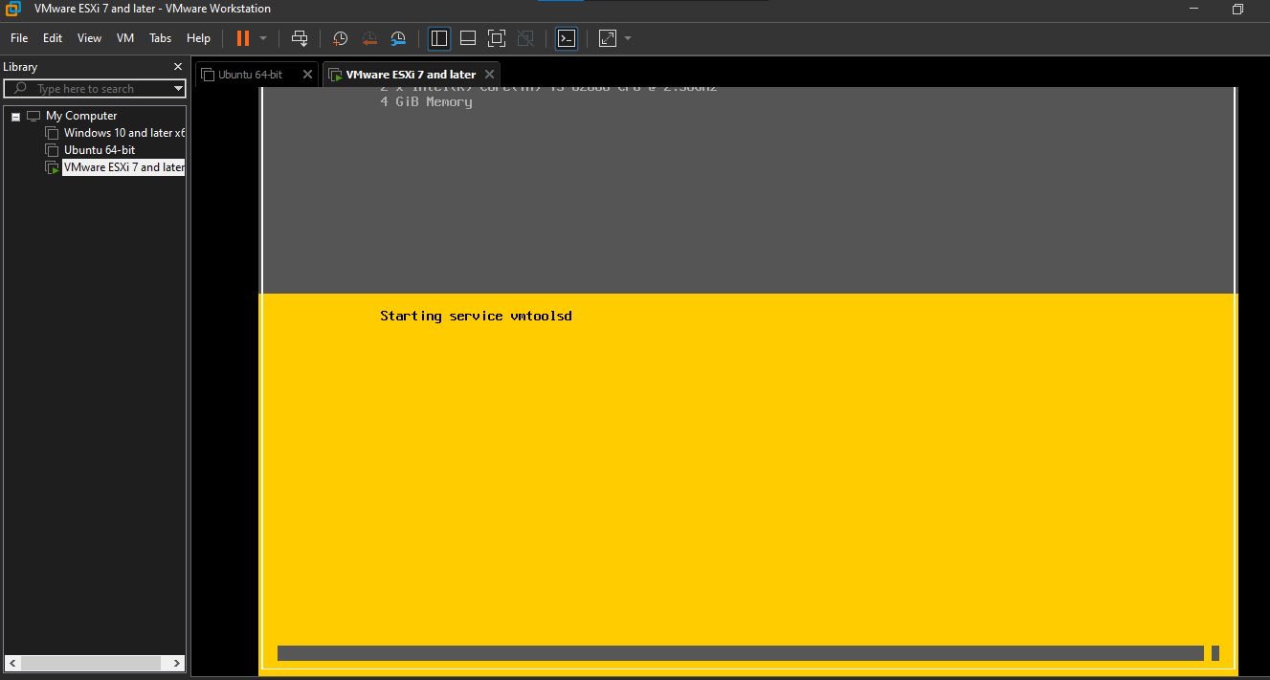

**Step-3:** After it is done, copy the IP address it shows and then paste it on the browser. Connect with the server.

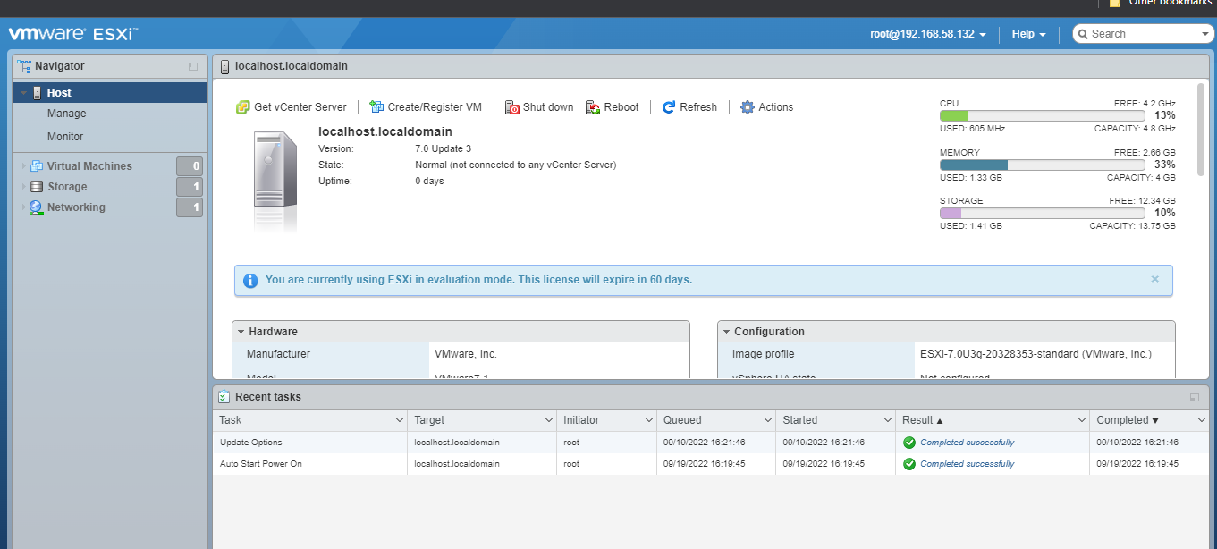

**Step-4:** After this, make a virtual machine in the same way we use to create in the vmware workstation or virtual box.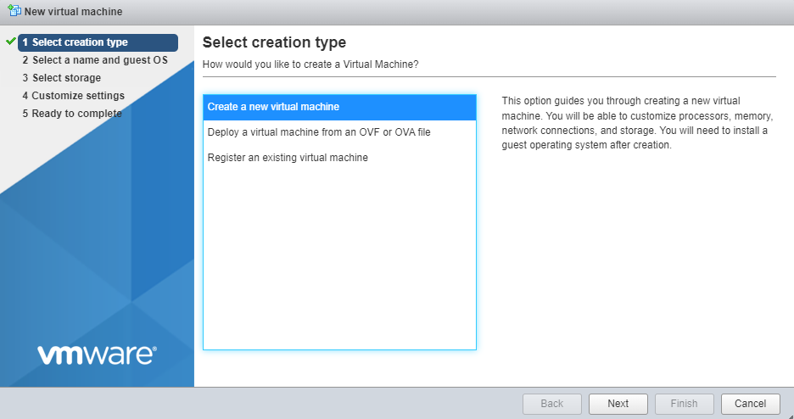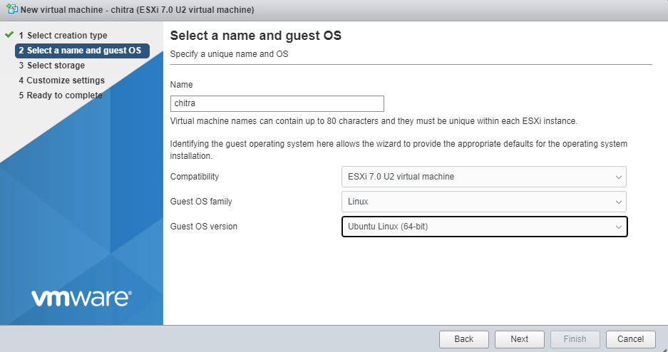

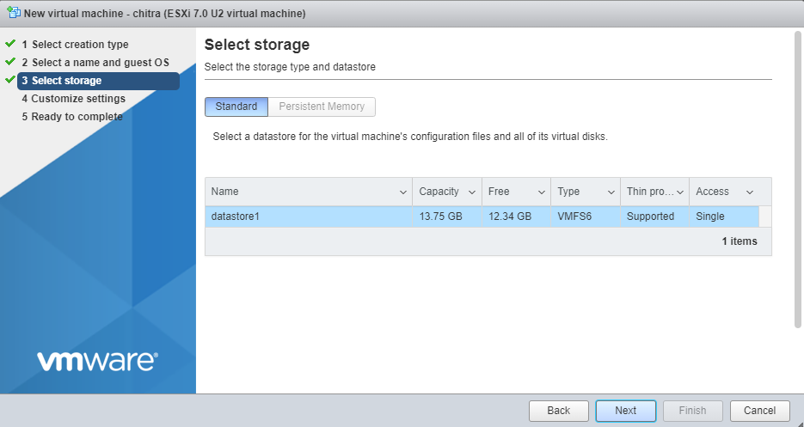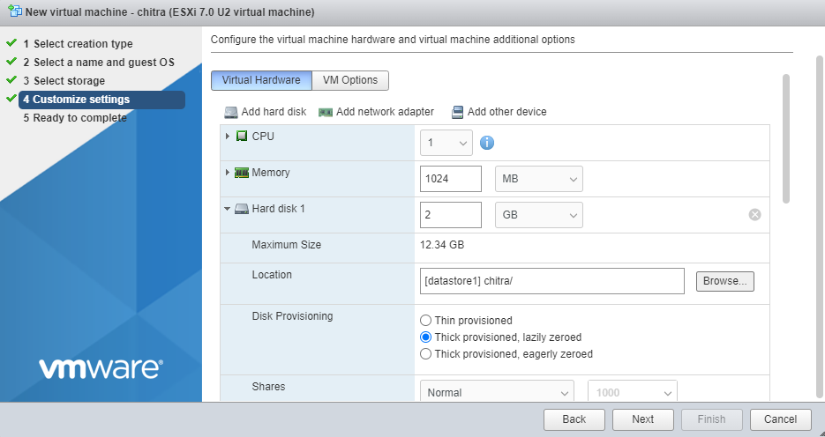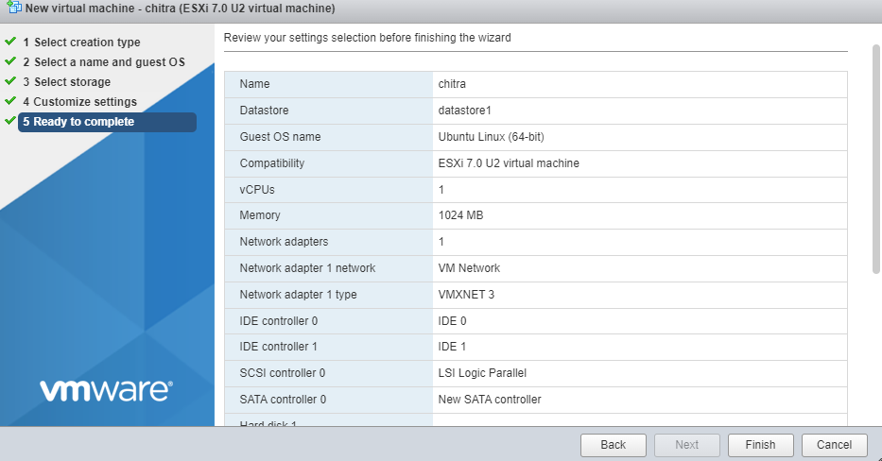

**Step-5:** The installation is complete. Now open the virtual machine.

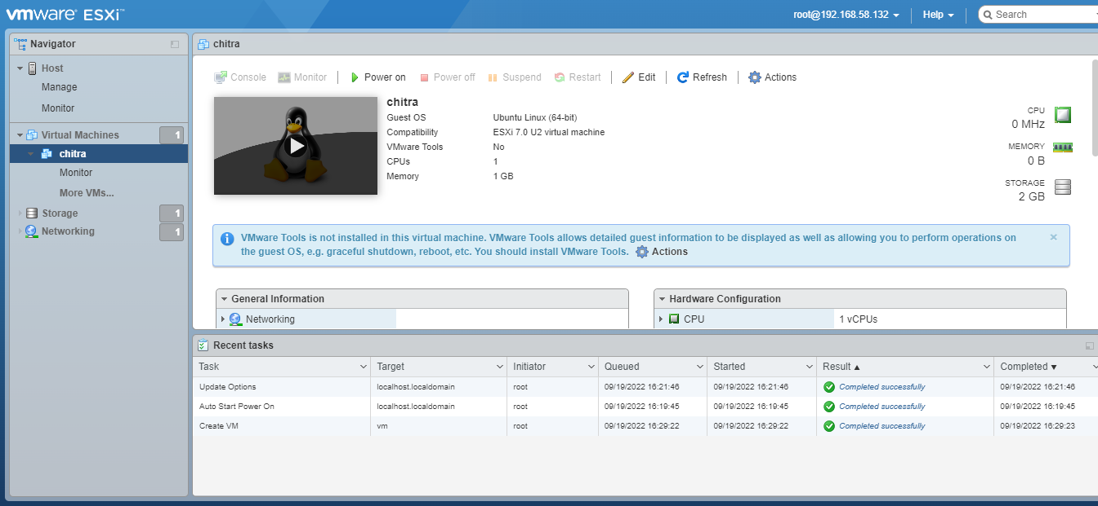

**Step-6:** My system does not support Intel VT-x, so it is unable to open.

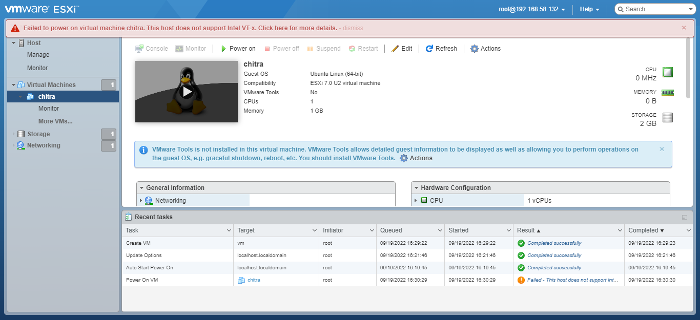

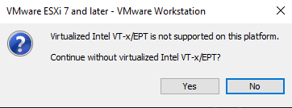

**QUESTIONS**

**Ques-1:** [What is VMware vSphere?](https://vmiss.net/vsphere-vs-esxi-vs-vcenter/#What_is_VMware_vSphere)

**Ans:** One of the major leaders in the information technology space, VMware has years of expertise in supplying virtualization solutions to business professionals. One of these VMware virtual solutions is vSphere, a sophisticated server virtualization program that provides users with a centralized administration platform for their virtual machines (VMs).

The primary virtualization tool in vSphere is ESXi, a Type 1 hypervisor. Emulation program called hypervisors are created to run virtual machines. While Type 2 hypervisors run on an operating system, Type 1 hypervisors can operate directly on the hardware of the host machine. Virtual machines are run by the ESXi component, which is installed on a host machine.

There are two main versions of vSphere:

• The VMware vSphere Standard is perfect for small businesses looking to get started with centralized VM management.

• The vSphere Enterprise Plus Edition has features for migrating existing data centers into cloud computing environments.

**Ques-2:** [vSphere vs ESXi](https://vmiss.net/vsphere-vs-esxi-vs-vcenter/#vSphere_vs_ESXi).

**Ans:**

**ESXi**

Type 1 hypervisors, or bare-metal hypervisors, are what ESXi is. It is a virtualization program that enables you to set up numerous virtual computers on a single physical host. It is installed right onto your actual computer and doesn't need an operating system to run. Because of this, ESXi can function more quickly, scale better, and operate more effectively than other types of hypervisors. However, ESXi's benefits don't stop there.

With a footprint of 150 MB, ESXi is among the tiniest hypervisors available. How does it affect us? It means that the ESXi installation procedure is short, that you may start the ESXi server from a USB drive, that it doesn't need frequent patches after installation, and that service maintenance is made easier. Greater security comes with the ESXi's reduced size and bare-metal hypervisor status.

**vSphere**

VMware has its vSphere platform, just like Microsoft has its Office 365 platform. A large number of applications and functionality for virtualization are included in the vSphere suite. A virtualization platform is called VSphere. The most notable components of vSphere are VMware ESXi, VMware vCenter, which we have already discussed, but also VMware vSphere Client and a great number of other components.

The goal of VMware vSphere is to assist existing data centres in making the transition to cloud computing while increasing the utilisation of the used hardware from, say, 10% to as much as 80% without sacrificing performance.

The vSphere client is a component of the VSphere suite and enables administrators to manage and maintain virtual machines running on the hypervisor by connecting to existing ESXi servers.

**Ques-3:** vSphere vs vCenter

**Ans:**

**vCenter**

A server program called VMware vCenter, or more precisely VMware vCenter Server, enables centralized management of your whole virtual infrastructure, including the virtual machines running on your ESXi instances as well as the ESXi instances themselves, from a single console. This system offers transparency, easy management, and error avoidance.

Technically speaking, running and managing virtual machines may be accomplished pretty well with just ESXi and no VCenter Server. But VCenter Server offers a lot, particularly when you need centralised management or wish to streamline your workflow. It allows administrators to provision, configure, and manage the complete VM environment from a single location. The automation, job scheduling, and alerts tools found in VCenter Server are additional highly valuable features.

**vSphere**

VMware has its vSphere platform, just like Microsoft has its Office 365 platform. A large number of applications and functionality for virtualization are included in the vSphere suite. A virtualization platform is called VSphere. The most notable components of vSphere are VMware ESXi, VMware vCenter, which we have already discussed, but also VMware vSphere Client and a great number of other components.

The goal of VMware vSphere is to assist existing data centres in making the transition to cloud computing while increasing the utilisation of the used hardware from, say, 10% to as much as 80% without sacrificing performance.

The vSphere client is a component of the VSphere suite and enables administrators to manage and maintain virtual machines running on the hypervisor by connecting to existing ESXi servers.