M.S.RAMAIAH INSTITUTE OF TECHNOLOGY
(Autonomous Institute, Affiliated to VTU)
www.msrit.edu
BANGALORE-560054

A SOLUTION FOR A SECURED ALERT SYSTEM

Submitted by
Abhilash Mukesh 1MS12CS001
Jayachitra T R 1MS12CS040
Manoj A 1MS12CS053
Veeresha N 1MS12CS063

Guided by
Dr.Anita Kanavalli
Professor
Department of Computer Science and Engineering

Effort Estimation using COCOMO Model

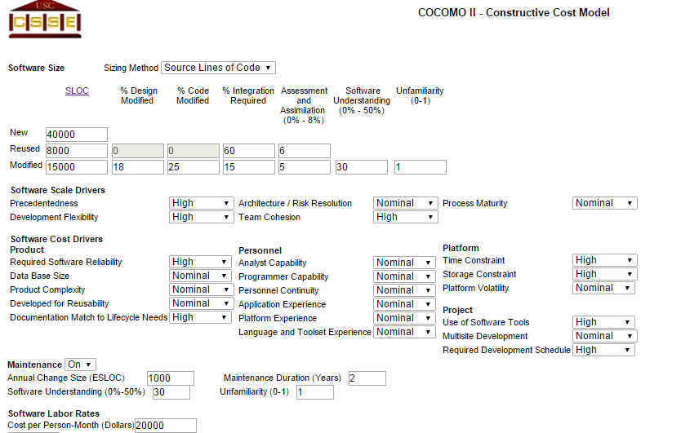

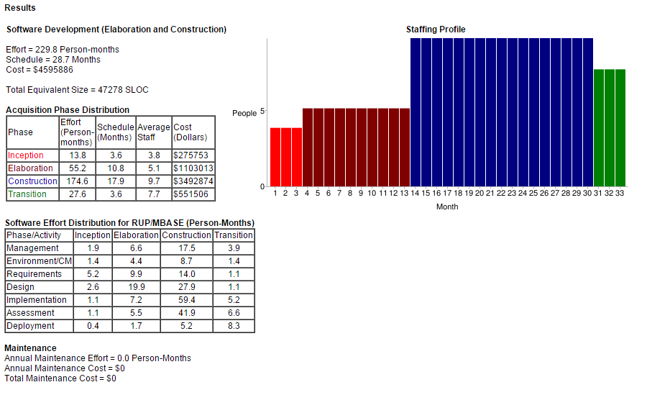

Schedule of project activities using Gantt Chart

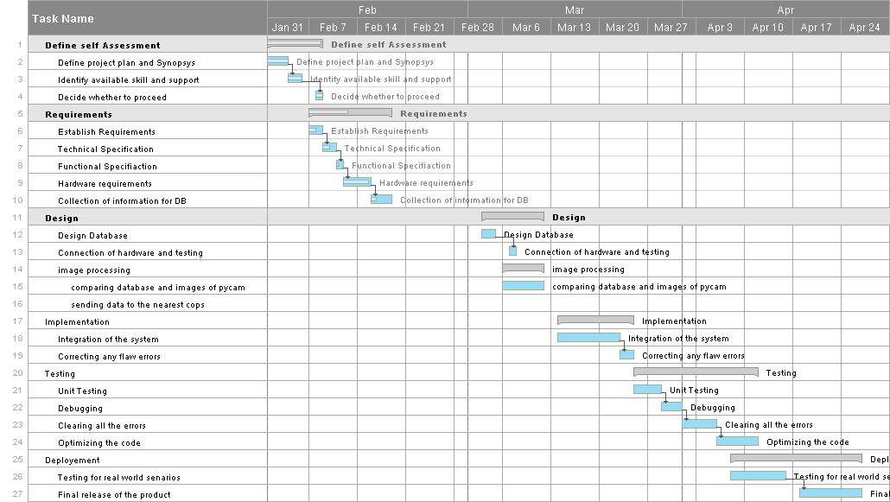

Risk Identification (Top 5 Risk) with Risk Mitigation Steps for each

