Enter Sample Data:

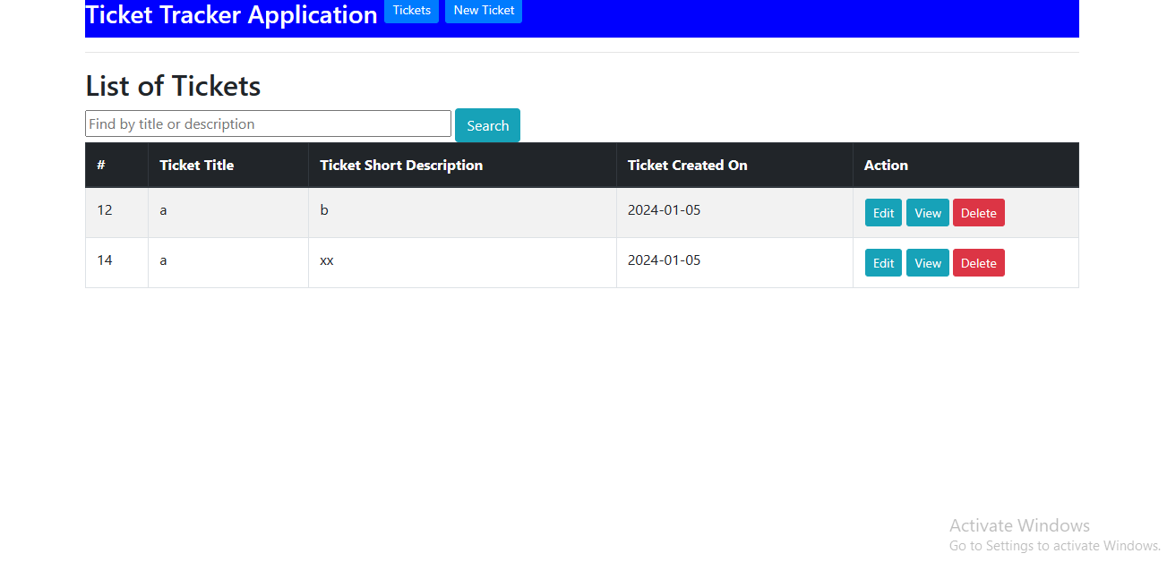

1.Click on ‘New Ticket’ Insert Ticket information

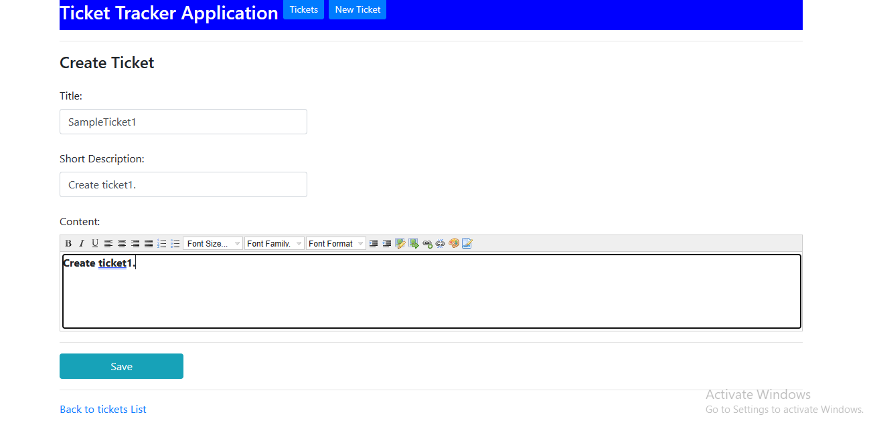

2.Click save .

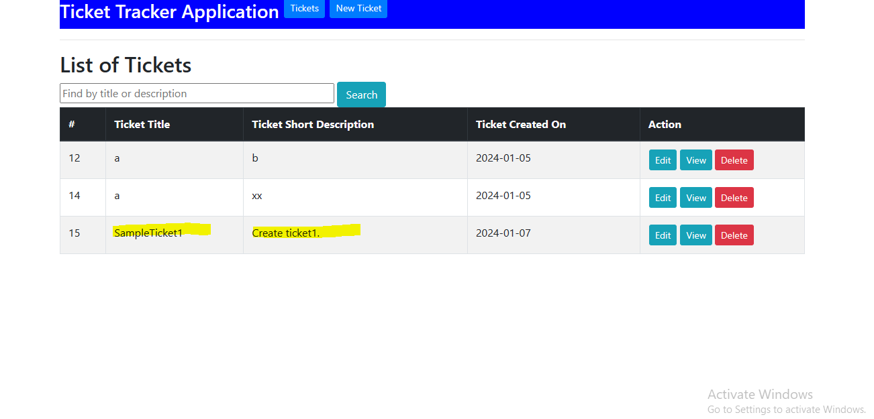

**3.Update/Edit ticket.**

Id=15.Click Edit button and update information

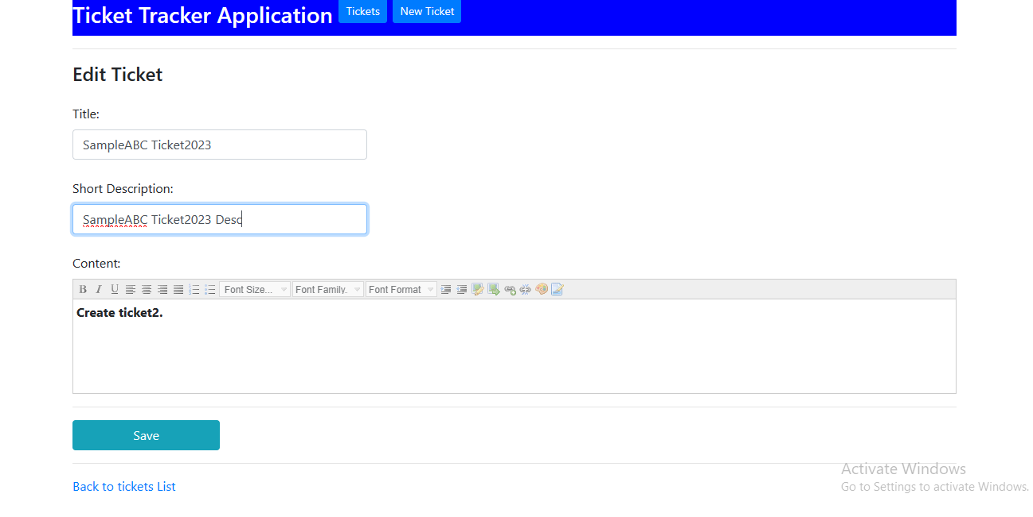

Save and check list.

Update information successfully.

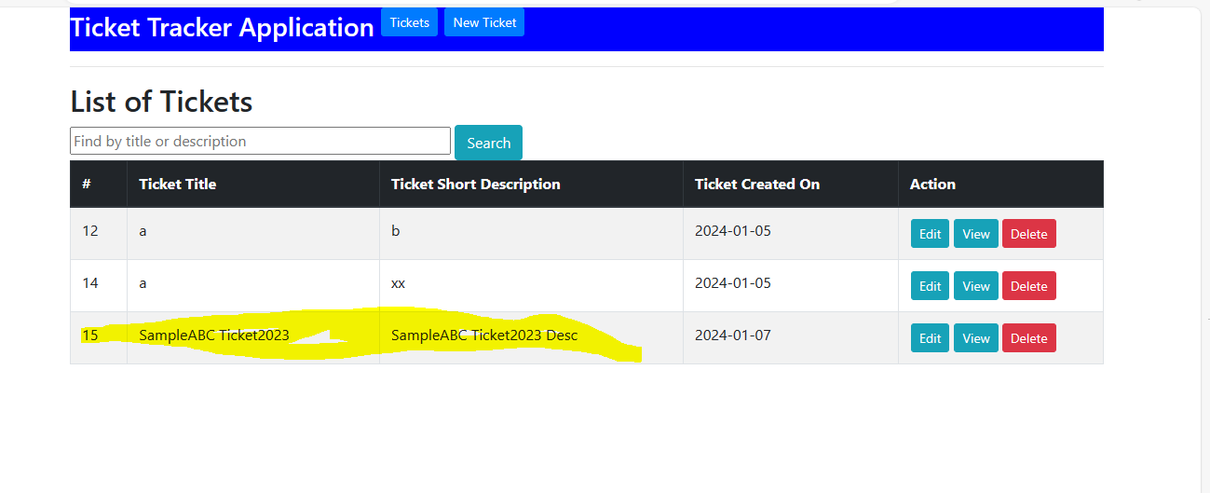

**4.Delete ticket**

Select ticket Id=15 and click ‘Delete’ button

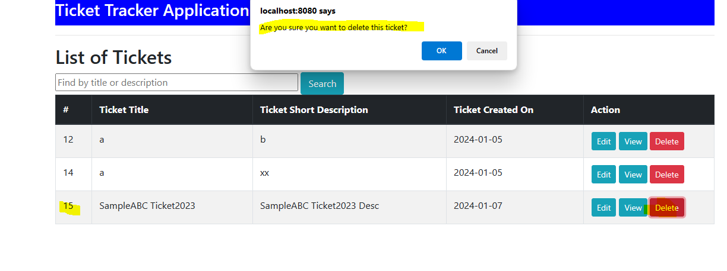

Click ok

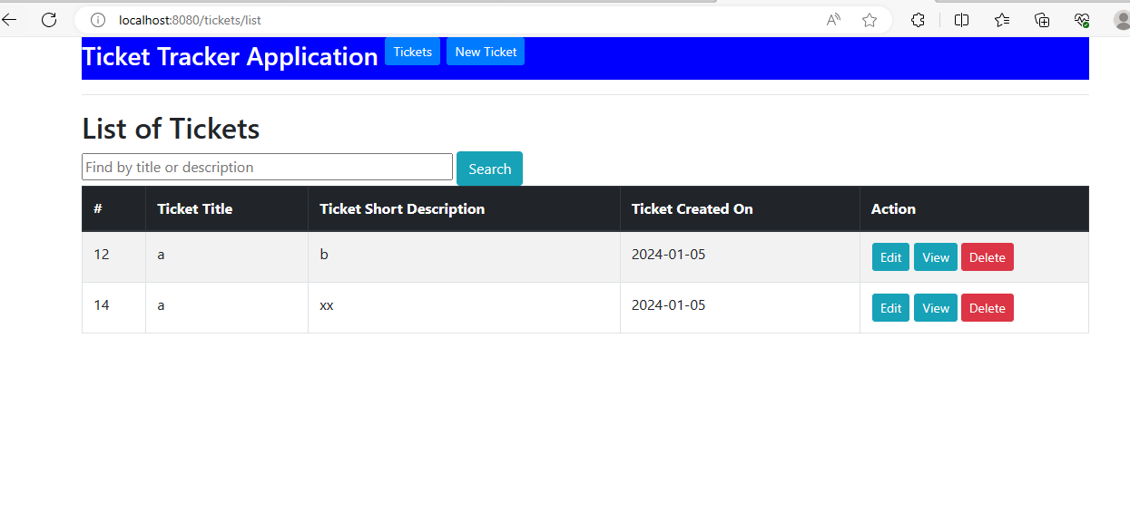

Delete working fine.

5.View Ticket info

Click on ‘View’ Button

