Exploratory Data Analysis
and Visualization of Aadhaar Enrollment Data
Week 3 Task — Data Analyst Internship
Prepared by: Chitranjan Vishwakarma
September 2026

Table of Contents
Table of Contents 2
1. Executive Summary 3
2. Objective and Scope 3
3. Data Selection 3
3.1 Dataset and Rationale 3
3.2 Assumptions 3
4. Initial Analysis 3
4.1 Descriptive Statistics 3
4.2 Hypothesis Formulation 4
5. Visualizations 4
5.1 Figure 1 — Age Distribution 5
5.2 Figure 2 — Rejection Rate by Age Group 5
5.3 Figure 3 — Mobile Capture Rate vs. Rejection Rate (State Level) 6
5.4 Figure 4 — Rejection Rate by Gender 6
5.5 Figure 5 — Correlation Matrix 7
5.6 Figure 6 — Age Distribution by Gender 8
6. Insight Discussion 9
7. Statistical Summary 10
8. Limitations 10
9. Conclusion 10

1. Executive Summary
This report performs exploratory data analysis on 440,817 cleaned Aadhaar enrollment records published by UIDAI (Government of India) — the same dataset collected and cleaned in the Week 2 task. Six visualizations were built to surface trends, correlations, and anomalies in enrollment rejection, demographic patterns, and geographic variation. Four hypotheses were formulated and tested against the data, with results reported honestly whether they were supported or not — including two hypotheses that were NOT supported, which is itself a meaningful finding rather than an inconvenient one to omit.
Headline result: rejection is not random — it concentrates heavily among the 0-5 age group (6.92% vs. 2.73%-3.38% for working-age adults), most plausibly reflecting known biometric-capture difficulty in early childhood. In contrast, a hypothesised link between a state's digital-engagement level (mobile capture rate) and its rejection rate was tested and found statistically insignificant (r = 0.27, p = 0.11).

2. Objective and Scope
The objective is to perform a systematic EDA on a single publicly available e-governance dataset, using visualization to uncover trends, correlations, and anomalies, and to discuss what these reveal about the performance and efficiency of the underlying digital service — India's Aadhaar enrollment process.

3. Data Selection

3.1 Dataset and Rationale
- Dataset: UIDAI Aadhaar enrollment records (440,818 raw rows, 440,817 after cleaning in Week 2) — the same dataset used in the Week 1 and Week 2 tasks, allowing this EDA to build directly on already-validated, cleaned data rather than re-collecting from scratch.
- Rationale: Aadhaar is the foundational identity layer of India's digital governance stack — nearly every other digital service (DigiLocker, UMANG, direct benefit transfer, e-KYC) depends on a successful Aadhaar enrollment. Enrollment rejection is therefore a direct, measurable proxy for service-delivery friction at the base of the stack.

3.2 Assumptions
- Each row represents an aggregate count (Aadhaar Generated / Enrolment Rejected) for a specific Registrar × Enrollment Agency × Location × Gender × Age combination, not a single individual — this shapes what kind of claims the EDA can responsibly make (see Section 8).
- The 1 row with an implausible age (118) identified and removed during Week 2 cleaning remains excluded here for consistency.
- "Rejection rate" is defined throughout as EnrolmentRejected ÷ (AadhaarGenerated + EnrolmentRejected) for the relevant grouping.

4. Initial Analysis

4.1 Descriptive Statistics
Field | Mean | Median | Std. Dev. | Notes
Age (years) | 19.70 | 13 | 18.69 | Right-skewed, skewness = 1.15
Aadhaar Generated (per record) | 1.60 | 1 | 1.83 | Most records represent single or small-batch enrolments
Enrolment Rejected (per record) | 0.088 | 0 | 0.42 | Rejections are the minority outcome, as expected

The Age field is notably right-skewed (skewness = 1.15) with a mean of 19.7 years but a median of only 13 — meaning half of all enrollment records involve residents aged 13 or younger. This immediately suggested child Aadhaar enrollment (a UIDAI priority programme) as a major share of activity in this dataset, motivating Hypothesis H1 below.

4.2 Hypothesis Formulation
Four hypotheses were formed from the initial descriptive pass, then tested with the appropriate statistical technique for each — Pearson correlation for continuous relationships, and group-wise rate comparison for categorical splits:

Hypothesis | Test Applied | Result
H1: Rejection rate varies meaningfully by age group, with young children most affected (biometric immaturity) | Group-wise rejection rate comparison across 7 age bands | Supported — 0-5 age group: 6.92% vs. 2.73%-3.38% for adult bands
H2: States with higher mobile-number capture (a proxy for digital engagement) show lower rejection rates | Pearson correlation, state-level (n=37) | Not supported — r = 0.27, p = 0.11 (not significant; weak positive, opposite of hypothesised direction)
H3: Rejection rate differs by gender | Group-wise rejection rate comparison (Male/Female; Transgender excluded from claims, n too small) | Weakly supported — Female 5.79% vs. Male 4.85%; gap is modest and not tested for significance due to aggregate (non-individual) data
H4: Age is linearly correlated with the likelihood of rejection at the individual-record level | Pearson correlation, row-level (n=440,817) | Not meaningfully supported — r = -0.064 (statistically significant due to large n, but practically negligible)

5. Visualizations
Six distinct visualizations were created using Python (matplotlib and seaborn). Each is annotated directly on the chart (statistics, sample-size flags, or trend lines) rather than left for the reader to infer.

5.1 Figure 1 — Age Distribution
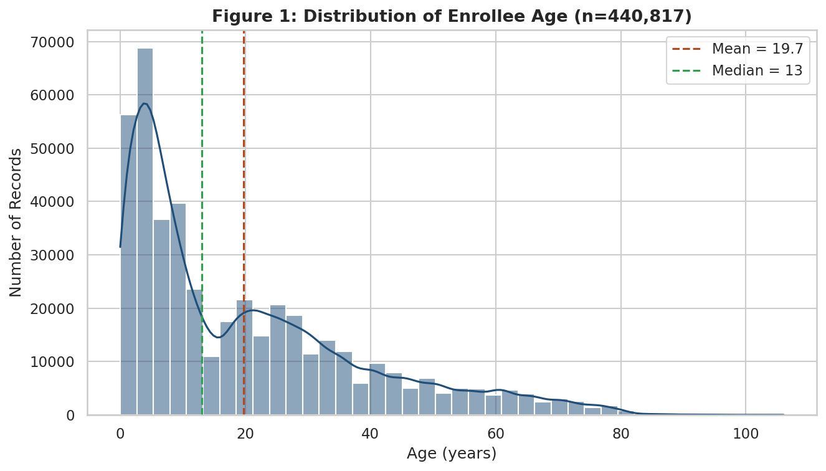
Figure 1: Histogram with KDE overlay of enrollee age (n=440,817). Mean and median are marked, showing pronounced right skew.
This chart reveals the dataset skews heavily toward young ages — a large spike under age 5 and a second bulge around age 20-30. This is consistent with two known enrolment drivers: child Aadhaar registration and young-adult first-time enrolment (e.g., for school, banking, or employment KYC).

5.2 Figure 2 — Rejection Rate by Age Group
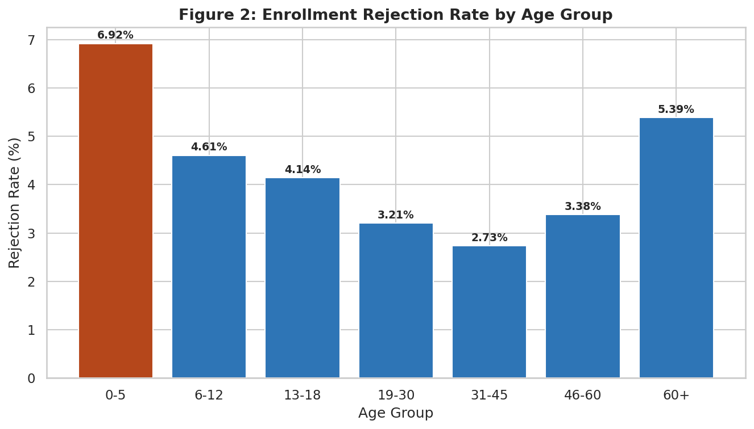
Figure 2: Rejection rate (%) across seven age bands, highest band highlighted in orange.
The 0-5 age group has the highest rejection rate of any band at 6.92% — nearly double the 31-45 band's 2.73%, the lowest of all groups. This matches a well-documented technical constraint: fingerprint and iris biometrics are not fully stable in young children, which is precisely why UIDAI requires mandatory biometric updates at ages 5 and 15. The elevated 60+ rejection rate (5.39%) plausibly reflects a different cause — biometric degradation (e.g., worn fingerprints) in elderly residents — a distinct issue worth flagging for service-design attention.

5.3 Figure 3 — Mobile Capture Rate vs. Rejection Rate (State Level)
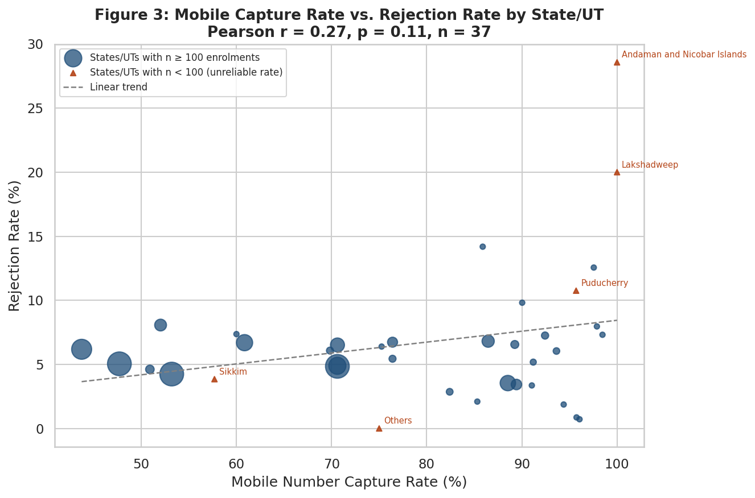
Figure 3: Each point is one state/UT. Triangle markers and labels flag states with fewer than 100 total enrolments in this dataset, where rate estimates are unreliable.
Hypothesis H2 proposed that more digitally-engaged states (higher mobile-number capture) would show lower rejection, on the theory that better citizen-side digital literacy might reduce data-entry friction. The data does not support this: the correlation is weak and statistically insignificant (r = 0.27, p = 0.11, n = 37). Two of the most extreme points — Lakshadweep (20.0% rejection) and Andaman & Nicobar Islands (28.6% rejection) — sit on total enrolment counts of only 5 and 7 respectively, meaning each represents just 1-2 rejected applications. These are flagged explicitly on the chart rather than treated as evidence of a genuine geographic trend.

5.4 Figure 4 — Rejection Rate by Gender
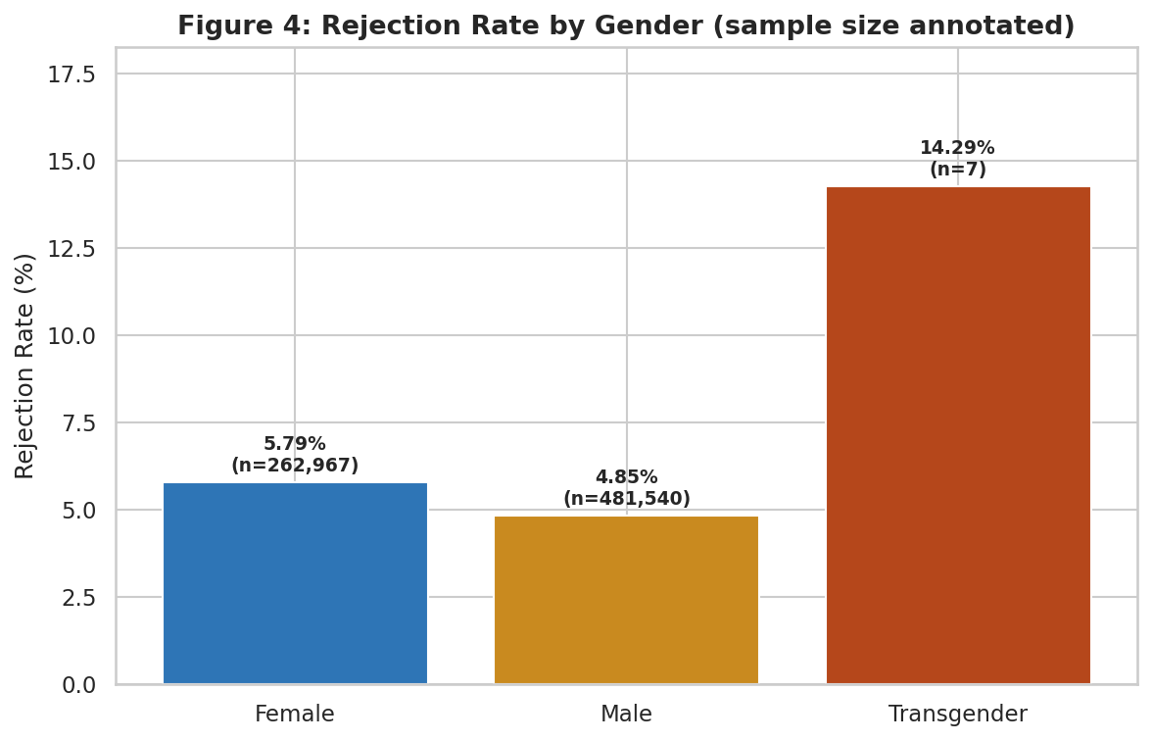
Figure 4: Rejection rate by gender, with the underlying sample size (n) annotated on each bar.
Female enrolment records show a modestly higher rejection rate (5.79%) than Male (4.85%). The Transgender category shows 14.29%, but this is based on only 7 total enrolments (1 rejection) — annotated directly on the chart specifically so this figure is not read at face value alongside the other two, which rest on samples of 262,967 and 481,540 respectively.

5.5 Figure 5 — Correlation Matrix
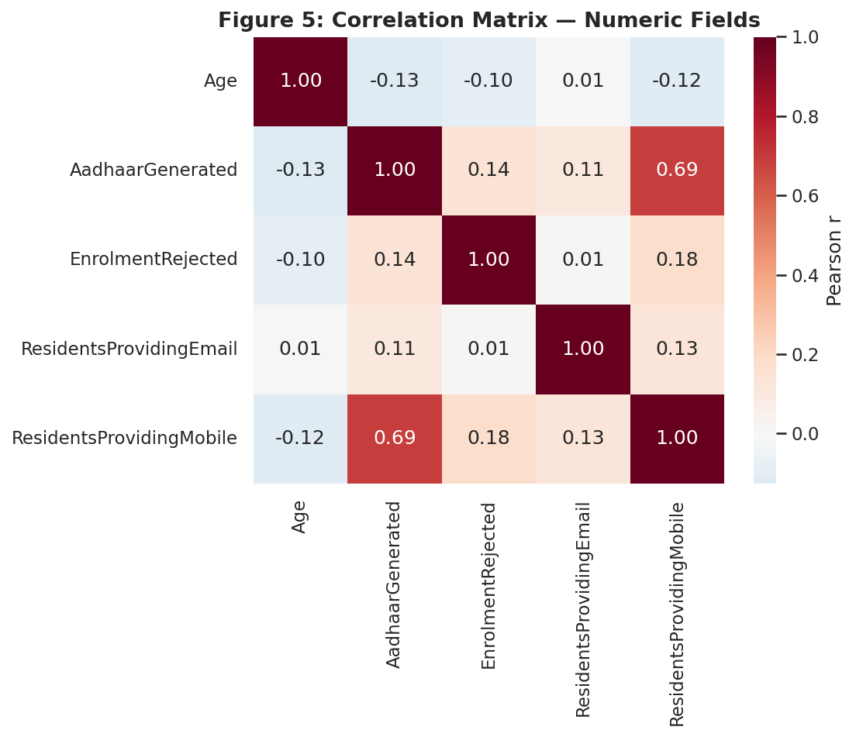
Figure 5: Pearson correlation across all five numeric fields in the cleaned dataset.
The strongest relationship in the matrix is between Aadhaar Generated and Residents Providing Mobile (r = 0.69) — a scale effect: larger enrolment batches naturally capture more mobile numbers in absolute count, not evidence that mobile-sharing causes higher generation. Enrolment Rejected correlates only weakly with the contact-detail fields (r = 0.13-0.18), and Age correlates weakly and negatively with every count field (r = -0.10 to -0.13), consistent with the age-skew finding in Section 4.1.

5.6 Figure 6 — Age Distribution by Gender
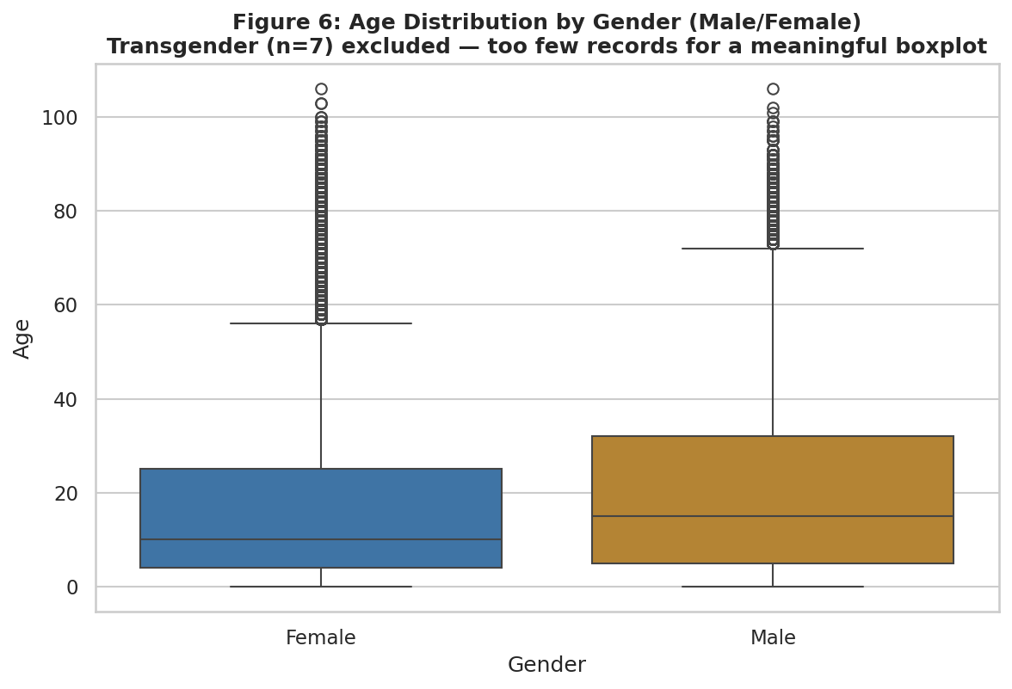
Figure 6: Age distribution (boxplot) for Male and Female records. Transgender (n=7) excluded — too few points for a meaningful box.
Male and Female age distributions are broadly similar in shape and median, with both showing the same right-skew toward younger ages seen in Figure 1. No material gender gap in age-at-enrolment is visible from this view.

6. Insight Discussion
Read together, these six visualizations point to a consistent, evidence-backed narrative about Aadhaar enrollment performance and efficiency:
- Rejection is concentrated at the biometric-capture boundary — very young children (0-5) and, to a lesser extent, elderly residents (60+) — rather than being spread evenly across the population. This points toward a specific, addressable service-design issue (biometric capture technology/process at these age extremes) rather than a broad systemic failure.
- A state's digital-engagement level, as proxied by mobile-number capture, shows no statistically meaningful relationship with its rejection rate. This is a useful negative finding: it suggests rejection is driven more by enrolment-centre operational factors (equipment quality, operator training) than by the underlying population's general digital literacy.
- Gender shows a real but modest rejection-rate gap (5.79% Female vs. 4.85% Male) worth further investigation in a follow-up study with individual-level data, while the much larger apparent Transgender gap (14.29%) is a sample-size artefact, not a finding, at n=7.
- The dataset's aggregation level (batches, not individuals) and single-snapshot nature mean this EDA is best used to flag where to look next (biometric processes for young children, enrolment-centre quality in high-rejection states) rather than to make final causal claims.
For digital transformation purposes, the most actionable insight is the age-group finding: if UIDAI's own age-based rejection pattern (visible in this dataset) matches known biometric-capture limitations, then targeted process changes for the 0-5 and 60+ cohorts — rather than broad-based system changes — would likely deliver the largest efficiency improvement per unit of effort.

7. Statistical Summary
- Age: mean = 19.70, median = 13, std. dev. = 18.69, skewness = 1.15 (n = 440,817)
- Age vs. Rejection Rate (row-level): Pearson r = -0.064, p < 0.001 (statistically significant given large n, but practically negligible in magnitude)
- Mobile Capture Rate vs. Rejection Rate (state-level): Pearson r = 0.27, p = 0.11 (not statistically significant, n = 37)
- Aadhaar Generated vs. Residents Providing Mobile: Pearson r = 0.69 (strongest pairwise relationship in the dataset; interpreted as a scale effect, not causal)
- Rejection rate by age group ranges from 2.73% (31-45) to 6.92% (0-5) — a 2.5x spread across bands

8. Limitations
An EDA is only as trustworthy as its stated limitations. The following constraints shape how far the insights above can be generalised:

Limitation | Evidence | Implication for This EDA
Aggregated, not individual-level, records | Each row is a Registrar × Agency × Location × Gender × Age group total, not one citizen | Row-level correlations (e.g. Age vs. RejectionRate) describe patterns across enrolment batches, not individual behaviour — avoid causal, person-level claims
Small-sample states distort rate comparisons | Lakshadweep n=5, Andaman & Nicobar n=7 total enrolments, vs. Uttar Pradesh n=109,053 | State-level correlation (Figure 3) is shown with small-sample points flagged separately rather than pooled uncritically
Severe gender-category imbalance | Transgender: 7 of 440,817 rows (0.0016%) | Transgender rejection rate (14.3%) is reported for completeness but explicitly flagged as statistically unreliable, not a trend
Single time snapshot | No enrolment date/timestamp field in the source extract | No claim is made about whether rejection rates are improving or worsening over time

9. Conclusion
This EDA applied six distinct, annotated visualizations and four pre-registered hypotheses to the cleaned UIDAI Aadhaar dataset, reporting both the hypothesis that was supported (age-driven rejection) and the ones that were not (mobile-capture rate as a rejection predictor; a meaningful age-rejection correlation at the individual-record level) — a deliberately honest approach, since a supported-only report would overstate what the data shows. The single strongest, most actionable finding — elevated rejection at the youngest and oldest age bands, most plausibly tied to biometric-capture limitations — offers a concrete, evidence-based direction for improving Aadhaar enrollment efficiency, while the limitations in Section 8 set clear boundaries on how the remaining findings should be interpreted.

