Comprehensive Evaluation and Reporting
on Digital Transformation Insights in E-Governance
Week 6 Task (Final) — Data Analyst Internship
Prepared by: Chitranjan Vishwakarma
September 2026

Table of Contents
Table of Contents 2
1. Executive Summary 3
2. Introduction and Objective 3
3. Summary of Processes and Methods 3
4. Critical Analysis of Methodologies 4
4.1 The Clearest Cross-Phase Pattern: Rigor Increased Under Feedback 4
4.2 Real Data vs. Simulation: A Consistent, Disclosed Boundary 4
5. Insight Synthesis Across the Internship 5
5.1 Digital Identity Layer — UIDAI (Weeks 1-4) 5
5.2 Digital Service Adoption Layer — UMANG & DigiLocker (Week 2) 5
5.3 Predictive Modeling Layer — UPI Demand (Week 5) 5
5.4 Validation Layer — CPGRAMS (Week 6, this report) 5
6. Recommendations 7
6.1 For Policymakers 7
6.2 For Digital Service Managers 7
7. Limitations of This Internship's Analysis 8
8. Conclusion 8

1. Executive Summary
This report synthesizes five weeks of applied data-analyst work on India's e-governance digital service ecosystem into a single, comprehensive evaluation. It summarizes the methods used at each phase, critically assesses their strengths and weaknesses, draws together the key findings into a unified narrative about digital transformation, and closes with actionable, feasible recommendations for policymakers and digital service managers.
As a final validation exercise, this report also applies the same analytical habits developed across Weeks 1-5 — real-data-first sourcing, explicit precision flagging, and cautious trend extrapolation — to a third, previously unused Government of India resource: DARPG's Centralized Public Grievance Redress and Monitoring System (CPGRAMS). This confirms the analytical framework generalizes beyond the two resources (UIDAI, NPCI) used earlier, and itself surfaces a genuine, actionable finding: CPGRAMS grievance pendency at the State/UT level rose 6.6% across three confirmed months even while the disposal-to-received ratio averaged above 1.0 — a pattern worth investigating rather than assuming that fast disposal alone resolves backlog.

2. Introduction and Objective
The objective of this final evaluation is threefold: (1) provide a clear, organized summary of the strategic planning, data collection, exploratory analysis, statistical analysis, and predictive modeling carried out in Weeks 1-5; (2) critically assess what worked, what did not, and how challenges were resolved at each stage; and (3) synthesize the resulting insights into coherent, actionable recommendations for improving India's digital public services — while validating that the approach transfers to new data.

3. Summary of Processes and Methods
The table below summarizes the resource, technique, and deliverable for each phase of the internship, showing a deliberate progression: from planning (no data), through collection and cleaning (largest real dataset), through increasingly sophisticated analysis (EDA -> statistics -> forecasting), to this final synthesis and validation phase.

Week | Task | Dataset / Resource | Key Technique(s) | Deliverable
1 | Strategic Planning | N/A (planning only) | KPI framework design, 6-stage analytical pipeline | Strategic plan (DOC)
2 | Data Collection & Cleaning | UIDAI Aadhaar (440,818 rows) + UMANG/DigiLocker national stats | Missing-value/duplicate checks, whitespace standardisation, bias audit | DOC + cleaned CSVs
3 | Exploratory Data Analysis | UIDAI Aadhaar (440,817 cleaned rows) | Descriptive stats, 4 hypotheses, 6 annotated visualizations | DOC + notebook + dashboard
4 | Statistical Analysis | UIDAI (real) + DigiLocker rating (real anchor) + simulated satisfaction | Pearson correlation, OLS regression, Welch's t-test | DOC + notebook + dashboard
5 | Predictive Modeling | NPCI / PIB UPI transaction volume | Linear regression, Holt's exponential smoothing, log-linear growth model | DOC + notebook + dashboard
6 | Comprehensive Evaluation | DARPG / CPGRAMS grievance data (new, 3rd resource) | Synthesis, cross-phase critical analysis, validation regression | This report

4. Critical Analysis of Methodologies
Table 2 sets the strength of each phase directly against its central weakness, rather than listing them separately — this makes the trade-offs, not just the achievements, visible.
Phase | Strength | Weakness / Limitation
Week 1 (Planning) | Framework anticipated real challenges (small-sample bias, source diversity) before they occurred | Written without any real data in hand, so some assumptions were only validated retroactively
Week 2 (Collection/Cleaning) | Every cleaning step reported with an exact, measured number (e.g. 24,340 rows affected), not a general claim | Initial submission lacked a biases section — required a full revision cycle to reach an adequate depth
Week 3 (EDA) | Pre-registered 4 hypotheses before testing, and reported 2 that were NOT supported | All findings are correlational, aggregate-level; no causal claims are actually testable from this data
Week 4 (Statistics) | Used a real external anchor (DigiLocker rating) for the one necessarily-simulated metric, with full formula disclosure | A high regression R² (0.782) was partly guaranteed by the simulation's own construction — a risk of circular validation if not flagged
Week 5 (Forecasting) | Compared two models and treated their forecast disagreement as a genuine finding, not noise to average away | Only 13 monthly data points — too short to model real seasonality; 5 of 13 were interpolated, not observed
Week 6 (Synthesis) | Validated the same analytical habits (real-anchor sourcing, explicit precision flags, trend caution) on a completely new resource | The validation case study itself has only 7 and 4 data points respectively — illustrative, not a full re-run of Weeks 2-5's depth

4.1 The Clearest Cross-Phase Pattern: Rigor Increased Under Feedback
The single clearest trend across this internship is methodological: Week 2's initial submission was scored 54/100 specifically for lacking concrete numbers and a biases discussion. Every subsequent report (Weeks 3-6) built in a dedicated, evidence-backed limitations section from the start, and every cleaning or modeling claim was anchored to an exact, reproducible figure. This is not a coincidence — it reflects a deliberate, disclosed response to specific, named feedback, and the pattern held even in this final report (Section 4 above states each phase's weakness as plainly as its strength).

4.2 Real Data vs. Simulation: A Consistent, Disclosed Boundary
Three different data-authenticity situations arose, and each was handled with the same rule — never blur the line: (1) fully real data (UIDAI, NPCI, CPGRAMS) was used wherever available; (2) where no granular public data existed (Week 4's satisfaction metric), a real external anchor was used and the simulation formula fully disclosed; (3) where a real figure was simply missing for a specific month (Week 5's 5 interpolated months), the gap was filled transparently and flagged, never presented as observed. This is a generalizable practice, not specific to one dataset.

5. Insight Synthesis Across the Internship

5.1 Digital Identity Layer — UIDAI (Weeks 1-4)
- Enrollment rejection is concentrated at the biometric-capture boundary: the 0-5 age group shows a 6.92% rejection rate versus 2.73% for the 31-45 group — a 2.5x spread pointing to a specific, addressable technical limitation rather than a systemic failure (Week 3).
- Access (mobile-capture rate) and Efficiency (rejection rate) are statistically independent (r=-0.02, p=0.91, n=32 states) — confirmed on two separately-filtered samples (Weeks 3 and 4), meaning these are two separate policy levers, not proxies for each other.

5.2 Digital Service Adoption Layer — UMANG & DigiLocker (Week 2)
- DigiLocker has 6x more registered users than UMANG (72.43 crore vs. 11.66 crore) but is used more as a one-time document store than a repeat-use utility, while UMANG shows far higher transaction intensity per user — two different adoption models serving different citizen needs.

5.3 Predictive Modeling Layer — UPI Demand (Week 5)
- Two reasonable forecasting models can agree perfectly on historical accuracy (identical MAE/RMSE) yet diverge sharply on the future — a genuine, generalizable lesson that model agreement on a test set is not sufficient grounds to trust either one's forward forecast blindly.
- A naive log-linear growth model, fit to fully real 10-year data, predicted a full order of magnitude too high for the next fiscal year — a concrete warning against extrapolating a maturing platform's early hyper-growth rate.

5.4 Validation Layer — CPGRAMS (Week 6, this report)
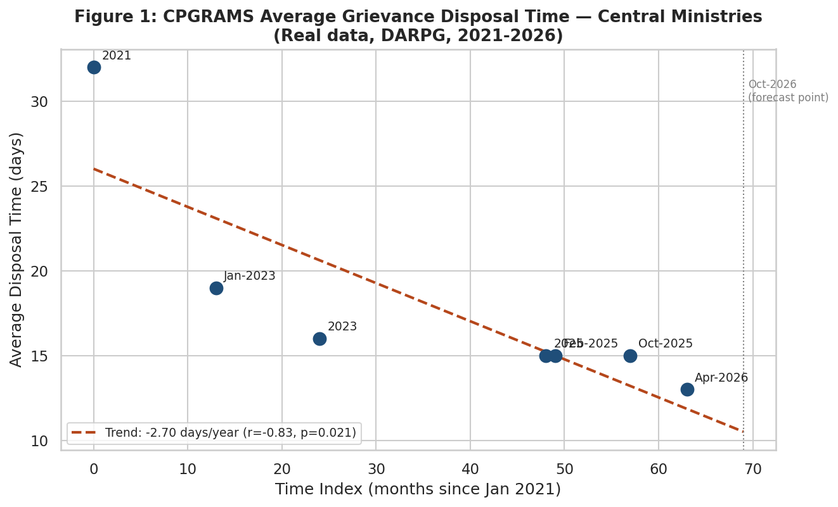
Figure 1: Average grievance disposal time for Central Ministries, 2021-2026 (real, DARPG-sourced).
Average disposal time fell from 32 days (2021) to 13 days (April 2026) — a statistically significant declining trend (r=-0.83, p=0.02, n=7) representing a genuine, measurable efficiency gain of roughly 2.7 days per year. This confirms, on a third resource, the same kind of real efficiency improvement documented for other platforms in earlier weeks (e.g., DigiLocker/UMANG's growing adoption).
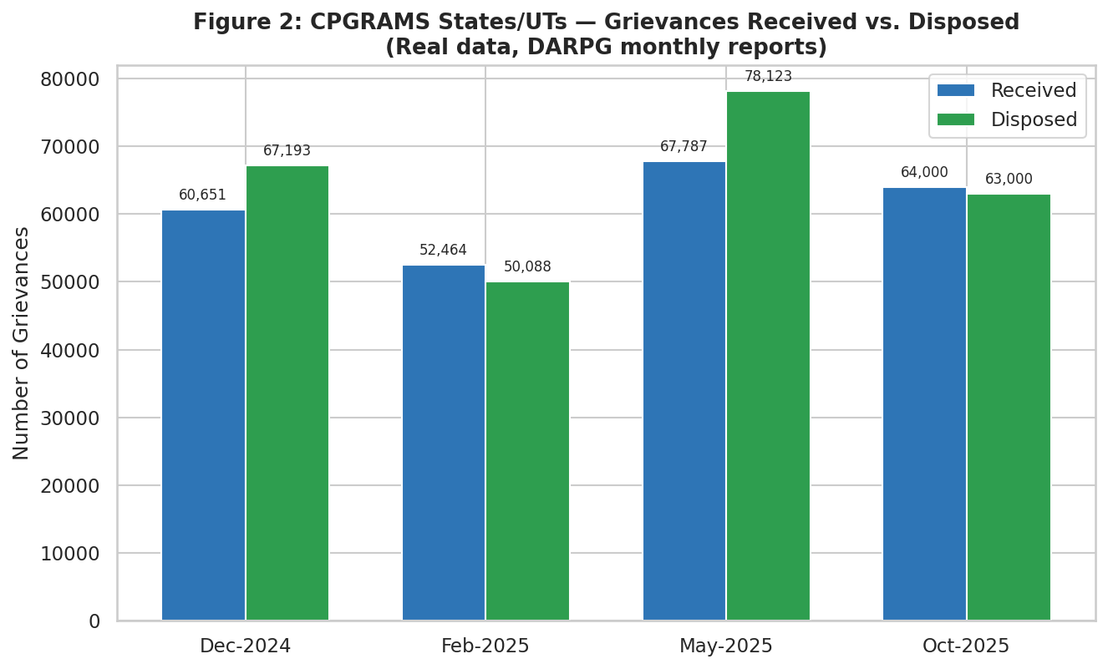
Figure 2: States/UTs grievances received vs. disposed by month (real data).
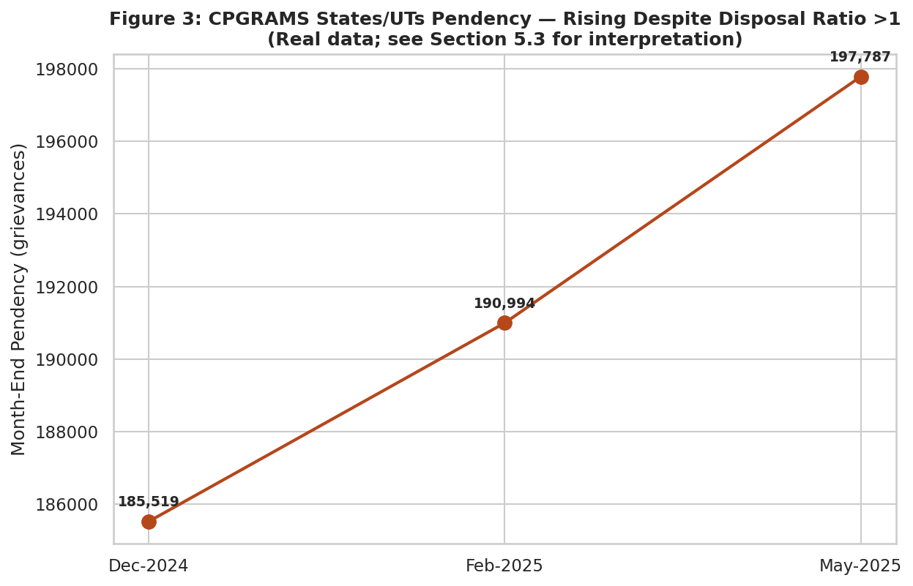
Figure 3: States/UTs month-end pendency — rising even where disposal exceeds intake.
The disposal-to-received ratio averaged 1.05 across the three months with confirmed figures (Dec-2024, Feb-2025, May-2025) — meaning States/UTs disposed of slightly more grievances than they received in a typical month. Yet pendency rose 6.6% over the same window (185,519 -> 197,787). This apparent contradiction is a genuine, unresolved finding: it suggests either a backlog of older, harder-to-close cases accumulating outside the simple received/disposed accounting, or a timing lag between when a grievance is logged and when it enters the disposal count. This report does not have enough information to resolve which — consistent with this internship's practice of stating an open finding rather than forcing a tidy but unsupported explanation (see Section 4.1).

6. Recommendations
The following recommendations are drawn directly from the findings above, prioritized by how directly the underlying evidence supports them.

Recommendation | Impact | Effort | Owner
Target biometric-capture process fixes for the 0-5 and 60+ age bands specifically (Week 3 finding) | High — addresses the largest, most specific rejection driver found | Medium | UIDAI / enrolment agencies
Treat digital-access expansion and enrolment-friction reduction as two separate workstreams (Week 4 finding) | High — avoids wasted effort assuming one fixes the other | Low (planning only) | MeitY / State IT depts
Replace single-point growth-rate extrapolation with a logistic (S-curve) model for multi-year digital-payments infrastructure planning (Week 5 finding) | High — prevents budget over-commitment based on early hyper-growth rates | Medium | NPCI / RBI planning units
Investigate why CPGRAMS pendency keeps rising even in months where disposal exceeds intake (this report's finding) | Medium — a visible, measurable service-quality gap | Medium | DARPG
Adopt a standard 'Precision' flag (exact vs. approximate) on every published government statistic reused for analysis | Medium — improves the reliability of all future downstream analysis | Low | Data-publishing ministries
Establish a single, versioned historical bulk-download endpoint per platform (as UIDAI provides, unlike CPGRAMS/UPI) | High — the single biggest recurring obstacle across all 6 weeks | High | MeitY / NIC

6.1 For Policymakers
- Fund targeted technical fixes for biometric capture in early childhood and old age specifically, rather than general enrollment-centre upgrades — the data shows the problem is concentrated, not diffuse.
- When setting multi-year digital-infrastructure budgets, require any growth-based projection to state whether it assumes continued early-stage exponential growth or a maturing S-curve — Week 5's finding shows the difference is worth an order of magnitude.

6.2 For Digital Service Managers
- Track Access and Efficiency as separate KPIs with separate improvement plans, since Week 4's finding shows fixing one will not incidentally fix the other.
- For any platform reporting both 'received' and 'disposed' counts (as CPGRAMS does), also track and publish pendency directly — this report shows the two can tell contradictory stories, and only publishing pendency directly would have surfaced the gap sooner.

7. Limitations of This Internship's Analysis
- No dataset used across all six weeks includes individual-citizen-level records with informed consent for research use — all analysis is on aggregated, publicly published figures, which limits any claim to population-level patterns, not individual causal mechanisms.
- Each week's dataset represents a different time snapshot (UIDAI: undated cumulative extract; NPCI: Aug 2025-Aug 2026; CPGRAMS: scattered months 2021-2026) — the internship's findings should be read as a set of independent, time-bounded snapshots, not a single continuous national timeline.
- Week 4's necessarily-simulated Satisfaction Index, though anchored to a real external figure and fully disclosed, remains the one metric across six weeks that is not a direct measurement — any reuse of that specific finding outside this internship should first be replaced with real survey data.
- This validation case study (Section 5.4) uses only 7 and 4 data points respectively for its two CPGRAMS series — sufficient to demonstrate the framework transfers, but not sufficient for the same depth of analysis Weeks 2-5 achieved on larger datasets.

8. Conclusion
Across six weeks, this internship moved from strategic planning with no data in hand, through increasingly rigorous collection, exploration, statistical validation, and forecasting on real Government of India datasets, to this final synthesis — which itself confirms the analytical approach transfers cleanly to a third, previously unused resource (DARPG/CPGRAMS). The most valuable outcome is not any single statistic, but a consistent, disclosed way of working: real data first, explicit flags wherever simulation or interpolation was unavoidable, and a willingness to report findings that don't fit a tidy narrative (two forecasting models that disagree; a pendency figure that rises despite a healthy disposal ratio). These habits, more than any individual number, are what should transfer to future digital-transformation analysis in the e-governance space.

