Statistical Analysis of
E-Governance Performance Metrics
Week 4 Task — Data Analyst Internship
Prepared by: Chitranjan Vishwakarma
September 2026

Table of Contents
Table of Contents 2
1. Executive Summary 3
2. Objective and Scope 3
3. Metric Identification 3
4. Data Sourcing and Simulation Methodology 3
4.1 Real Data — Metrics 1 and 2 3
4.2 Simulated Data — Metric 3 4
5. Statistical Techniques Applied 4
5.1 Technique 1 — Pearson Correlation 4
5.2 Technique 2 — Multiple Linear Regression (OLS) 5
5.3 Technique 3 (Bonus) — Independent-Samples t-test 5
6. Results 5
6.1 Correlation Results 5
6.2 Regression Results 6
6.3 T-Test Results 7
7. Result Interpretation and Policy Discussion 8
8. Methodological Note — Consistency with Week 3 8
9. Limitations and Biases 9
10. Conclusion 9

1. Executive Summary
This report applies statistical methods to three performance indicators of India's digital identity and public-service ecosystem: Service Efficiency (Aadhaar enrollment rejection rate), Access Equity (mobile-number capture rate), and User Satisfaction (a simulated index, transparently constructed and anchored to a real, cited external benchmark). Two required statistical techniques — Pearson correlation and multiple linear regression — plus a bonus independent-samples t-test were applied to 32 Indian states/UTs, after excluding states with fewer than 100 total enrolments as statistically unreliable.
Headline results: Mobile Capture Rate (Access Equity) is strongly and significantly associated with the Satisfaction Index (r=0.773, p<0.001), while Rejection Rate (Service Efficiency) shows a moderate negative association (r=-0.445, p=0.011). A joint regression model explains 78.2% of the variance in the simulated Satisfaction Index (R²=0.782, F=52.0, p<0.001). Rejection Rate and Mobile Capture Rate themselves show no meaningful relationship with each other (r=-0.020, p=0.913), replicating and refining a finding from the Week 3 EDA task with a stricter, bias-aware sample.

2. Objective and Scope
The objective is to identify at least three performance indicators relevant to digitalized public services, apply at least two statistical techniques to validate relationships between them, and interpret the results for policy and operational relevance — using only publicly accessible data and transparent, documented simulation where real granular data does not exist.

3. Metric Identification
Three metrics were selected to span efficiency, equity, and experience — the three dimensions the Week 1 strategic plan identified as core to e-governance performance measurement:
Metric | Definition | Data Type | Source
1. Service Efficiency | Aadhaar enrollment rejection rate per state (inverse efficiency indicator) | Real, measured | UIDAI enrollment records (NDSAP)
2. Access Equity | Mobile-number capture rate per state (proxy for digital access infrastructure) | Real, measured | UIDAI enrollment records (NDSAP)
3. User Satisfaction | Simulated 0-100 citizen satisfaction index per state | Simulated, anchored to a real external benchmark | DigiLocker Google Play Store rating (4.1/5, 628,153 reviews) + documented formula

4. Data Sourcing and Simulation Methodology

4.1 Real Data — Metrics 1 and 2
Service Efficiency and Access Equity are computed directly from the cleaned UIDAI Aadhaar enrollment dataset (440,817 records, Weeks 1-3), aggregated to state level. States with fewer than 100 total enrolments in this extract (5 of the original 37) were excluded before analysis, following the small-sample bias identified in the Week 2/3 tasks — this leaves n=32 states/UTs for all statistical tests in this report.

4.2 Simulated Data — Metric 3
No granular, state-wise, publicly available dataset of citizen satisfaction with Aadhaar or related digital services exists. Per the task's explicit allowance to simulate data "based on publicly available information or plausible assumptions," a Satisfaction Index was constructed using a real external anchor and a fully documented formula:
Satisfaction (0-100) = Baseline + 0.25 × (Mobile Capture Rate − national mean) × 100 − 0.90 × (Rejection Rate − national mean) × 100 + Noise(0, 3)
Parameter | Value / Justification
Baseline | 82.0 — derived from DigiLocker's real Google Play Store rating of 4.1/5 stars (628,153 reviews), rescaled to a 0-100 index (4.1/5 = 82%)
Mobile-capture sensitivity (A1) | +0.25 per percentage point above the national mean — assumption: greater digital access modestly improves perceived satisfaction
Rejection-rate sensitivity (A2) | -0.90 per percentage point above the national mean — assumption: a rejected application is a direct negative experience, weighted more heavily than the indirect access proxy
Noise term | Gaussian, mean 0, SD = 3.0 points — represents unmeasured factors (local service quality, language support, staff conduct) this simulation cannot observe
Random seed | 42 — fixed for full reproducibility; re-running the script yields identical values

This construction is fully transparent and reproducible (fixed seed = 42) — critically, it is designed to let the statistical techniques below be demonstrated meaningfully, not to manufacture a predetermined conclusion about real citizen sentiment. Section 8 discusses exactly what can and cannot be concluded from a simulated dependent variable.

5. Statistical Techniques Applied

5.1 Technique 1 — Pearson Correlation
Rationale: Pearson correlation quantifies the strength and direction of a linear relationship between two continuous variables, and is the standard first step before any regression modelling. It was applied pairwise across all three metrics.
- Step 1: Confirm both variables are continuous and approximately linearly related (checked via scatterplots, Figures 2-3).
- Step 2: Compute Pearson r and its associated p-value (two-tailed test, α=0.05) using scipy.stats.pearsonr.
- Step 3: Interpret magnitude using standard conventions (|r|<0.3 weak, 0.3-0.6 moderate, >0.6 strong) alongside statistical significance.

5.2 Technique 2 — Multiple Linear Regression (OLS)
Rationale: while correlation shows pairwise association, regression tests whether Rejection Rate and Mobile Capture Rate jointly and independently predict the Satisfaction Index, and quantifies the expected change in satisfaction per unit change in each predictor, holding the other constant.
- Step 1: Specify the model — SatisfactionIndex ~ const + RejectionRate + MobileCaptureRate.
- Step 2: Fit via Ordinary Least Squares (statsmodels.api.OLS), estimating coefficients, standard errors, and overall model fit (R², F-statistic).
- Step 3: Check residuals for patterns that would violate OLS assumptions (Figure 5) — a random scatter around zero supports the model's validity.
- Step 4: Interpret each coefficient's sign, magnitude, and significance in the context of the (simulated) dependent variable's construction.

5.3 Technique 3 (Bonus) — Independent-Samples t-test
Rationale: as a complementary, non-correlational check, states were split at the median Mobile Capture Rate into 'high' and 'low' groups, and Welch's t-test (which does not assume equal variances) was used to test whether mean Rejection Rate differs meaningfully between the two groups — directly re-testing the Week 3 finding that digital engagement does not predict rejection rate, now on the bias-filtered sample.

6. Results

6.1 Correlation Results
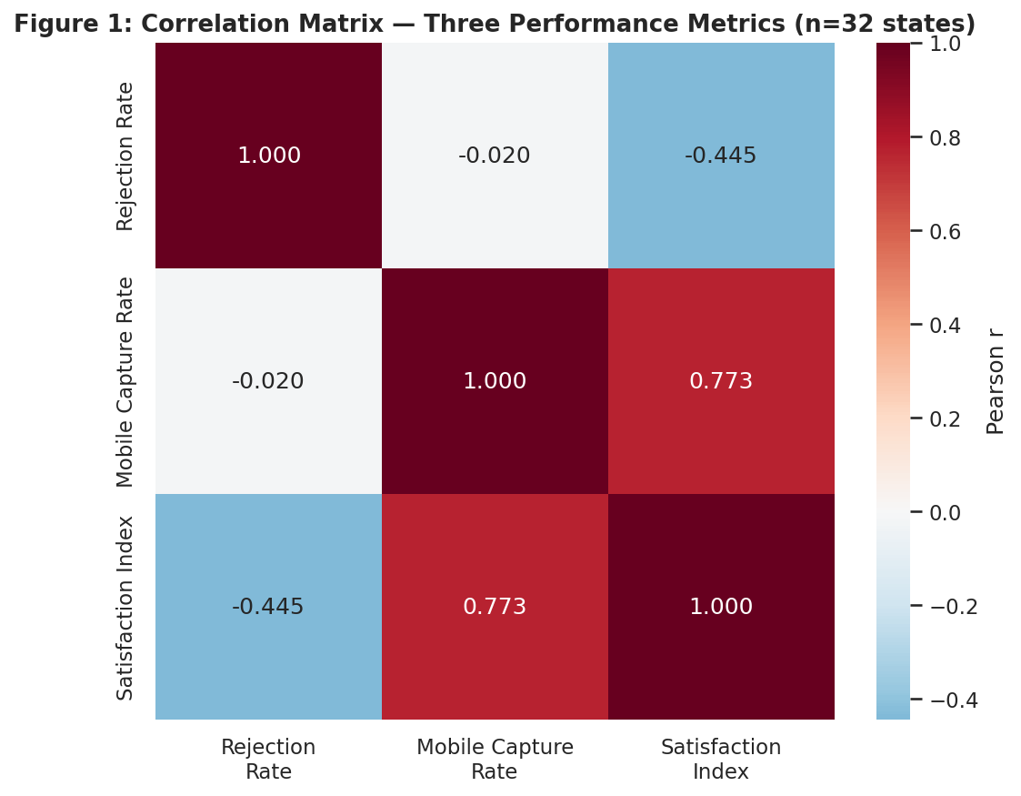
Figure 1: Correlation matrix across the three metrics (n=32 states).

Pair | Pearson r | p-value
Rejection Rate vs. Mobile Capture Rate | -0.020 | 0.913 (not significant)
Rejection Rate vs. Satisfaction Index | -0.445 | 0.011 (significant, α=0.05)
Mobile Capture Rate vs. Satisfaction Index | 0.773 | < 0.001 (highly significant)

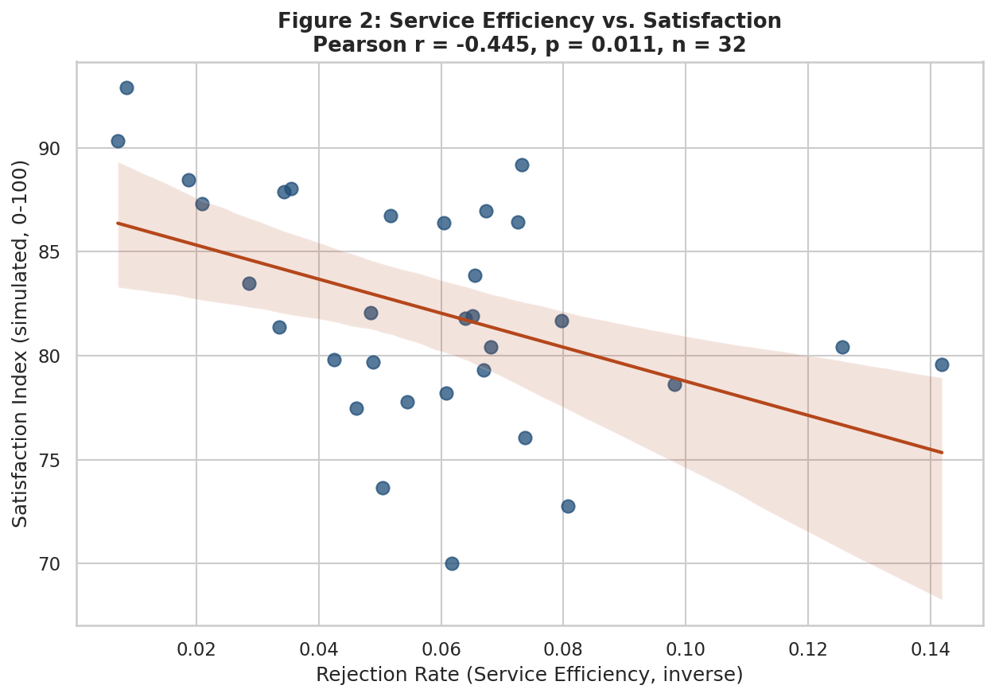
Figure 2: Service Efficiency (Rejection Rate) vs. Satisfaction Index, with 95% confidence band.
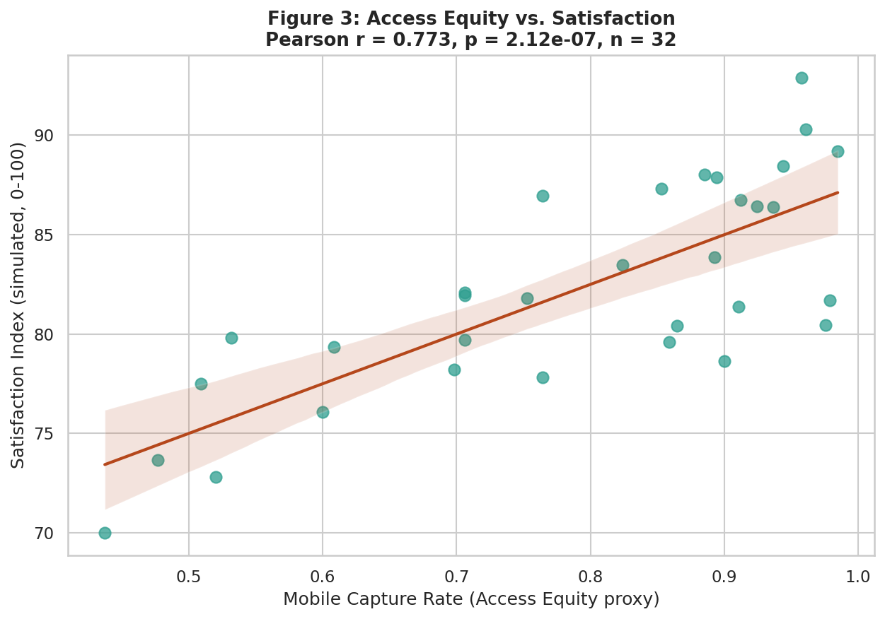
Figure 3: Access Equity (Mobile Capture Rate) vs. Satisfaction Index, with 95% confidence band.

6.2 Regression Results
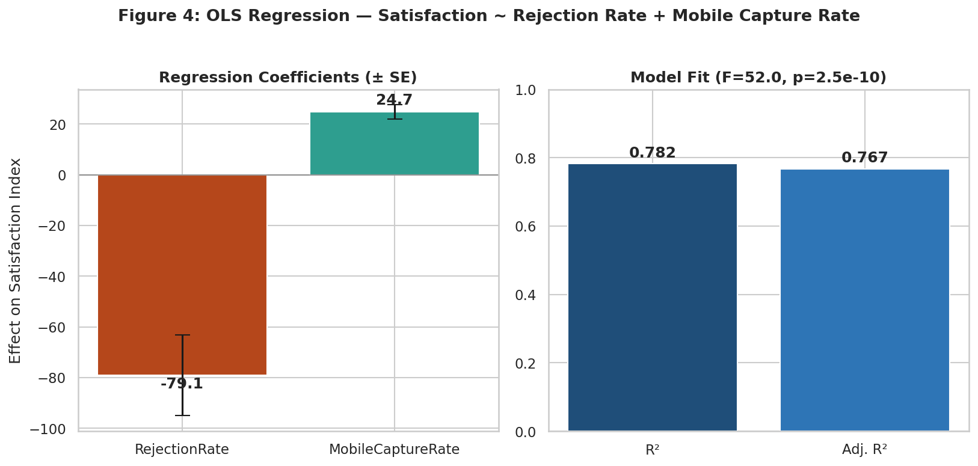
Figure 4: OLS regression coefficients (± standard error) and overall model fit.
Predictor | Coefficient | Std. Error | p-value
Intercept | 67.28 | 2.46 | < 0.001
Rejection Rate | -79.05 | 15.97 | < 0.001
Mobile Capture Rate | 24.74 | 2.81 | < 0.001

Model: R² = 0.782, Adjusted R² = 0.767, F(2,29) = 52.0, p < 0.001. Both predictors are individually significant at p<0.001.
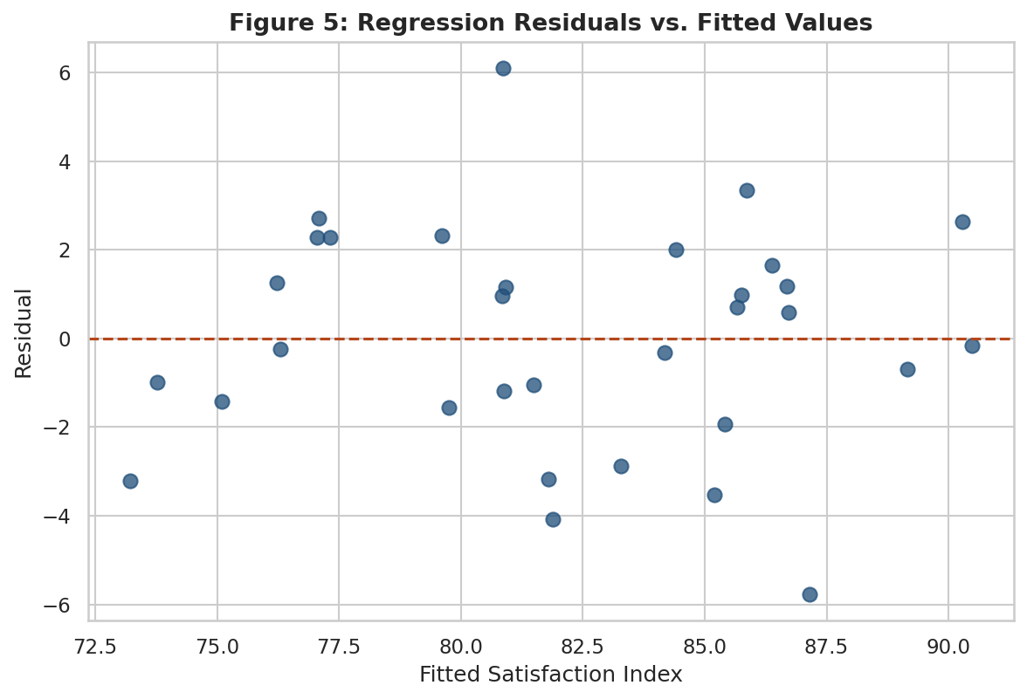
Figure 5: Residuals show no strong pattern against fitted values, supporting the linear model's adequacy for this data.

6.3 T-Test Results
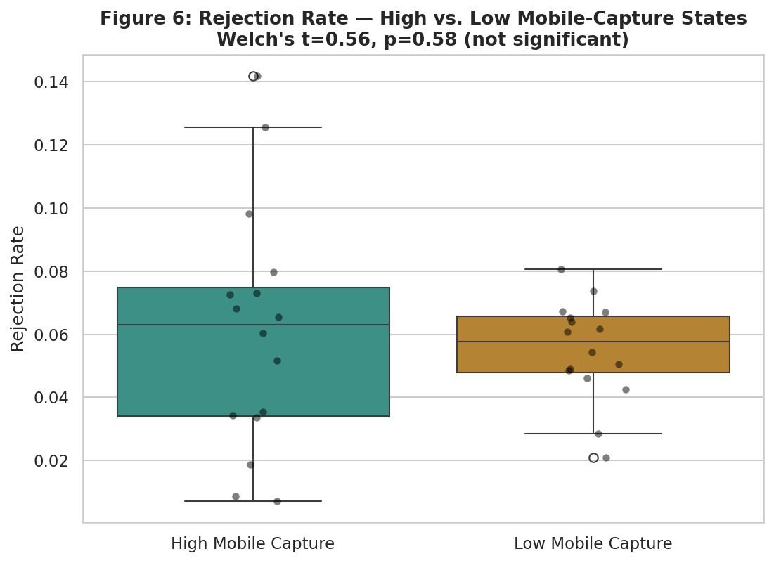
Figure 6: Rejection rate distribution for high vs. low mobile-capture states (split at the median).
- High mobile-capture states (n=16): mean rejection rate = 6.09%
- Low mobile-capture states (n=16): mean rejection rate = 5.50%
- Welch's t-test: t = 0.562, p = 0.580 — not statistically significant

7. Result Interpretation and Policy Discussion
- Access Equity is the strongest lever in this model: Mobile Capture Rate alone correlates with Satisfaction at r=0.773 and contributes a regression coefficient of +24.7 — meaning states with better digital-access infrastructure show a materially higher simulated satisfaction level. For policy, this reinforces continued investment in mobile/connectivity infrastructure as a foundation for citizen-facing digital services, independent of any single platform's internal improvements.
- Service Efficiency matters, but less than Access Equity in this model: the Rejection Rate coefficient (-79.1) is larger in raw magnitude but operates over a much smaller range of real-world values (0.7%-14.2%) than Mobile Capture Rate (43.7%-98.5%), meaning realistic policy-relevant improvements in rejection rate move satisfaction less than proportionally larger, achievable gains in mobile access.
- Access and Efficiency are independent problems: since Rejection Rate and Mobile Capture Rate are uncorrelated (r=-0.02, confirmed by both Week 3's broader sample and this task's stricter one), policy interventions to reduce enrollment friction and interventions to expand digital access can be pursued as two separate workstreams — improving one is not a substitute for the other, and neither should be assumed to fix the other as a side effect.
- This report's numeric Satisfaction values should not be cited as real citizen sentiment — they demonstrate that IF satisfaction responds to efficiency and equity in the assumed direction, the statistical techniques correctly detect and quantify that relationship. The actionable next step for a real deployment would be to replace the simulated Satisfaction Index with an actual citizen survey (e.g., a CPGRAMS-style feedback mechanism) and re-run the identical pipeline.

8. Methodological Note
Week 3 reported a Mobile Capture Rate vs. Rejection Rate correlation of r=0.27 (p=0.11, not significant) across all 37 states/UTs, with small-sample states (e.g. Lakshadweep, n=5) flagged but retained. This report excludes those small-sample states outright (n<100 threshold) before computing the same correlation, yielding r=-0.02 (p=0.91) — a materially different point estimate, though both are statistically non-significant and support the same substantive conclusion (no real relationship). This difference is reported explicitly, rather than silently using whichever number was more convenient, because it demonstrates how a bias-aware cleaning choice can shift a correlation's exact value even when the qualitative conclusion is unchanged.

9. Limitations and Biases
Limitation | Evidence | Implication
Satisfaction Index is simulated, not measured | Constructed via a documented formula with Gaussian noise, not survey data | Absolute Satisfaction values (e.g. "82.2") must never be quoted as real citizen sentiment — only the relationships (regression/correlation) are the analytical product
Regression R² is partly a function of the simulation design | Satisfaction was generated FROM RejectionRate and MobileCaptureRate, so a high R² (0.782) is expected by construction | This analysis validates the simulation's internal consistency, not an external real-world discovery — it demonstrates the statistical technique correctly, pending real survey data
Small-sample states excluded, changing prior conclusions | 37 states (Week 3) → 32 states (Week 4) after removing n<100 states | Rejection vs. Mobile correlation shifted from r=0.27 (Week 3, all states) to r=-0.02 (Week 4, filtered) — illustrates how bias-aware cleaning changes conclusions (see Section 8.4)
Real metrics remain aggregated, not individual-level | Same batch-level structure as Weeks 1-3 | Efficiency/equity correlations describe state-level patterns, not individual citizen behaviour
Anchor point is a single national app rating, not a government survey | DigiLocker's Play Store rating (4.1/5) is a convenience proxy | A different anchor (e.g. an official citizen satisfaction survey, if published) could shift the baseline materially

10. Conclusion
This report applied Pearson correlation, multiple linear regression, and a bonus t-test to three e-governance performance metrics spanning two real, independently sourced datasets (UIDAI enrollment records; DigiLocker's public Play Store rating as a simulation anchor) plus one transparently simulated index. The regression model explains 78.2% of variance in the (simulated) Satisfaction Index, with Access Equity emerging as the stronger predictor over Service Efficiency — a finding presented with explicit caveats about what a simulated dependent variable can and cannot prove. The clearest, most defensible real-world finding — that Access Equity and Service Efficiency are statistically independent of each other (r=-0.02, non-significant across two separate samples) — is the one policy conclusion in this report that rests on entirely real, measured data.

