PRODUCT BROCHURE
SPEAKCOACH
Build confident conversations
An AI-powered practice environment for the professional conversations that shape careers, deals and teams.
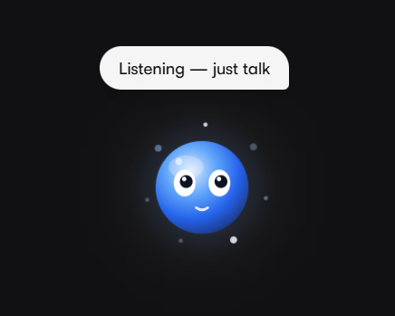

303  Practice scenarios | 74  Languages supported | 70/100  Pass-mark threshold | 5  Scoring criteria

speakcoach.ai · 2026 Product Overview

CONTENTS
What's inside
A guided tour of every SpeakCoach workspace — from first-time orientation to team-wide analytics.

01 | The SpeakCoach platform | 3
02 | Bixy — the always-on voice guide | 4
03 | My Journey — a personalized learning plan | 5
04 | The scenario library and smart discovery | 6
05 | Learn, Watch, Practice — the guided journey | 8
06 | Configuring a realistic practice call | 10
07 | Live practice calls | 12
08 | Performance scoring and feedback | 13
09 | My Scenarios and AI scenario creation | 15
10 | Live Studio — rapid speaking drills | 17
11 | Teams and competition | 18
12 | Activity timeline and analytics | 19
13 | Profile, balance, appearance and privacy | 21

A COMPLETE COMMUNICATION PRACTICE PLATFORM
Practice for the moments that matter
SpeakCoach brings structured learning content, realistic AI-led conversation and evidence-based feedback into a single workspace. Learners prepare for a real situation, rehearse it against a responsive AI participant, and walk away with a transcript-backed score they can act on — instead of generic tips or a one-off role-play.
A searchable library of 303 practice scenarios spans interviews, sales, negotiation, client growth, customer support and more, organised into topic tracks and delivered in 74 languages. Every call is measured against a transparent, five-part rubric and a 70-point pass mark, so progress is never a matter of opinion.

①  Choose a path  Explore focused scenario tracks and personalized recommendations from My Journey. | ②  Practice realistically  Set the language, accent and voice for the person you need to speak with, then take the call live. | ③  Improve with evidence  Review strengths, improvement priorities, score detail and a full conversation record.

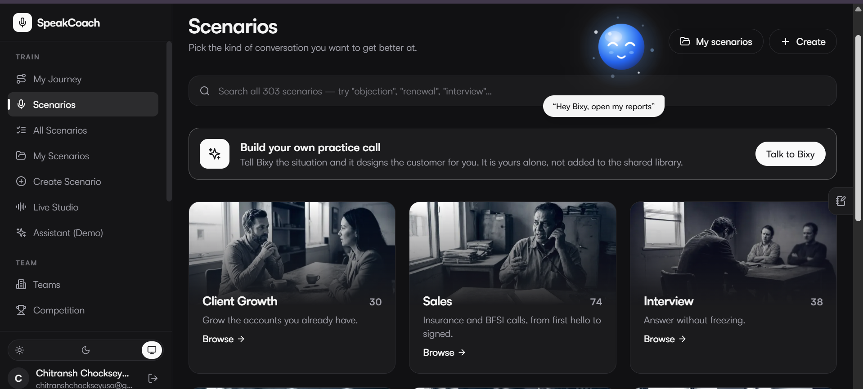
Browse scenario tracks from a single, focused workspace.

ALWAYS-AVAILABLE GUIDANCE
Bixy — the always-on voice guide
Bixy, the SpeakCoach voice chatbot, gives learners a fast, natural way to move through the platform without breaking flow. Activate Bixy by selecting the assistant or saying “Hey Bixy” to begin a time-bound session that stays available while you work.
Rather than operating as a separate destination, Bixy is designed to support the learner in the moment — helping them discover content, understand their current position, and start the next relevant activity.
Navigate | Move to the right area of the application without interrupting your flow — jump straight to My Journey, a track, or Settings by voice.
Search | Ask for the scenario, track or practice context you need, and Bixy surfaces it instantly from the full catalog.
Understand | Access relevant score and performance information through conversation — recent results, streaks or completion status.
Create | Request a tailored scenario when the catalog does not match your need, or hand Bixy a document to build one from.

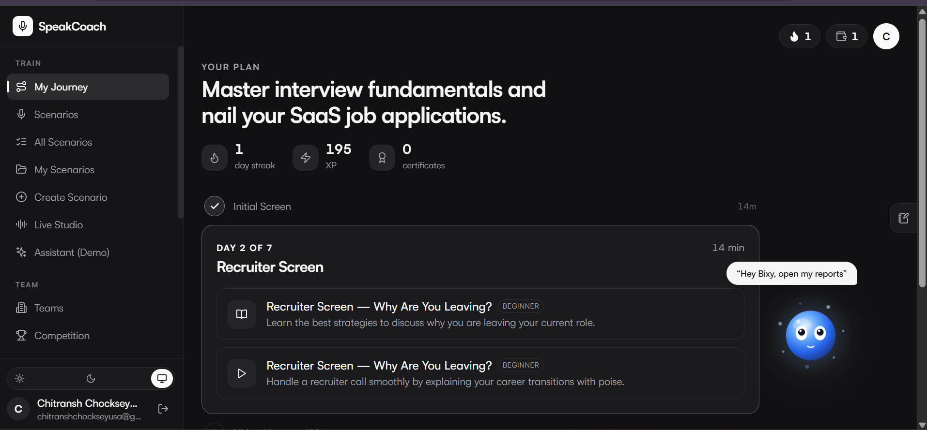
The voice chatbot remains visible in the workspace to provide contextual help during a session.

LEARNING PLANS AND MOMENTUM
My Journey — a personalized learning plan
My Journey turns practice into a structured plan, surfacing the next recommended activity alongside daily streaks, XP and certificates. Learners always see their current progress and can return to the next relevant exercise without losing momentum.
Guided plan | A recommended sequence of scenarios built around the learner's stated goal, such as mastering interview fundamentals for a specific role.
Next step | A single, clearly highlighted next activity so learners always know what to do when they open the app.
Streaks & XP | Daily streaks and experience points reinforce consistent practice and make progress visible at a glance.
Certificates | Completion is recognised with certificates that mark milestones in a learner's development.

WHY IT MATTERS
A clear next step, visible daily, is what turns occasional practice into a habit — and a habit is what changes how someone actually performs in the room.

SCENARIO TRACKS
Find the right scenario
Start with a business challenge, then move into the specific situations that demand practice. The searchable scenario library organises 303 scenarios into topic-based tracks — interviews, sales, negotiation, client growth, customer support and more — so learners can build skill progressively rather than practising at random.
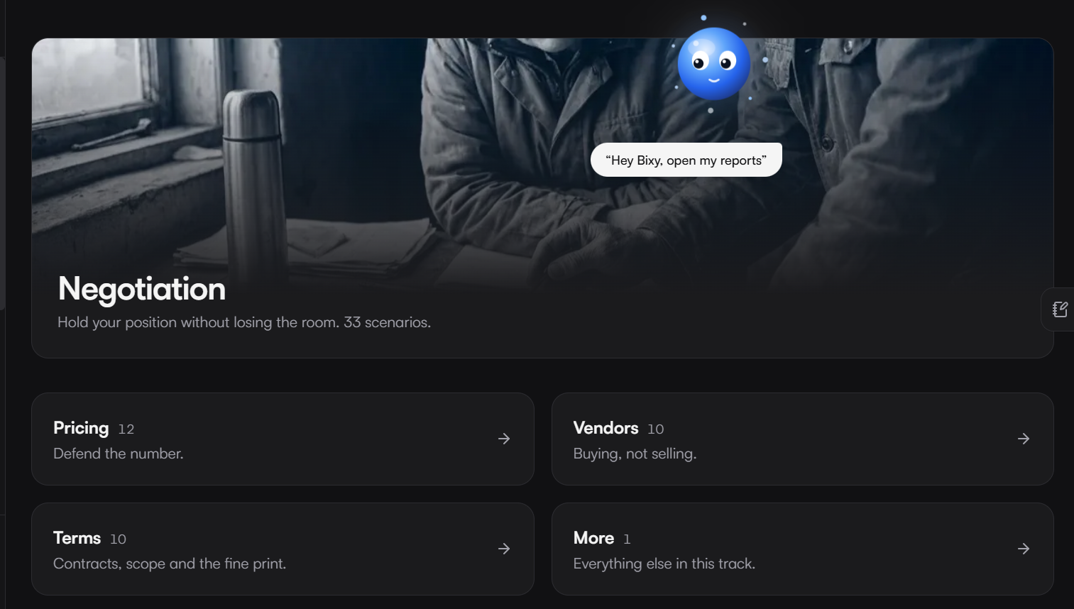
Negotiation is organized into focused sub-tracks such as pricing, vendors, terms and more.
01  Select a track  Start with the capability you want to build. | 02  Choose a scenario  Pick a focused business situation within that track. | 03  Progress by level  Build from beginner to advanced practice.

DISCOVER THE RIGHT LEVEL OF CHALLENGE
Smart discovery
Scenario lists can be searched, sorted and filtered so the right challenge is always easy to find.
Filter by completion | Show scenarios that are not yet started, in progress, or already completed.
Filter by level | Select beginner, intermediate or advanced practice to match current ability.
Filter by language | Narrow the catalog to scenarios available in a specific practice language.
Sort by difficulty | Order results from easiest to hardest, or the reverse, to plan a session.
Surprise Me | Let SpeakCoach select an unexpected scenario to stretch a learner beyond their usual comfort zone.

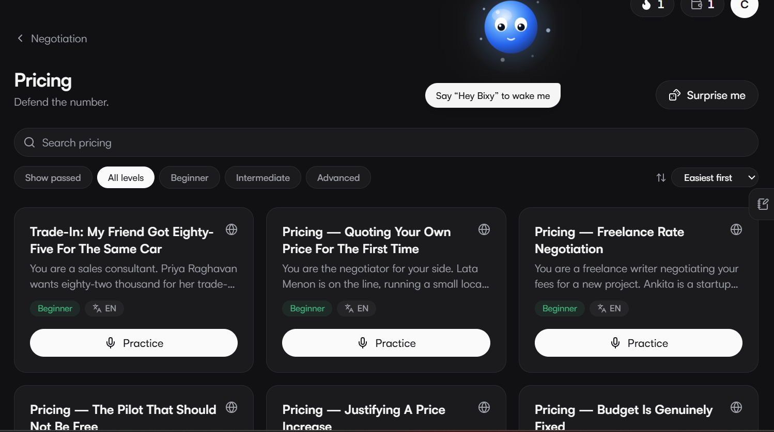
Scenario cards support browse, search and progression from beginner to advanced practice.

A GUIDED PRACTICE JOURNEY
Learn before the conversation
Each scenario follows a clear three-step journey designed to make practice deliberate rather than repetitive. Scenario pages also show estimated duration, points, lesson timing and completion status, so learners know exactly what to expect before starting.
01  Learn  Review the context, participant profile and insight needed to enter the conversation prepared. | 02  Watch  Study an example conversation to understand flow, language and decision points. | 03  Practice  Put the learning into action in a live AI conversation tailored to your setup.

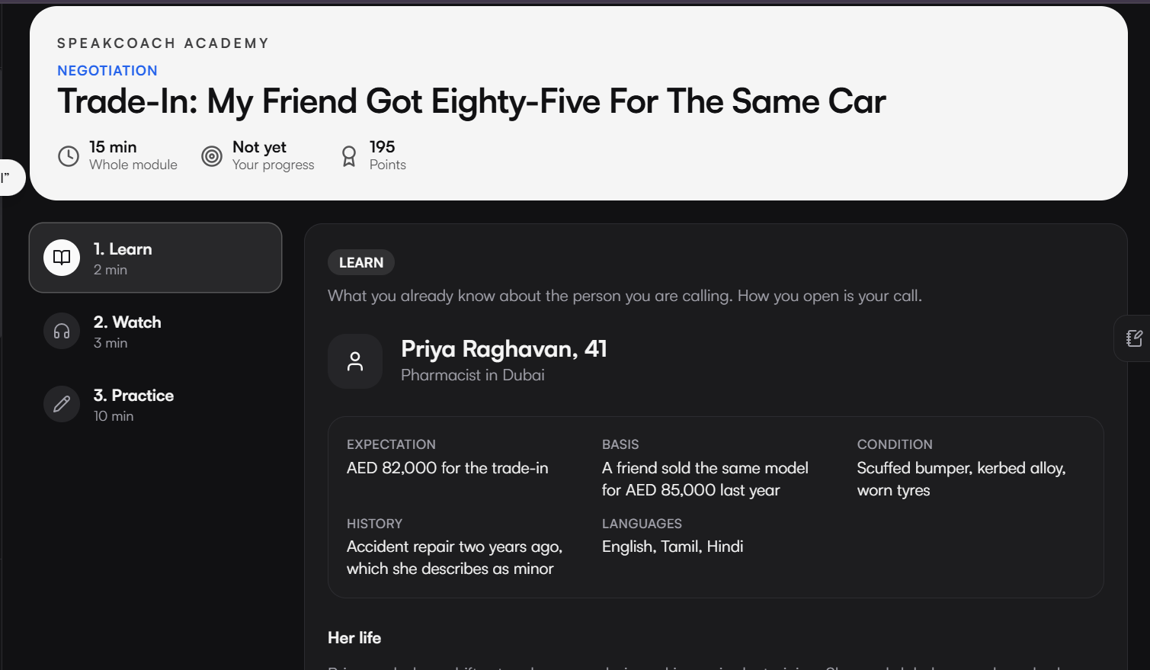
Learning content frames the situation, participant profile and practical context.

Briefing and knowledge check
The Learn step can include a detailed participant briefing: background, expectations, history, constraints, languages, current position and the practical issues that matter in the conversation. A short knowledge check confirms preparation before the learner progresses to Watch — reinforcing attention rather than letting learners skip straight to the call.
Watch the model exchange
The Watch step presents a model conversation and then hands the learner into Practice. It shows how the dialogue may unfold, where language and pacing matter, and how to respond when the other participant challenges the conversation.

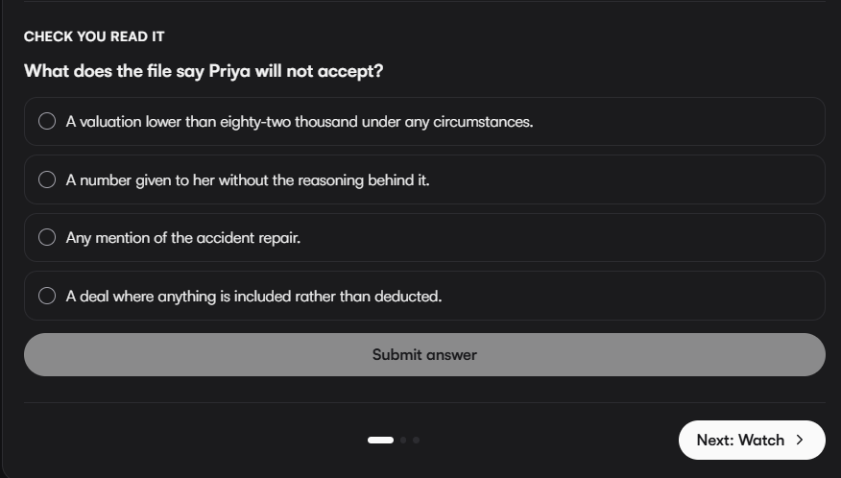
Knowledge checks reinforce attention before moving into the modeled conversation.

PERSONALIZE EVERY PRACTICE CALL
Configure a realistic conversation
Before a call begins, learners can tailor the experience to the people and markets they need to communicate with. A four-step setup flow supports 74 languages, spoken accent, a scenario-appropriate voice and a final readiness check.
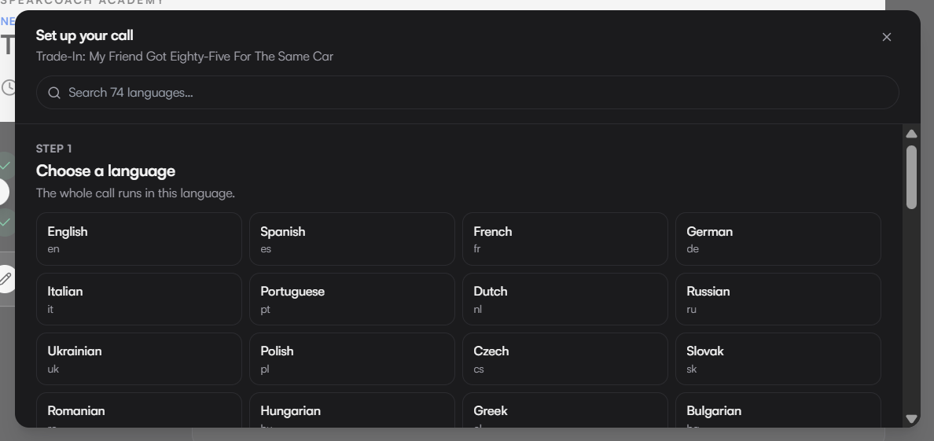  Language selection supports a broad range of practice contexts. | 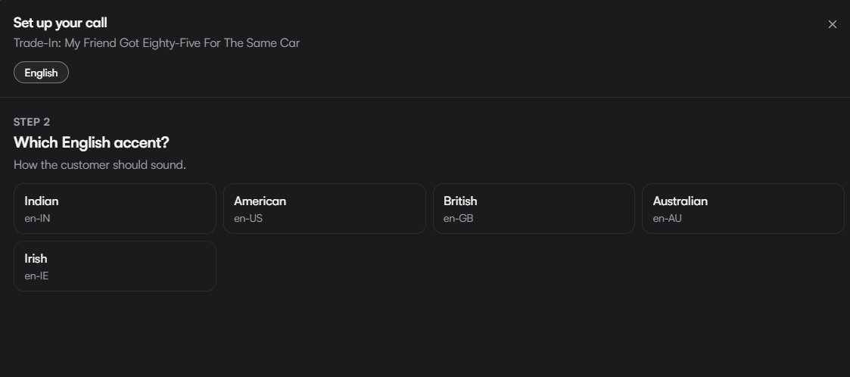  Accent configuration helps reflect the conversation a learner expects to have.

A  Language  Match the practice language to your context — 74 languages are supported. | B  Accent  Reflect the listener you expect to meet with a matching spoken accent. | C  Voice  Set the tone of the AI participant with a scenario-appropriate voice.

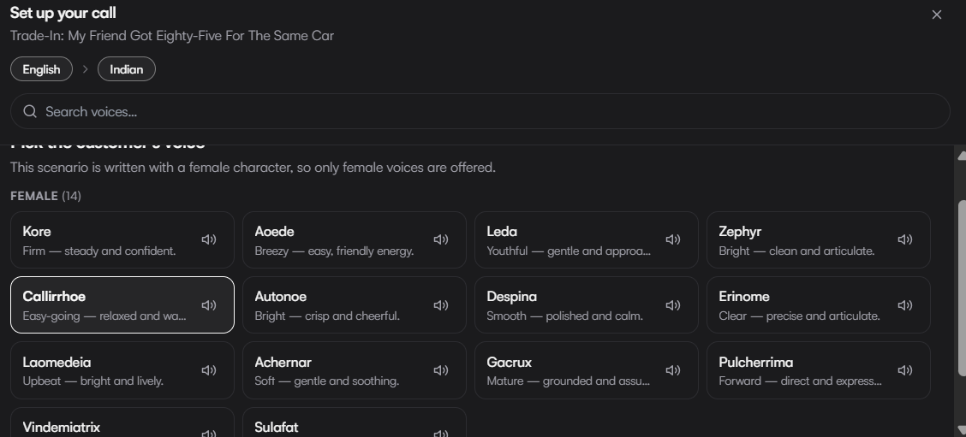
Voice options provide additional control over the practice experience.

Optional body-language grading
Learners can opt in to camera-based assessment of posture and presence before a call begins. The camera feed is read live for a body-language note and is never saved — see Privacy controls on page 22 for full detail.

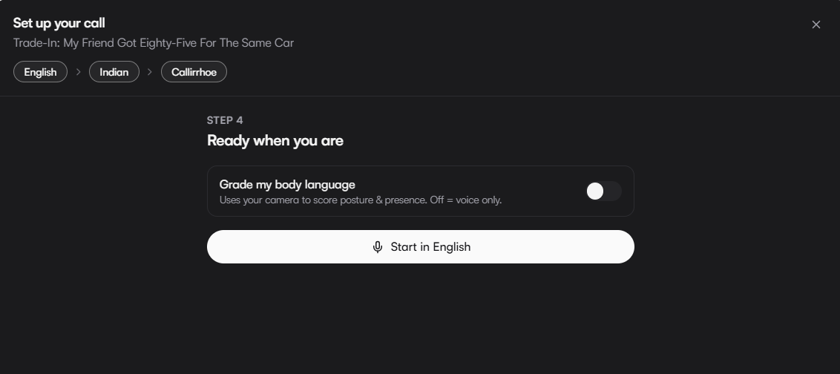
Optional body-language grading can be enabled before the call begins.

GOOD TO KNOW
Grading is opt-in for every call. Learners choose whether the camera is used each time they set up a session — there is no default that turns it on without a choice.

LIVE AI CONVERSATIONS
Put communication into practice
Practice calls are designed to respond dynamically. Once setup is complete, learners begin a real-time voice conversation with an AI participant that reacts to the quality and direction of the interaction — not a fixed script.
Timed sessions | Learners can track the session timer, mark moments worth revisiting, and end the conversation when ready to receive feedback.
Realistic outcomes | The AI participant can challenge, disengage, or end a call when the interaction is unproductive, mirroring the consequences of a real conversation.
Responsive dialogue | The live exchange is designed to feel purposeful, giving learners room to apply what they prepared while the AI participant reacts in real time.

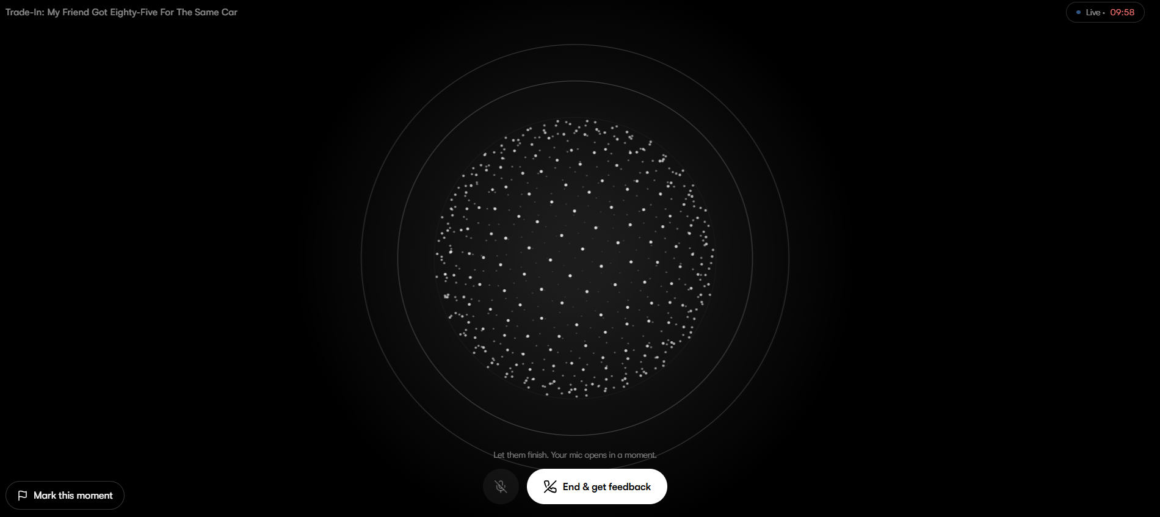
A live conversation starts when the learner is ready.
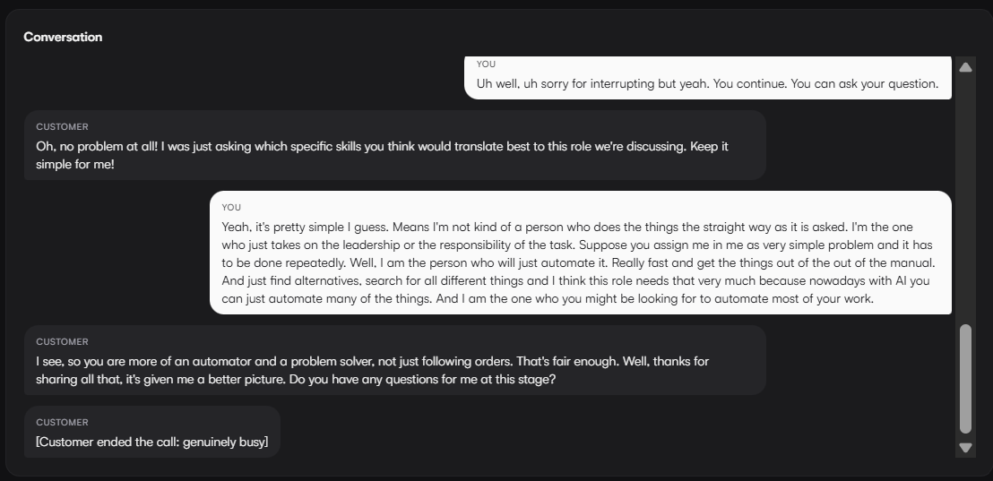
The conversation view provides a real-time exchange with the AI participant.

ACTIONABLE PERFORMANCE FEEDBACK
Turn each call into progress
After the conversation, SpeakCoach provides a structured review. Learners see their result against the 70-point pass mark, identify strengths and focus areas, examine detailed performance measures, and revisit the full transcript.
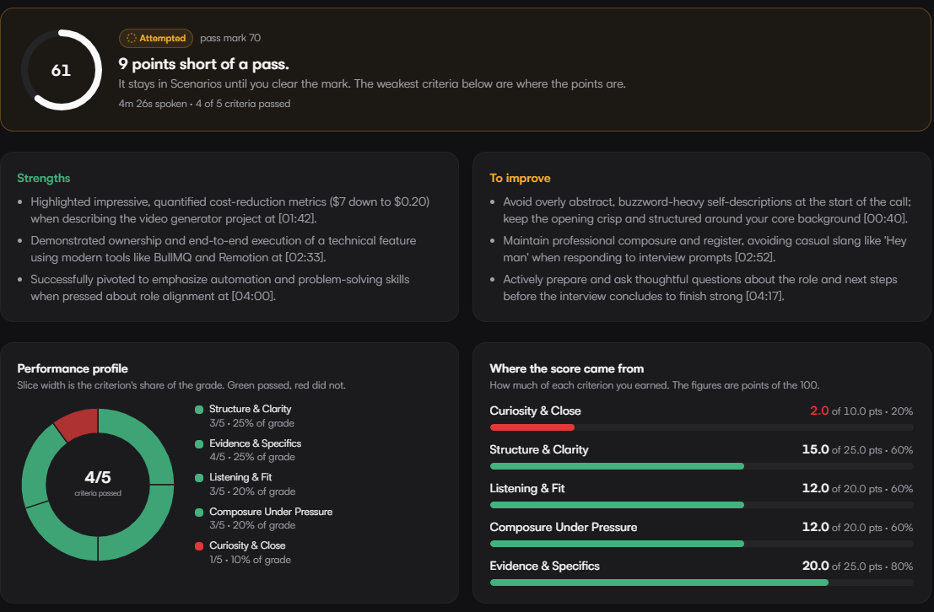
A focused feedback view summarizes strengths, priority improvements and performance detail.
A transparent scoring rubric
Assessment is organised around five criteria. Each one carries its own weight, score, supporting evidence and a relevant conversation timestamp, so a result is never a mystery.
Curiosity & Close | Whether the learner asked purposeful questions and moved the conversation toward a clear next step.
Structure & Clarity | How well the conversation was organised and how clearly ideas were communicated.
Listening & Fit | How closely the learner listened and adapted their response to what the other participant actually said.
Composure Under Pressure | How the learner handled pushback, objections or a difficult turn in the conversation.
Evidence & Specifics | Whether claims were backed with concrete detail, numbers or examples rather than generalities.

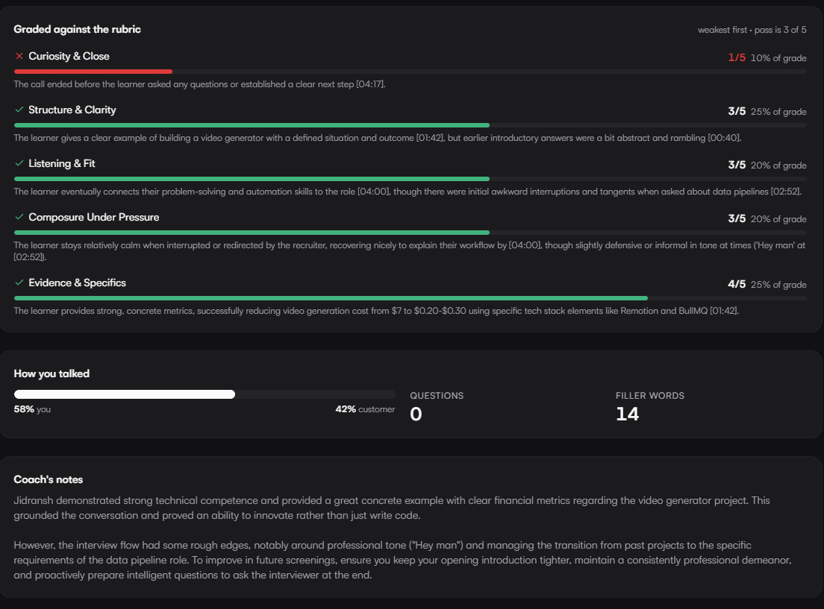
Scorecards break feedback into individual communication measures and supporting evidence.
01  Review  See the result and call summary. | 02  Understand  Explore strengths and improvement priorities. | 03  Repeat  Apply feedback in the next scenario.

Behavioral evidence and coach notes
The review also reports talk-to-listen balance, questions asked and filler words, then pairs those measures with coach notes and practical next steps. Learners can identify what happened, why it affected the result, and what to improve in the next attempt.
Timestamped feedback | Every strength and improvement point links back to the exact moment in the transcript that produced it.
Coach notes | Plain-language guidance that explains the score and what to change next time.
Transcript replay | The full conversation record is available to revisit alongside the score.
Communication metrics | Talk/listen balance, questions asked, filler-word count and criterion-level performance are tracked for every call.

PERSONALIZED AND COLLABORATIVE LEARNING
Extend practice beyond the catalogue
The platform supports both individual development and shared capability building. Learners can create bespoke scenarios, practice quick communication drills, and build teams around common development goals.
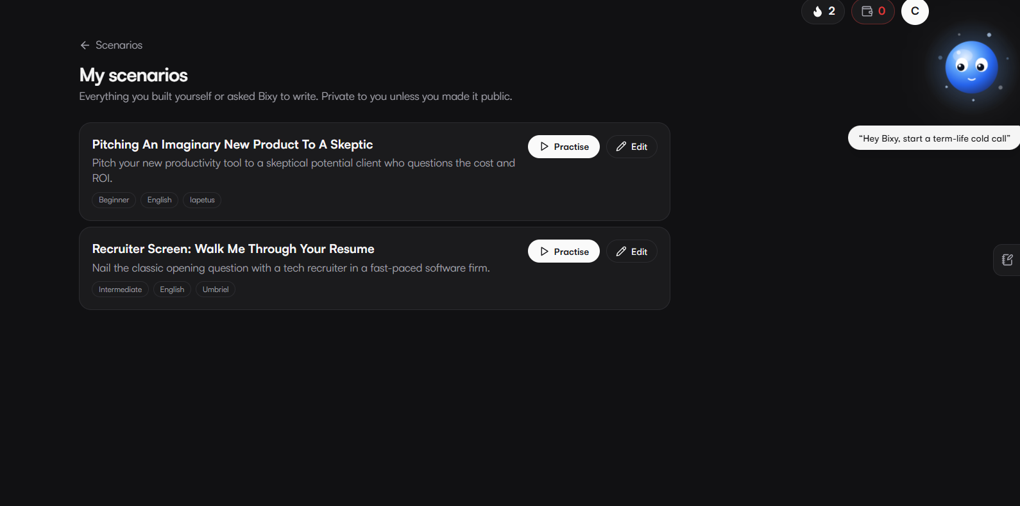
Personalized scenarios can be revisited and practiced on demand.
My Scenarios — private, editable practice
My Scenarios keeps bespoke practice private by default, with the option to make a scenario public and share it. Learners can revisit, practice and edit their scenarios as their goals change.

WHY IT MATTERS
The best practice for an upcoming conversation is often one nobody has written yet. Private-by-default scenarios let a learner rehearse their exact situation, then decide later whether it is worth sharing.

Create from a brief or a document
A new scenario can be created from a written brief, or by uploading a PDF, presentation or policy document for Bixy to read and turn into a practice conversation — complete with real details quoted from the source material.
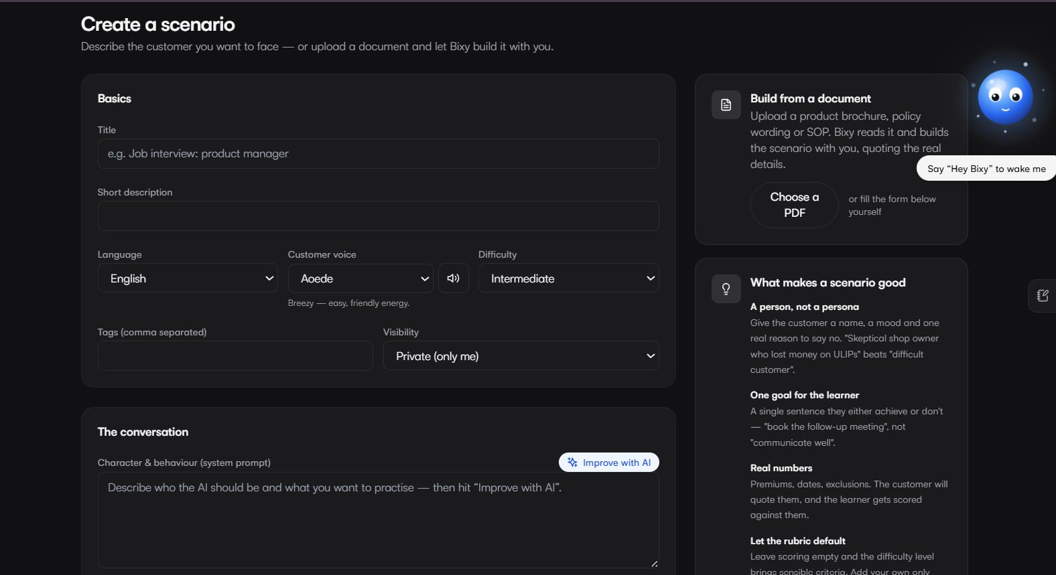
Create a new scenario with topic, language, accent and difficulty preferences.
Scenario controls
Title & description | Name the scenario and summarise the situation in a short description.
Language & voice | Set the practice language and choose a customer voice for the AI participant.
Difficulty & tags | Set beginner, intermediate or advanced difficulty and add tags for discovery.
Visibility | Keep a scenario private, or publish it so other learners can practice it too.
Conversation prompt | Define the AI character's behaviour and what the learner should be practising.
Improve with AI | Refines the scenario content and helps generate a scoring rubric suited to the goal and difficulty.

RAPID SPEAKING DRILLS
Live Studio
Live Studio offers short, high-frequency speaking drills focused on structure, ideas and reasoning rather than a full conversation. Each format defines its own preparation window and speaking time, and learners can track drills completed and best score.
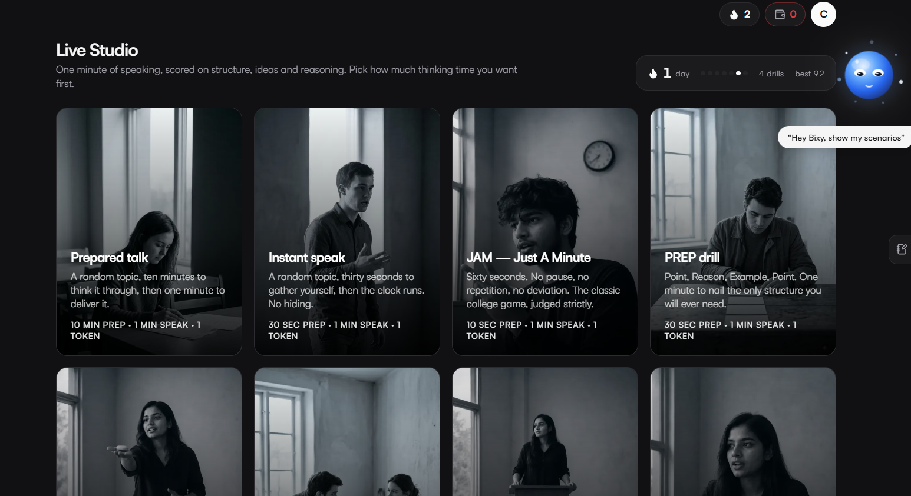
Live Studio offers compact communication drills.
Prepared Talk | A random topic with ten minutes to think it through, then one minute to deliver it.
Instant Speak | A random topic with thirty seconds to gather your thoughts before the clock runs — no hiding.
JAM (Just A Minute) | Sixty seconds, no pause, no repetition, no deviation — the classic drill, judged strictly.
PREP | Point, Reason, Example, Point — one minute to apply the structure with only a short preparation window.
Every format is scored on structure, ideas and reasoning, and each attempt is logged against a defined preparation time, speaking time and token cost, so learners can fit a drill into even a short break.

WHY IT MATTERS
One minute is short enough to fit between meetings, and frequent repetition is what actually builds fluency — Live Studio is designed for that daily rep, not an occasional deep session.

REVIEW, ANALYTICS AND ACCOUNT CONTROLS
Teams and competition
Teams can create a workspace, or join one with a code, to support shared practice goals. Competition views compare performance by team, city, role, state or country, with leaderboards for minutes practiced and average score across selectable time periods, including This Week and All Time.
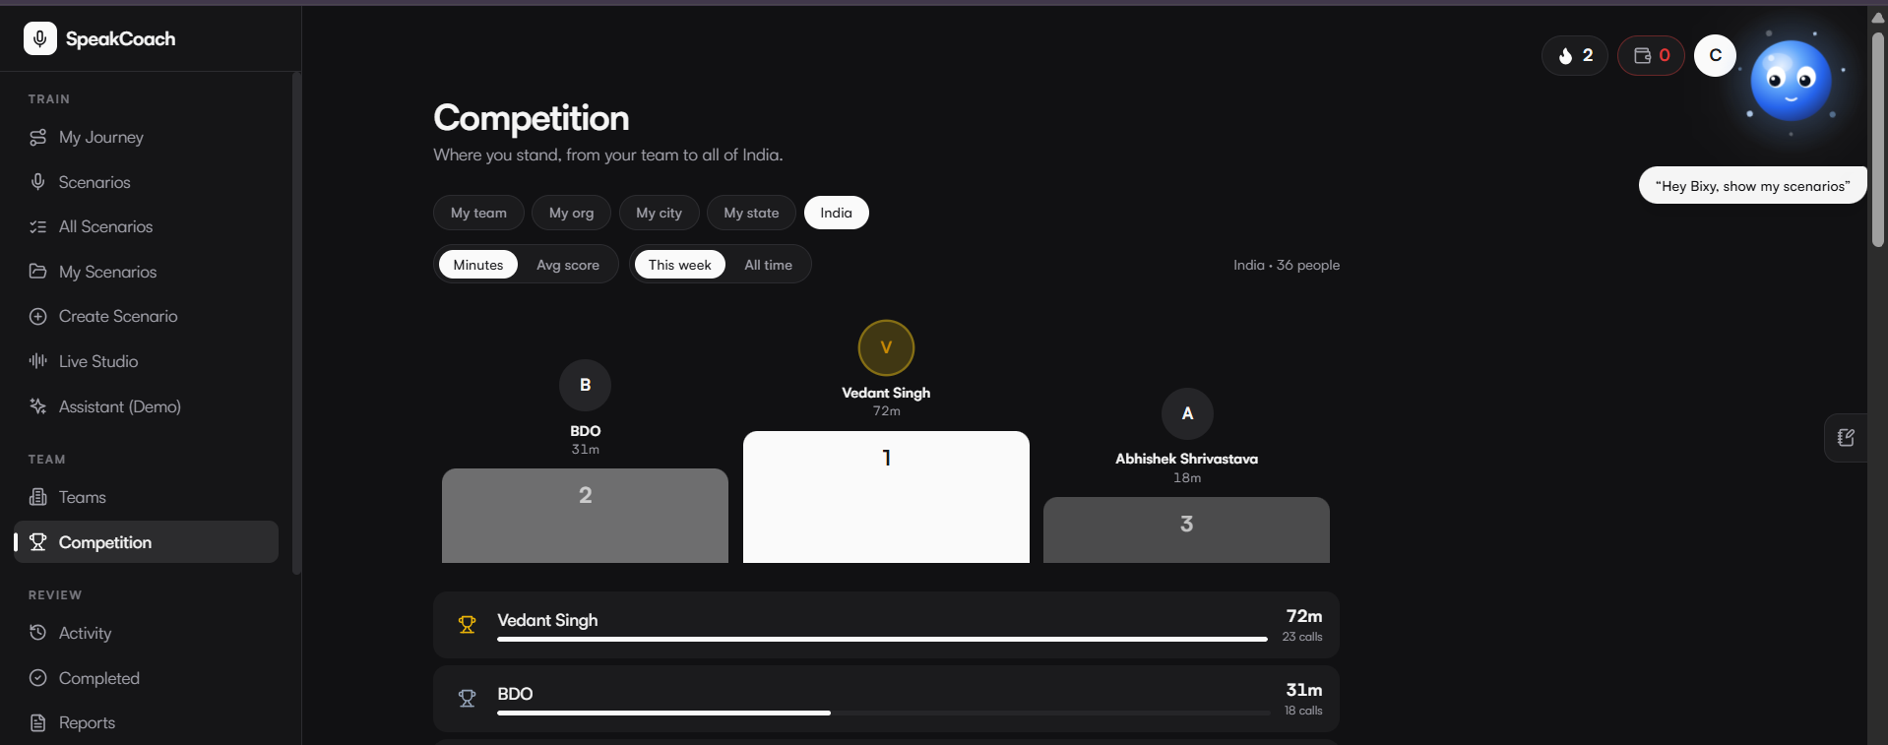
Competition introduces team and geographic leaderboards.
Create or join | Start a team workspace or join an existing one using a share code.
Compare views | Filter leaderboards by team, organisation, city, role, state or country.
Leaderboard metrics | Rank by minutes practiced or average score, over This Week or All Time.

WHY IT MATTERS
Visible, friendly competition gives teams a reason to practice consistently, not just once before a big meeting — minutes and scores on a shared board turn individual habit into a team norm.

MAKE DEVELOPMENT VISIBLE
Activity and analytics
Progress is easier to sustain when performance is visible. The Activity timeline records every completed call, drill and created scenario in newest-first order, including source, duration and score.
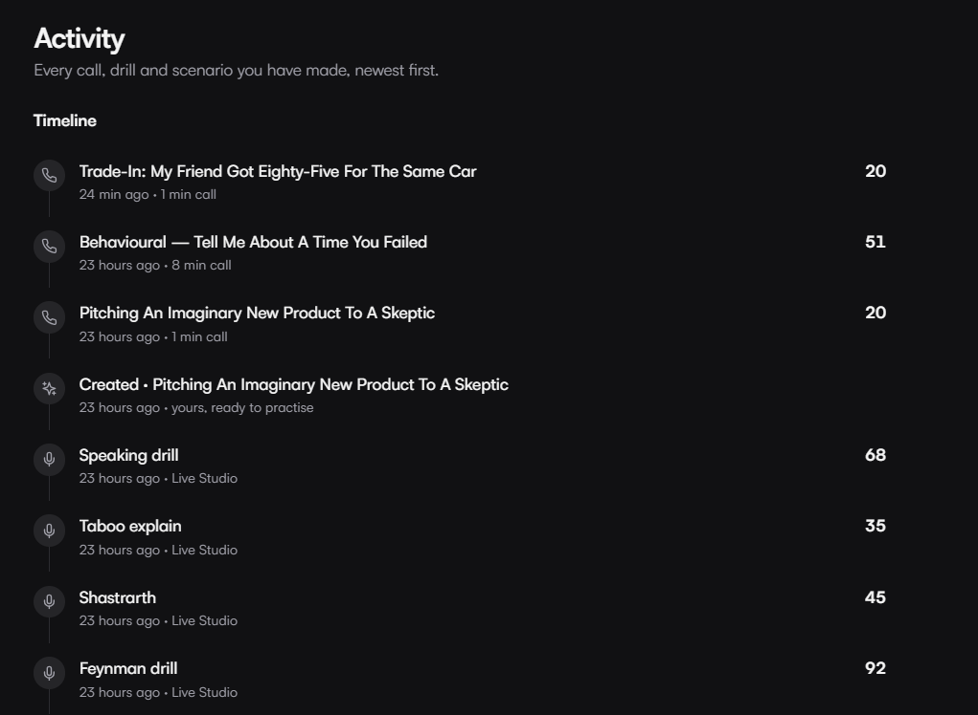
Activity records a timeline of scenarios and drills.

WHY IT MATTERS
A newest-first record of every call, drill and scenario turns “did I actually practice this week” into something a learner can simply look at, rather than guess.

Analytics
Analytics can be viewed over 7 days, 30 days or all time, turning practice history into a clear picture of improvement.
Practice volume | Call count and total minutes practiced over the selected period.
Score performance | Average score, best score, and the score trend across recent calls.
Skill trends | Per-criterion skill scores, tracked over time as more calls are completed.
Behavioral metrics | Talk-to-listen balance, questions asked per call, and filler words per call.

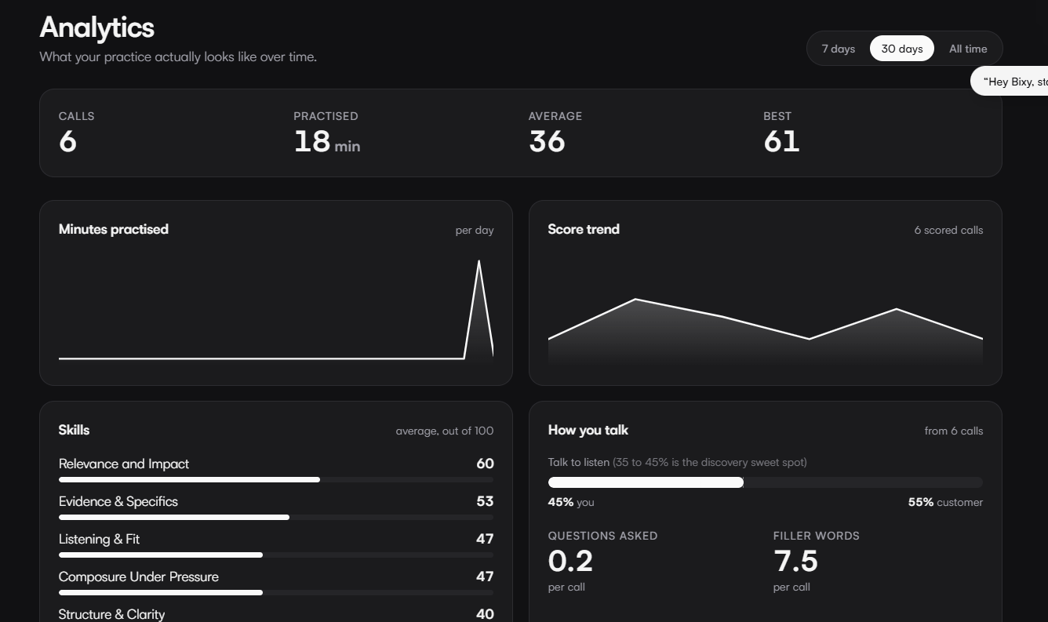
Analytics visualizes practice time, scores and skills over time.

READY WHEN PRACTICE MATTERS
Profile, balance and privacy
Profiles store a display name, role, field and practice location alongside visible progress statistics — total calls, best score, streaks, XP and Studio activity. These details are also what other learners see on competition boards.
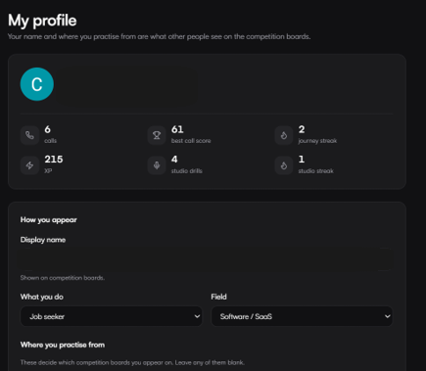
Profile settings keep personal preferences and progress accessible.
Profile | Display name, role, field and practice location, plus progress statistics used across the platform.
Appearance | Light, dark or system display modes; live calls stay dark either way.
Balance | Tokens, session costs and a full activity ledger, available from a dedicated Balance area.
Privacy controls | Explains how transcripts, scores, notes and webcam frames are handled, and lets learners request data deletion.

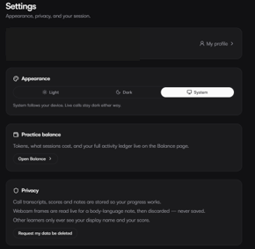
Manage appearance, balance and privacy settings from one account area.
Privacy, in plain terms
- Call transcripts, scores and notes are stored so a learner's progress works over time.
- Webcam frames used for body-language assessment are read live for a note, then discarded — never saved.
- Other learners only ever see a display name and score on competition boards.
- Learners can request that their data be deleted at any time
READY WHEN PRACTICE MATTERS
A clearer path to stronger communication
SpeakCoach combines structured content, realistic AI conversation and evidence-based feedback to help learners prepare for the professional conversations that matter most.
303  Practice scenarios | 74  Languages | 5  Rubric criteria | 70/100  Pass mark

SPEAKCOACH
AI-powered communication practice
speakcoach.ai

