3.1.2. Celsius to Fahrenheit
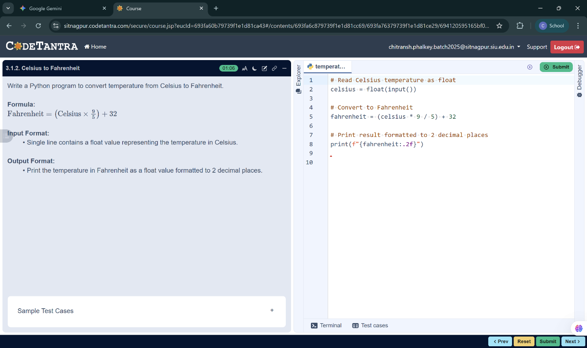

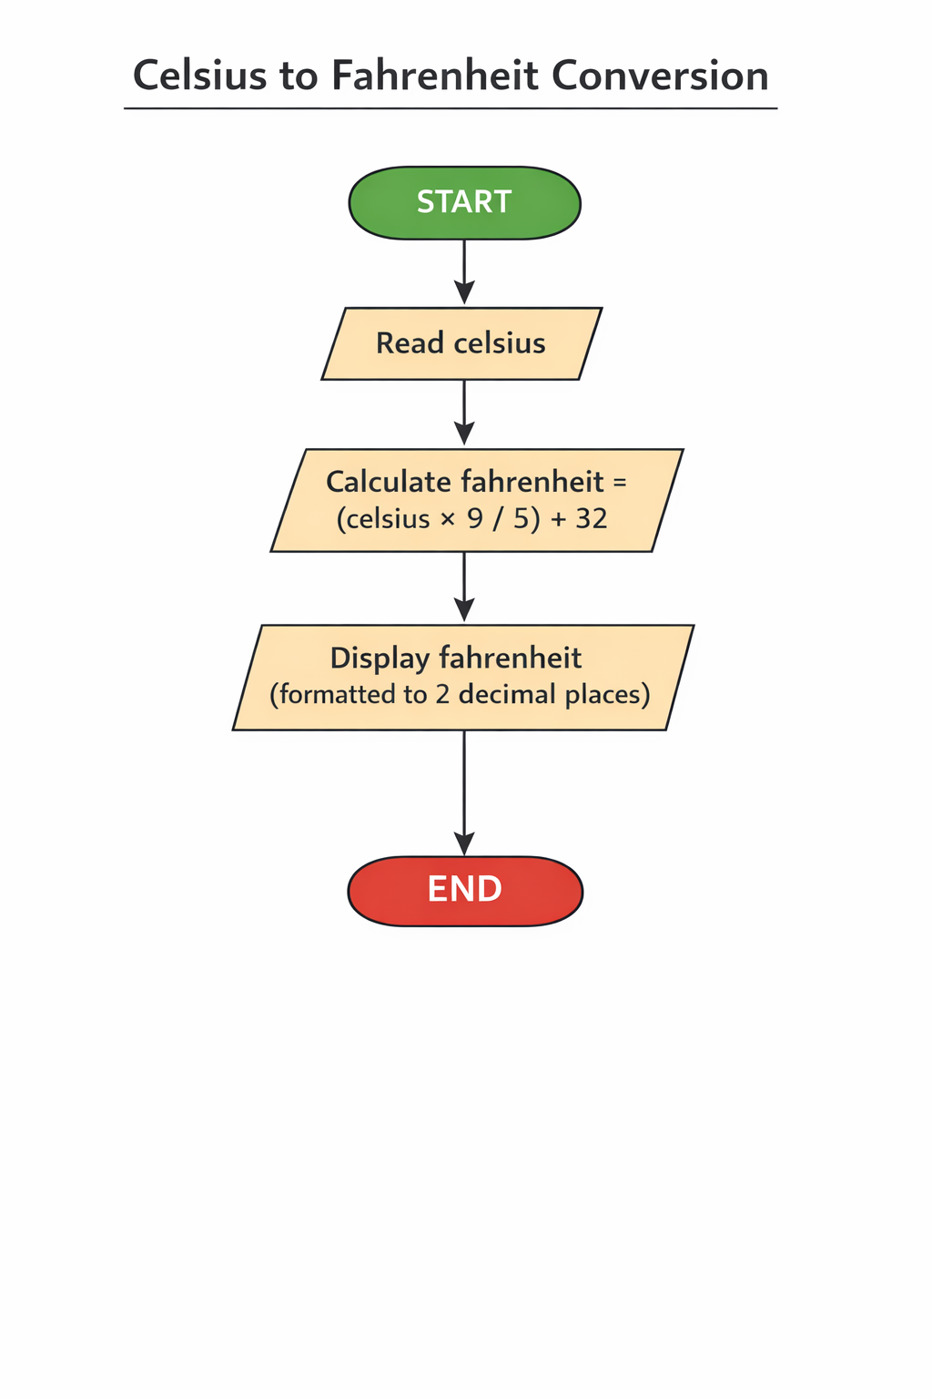

ALGORITHM: To Convert Celsius to Fahrenheit
Step 1: Start
Step 2: Read the temperature in Celsius (celsius)
Step 3: Calculate Fahrenheit using the formula
fahrenheit = (celsius × 9 / 5) + 32
Step 4: Display the value of fahrenheit (up to 2 decimal places)
Step 5: End

