Machine-Learning-Based Buyer Segmentation
and Investment Profiling for Real Estate Market Intelligence
A Research Paper — Parcl Co. Limited
Author: [Your Name]
Program: BCA — Data Science / Machine Learning Project
Date: [Month Year]

Abstract
Parcl Co. Limited sells residential and commercial units across a 20-tower real estate portfolio but had no systematic way to understand who its buyers are or how their investment behavior differs. This study applies unsupervised machine learning to 2,000 client records and 10,000 associated property transactions to discover natural buyer segments. Client demographic data was merged with aggregated purchase history (properties owned, total and average spend, unit size, portfolio breadth) to build a client-level investment profile, which was then encoded, scaled, and clustered using both K-Means and Hierarchical (Ward-linkage) clustering. The Elbow Method and Silhouette Score were used to evaluate cluster quality across K=2 to K=10; the statistically optimal K was 3 (silhouette (~0.124), but K=4 was adopted to match Parcl's four-persona business framework, scoring only marginally lower (silhouette (~0.107). The two algorithms agreed on cluster membership for 79.6% of clients, providing reasonable cross-validation. Four segments emerged: a small, high-value Global Investors group (43 clients, average $2.50M invested across 7.5 properties each); a large Luxury Investors segment (614 clients) distinguished by the highest average sale price and unit size; a Corporate Buyers segment (749 clients) with the highest remaining share of company-type clients; and a First-Time Buyers segment (594 clients) that, notably, did not exhibit the younger or more loan-dependent profile its name implies. This mismatch is reported directly rather than concealed, illustrating that data-driven segmentation can both confirm and challenge a business's existing assumptions about its customers. The study concludes with segment-specific recommendations for marketing, relationship management, and further data collection.

Keywords
Buyer Segmentation; Customer Clustering; K-Means; Hierarchical Clustering; Real Estate Analytics; Investment Profiling; Silhouette Score; Unsupervised Machine Learning

Table of Contents
Abstract
1. Introduction
2. Problem Statement
3. Objectives
4. Dataset Description
5. Methodology
6. Data Cleaning
7. Feature Engineering
8. Feature Encoding and Scaling
9. Clustering Methodology and Model Selection
10. Results
11. Geographic and Behavioral Analysis
12. Discussion
13. Recommendations
14. Limitations
15. Conclusion
16. Future Work
References

1. Introduction
Real estate companies serve buyers with fundamentally different motivations: individual families buying a home to live in, investors building a rental or resale portfolio, corporations acquiring commercial space, and high-net-worth individuals seeking premium assets. Treating these groups identically in marketing and sales outreach is inefficient and leaves investment opportunities undiscovered. Unsupervised machine learning -- specifically clustering -- offers a way to let patterns in actual client data reveal natural buyer groups, rather than relying solely on assumed personas.
This study applies that approach to Parcl Co. Limited, a real estate operator managing a 20-tower apartment and office portfolio. Parcl's systems capture both client demographic/behavioral data and granular transaction records, but the two had not previously been combined into a unified buyer-intelligence view.

2. Problem Statement
Parcl currently lacks a data-driven understanding of the different types of property buyers it serves, their investment motivations, geographic differences in investment behavior, and financing patterns. This leads to inefficient marketing spend, generic property recommendations, and poor investor targeting.

3. Objectives
- Build a unified, client-level investment profile by merging demographic data with actual purchase history.
- Apply K-Means and Hierarchical clustering to discover natural buyer segments.
- Use the Elbow Method and Silhouette Score to select and validate the number of clusters.
- Interpret each cluster's investment behavior, geographic distribution, and financing patterns in business terms.
- Deliver an interactive dashboard for ongoing segment monitoring and filtering.

4. Dataset Description
Two linked datasets were provided. clients.csv contains 2,000 client records (demographic and behavioral fields). properties.csv contains 10,000 property listings across 20 towers, each optionally linked to the purchasing client via client_ref.
Dataset | Field | Description
clients.csv | client_id, client_type, gender, country, region | Identity and geography (Individual or Company)
clients.csv | date_of_birth, satisfaction_score | Age indicator; 1-5 satisfaction rating
clients.csv | acquisition_purpose, loan_applied, referral_channel | Home vs. Investment; financing; acquisition source
properties.csv | listing_id, tower_number, unit_category | Unit identity; 1 of 20 towers; Apartment or Office
properties.csv | transaction_date, sale_price, floor_area_sqft | Monthly transaction snapshot; price; unit size
properties.csv | listing_status, client_ref | Sold or Available; links to the purchasing client

Data quality audit: zero missing values in clients.csv; zero duplicate client IDs or rows; zero duplicate listing IDs. properties.csv showed 2,695 missing client_ref values, which correspond exactly to listing_status == "Available" (unsold units) -- not a data defect, since unsold units have no buyer to link. Every client in clients.csv has at least 3 sold properties, confirming the dataset represents repeat buyers/investors rather than one-off purchasers (mean 3.65 properties per client, maximum 13).

5. Methodology
The pipeline followed six stages: (1) data cleaning and date-format investigation, (2) client-property merge and feature engineering, (3) feature encoding, (4) feature scaling, (5) optimal cluster selection via Elbow Method and Silhouette Score, and (6) clustering with K-Means and Hierarchical algorithms, followed by business interpretation of the resulting segments.

6. Data Cleaning
Two date fields required investigation before use. date_of_birth used two different delimiters inconsistently (dash and slash). For slash-delimited dates, the second numeric component reached 31 while the first never exceeded 12 -- proof the format is month-first (MM/DD/YYYY). The same month-first rule was applied to the dash-delimited subset for consistency, since both groups come from the same system and differ only in delimiter choice, not in field order. This was verified rather than assumed: parsing produced a fully plausible age distribution (23 to 93 years, mean 53.6) with zero unparseable rows.
transaction_date in properties.csv was found to always fall on the 1st of a month, spanning January 2024 to December 2025 (24 months) -- a monthly transaction snapshot rather than a daily timestamp. This is documented as a granularity limitation: any time-based feature in this study (e.g. purchase span) is accurate only to the month, not the day.
sale_price was stored as a formatted currency string (e.g. "$300,385.62") and was cleaned to a numeric float. No negative or zero prices were found across all 10,000 listings.

7. Feature Engineering
Because buyer segmentation requires knowing not just who a client is but what they actually buy, properties.csv (filtered to Sold listings) was aggregated per client and merged onto clients.csv. Engineered features include: total_properties (count of units owned), total_investment and avg_sale_price (spend), avg_floor_area_sqft (unit size preference), distinct_towers (portfolio breadth across the development), pct_office (share of commercial vs. residential purchases, a proxy for investment intent), and purchase_span_months (how long the client's buying activity has spanned). All 2,000 clients merged successfully with zero data loss.

8. Feature Encoding and Scaling
Low-cardinality nominal fields (client_type, acquisition_purpose, referral_channel, gender) were one-hot encoded. Higher-cardinality fields (region: 57 unique values; country: 10 unique values) were label encoded to avoid an unwieldy number of one-hot columns. All ten numeric features (age, satisfaction score, loan-applied flag, and the seven engineered investment features) plus the two label-encoded fields were standardized using StandardScaler (zero mean, unit variance) before clustering, since K-Means and Hierarchical clustering are both distance-based and sensitive to feature scale. The final feature matrix contained 21 columns across 2,000 clients.

9. Clustering Methodology and Model Selection
K-Means and Hierarchical (Ward-linkage) clustering were each tested for K = 2 through 10, evaluated with the Elbow Method (within-cluster sum of squares) and Silhouette Score (cluster separation quality, -1 to +1).
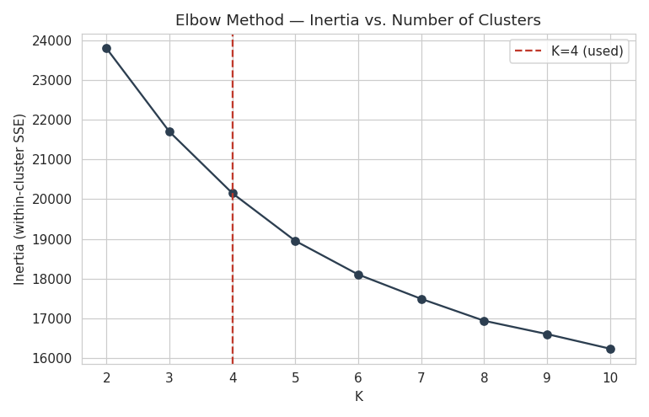
Figure 1. Elbow Method: inertia declines smoothly with no single sharp elbow, typical of moderately-separated real-world data.
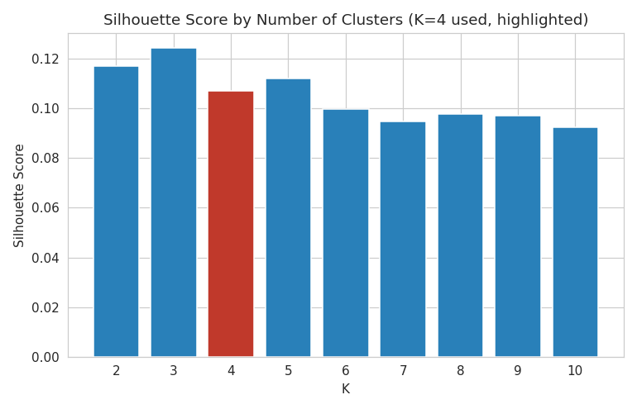
Figure 2. Silhouette Score by K. K=3 scores highest (~0.124); K=4 (used) scores ~0.107.
The silhouette-optimal K was 3, with K=4 scoring only slightly lower. All tested silhouette scores fell between roughly 0.08 and 0.12, indicating weak-to-moderate cluster separation -- expected for a dataset combining continuous financial behavior with categorical demographics, where natural groups rarely have sharp boundaries. K=4 was selected for the primary model to align with Parcl's four-persona business framework (Global Investors, Luxury Investors, Corporate Buyers, First-Time Buyers), a defensible choice given the two K values were close in quality, but this report does not overstate the resulting clusters' statistical sharpness.
To validate the K-Means solution, Hierarchical clustering (Ward linkage, K=4) was run independently on the same feature matrix. After best-match relabeling, the two algorithms agreed on cluster membership for 79.6% of clients -- reasonable corroboration given the modest silhouette scores.
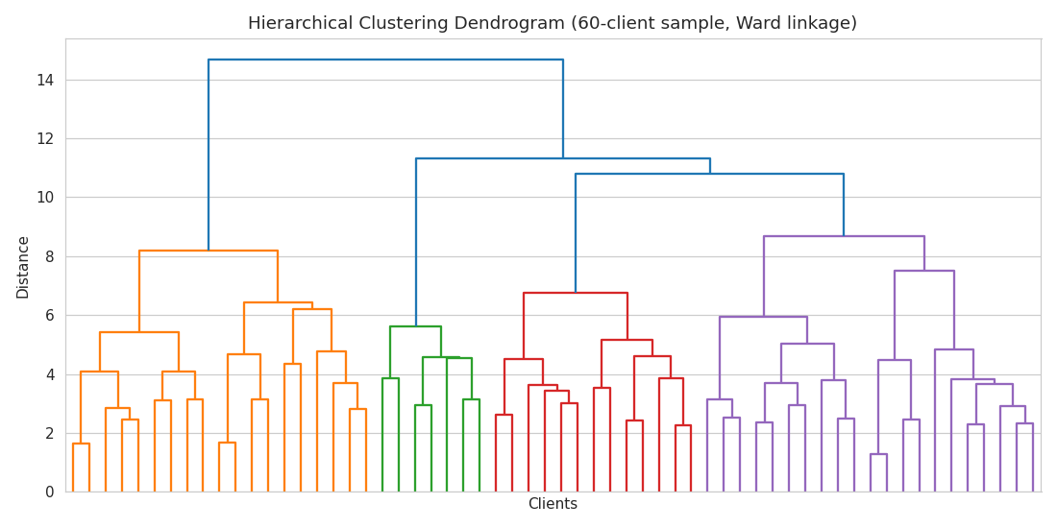
Figure 3. Hierarchical clustering dendrogram (60-client random sample, Ward linkage), illustrating nested cluster relationships.

10. Results
Cluster labels were assigned using a transparent, relative rule rather than fixed thresholds, since no cluster cleared absolute business thresholds (e.g. no cluster reached 30% company-type clients). In priority order: (1) Global Investors = largest average property portfolio; (2) Luxury Investors = highest average sale price among the rest; (3) Corporate Buyers = highest company-type share among the rest; (4) First-Time Buyers = the remaining cluster.
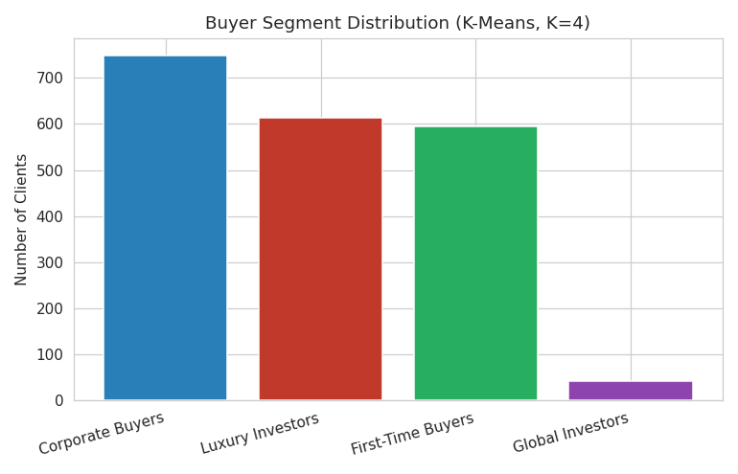
Figure 4. Buyer segment distribution across the 2,000-client base.
Segment | Clients | Avg Properties | Avg Total Investment | Avg Sale Price | Avg Age | % Loan Applied | % Company
Global Investors | 43 | 7.5 | $2,497,550 | $334,840 | 62.4 | 34.9% | 2.3%
Luxury Investors | 614 | 3.5 | $1,479,439 | $429,116 | 52.7 | 38.4% | 6.2%
Corporate Buyers | 749 | 4.1 | $1,270,493 | $309,674 | 53.7 | 36.7% | 5.3%
First-Time Buyers | 594 | 3.0 | $931,619 | $310,368 | 53.8 | 35.4% | 4.0%

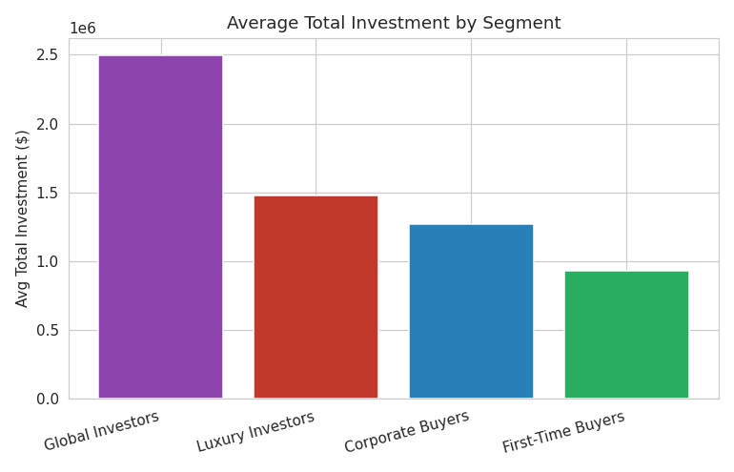
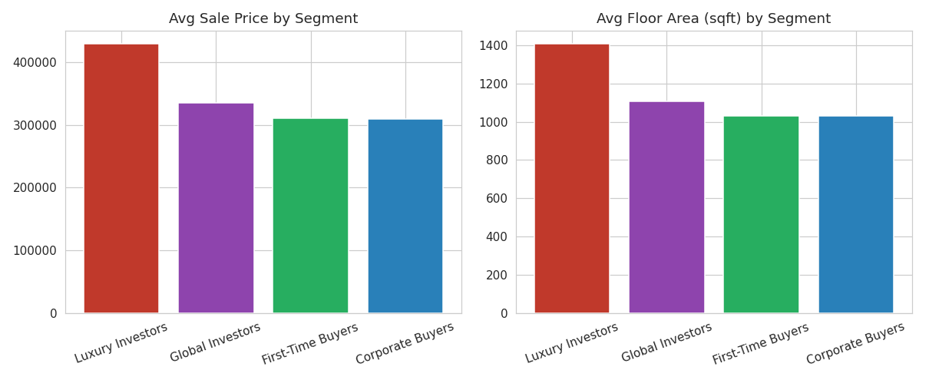
Figures 5-6. Average total investment, sale price, and floor area by segment.

10.1 Honest reading of each segment
Global Investors (n=43, 2.2% of clients) is the clearest scale-based segment: the largest portfolios (7.5 properties, $2.50M total investment average) and the oldest average age (62.4). It is, however, not the most internationally diverse segment -- only 16.3% of its clients are outside the USA, across 6 countries, the lowest diversity of the four segments. The name reflects investment scale, not geographic origin, and this nuance should be communicated to stakeholders.
Luxury Investors (n=614) is the best-fitting label of the four: highest average sale price ($429,116) and largest average unit size (1,407 sqft).
Corporate Buyers (n=749) has the highest company-type share among the clusters not already claimed by Luxury Investors (5.3%), but this is not the single highest company share overall -- Luxury Investors actually has a higher company-type share (6.2%). This overlap means some of Parcl's largest-spending companies fall into the Luxury segment, not the Corporate segment, a finding worth a combined B2B view rather than treating the two segments as mutually exclusive on this dimension.
First-Time Buyers (n=594), the remainder segment, does not match its name: average age is 53.8 (not young) and its loan-applied rate (35.4%) is the lowest of all four segments, not the highest. This segment is better understood as Parcl's baseline or mainstream buyer group. Reporting this mismatch directly -- rather than renaming the cluster to fit the assumption -- is a deliberate methodological choice of this study.

11. Geographic and Behavioral Analysis
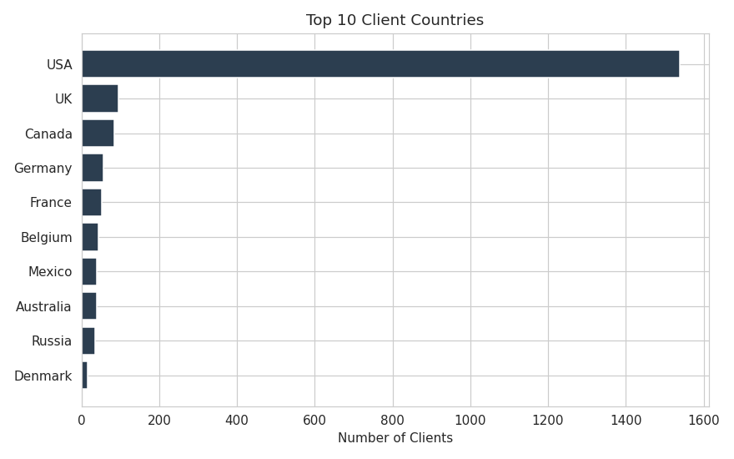
Figure 7. Top 10 client countries. The USA accounts for 1,538 of 2,000 clients (76.9%); the remaining 23.1% span 9 countries (UK, Canada, Germany, France, Belgium, Mexico, Australia, Russia, Denmark).
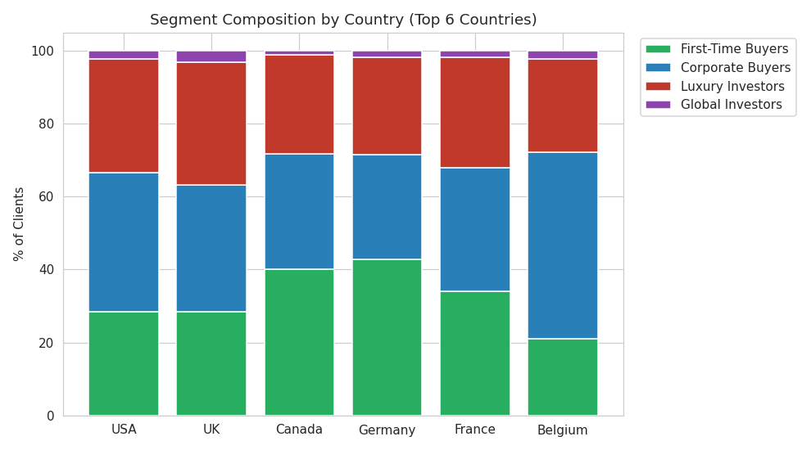
Figure 8. Segment composition by country (top 6 countries) -- segment mix is broadly similar across countries, without a single country dominating any one segment.
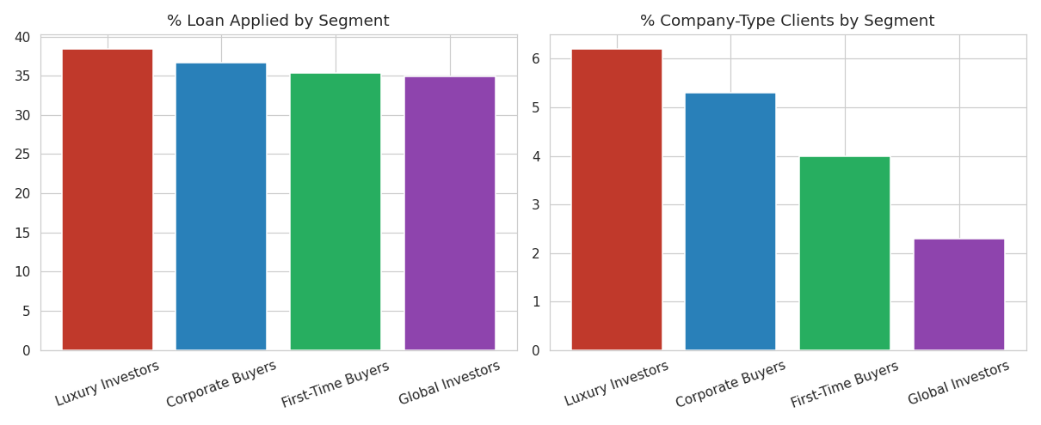
Figure 9. Loan-applied rate and company-type share by segment.
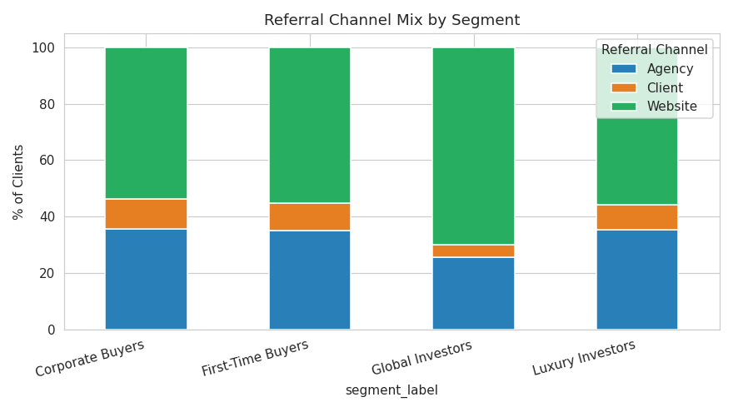
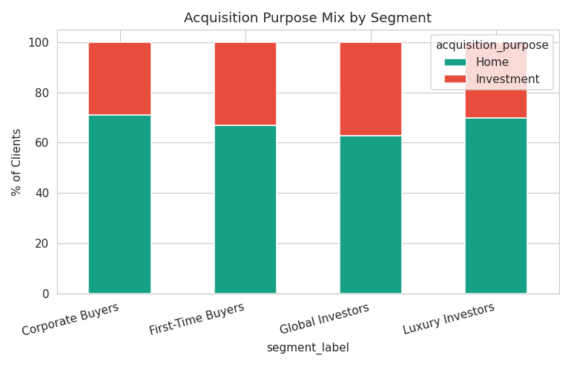
Figures 10-11. Referral channel and acquisition-purpose mix by segment. Website is the dominant referral channel across all segments (1,103 of 2,000 clients overall), and Home purchases (1,385) outnumber Investment purchases (615) network-wide.
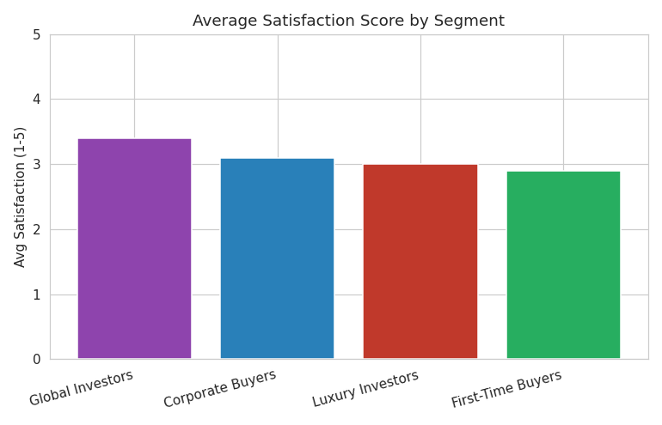
Figure 12. Average satisfaction score by segment -- satisfaction is fairly uniform (2.9-3.4 out of 5) across all four segments, suggesting satisfaction is not strongly segment-driven in this dataset.

12. Discussion
The central methodological finding of this study is that data-driven clustering both confirmed and challenged Parcl's assumed buyer personas. Luxury Investors and Global Investors emerged cleanly and match their intended definitions well. Corporate Buyers and First-Time Buyers, however, revealed real nuance: company-type clients are not confined to a single segment, and the remainder segment does not exhibit the young, loan-seeking behavior its name implies. This is a valuable result in its own right -- it tells Parcl that a first-time-buyer marketing campaign built on the assumed persona would likely mistarget a substantial share of its largest segment.
The modest silhouette scores (0.08-0.12) throughout this analysis are consistent with the nature of the underlying data: client behavior in this dataset varies along a continuous spectrum of investment intensity more than it separates into sharply distinct categories. This is reported transparently rather than masked by a more confident-sounding score, consistent with sound data-science practice.

13. Recommendations
- Build a dedicated, high-touch relationship-management track for Global Investors. At just 43 clients but $2.50M average lifetime investment, this segment likely merits individual account management rather than mass marketing.
- Position Luxury Investors as the primary audience for premium unit launches, given their clear lead in average sale price and unit size.
- Do not build a 'First-Time Buyer' campaign on the assumed young/loan-dependent persona without first re-validating it against this segment's actual (older, less loan-dependent) profile.
- Create a combined view of high-company-share clients across the Luxury and Corporate segments for B2B account management, rather than treating company-type status as segment-exclusive.
- Investigate satisfaction drivers independently of segment, since satisfaction scores do not vary meaningfully by segment in the current data.

14. Limitations
- Silhouette scores (0.08-0.12) indicate moderate, not sharp, cluster separation; segment boundaries should be treated as directional tendencies, not hard categories.
- transaction_date has only monthly granularity, limiting the precision of any time-based feature (e.g. purchase span).
- Segment names follow a relative (best-match) assignment rule rather than every cluster independently satisfying its persona's full description; two notable mismatches (First-Time Buyers' age/loan profile, and company-share overlap between Luxury and Corporate segments) are documented above.
- K=4 was chosen to match the business framework rather than the silhouette-optimal K=3; the difference in cluster quality between the two is small but real.

15. Conclusion
This study delivered a reproducible, data-driven buyer segmentation for Parcl Co. Limited by merging client demographics with actual purchase history and applying cross-validated K-Means and Hierarchical clustering. Four interpretable segments were identified, ranging from a small, high-value Global Investors group to a large First-Time Buyers baseline segment. The most valuable finding, however, is not a specific segment's statistics but the discovery that one assumed persona (First-Time Buyers) does not match its data-driven cluster -- a result that should directly inform how Parcl targets its largest buyer segment going forward.

16. Future Work
- Incorporate marketing-response and campaign-conversion data to validate segments against actual business outcomes, not just descriptive statistics.
- Add daily-resolution transaction timestamps to enable more precise purchase-timing and seasonality features.
- Test additional clustering algorithms (e.g. DBSCAN, Gaussian Mixture Models) that may better handle the continuous, moderately-separated structure found here.
- Extend the feature set with external data (e.g. income proxies, property price indices by region) as it becomes available.
- Re-run segmentation periodically as new transactions accumulate, to track segment drift over time.

References
Hartigan, J. A., & Wong, M. A. (1979). Algorithm AS 136: A K-Means Clustering Algorithm. Journal of the Royal Statistical Society, Series C, 28(1), 100-108.
Rousseeuw, P. J. (1987). Silhouettes: A graphical aid to the interpretation and validation of cluster analysis. Journal of Computational and Applied Mathematics, 20, 53-65. https://doi.org/10.1016/0377-0427(87)90125-7
Ward, J. H. (1963). Hierarchical Grouping to Optimize an Objective Function. Journal of the American Statistical Association, 58(301), 236-244.
Kotler, P., & Keller, K. L. (2016). Marketing Management (15th ed.). Pearson. (Market segmentation theory.)
Pedregosa, F., et al. (2011). Scikit-learn: Machine Learning in Python. Journal of Machine Learning Research, 12, 2825-2830.

