Store sales data

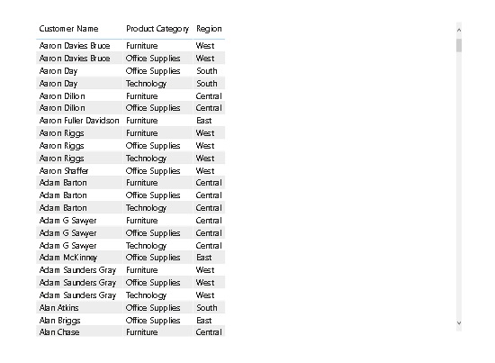

**A line and Clustered Column Chart showing the Sales and Discount as per the State or Province**

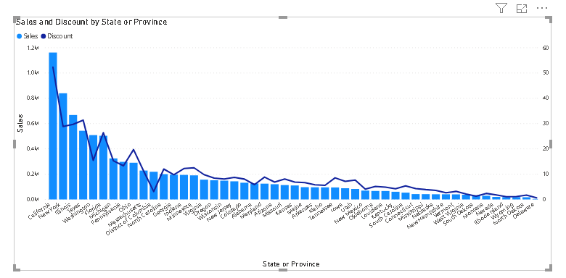

**Utah state has the highest sales in terms Technology.**

**Sales in terms of Product category**

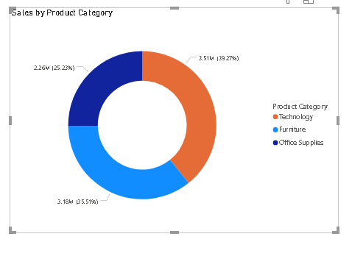

**Category**

