Report view

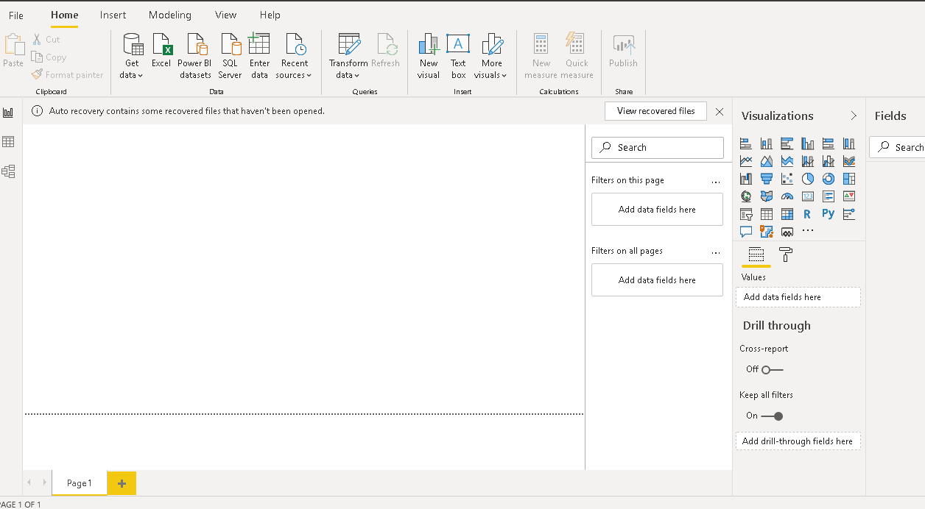

Data View

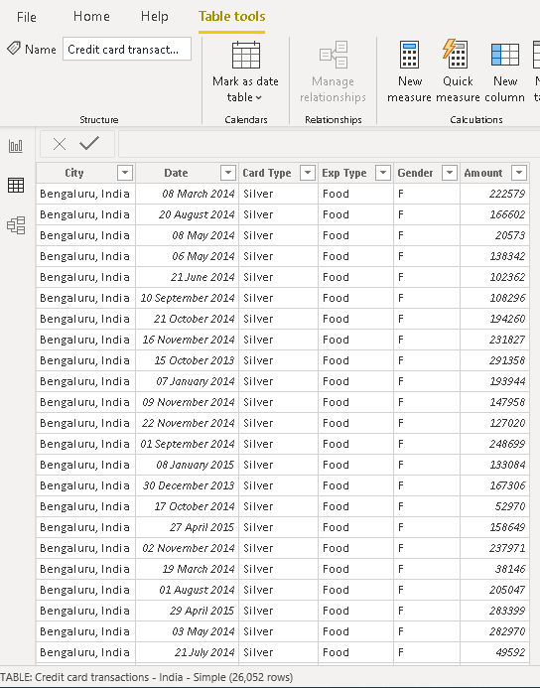

Model view 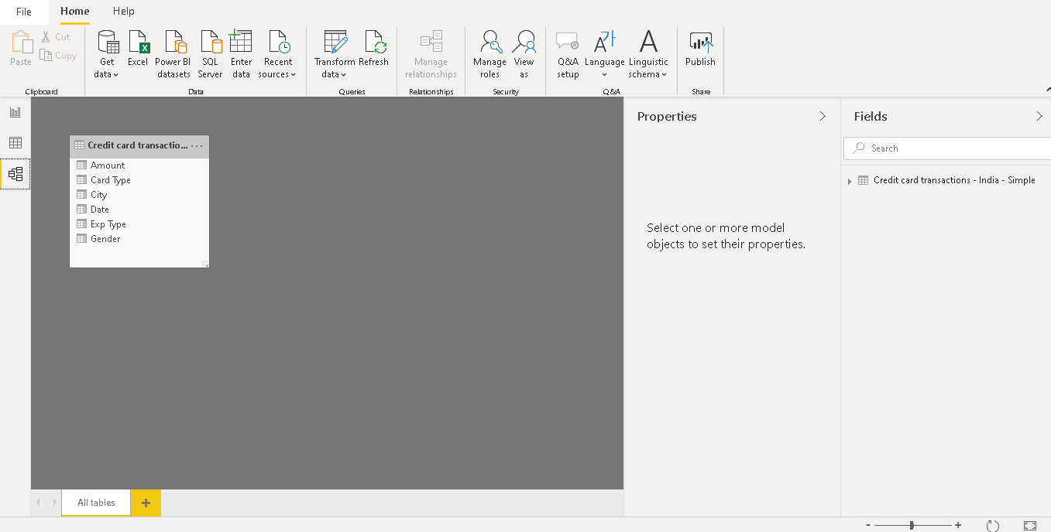

Power Query Editor

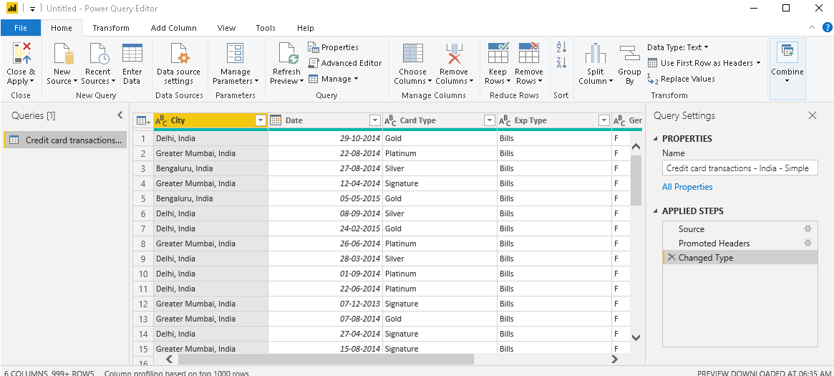

Advance Editor

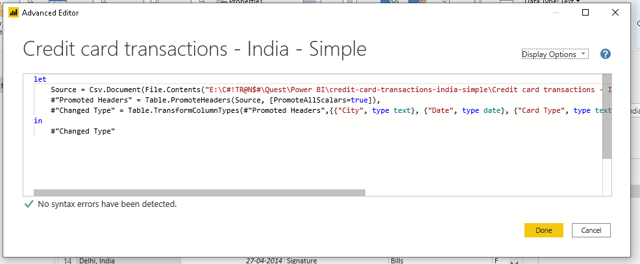

I am unable to comprehend what do I need to do with the prices of PowerBI pro and premium

PowerBI pro = $9.99 per month per user

PowerBI premium = $4,995 per month per cloud compute