1. **One to Many Mapping :**  One to Many Mapping means that one in a table is mapped to multiple rows in another table.

Unidirectional - @OneToMany and @JoinColumn

Bidirectional - @OneToMany and @ManyToOne annotation

Tables - 1. Post 2. Commet

1. Post

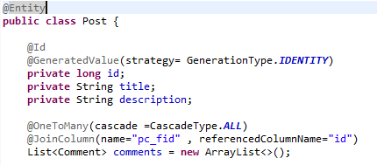

1. Comment

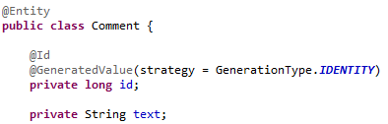

1. Code

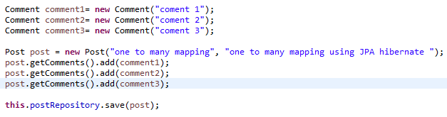

1. Output.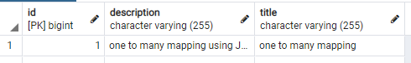
2. Post table
3. Comment table

