Ayush Raj (210249)

Chitresh Meena (210291)

Rajendra Kumar(210816)

Sneha (211042)

Yatendra Singh (211202)

**Structural Gravity Model Estimation Using India-ASEAN Trade Data & Counterfactual Analysis**

**Introduction:**

India’s FTA with ASEAN (Association of Southeast Asian Nations) called **AIFTA** (ASEAN-India Free Trade Area) is one such FTA that has captured significant attention. It was signed in 2009 and came into effect in 2010, creating a free trade area among member countries. The paper aims to analyze its effect on India’s global trade and its trade flows both with the ASEAN countries, as well as with other non-member trading partners using a structural gravity model. As India and ASEAN countries continue to develop their economies, their relationship has become a crucial component of their foreign policies. Hence with the objective of increasing economic integration with ASEAN, AIFTA was signed. The Structural Gravity model presented by Anderson and Wincoop in 2003 is used in this research to explain the pattern of trade between ASEAN countries and India. The Anderson and Wincoop gravity equation modifies the original McCallum gravity equation by considering trade expenses and transportation costs in addition to the country border impacts. In this model prices are not equalized among the countries. Ten countries currently comprise the ASEAN or Association of Southeast Asian Nations including Brunei, Cambodia, Indonesia, Laos, Malaysia, Myanmar, Philippines, Singapore, Thailand and Vietnam. We have 27 countries in total - 10 ASEAN member countries, one India and 16 other countries. There would be 729 observations as a result of 27*27.

If India ratifies the ASEAN agreement by simulating trade patterns, we would also employ the counterfactual approach to examine the welfare consequences. This could be done by using the ‘gegravity’ python package to estimate general equilibrium (GE) structural gravity models and simulate counterfactual experiments. The package is based on the well established version of the gravity model described by Yotov et al (2016).

**Objective:**

The primary objectives of this term paper are:

1. Estimation of a Structural Gravity Model: The first objective is to estimate a structural gravity model using trade data between India and the Association of Southeast Asian Nations (ASEAN) member states. By employing this econometric framework, we aim to identify and quantify the key determinants driving bilateral trade flows between India and ASEAN countries. This includes factors such as economic size (proxied by GDP), distance (geographical and non-geographical), and other relevant variables that may influence trade patterns.
2. Conducting Counterfactual Analysis: The second objective is to conduct counterfactual analysis based on the estimated structural gravity model. Through this analysis, we seek to explore the potential impact of various policy changes or external shocks on India-ASEAN trade dynamics. By simulating different scenarios and assessing their effects on trade flows, we aim to provide insights into the resilience of India-ASEAN trade relations and the potential implications for regional economic integration.

**Literature Review**

In this section, we encapsulate some of the previous studies carried out which used the gravity model for estimating the effects of trade agreements on trade flows. The usage of the gravity model has been relatively recent and has also been challenged due to the absence of weak theory to support it. Most of the literary work carried out pertains to the NAFTA, Latin American, and EU agreements, because of its prior existence. However, in later years we do have studies to analyze the effects of the ASEAN-FTA. A series of such studies have documented the increasing trade among members, as well as with non-members. These include Hur and Nandasiri (2008), Ekanayake and Mukherjee (2010), and Eicher, Henn and Papageorgiou (2012). There are inconsistent results on the trade creation dummy, with some papers like Dee and Gali (2005), and Soloaga and Winters (2001) reporting it to be negative, while Elliot and Ikemoto (2004) reported it to be positive. Interestingly, while the agreements have proven to be beneficial for China, they were unfruitful for India. Note that the majority of these studies have utilized a double or triple indexed model to differentiate the impact on members and non-members due to FTA. On the other hand, a recent paper by Subhash Jagambe and Elumulai Kannan (2020), analyzing the impact of ASEAN-India FTA on agricultural trade have found positive results for India. Using the more reliable PPML method, they have shown a higher magnitude of the TC effect as compared to the TD effect.

**Data Sources**

The amount of exports for each country to several other countries was taken from World Integrated Trade Solutions (WITS) database. We obtained the distance between countries using the CEPII (Center for Prospective Studies & International Information) database. We used the World Bank database to download the GDP (Gross Domestic Product) of each country. Common language, common colony, colony and common border dummies were obtained from the same CEPII database. Bilateral Trade flows as reported by the origin (1000 current USD) were obtained from UN Comtrade. We also obtained bilateral trade flows from the International Monetary Fund (IMF).

**Model Description**

The OneSectorGE model in the gegravity package replicates the structural model of Yotov et al. (2016). That model is based on the earlier demand-side, constant elasticity of substitution (CES)-Armington structural gravity model of Anderson and van Wincoop (2003). As shown by Arkolakis (2012), the structural gravity model can be derived from a wide range of different trade models such as the canonical supply-side, Ricardian version of Eaton and Kortum (2002). Thus, this particular version of the model can be considered reflective of a much more general class of trade models. For the sake of parsimony, I keep the theoretical discussion short as the ‘gegravity’ package is merely an implementation of an existing model and makes no theoretical contributions of its own. For more details and discussion of the model, I refer the reader to Yotov et al. (2016) and Anderson et al. (2018). The model system takes the following form:

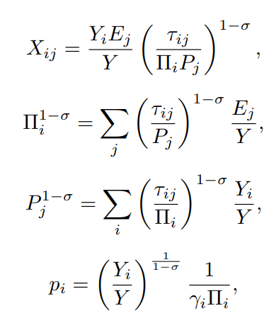

First equation is a typical gravity equation, which relates bilateral trade (Xij) between exporter ‘i’ and importer ‘j’ to exporter output (Yi), importer expenditures (Ej ), global output (Y), bilateral trade costs (τij), the elasticity of substitution (σ) and outward and inward multilateral resistances (Πi and Pj respectively). The multilateral resistance (MR) terms are defined by second and third equations. These terms can be thought of as aggregate trade cost or price indices for the exporter and importer. Fourth equation defines factory gate prices (pi), which are determined by output, OMRs, and the CES preference parameter (γi).

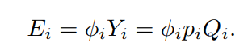

Finally the last equation determines expenditures and provides a market clearing condition. Expenditures are determined as a fixed ratio (φi) of the value of domestic production. Domestic production is defined by the product of output quantity (Qi) and factory gate prices. In this version of the model, output quantity is fixed/exogenous and all changes in the value of output are captured though the price term.

**Methodology**

We used the Poisson Pseudo-Maximum Likelihood Estimator for estimation of the gravity model. It is the same as applying a specific kind of nonlinear least squares to the initial equation. Poisson Probability Mass Function given by : (𝛬𝑘*𝑒−ᴧ)/(𝑘!) For applied policy researchers utilizing gravity models, the Poisson estimator provides a number of extra useful characteristics. First off, it makes sense when there are fixed effects, which may be inserted as dummy variables just like in a straightforward OLS model. Second, observations for which the observed trade values 0 are naturally included in the Poisson estimator. Third, the interpretation of the Poisson model's coefficients is simple and adheres to the same pattern as OLS. The Poisson model's coefficients may be easily understood and are interpreted in exactly the same way as they would be under OLS. The coefficients of any independent variables entered in logarithms can still be regarded as simple elasticities even when the dependent variable for the Poisson regression is stated as exports in levels rather than in logarithms. As with OLS, the independent variable coefficients entered in levels are read as semi-elasticities. Poisson has the further benefit of readily supporting counterfactual simulations while adhering to key empirical limitations.

**Results**

The results obtained after estimating the structural gravity model are as follows:

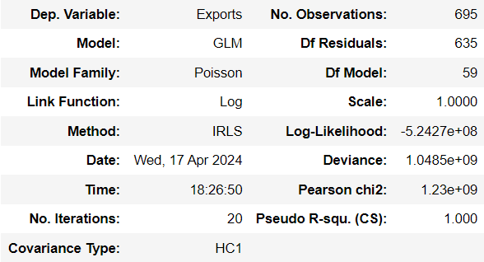

The coefficient estimates for independent variables are as follows:

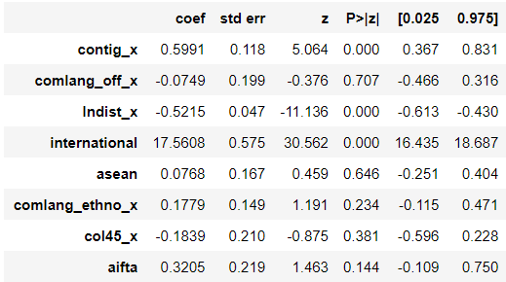

The coefficient for contig_x is positive, indicating that borders play an important role in increasing trade flows amongst the countries. Two countries close to the border share a cultural history which facilitates increased trade flows.

The coefficients for comlang_off_x & comlang_ethno_x are negative & positive respectively.

The coefficient for lndist_x is negative, incorporating the fact that as distance between two trading partners increases, trade cost also increases. As a result there is a decrease in trade flows between the countries.

The coefficient for 'asean’ is positive but insignificant, which implies that there is no significant impact of the ASEAN agreement on trade flows.

But the coefficient for ‘aifta’ is positive and significant which implies that the trade flows between India and ASEAN countries due to the agreement signed in 2009-10 have increased significantly.

The baseline Inward Multilateral Resistance (IMR) and Outward Multilateral Resistance (OMR) are obtained to be:

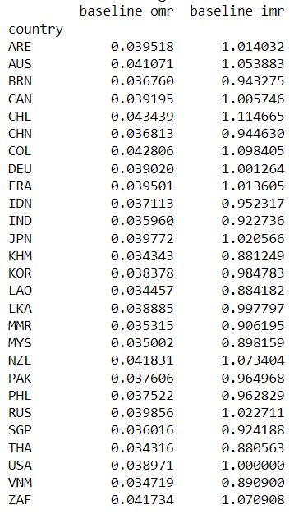

After implementing the counterfactual that Indian joins the ASEAN nations, the results obtained are:

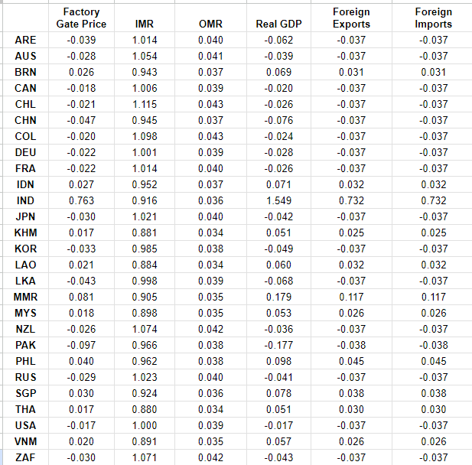

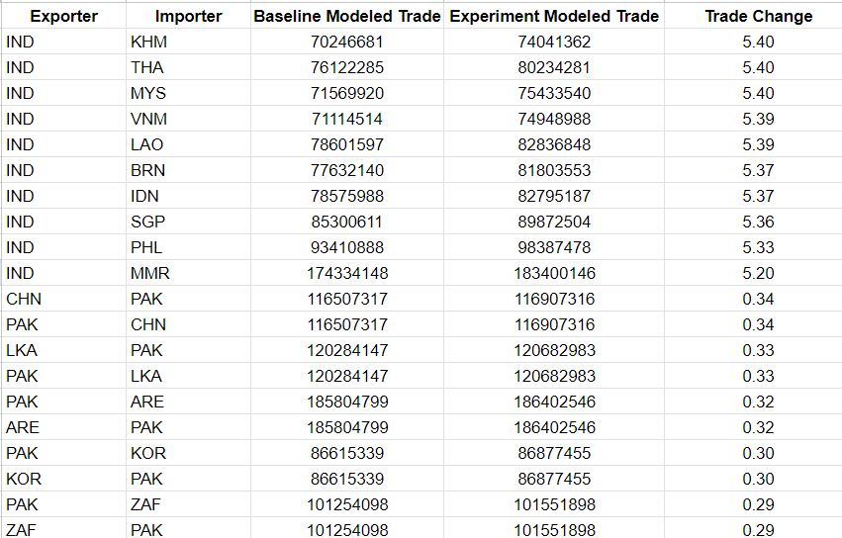

We observed that the trade change is positive and more than 5% for each and every IND & ASEAN member nation. While the trade change for other countries’ pairs is less than 1%.

If India joins ASEAN, this will trigger a positive shift in factory gate prices for India & ASEAN countries.

GDP change is positive for the ASEAN member nations. This is due to market expansion, larger consumer base and potential for higher export markups.

While for the non-members there are reduced trade flows. This also incentivizes the non-members to pursue bilateral agreements with India.

Both foreign exports and foreign imports increase for the ASEAN member nations.

**References:**

* Anderson, J. E., M. Larch, and Y.V. Yotov (2018). GEPPML: General equilibrium analysis with ppml. The World Economy 41 (10), 2750–2782.
* Anderson, J. E. and E. van Wincoop (2003). Gravity with gravitas: A solution to the border problem. American Economic Review 93, 170–192.
* gegravity: General Equilibrium Gravity Modeling in Python by Peter R. Herman
* https://www.researchgate.net/publication/370625410
* An Advanced Guide to Trade Policy Analysis: The Structural Gravity Model by Yoto V. Yotov, Roberta Piermartini, José-Antonio Monteiro, and Mario Larch
* Richa Khurana & D. K. Nauriyal (2017): ASEAN-India Free Trade Agreement: Evaluating Trade Creation and Trade Diversion Effects, Journal of East-West Business
* Bharti, S.K., & Nisa, S. (2021). A Study of India’s Trade Flows with the ASEAN: Gravity Model Analysis, Orissa Journal of Commerce 42(3), 15-26

**Plagiarism Report:**

[**https://drive.google.com/drive/folders/1zBBsTnZtDzceYTIKz1co4Dw_Lv9UO_u0**](https://drive.google.com/drive/folders/1zBBsTnZtDzceYTIKz1co4Dw_Lv9UO_u0)

**Designed By:**

Ayush Raj(210249)

Chitresh Meena(210291)

Rajendra Kumar(210816)

Sneha(211042)

Yatendra Singh(211202)