**Unit-1**

**1)Create a webpage to print a paragraph with 4 – 5 sentences. Each sentence should be in a different font and color.**

**Program:**

<!DOCTYPE html>

<html lang="en">

<head><title>Diffrent Paras</title><style>

        p{font-size: x-large;}

        .sentence1 { font-family: Arial, sans-serif; color: red; }

        .sentence2 { font-family: "Times New Roman", serif; color: blue; }

        .sentence3 { font-family: "Courier New", monospace; color: green; }

        .sentence4 { font-family: "Georgia", serif; color: purple; }

        .sentence5 { font-family: "Verdana", sans-serif; color: orange; }

    </style>

</head>

<body>

    <p>

        <p class="sentence1">This is the first sentence...</p>

        <p class="sentence2">Here is the second sentence...</p>

        <p class="sentence3">The is the third sentence...</p>

        <p class="sentence4">This is the fourth sentence...</p>

        <p class="sentence5">Fifth sentence...</p>

    </p></body></html>

**Output:**

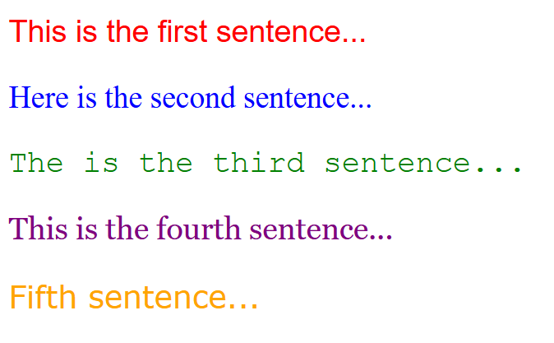

**2)From a design for nav bar**

**Program:**

<!DOCTYPE html>

<html lang="en">

<head><title>Side Navbar</title>

    <style>body {margin: 0;background-color: #f4f4f4;}

        .sidenav {height: 100vh;width: 250px;background-color: #fff;

            padding: 20px;position: fixed;right: 0;top: 0;

            box-shadow: 2px 0 5px rgba(0, 0, 0, 0.1);

            transform: translateX(100%);

            transition: transform 0.3s ease-in-out;

        }

        .sidenav.active transform: translateX(0);}

        .sidenav a {display: flex;padding: 12px 15px;

            text-decoration: none;

            font-size: 16px;color: #333;

            transition: 0.3s;border-radius: 5px;

            margin-bottom: 5px;

        }

        .sidenav a:hover {background-color: #e0f2f7;color: #007bff;}

        .sidenav a.active {background-color: #bbdefb;color: #007bff;}

        .menu {position: absolute;right: 20px;top: 20px;

            background-color: #007bff;padding: 8px;

            border-radius: 4px;cursor: pointer;

        }

        .menu img {width: 24px;height: 24px;}

        .close-btn {display: flex;justify-content: flex-end;

            cursor: pointer;

        }

        .content {padding: 20px;}

    </style>

</head>

<body>

    <div class="menu" onclick="toggleNav()"><img src="./images/menu.svg" alt="menu"/></div>

    <div class="sidenav" id="sidenav">

        <div class="close-btn" onclick="toggleNav()"><img src="./images/close.svg" alt="close" /></div>

        <a href="#" class="active">Home</a>

        <a href="#">About</a>

        <a href="#">Services</a>

        <a href="#">Videos</a>

        <a href="#">Contact</a>

        <a href="#">Subscribe</a>

    </div>

    <div class="content">

        <h2>This is a Side Navigation Bar</h2>

        <p>This is some content in this area....</p>

    </div>

    <script>

*function* toggleNav() {

            document.getElementById("sidenav").classList.toggle("active");

        }

    </script></body></html>

**Output:**

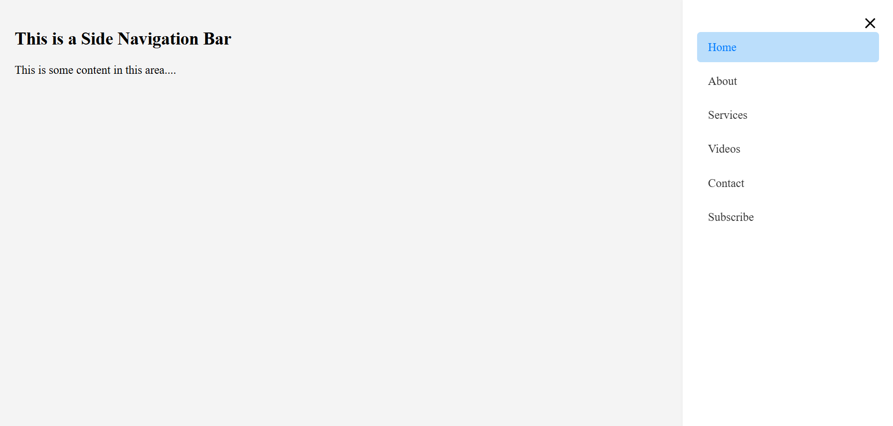

**Unit -2**

**1)Write a function which checks number till the given input/parameter is odd or even**

**Program:**

<!DOCTYPE html>

<html lang="en">

<head><title>Odd Even</title></head>

<body>

    <h1 style="text-align: center;">EVEN-ODD Check</h1>

    <div style="text-align: center;">

        <input type="number" id="number" placeholder="Enter a number">

        <button onclick="check()">Check</button>

    </div>

    <div id="container" style="text-align: center;"></div>

    <script>

*function* check() {

*let* number = document.getElementById('number').value;

*let* container = document.getElementById('container');

            container.innerHTML = "Given Number is:"+number;

            for(*let* i = 0; i < number; i++) {

                if(i % 2 == 0) {container.innerHTML += `<p>${i} is Even</p>`;

                } else {container.innerHTML += `<p>${i} is Odd</p>`;}}}

    </script>

</body>

</html>

**Output:**

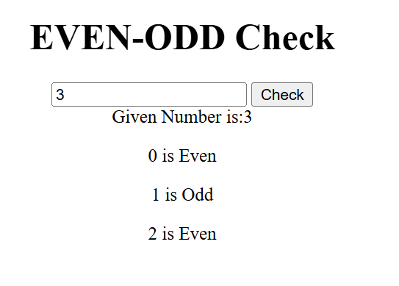

**2)Implement a simple stopwatch that: Starts counting on a button click ,Stops when another button is clicked**

**Program:**

<!DOCTYPE html><html lang="en"><head><title>Stop watch</title><style>

        .counter {display: flex; justify-content: center; margin-top: 20px;}

        .counter p {font-size: 30px;margin: 0 10px;}</style></head>

<body><h1 style="text-align: center;">Simple StopWatch</h1>

    <div style="text-align: center;"><button onclick="start()">Start</button>

        <button onclick="stop()">Stop</button>

        <button onclick="reset()">Reset</button></div>

    <div class="counter"><p id="minutes"></p><p id="seconds"></p><p id="milliseconds"></p></div>

    <script>*let* minutes = 0; *let* seconds = 0; *let* milliseconds = 0;isCounting = false;

*function* start(){isCounting = true;

            setInterval(() *=>* {if(!isCounting){return;}milliseconds++;

                if(milliseconds == 100){milliseconds = 0;seconds++;}

                if(seconds == 60){seconds = 0;minutes++;}

                document.getElementById('minutes').innerText = minutes;

                document.getElementById('seconds').innerText = seconds;

                document.getElementById('milliseconds').innerText = milliseconds;

            }, 10);}

*function* stop(){isCounting = false; }

*function* reset(){isCounting = false;minutes = 0;seconds = 0;milliseconds = 0;

            document.getElementById('minutes').innerText = minutes;

            document.getElementById('seconds').innerText = seconds;

            document.getElementById('milliseconds').innerText = milliseconds;}

    </script></body></html>

**Output:**

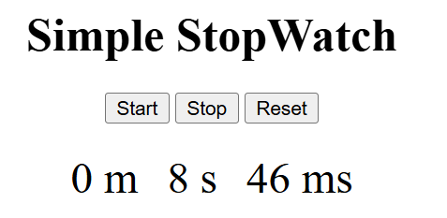

**3)Write a function which prints * for the numbers of times and rows provided**

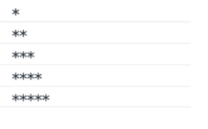

**Program:**

<!DOCTYPE html>

<html lang="en">

<head><title>Star Pattren</title></head>

<body><h1 style="text-align: center;">Star (*) Pattren</h1>

    <div style="display: flex; justify-content: center;">

        <input type="number" id="number" placeholder="Enter a number">

        <button onclick="Print()">Print</button></div>

    <div style="display: flex; justify-content: center;"><div id="pattren" ></div></div>

    <script>*function* Print() {

*let* number = document.getElementById('number').value;

*let* container = document.getElementById('pattren');

            for(*let* i = 1; i <= number; i++) {

*let* str = '*'.repeat(i);

                container.innerHTML += `<p>${str}</p>`;}}

    </script>

</body>

</html>

**Output:**

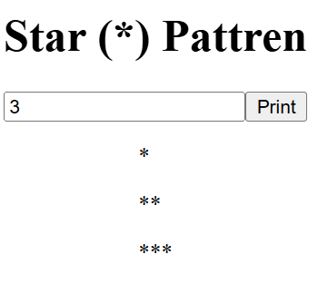

**4) Create a method ‘excludes’ which excludes values from existing array and push to new array.**

**Program:**

<!DOCTYPE html>

<html lang="en">

<head><title>Exclude</title></head>

<body><h1 style="text-align: center;">Excluding Elements in arrays</h1>

    <div style="text-align: center;">

        <input type="number" id="number" placeholder="Enter a number to push into array">

        <input type="button" value="Push" onclick="push()"></div>

    <div style="margin-top: 20px; text-align: center;">

        <input type="number" id="excludeNumber" placeholder="Enter number to exclude">

        <input type="button" value="Exclude" onclick="exclude()"></div>

    <div  style="margin-top: 20px; text-align: center;"><h4>Output:</h4><div id="array"></div>

        <div id="exNumber"></div>

        <div id="exArray"></div></div><script>

*let* arr = [];*let* eArr = [];

*function* push(){*let* number = document.getElementById('number').value;arr.push(number);

            document.getElementById('array').innerText = "Array to Exclude: ["+arr+"]";    }

*function* exclude(){

*let* number = document.getElementById('excludeNumber').value;

            for(*let* i = 0; i < arr.length; i++){

                if(arr[i] != number){eArr.push(arr[i]);}}

            document.getElementById('exNumber').innerText = "Number to Exclude: "+number;

            document.getElementById('exArray').innerText = "Excluded Array: ["+eArr +"]";}

    </script></body></html>

**Output:**

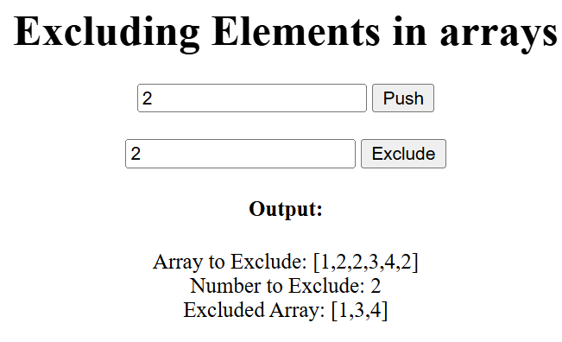

**5) Create two variables grade and passingYear. Check if your grade == "A" and passingYear < 2020 with the help of ternary operator(Not allowed to use any logical operator).If both condition true print on console Qualify. Otherwise Fail.**

**Program:**

<!DOCTYPE html>

<html lang="en">

<head><title>Qualify</title></head>

<body>

    <h1 style="text-align: center;">Qualified or Not</h1>

    <div style="text-align: center;">

        <input type="text" maxlength="2" id="grade" placeholder="grade"/>

        <input type="number" id="year" placeholder="year"/>

        <input type="button" value="Check" onclick="check()"/>

        <h2 id="result"></h2>

    </div>

    <script>

*function* check(){

*let* grade = document.getElementById('grade').value;

*let* year = document.getElementById('year').value;

*let* result = (grade=="A" && year <2020)? "Qualified":"Failed";

            document.getElementById("result").innerHTML = "You are "+result;

            console.log(result);

        }

    </script>

</body>

</html>

**Output:**

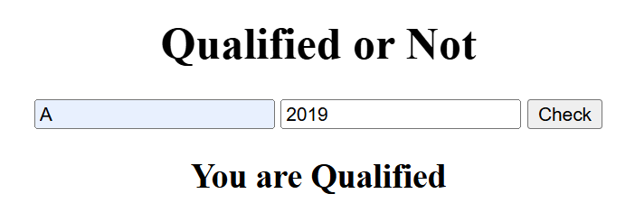

**6) Find the frequency of characters inside a string. Return the result as an array of objects. Each object has 2 fields: character and number of occurrences.**

**Program:**

<!DOCTYPE html>

<html lang="en">

<head><title>Frequency</title></head>

<body><h1 style="text-align: center;">Frequency of an element in a String</h1>

    <div style="text-align: center;"><input type="text" id="str" />

        <input type="button" value="Submit" onclick="check()"/></div>

    <div id="output" style="text-align: center;"></div>

    <script>

*function* check(){

*let* givenString = document.getElementById("str").value;

*const* outputDiv = document.querySelector("#output");

            outputDiv.innerHTML += "<br>Given String:"+givenString+"<br>";

*let* uniqueSet = new Set(givenString);*let* ouput = [];

            for(x of uniqueSet){

*let* frequencyObject = new Object();

*let* count = 0;

                for(y of givenString){ if(x==y){ count++;}}

                frequencyObject.charecter = x;

                frequencyObject.count = count;

                outputDiv.innerHTML += "<br>Charecter:"+x+" number: "+count;

                ouput.push(frequencyObject);

            }console.log(ouput);}

    </script></body></html>

**Output**:

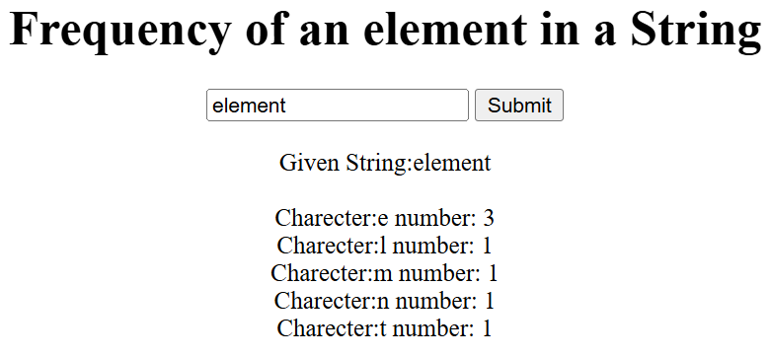

**7) Create a function that will receive n as argument and return an array of n unique random numbers from 1 to n.**

**Program:**

<!DOCTYPE html>

<html lang="en">

<head><title>Return M Unique Values for N natural Number</title></head>

<body><h1 style="text-align: center;">Return M Unique Values for N natural Number</h1>

    <div style="text-align: center;">

        <input type="number" id="n"/>

        <input type="button" value="submit" onclick="random()"/>

    </div><h4 id="output" style="text-align: center;"></h4>

    <script>

*function* random(){

*let* val = document.getElementById("n").value;

*let* num = Math.floor(Math.random() * val);

*let* out = [...(getUniqueRandomNumbers(num,val))];

            document.getElementById("output").textContent = "["+out+"]";

            console.log(out);               }

*function* getUniqueRandomNumbers(*range*,*val*) {

*let* numbers = new Set();

            while (numbers.size < range) {

*let* num = Math.floor(Math.random() * val);

                numbers.add(num);}

return numbers;}

    </script></body></html>

**Output:**

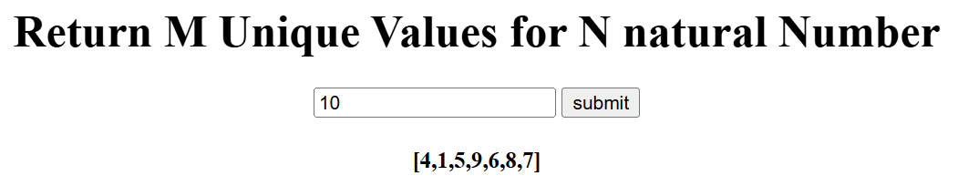

**8) Write a JavaScript program to calculate age.**

**Program:**

<!DOCTYPE html>

<html lang="en">

<head>    <title>Calculate Age</title></head>

<body><h1 style="text-align: center;">Age Calculator</h1>

    <div  style="text-align: center;">

        <input type="date" id="d"/>

        <input type="button" value="Calculate" onclick="calculate()"/>

        <h4 id="age"></h4>

    </div>

    <script>

*function* calculate() {

*let* dob = new Date(document.getElementById("d").value);

*let* todayDate = new Date();

*let* year = todayDate.getFullYear() - dob.getFullYear();

*let* month = todayDate.getMonth() - dob.getMonth();

*let* days = todayDate.getDate() - dob.getDate();

            console.log(year,month,days);

            if (dob > todayDate) {alert("Check the input Date...");return;}

            if (month < 0) {year--;month += 12;}

            if (days < 0) {month--;

*let* prevMonth = new Date(todayDate.getFullYear(), todayDate.getMonth(), 0);

                days += prevMonth.getDate();}

            document.getElementById("age").innerText = "Your Age: "+year+" Years, "+month+" Months, and "+days+" Days";}

    </script></body></html>

**Output:**

