# URL:

A URL is a type of uniform resource identifier and is address of a resource on the World Wide Web and the protocol used to access it. It is used to indicate the location of a web resource to access the web pages.

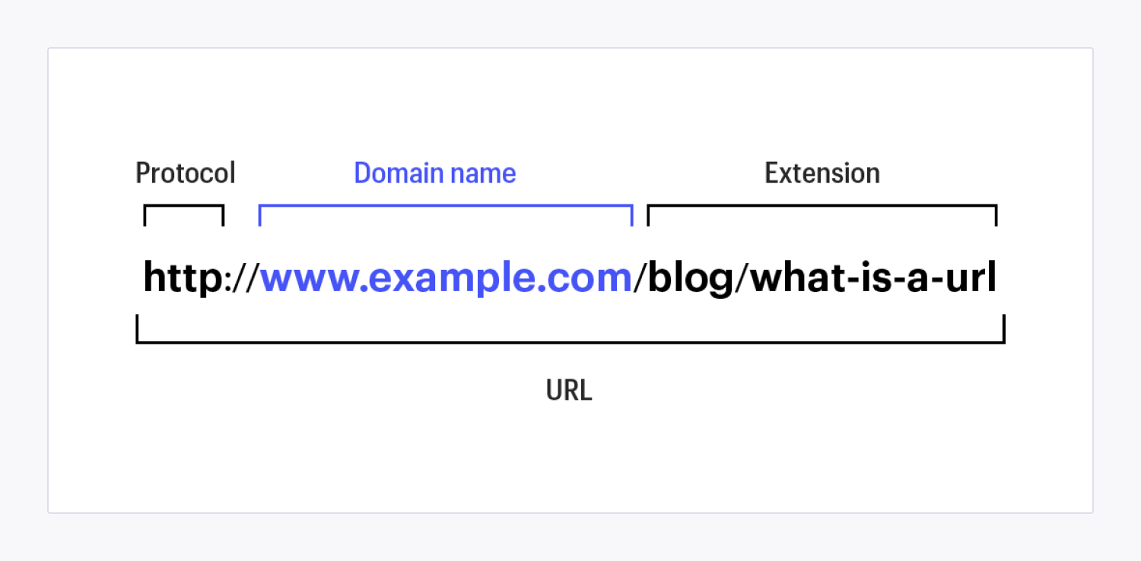

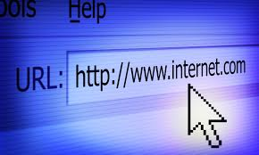

The URL sends users to a specific resource online such as video, webpage, or other resources. When you search any query on Google, it will display the multiple URLs of the resource that are all related to your search query. The displayed URLs are the hyperlink to access the webpages

A [URL](https://www.javatpoint.com/url-full-form) (Uniform Resource Locator) contains the information, which is as follows:

* The port number on the server, which is optional.
* It contains a protocol that is used to access the resource.
* The location of the server
* A fragment identifier
* In the directory structure of the server, it contains the location of the resource.
* **http:// or https://**
* The [http](https://www.javatpoint.com/http-tutorial) is a protocol that stands for Hypertext Transfer Protocol. It tells the browser to which protocol will be preferred to use for accessing the information that is specified in the domain.
* The https (Hypertext Transfer Protocol Secure) is an enhanced protocol as compared to [http](https://www.javatpoint.com/http) as it concerned with security. It provides the surety that the information, which is transmitted over [HTTP](https://www.javatpoint.com/computer-network-http) is secure and encrypted. The colon (:) and two forward slashes (//) are used to separate the protocol from the rest of the part of the URL.
* **www.**
* The www is used to distinguish the content, which stands for World Wide Web. This portion of the URL can be left out many times, as it is not required. For instance, if you type "http://javatpoint.com," you will still get the javatpoint website. For an important subpage, this portion can also be substituted, which is known as a subdomain

### **What is URL Redirect?**

A URL redirect is a web server function that takes your URL and points it to another. For example, consider, you had the old URL "myvlogsite.com," and you wanted to visitors' access directly to the new URL "javatpoint.com." Redirect is the best solution for it; when anyone type "myvlogsite.com" in the browser would be redirected to the new URL "javatpoint.com." There are various kinds of redirects for web developers, such as HTTP 3xx series status codes, manual redirects, JavaScript, metatag refreshes, server-side scripts, frame redirects, and more. Furthermore, the URL redirect may also be known as URL forwarding, domain forwarding, HTTP code 3xx redirect, and domain redirection.

There are many reasons for web users may be redirected from one URL to another, such are as follows:

* Merging of two websites
* Change of business name
* To direct content to a recently updated domain name
* Landing page-split testing for marketing tests
* To direct traffic toward recently updated content

A URL redirect is also used to cause problems for users and their computers through illegal activities like phishing. Additionally, it can be used to remove the search results of web browsers, but nowadays, most of the search engines are capable of detecting these types of fraud attempts. Redirect a web page, the several HTTP protocol 3xx series codes are the most common way. The members of this series have various attributes, such are as follows:

* The number 300 provides various redirect choices. For instance, an option to select alternative languages.
* The number 301 indicates when a site is moved permanently. For example, when the name of a business has changed.
* The number 302 is used for an unspecified redirect.
* 303 display the output of CGI (common gateway interface) scripts.
* 307 is used, when a site is to be redesigned.

The website address obtains a new URL when a website visitor is redirected to a newly named website URL. Businesses often change their website's homepage into a redirect page. They transform page with a concurrent message briefly describing the redirect. A meta tag is embedded into the website's source code behind the scenes. The regular visitors of the website will receive an error message "404 - Not Found" without a redirect.

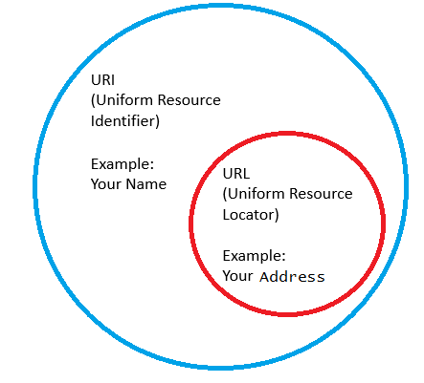

**Difference between URL and URI**

There are numerous differences between URL and [URI](https://www.javatpoint.com/custom-uri-in-jsp-custom-tag), which are as follows:

There are numerous differences between URL and [URI](https://www.javatpoint.com/custom-uri-in-jsp-custom-tag), which are as follows:

|  |  |
| --- | --- |
| **URL** | **URI** |
| URL stands for Uniform Resource Locator that used to describe the identity of an item. | URI stands for Uniform Resource Identifier, which offers a technique for defining the identity of an item. |
| The primary objective of the URL is to get the address or location of the resource. | The primary objective is to find a resource and distinguish it from other resources with the help of a name or location. |
| URL is a type of URI; therefore, all URLs can be URIs. | URI is the superset of URL; thus, all URIs are not URLs as a URI can be a name rather than a locator. |
| It is only used for locating web pages. | It is used in various languages such as HTML, XML and other files XSLT, and more. |
| A URL specifies where a resource is occurring and a way for retrieving a resource. | A URI identifies a resource either by URL or URN or both. |
| In URL, the scheme must be a protocol such as FTP, HTTP, HTPPS, and more. | The scheme may be anything in URI like a name, specification, protocol, and more. |
| It contains the protocol information in the URL. | It does not include protocol information. |
| It includes components like path, domain, hash, string, query, and more. | It includes components such as path, scheme, query, fragment component, and more. |
| It offers specification on what type of protocol is to be used. | It does not contain protocol specification. |
| An example of URL: https://google.com | An example of URI: urn:isbn:0-486-27557-4 |